**Q.1 What is cloud computing ? explain the cloud computing architecture explain with neat diagram.**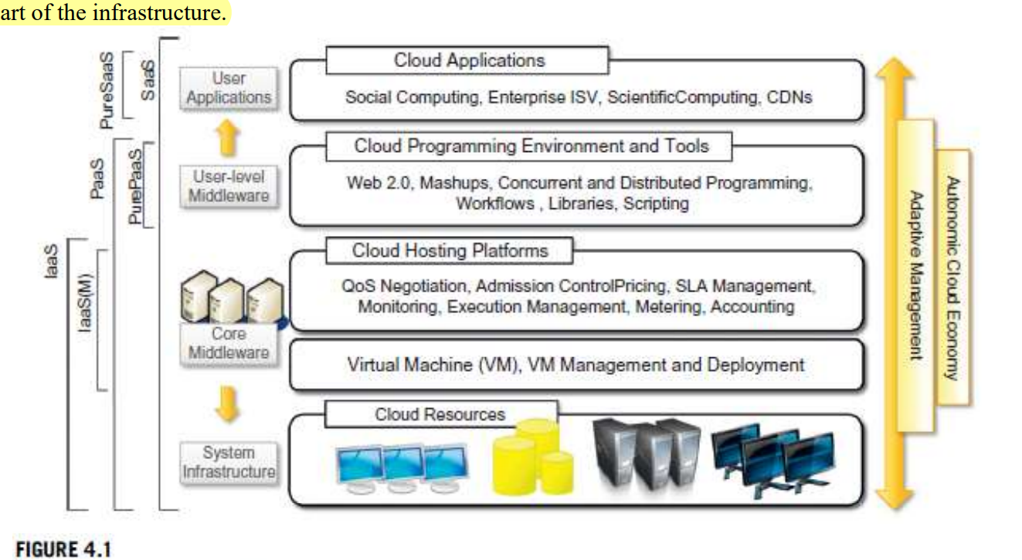

**Cloud Computing Deffn:**

1. The term cloud refers to a network or the internet.
2. It is a technology that uses remote servers on the internet to store, manage, and access data online rather than local drives.
3. The data can be anything such as files, images, documents, audio, video, and more.

**Architecture:**

1. Cloud computing can be organized into layers, from hardware to software.
2. Cloud infrastructure can be made up of a variety of different resources, such as clusters, networked PCs, database systems, and storage services.
3. Core middleware manages physical infrastructure to provide a good runtime environment for applications and optimize resource utilization.
4. Virtualization technologies are used to customize runtime environments, isolate applications, and guarantee quality of service.
5. Virtual machine technology allows for fine-grained partitioning of hardware resources and virtualization of specific devices, meeting user and application needs.
6. IaaS solutions are good for designing system infrastructure but not for building applications.
7. Cloud programming environments and tools provide a development platform for applications.
8. Platform-as-a-Service (PaaS) provides a development platform for applications, which includes the infrastructure as well. In the case of Pure PaaS, only the user-level middleware is offered.
9. The top layer of the cloud computing reference model is SaaS, which provides software applications over the internet.

**Q.2 Explain the different Cloud Delivery Models.**

1. **Infrastructure as a Service (IaaS)**:
2. **Resource Provisioning:** IaaS provides on-demand access to virtualized computing resources like servers, storage, and networking.
3. **Scalability:** Users can scale resources up or down based on their needs, paying only for what they use.
4. **No Hardware Management:** In IaaS there is no need to establish physical hardware management.
5. **Self-Service:** Users can manage resources through a web interface or API
6. **Cost-Efficiency:** IaaS follows a pay-as-you-go pricing model, reducing upfront costs.
7. **Disaster Recovery:** Backup and recovery options are available, enhancing data protection.
8. **Use Cases:** IaaS is suitable for hosting websites, running virtual machines, and supporting development and testing environments.
9. **Provider Diversity:** Leading IaaS providers include AWS, Azure, Google Cloud.
10. **Platform as a Service (PaaS)**:
11. **Application Development:** PaaS offers a platform with development tools, libraries, and services for building, testing, and deploying software applications.
12. **Infrastructure Management:** PaaS offers a platform that includes infrastructure, development tools, and services to build, deploy, and manage applications.
13. **Scalability:** PaaS allow applications to scale easily based on demand, ensuring optimal performance.
14. **Cost-Efficiency:** Users pay for the resources and services they use, reducing upfront costs.
15. **Focus :** Users can focus on application development without managing hardware or software.
16. **Middleware Services:** PaaS often includes middleware services like databases, messaging, and caching.
17. **Cross-Platform:** PaaS supports multiple programming languages and frameworks, making it versatile.
18. **Rapid Deployment:** Applications can be deployed quickly.
19. **Software as a Service (SaaS)**:
    1. SaaS delivers fully functional software applications over the internet.
    2. **Subscription-Based:** SaaS applications are accessed through a subscription model, where users pay regularly for access.
    3. **Central :** Software hosted on remote servers eliminates local installation and maintenance.
    4. **Accessibility:** SaaS applications are typically accessible via a web browser, available anywhere with an internet connection.
    5. **Updates and Maintenance:** Providers can handle all work like updates, patches, and maintenance.
    6. **Scalability:** Users can often scale their usage up or down based on their needs, paying only for what they use.
    7. **Multi-Tenancy:** SaaS platforms serve multiple tenants with isolated data and configuration.
    8. **Cost-Efficiency:** SaaS eliminates the need for significant upfront software investments and reduces IT infrastructure costs.
    9. **Rapid Deployment:** Users can start using SaaS applications quickly, as there's no software installation required.

Each delivery model provides different levels of control and responsibility, allowing users to choose the most suitable option based on their specific requirements.

**Q.3 State the difference between Public Cloud and Private Cloud.**

**Public Cloud**:

1. **Ownership**: Public clouds are owned and operated by third-party cloud service providers, making resources accessible to the general public.
2. **Accessibility**: These clouds are open to anyone with internet access, offering a shared pool of resources.
3. **Cost**: Public clouds follow a pay-as-you-go model, where users pay only for the resources they use.
4. **Scalability**: They provide high scalability and can handle a wide range of workloads.
5. **Performance:** Low performance as compare to private, because opent network.
6. **Security:** Less secure, because connections is in public network
7. **Examples**: AWS, Azure, Google Cloud.

**Private Cloud**:

1. **Ownership**: Private clouds are owned and used exclusively by a single organization or business.
2. **Accessibility**: They are more secure and accessible only to authorized users within the organization.
3. **Cost**: Private clouds involve higher initial setup and maintenance costs, but they offer more control over expenses.
4. **Scalability**: Scaling a private cloud may be limited compared to public clouds.
5. **Performance:** Very high performance, because private network.
6. **Security:** Highly secure, because connections is in private network
7. **Examples**: On-premises data centers, cloud platforms designed for a specific organization

**Q.4 What are different cloud security threats?**

Cloud security threats include various risks and vulnerabilities in cloud computing environments.

1. **Traffic Eavesdropping:**

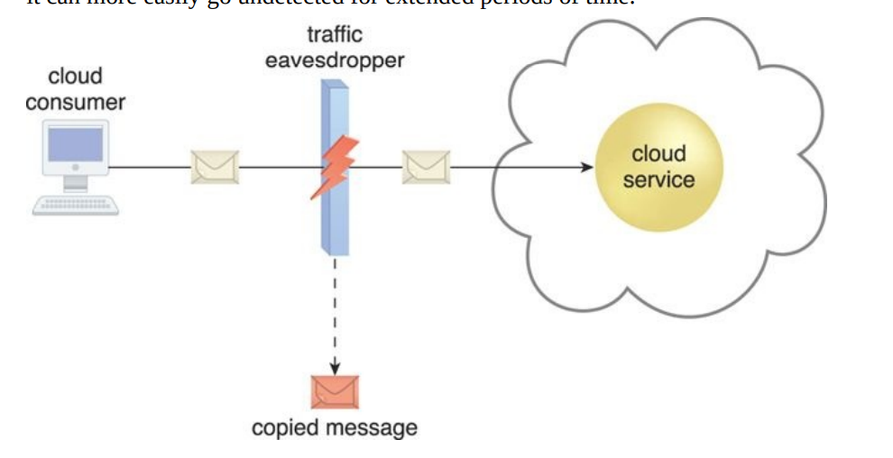

1. **Definition**: Traffic eavesdropping: Spying on network traffic to steal secrets.
2. **Methods**: Attackers eavesdrop using packet sniffing, man-in-the-middle attacks, and network protocol vulnerabilities.
3. **Data Privacy**: It can leak sensitive data.
4. **Data Interception**: It can steal text, images, files, and logins from network traffic.
5. **Wireless Vulnerability**: Wireless networks are easy to eavesdrop on.
6. **Packet Sniffers**: Attackers use packet sniffers to steal information from network traffic
7. **MitM Attacks**: attacker intercepts and alters data between two parties.
8. **Encryption Importance**: Encryption stops eavesdroppers from reading your data.
9. **Secure Protocols**: Use HTTPS and VPNs to protect against eavesdropping.
10. **Malicious Intermediary:**

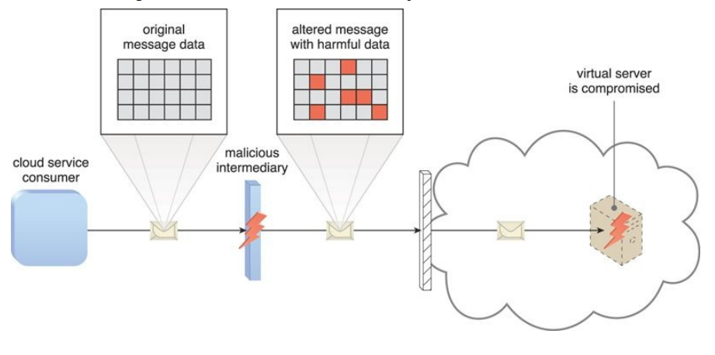

1. **Man-in-the-Middle (MitM) Attack**:   
    They intercept between users and cloud services, and steal data or inject malicious content.
2. **Eavesdropping**:

Attacker can steal data by eavesdropping on communication between user and cloud.

1. **Data Manipulation**: Malicious Intermediaries can modify data packets, injecting malicious code or altering data in transit.
2. **Session Hijacking**: By intercepting authentication tokens or session cookies, attackers can take control of a user's session, gaining unauthorized access.
3. **Phishing**: Malicious Intermediaries may redirect users to fake login pages or cloud service clones to steal login credentials.
4. **Traffic Redirection:** Malicious intermediaries reroute network traffic through malicious servers, capturing data in transit.
5. **API Exploitation:** They target vulnerabilities in cloud service APIs, gaining unauthorized access and control over cloud resources
6. **Denial of Service (DoS)**: Malicious Intermediaries can disrupt cloud services by overloading them with traffic or exploiting vulnerabilities.
7. **Data Exfiltration**: Attackers can exfiltrate sensitive data, compromising confidentiality and integrity.
8. **Resource Tampering**: Modifying responses from the cloud service, attackers can deliver malicious content or malware to users.
9. **Denial of Service:**

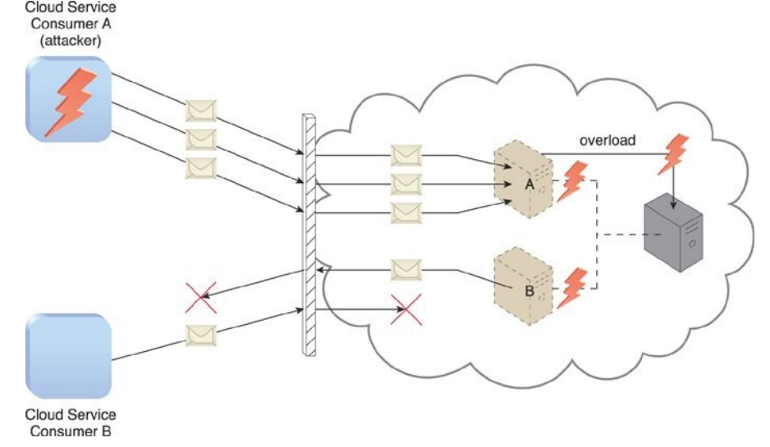

1. **Definition:** A DoS attacks a service or network with a flood of traffic, causing slow or completely unresponsive.
2. **Motivation:** Attackers use DoS attacks for various reasons, including financial gain, revenge, competition, or simply to disrupt operations.
3. **Types:** There are two of DoS attacks - network-based and application-based
4. **DDoS Attacks:** Distributed Denial-of-Service (DDoS) DDoS attacks use many devices to launch DoS attacks. making mitigation more challenging.
5. **Detection and Mitigation:** Uses tools and services, such as firewalls, intrusion detection systems (IDS), and content delivery networks (CDNs), are used to detect and mitigate DoS attacks.
6. **Insufficient Authorization:**

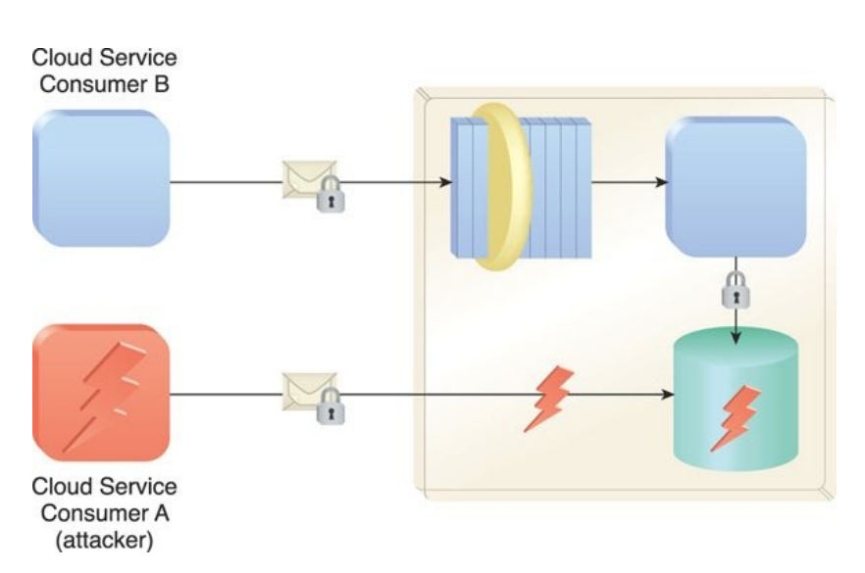

1. **Definition:** Insufficient authorization means not having permission to do something.
2. **Access Control:** Only authorized people or systems should be able to access data or functionalities.
3. **Authentication vs. Authorization:** Authentication checks who you are, authorization checks what you can do.
4. **Common Scenarios:** Insufficient authorization can lead to unauthorized access or unauthorized changes.
5. **Security Risks:** Insufficient authorization is a major security risk. It can lead to data breaches, information leakage, and system vulnerabilities.
6. **Testing:** Vulnerability assessments testing is helps to identify authorization weaknesses.
7. **Compliance:** industries and regulations requires strict authorization controls to protect sensitive information.
8. **Continuous Monitoring:** Regular monitoring and auditing helps to detect and fix authorization issues quickly.
9. **Virtualization Attack:**

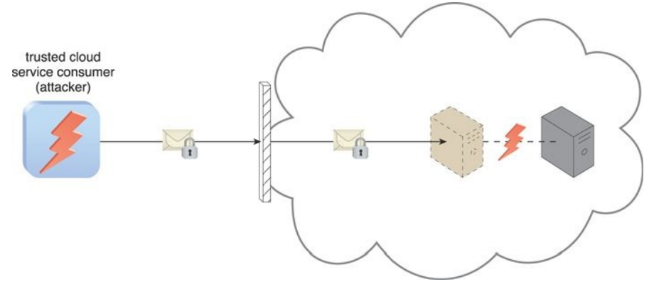

1. **Definition:** Virtualization attacks target virtualized systems and their resources.
2. **Targets:** Virtualization attacks can target hypervisors, VMs, and containers.
3. **Attack Vectors:** Attackers can exploit hypervisor vulnerabilities, escape VMs, or attack virtualized networks.
4. **Goals:** Virtualization attacks aim to steal data, disrupt services, or control the host system.
5. **Isolation:** Strong VM isolation and secure virtualization layer minimize attack surface.
6. **Importance:** Virtualization security is Importance for cloud and data center security.
7. **Overlapping Trust Boundaries:**
8. **Resource Sharing:** Overlapping trust boundaries occur in shared cloud resources.
9. **Security Domains:** Entities have different security policies, controls, and trust levels.
10. **Potential Risks:** Overlapping trust boundaries can be risky, as entities may have different security requirements or vulnerabilities.
11. **Data Segmentation:** Proper segmentation is important to prevent data leakage or unauthorized access across trust boundaries.
12. **Access Control:** Access controls should be enforced to restrict interactions between security domains.
13. **Encryption:** Data encryption can protect information even if it crosses trust boundaries.
14. **Audit and Monitoring:** Continuous monitoring is essential to detect and respond to security breaches or policy violations.
15. **Identity and Access Management (IAM):** Robust IAM systems manage access, across trust boundaries.

**Q.5 What are different Threat Agents in cloud infrastructure?**

Threat agents in cloud infrastructure are individuals, groups, or entities that cause security risks and may exploit vulnerabilities.

1. **Anonymous attackers**:

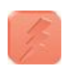

1. Anonymous attackers are individuals or groups who hide their identities while engaging in cyberattacks.
2. They often use techniques like unnamed networks or VPNs to hide their real IP addresses.
3. Anonymous attackers can be motivated by hacktivism, cybercrime, or state-sponsored actions.
4. Anonymous attackers have been known to target a wide range of victims, including governments, organizations, and individuals.
5. They have also been known to use a variety of attack methods, including DDoS attacks, data breaches, and malware attacks.
6. Anonymous attackers can be difficult to track and prosecute, as they often operate in a decentralized manner.
7. **Malicious Service Agent**:



1. A malicious service agent can capture network traffic in the cloud.
2. MSAs can include malware-infected servers, applications, or even cloud services.
3. Malicious Service Agent can be used to steal data, launch denial-of-service attacks, or even take control of systems.
4. they can be easily deployed and hidden from detection.
5. MSAs can be difficult to detect, as they often blend in with legitimate traffic.
6. It is important to be aware of the threat posed by MSAs and to take steps to protect your systems.
7. **Malicious Insider:**

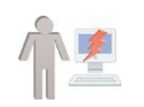

1. A malicious insider is a person who has authorized access to an organization's systems and data and intentionally misuses that access to harm the organization.
2. Malicious insiders can be current or ex-employees, contractors, or business partners.
3. They can cause a variety of damage, including data theft, fraud, sabotage, and espionage.
4. Malicious insiders are often motivated by financial gain, revenge, or ideology.
5. They can be difficult to detect, as they have legal access to the organization's systems.
6. **Trusted Attacker:**

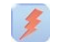

1. A trusted attacker is a cloud service consumer who has legal access to the cloud environment.
2. They misuse their authorized access to security, data, or systems.
3. Trusted attackers can launch attacks from within the cloud, which makes them more difficult to detect and defend against.
4. This makes them more dangerous than anonymous attackers.
5. They attacks in cloud applications and infrastructure to gain access to sensitive data and systems.
6. They can be current or ex-employees, contractors, or partners of the cloud service provider..

Understanding these threat agents is important for developing effective security strategies to protect cloud infrastructure.

**Q.6 How can a Malicious Intermediary attack cloud service?**

A Malicious Intermediary can attack a cloud service by intercepting and manipulating communication between a user and the cloud provider. Here's how such an attack can occur:

1. **Man-in-the-Middle (MitM) Attack**:   
    They intercepting communications between users and cloud services, and they potentially stealing

data or injecting malicious content.

1. **Eavesdropping**:

Attacker can steal data by eavesdropping on communication between user and cloud.

1. **Data Manipulation**: Malicious Intermediaries can modify data packets, injecting malicious code or altering data in transit.
2. **Session Hijacking**: By intercepting authentication tokens or session cookies, attackers can take control of a user's session, gaining unauthorized access.
3. **Phishing**: Malicious Intermediaries may redirect users to fake login pages or cloud service clones to steal login credentials.
4. **Traffic Redirection:** Malicious intermediaries reroute network traffic through malicious servers, capturing data in transit.
5. **DNS(Domain Name Syytem) Spoofing**: Manipulating DNS settings, attackers can redirect users to malicious cloud servers under their control.
6. **SSL(secure sockets layer)/TLS(transport layer security) Attacks**: Attackers may downgrade secure connections to unencrypted ones, exposing data to theft.
7. **API Exploitation:** They target vulnerabilities in cloud service APIs, gaining unauthorized access and control over cloud resources
8. **Denial of Service (DoS)**: Malicious Intermediaries can disrupt cloud services by overloading them with traffic or exploiting vulnerabilities.
9. **Data Exfiltration**: Attackers can exfiltrate sensitive data, compromising confidentiality and integrity.
10. **Resource Tampering**: Modifying responses from the cloud service, attackers can deliver malicious content or malware to users.

**Q.7 Explain the Amazon Elastic Block Store and Amazon Elastic Cache.**

1. **Amazon Elastic Block Store (EBS)**:
2. **Storage Solution**: EBS is a block-level storage service provided by Amazon Web Services (AWS).
3. **Persistence**: It offers durable, persistent block storage for Amazon EC2 instances.
4. **Data Types**: EBS offers different volume types for different performance and cost requirements.
5. **Snapshotting**: EBS snapshots can be used for backup and disaster recovery.
6. **Scalability**: EBS volumes are flexible and can be resized or moved as needed.
7. **Use Cases**: EBS is suitable for databases, application hosting, and data warehousing.
8. **Amazon Elastic Cache**:
9. **In-Memory Data Store**: Elastic Cache is a way to store data in-memory for faster access.
10. **Caching**: It is used to improve performance and responsiveness of web applications.
11. **Compatibility**: Elastic Cache supports two popular open-source caching engines: Memcached and Redis.
12. **Scaling**: Users can easily scale their cache clusters to handle varying workloads.
13. **Real-Time Analytics**: It is commonly used for real-time analytics and high-performance applications.
14. **Use Cases**: Elastic Cache is suitable for content delivery, session management, and reducing database load.

Both services are integral to building scalable, high-performance applications on the AWS cloud platform.

**Q.8 State and explain the different application services offered by Google App Engine.**

Google App Engine offers various application services to simplify application deployment and management:

1. **App Engine Standard Environment**:
   * A fully managed environment for building and deploying applications with minimal server management.
   * Supports multiple programming languages, including Python, Java, and Go.
   * Automatic scaling, load balancing, and security updates.
   * Well-suited for web and mobile app development.
2. **App Engine Flexible Environment**:
   * Offers more flexibility in terms of language and runtime selection.
   * Allows users to customize runtime, install libraries, and use Docker containers.
   * Scalable and ideal for microservices and custom application environments.
3. **App Engine APIs**:
   * Provides APIs for various cloud services, including data storage (Datastore), machine learning (ML Engine), and cloud messaging (Cloud Pub/Sub).
   * Integration with Google Cloud services simplifies application development.
4. **App Engine Endpoints**:
   * Enables the creation of APIs for web and mobile apps.
   * Supports authentication, access control, and easy API deployment.
5. **App Engine Task Queues**:
   * A task execution service for handling background processes and asynchronous tasks.
   * Useful for offloading time-consuming tasks from the main application.
6. **App Engine Cron Jobs**:
   * Allows the scheduling of recurring tasks, such as data backups or notifications.
   * Ensures automated, timely execution of routine operations.
7. **App Engine Memcache**:
   * Provides a distributed caching service to improve application response times by reducing database load.

**Q.9 Describe Amazon EC2 and its basic features.**

**Amazon Elastic Compute Cloud (EC2)**:

1. **Virtual Servers**: EC2 offers resizable virtual machines, known as instances, which can run various operating systems.
2. **Scalability**: Instances can be easily scaled up or down to meet computing demands.
3. **Instance Types**: Various instance types to different workloads, such as compute-optimized, memory-optimized, and GPU instances.
4. **Elastic Load Balancing**: EC2 works with load balancers to spread traffic across multiple instances for high availability.(EC2 uses load balancing for high availability)
5. **Security Groups**: Users can define security groups to control inbound and outbound traffic to instances.
6. **Amazon Machine Images (AMIs)**: AMIs are templates that provide pre-configured instances, making it easy to deploy applications.
7. **Elastic Block Store (EBS)**: EBS volumes can be used to store data on EC2 instances.
8. **Auto Scaling**: Automatically adjusts the number of instances to maintain application performance.
9. **Virtual Private Cloud (VPC)**: VPC allows users to create isolated network environments for their EC2 instances.
10. **Identity and Access Management (IAM)**: Provides fine-grained control over who can access and manage EC2 resources.

**>**Amazon EC2 is a foundational service of AWS, offering flexibility, scalability, and compute power for a wide range of applications and workloads.

**Q.10 What is a bucket? What type of storage does it provide?**

Buckets organize and store data in cloud object storage services like Amazon S3 and Google Cloud Storage. Buckets are also used to organize and store data in a hierarchical manner. Here's an explanation:

1. **Storage Container**: A bucket is like a virtual hard drive or folder where you store data objects.
2. **Naming**: Buckets have unique names within the cloud storage service, forming part of the object's URL.
3. **Hierarchy**: Objects within a bucket can be organized using a folder-like hierarchy, making it easier to manage large datasets.
4. **Access Control**: You can configure access control policies for buckets, defining who can read, write, or delete objects.
5. **Data Types**: Buckets can store various data types, including documents, images, videos, backups, and more.
6. **Scalability**: Cloud storage services automatically handle the scaling of buckets to accommodate growing data.
7. **Durability**: Data stored in buckets is highly durable and designed for redundancy to ensure data availability.
8. **Use Cases**: Buckets are suitable for data storage, backups, website hosting, and serving static content in web applications.

Buckets in cloud object storage provide a scalable and cost-effective way to store and manage data in the cloud.

**Q.11 Describe the core components of AppEngine.**

Google App Engine has several core components that facilitate the development and deployment of applications:

1. **App Engine Standard Environment**:
   * A fully managed environment for building and deploying applications with minimal server management.
   * Supports multiple programming languages, including Python, Java, and Go.
2. **App Engine Flexible Environment**:
   * Offers more flexibility in terms of language and runtime selection.
   * Allows users to customize runtime, install libraries, and use Docker containers.
3. **App Engine APIs**:
   * Provides APIs for various cloud services, including data storage (Datastore), machine learning (ML Engine), and cloud messaging (Cloud Pub/Sub).
   * Integration with Google Cloud services simplifies application development.
4. **App Engine Endpoints**:
   * Enables the creation of APIs for web and mobile apps.
   * Supports authentication, access control, and easy API deployment.
5. **App Engine Task Queues**:
   * A task execution service for handling background processes and asynchronous tasks.
   * Useful for offloading time-consuming tasks from the main application.
6. **App Engine Cron Jobs**:
   * Allows the scheduling of recurring tasks, such as data backups or notifications.
   * Ensures automated, timely execution of routine operations.
7. **App Engine Memcache**:
   * Provides a distributed caching service to improve application response times by reducing database load.

Google App Engine's diverse set of services simplifies development, scalability, and management for a wide range of applications.

**Q.12 What is Data Store? What type of data can be stored in it?**

**Datastore** refers to Google Cloud's NoSQL, schema-less database service that is part of the Google Cloud Platform. Here's an overview:

1. **NoSQL Database**: Datastore is a NoSQL database, it does not required any fixed schema, it is flexible for various data types and structures.
2. **Structured Data**: It can store structured data, including text, numbers, dates, and geospatial data.
3. **Hierarchical Structure**: Datastore organizes data hierarchically, allowing for easy querying and retrieval.
4. **Highly Scalable**: It can handle large amounts of data and traffic and automatically scales to meet demand.
5. **Consistency**: Datastore offers strong consistency for read and write operations within an entity group.
6. **ACID Transactions**: It supports ACID (Atomicity, Consistency, Isolation, Durability) transactions for ensuring data integrity.
7. **Indexes**: Datastore automatically indexes data, for fast querying.
8. **Use Cases**: It is suitable for a wide range of applications, including web and mobile apps, e-commerce platforms, and content management systems.

Datastore is particularly well-suited for applications that require flexible data storage and high scalability.

**Q.13 What are the differences between Amazon SimpleDB and Amazon RDS?**

**Amazon SimpleDB** and **Amazon RDS** are both database services provided by AWS, but they have significant differences:

**Amazon SimpleDB**:

1. **Data Model**: SimpleDB uses a schema-less data model, allowing for flexible data storage without schemas.
2. **Query Language**: It uses a simple query language for easy data retrieval.
3. **Scalability**: Highly available and scalable with limited advanced features. and It is not suitable for complex applications.
4. **Use Cases**: Suitable for smaller-scale applications, simple data storage needs, and scenarios where flexibility is more critical than performance.

**Amazon RDS (Relational Database Service)**:

1. **Data Model**: RDS supports traditional relational database systems such as MySQL, PostgreSQL, and SQL Server, which use structured schemas and tables.
2. **Query Language**: Supports standard SQL for querying and managing data.
3. **Scalability**: Offers advanced features like automatic backups, replication, and scaling, making it suitable for complex, high-performance applications.
4. **Use Cases**: Ideal for applications that require relational data modeling, strong consistency, and advanced database features.

**Q.1 What is cloud computing ? explain the cloud computing architecture explain with neat diagram.**



1. Cloud computing can be organized into layers, from hardware to software.
2. Cloud infrastructure can be made up of a variety of different resources, such as clusters, networked PCs, database systems, and storage services.
3. Core middleware manages physical infrastructure to provide a good runtime environment for applications and optimize resource utilization.
4. Virtualization technologies are used to customize runtime environments, isolate applications, and guarantee quality of service.
5. Virtual machine technology allows for fine-grained partitioning of hardware resources and virtualization of specific devices, meeting user and application needs.
6. IaaS solutions are good for designing system infrastructure but not for building applications.
7. Cloud programming environments and tools provide a development platform for applications.
8. Platform-as-a-Service (PaaS) provides a development platform for applications, which includes the infrastructure as well. In the case of Pure PaaS, only the user-level middleware is offered.
9. The top layer of the cloud computing reference model is SaaS, which provides software applications over the internet.