# **AIM:** Implement ANDNOT function using McCulloch-Pits neuron (use binary data representation

print("#######______Methos_1______########")

class McCullochPittsNeuron:

    def __init__(self, weights, threshold):

        self.weights = weights

        self.threshold = threshold

    def activate(self, inputs):

        if sum([x * w for x, w in zip(inputs, self.weights)]) >= self.threshold:

            return 1

        else:

            return 0

def ANDNOT(a, b):

    weights = [1, -1]

    threshold = 1

    neuron = McCullochPittsNeuron(weights, threshold)

    return neuron.activate([a, b])

print("ANDNOT(0, 0) =", ANDNOT(0, 0))

print("ANDNOT(0, 1) =", ANDNOT(0, 1))

print("ANDNOT(1, 0) =", ANDNOT(1, 0))

print("ANDNOT(1, 1) =", ANDNOT(1, 1))

print("#########______Methos_2______###########")

def mccullock_pitts_andnot(A,B):

    w1=1

    w2=-1

    threshold=0

    weighted_sum=w1*A+w2*B

    output=1 if weighted_sum>threshold else 0

    return output

input_A=int(input("Enter the value of A (0 or 1): "))

input_B=int(input("Enter the value of B (0 or 1): "))

if input_A in (0,1) and input_B in (0,1):

    result=mccullock_pitts_andnot(input_A,input_B)

    print(f"ANNOT({input_A},{input_B})={result}")

else:

    print("Invalid input.Please enter 0 or 1 for A and B.")

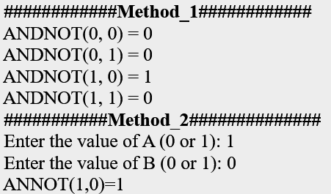**Output:**

## **AIM:** Generate XOR function using McCulloch-Pitts neural network.

import numpy as np

print("****** XOR CODE *********")

def sigmoid(x):

  return 1 / (1 + np.exp(-x))

def sigmoid_derivative(x):

  return x * (1 - x)

try:

  A = int(input("Enter 1st Binary Input(0,1): "))

  B = int(input("Enter 2nd Binary Input (0,1): "))

  if A in [0, 1] and B in [0, 1]:

    # Create the XOR truth table

    x = np.array([[0, 0], [0, 1], [1, 0], [1, 1]])

    y = np.array([[0], [1], [1], [0]])

    # Initialize the network parameters

    input_size = 2

    hidden_size = 2

    output_size = 1

    hidden_weight = np.random.uniform(size=(input_size, hidden_size))

    hidden_bias = np.random.uniform(size=(1, hidden_size))

    output_weights = np.random.uniform(size=(hidden_size, output_size))

    output_bias = np.random.uniform(size=(1, output_size))

    # Forward pass

    hidden_layer_input = np.dot(x, hidden_weight) + hidden_bias

    hidden_layer_output = sigmoid(hidden_layer_input)

    output_layer_input = np.dot(hidden_layer_output, output_weights)

+ output_bias

    output_layer_output = sigmoid(output_layer_input)

    # Print the output

    print(f"XOR({A}, {B}) = {(output_layer_output[0][0])}")

  else:

    print("Invalid Input. Please enter 0 or 1 for binary input.")

except:

  print("Invalid input.")

**Output:**

****** XOR CODE *********

Enter 1st Binary Input(0,1): 1

Enter 2nd Binary Input (0,1): 0

XOR(1, 0) = 0.7789986774398672