# **Aim:** Write a program for Hopfield Network.

import numpy as np

class HopfieldNetwork:

    def __init__(self, pattern_size):

        self.pattern_size = pattern_size

        self.weights = np.zeros((pattern_size, pattern_size))

    def train(self, patterns):

        for i in range(self.pattern_size):

            for j in range(i, self.pattern_size):

                if i != j:

                    weight = 0

                    for pattern in patterns:

                        weight += pattern[i] * pattern[j]

                    self.weights[i][j] = weight

                    self.weights[j][i] = weight

    def recall(self, pattern):

        for _ in range(10):

            for i in range(self.pattern_size):

                activation = 0

                for j in range(self.pattern_size):

                    activation+=self.weights[i][j]*pattern[j]

                pattern[i] = 1 if activation > 0 else -1

        return pattern

if __name__ == "__main__":

    pattern_size = 9

    patterns = [np.array([-1, 1, 1, -1, 1, -1, -1, 1, -1]),

        np.array([1, 1, 1, -1, -1, -1, 1, 1, 1]),

        np.array([1, -1, 1, 1, -1, 1, 1, -1, 1])]

    hopfield_net = HopfieldNetwork(pattern_size)

    hopfield_net.train(patterns)

    for pattern in patterns:

        recalled_pattern = hopfield_net.recall(pattern.copy())

        print("Original Pattern:")

        print(pattern.reshape(3, 3))

        print("Recalled Pattern:")

        print(recalled_pattern.reshape(3, 3), "\n")

**Output:**

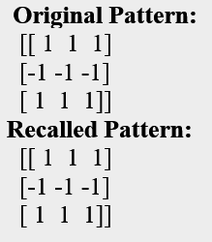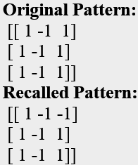**Original Pattern:**

[[-1 1 1]

[-1 1 -1]

[-1 1 -1]]

**Recalled Pattern:**

[[-1 1 -1]

[-1 1 -1]

[-1 1 -1]]

# **Aim:** Write a program for Radial Basis function

import numpy as np

import matplotlib.pyplot as plt

def radial_basis_function(x, c, sigma):

    return np.exp(-((x - c) ** 2) / (2 * sigma ** 2))

x = np.linspace(0, 2 * np.pi, 100)

y_target = np.sin(x)

num_centers = 5

centers = np.linspace(0, 2 * np.pi, num_centers)

sigma = (max(centers) - min(centers)) / (2 * num_centers)

rbf_activations = np.zeros((len(x), num_centers))

for i in range(len(x)):

    for j in range(num_centers):

        rbf_activations[i, j] = radial_basis_function(x[i], centers[j], sigma)

weights = np.linalg.pinv(rbf_activations).dot(y_target)

y_approximated = rbf_activations.dot(weights)

plt.figure()

plt.plot(x, y_target, label="Target Function (sin(x)")

plt.plot(x, y_approximated, label="RBF Approximation")

plt.scatter(centers, np.sin(centers), c='red', marker='o', label="RBF Centers")

plt.legend()

plt.title("Radial Basis Function Approximation")

plt.show()

