**Practical: 01**

1. **Write a program for obtaining descriptive statistics of data.**

Go to File Menu > Options Add-Ins > Select Analysis ToolPak > press Ok.

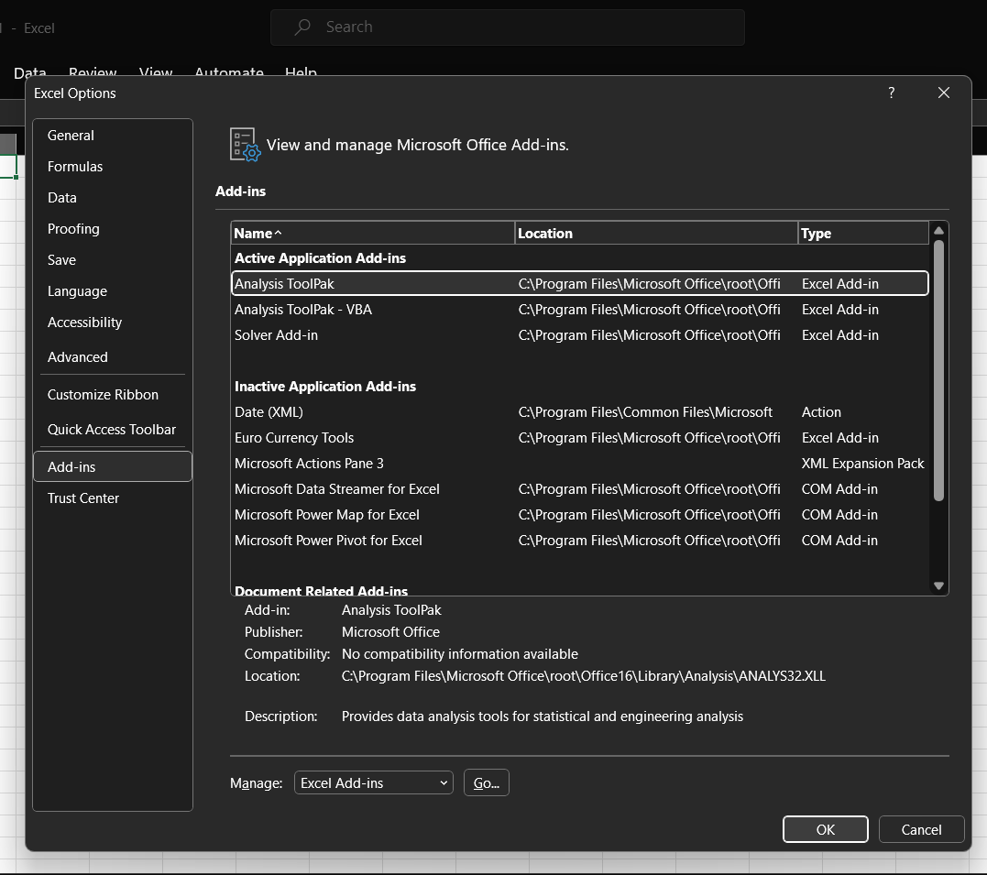

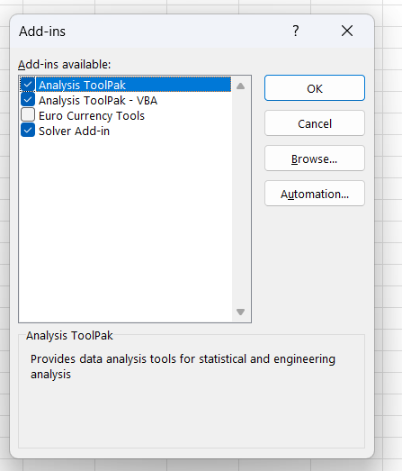

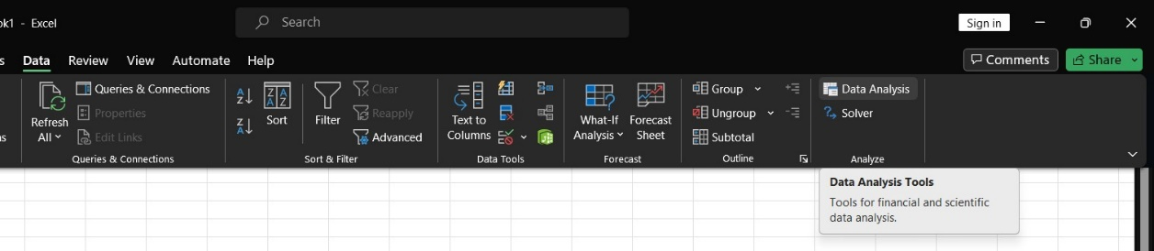

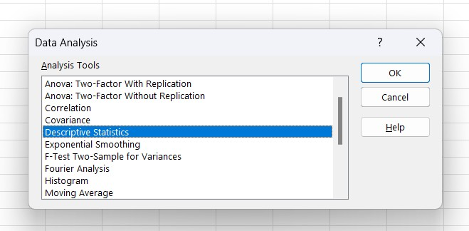

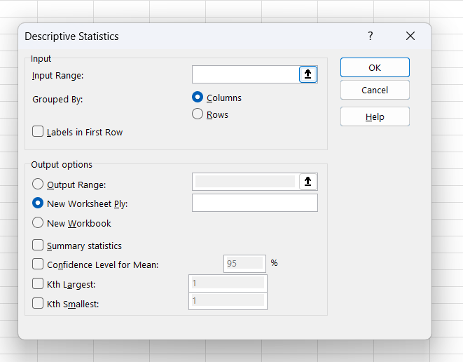

Select the data range from excel worksheet.

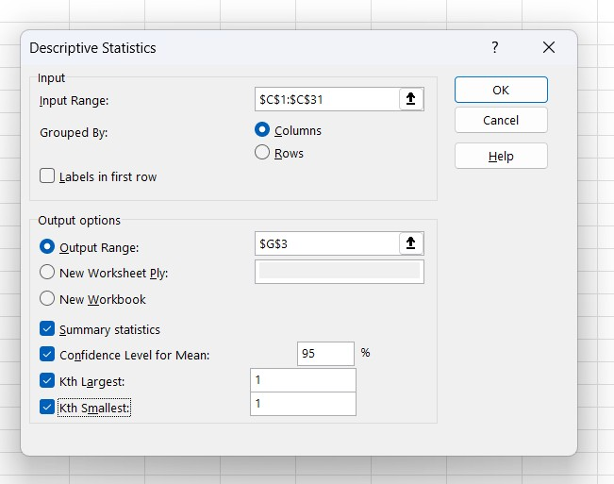

**Output:**

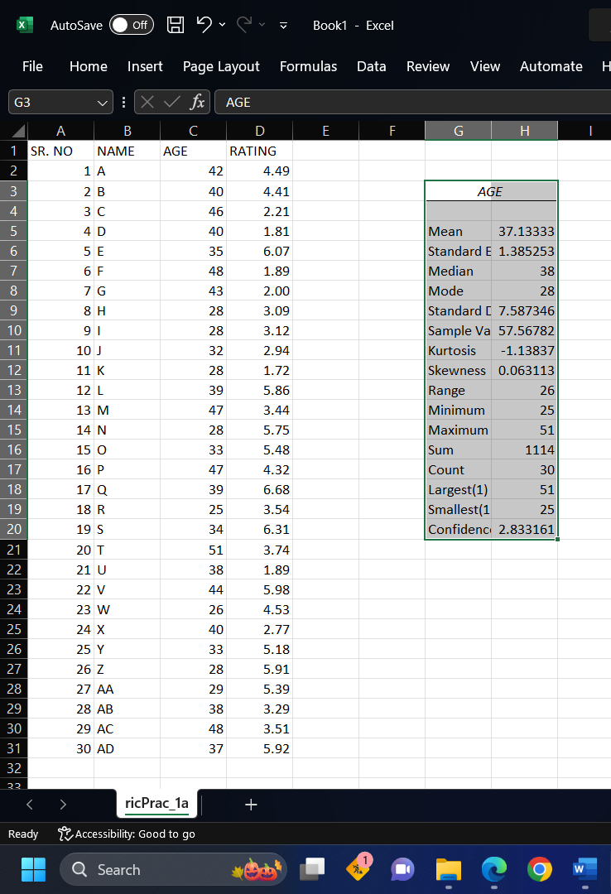

**Practical: 02**

* **Import data from different data sources.**

Go to Data > click on “From Text/CSV”.

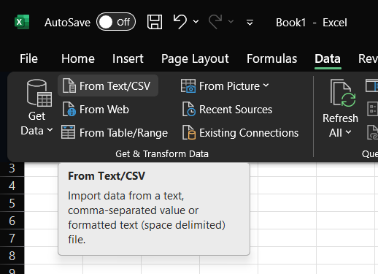

Select file you require > click on import

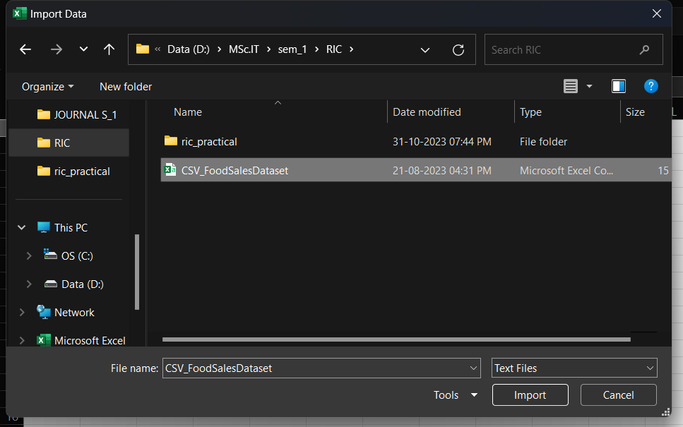

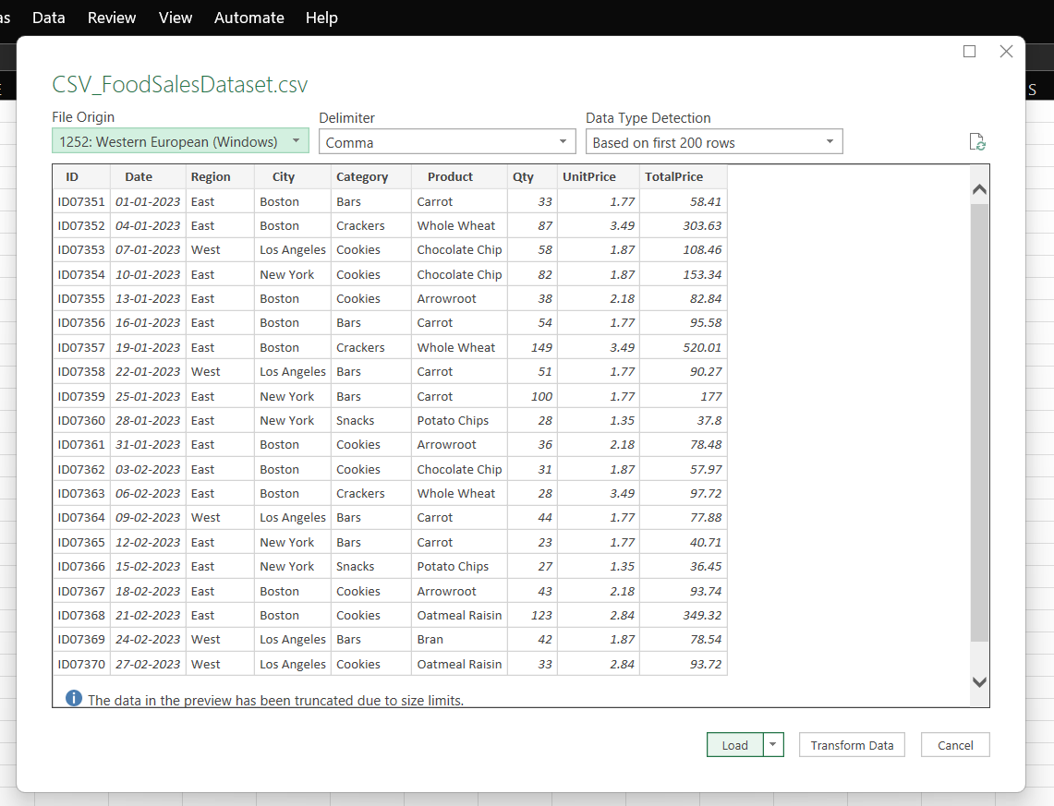

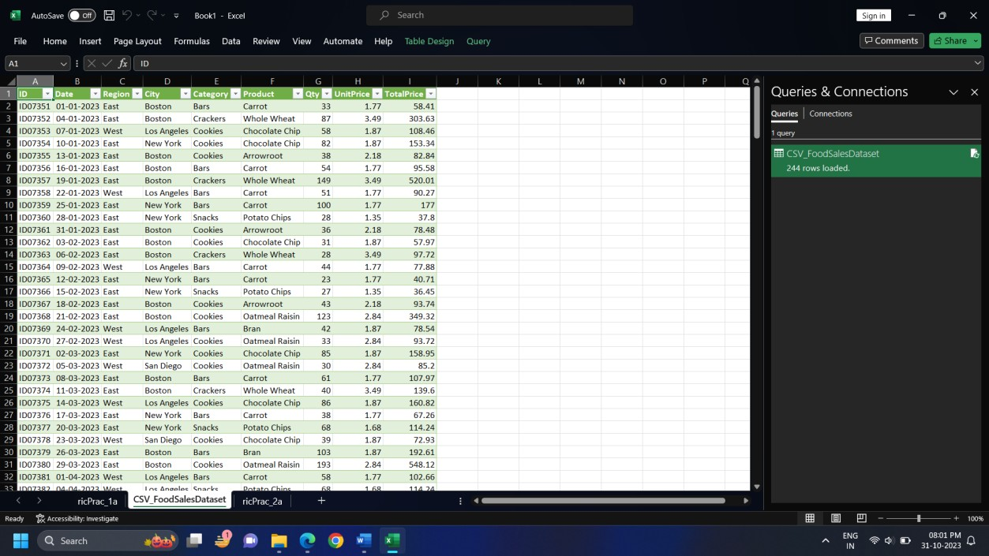

**Practical: 03**

* **Perform analysis of given secondary data.**

**Determine your research question -** Knowing exactly what you are looking for.

**Locating data -** Knowing what is out there and whether you can gain access to it. A quick Internet search, possibly with the help of a librarian, will reveal a wealth of options.

**Evaluating relevance of the data -** Considering things like the data’s original purpose, when it was collected, population, sampling strategy/sample, data collection protocols, operationalization of concepts, questions asked, and form/shape of the data.

**Assessing credibility of the data -** Establishing the credentials of the original researchers, searching for full explication of methods including any problems encountered, determining how consistent the data is with data from other sources, and discovering whether the data has been used in any credible published research.

**Analysis -** This will generally involve a range of statistical processes.

**Example:** Analyze the given Population Census Data for Planning and Decision Making by using the size and composition of populations.

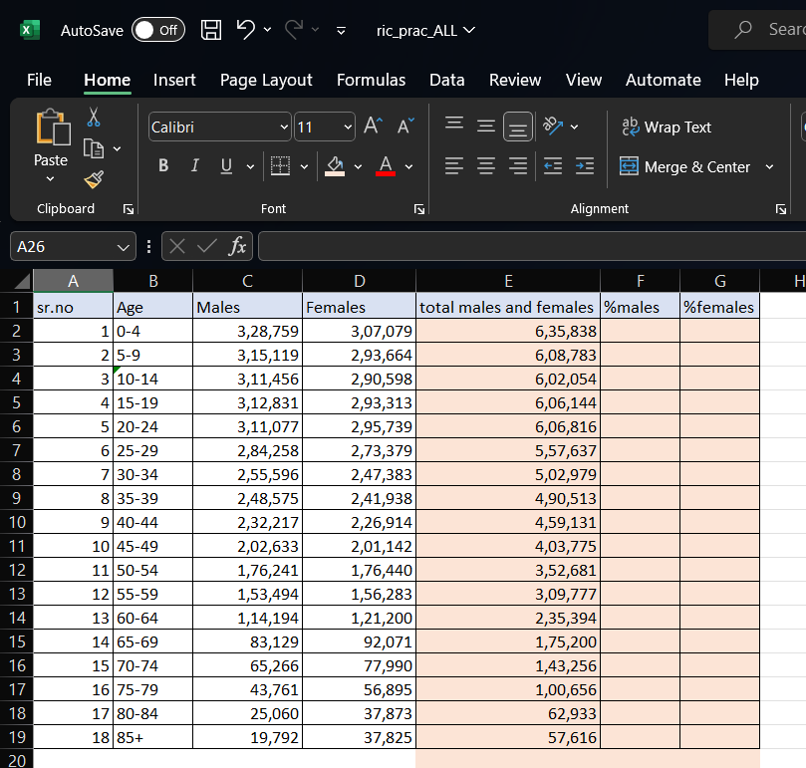

**Click** on cell **A20** and label it as “total population”.

**Click** on **C20** and click on

*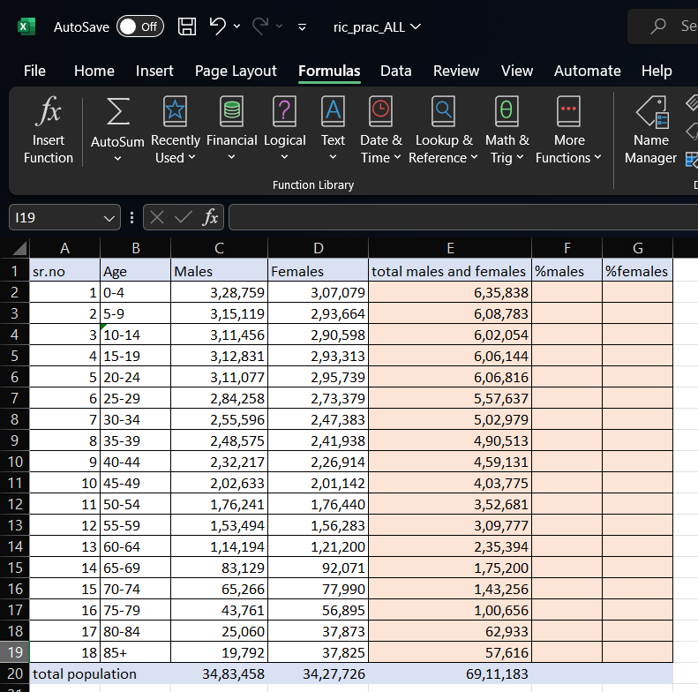AutoSum* > a range will be selected *automatically* > click enter. Similarly follow this for cell **D20** and **E20**.

To calculate percent of males in cell F2, enter formula=100*C2/E20. And copy the formula in cell F2 down to cell F19.

Similarly, to calculate the percent of females in cell G2, enter the formula =100*D2/E20. Copy the formula in cell G2 down to cell G19.

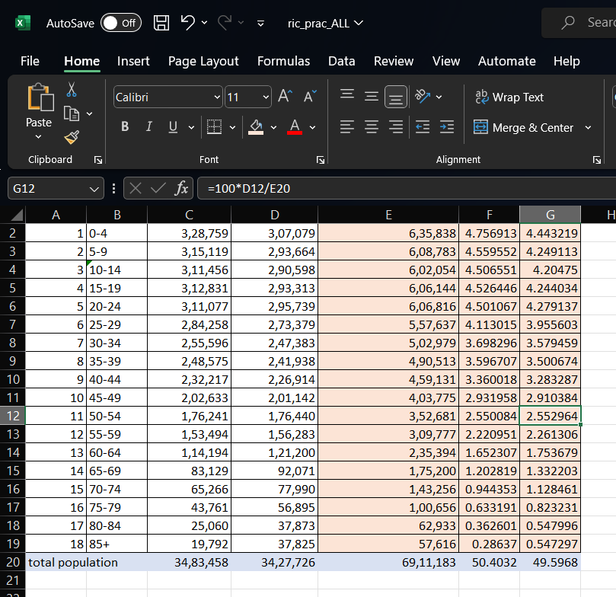

We need to show a chart with two series of data (% male and % female) and the age labels in column A as the  
 Category X-axis labels. Highlight the range A2:A19, hold down the CTRL key and highlight the range E2:F19

Under inset tab, under horizontal bar charts select clustered bar chart and under line or area chart  
 select line chart.

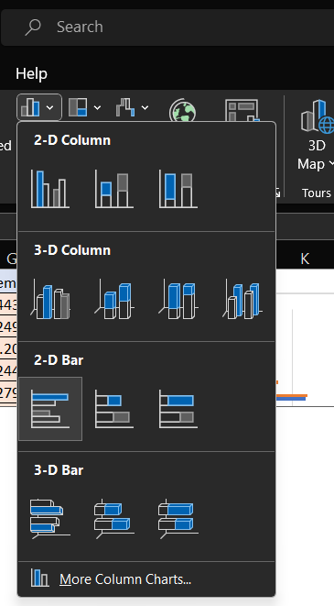

**Output:**

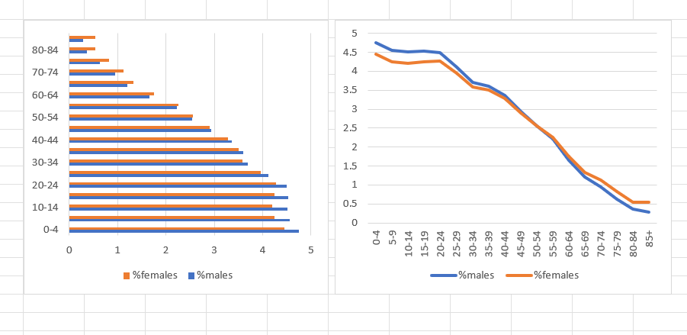

**Practical: 04**

1. **Perform testing of hypothesis using one sample t-test.**

**One sample t-test:** The One Sample T Test determines whether the sample mean is statistically different from a known or hypothesized population mean. The One Sample T Test is a parametric test.

|  |  |
| --- | --- |
| No. Of Bars | Protein Values |
| 1 | 20.7 |
| 2 | 20.75 |
| 3 | 22.14 |
| 4 | 22.12 |
| 5 | 27.46 |
| 6 | 22.91 |
| 7 | 19.56 |
| 8 | 22.15 |
| 9 | 25.34 |
| 10 | 21.1 |
| 11 | 19.85 |
| 12 | 20.33 |
| 13 | 18.04 |
| 14 | 21.29 |
| 15 | 21.54 |

|  |  |
| --- | --- |
| 16 | 24.12 |
| 17 | 24.75 |
| 18 | 21.08 |
| 19 | 19.95 |
| 20 | 25.06 |
| 21 | 21.39 |
| 22 | 19.72 |
| 23 | 22.44 |
| 24 | 22.33 |
| 25 | 18.28 |
| 26 | 19.08 |
| 27 | 25.79 |
| 28 | 16.26 |
| 29 | 19.88 |
| 30 | 20.53 |
| 31 | 17.46 |

Here,

H0 is population mean is 20.

H1 is population mean is not 20.

<<

First, we require descriptive statistics for above data.

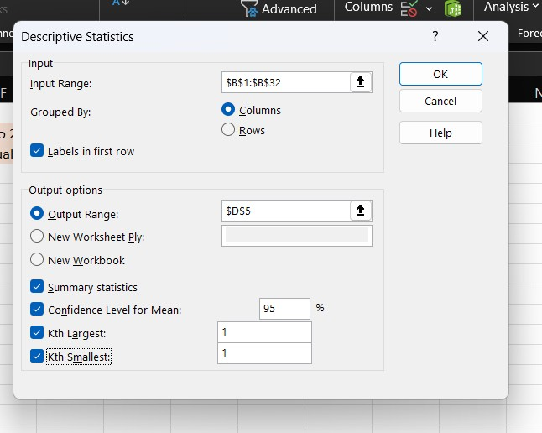

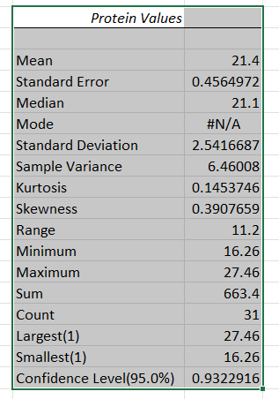

We require Mean, Standard Error, Standard Deviation and Count.

We require to degrees of freedom, hypothesized mean, alpha value,   
 t-statistic, p-value.

We calculate degrees of freedom as function= E19 -1.   
 Hypothesized mean is 20 and Alpha value is taken as 0.05.   
 t-statistic is calculated as function = (E7-E25)/E8.   
 P value is calculated as function = TDIST (E27, E24, 2)

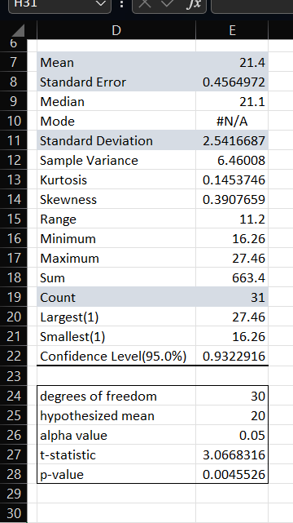

Then for final step of T-test, we use function =IF(E28>E26,"H0 accepted, H1 rejected","H1 accepted")

**Output:**

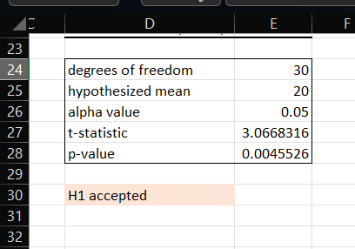

**B. Perform testing of hypothesis using two sample t-test.**

Suppose researchers want to know whether or not two different species of plants in a particular country have the same mean height. Because it would take too long to go around and measure every single plant, they decide to collect a sample of 20 plants from each species.

The following data shows the height (in inches) for each plant in each sample:

|  |  |
| --- | --- |
| species 1 | species 2 |
| 12 | 10 |
| 12 | 24 |
| 20 | 17 |
| 12 | 23 |
| 24 | 19 |
| 25 | 16 |
| 10 | 10 |
| 15 | 14 |
| 16 | 19 |
| 21 | 14 |
| 21 | 12 |

|  |  |
| --- | --- |
| 11 | 21 |
| 12 | 12 |
| 16 | 12 |
| 15 | 11 |
| 17 | 21 |
| 17 | 18 |
| 14 | 23 |
| 19 | 16 |
| 19 | 23 |

When we conduct a two-sample t-test, we must first decide if we will assume that the two populations have equal or unequal variances. As a rule of thumb, we can assume the populations have equal variances if the ratio of the larger sample variance to the smaller sample variance is less than 4:1.

To calculate the variance of two samples Click on cell A22 and type = VAR.S(A2:A21) Click on cell B22 and type = VAR.S(B2:B21)

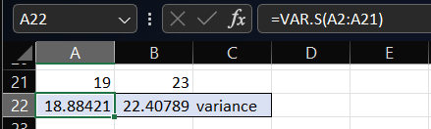

The ratio of the larger sample variance to the smaller sample variance is 1.1865, which is less than 4. This means we can assume that the population variances are equal.

<

H0= Two different species of plants in a particular country have the same mean height.

H1= Two different species of plants in a particular country do not have the same mean height.

Go to Data tab > Data Analysis

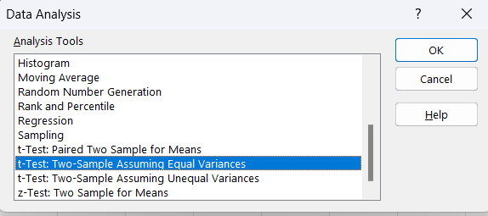

Click on OK.

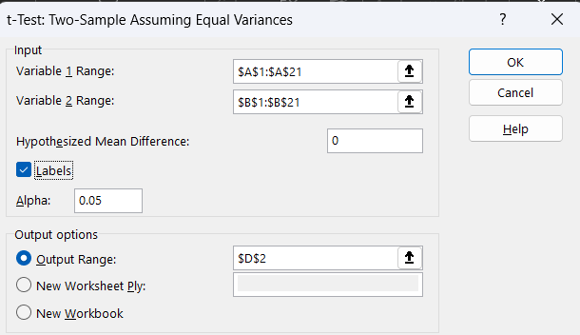

Click on OK.

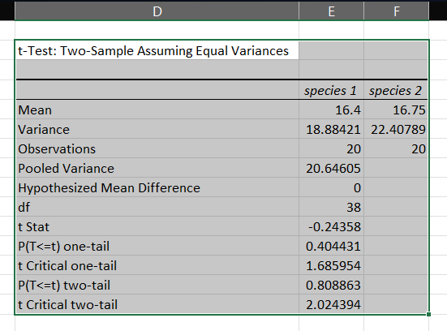

Click on D18 type =IF(E14>0.05,"H0 accepted","H1 accepted, H0 rejected")

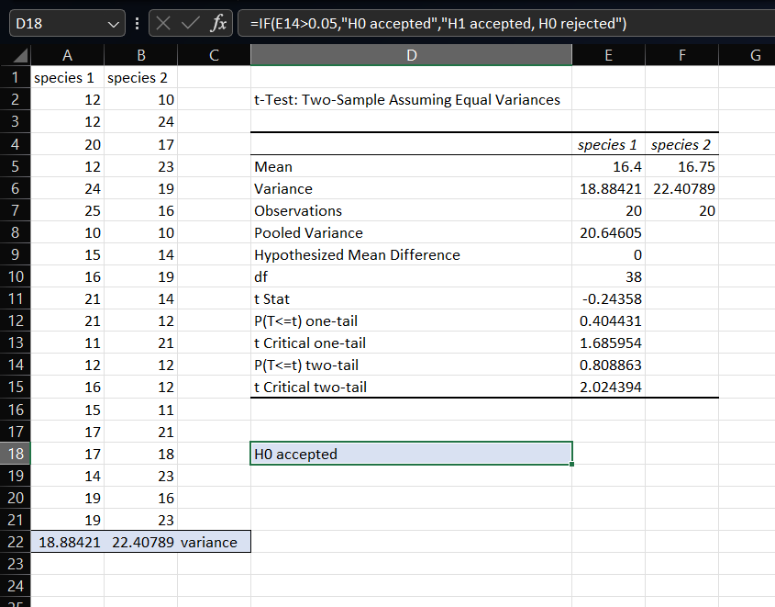

**C. Perform testing of hypothesis using paired t-test.**

The T distribution provides a good way to perform one sample tests on the mean when the population variance is not known provided the population is normal or the sample is sufficiently large so that the Central Limit Theorem applies.

**Paired Sample t Test**

**Example:** A college Principal informed classroom teachers that some of their students showed unusual potential for intellectual gains. One months later the students identified to teachers as having potential for unusual intellectual gains showed significantly greater gains performance on a test said to measure IQ than did students who were not so identified. Below are the data for the students:

|  |  |  |
| --- | --- | --- |
|  | experimental | comparison |
| 1 | 35 | 2 |
| 2 | 40 | 27 |
| 3 | 12 | 38 |
| 4 | 15 | 31 |
| 5 | 21 | 1 |
| 6 | 14 | 19 |
| 7 | 46 | 1 |
| 8 | 10 | 34 |
| 9 | 28 | 3 |
| 10 | 48 | 1 |
| 11 | 16 | 2 |
| 12 | 30 | 3 |
| 13 | 32 | 2 |
| 14 | 48 | 1 |
| 15 | 31 | 2 |
| 16 | 22 | 1 |
| 17 | 12 | 3 |
| 18 | 39 | 29 |
| 19 | 19 | 37 |
| 20 | 25 | 2 |

H0 represents that the difference in gain scores is not likely the result of the experimental treatment.

H1 represents that the difference in gain scores is likely the result of the experimental treatment and not the result of chance variation.

**Experimental Data**

To calculate Standard Mean, go to cell B22 and type =AVERAGE (B2:B21) To calculate Standard Deviation, go to cell B23 and type =STDEV (B2:B21)

**Comparison Data**

To calculate Standard Mean, go to cell C22 and type =AVERAGE (C2:C21) To calculate Standard Deviation, go to cell C23 and type =STDEV (C2:C21)

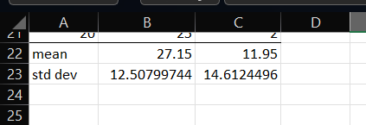

Find T-test Statistics, go to Data > Data Analysis> Click on Ok.

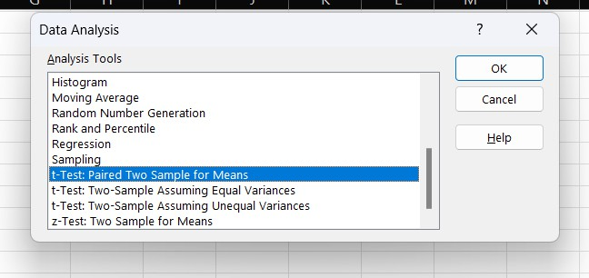

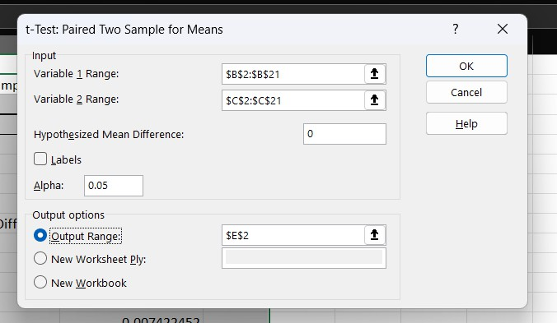

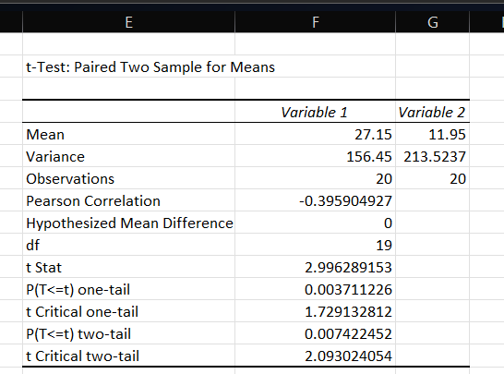

To calculate the T-Test square value go to cell F17 and type =(B22- C22)/SQRT(((B23*B23)/COUNT (B2:B21)) +((C23*C23)/ COUNT (C2:C21)))

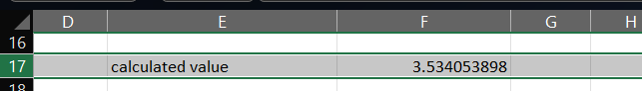

Now go to cell F18 and type =IF (F17<F9,"H0 is Accepted", "H0 is Rejected and H1 is Accepted")

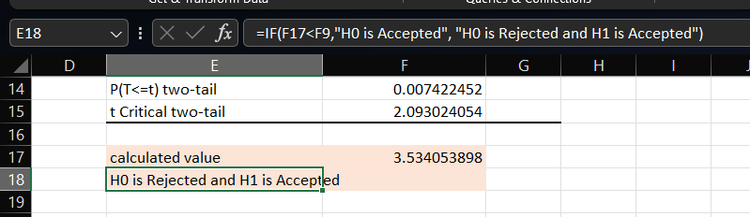

Our calculated value is larger than the tabled value at alpha = 0.05, so we reject the null hypothesis and accept the alternative hypothesis, namely, that the difference in gain scores is likely the result of the experimental treatment and not the result of chance variation.

**Practical: 05**

1. **Perform testing of hypothesis using chi-squared goodness-of-fit test.**

**Problem**: A system administrator needs to upgrade the computers for his division. He wants to know what sort of computer system his workers prefer. He gives three choices: Windows, Mac, or Linux. Test the hypothesis or theory that an equal percentage of the population prefers each type of computer.

|  |  |  |
| --- | --- | --- |
| system | Oi | Ei |
| windows | 20 | 33.33333 |
| mac | 60 | 33.33333 |
| linux | 20 | 33.33333 |

H0: The population distribution of the variable is the same as the proposed distribution.

H1: The distributions are different.

**To calculate the Chi –**Squared value for Windows go to cell D2 and type =((B2-C2)^2)/C2

**To calculate the Chi –**Squared value for mac go to cell D3 and type =((B3-C3)^2)/C3

**To calculate the Chi –**Squared value for linux go to cell D4 and type =((B4-C4)^2)/C4

Go to Cell D5 for “sum{[(Oi-Ei)^2]/Ei}” and type=SUM(D2:D4)

To get the table value for Chi-Square for α = 0.05 and dof = 2, go to cell D7 and type = CHIINV(0.05,2)

At cell D8 type =IF(D5>D7, "H0 Accepted","H0 Rejected")

**Output:**

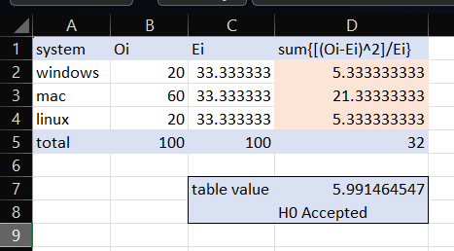

1. **Perform testing of hypothesis using chi-squared test of independence.**

In a study to understand the performance of M. Sc. IT Part -1 class, a college selects a random sample of 100 students. Each student was asked his grade obtained in B. Sc. IT. The sample is as given below.

|  |  |  |  |  |
| --- | --- | --- | --- | --- |
| 46 | 22 | Cape Coast | m | C |
| 47 | 29 | Kwabeng | m | C |
| 48 | 30 | Algiers | m | C |
| 49 | 31 | Laghouat | m | C |
| 50 | 39 | Relizane | m | C |
| 51 | 52 | Setif | m | C |
| 52 | 53 | Biskra | m | C |
| 53 | 67 | Kolea | m | C |
| 54 | 100 | AefnFakroun | m | C |
| 55 | 26 | Nima | m | B |
| 56 | 32 | TiziOuzou | m | B |
| 57 | 33 | Chlef | m | B |
| 58 | 89 | M'sila | m | A |
| 59 | 96 | Heliopolis | m | A |
| 60 | 97 | Berrouaghia | m | A |
| 61 | 98 | Sougueur | m | A |
| 62 | 3 | Maun | f | O |
| 63 | 7 | Tete | f | O |
| 64 | 9 | Chimoio | f | O |
| 65 | 11 | Pemba | f | O |
| 66 | 14 | Chibuto | f | O |
| 67 | 25 | Mampong | f | O |
| 68 | 36 | Tlemcen | f | O |
| 69 | 40 | Adrar | f | O |
| 70 | 41 | Tindouf | f | O |
| 71 | 46 | Skikda | f | O |
| 72 | 47 | Ouargla | f | O |
| 73 | 10 | Matola | f | D |
| 74 | 20 | Legon | f | D |
| 75 | 21 | Sunyani | f | D |
| 76 | 72 | Teenas | f | D |
| 77 | 73 | Kouba | f | D |
| 78 | 75 | HussenDey | f | D |
| 79 | 77 | Khenchela | f | D |
| 80 | 82 | HassiBahbah | f | D |
| 81 | 84 | Baraki | f | D |
| 82 | 91 | Boudouaou | f | D |
| 83 | 95 | Tadjenanet | f | D |
| 84 | 4 | Molepolole | f | C |
| 85 | 8 | Quelimane | f | C |
| 86 | 23 | Bolgatanga | f | C |
| 87 | 58 | Mohammadia | f | C |
| 88 | 83 | Merouana | f | C |
| 89 | 24 | Ashaiman | f | B |
| 90 | 76 | N'gaous | f | B |
| 91 | 90 | Oued | f | B |

|  |  |  |  |  |
| --- | --- | --- | --- | --- |
| Sr. No | Roll No | Name | Gen | Grd |
| 1 | 1 | Gaborone | m | O |
| 2 | 2 | Francesco | m | O |
| 3 | 5 | Niamey | m | O |
| 4 | 13 | Maxixe | m | O |
| 5 | 16 | Tema | m | O |
| 6 | 17 | Kumasi | m | O |
| 7 | 34 | Blida | m | O |
| 8 | 35 | Oran | m | O |
| 9 | 38 | Saefda | m | O |
| 10 | 42 | sonam | m | O |
| 11 | 43 | Annaba | m | O |
| 12 | 45 | Bejaefa | m | O |
| 13 | 48 | Medea | m | O |
| 14 | 49 | Djelfa | m | O |
| 15 | 50 | Tipaza | m | O |
| 16 | 51 | Bechar | m | O |
| 17 | 54 | Mostag | m | O |
| 18 | 55 | Tiaret | m | O |
| 19 | 56 | Bouira | m | O |
| 20 | 59 | Tebessa | m | O |
| 21 | 61 | Harrach | m | O |
| 22 | 62 | Mila | m | O |
| 23 | 65 | Fouka | m | O |
| 24 | 66 | El Eulma | m | O |
| 25 | 68 | Abbes | m | O |
| 26 | 69 | Jijel | m | O |
| 27 | 70 | Guelma | m | O |
| 28 | 85 | Khechna | m | O |
| 29 | 87 | Kiffan | m | O |
| 30 | 88 | Lakhdaria | m | O |
| 31 | 6 | Maputo | m | D |
| 32 | 12 | Lichinga | m | D |
| 33 | 15 | Garcia | m | D |
| 34 | 19 | Accra | m | D |
| 35 | 27 | Wa | m | D |
| 36 | 28 | Navrongo | m | D |
| 37 | 37 | Mascara | m | D |
| 38 | 44 | Batna | m | D |
| 39 | 57 | El Biar | m | D |
| 40 | 60 | Boufarik | m | D |
| 41 | 63 | Oued | m | D |
| 42 | 64 | Ahras | m | D |
| 43 | 71 | Befda | m | D |
| 44 | 86 | Birtouta | m | D |
| 45 | 18 | Takoradi | m | C |

|  |  |  |  |  |
| --- | --- | --- | --- | --- |
| 92 | 92 | BordjMenael | f | B |
| 93 | 93 | Boukhari | f | B |
| 94 | 74 | Reghaa | f | A |
| 95 | 78 | Cheria | f | A |
| 96 | 79 | Mouzaa | f | A |
| 97 | 80 | Meskiana | f | A |
| 98 | 81 | Miliana | f | A |
| 99 | 94 | Sig | f | A |
| 100 | 99 | Kadiria | f | A |

H0: The performance of girl students is same as boy students.

H1: The performance of boy and girl students are different.

Open Excel Workbook

|  |  |  |  |  |  |  |  |
| --- | --- | --- | --- | --- | --- | --- | --- |
|  | O | A | B | C | D | total | sum{[(Oi-Ei)^2]/Ei} |
| girls | 11 | 7 | 5 | 5 | 11 | 39 | 6.074863267 |
| boys | 30 | 4 | 3 | 10 | 14 | 61 | 6.074863267 |
| total | 41 | 11 | 8 | 15 | 25 | 100 | 12.14972653 |
| Ei | 20.5 | 5.5 | 4 | 7.5 | 12.5 | 50 |  |

To prepare a contingency table as shown above. To calculate Girls Std with “O” Grade

Go to Cell H2 and type =COUNTIFS(D2:D101,"f",E2:E101,"O")

To calculate Girls Students with “A” Grade

Go to Cell I2 and type =COUNTIFS(D2:D101,"f",E2:E101,"A")

To calculate Girls Students with “B” Grade

Go to Cell J2 and type =COUNTIFS(D2:D101,"f",E2:E101,"B")

To calculate Girls Students with “C” Grade

Go to Cell K2 and type =COUNTIFS(D2:D101,"f",E2:E101,"C")

To calculate Girls Students with “D” Grade

Go to Cell L2 and type =COUNTIFS(D2:D101,"m",E2:E101,"D")

To calculate Boys Students with “O” Grade

Go to Cell H3 and type =COUNTIFS(D2:D101,"m",E2:E101,"O")

To calculate Boys Students with “A” Grade

Go to Cell I3 and type =COUNTIFS(D2:D101,"m",E2:E101,"A")

To calculate Boys Students with “B” Grade

Go to Cell J3 and type =COUNTIFS(D2:D101,"m",E2:E101,"B")

To calculate Boys Students with “C” Grade

Go to Cell K3 and type =COUNTIFS(D2:D101,"m",E2:E101,"C")

To calculate Boys Students with “D” Grade

Go to Cell L3 and type =COUNTIFS(D2:D101,"m",E2:E101,"D")

Use AutoSum to get total values.

To calculate Ei

On H5 type =H4/2 On I5 type =I4/2 On J5 type =J4/2 On K5 type =K4/2 On L5 type =L4/2 On M5 type =M4/2

Now calculate “sum{[(Oi-Ei)^2]/Ei}”

Go to cell N2 and type

=SUM((H2-H5)^2/H5,(I2-I5)^2/I5,(J2-J5)^2/J5,(K2-K5)^2/K5,(L2-L5)^2/L5)

Go to cell N3 and type

=SUM((H3-H5)^2/H5,(I3-I5)^2/I5,(J3-J5)^2/J5,(K3-K5)^2/K5,(L3-L5)^2/L5)

To get the table value go to cell N7 and type =CHIINV(0.05,4)

Go to cell N8 and type =IF(N4>=N7," H0 is Accepted", "H0 is Rejected")

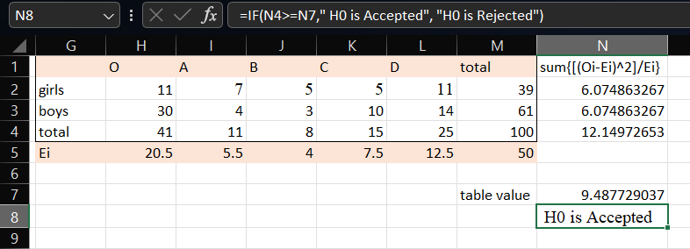

**Output:**

**Practical: 06**

* **Perform testing of hypothesis using Z-test.**

**One sample:**

|  |
| --- |
| IQ |
| 82 |
| 82 |
| 85 |
| 87 |
| 87 |
| 88 |
| 92 |
| 92 |
| 94 |
| 94 |
| 95 |
| 96 |
| 97 |
| 97 |
| 97 |
| 99 |
| 99 |
| 101 |
| 101 |
| 103 |
| 103 |
| 105 |
| 107 |
| 109 |
| 109 |
| 109 |
| 110 |
| 112 |
| 112 |
| 113 |
| 114 |
| 115 |

Given:

population mean = 100,

population std dev = 15.

H0: population mean is equal to 100.

H1: population mean is not equal to 100.

Click on D2 and type =Z.TEST(A2:A33,100,15)

*(Please note that this gives us value for a one-tailed test. To obtain P-value for*

*two-tailed test click on D4 and type =D2*2. This will give us an approximate P-value  
 for two-tailed Z-test.)*

|  |  |  |
| --- | --- | --- |
| P-value | 0.565525 | one tail |
|  |  |
| 1.131049 | two tail |

Go to D6 and type =IF(D4>0.05,"H0 accepted","H1 accepted,H0 rejected")

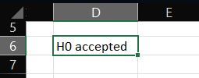

**Two sample:**

|  |  |
| --- | --- |
| CITY A | CITY B |
| 82 | 88 |
| 84 | 88 |
| 85 | 90 |
| 89 | 91 |
| 89 | 91 |
| 90 | 91 |
| 90 | 93 |
| 90 | 93 |
| 91 | 95 |
| 91 | 95 |
| 92 | 99 |
| 94 | 99 |
| 94 | 102 |
| 94 | 102 |
| 98 | 105 |
| 98 | 107 |
| 99 | 108 |
| 99 | 109 |
| 105 | 109 |
| 106 | 114 |
| 106 | 115 |
| 109 | 116 |
| 109 | 117 |
| 109 | 117 |
| 110 | 119 |
| 112 | 123 |
| 112 | 128 |
| 113 | 129 |
| 114 | 130 |
| 114 | 133 |

**Given:** variance for city

a: 225 Variance for city b: 225

**H0:** population mean for city a = population mean for city b

**H1:** population mean for city a is not equal to population mean for city b.

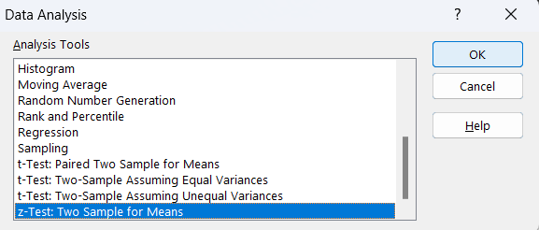Go to Data tab > Data Analysis

Click on OK.

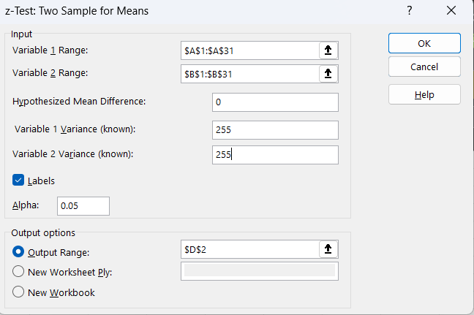

Click on OK.

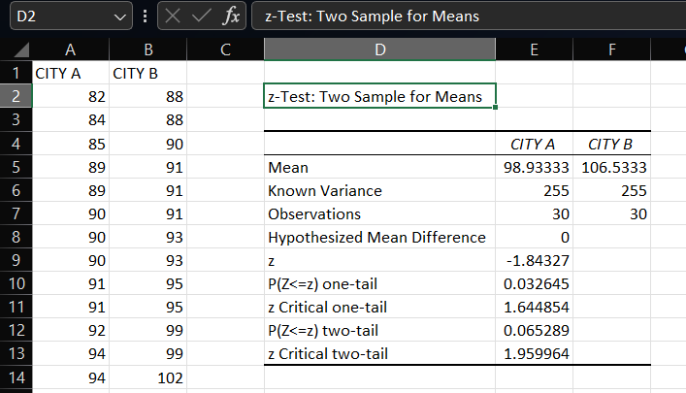

Click on D15 and type =IF(E12>0.05,"H0 accepted","H1 accepted, H0 rejected")

**Output:**

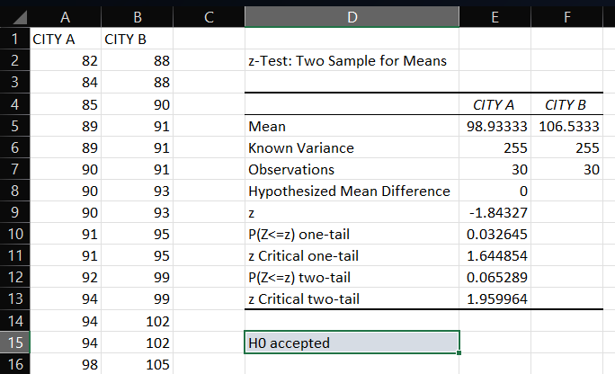

**Practical: 07**

1. **Perform testing of hypothesis using One-way ANOVA.**

ANOVA assumptions:

* The dependent variable (none, low medium and high in our example) should be continuous.
* The independent variables (daily and weekly in our example) should be two or more categorical groups.
* There must be different participants in each group with no participant being in more than one group.
* The dependent variable should be approximately normally distributed for each category.
* Variances of each group are approximately equal.

Below you can find the salaries of people who have a degree in economics, medicine or history.

|  |  |  |
| --- | --- | --- |
| economics | medicine | history |
| 42 | 69 | 35 |
| 53 | 54 | 40 |
| 49 | 58 | 53 |
| 53 | 64 | 42 |
| 43 | 64 | 50 |
| 44 | 55 | 39 |
| 45 | 56 | 55 |
| 52 |  | 39 |
| 54 |  | 40 |

H0 – all means are same ( µ1 = µ2 = µ3 ).

H1 – at least one mean is different.

To perform ANOVA, go to Data > Data Analysis

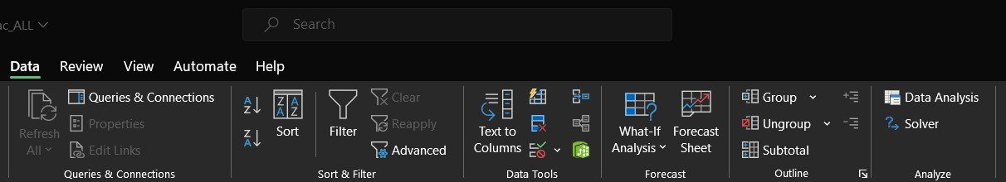

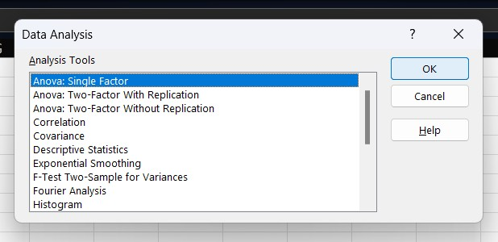

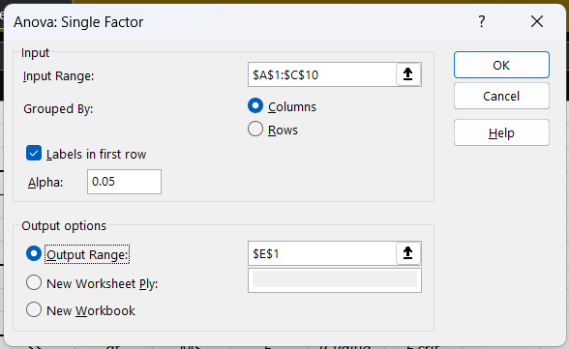

**Input Range: A1:C10**

**Output Range: E1**

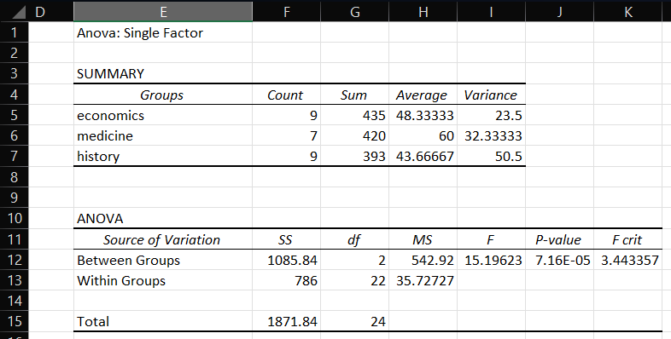

To take a decision, in cell B14 type =IF(J11<C13,"H0 accepted","H1 accepted, H0 rejected")

Since the resulting p value is less than 0.05. The null hypothesis (H0) is rejected and concluded that at least one mean is different.

**Output:**

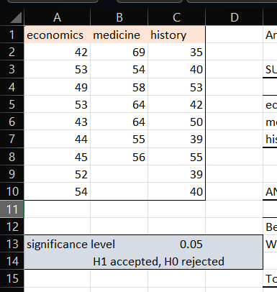

1. **Perform testing of hypothesis using Two-way ANOVA.**

A two-way ANOVA (“analysis of variance”) is used to determine whether or not there is a statistically  
 significant difference between the means of three or more independent groups that have been split on two  
 variables (sometimes called “factors”).

The results of a two-way ANOVA to be valid, the following assumptions should be met:

* **Normality** – The response variable is approximately normally distributed for each group.
* **Equal Variances** – The variances for each group should be roughly equal.
* **Independence** – The observations in each group are independent of each other and the observations within groups were obtained by a random sample.

**Example:**

A botanist wants to know whether plant growth is influenced by sunlight exposure and watering  
frequency. She plants 40 seeds and lets grow for two months under different conditions for  
sunlight  
exposure and watering frequency. After two months, she records the height of each plant. The results are shown below:

|  |  |  |  |  |
| --- | --- | --- | --- | --- |
| **Water Frequency** | **Sunlight Exposure** | | | |
| **None** | **Low** | **Medium** | **High** |
| **Daily** | 4.8 | 5 | 6.4 | 6.3 |
| 4.4 | 5.2 | 6.2 | 6.4 |
| 3.2 | 5.6 | 4.7 | 5.6 |
| 3.9 | 4.3 | 5.5 | 4.8 |
| 4.4 | 4.8 | 5.8 | 5.8 |
| **Weekly** | 4.4 | 4.9 | 5.8 | 6 |
| 4.2 | 5.3 | 6.2 | 4.9 |
| 3.8 | 5.7 | 6.3 | 4.6 |
| 3.7 | 5.4 | 6.5 | 5.6 |
| 3.9 | 4.8 | 5.5 | 5.5 |

**H0** represents whether a plant watered daily or weekly has impact on how sunlight exposure affects a plant.

**H1** represents whether a plant watered daily or weekly has no impact, how sunlight exposure affects a plant.

Go to Data tab > Data Analysis

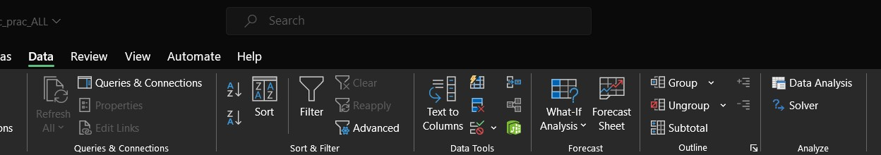

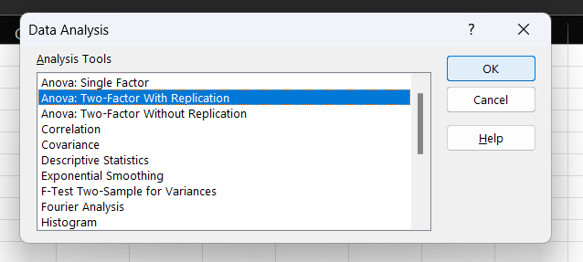

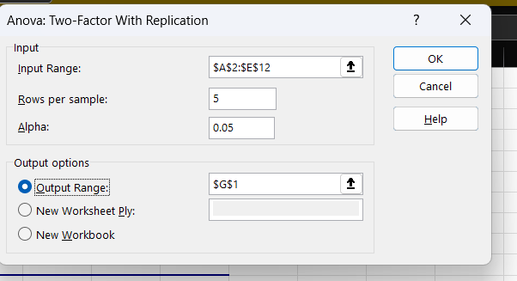

**Input Range -** A2:E12

**Rows Per Sample** – 5

**Alpha** – 0.05

**Output Range -** G1

|  |  |  |  |  |  |  |
| --- | --- | --- | --- | --- | --- | --- |
| Anova: Two-Factor With Replication | | | | | |  |
| SUMMARY | none | low | medium | high | Total |
|  | *daily* |  |  |  |  |
| Count | 5 | 5 | 5 | 5 | 20 |
| Sum | 20.7 | 24.9 | 28.6 | 28.9 | 103.1 |
| Average | 4.14 | 4.98 | 5.72 | 5.78 | 5.155 |
| Variance | 0.378 | 0.232 | 0.447 | 0.412 | 0.775237 |
| *weekly* | |  |  |  |  |
| Count | 5 | 5 | 5 | 5 | 20 |  |
| Sum | 20 | 26.1 | 30.3 | 26.6 | 103 |  |
| Average | 4 | 5.22 | 6.06 | 5.32 | 5.15 |  |

|  |  |  |  |  |  |  |
| --- | --- | --- | --- | --- | --- | --- |
| Variance | 0.085 | 0.137 | 0.163 | 0.317 | 0.722632 |  |
| *Total* |  |  |  |  |  |  |
| Count | 10 | 10 | 10 | 10 |  |  |
| Sum | 40.7 | 51 | 58.9 | 55.5 |  |  |
| Average | 4.07 | 5.1 | 5.89 | 5.55 |  |  |
| Variance | 0.211222 | 0.18 | 0.303222 | 0.382778 |  |  |
| ANOVA |  |  |  |  |  |  |
| *Source of Variation* | *SS* | *df* | *MS* | *F* | *P-value* | *F crit* |
| Sample | 0.00025 | 1 | 0.00025 | 0.000921 | 0.975975 | 4.149097 |
| Columns | 18.76475 | 3 | 6.254917 | 23.04898 | 3.9E-08 | 2.90112 |
| Interaction | 1.01075 | 3 | 0.336917 | 1.241517 | 0.310898 | 2.90112 |
| Within | 8.684 | 32 | 0.271375 |  |  |  |
| Total | 28.45975 | 39 |  |  |  |  |

To take a decision, click on cell B15 and type==IF(L24<B14,"H0 accepted","H1 accepted, H0 rejected")

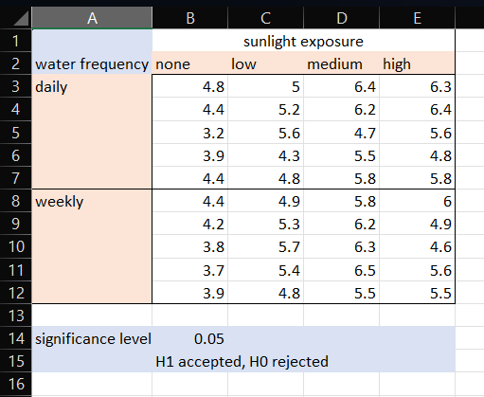**Output:**

**Practical: 08**

1. **Perform the Random sampling for the given data and analyze it.**

**Example:** A test conducted of 40 marks for a class of 100. We want a sample that represents the class. Data for the same is given below.

|  |  |
| --- | --- |
| rollno | marks |
| 1 | 19 |
| 2 | 29 |
| 3 | 8 |
| 4 | 27 |
| 5 | 38 |
| 6 | 5 |
| 7 | 36 |
| 8 | 24 |
| 9 | 23 |
| 10 | 12 |
| 11 | 33 |
| 12 | 30 |
| 13 | 27 |
| 14 | 13 |
| 15 | 22 |
| 16 | 10 |
| 17 | 36 |
| 18 | 17 |
| 19 | 26 |
| 20 | 10 |
| 21 | 17 |
| 22 | 12 |
| 23 | 4 |
| 24 | 22 |
| 25 | 23 |

|  |  |
| --- | --- |
| 51 | 36 |
| 52 | 6 |
| 53 | 26 |
| 54 | 0 |
| 55 | 4 |
| 56 | 4 |
| 57 | 19 |
| 58 | 38 |
| 59 | 40 |
| 60 | 13 |
| 61 | 25 |
| 62 | 30 |
| 63 | 21 |
| 64 | 5 |
| 65 | 21 |
| 66 | 33 |
| 67 | 29 |
| 68 | 1 |
| 69 | 7 |
| 70 | 19 |
| 71 | 24 |
| 72 | 33 |
| 73 | 21 |
| 74 | 7 |
| 75 | 34 |

|  |  |
| --- | --- |
| 26 | 1 |
| 27 | 9 |
| 28 | 12 |
| 29 | 3 |
| 30 | 8 |
| 31 | 18 |
| 32 | 5 |
| 33 | 32 |
| 34 | 15 |
| 35 | 26 |
| 36 | 5 |
| 37 | 24 |
| 38 | 2 |
| 39 | 29 |
| 40 | 4 |
| 41 | 31 |
| 42 | 31 |
| 43 | 13 |
| 44 | 7 |
| 45 | 31 |
| 46 | 31 |
| 47 | 8 |
| 48 | 13 |
| 49 | 20 |
| 50 | 13 |

|  |  |
| --- | --- |
| 76 | 25 |
| 77 | 33 |
| 78 | 10 |
| 79 | 26 |
| 80 | 17 |
| 81 | 34 |
| 82 | 18 |
| 83 | 19 |
| 84 | 22 |
| 85 | 3 |
| 86 | 31 |
| 87 | 4 |
| 88 | 31 |
| 89 | 25 |
| 90 | 25 |
| 91 | 28 |
| 92 | 8 |
| 93 | 13 |
| 94 | 9 |
| 95 | 1 |
| 96 | 25 |
| 97 | 39 |
| 98 | 2 |
| 99 | 33 |
| 100 | 38 |

Go to Data tab > Data Analysis

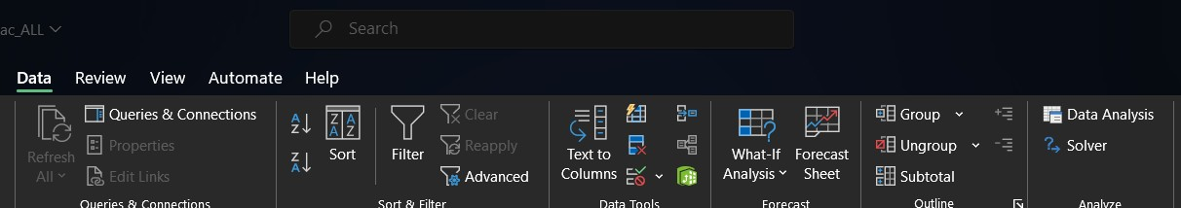

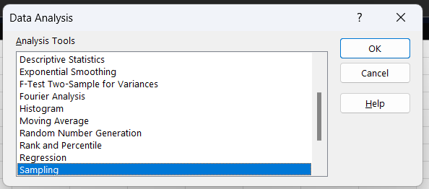Select sampling > ok

* **For random sampling**

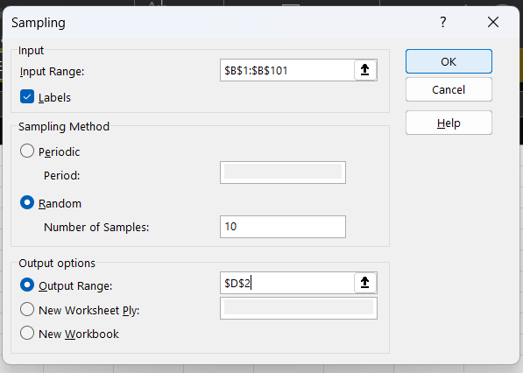

Select **input range** - B1:B101

Make sure you have checked checkbox for labels.

Select Sampling method as Random.

Number of samples – 10

Select **output range** – D2.

* **For periodic sampling**

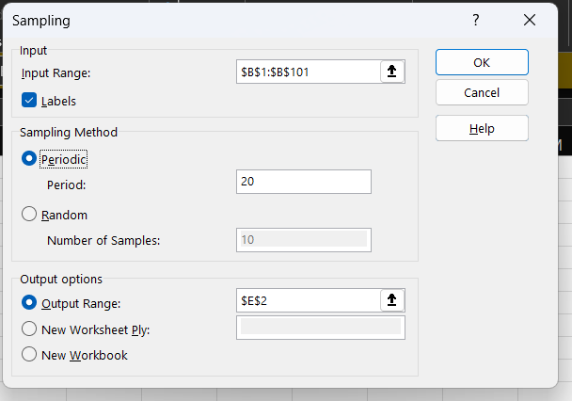

Select **input range** - B1:B101

Make sure you have checked  
 checkbox for labels.   
 Select Sampling method as Periodic.

period – 20

if you want a specific number of samples and you want to know what to type in this field then use the  
 formula: total number of samples/samples required.

**Example: Select output range – E2**

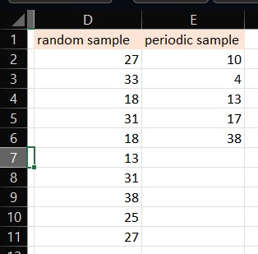**Output:**

1. **Perform the Periodic sampling for the given data and analyze it.**

**Example:** A test conducted of 40 marks for a class of 100. We want a sample that represent intervals such as below 10, between 11 to 20, between 21 to 30, greater than 30, etc. Data for the same is given below.

|  |  |
| --- | --- |
| rollno | marks |
| 1 | 19 |
| 2 | 29 |
| 3 | 8 |
| 4 | 27 |
| 5 | 38 |
| 6 | 5 |
| 7 | 36 |
| 8 | 24 |
| 9 | 23 |
| 10 | 12 |
| 11 | 33 |
| 12 | 30 |
| 13 | 27 |
| 14 | 13 |
| 15 | 22 |
| 16 | 10 |
| 17 | 36 |
| 18 | 17 |
| 19 | 26 |
| 20 | 10 |
| 21 | 17 |
| 22 | 12 |
| 23 | 4 |
| 24 | 22 |
| 25 | 23 |

|  |  |
| --- | --- |
| 26 | 1 |
| 27 | 9 |
| 28 | 12 |
| 29 | 3 |
| 30 | 8 |
| 31 | 18 |
| 32 | 5 |
| 33 | 32 |
| 34 | 15 |
| 35 | 26 |
| 36 | 5 |
| 37 | 24 |
| 38 | 2 |
| 39 | 29 |
| 40 | 4 |
| 41 | 31 |
| 42 | 31 |
| 43 | 13 |
| 44 | 7 |
| 45 | 31 |
| 46 | 31 |
| 47 | 8 |
| 48 | 13 |
| 49 | 20 |
| 50 | 13 |

|  |  |
| --- | --- |
| 51 | 36 |
| 52 | 6 |
| 53 | 26 |
| 54 | 0 |
| 55 | 4 |
| 56 | 4 |
| 57 | 19 |
| 58 | 38 |
| 59 | 40 |
| 60 | 13 |
| 61 | 25 |
| 62 | 30 |
| 63 | 21 |
| 64 | 5 |
| 65 | 21 |
| 66 | 33 |
| 67 | 29 |
| 68 | 1 |
| 69 | 7 |
| 70 | 19 |
| 71 | 24 |
| 72 | 33 |
| 73 | 21 |
| 74 | 7 |
| 75 | 34 |

|  |  |
| --- | --- |
| 76 | 25 |
| 77 | 33 |
| 78 | 10 |
| 79 | 26 |
| 80 | 17 |
| 81 | 34 |
| 82 | 18 |
| 83 | 19 |
| 84 | 22 |
| 85 | 3 |
| 86 | 31 |
| 87 | 4 |
| 88 | 31 |
| 89 | 25 |
| 90 | 25 |
| 91 | 28 |
| 92 | 8 |
| 93 | 13 |
| 94 | 9 |
| 95 | 1 |
| 96 | 25 |
| 97 | 39 |
| 98 | 2 |
| 99 | 33 |
| 100 | 38 |

Go to Data tab > Data Analysis

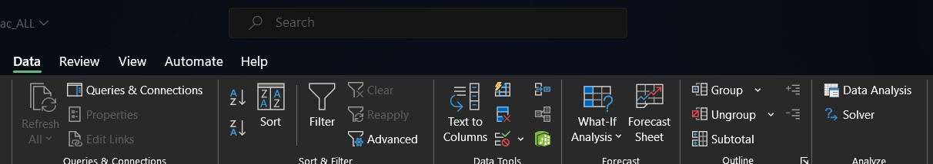

Select sampling > ok



For periodic sampling



**Select input range** - B1:B101

Make sure you have checked checkbox for labels. Select Sampling method as Periodic.

period – 20

if you want a specific number of samples and you want to know what to type in this field then use the formula: total number of samples/samples required.

**Example**: Select **output range –** E2

**Output:**

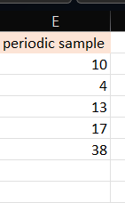

**Practical: 09**

* **Compute different types of correlation.**

Correlation is a statistical term describing the degree to which two variables move in coordination with one another. If the two variables move in the same direction, then those variables are said to have a positive correlation. If they move in opposite directions, then they have a negative correlation.

In Excel,

“1” represents positive correlation.

“0” represents no correlation.

“-1” represents negative correlation.

|  |  |
| --- | --- |
| X | Y |
| 0 | 2 |
| 10 | 12 |
| 2 | 4 |
| 12 | 14 |
| 6 | 8 |

* **Positive correlation**

Go to Data tab > Data Analysis > Correlation > Click Ok.

Select **input range** – A1:B6.

Select radio button Columns.

Check checkbox labels in first row.

Select **output range** – A8.

Click on Ok.

Another way to calculate correlation is to type =CORREL(A2:A6,B2:B6) in cell B12.

To plot a graph, go to Insert tab > Charts > Line Chart > Line.

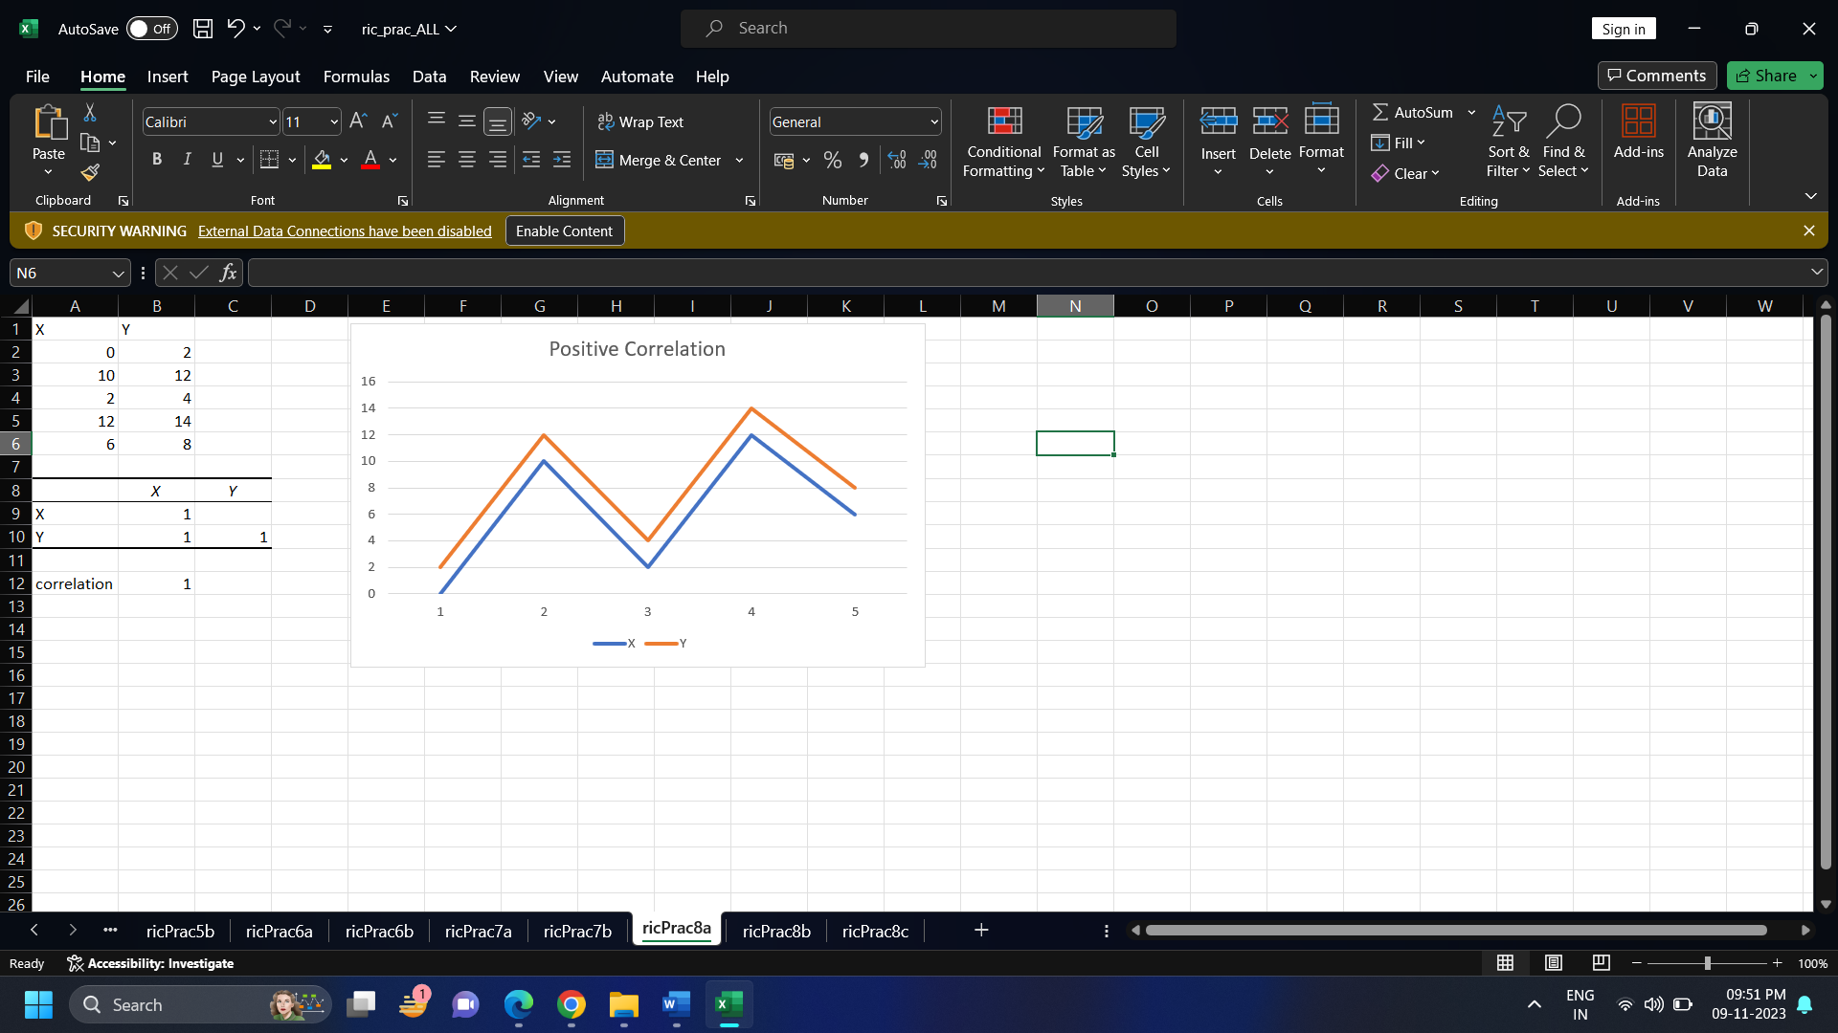

* **Negative correlation**

|  |  |
| --- | --- |
| X | Z |
| 0 | 2 |
| 10 | -8 |
| 2 | 0 |
| 12 | -10 |
| 6 | -4 |

Go to Data tab > Data Analysis > Correlation > Click Ok.

**Select input range** – A1:B6.

Select radio button Columns.

Check checkbox labels in first row.

**Select output range** – A8.

Click on Ok.

Another way to calculate correlation is to type =CORREL(A2:A6,B2:B6) in cell B12.

To plot a graph, go to Insert tab > Charts > Line Chart > Line.

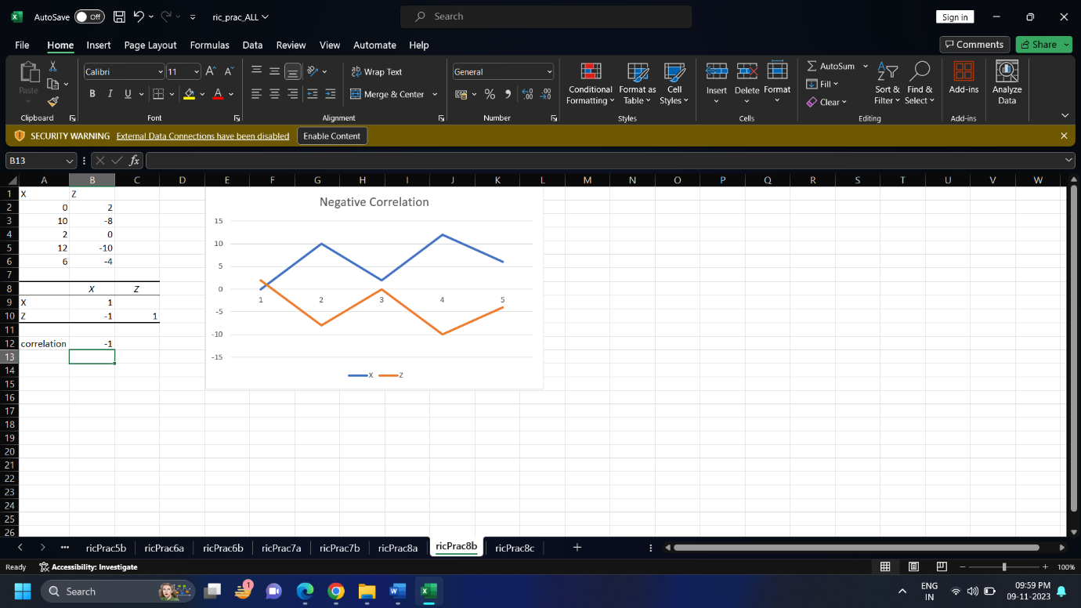

* **Correlation for three or more variables**

|  |  |  |
| --- | --- | --- |
| A | B | C |
| 0 | 2 | 2 |
| 14 | 6 | 11 |
| 1 | 8 | 3 |
| 10 | 5 | 13 |
| 5 | 6 | 4 |

Go to Data tab > Data Analysis > Correlation > Click Ok.

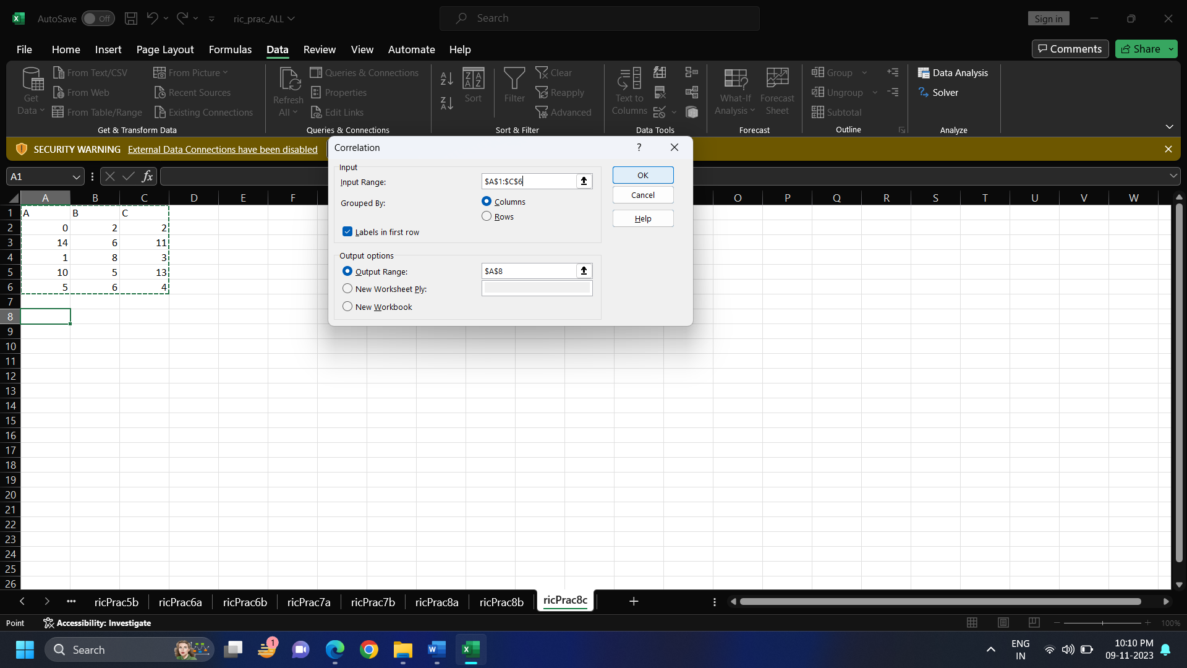

Select input range – A1:C6.

Select radio button Columns.

Check checkbox labels in first row.

Select output range – A8.

Click on Ok.

To plot a graph, go to Insert tab > Charts > Line Chart > Line.

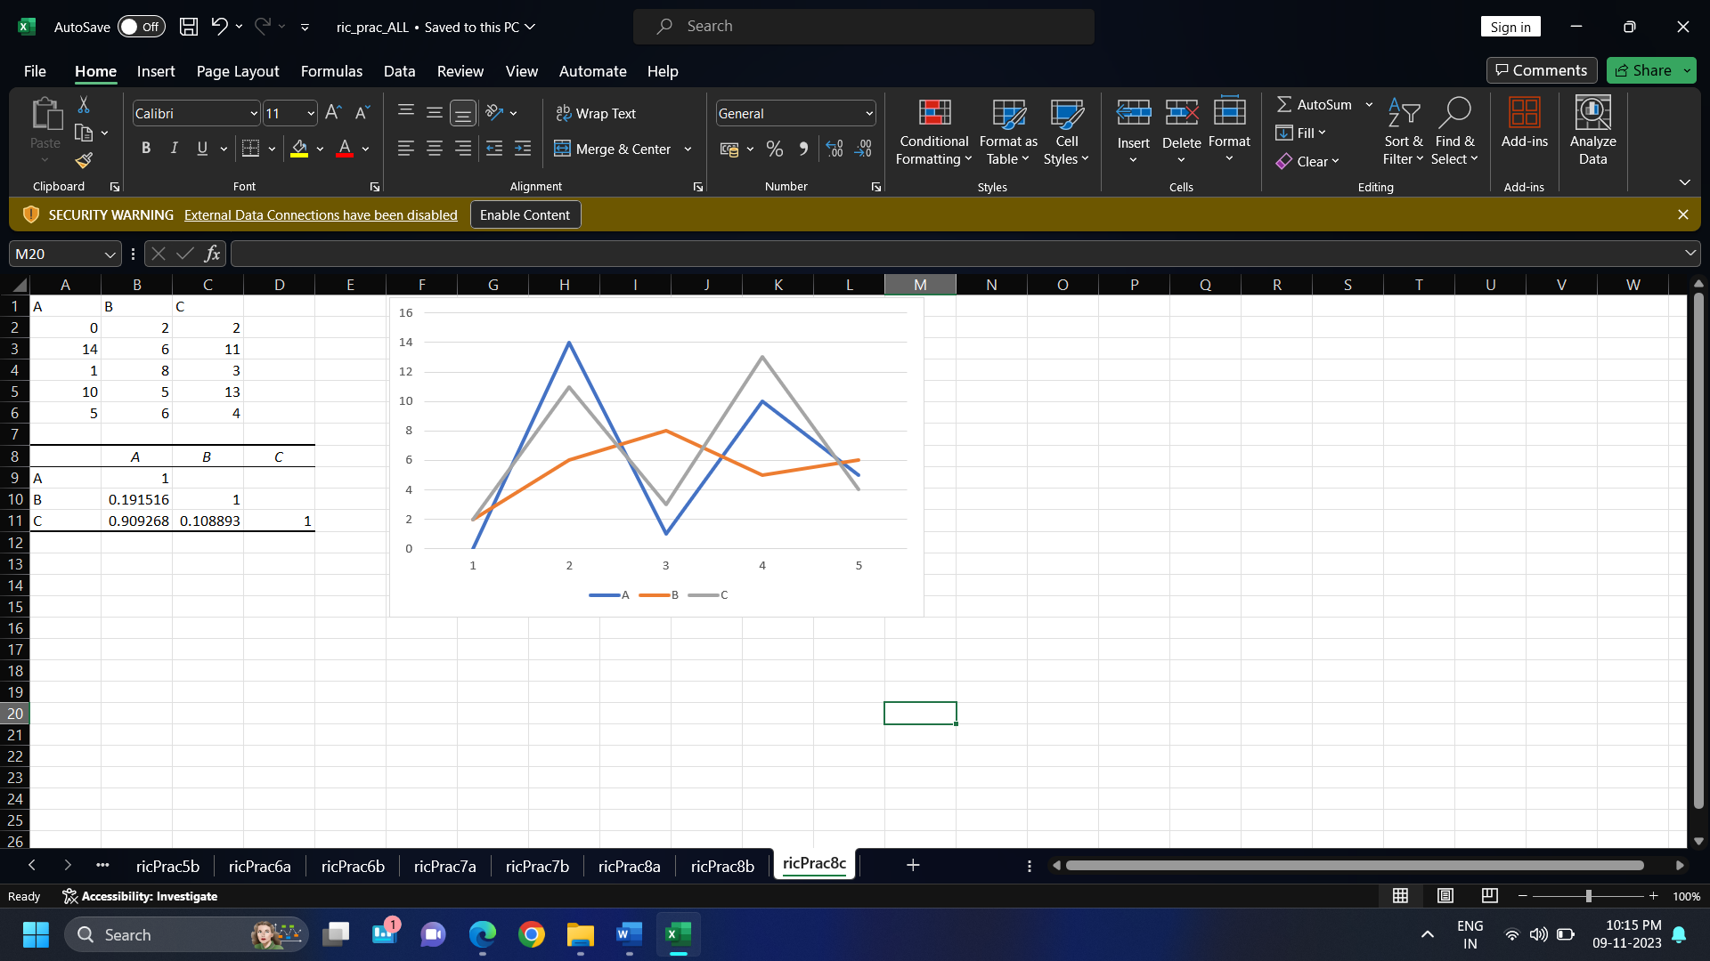

This example represents more real life situations.

Correlation between A and B is near “0”.

Correlation between A and C is near “1”.

Correlation between B and C is near “0”.

**Practical: 10**

**A. Perform linear regression for prediction.**

|  |  |  |
| --- | --- | --- |
| Car_Name | Selling_Price | Present_Price |
| ritz | 3.35 | 5.59 |
| sx4 | 4.75 | 9.54 |
| ciaz | 7.25 | 9.85 |
| wagon r | 2.85 | 4.15 |
| swift | 4.6 | 6.87 |
| vitara brezza | 9.25 | 9.83 |
| ciaz | 6.75 | 8.12 |
| s cross | 6.5 | 8.61 |
| ciaz | 8.75 | 8.89 |
| ciaz | 7.45 | 8.92 |

Go to Data tab > Data Analysis > Regression > Click Ok.

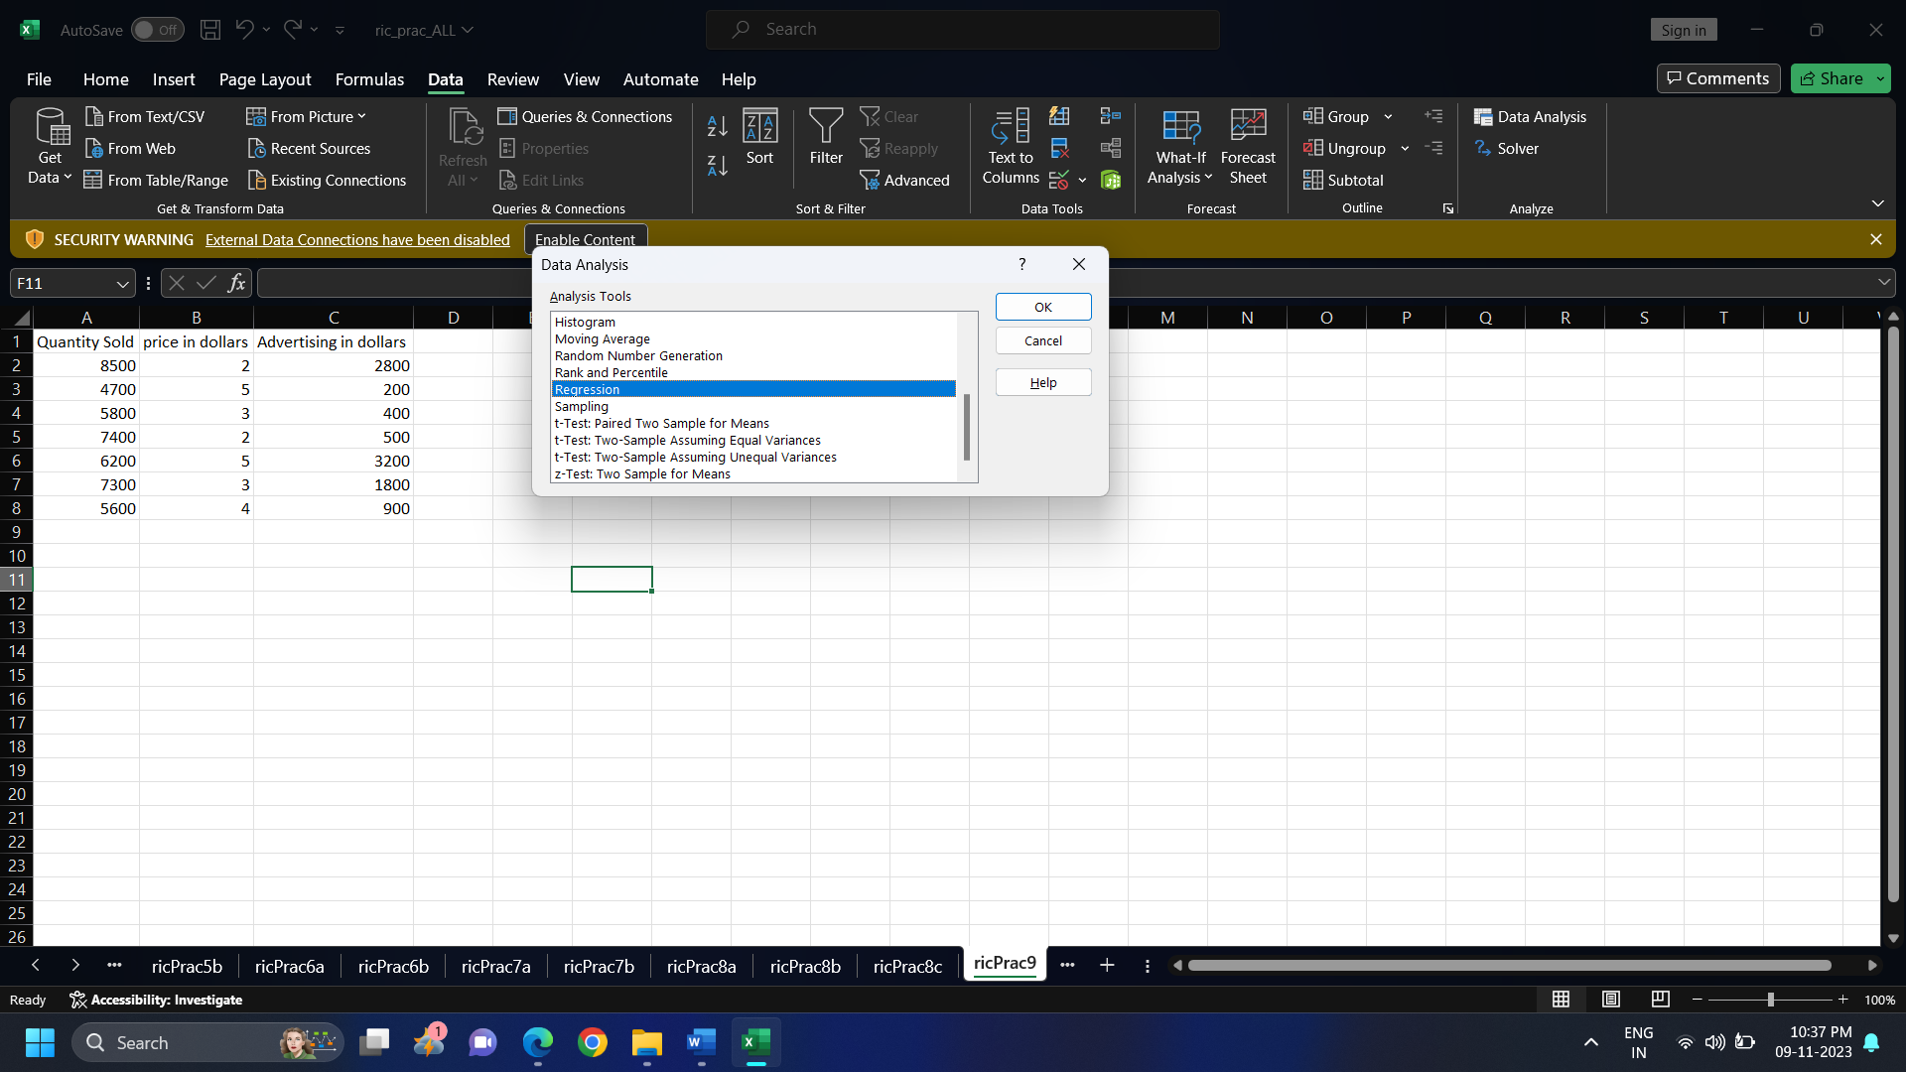

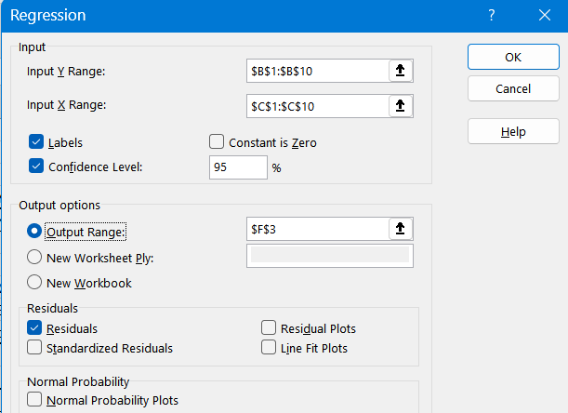

Select **input Y range –** B1:B10.

Select **input X range** – C1:C10.

Check checkboxes for Labels and Confidence Level.

Select **output range** – F3.

Check checkbox Residuals.

Click Ok.

**Output:**

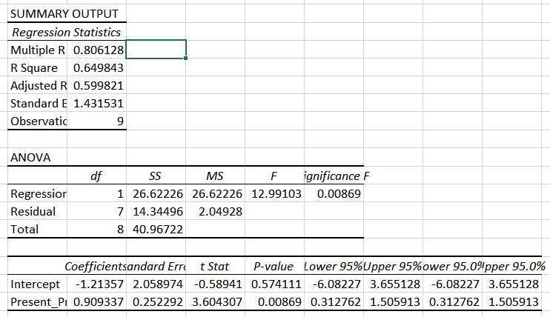

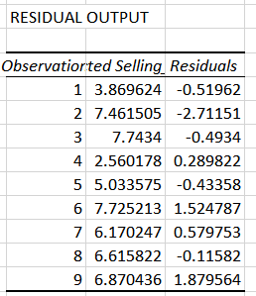

**B. Perform multiple regression for prediction.**

|  |  |  |
| --- | --- | --- |
| Quantity Sold | price in dollars | Advertising in dollars |
| 8500 | 2 | 2800 |
| 4700 | 5 | 200 |
| 5800 | 3 | 400 |
| 7400 | 2 | 500 |
| 6200 | 5 | 3200 |
| 7300 | 3 | 1800 |
| 5600 | 4 | 900 |

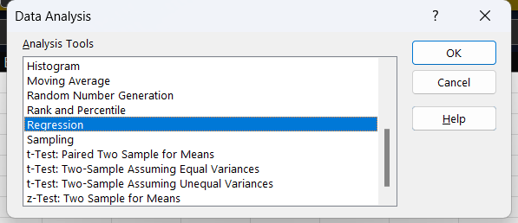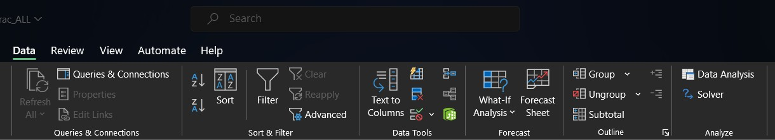Go to Data tab > Data Analysis > Regression > Click Ok.

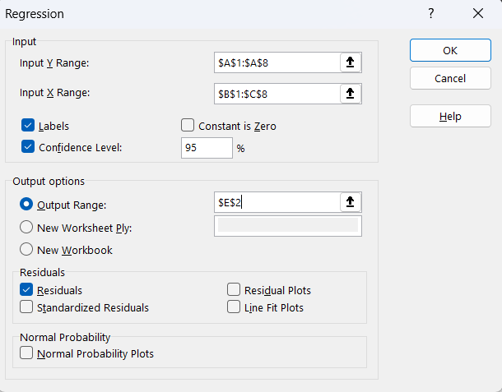

Select **input Y range** – A1:A8.

Select **input X range** – B1:C8.

Check checkboxes for Labels and Confidence Level.

Select **output range –** E2. Check checkbox Residuals.

Click Ok.

**Output:**

