Yousef Jubili
S24108969

Discussion Questions
- Why does the current implementation use StackFrontier instead of QueueFrontier?
Line 127 initializes frontier as stack frontier
frontier = StackFrontier()

- What would happen if you changed line 127 to use QueueFrontier()? • How would the exploration pattern change? • Would it find the same path? • Would it explore more or fewer states?
The search would be BFS (Breadth-First Search) using FIFO.
It finds the same path but with less states explored.

- Is DFS guaranteed to find the shortest path? Why or why not?
Each one is good in certain situations. It all depends on the goal states position.
Maze1 With stack: 11 | Maze1 With queue: 11

Maze2 With stack: 194 | Maze2 With queue: 77

Maze3 With stack: 17 | Maze3 With queue: 6

- How does the number of explored states differ between maze1.txt and maze2.txt? • Run both and compare the "States Explored" output • Why is there a difference?
11 and 194, this is because the are different maze structures with different goal states and different paths.

- What would happen if we removed the explored set check? • Hint: Think about cycles in the maze
There would be a redundant loop where it would execute and already executed state increasing states explored output number but not really exploring anything useful or new. In some cases it would create an infinite loop.

Exercise 1: Run and Observe
- Run the program with all three maze files

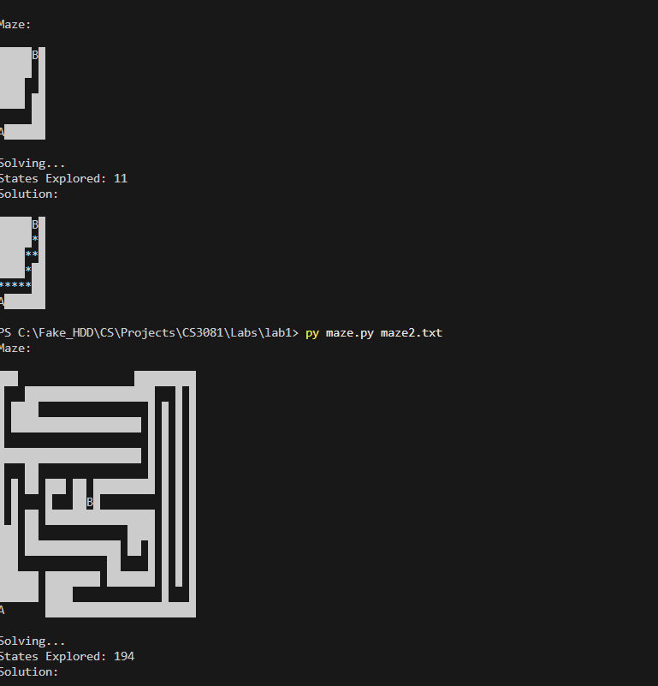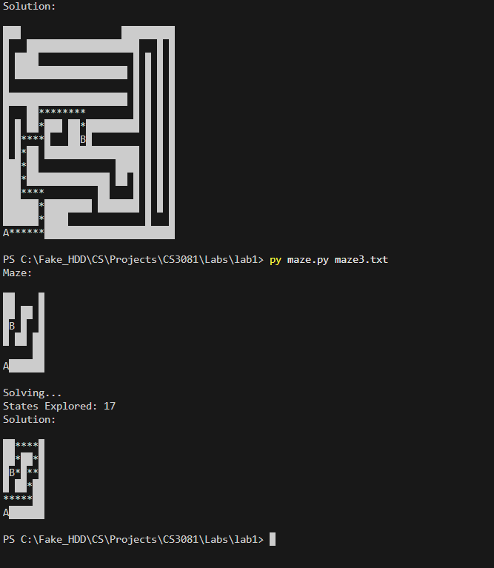
- Record the number of states explored for each
11,194,17

- Compare the solution paths in the generated images

Different mazes requires different paths

Exercise 2: Switch to BFS
- Modify line 127 to use QueueFrontier() instead of StackFrontier()
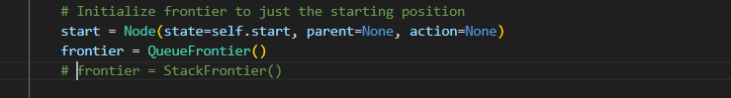
- Run the program again with all maze files
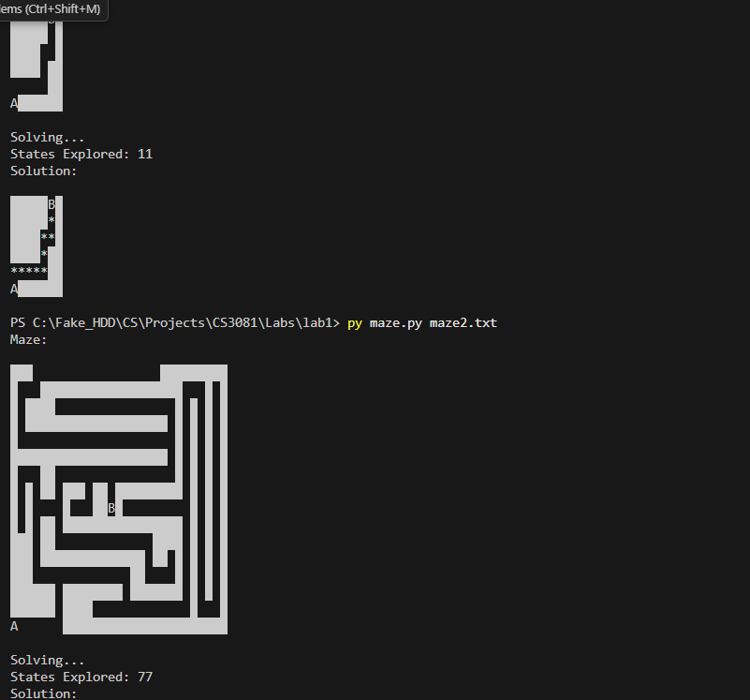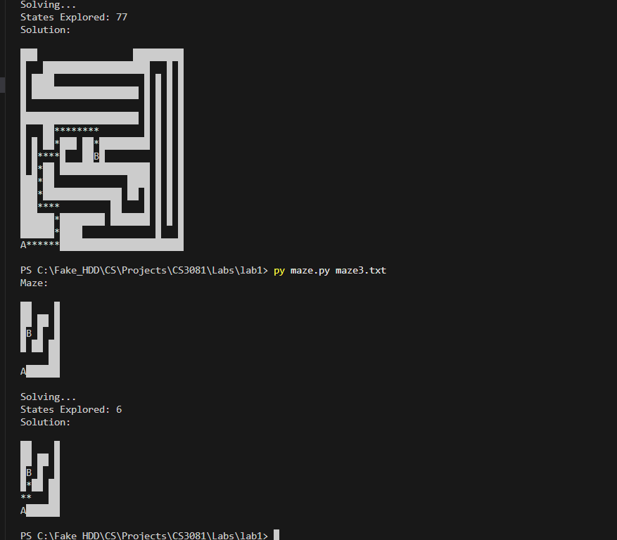

- Compare: states explored, path length, and path shape

Maze1 With stack: 11 | Maze1 With queue: 11

Maze2 With stack: 194 | Maze2 With queue: 77

Maze3 With stack: 17 | Maze3 With queue: 6

- Document your findings
While there is a difference in the logic or method used to find the goal state leading to differences is number of states explored. Both DFS and BFS end up the with the same result path.

Exercise 3: Create Your Own Maze
- Create a new file maze4.txt with your own maze design
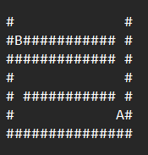!!!Attached!!!

2. Make sure it has exactly one A and one B
3. Test it with both DFS and BFS
4. Design a maze where DFS and BFS find different paths
