Lab3
Search & Knowledge
EffatUniversity
•
DepartmentofComputerScience
CS3081–ArtificialIntelligence
•
Spring2026
Makkah
Jeddah
Taif
Riyadh
Madinah
Dammam
Instructor: | Dr. Naila Marir
Duration: | 2 Hours
Tools: | VS Code + Python 3
Files: | part1 search.py part2 knowledge.py | logic.py
Student Name: Yousef Jubili
Student ID: S24108969

1. Lab Overview
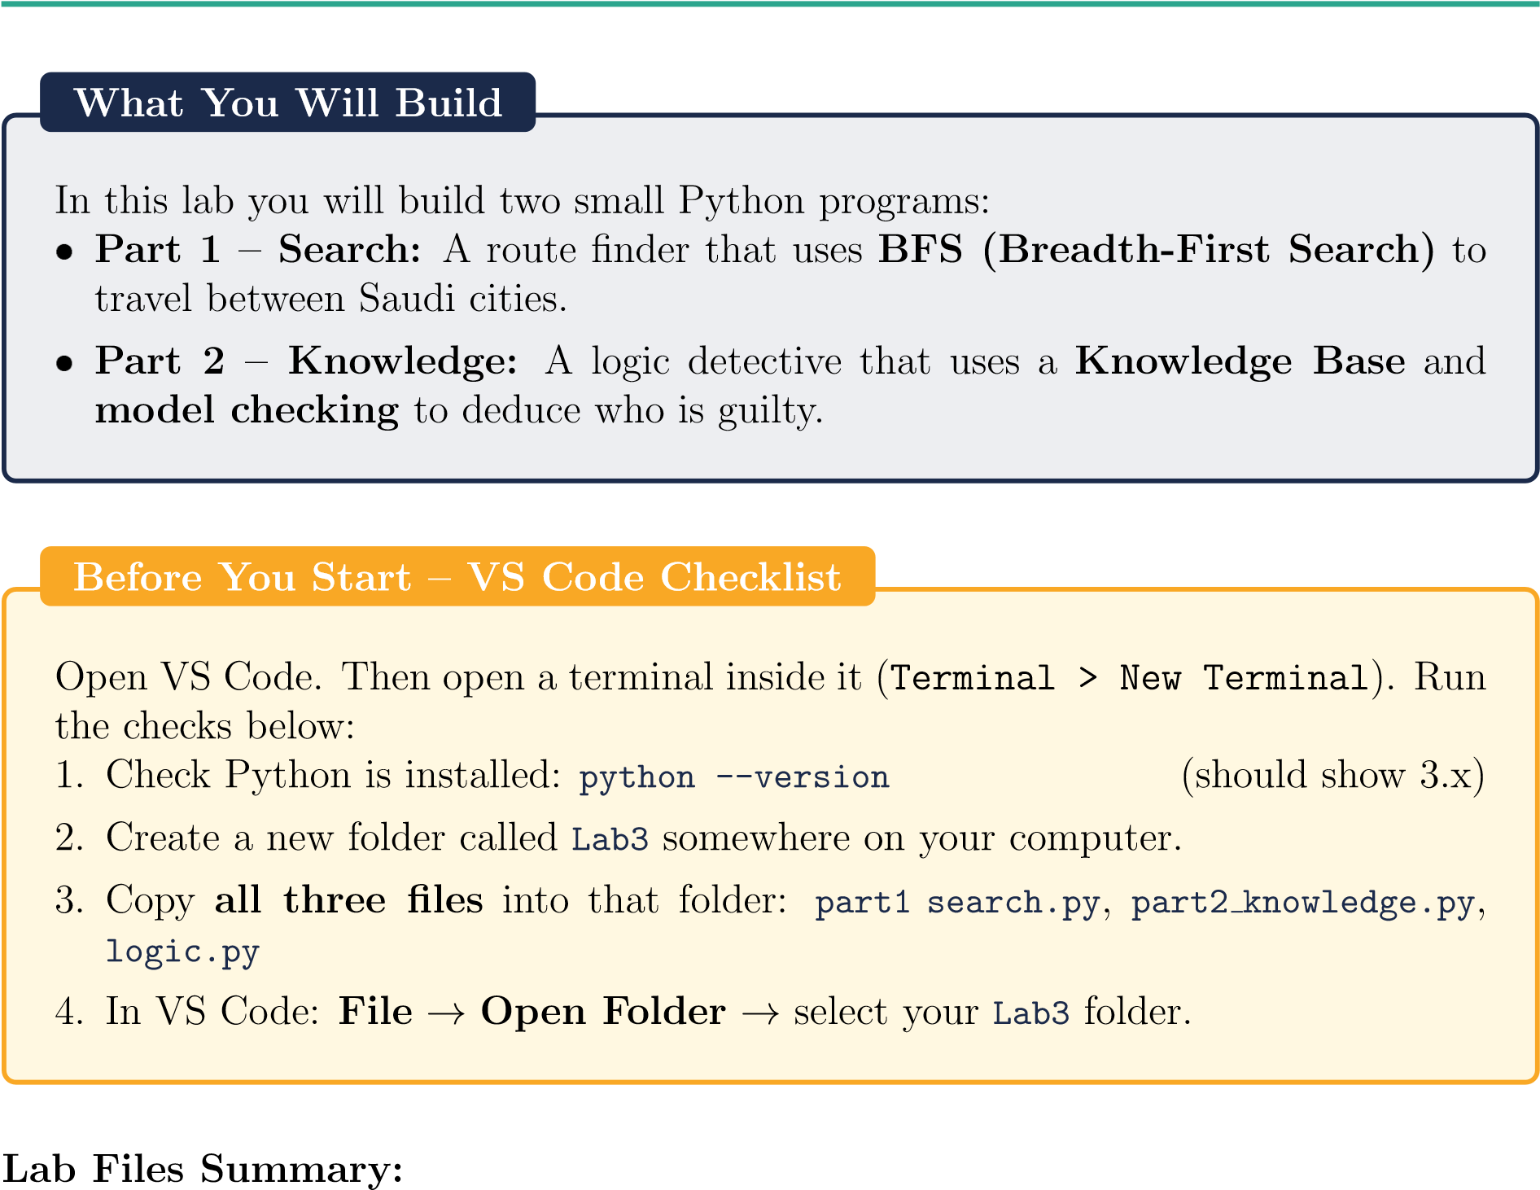

File | Description
part1 search.py | Your work for Part 1 – city graph and BFS
part2 knowledge.py | Your work for Part 2 – knowledge base and deduction
logic.py | Helper classes for Part 2 – do not edit this file

2. Part 1 – Search: Finding a Route with BFS

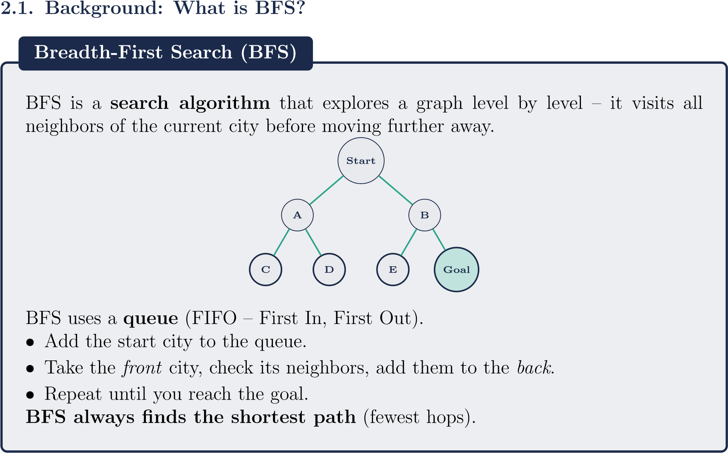

2.2. The City Map
Our map has 6 Saudi cities. Each city is connected to one or more neighbors.
Makkah
Jeddah
Taif
Riyadh
Madinah
Dammam
In Python, this map is stored as a dictionary:
1 | city_map = {
2 | "Makkah": ["Jeddah", |  | "Taif"],
3 | "Jeddah": ["Makkah", |  | "Riyadh", "Madinah"],
4 | "Taif": ["Makkah", |  | "Riyadh"],
5 | "Riyadh": ["Jeddah", |  | "Taif", "Dammam"],
6 |  | "Madinah": ["Jeddah"],
7  8 } |  | "Dammam": ["Riyadh"]
Listing 1: City map as a Python dictionary (part1 search.py lines 14–21)
ReadingaPythonDictionary
"Jeddah": ["Makkah", "Riyadh", "Madinah"]
means:
fromJeddahyoucanreach
Makkah,Riyadh,andMadinah
.

2.3. Step-by-Step Code Walkthrough
Open part1 search.py in VS Code. Read each section carefully.
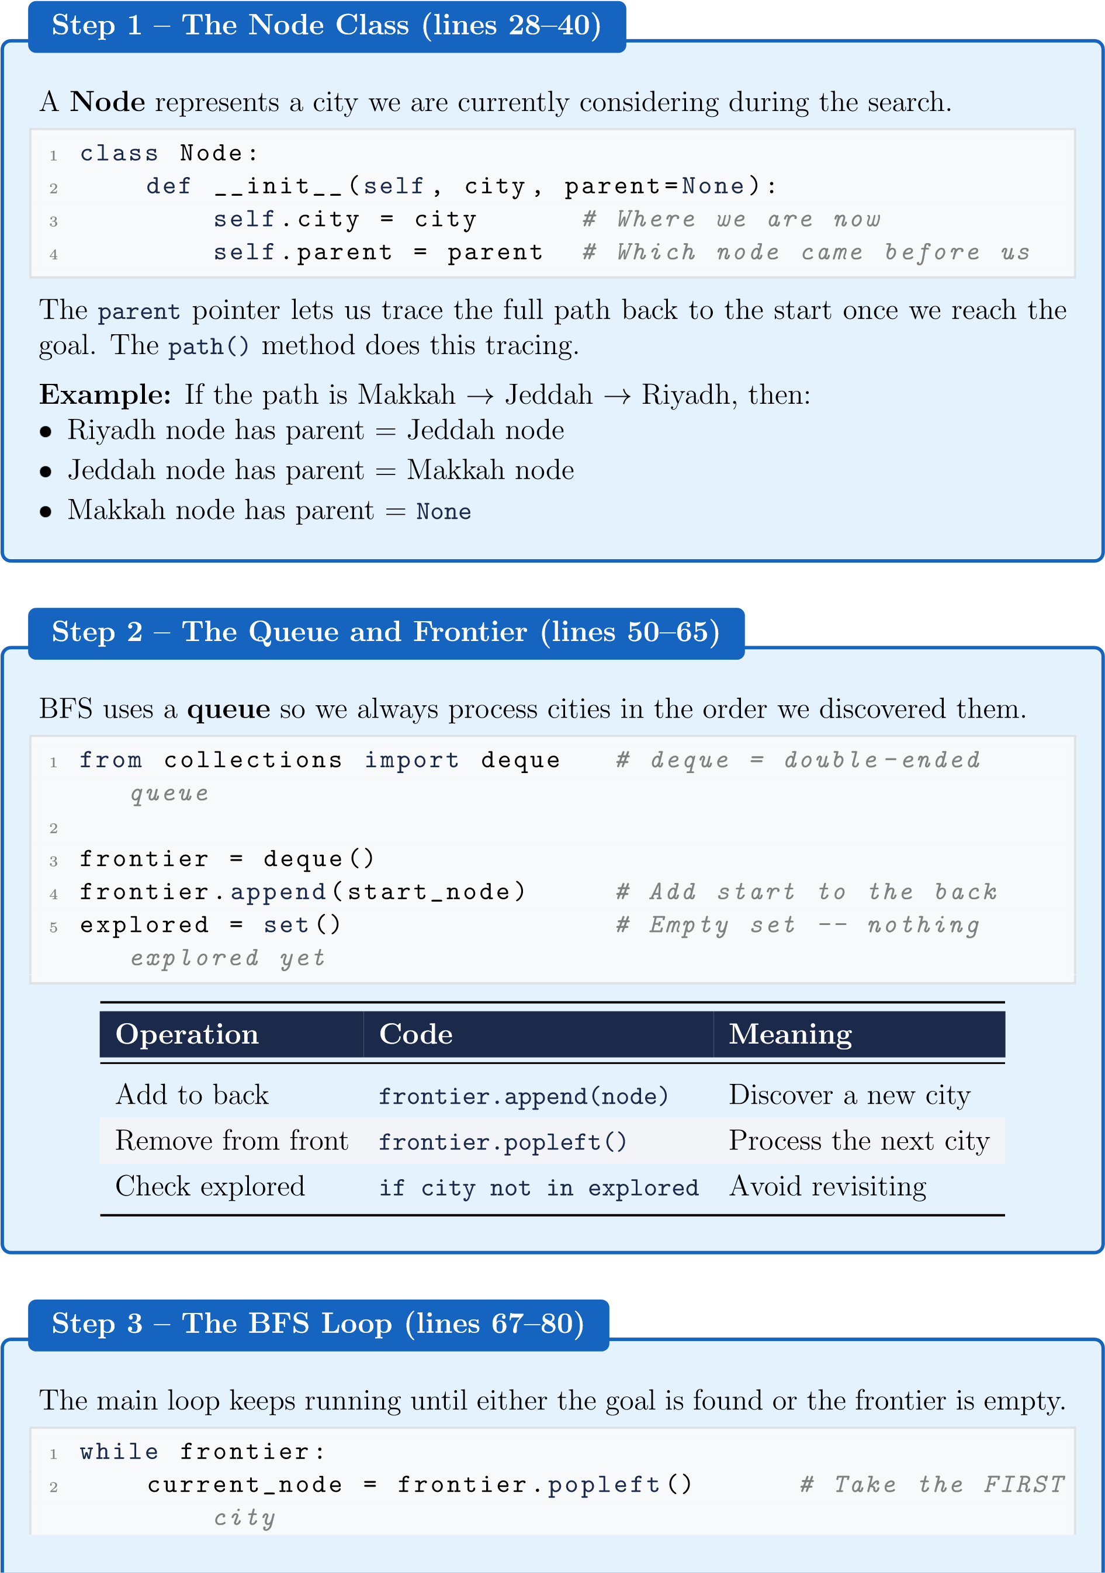
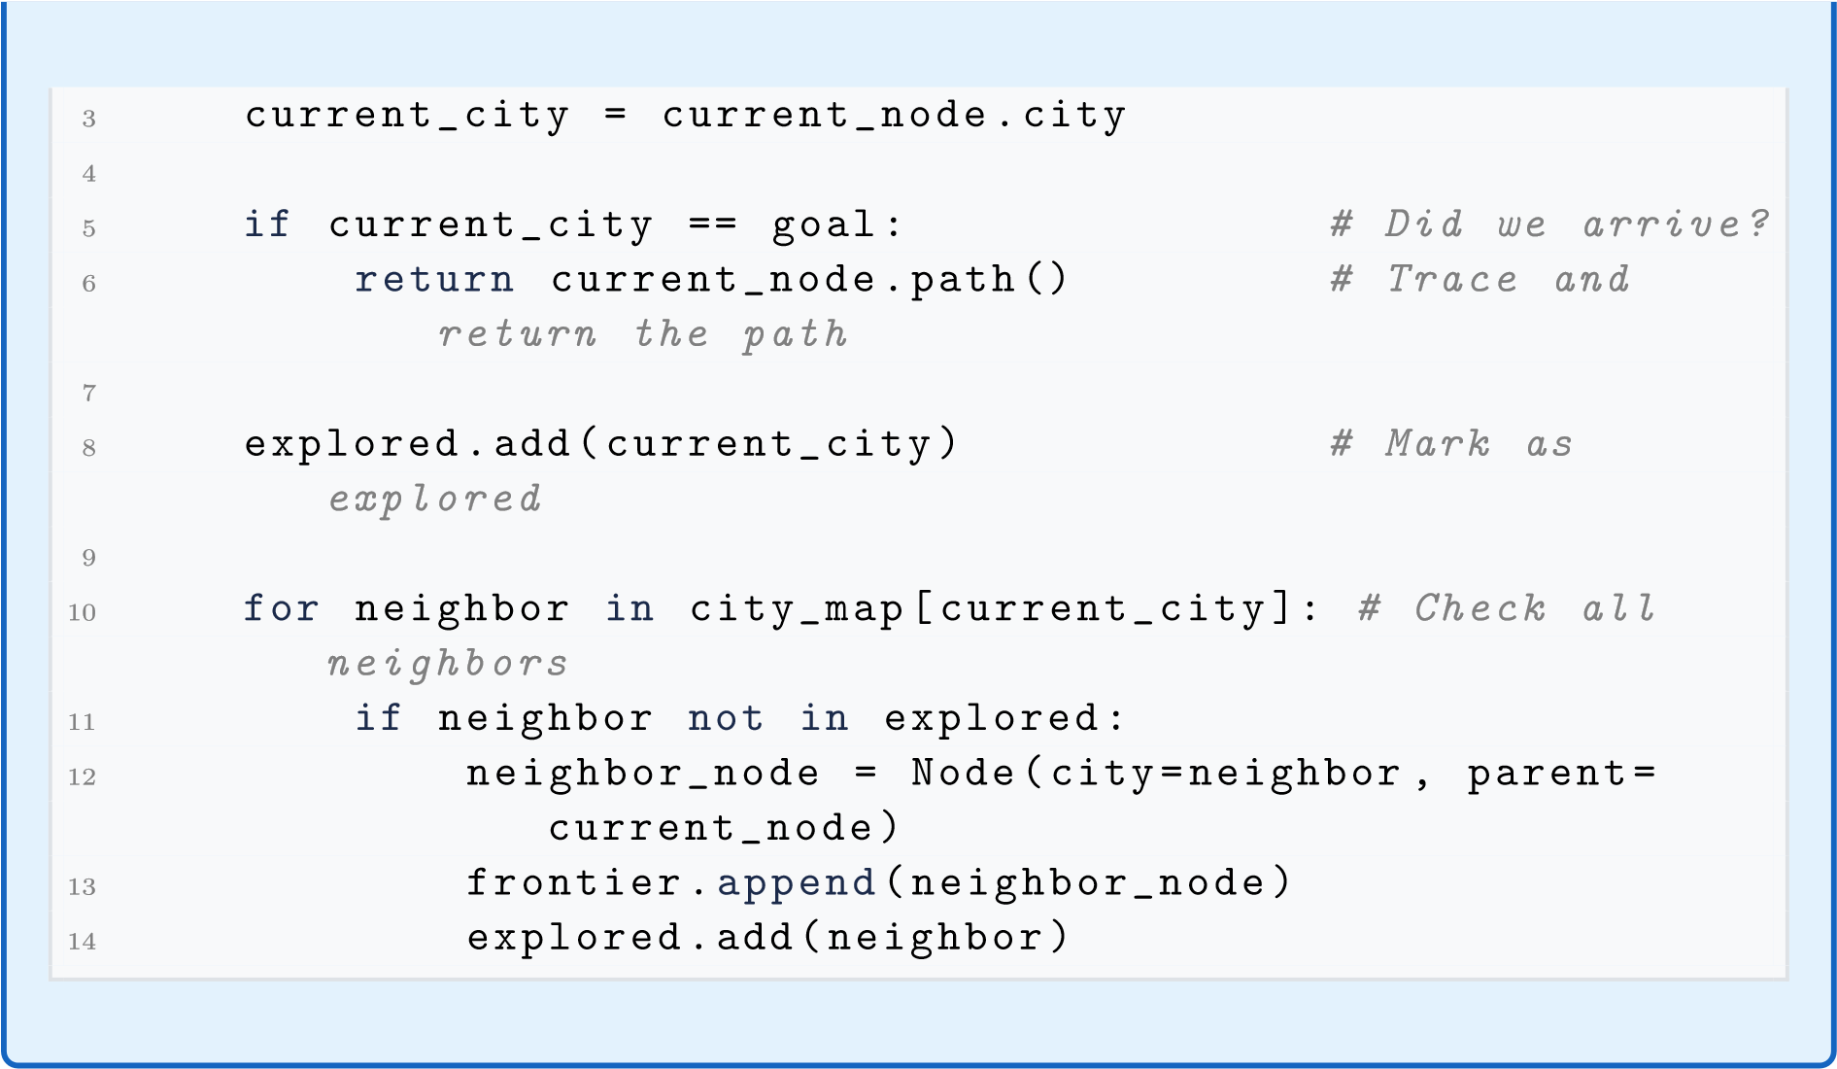

2.4. Run the Program
In the VS Code terminal, make sure you are inside the Lab3 folder:
cd Lab3 python part1_search.py
You should see output like this:
Searching from ’Makkah’ to ’Dammam’ using BFS...
Step 1: Visiting ’Makkah’
Step 2: Visiting ’Jeddah’
Step 3: Visiting ’Taif’
Step 4: Visiting ’Riyadh’
Step 5: Visiting ’Madinah’ Step 6: Visiting ’Dammam’ Goal reached! ’Dammam’ found.
Path found (4 steps):
Makkah -> Jeddah -> Riyadh -> Dammam
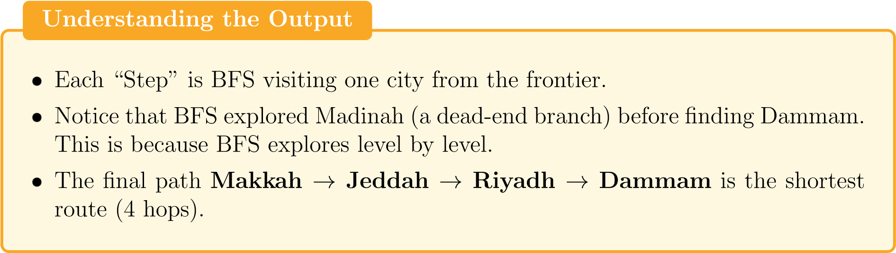
2.5.
Part1Exercises
Exercise1–ChangetheGoalCity
Atthebottomof
part1
search.py
(
:
line91–92),changethedestination
1
start_city =
"Makkah"
2
goal_city =
"Madinah"
#
<--
change
this
Runtheprogramagain.Answerthesequestionsinyourlabreport:
a.
HowmanystepsdidBFStaketoreachMadinah? 5 steps
b.
Whatisthepathitfound? Makkah → Jeddah → Madinah jhhhhhhhhMakkagMakkahjMakkah → Jeddah → MadinahMakkah → Jeddah → Madinah Makkah → Jeddah → MadinahMakkah → Jeddah → MadinahMakkah → Jeddah → Madinah
c.
Isthistheshortestpath?Verifybylookingatthecitymapdiagram.
Yes, since we are starting from Makkah. We either go to Jeddah or taif and the only place that Madinah has in its dict is Jeddah

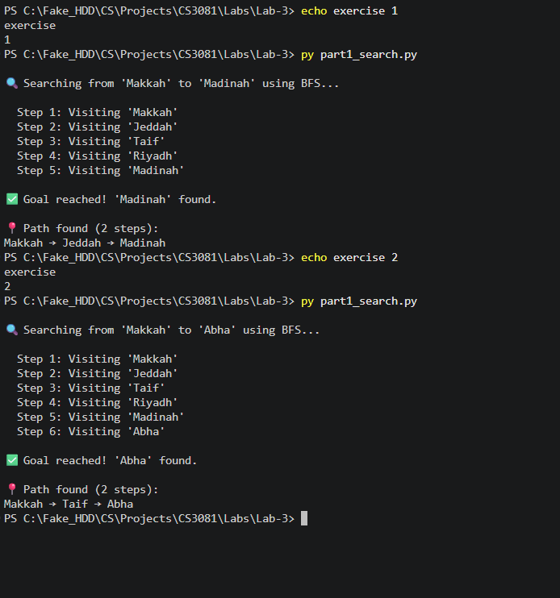
📍 Path found (2 steps):
Makkah → Taif → Abha
Exercise2–AddaNewCity
Addanewcity
Abha
tothemap,connectedtoTaif:
a.
In
city
map
,add:
"Abha": ["Taif"]
b.
AlsoupdateTaif’slisttoincludeAbha.
c.
Set
goal
city = "Abha"
andrun.
d.
WritethepathBFSfoundfromMakkahtoAbha.



3. Part 2 – Knowledge: Logic Detective

3.1. Background: Propositional Logic and the Knowledge Base
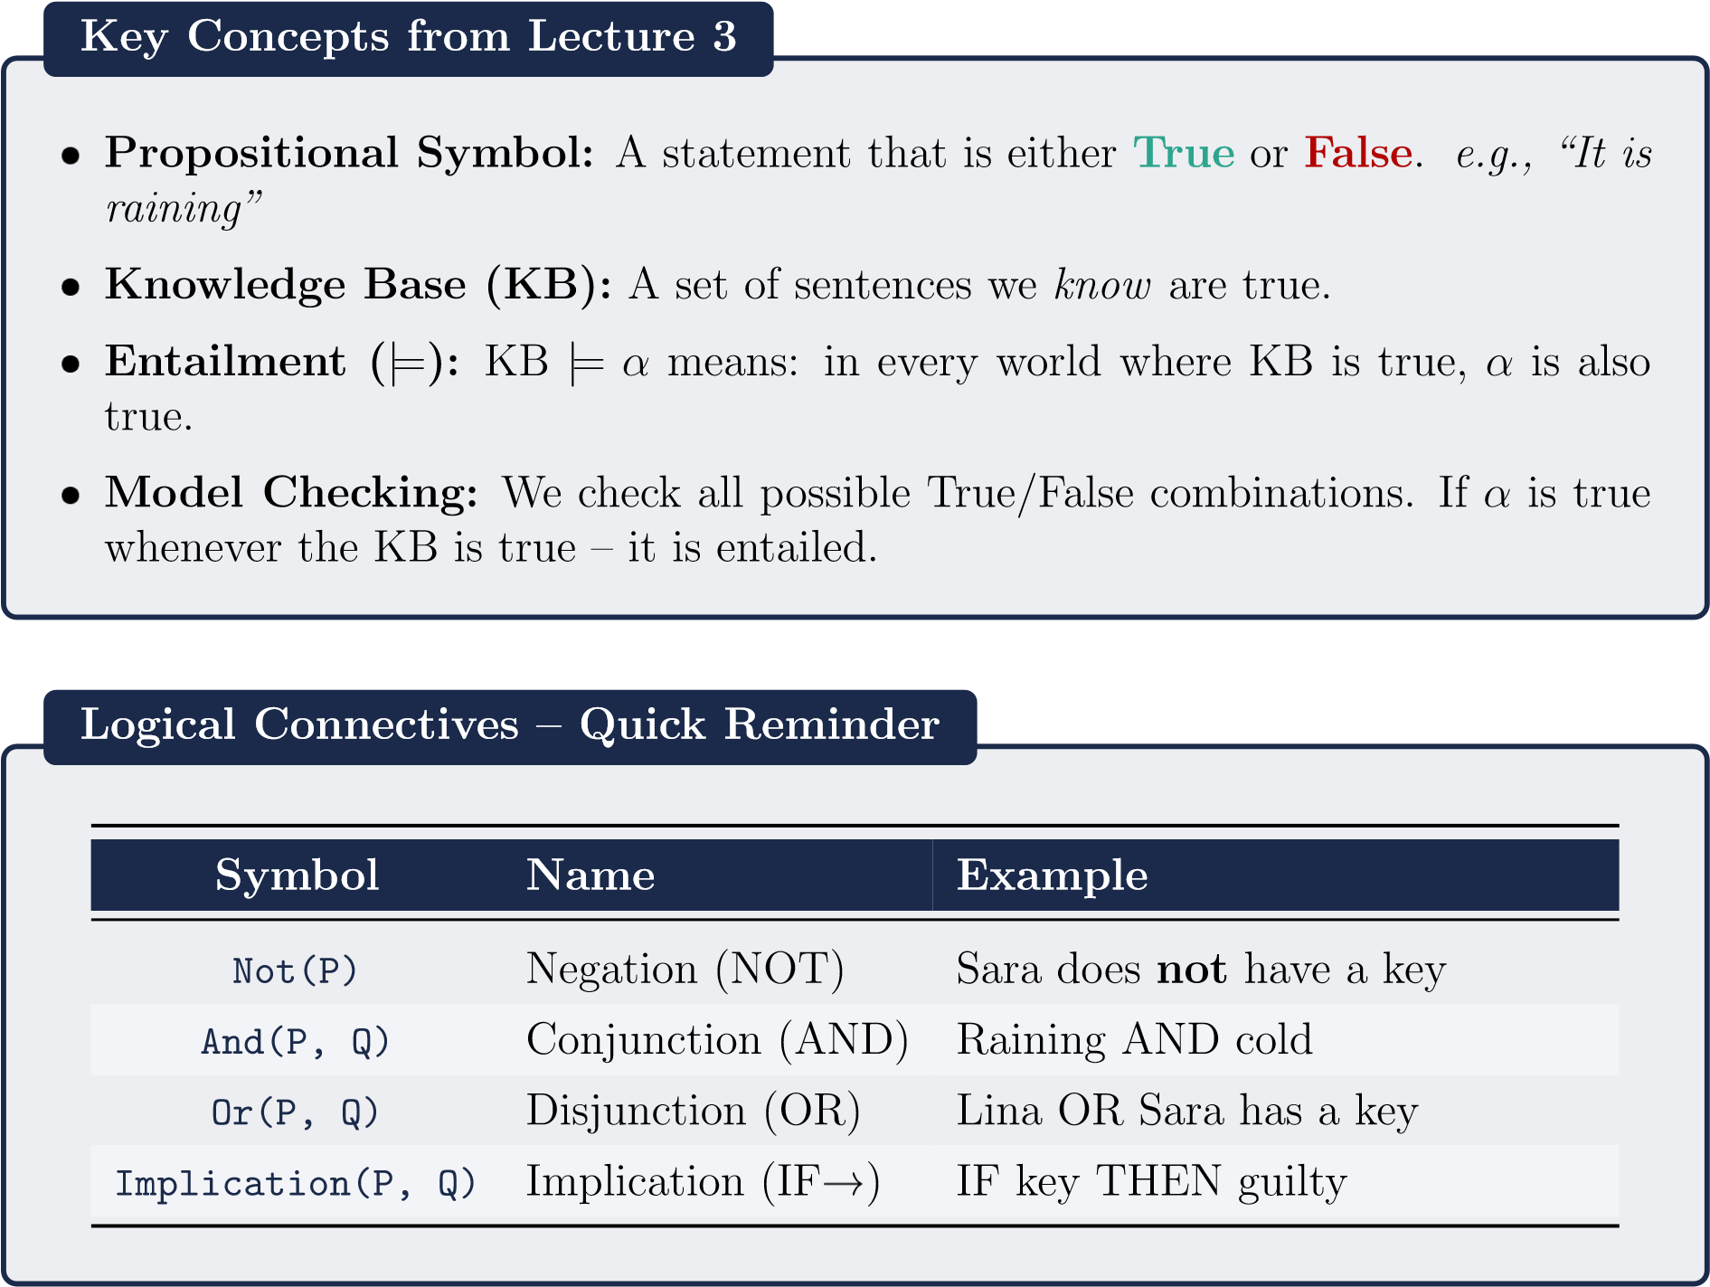

3.2. The Mystery Scenario
The Case: A valuable item went missing at Effat University.
Three suspects: Sara, Lina, Nora
The Clues (what our AI knows):
Clue 1: If Lina has a key → Lina is guilty.
Clue 2: Sara does not have a key.
Clue 3: Lina was seen near the room. (this is a known fact)
Clue 4: If Lina was seen near the room → Lina has a key.
The Question: Can our AI prove that Lina is guilty?

3.3. Step-by-Step Code Walkthrough
Open part2 knowledge.py in VS Code. Read each section carefully.
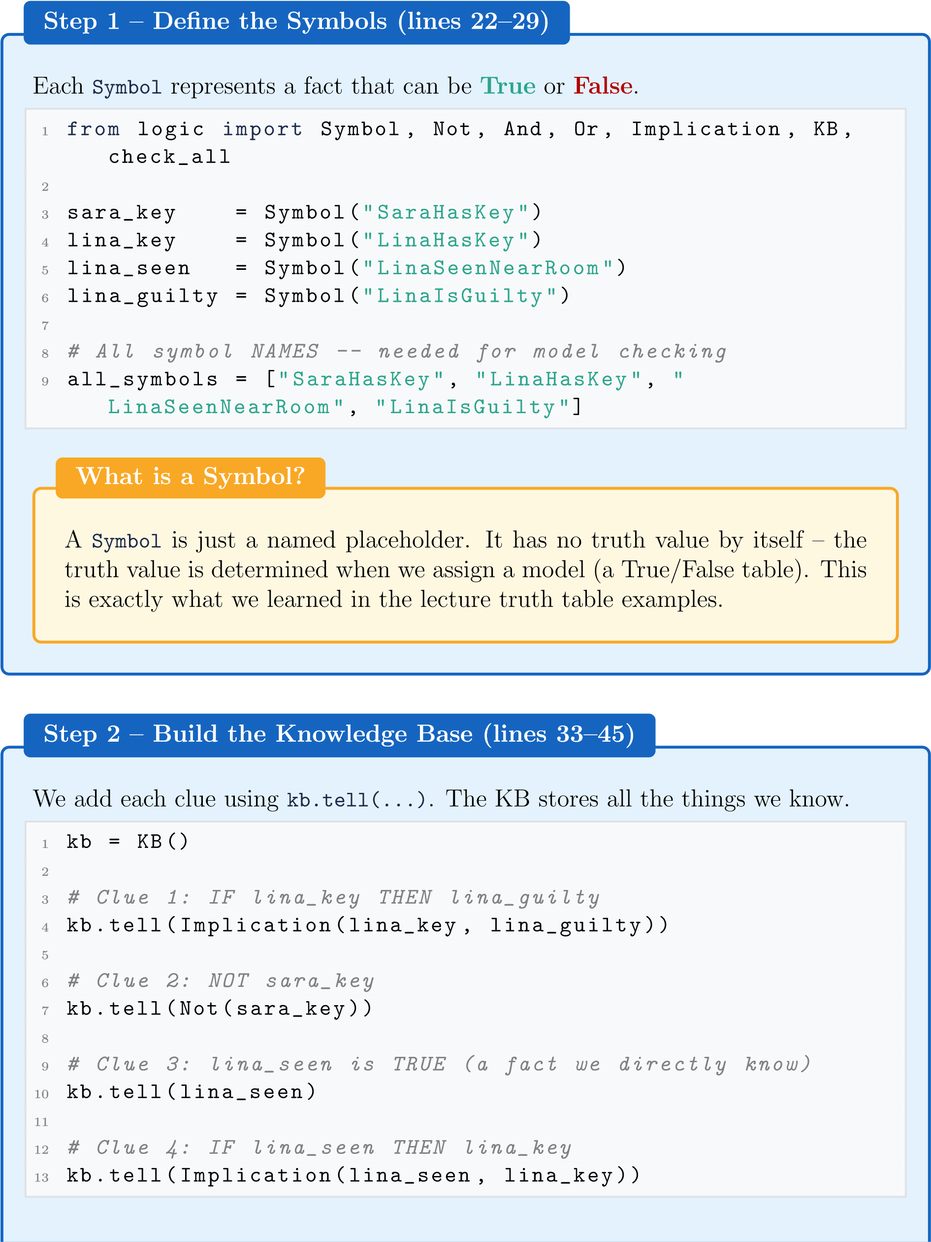
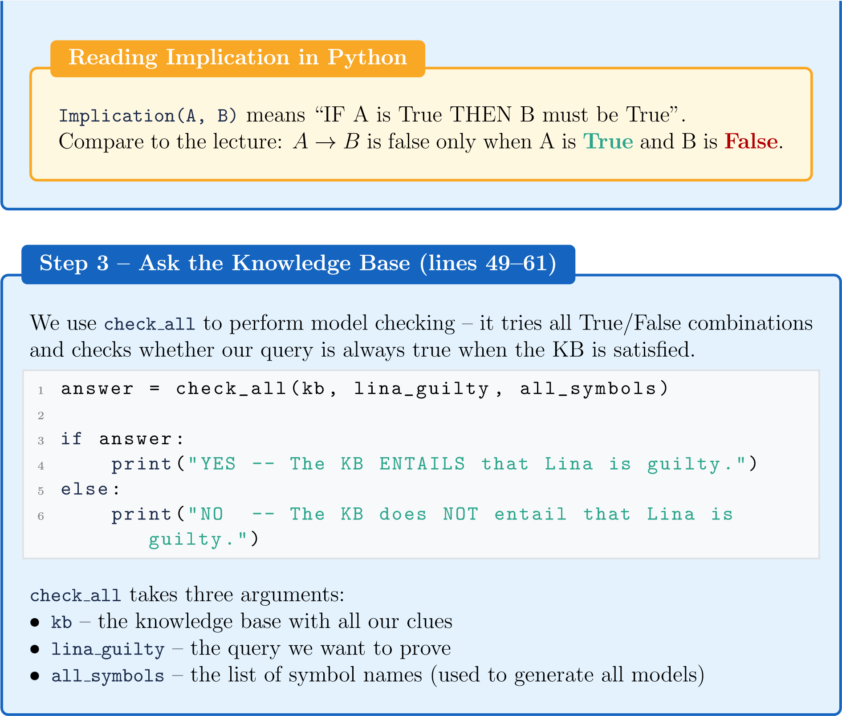

3.4. How Model Checking Works Internally
The check all function in logic.py tries all possible worlds. With 4 symbols, there are 2⁴ = 16 possible worlds (combinations of True/False).

SaraKey LinaKey LinaSeen LinaGuilty |  |  |  | KB True? | Query True?
False | False | False | False | False | (skip)
False | False | True | False | False | (skip)
··· | ··· | ··· | ··· | False | (skip)
False | True | True | True | True | True ✓

Only one model makes the KB true. In that model, LinaIsGuilty is also True. Therefore: KB |= LinaIsGuilty – the KB entails Lina is guilty.

3.5. Run the Program
In the VS Code terminal (make sure you are in the Lab3 folder):
python part2_knowledge.py
Expected output:
==================================================
CS3081 Lab 3 -- Knowledge Base Detective
==================================================
Query: Is Lina guilty?
YES -- The KB ENTAILS that Lina is guilty.
Query: Does Sara have a key?
NO -- The KB does NOT entail Sara has a key.
WhydoesSarahavingakeyreturnNO?
OurKBsays
Not(sara
key)
–meaningwe
know
Saradoes
not
haveakey.So
asking“doesSarahaveakey?”correctlyreturns
False
.TheKBprovesshedoes
nothaveone!
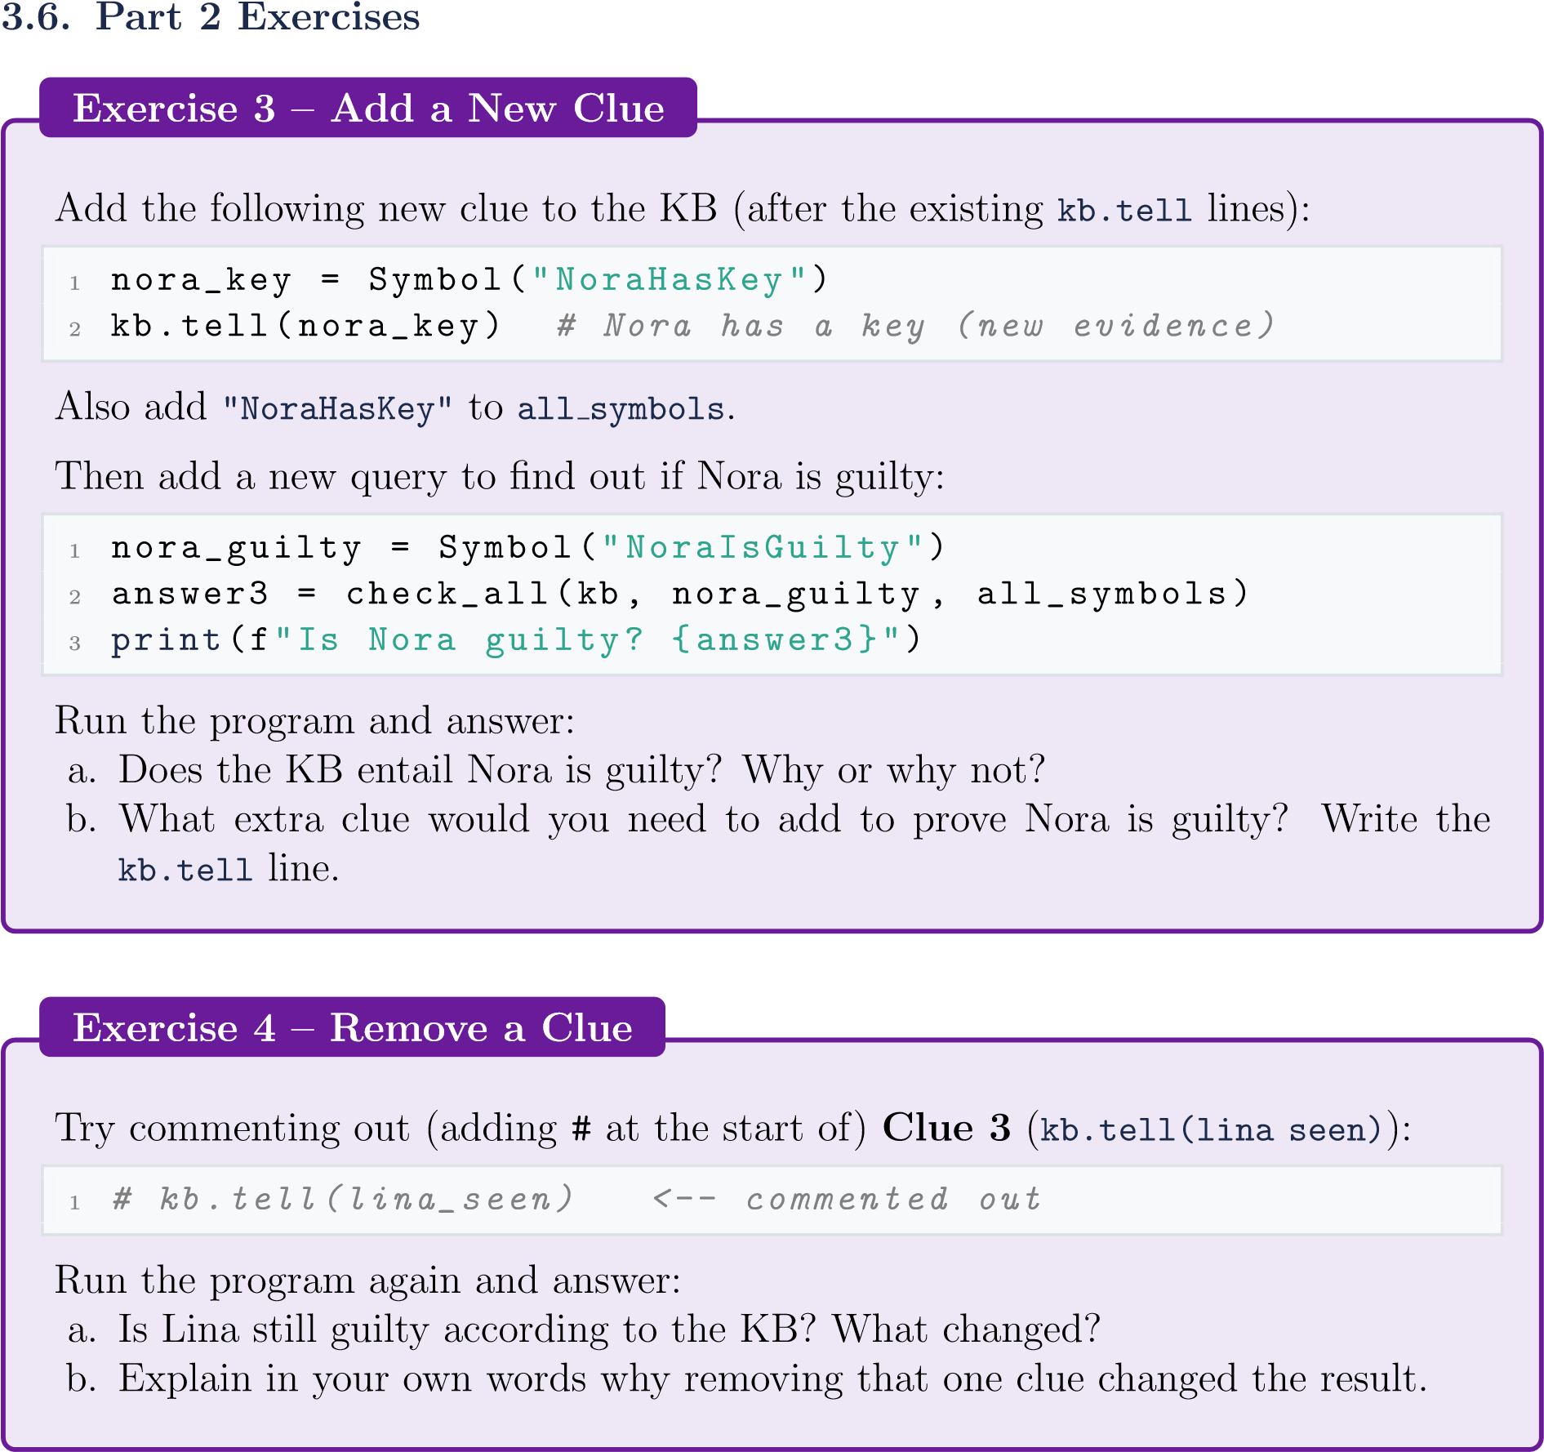
- No, there is no proof. Yes she has a key but it is never specified that if she has a key she is guilty
- kb.tell(Implication(nora_key, nora_guilty))
which basically makes a rule where if nora has key she is guilty
- No, she hasn’t been seen near the room so we don’t know if she has a a key..
- To prove that Lina is guilty, we need to know if she has a a key; to know if she has a key we need to have seen her near the room. Which isn’t a fact anymore disproving her being guilty.

4. Discussion Questions

Answer these questions in your lab report. Full sentences, please.
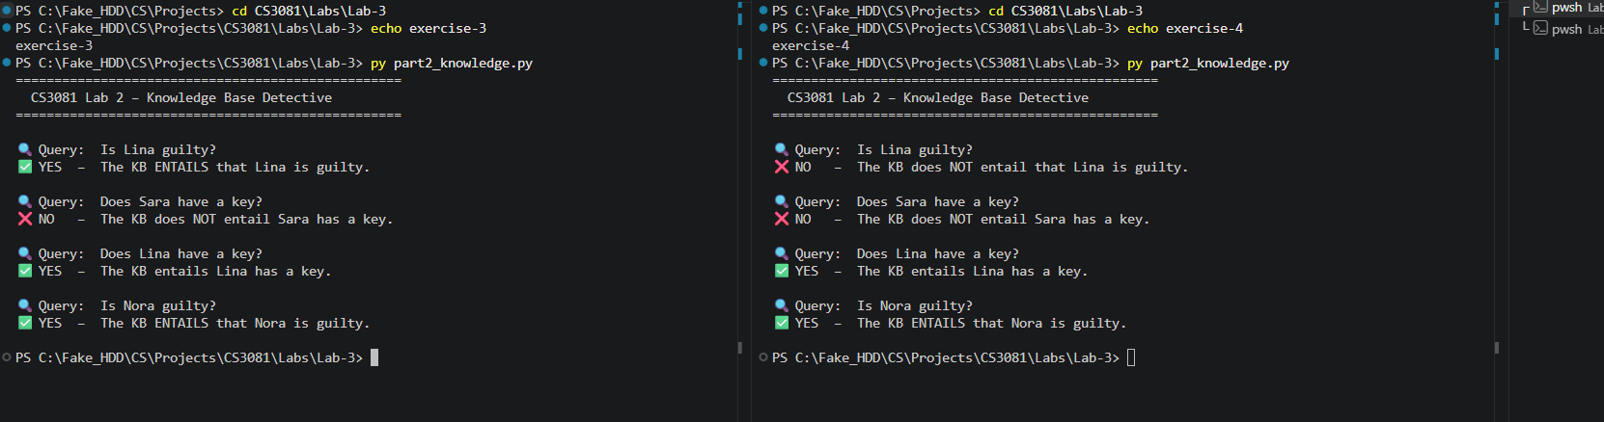
Implication shows relationship between when P is ts false or true what can Q possibly be.
Entailment shows only the worlds or states where P is true while Q is also true.
A informed search like the A* search or GBFS.
In Dammam’s case, BFS is better due to the way it searches. BFS finds the shortest path (direct path no unnecessary visits) and does that all in less hops.
BFS explores wide before going deep in a path. In this case it went from Riyadh to Madinah on the same level before going deeper into Riyadh path.
SearchQuestions
1.
InPart1,BFSvisited
Madinah
eventhoughitisnotonthepathtoDammam.
WhydoesBFSvisit“wrong”cities,andisthisaproblem?
2.
CompareBFStoDFS(fromLab1).Forfindingthe
shortest
path,whichis
betterandwhy?
3.
Imagineyouadded
roaddistances
(
e.g.,JeddahtoRiyadh=900km).BFS
doesnotconsiderdistances–itjustcountshops.Whatkindofsearchalgorithm
couldusethosedistancestofinda
cheaper
route?
KnowledgeQuestions
4.
Inyourownwords,whatisthedifferencebetween
implication
(
P
→
Q
)
and
entailment
(
KB
|
=
α
)
?
5.
InPart2,modelcheckingtriedall2
4
=16
worlds.Ifwehad10symbolsinstead
of4,howmanyworldswouldneedtobechecked?Isthispracticalforverylarge
problems?
2^10 which is 1024. This would definitely take much more time and usage.

5. What to Submit
Submit
oneZIPfile
named
Lab3
YourName
ID.zip
containing:
Item Details
part1 search.py Your modified file with Exercises 1 & 2 completed
part2 knowledge.py | Your modified file with Exercises 3 & 4 completed
Screenshots | Terminal output for both parts (all exercises)
Lab Report (PDF or Word) | Answers to all discussion questions
ScreenshotTip
OnWindows:press
Win+Shift+S
totakearegionscreenshot.
PasteitdirectlyintoyourWordreportorsaveasanimagefile.
Grading
Component
Marks
Part1–Exercise1(changegoal,observations)
15
Part1–Exercise2(addnewcity)
15
Part2–Exercise3(addnewclue)
20
Part2–Exercise4(removeaclue)
20
DiscussionQuestions(5questions)
30
Total
100

Good luck! Think like an AI.
Dr. Naila Marir
CS3081 • Artificial Intelligence • Spring 2026

