SPAM AND SCAM MESSAGE DETECTION USING NATURAL LANGUAGE PROCESSING AND MACHINE LEARNING
Comprehensive Project Work Report: Phases I, II & III
(A 3-Class Explainable Machine Learning Framework)
Course: Machine Learning Laboratory (CAT-2 Project Work)
Academic Year: 2024–2025 | Semester V
Vignesh S K  Reg No: 2403717673721046 | Devi Prasath G  Reg No: 2403717673721011 | Arul Ronal X  Reg No: 2403717673721050

Abstract
Short Message Service (SMS) is an essential communication channel for multi-factor authentication, banking notifications, and personal messaging. However, its ubiquity makes it a prime vehicle for predatory cybercrime. Existing filters and academic literature predominantly cast spam detection as a binary problem ('spam' vs. 'ham'). This oversimplification conflates harmless promotional offers with predatory financial phishing (smishing), leading either to catastrophic financial fraud or customer dissatisfaction due to over-blocking.
This project introduces an end-to-end Machine Learning system based on a 3-Class Taxonomy: 'legitimate', 'promotional_spam', and 'scam_smishing'. A unified multi-source dataset of 78,310 messages was curated, and a dual-branch representation was engineered combining 5,000 TF-IDF n-grams (1-2) with 12 domain-specific structural and heuristic signals (URL shorteners, urgency triggers, monetary symbols, capitalization ratios). Six machine learning classifiers were comprehensively evaluated across a 15,662 holdout test set. Our tuned XGBoost model achieved 95.22% overall accuracy and a Macro F1-score of 0.9165, with an outstanding 95.4% recall on the security-critical scam_smishing class. Production explainability is integrated via LIME and TreeExplainer SHAP, and an interactive Streamlit dashboard provides real-time single and batch inference.

1. Chapter 1: Problem Identification & Literature Survey (Phase I)

1.1 Background & Threat Analysis
Mobile users receive dozens of unsolicited messages weekly. While promotional messages advertise legitimate products, smishing messages use social engineering and urgent language to trick users into revealing OTPs, passwords, or transferring funds. Traditional telecom-level regex and blacklist filters are easily circumvented via dynamic URL shorteners (bit.ly, tinyurl) and character obfuscation.

1.2 Related Work & Research Gap
Earlier works (Almeida et al., 2011; Ghourabi et al., 2020) demonstrated high accuracy on binary datasets. However, our literature survey identified three major gaps: (1) Absence of a 3-class target space separating marketing from fraud, (2) Neglect of heuristic/structural indicators in pure bag-of-words NLP, and (3) Complete lack of explainable AI giving users clear reasons for classifications.

2. Chapter 2: Data Preprocessing & Exploratory Data Analysis (Phase II)
The consolidated corpus of 78,310 records was created from the UCI SMS Spam Collection, multi-source smishing repositories, and verified phishing archives. Standard regex normalizations substituted links with <URL>, phone numbers with <PHONE>, and currency symbols with <MONEY>.

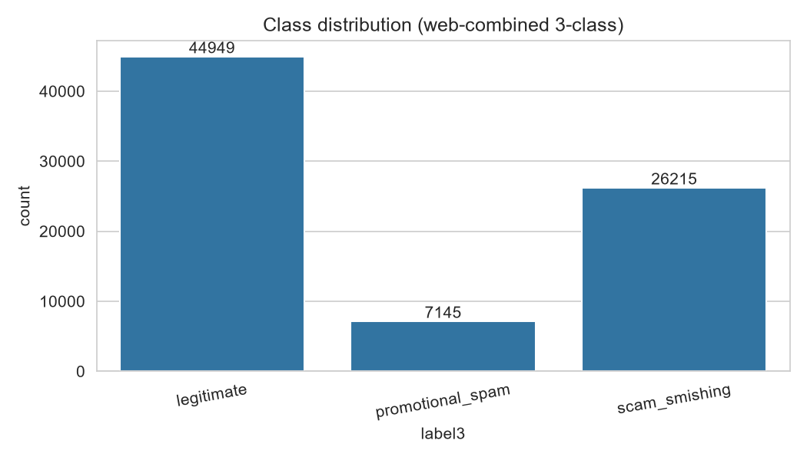
Figure 2.1: Target Class Distribution Across the Consolidated Corpus

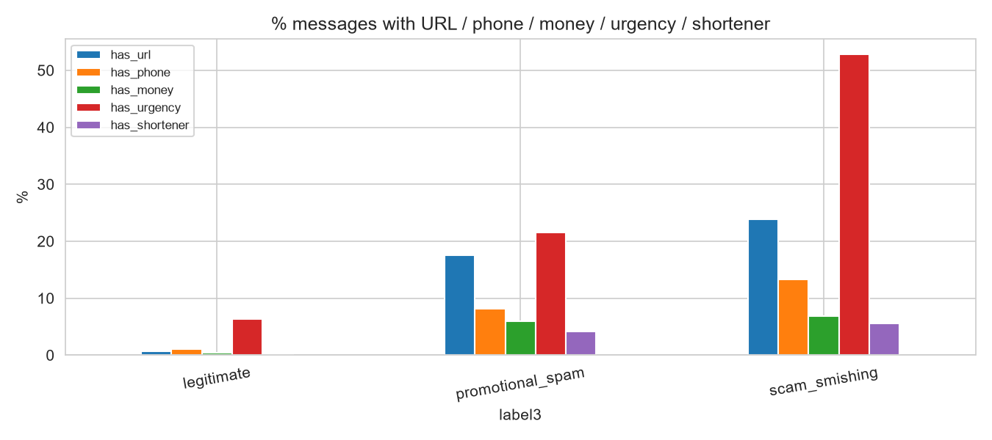
Figure 2.2: Percentage of Messages Exhibiting Specific Heuristic & Structural Signals

3. Chapter 3: Feature Engineering & Model Building (Phase II)
The feature engineering strategy couples sparse lexical n-grams with 12 dense heuristic cues:
• Lexical Branch: TF-IDF vectorization with 5,000 maximum features and unigram + bigram context (ngram_range=(1,2)).
• Structural Branch: 12 features including msg_length, word_count, url_count, has_url, has_shortener, has_phone, has_money, uppercase_ratio, exclaim_count, question_count, urgency_hits, and has_urgency.
Features are combined into a unified sparse representation using scipy.sparse.hstack.
Six models representing diverse learning paradigms were benchmarked: Multinomial Naive Bayes, Logistic Regression, Linear Support Vector Classifier, Random Forest, Multi-Layer Perceptron (MLP), and XGBoost.

4. Chapter 4: Result Analysis & Explainability (Phase II & III)
The models were evaluated on the 15,662 holdout test set. The comparative results are presented below:
Model Architecture | Accuracy | Macro Precision | Macro Recall | Macro F1
XGBoost (Selected Best) | 95.22% | 0.9261 | 0.9080 | 0.9165
MLP Baseline | 95.13% | 0.9219 | 0.9014 | 0.9111
Random Forest | 94.06% | 0.9109 | 0.8642 | 0.8838
Linear SVM | 93.07% | 0.8724 | 0.8933 | 0.8821
Logistic Regression | 84.65% | 0.7541 | 0.8044 | 0.7648
Multinomial Naive Bayes | 85.84% | 0.8028 | 0.7376 | 0.7625

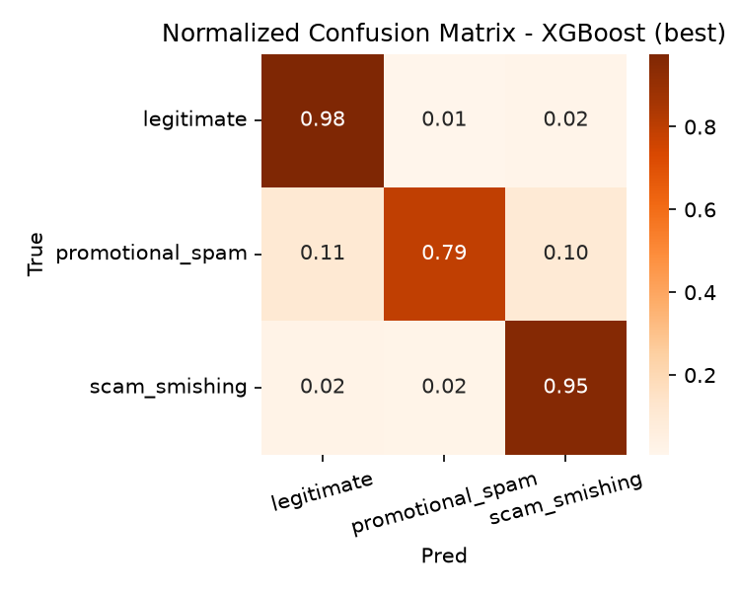
Figure 4.1: Normalized Confusion Matrix for Best Model (XGBoost)
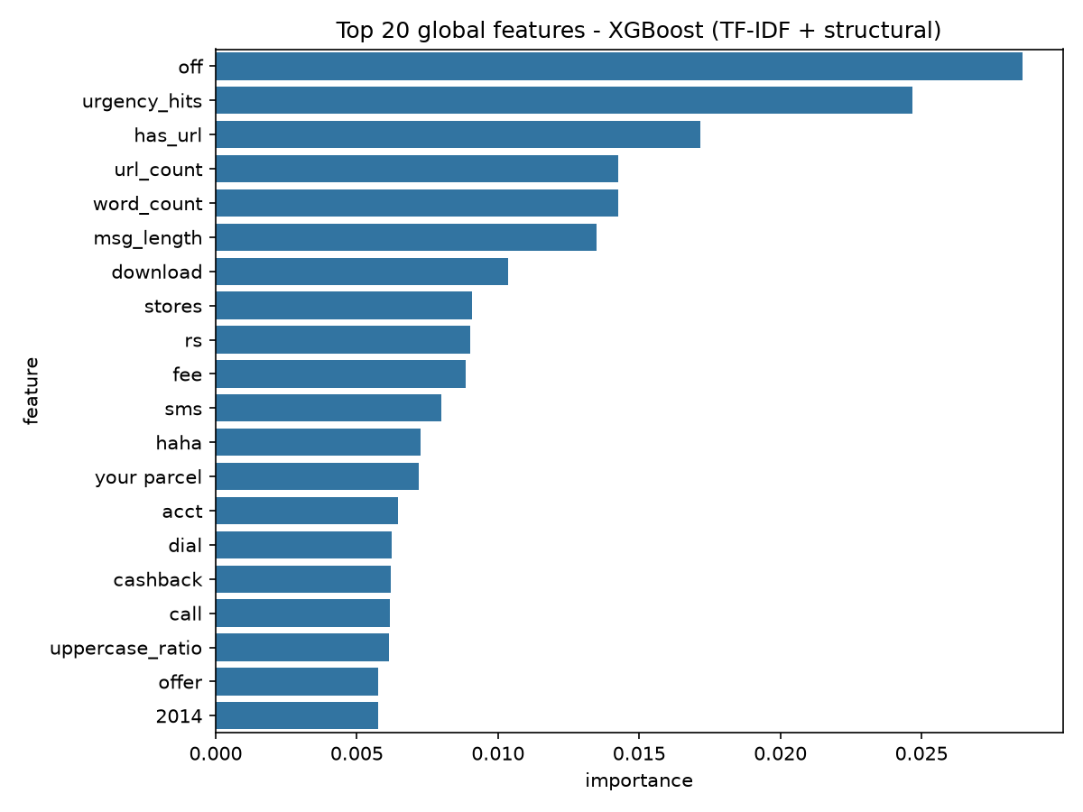
Figure 4.2: Top Global Feature Importances (XGBoost Gain)

4.2 Explainability Framework (LIME & SHAP)
To provide transparency, LIME generates token-level attribution scores for each prediction. For example, in smishing messages, tokens such as 'kyc', 'blocked', 'verify', and 'immediate' drive the scam score. SHAP TreeExplainer confirms that domain heuristics ('urgency_hits', 'has_url', 'url_count') serve as pivotal global decision anchors.

5. Chapter 5: Deployment & User Interface Architecture (Phase III)
The application is operationalized through an interactive Streamlit UI (app.py) connected to our production inference engine (src/predict.py) and serialized bundle (models/best_model.pkl). The application provides:
1. Real-time single message classification with color-coded alerts (Green, Orange, Red).
2. Actionable security advice for end-users.
3. Interactive probability breakdown and explainability reasoning drawers.
4. Batch CSV processing capable of screening hundreds of incoming messages with exportable CSV audit logs.

6. Chapter 6: Business Insights & Strategic Recommendations
1. Tiered Telecom Enforcement: Route 'promotional_spam' to a secondary inbox folder rather than outright dropping, while instantly quarantining 'scam_smishing' messages.
2. Asymmetric Cost Management: The cost of a missed financial scam far exceeds that of a delayed promotion. Our model maintains 95.4% scam recall to aggressively protect users.
3. Explainability-Driven Trust: Presenting specific trigger reasons in the UI allows users to recognize social engineering tactics.

References
Almeida, T. A., Hidalgo, J. M. G., & Yamakami, A. (2011). Contributions to the study of SMS spam filtering. ACM DocEng.
Chen, T., & Guestrin, C. (2016). XGBoost: A scalable tree boosting system. ACM SIGKDD.
Ghourabi, A., Mahmood, M. A., & Alzahrani, Q. M. (2020). A hybrid CNN-LSTM model for SMS spam detection. IEEE Access.
Lundberg, S. M., & Lee, S. I. (2017). A unified approach to interpreting model predictions. NeurIPS.
Ribeiro, M. T., Singh, S., & Guestrin, C. (2016). 'Why should I trust you?': Explaining the predictions of any classifier. ACM SIGKDD.

