**PRINCIPLES OF DATA SCIENCE**

**ASSIGNMENT 3**

*presented by*

**SWARNA KUMAR VUSA**

**14426869**

*Under the Guidance of*

**Syed Jawad Hussain Shah, PhD**

*At*

**

**Observations:**

1. From these charts it is observed that the population's Mean Glucose and Max Glucose are slightly greater than the sample taken.

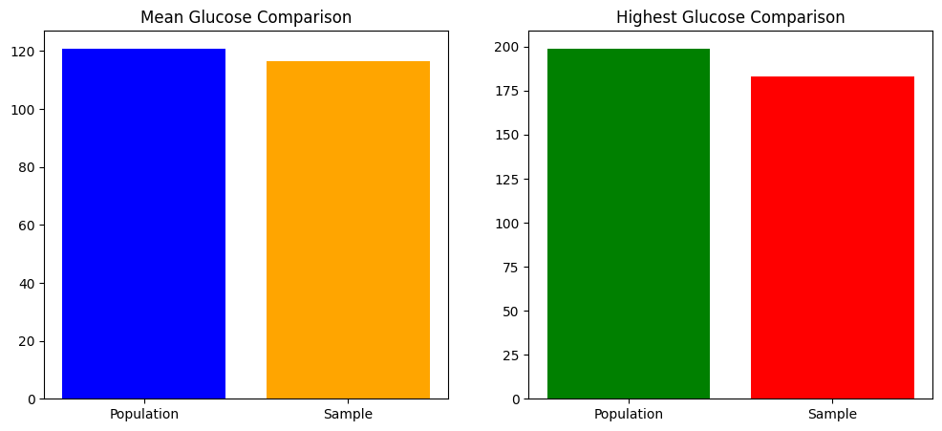

1. From these charts it is observed that the population’s 98th percentile is greater than the sample’s 98th percentile.

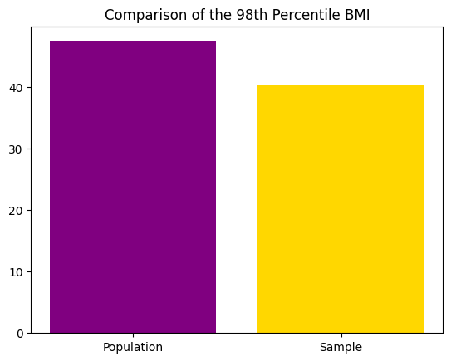

1. From these charts we have taken bootstrap samples instead of samples and it is observed that the statistics of bootstrap samples to the population are slightly different. Hence bootstrapping provides insights into the variability of the statistic across multiple simulated samples that the traditional sampling.

