Objective
Salesforce is retiring its Connected App framework for external integrations and requires migration to External Client Apps (ECA). This is a Salesforce platform change, not a SailPoint product update. SailPoint has updated the ISC Salesforce connector to comply and published the ECA package on AgentExchange. You must complete migration by September 30, 2026, to maintain connectivity.
This document describes the steps to migrate the SailPoint Salesforce integration from the legacy Connected App authentication to the new External Client App (ECA) authentication.
Prerequisites
Before starting the authentication process, ensure the following are completed in Salesforce:
- Install the SailPoint External Client App package from AppExchange in Salesforce.
- Enable the External Client App (ECA) feature in Salesforce.
- Ensure the Service Account has required permissions.
- Confirm the ECA feature is enabled in the Salesforce org.
Salesforce Configuration Steps
Step 1 – Install External Client App
Install the Salesforce External Client App package (SailPoint Identity Security for Salesforce) from AppExchange.
After installation, verify the package is available under: Setup → Installed Packages
Step 2 - Enable External Client App
Navigate to:
Setup → External Client App Manager
Enable the SailPoint External Client App feature for the Salesforce org.
Step 3 - Ensure Service Account Permission
Navigate to:
Setup → Users → Service Account
Username: User IdentityNow (identitynowuser@nationallife.com)
Profile: Identity Now read Only
Permission set: No permission set is assigned to this Service account.
UI Access Restriction: The profile (Identity Now read Only) has both API Enabled and API Only User permissions enabled. As a result, the integration account is restricted to API-based access and cannot log in to the Salesforce user interface.
IP Restriction: Below are the Login IP Ranges added to this Service account (identitynowuser@nationallife.com).
160.109.97.160 | 160.109.97.167 | PTC On Prem
160.109.125.1 | 160.109.125.254 | PTC On Prem
204.115.121.1 | 204.115.121.254 | Montpelier On Prem

Note: Ensure this account has all permissions required by the SailPoint integration.

SailPoint Configuration
Authentication Flow: The SailPoint External Client App authenticates using the OAuth 2.0 Authorization Code Grant (Web Server Flow).
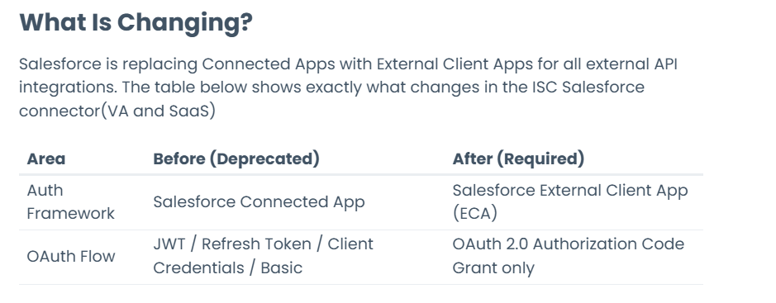
Note: SailPoint External Client App only supports OAuth 2.0 Authorization Code Grant Type.
The SailPoint team must complete the following configuration.
Step 1 - Enable ECA Toggle
Navigate to the Salesforce Source configuration in SailPoint.
Enable: Enable External Client App (ECA) toggle in SailPoint.
Step 2 - Enter Salesforce Details
Provide the following values:
Key | host_name
Value | https://login.salesforce.com (Production)  https://test.salesforce.com (Sandbox)
Step 3 - Add the parameter by clicking Add button
Step 4 - Click Authorize
User is redirected to the Salesforce login page.
Login using the User IdentityNow Service Account credentials.
- Username
- Password
Step 5 - Consent Screen
Review the requested permission and click: Allow
This grants SailPoint access to the Salesforce org.
After successful login, Salesforce displays the authorization screen.
Step 6 - Authentication Complete
After clicking Allow, Salesforce redirects back to SailPoint
Authentication completes and OAuth access/refresh tokens are issued.
The External Client App is now successfully authorized.

Validation
Validate the following after authentication:
- Check the login the history of the Service account for any IP restrictions.
- Authentication completes successfully.
- SailPoint can connect to Salesforce.
- Account aggregation works successfully.
- Provisioning (if configured) functions correctly.
- No authentication or permission errors are observed.
Troubleshooting Checklist
If authentication fails, verify:
- External Client App package is installed.
- ECA feature is enabled.
- OAuth Setting is enabled in ECA.
- Service Account is active.
- Service Account has required permissions.
- Login URL is correct.
- Host Name is correct.
- No Login IP restrictions block authentication.
- SailPoint ECA toggle is enabled.
- User clicked Allow on the Salesforce consent screen.

