In our definition of housing precarity, it comprises of 3 dimensions: 1) unaffordability, 2) insecurity, and 3) low housing quality. According to the EU-SILC 2023 data, the highest precarity in the 8 core countries was recorded in Romania with almost 50 % of households having deficiencies in at least one of the three dimensions. In contrast, the country with the lowest housing precarity was Belgium with less than a third of households having problems in at least one dimension.

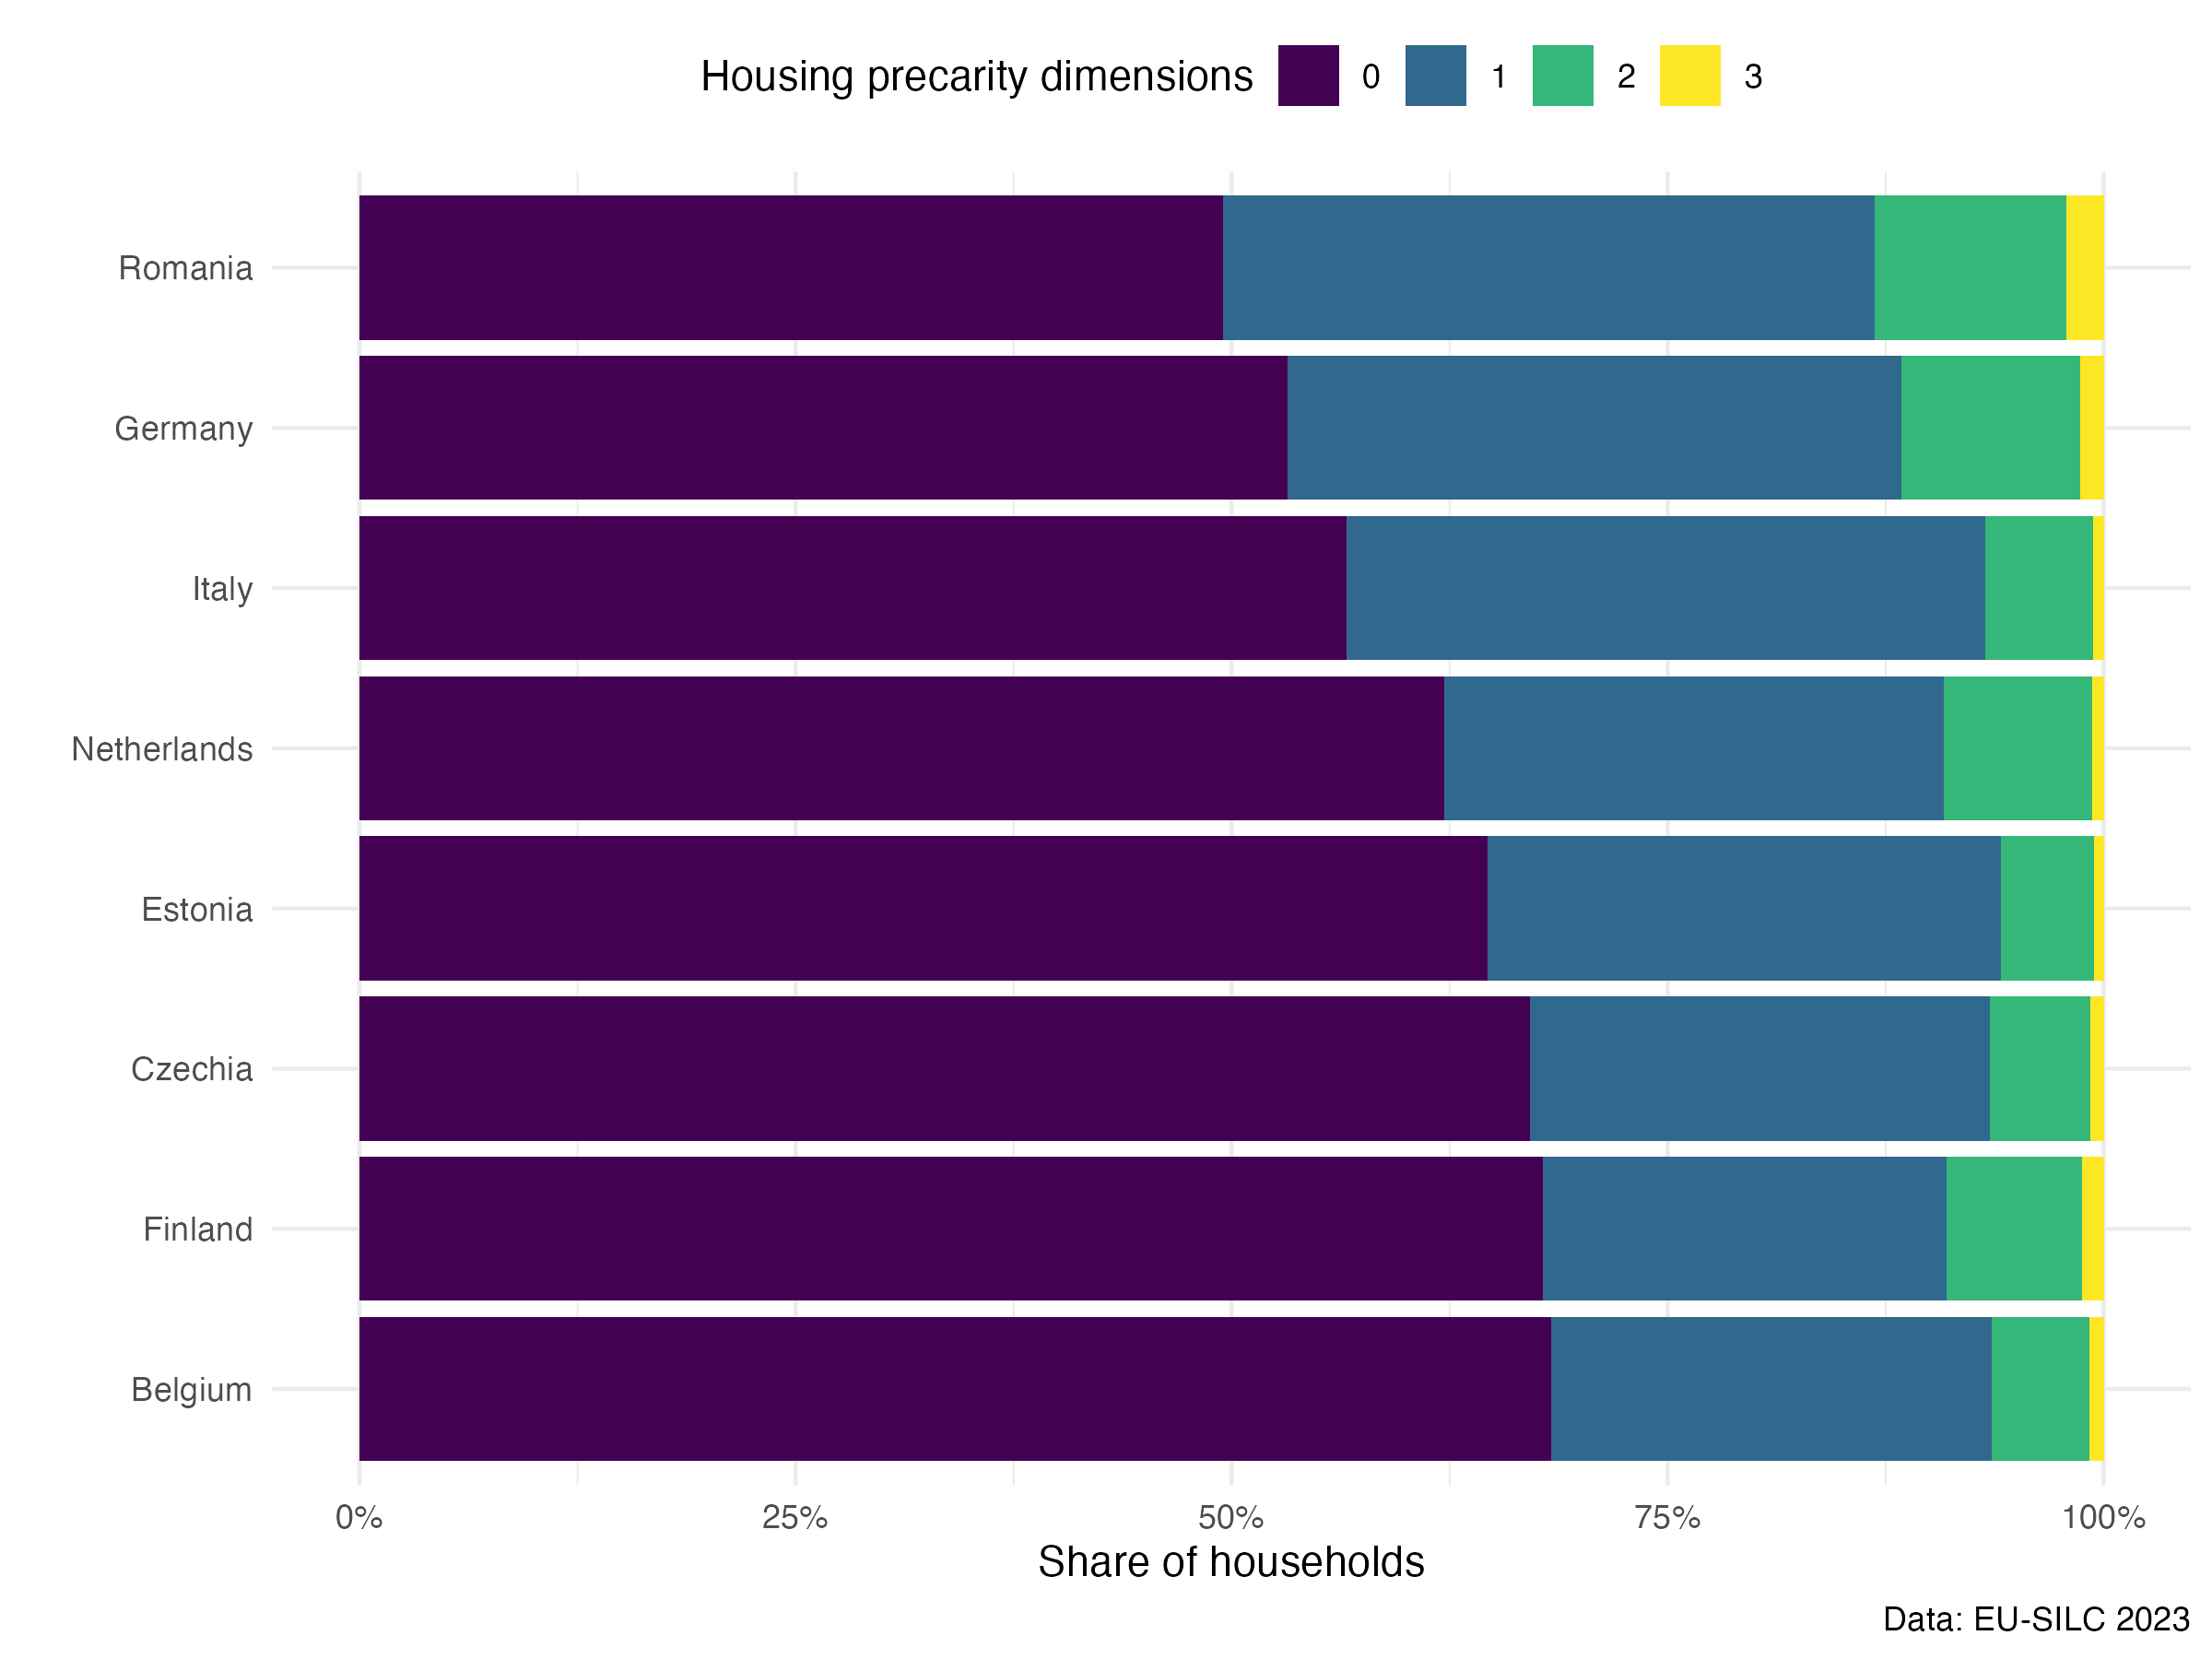

**Figure 1: Housing precarity**

As the Figure 1 shows, the overall levels of housing precarity in multiple of the core countries do not differ substantially (e.g. Czechia, Finland and Belgium have almost the same share of households without problems in any of the dimensions). However, when we look at particular dimensions of housing precarity, we see larger variance.

For instance, in the case of housing affordability measured by housing overburden, the Netherlands have highest share of households that spends over 40% of disposable income on housing costs (21% households) which explains most of its housing precarity (38% households with problems in at least one dimension).

**Figure 2: Housing affordability**

Concerning housing affordability, it should be noted that recent events such as the COVID-19 pandemics and the full-scale invasion of Russia to Ukraine and the following energy crisis has affected the levels of housing affordability as shows Figure 3 (below). In all of the core countries except for Italy, the share of households overburdened by housing costs increased after 2020. In East European countries, these events reversed the trajectory of decreasing share of households affected by housing overburden.

**Figure 3: Housing affordability in time**

The second dimension of housing precarity is housing security, measured by the existence of arrears on utilities and mortgage/rent payments. Here, the core country with the highest share of households having problems in this dimension is Romania (14%), while the country with the lowest share is the Netherlands (2.5%). Disaggregating into the indicators, the high position of Romania is driven by a high share of households having arrears on utilities (see Figure 5).

**Figure 4: Housing insecurity**

**Figure 5: Housing insecurity indicators**

Finally, the last dimension is housing quality measured by three indicators: 1) overcrowding, 2) leaks/damp, and 3) inability to keep dwelling warm. Here, Romania tops the list of core countries, followed by Italy and Germany.

**Figure 6: Housing quality**

**Figure 7: Housing quality indicators**