You must have ENOVIA Collaboration for Microsoft Client (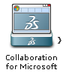from north quadrant of the Compass) installed to open the content.

Loading content…