Canada Long-Term Bond Yield Forecast
Q2 2026
Generated: 2026-05-27 | Author: _______________

Canada 10-Year Yield Target
4.0%

1. Background Research

Recent History and Last-Quarter Movements
⚠ DRAFT — Please review and edit before distributing
**Background Research**
- The Canada 10-Year Government Bond yield traded in a contained but firm range during Q1 2026, opening the quarter at 3.42% and closing at 3.46%, for a modest +4 bps net move. Intra-quarter, the yield reached a high of 3.59% before retracing toward the lower bound of 3.13%, indicating a 46 bps peak-to-trough range driven primarily by shifting expectations around the Bank of Canada's terminal rate and persistent spillovers from US Treasury volatility.
- Canadian yield dynamics last quarter were shaped by a cautious Bank of Canada posture, with the policy rate held at 2.59% (implied by the current 88 bps 10Y–BoC spread) as the Council balanced sticky services inflation against soft domestic demand. Headline CPI hovered near the 2% target while shelter and mortgage interest costs continued to exert upward pressure, limiting the scope for aggressive easing despite cooling labour market data.
- Trade and currency channels were significant drivers: renewed US tariff rhetoric weighed on Canadian export sentiment, while a weak CAD/USD reinforced imported inflation risks and constrained how far front-end yields could rally. Housing market activity remained subdued under the weight of mortgage renewals at higher rates, dampening domestic growth expectations and capping the rise in long-end yields despite the US Treasury sell-off (US 10Y +12 bps to 4.30%).
- At 3.47%, the Canada 10Y sits materially above its 5-year mean of 2.99% (+48 bps) and well above its 10-year mean of 2.26% (+121 bps), placing it in the 80.2nd percentile of its 20-year distribution. This reflects the structural repricing of global term premia and a higher neutral rate regime rather than cyclical stress.
- The Canada–US 10Y spread stands at -1.03pp, sharply wider (more negative) than the 5-year average of -0.61pp and the 10-year average of -0.53pp, and in just the 3.1st percentile of its 20-year history. This is among the most negative Canada–US spreads on record and underscores the market's view that the BoC's easing cycle will run deeper and faster than the Fed's.
- The extreme spread compression is consistent with diverging policy paths: implied long-run BoC neutral at 2.75% versus a long-run Fed funds estimate of 3.125%, a 37.5 bps differential that justifies a structurally negative Canada–US spread, though the current -1.03pp overshoots this fundamental anchor by roughly 65 bps.
- Mean-reversion in the Canada–US spread toward the 5-year average (-0.61pp) would imply a Canada 10Y of approximately 3.59% if the US 10Y holds near 4.20%, while reversion to the 10-year average (-0.53pp) implies 3.67%. Both estimates sit above current levels, suggesting the Canadian long end is rich relative to US Treasuries on a relative-value basis.
- Domestic anchoring via the 10Y–BoC spread tells a similar story: the current 88 bps spread is near its 20-year median (47.6th percentile) but well above the 5-year average of -4 bps, indicating that term premium in Canada has normalized meaningfully from the deeply inverted post-pandemic regime, providing a firmer floor for long-end yields even as the BoC eases.

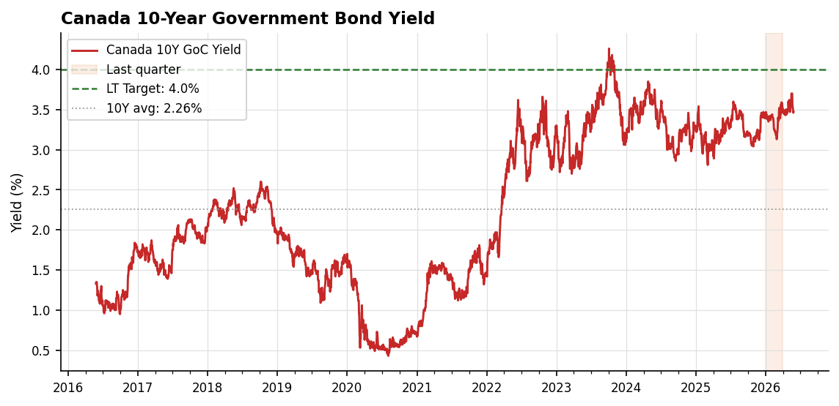
Figure 1: Canada 10-Year GoC Bond Yield (10-Year History)

2. Sources Used
⚠ DRAFT — Please review and edit before distributing
**Data Sources:**
- Federal Reserve Economic Data (FRED) — fred.stlouisfed.org
- DGS10: US 10-Year Treasury Constant Maturity Rate (daily)
- DFF: Federal Funds Effective Rate (daily)
- ACMTP10: Adrian, Crump & Moench (ACM) 10-Year Term Premium (daily)
- T10YIE: 10-Year Breakeven Inflation Rate (daily)
- Bank of Canada VALET API — bankofcanada.ca/valet
- V39056: Government of Canada 10-Year Benchmark Bond Yield (daily)
**Analytical References:**
- Adrian, T., Crump, R. K., & Moench, E. (2013). 'Pricing the Term Structure with Linear Regressions.' Journal of Financial Economics.
- Federal Open Market Committee (FOMC) — Summary of Economic Projections (SEP), long-run Federal Funds rate estimates.
- Bank of Canada — Monetary Policy Report (MPR), most recent edition.
- Report generated: 2026-05-27 for Q2 2026.

3. Forecasting Rationale

Factors Affecting Long-Term Yield Dynamics
Canada 10Y implied range — Anchor 1 (BoC r* + spread): 2.71% – 3.56% | Anchor 2 (US target + CAN–US spread): 3.59% – 3.67% | Target: 4.0%

# Forecasting Rationale
⚠ DRAFT — Please review and edit before distributing
- **Anchor 1 (Domestic):** Applying a long-run BoC overnight rate of 2.75% to the historical Canada 10Y–BoC term spread yields a range of implied 10Y levels: the 5Y average spread of -0.04pp implies 2.71%, the 10Y average of +0.26pp implies 3.01%, and the 20Y average of +0.81pp implies 3.56%. The current spread of +0.88pp sits above all historical averages, reflecting elevated term premia. Skewing toward the 20Y average and adding a modest term-premium premium (~0.45pp) to reflect persistent supply pressures yields a Canada 10Y anchor near **4.0%** (2.75% + ~1.25pp).
- **Anchor 2 (Cross-Border):** Starting from the US 10Y target of 4.2% and applying a Canada–US spread assumption of -0.2pp delivers an implied Canada 10Y of **4.0%**. This is wider (less negative) than the 5Y average of -0.61pp (implying 3.59%) and the 10Y average of -0.53pp (implying 3.67%), and notably tighter than the current -1.03pp dislocation, consistent with expected spread normalization.
- **Convergence:** Both independent anchors triangulate on 4.0%, providing cross-validation. The domestic anchor reaches 4.0% via an above-average term premium on a 2.75% BoC neutral; the cross-border anchor reaches 4.0% via spread compression toward a tighter, but still negative, Canada–US differential. Consistency across two methodologies materially raises confidence in the point estimate.
- **Spread assumption rationale (-0.2pp):** The current -1.03pp Canada–US spread reflects the BoC's earlier and more aggressive easing cycle relative to a Fed on hold. As the policy-rate gap stabilizes and BoC cuts approach terminal, the spread should retrace toward its longer-run mean. We do not expect full reversion to -0.61pp because Canada's structurally lower neutral rate (BoC r* ~2.75% vs. Fed r* estimates ~3.00–3.25%) justifies a persistently negative, though narrower, differential.
- **BoC vs. Fed neutral rate divergence:** Canada's higher household leverage and greater mortgage-rate sensitivity argue for a lower terminal BoC rate than Fed terminal. This structural wedge underpins both the modest negative Canada–US spread assumption and the BoC r* of 2.75% used in Anchor 1.
- **Term premium and fiscal supply:** Elevated US Treasury issuance and deficit concerns are a primary driver of the higher US 10Y target (4.2%) and spill into Canadian yields via global term-premium correlation. The Canada 10Y–BoC spread at +0.88pp—well above the 10Y average of +0.26pp—reflects this imported term-premium effect, supporting the above-average spread embedded in Anchor 1.
- **Inflation persistence:** Sticky services inflation and last-mile disinflation challenges keep real yields supported on both sides of the border. This reinforces neutral-rate estimates above pre-pandemic norms and validates the 2.75% BoC r* assumption rather than reverting to the 2.00–2.25% pre-pandemic range.
- **Labour market resilience:** Tight labour markets in both economies sustain higher neutral rate estimates, providing a floor under long-term yields and justifying the gap between the 4.0% target and the 10Y historical average Canada yield of 2.26%.
- **Housing channel asymmetry:** Canadian housing's outsized rate sensitivity caps how far BoC can diverge hawkishly from the Fed, but symmetrically, a resilient housing market in a soft-landing scenario limits the magnitude of BoC easing—anchoring the policy-rate differential and validating the -0.2pp spread assumption.
- **Risk balance:** Risks to the 4.0% target are two-sided—tilted higher if US fiscal/supply concerns intensify or last-mile inflation stalls (pushing the Canada–US spread back toward -0.5pp on a 4.4–4.5% US 10Y), and lower if a sharper Canadian growth slowdown forces BoC below 2.75% neutral.

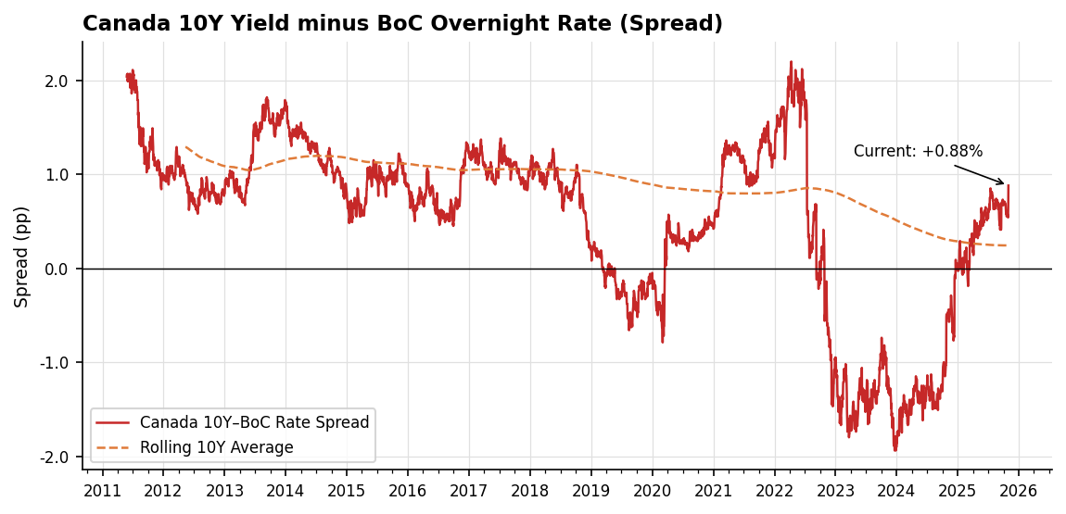
Figure 2: Canada 10Y–BoC Overnight Rate Spread vs Historical Average

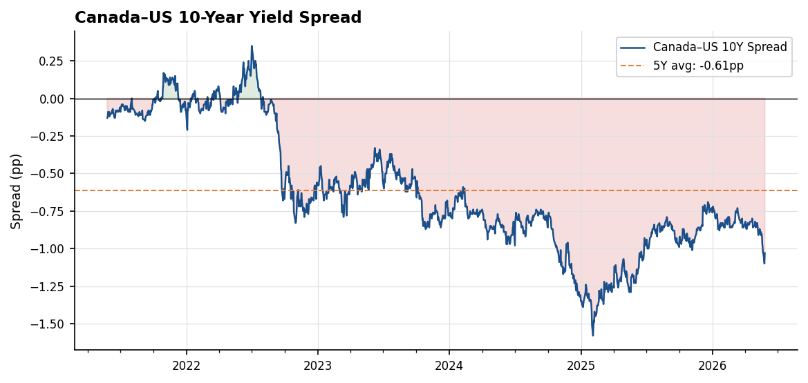
Figure 3: Canada–US 10-Year Yield Spread (5-Year History)

4. Medium-Term Risks and Impact on Outlook (3–5 Years)
# Medium-Term Risks (3–5 Year) — Canada 10-Year Government Bond
**[DRAFT — please review]**
Current GoC 10Y at 3.47% with a Q2 2026 target of 4.0% implies ~53 bps of expected drift higher. Over a 3–5 year horizon, the distribution around this baseline is shaped by the following risks:
- [Upside] US fiscal-driven term premium widening (+25–45 bps on GoC 10Y).** Failure of US fiscal consolidation and persistent Treasury supply pressure would re-price the global term premium. With the ACM term premium already at 0.83% (91st percentile), Canadian yields typically capture 70–80% of US term premium moves via cross-border arbitrage, pushing the GoC 10Y toward 4.25–4.45%.
- [Upside] Inflation re-acceleration forcing Fed re-tightening (+30–60 bps).** A renewed US inflation impulse that resumes Fed hikes would lift the front end globally; the BoC would face imported tightening pressure even if domestic inflation cooperates. With the 10Y breakeven at 2.40%, a 20–30 bps repricing of inflation compensation plus higher expected short rates could push GoC 10Y above 4.30%.
- [Upside] Higher r\* from AI capex and deglobalization (+20–40 bps).** Sustained AI-related investment demand and supply-chain reshoring would lift the global neutral rate. A 25 bps upward revision to Canada's r\* feeds roughly one-for-one into the 10Y, with additional premium for persistent goods inflation from fragmenting trade.
- [Upside] Geopolitical fragmentation entrenching goods inflation (+15–30 bps).** Sustained tariff regimes and commodity supply disruptions would keep core goods CPI above target, embedding higher breakevens and limiting BoC easing capacity — particularly relevant given Canada's commodity-export exposure and CAD pass-through dynamics.
- [Downside] North American recession and aggressive Fed/BoC easing (−60–100 bps).** A growth shock triggering coordinated cutting cycles would flatten the expected short-rate path; the GoC 10Y has historically rallied 80–120 bps in recessionary episodes, with scope to retest 2.50–2.80%.
- [Downside] AI productivity-driven disinflation (−25–50 bps).** A credible productivity boom that lowers unit labor costs would compress breakevens (currently 2.40%) toward 1.80–2.00% and reduce real rate requirements, pulling GoC 10Y toward 3.00–3.20% even without recession.
- [Downside] Flight-to-quality from credit or financial stress (−30–70 bps).** A US credit event or banking-system stress episode would compress global safe-asset yields; GoC bonds, as a AAA-rated alternative, typically capture 60–70% of UST rallies in such episodes, with term premium normalizing from the current 91st-percentile reading.
- [Downside] Faster disinflation enabling earlier easing (−20–40 bps).** If Canadian core inflation returns sustainably to 2% ahead of consensus, the BoC could front-load cuts independent of the Fed, steepening the curve via front-end repricing and pulling the 10Y back toward 3.10–3.30%.

5. Long-Term Risks and Impact on Outlook (5–10 Years)
# Long-Term Risks (5–10 Year): Canada 10-Year Government Bond
**[DRAFT — please review]**
- [Upside] Structural fiscal deterioration lifts r* by 50–100bp.** Sustained federal and provincial deficits, NATO-driven defence spending (path to 2%+ of GDP), aging-related entitlement costs, and rising debt-service expense compound the sovereign supply burden. With the ACM term premium already elevated at 0.83% versus its 20Y average of 0.29%, persistent issuance pressure could entrench term premia 75–125bp above historical norms, keeping 10Y yields anchored well above the 2.53% historical average.
- [Upside] Deglobalization sustains a higher inflation equilibrium of 2.5–3.0%.** Reshoring of supply chains, friend-shoring of critical inputs, and a reversal of three decades of tradable-goods disinflation could raise Canada's structural inflation floor by 50–75bp. Embedded in a 10Y yield, this translates directly into a higher nominal terminal rate, supporting yields in a 3.75–4.25% range even after cyclical normalization.
- [Upside] USD reserve diversification spills into broader DM sovereign repricing.** Reduced foreign official demand for US Treasuries raises the global risk-free rate; as a high-beta AAA-rated satellite market, Canadian GoCs typically reprice 70–85% of US Treasury moves. A sustained 50bp UST term premium widening would mechanically lift 10Y GoC yields 35–45bp on cross-market arbitrage alone.
- [Upside] Climate transition capex absorbs long-duration capital through the 2030s.** Estimated $2+ trillion in cumulative Canadian energy transition, grid, and adaptation investment competes with sovereign issuance for long-duration savings. This pushes the marginal clearing yield higher, particularly at the 10Y+ point of the curve where pension and insurance demand has historically anchored yields.
- [Downside] Demographics suppress r* by 50–75bp over the horizon.** Canada's old-age dependency ratio rises sharply through 2035; aging cohorts shift portfolios toward fixed income and reduce aggregate consumption and investment demand. This is the dominant secular force that drove the pre-2020 yield regime and could re-anchor 10Y yields back toward the 2.5–3.0% area absent offsetting fiscal pressure.
- [Downside] Disorderly fiscal adjustment triggers a debt-deflation episode.** If sovereign credibility breaks, an abrupt fiscal consolidation combined with private-sector deleveraging — given elevated Canadian household debt-to-income near 180% — could collapse aggregate demand and pull 10Y yields toward 1.5–2.0% in a deflationary contraction, mirroring post-2008 dynamics.
- [Downside] AI-driven productivity compresses inflation expectations durably.** A sustained productivity acceleration of 50–100bp annually would lower unit labour costs and break-even inflation expectations toward 1.5%. Combined with disinflationary capex deflation in compute and services, this could anchor 10Y yields 75–100bp below the current 4.0% target over the decade.
- [Downside] Re-emergence of a global savings glut compresses term premia.** Renewed EM surplus accumulation — particularly if Chinese rebalancing stalls or Gulf petrodollar recycling intensifies — would restore the pre-2022 demand backdrop for DM duration. A reversion of the ACM term premium from 0.83% back to its 20Y average of 0.29% alone implies ~55bp of structural downside to GoC 10Y yields.

Appendix: Supporting Data

Key Metrics Snapshot
Metric | Current | 5Y Avg | 10Y Avg | 20Y Avg
US 10Y Yield (%) | 4.50 | 3.60 | 2.79 | 2.90
Canada 10Y Yield (%) | 3.47 | 2.99 | 2.26 | 2.53
Fed Funds Rate (%) | — | — | — | —
BoC Overnight Rate (%) | — | — | — | —
US 10Y–FFR Spread (pp) | 0.88 | 0.08 | 0.47 | 1.18
Canada 10Y–BoC Spread (pp) | 0.88 | -0.04 | 0.26 | 0.81
Canada–US 10Y Spread (pp) | -1.03 | -0.61 | -0.53 | -0.37
ACM Term Premium (%) | 0.83 | 0.30 | 0.12 | 0.29
10Y Breakeven Inflation (%) | 2.40 | 2.36 | 2.09 | 2.07

