US Long-Term Bond Yield Forecast
Q2 2026
Generated: 2026-05-27 | Author: _______________

US 10-Year Yield Target
4.2%

1. Background Research

Recent History and Last-Quarter Movements
⚠ DRAFT — Please review and edit before distributing
**Background Research**
- The US 10-Year Treasury yield rose 12 bps over Q1 2026, opening at 4.18% on January 1 and closing at 4.30% on March 31. Intra-quarter price action was wide, with the yield ranging from a low of 3.97% to a high of 4.44%, reflecting episodic repricing of the Fed policy path and term premium rather than a unidirectional trend.
- Fed policy expectations were the dominant driver: sticky core services inflation and resilient labor market prints early in the quarter pushed market-implied cuts further out, lifting yields toward the 4.44% high. A softer set of activity indicators later in the quarter pulled yields back to the 3.97% low before fiscal/supply concerns reasserted upward pressure into quarter-end.
- Fiscal and supply dynamics remained a persistent headwind. Elevated coupon issuance, ongoing debate over the deficit trajectory, and rating-agency commentary contributed to a steeper term-premium component, even as front-end rate expectations were broadly stable around the 3.125% long-run Fed funds estimate.
- Geopolitical factors — including energy-market volatility and trade-policy uncertainty — added an inflation-risk premium, reinforced by the 10Y breakeven holding at 2.40%, modestly above its 5Y mean of 2.36% and well above its 10Y average of 2.09% (84th percentile over 20 years).
- At 4.50% currently, the US 10Y sits roughly 90 bps above its 5Y mean of 3.60% and approximately 171 bps above its 10Y mean of 2.79%, placing it in the 91st percentile of its 20-year distribution. This marks one of the highest sustained yield regimes since the pre-GFC period.
- The 10Y–Fed Funds spread of 88 bps is materially wider than the 5Y average of 8 bps and 10Y average of 47 bps, though still below the 20Y mean of 118 bps (38th percentile). The curve has normalized from prior inversion but has not yet re-steepened to long-run norms.
- The ACM term premium has been the key swing factor, currently at 0.83% versus a 10Y average of 0.12% and 5Y average of 0.30% — the 91st percentile of its 20-year history. This indicates that roughly 80–100 bps of the current 10Y yield reflects compensation for duration risk rather than expected future short rates, consistent with elevated supply and macro uncertainty.
- Cross-market signals corroborate the US-specific term-premium story: the Canada–US 10Y spread stands at –103 bps (3rd percentile over 20 years), well below its 20Y mean of –37 bps, indicating that US yields have decoupled meaningfully from a G7 peer facing similar policy-rate anchors.

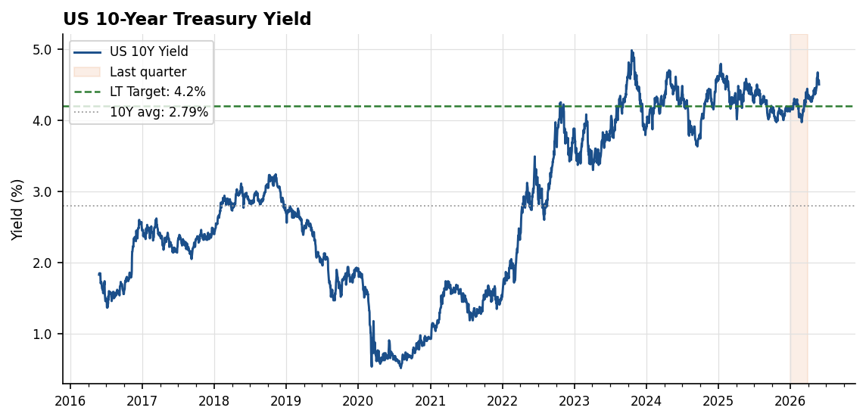
Figure 1: US 10-Year Treasury Yield (10-Year History)

2. Sources Used
⚠ DRAFT — Please review and edit before distributing
**Data Sources:**
- Federal Reserve Economic Data (FRED) — fred.stlouisfed.org
- DGS10: US 10-Year Treasury Constant Maturity Rate (daily)
- DFF: Federal Funds Effective Rate (daily)
- ACMTP10: Adrian, Crump & Moench (ACM) 10-Year Term Premium (daily)
- T10YIE: 10-Year Breakeven Inflation Rate (daily)
- Bank of Canada VALET API — bankofcanada.ca/valet
- V39056: Government of Canada 10-Year Benchmark Bond Yield (daily)
**Analytical References:**
- Adrian, T., Crump, R. K., & Moench, E. (2013). 'Pricing the Term Structure with Linear Regressions.' Journal of Financial Economics.
- Federal Open Market Committee (FOMC) — Summary of Economic Projections (SEP), long-run Federal Funds rate estimates.
- Bank of Canada — Monetary Policy Report (MPR), most recent edition.
- Report generated: 2026-05-27 for Q2 2026.

3. Forecasting Rationale

Factors Affecting Long-Term Yield Dynamics
Three-framework convergence | Target: 4.2%
Framework | Approach | Implied 10Y Range
1 — Spread-based | r* (3.12%) + hist. 10Y–FFR spread (TP implicit) | 3.21% – 4.31%
2 — ACM decomposition | r* (3.12%) + avg term premium (explicit TP) | 3.42% – 3.24%
3 — GDP + Inflation | Real GDP (2.15%) + PCE (2.00%) | 4.15%

⚠ DRAFT — Please review and edit before distributing
**Forecasting Rationale**
- Framework 1 (spread-based): Anchoring to the FOMC's long-run Fed Funds dot of 3.125% and applying historical 10Y–FFR spreads yields a triangulated range — the 5Y average spread of +0.08pp implies 3.21%, the 10Y average of +0.47pp implies 3.60%, and the 20Y average of +1.18pp implies 4.31%. The upper bound of this range is most relevant given the current regime of elevated supply and re-normalising term premium, pointing to a fair value in the upper-3% to low-4% area.
- The 20Y spread average is given greater weight than the 5Y/10Y averages because the latter embed an unrepresentative period of QE-compressed term premium (2014–2021); the 20Y window better captures a structurally normal supply/demand balance for duration, consistent with the current fiscal trajectory.
- Framework 2 (ACM decomposition): Decomposing the 10Y into an expected short-rate path (anchored at 3.125% long-run FFR) plus an explicit term premium yields 3.24% using the 10Y average TP of 0.12% and 3.42% using the 20Y average TP of 0.29%. Critically, this should not be additive to Framework 1 — the historical spread already embeds term premium, so stacking would double-count. Framework 2 instead serves as a cross-check, confirming that under average-TP assumptions fair value sits in the low-3% range.
- The current ACM term premium of 0.83% (91st percentile of 20Y history) is treated as a risk signal rather than a forecast input: it indicates the market is currently pricing well above long-run TP norms, and any partial mean-reversion over the forecast horizon would pull yields lower from the current 4.50%, while persistence of elevated TP would sustain yields nearer Framework 1's upper bound.
- Framework 3 (Fisher/neutral rate): The classical nominal neutral rate equals long-run real GDP growth plus long-run inflation — i.e., 2.15% (FOMC SEP) + 2.00% (PCE target) = 4.15%. This uses real GDP growth as a proxy for real r*, and the resulting gap versus the FOMC's lower r* of roughly 1.125% reflects unresolved tension between structural headwinds (demographics, global savings glut) and post-pandemic forces lifting equilibrium rates (fiscal expansion, reshoring, defence spending).
- Convergence across frameworks: Framework 1 (upper bound 4.31%), Framework 2 (3.24–3.42% under mean-TP, higher under current TP), and Framework 3 (4.15%) collectively bracket a fair-value zone of roughly 3.4–4.3%. A target of 4.2% sits at the intersection of Framework 1's 20Y-spread anchor and Framework 3's Fisher-based neutral, while remaining consistent with Framework 2 if term premium normalises only partially from its current 91st-percentile reading.
- The 4.2% target implies a 30bp decline from current 4.50% over the forecast horizon — modest, and consistent with gradual TP normalisation rather than a decisive rally. This reflects sticky services inflation keeping the Fed higher-for-longer, elevated Treasury supply sustaining term premium, and a 10Y breakeven of 2.40% suggesting inflation expectations remain above the 2.00% target.
- Structural anchors supporting the 4.2% level: (i) a neutral rate plausibly closer to the GDP-implied 4.15% than the FOMC's 3.125% long-run dot, reflecting tight labour markets and resilient growth; (ii) fiscal deficit dynamics and Treasury issuance keeping term premium structurally elevated relative to the 2014–2021 QE era; (iii) last-mile inflation persistence preventing a return to pre-pandemic yield norms (current 10Y is 4.50% vs the 10Y average of 2.79%).
- Cross-border dynamics provide a secondary anchor: BoC easing ahead of the Fed narrows the policy-rate differential and compresses the Canada-US spread, but does not materially alter the US long-end fair value, which remains driven by domestic neutral-rate, inflation, and fiscal fundamentals.
- Net assessment: 4.2% represents a calibrated central estimate where the spread-based historical anchor (Framework 1), the Fis

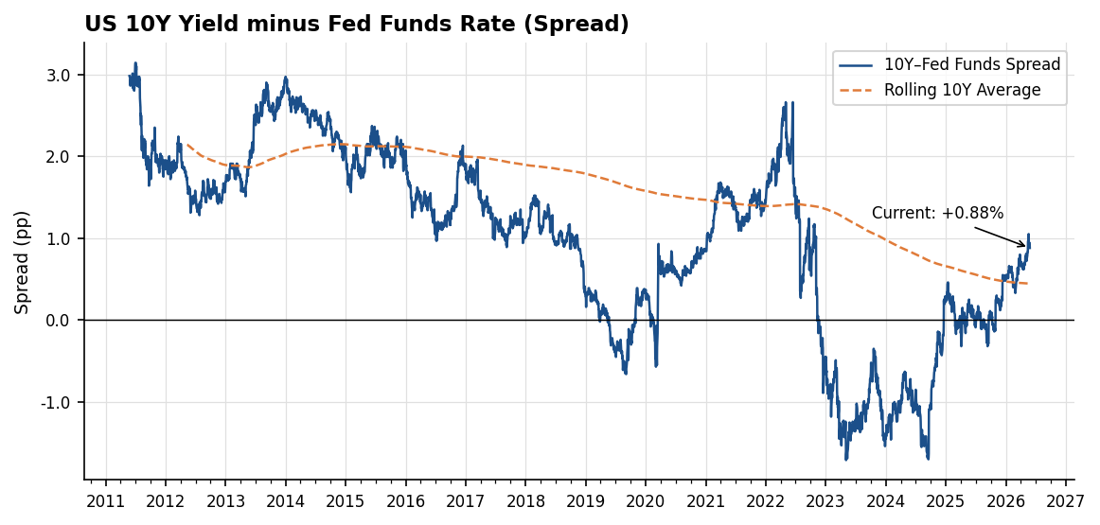
Figure 2: US 10Y–Fed Funds Rate Spread vs Historical Average

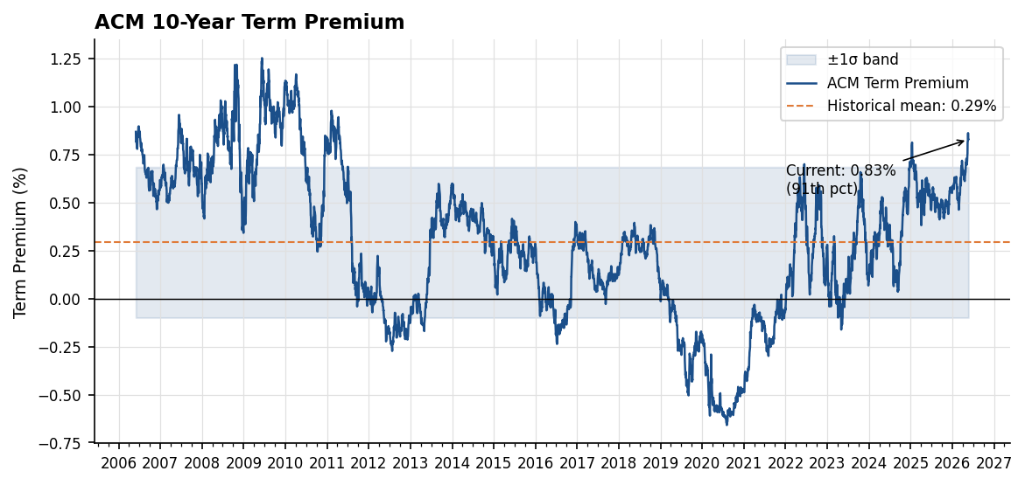
Figure 3: ACM 10-Year Term Premium

4. Medium-Term Risks and Impact on Outlook (3–5 Years)
# Medium-Term Risks (3–5 Year) — US 10-Year Treasury
⚠ DRAFT — Please review and edit before distributing
- [Upside] **Inflation re-acceleration forcing a renewed hiking cycle:** A stall in disinflation that lifts the 10Y breakeven materially above its current 2.40% — toward 2.75–3.00% — would force the Fed to resume tightening, repricing the expectations component of the 10Y yield by an estimated **+40–70 bps** versus the 4.2% target.
- [Upside] **Fiscal slippage and Treasury supply shock:** Failure of fiscal consolidation against a deteriorating debt trajectory would widen the ACM term premium from its current 0.83% (already at the 91st percentile) toward 1.20–1.30%, adding **+30–50 bps** to the 10Y, with risk skewed higher given limited historical precedent for sustained premia at these levels.
- [Upside] **Higher r\* from AI-driven capital demand:** A market re-estimation of the neutral rate by 50–75 bps, as AI capex absorbs global savings, would lift the entire long-end term structure by roughly **+30–60 bps**, independent of cyclical Fed policy.
- [Upside] **Geopolitical fragmentation and persistent goods inflation:** Accelerating supply-chain reshoring and tariff escalation would sustain core goods inflation 50–100 bps above baseline, embedding a higher inflation risk premium worth **+20–40 bps** on the 10Y.
- [Downside] **Recession-driven aggressive easing cycle:** A hard-landing scenario triggering 200–300 bps of cumulative Fed cuts would pull the expectations component sharply lower, taking the 10Y toward **3.00–3.50% (–70 to –120 bps)** versus the 4.2% target, partially offset by steepening dynamics.
- [Downside] **AI productivity-led disinflation:** A genuine productivity boom that lowers trend inflation toward 1.5–1.75% while sustaining real growth would compress breakevens by 50–75 bps from 2.40%, lowering the 10Y by **–40–60 bps** even without recession.
- [Downside] **Credit event or financial-stress flight-to-quality:** A systemic credit shock would compress the term premium from 0.83% back toward its long-run mean (~0.0–0.2%) and pull duration demand forward, worth **–50–80 bps** in a tail scenario, though likely transitory.
- [Downside] **Faster disinflation enabling earlier, deeper easing:** A cleaner glide path to the 2% target by late 2026 would allow the Fed to front-load cuts beyond current market pricing, lowering the expected average policy rate over the 10Y horizon and reducing the yield by **–25–45 bps**.

5. Long-Term Risks and Impact on Outlook (5–10 Years)
# Long-Term Risks (5–10 Year): US 10-Year Treasury
**[DRAFT — please review]**
The 4.2% Q2 2026 target sits 130bp above the 20-year average of 2.90%, with the ACM term premium (0.83%) already 54bp above its 20-year norm (0.29%). The following structural forces could entrench — or unwind — this elevated regime over the coming decade.
- [Upside] Fiscal trajectory lifts r* and term premium.** CBO baselines point to federal debt-to-GDP rising through 110–125% by the mid-2030s, with net interest outlays already exceeding defense. Persistent primary deficits of 5–7% of GDP, combined with rising defense and entitlement claims, plausibly add 50–100bp to the equilibrium 10Y through a higher neutral rate and a wider term premium — supporting a terminal nominal yield in the 4.0–4.75% range.
- [Upside] Deglobalization sustains a higher inflation floor.** Reshoring, tariff regimes, and friend-shoring of semiconductors, pharmaceuticals, and critical minerals raise tradable goods inflation by an estimated 30–60bp relative to the 2010s equilibrium. A long-run CPI anchor closer to 2.5–3.0% rather than sub-2% translates roughly one-for-one into 10Y nominal yields.
- [Upside] Reserve diversification erodes structural Treasury demand.** Foreign official holdings have declined from ~50% of marketable Treasuries in 2014 to ~30% currently. Continued diversification into gold, RMB instruments, and bilateral settlement could lift the term premium an additional 20–40bp, particularly at the long end where price-insensitive official buyers historically concentrated.
- [Upside] Climate capex tightens the global capital market.** IEA estimates net-zero pathways require $4–5trn in annual energy investment by 2030, roughly double current levels. Sustained demand for long-duration capital — much of it debt-financed — competes directly with Treasury issuance and biases real yields upward by 15–30bp.
- [Downside] Demographics suppress trend growth and r*.** US working-age population growth slows to ~0.2% annually through the 2030s, and the dependency ratio rises sharply. Aging-driven precautionary saving and weaker investment demand — the Rachel-Summers channel — could subtract 50–75bp from r*, pulling the terminal 10Y back toward 3.25–3.50%.
- [Downside] Disorderly fiscal adjustment triggers debt deflation.** A sovereign credibility shock forcing abrupt fiscal consolidation, paired with private sector deleveraging, would compress nominal growth and inflation expectations. Historical analogues (post-1990 Japan) suggest 10Y yields could anchor below 2% for an extended period despite — or because of — the initial debt overhang.
- [Downside] AI-driven productivity gains compress inflation expectations.** If generative AI delivers sustained 50–100bp of additional TFP growth, the disinflationary impulse through labor cost compression and capital efficiency could durably anchor core inflation near 1.5%. Nominal 10Y yields would re-rate 50–80bp lower even with a higher real r*.
- [Downside] Renewed global savings glut.** Re-emergence of EM surplus economies — a re-industrializing India, Gulf sovereign accumulation, or a Chinese current account rebound — could restore the pre-2014 demand backdrop. Each $500bn of incremental foreign Treasury demand has historically been associated with roughly 15–20bp of yield compression at the 10Y point.

Appendix: Supporting Data

Key Metrics Snapshot
Metric | Current | 5Y Avg | 10Y Avg | 20Y Avg
US 10Y Yield (%) | 4.50 | 3.60 | 2.79 | 2.90
Canada 10Y Yield (%) | 3.47 | 2.99 | 2.26 | 2.53
Fed Funds Rate (%) | — | — | — | —
BoC Overnight Rate (%) | — | — | — | —
US 10Y–FFR Spread (pp) | 0.88 | 0.08 | 0.47 | 1.18
Canada 10Y–BoC Spread (pp) | 0.88 | -0.04 | 0.26 | 0.81
Canada–US 10Y Spread (pp) | -1.03 | -0.61 | -0.53 | -0.37
ACM Term Premium (%) | 0.83 | 0.30 | 0.12 | 0.29
10Y Breakeven Inflation (%) | 2.40 | 2.36 | 2.09 | 2.07

