**Creating a S3 bucket**

**Simple Storage Service(S3)**

* S3 is one of the first services that has been produced by aws.
* S3 stands for Simple Storage Service.
* S3 provides developers and IT teams with secure, durable, highly scalable object storage.
* It is easy to use with a simple web services interface to store and retrieve any amount of data from anywhere on the web.

**What is S3?**

* S3 is a safe place to store the files.
* It is Object-based storage, i.e., you can store the images, word files, pdf files, etc.
* The files which are stored in S3 can be from 0 Bytes to 5 TB.
* It has unlimited storage means that you can store the data as much you want.
* Files are stored in Bucket. A bucket is like a folder available in S3 that stores the files.
* S3 is a universal namespace, i.e., the names must be unique globally. Bucket contains a DNS address. Therefore, the bucket must contain a unique name to generate a unique DNS address

**Advantages of S3:**

* **Create Buckets:** Firstly, we create a bucket and provide a name to the bucket. Buckets are the containers in S3 that stores the data. Buckets must have a unique name to generate a unique DNS address.
* **Storing data in buckets:** Bucket can be used to store an infinite amount of data. You can upload the files as much you want into an Amazon S3 bucket, i.e., there is no maximum limit to store the files. Each object can contain upto 5 TB of data. Each object can be stored and retrieved by using a unique developer assigned-key.
* 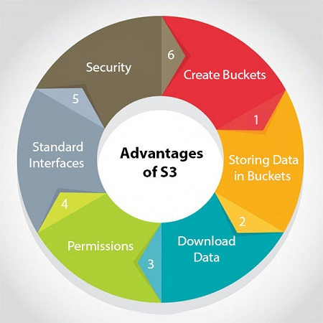**Download data:** You can also download your data from a bucket and can also give permission to others to download the same data. You can download the data at any time whenever you want.
* **Permissions:** You can also grant or deny access to others who want to download or upload the data from your Amazon S3 bucket. Authentication mechanism keeps the data secure from unauthorized access.
* **Standard interfaces:** S3 is used with the standard interfaces REST and SOAP interfaces which are designed in such a way that they can work with any development toolkit.
* **Security:** Amazon S3 offers security features by protecting unauthorized users from accessing your data.

**S3 is object-based. Objects consist of the following:**

* **Key:** It is simply the name of the object. For example, hello.txt, spreadsheet.xlsx, etc. You can use the key to retrieve the object.
* **Value:** It is simply the data which is made up of a sequence of bytes. It is actually a data inside the file.
* **Version ID:** Version ID uniquely identifies the object. It is a string generated by S3 when you add an object to the S3 bucket.
* **Metadata:** It is the data about data that you are storing. A set of a name-value pair with which you can store the information regarding an object. Metadata can be assigned to the objects in Amazon S3 bucket.
* **Subresources:** Subresource mechanism is used to store object-specific information.
* **Access control information:** You can put the permissions individually on your files.

**Creating an S3 Bucket:**

**Step-1:**

Sign in to the preview version of the AWS Management Console.

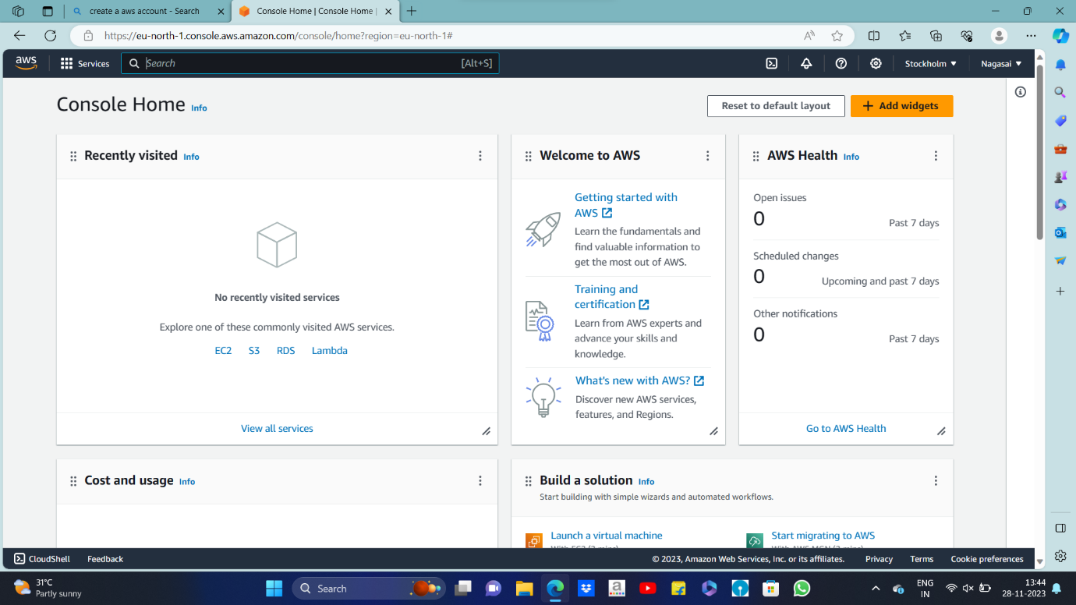

**Step-2:**

Under **Storage & Content Delivery**, choose **S3** to open the Amazon S3 console.

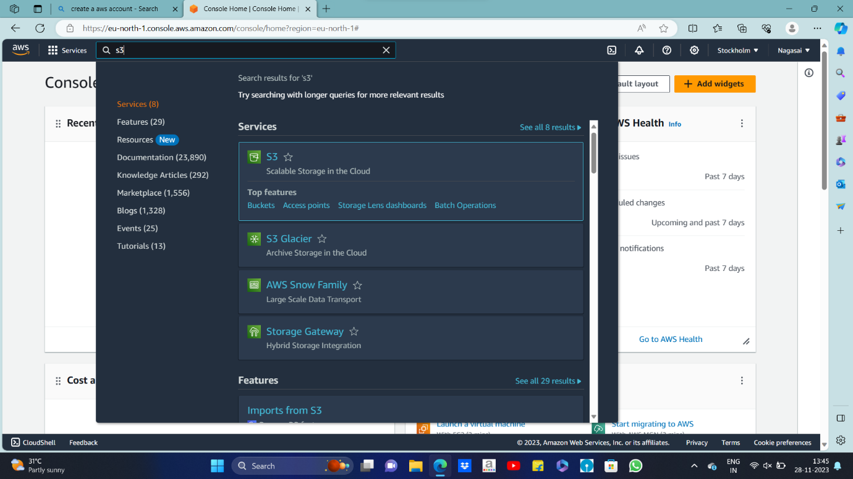

**Step-3:**

From the Amazon S3 console dashboard, choose **Create Bucket**.

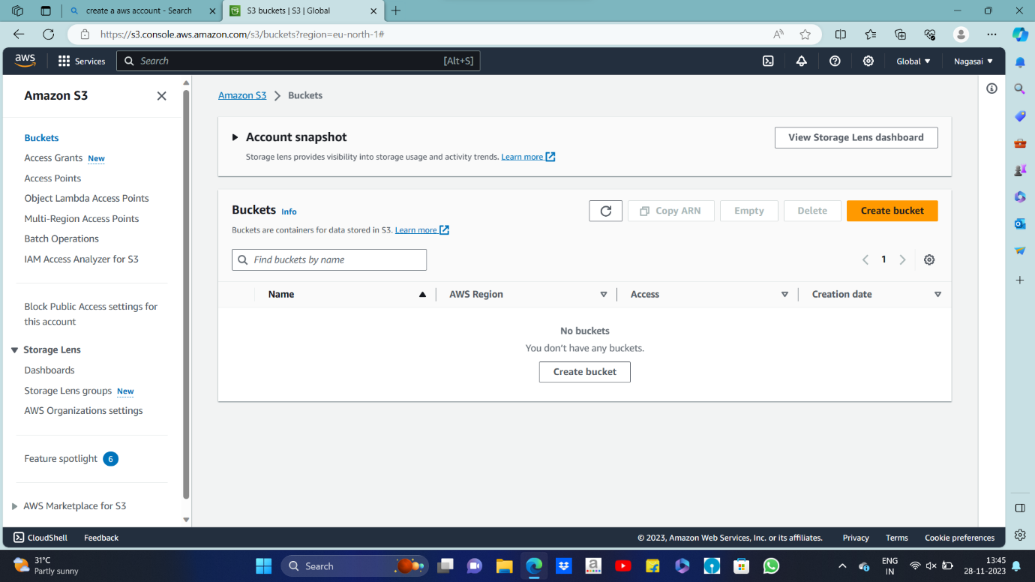

**Step-4:**

In **Create a Bucket**, type a bucket name in **Bucket Name**.Bucket name will be unique.

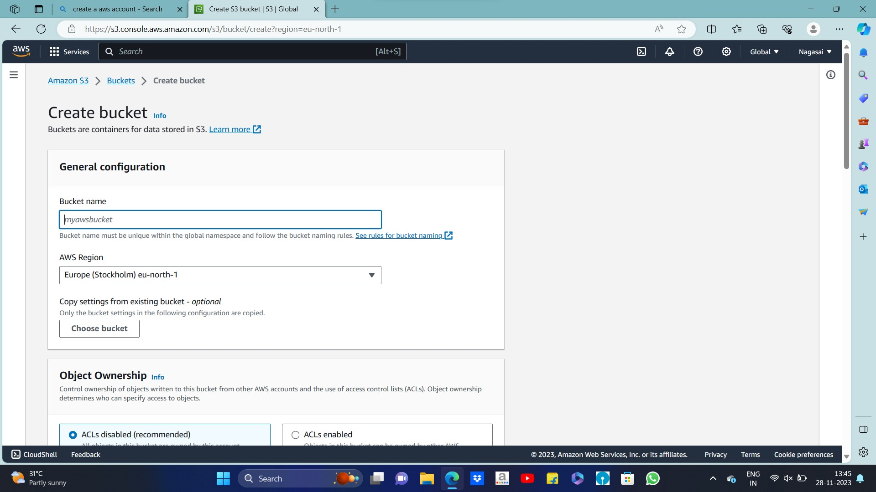

**Step-5:**

In **Region**, choose the region where you want to create the bucket.

Choose **Create**.

