- Introduction
Nowadays, many people have been exposed to stocks, and there are many people who have lost their lives or lost their savings for many years because of stocks, so I will predict the trend of stocks this time. Hopefully this prediction can help reduce the chances of people losing their entire savings. In this time, I will predict the most popular company “Apple” stock price cause Apple is a stock which most people have buy it.

- Data Source
The training data is obtained from open source data platform Kaggle.

https://www.kaggle.com/datasets/rishabhkmr/appleaapl-historical-share-price-since-listing

It is the record of aapl history stock price

It has 10121 rows and 7 columns.

The testing data is the prices of aapl market stock price from listing to 7/2022.

It include Date, Open price, High price, low price, close price, adj close price and volume.

- Method
- Data preparation: data cleaning from 1980 to 2010, we will just use stock price data from 2010 to 2022
- Data Analysis:
Our target is predict the stock future price, The useful data is close price value and date.

I have choose this 2 attribute because the close price of stock is important for everyone, and it will be changed by day, so I have choose this 2 attribute.

- Linear regression prediction of “AAPL” future price by “AAPL” history stock price.
Python code:

Step:
- Get data set from google drive
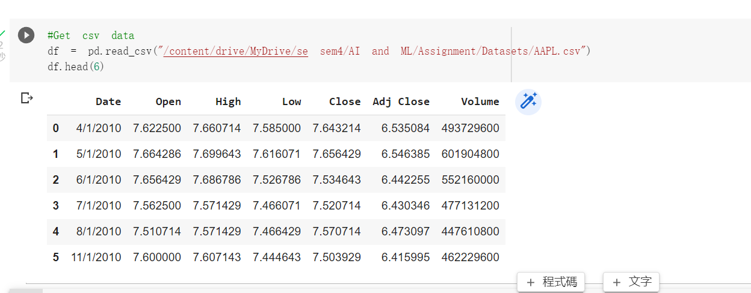
- Get stock history price
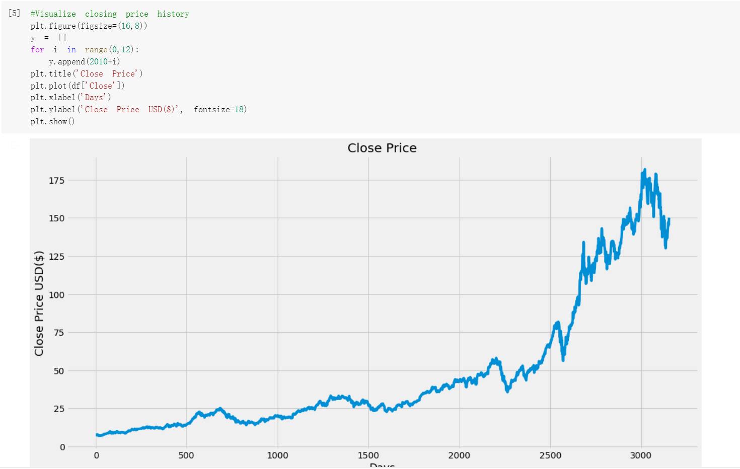
- Define how many days we want to predict and create new column in df
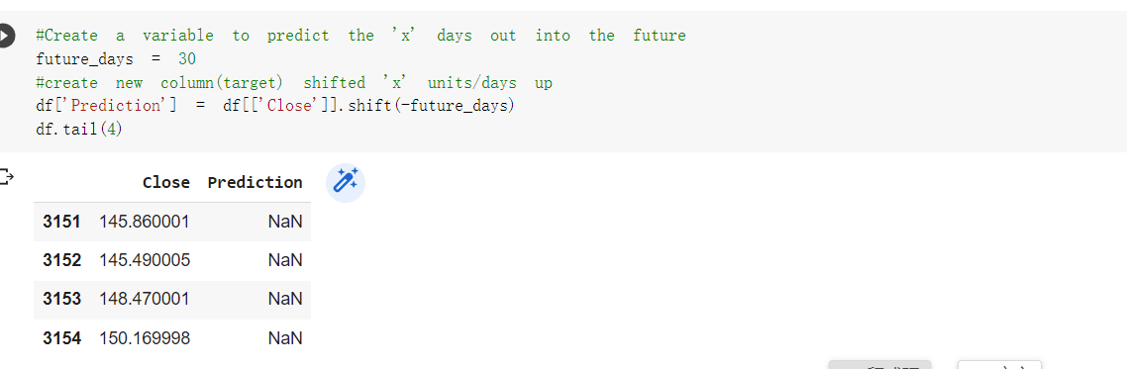
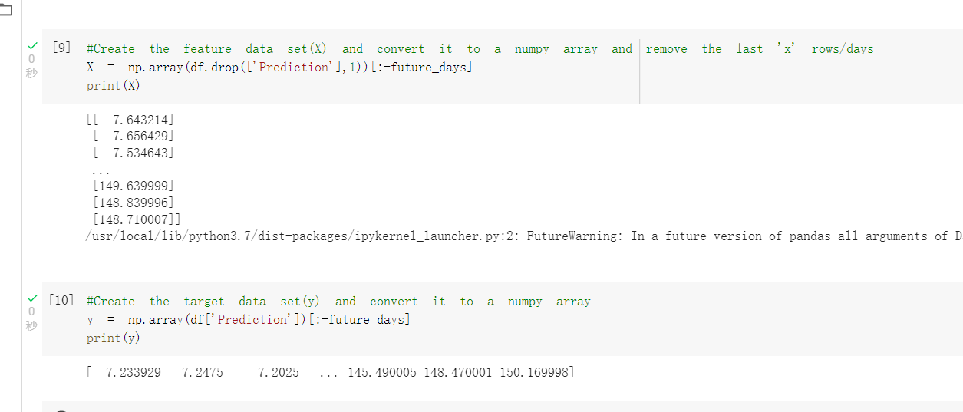
- Split data into 75% training and 25% testing
- Create Decision tree regression model and linear regression model
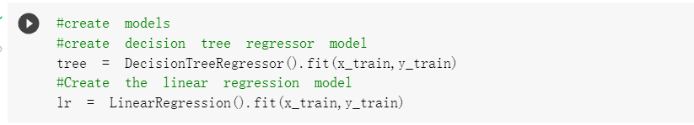
- Show and visual the prediction data
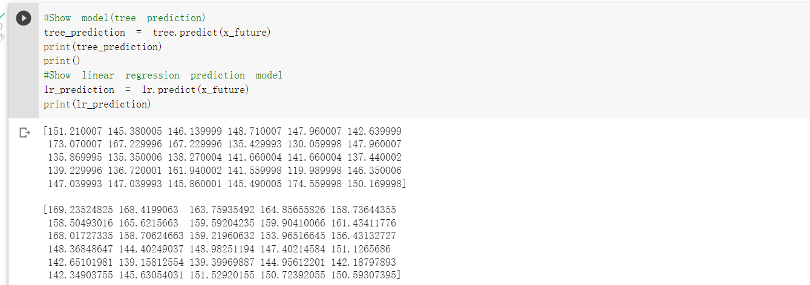
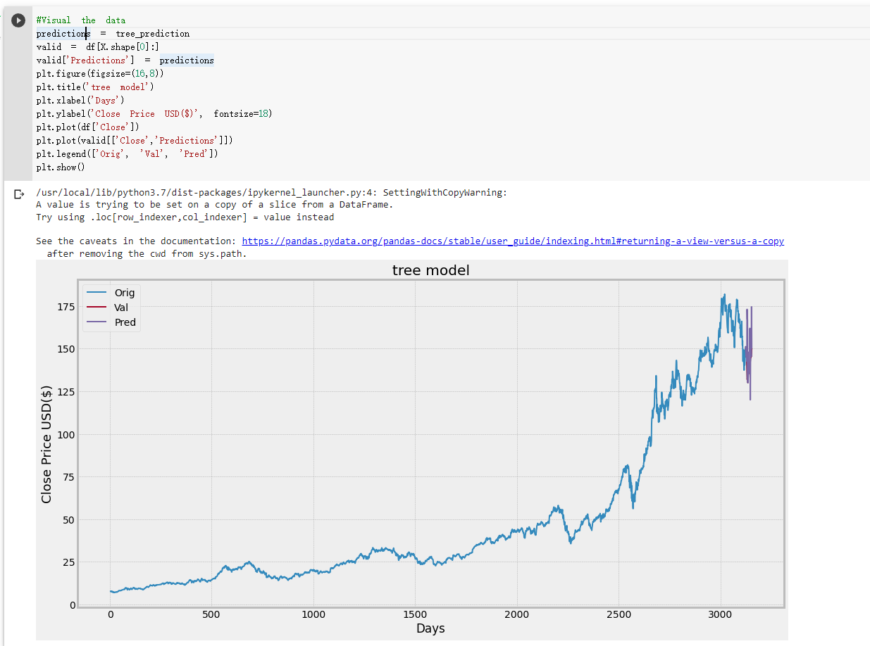
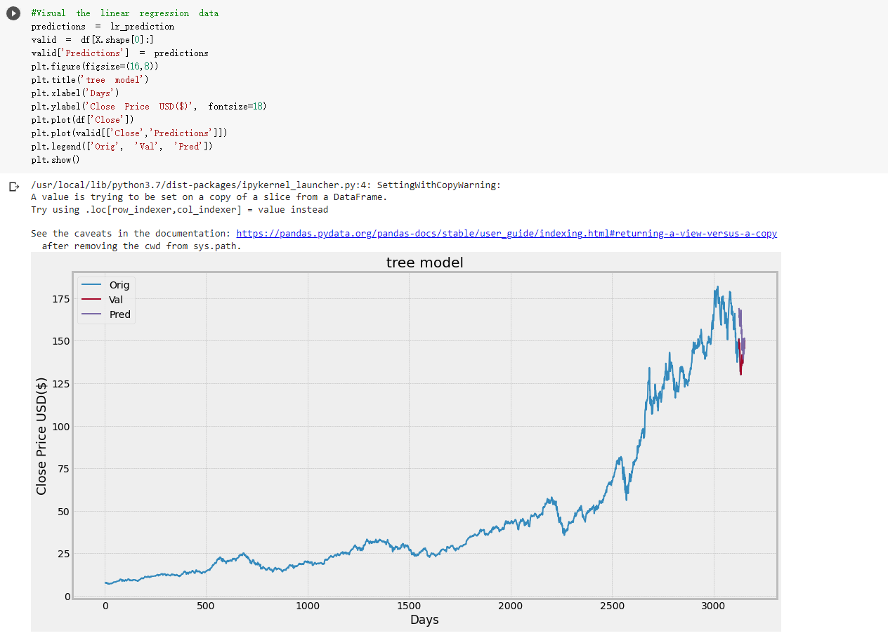
The output is not correct enough. I guess that there might have some problems.
- Few factor might affect the stock price such as volume, interest rate.
- Apple sales
As a result, I tried to predict the data again with LSTM predict way.

I have changed coding from linear regression step 3.
Step 3:
Create new dataframe with only close column
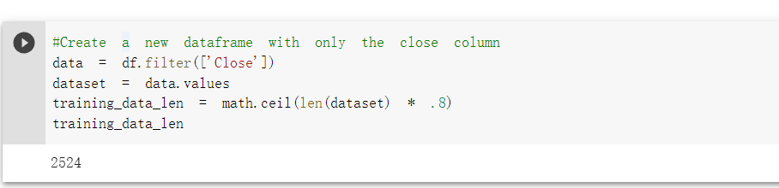
- Scale the data of close column
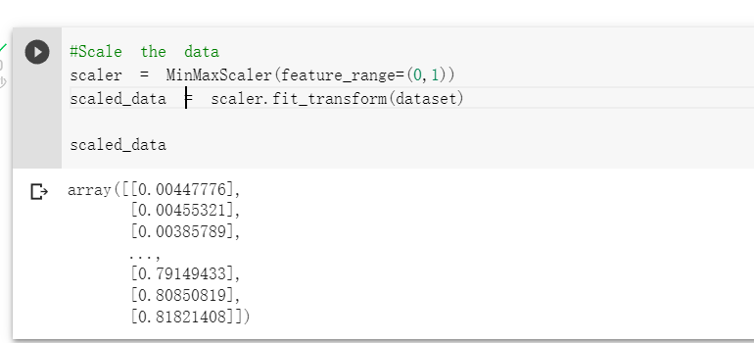
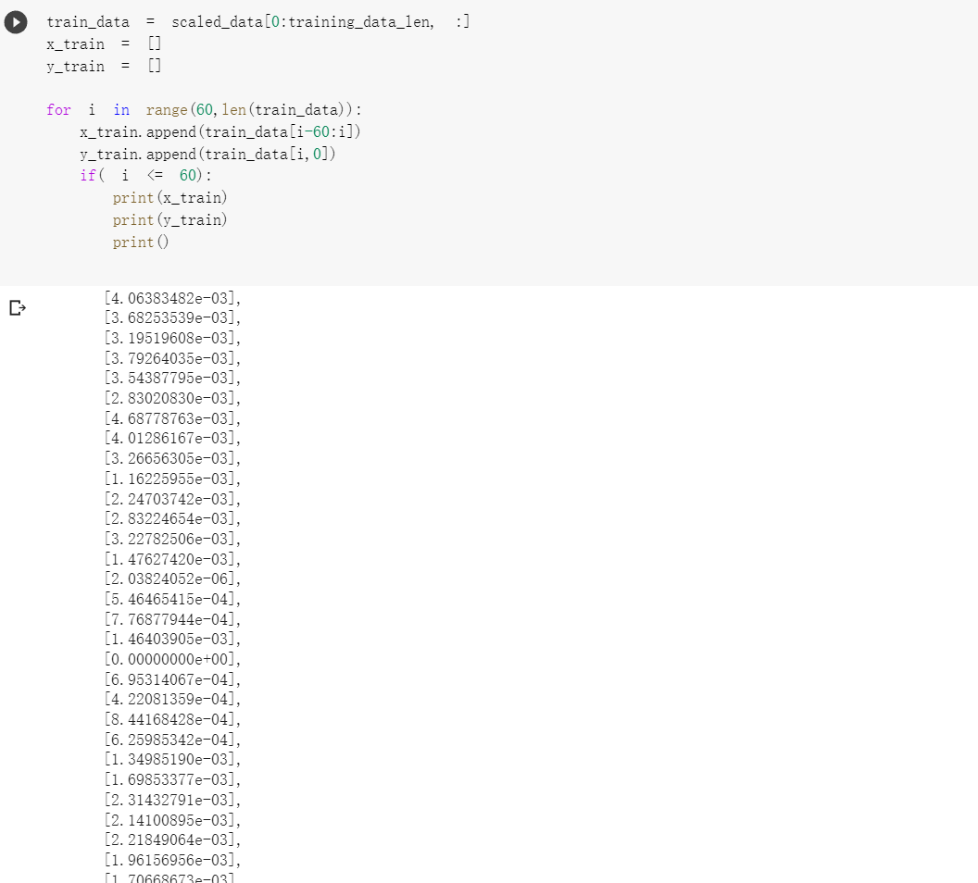
- Convert train data to numpy array and reshape data.
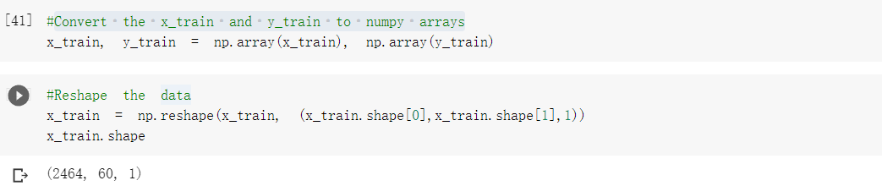
- Build LSTM model and compile the model
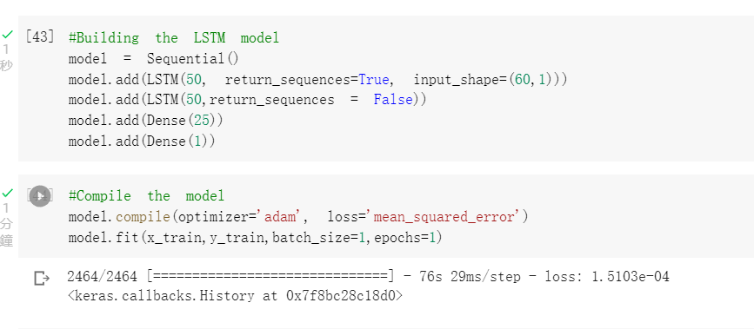
- Create testing data set and data sets and convert the data sets to numpy array and do reshape.
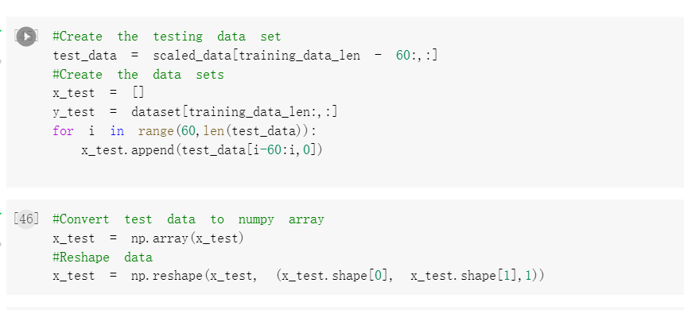
- Then I will try go get models predicted price values
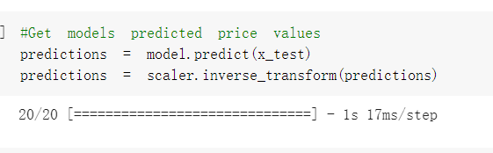
- Finally show the result of prediction
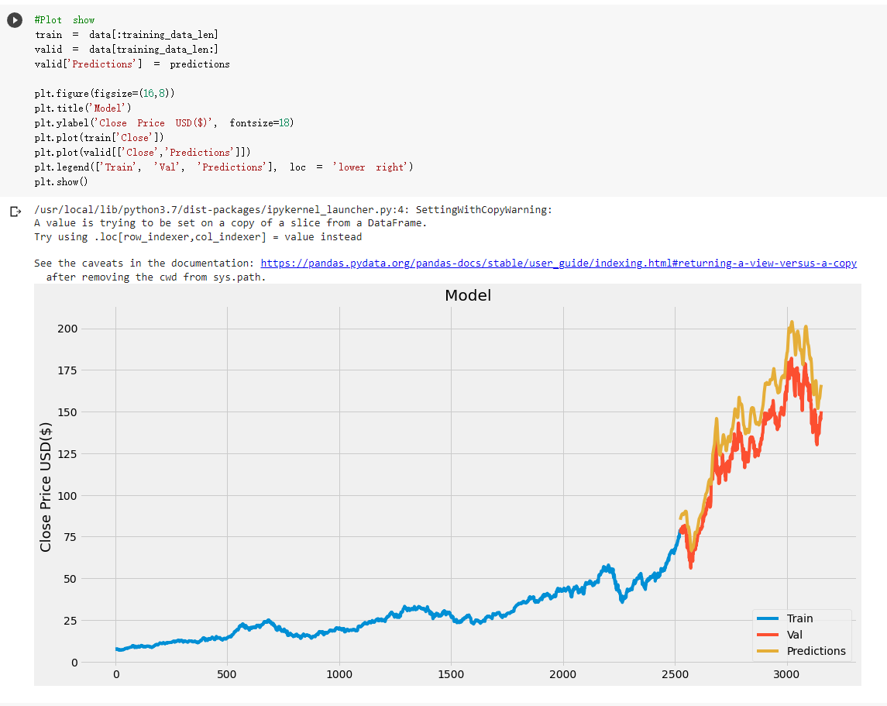
In LSTM model, we can see the data is still not correct enough. But this is not bad to predict the stock price. In this model, mean squared error value is 16.59899592917987. From the plot and the mean square error. This prediction is good. However, due to the fact that there are many factors that will affect the stock price. so this model should just be reference for investor.

Therefore, the LSTM model was adopted.

- Report
In this project, I tried to use linear regression to predict the current data but data is not correct enough. So I have tried to use LSTM to predict data. But the LSTM skills which I don’t know how to use so I have search the LSTM using example to learn about LSTM predict.

I have also use LSTM model to predict the stock price, in this model, mean squared error has around 16.5 and from the plot. This model is more better for prediction the stock price.

