**Group 9 Katacoda Scenario**

Link: <https://www.katacoda.com/easyeats/scenarios/easyeats>

Discussion & Screenshot

Here is group 9 Katacoda scenario which including 8 following steps.

In this Katacoda scenario, we use editor-terminal layout to run it.

Introduction:

First of all, user will go into intro.md page. In this page, there is a introduction for user including 4 part a short description of our system, learning outcomes which are user learnt in this scenario, requisite skills and content.

Step 1: Overview of EasyEats

Next, user will go into the overview, there are some introductions about all components of EasyEats..

Also, user can click the git clone and clone the file from github 

After that user will get the EasyEats file.

Next, you can click dockeer-compose.yaml to view application's services.



Step 2: Setup the Docker-compose

Then, user will go into step two which will tech how to setup the Docker-compose and run it. Furthermore, user can click to the black box to boost up. We also provide the response to user, they can review it and check by themselves.

Step 3 - 5: Learn with different order/store/menu endpoint

Thirdly, user will go to step3, 4 and 5. These 3 parts are the main content in this scenario which is teaching user how to use EasyEats with different endpoints.

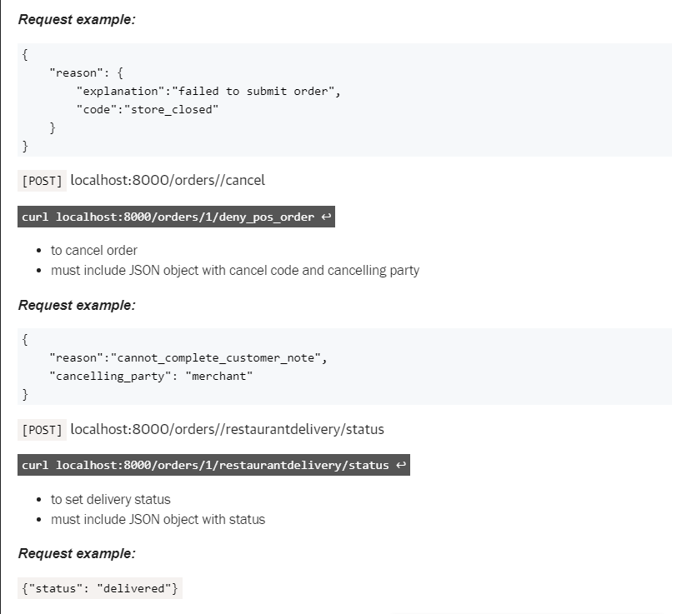

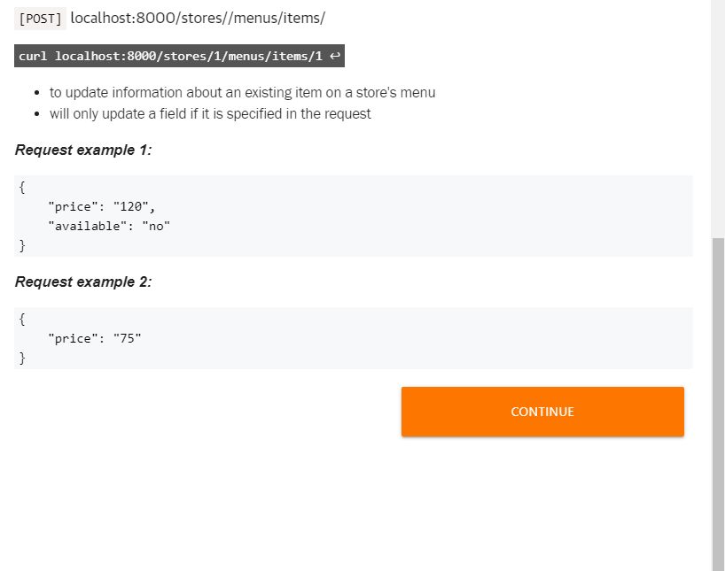

Within these main steps, user will learn several things.

* Which type HTML methods the API using. For example:



The above one is using [GET] method.

* How to enter the endpoints. For example:



The above one enters to stores by localhost:8000/stores/menus.

* Providing the example which user can try quickly. For example:



The above one is an execute layer.

* Providing the description of each comment. For example:



The above one is an execute layer.

* Lastly, showing the request example for user checking. For example:

Step 6:

After learning how to access to different endpoints. User can

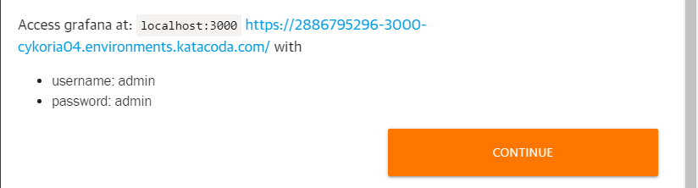

Also, they can access to different port such as 3000 or 9090 for using Grafana and Prometheus.

Finish:

Finally, user will go to the last page. User can review what they have learnt. If they have any question, they can see the content and get back to the scenario. Moreover, we will recommend some further learning to the user which can help them to maintain EasyEats.

