EE 631 Midterm Project Multi robot path Planning
Guanghua Zha

Introduction
In this project the target is to implement the path planning in a multi robot environment. In order to achieve this target there is several procedure that should be done in order to setup up the simulation environment.
Step one: generate a map and save the map as a file that can be loaded into ROS simulation.
Step two: load the map, robot model and robot controller into the simulation environment.
Step three: run the simulation with several robots and apply the path planning algorithm.

To make the project more realistic and benefit for future work, I use turtulebot3 as my robot along with the turtlebot3, turtulebot3_gazebo, turtlebot3_simulation package. The simulation is running on gazebo7, ROS kinetic and Ubuntu 16.04.

Step One: Map Generation.
In this project I use gazebo to build the simulation playground. First use the ‘Building Editor’ in gazebo to build the wall, and then place several cylinder as reference point in the map. Since we use gmapping and laser scanner to generate the map, without these cylinder in a situation where the robot is moving in parallel wall, the gmapping will think that the robot is not actually moving as the laser scanner data is not changing, and this will result inaccurate mapping. Then save the world as a .world file.
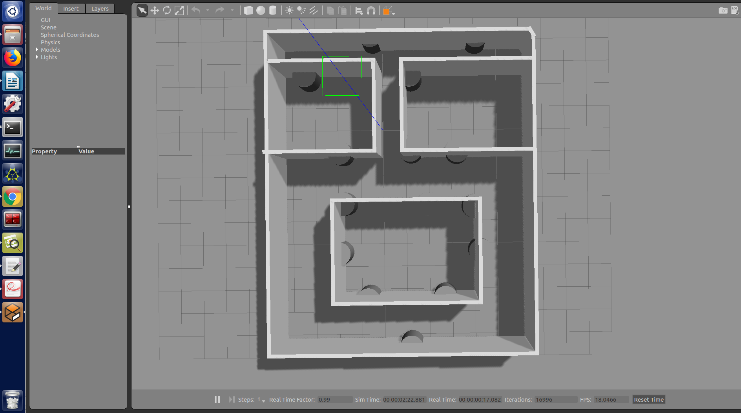

Next modified the file turtlebot3_empty_world.launch in the package turtlebot3_gazebo to load the world that generate from gazebo and move the robot to a valid start position.
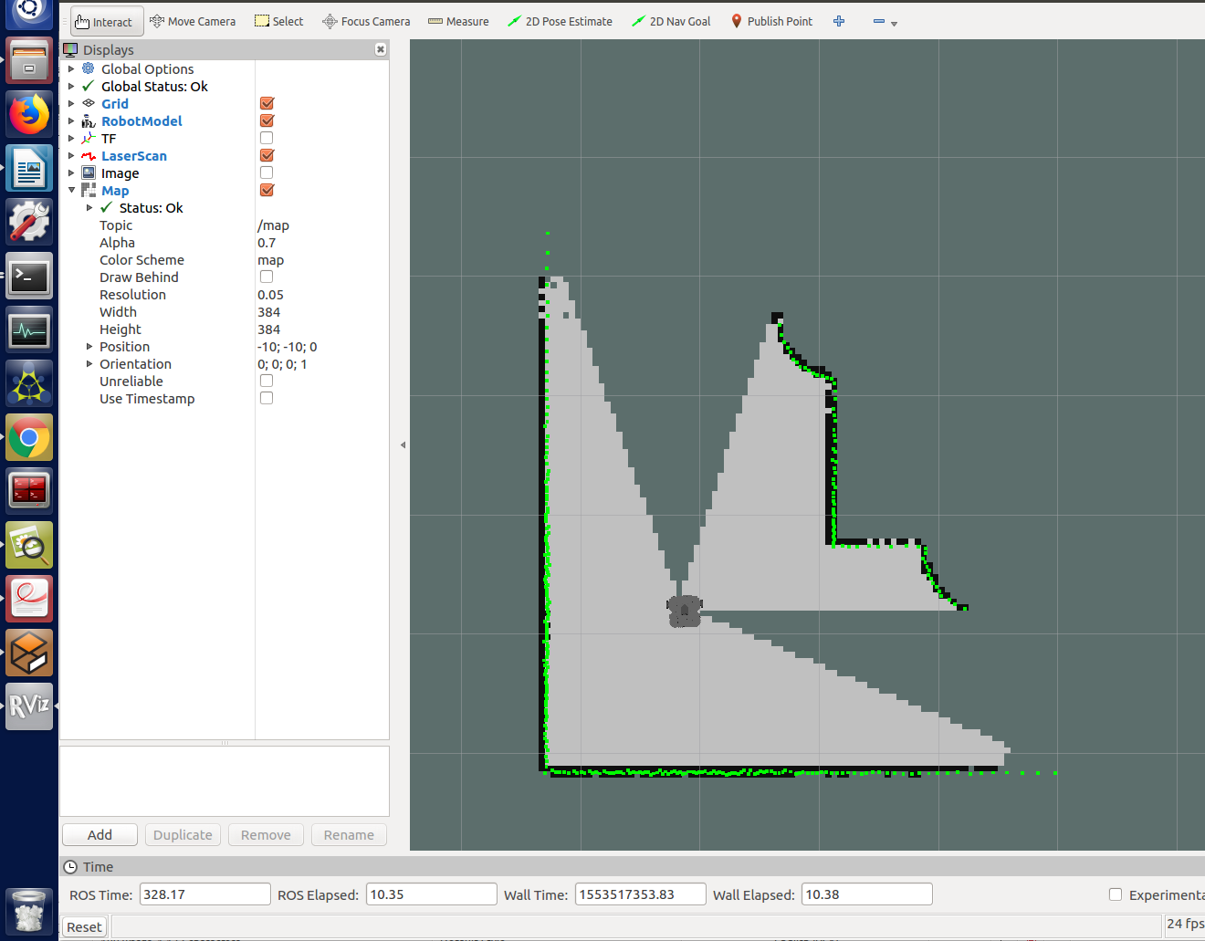
Then launch the file with command:
roslaunch turtlebot3_gazebo turtlebot3_ww.launch

In another terminal launch the turtlebot3 slam node with command:
export TURTLEBOT3_MODEL=waffle
roslaunch turtlebot3_slam turtlebot3_slam.launch

Rviz window will pop up and looks like the picture on the right.

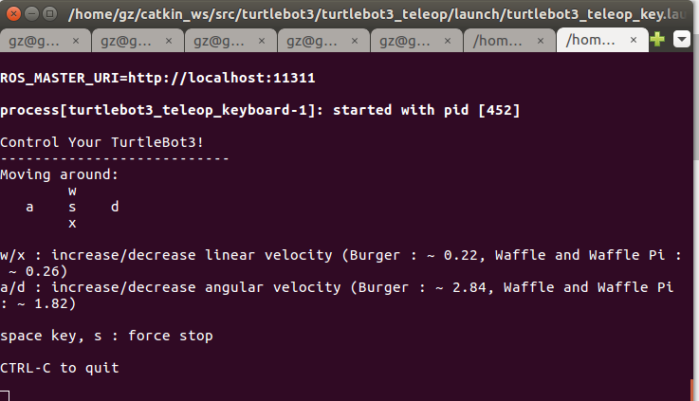

Open another terminal and run the command:
export TURTLEBOT3_MODEL=waffle
roslaunch turtlebot3_teleop turtlebot3_teleop_key.launch

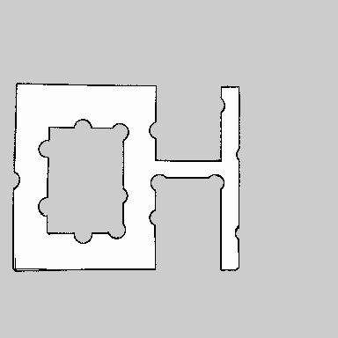
Then use keyboard to guide the robot to explore the entire map. The gmapping method will use the laser scanner data to build the map.

Finally save the map with command:
rosrun map_server map_saver -f ~/map

Step Two: Setup Multi robot Simulation Environment
There is no simulation environment that target for multi robot path planning inside turtlebot3 package. However, there is a multi robot playground for slam simulation that generate map for a large house with three robot. With part of the code from this simulation along with other on-line projects, I were able to modified the script to launch the customized multi robot simulation.

In order to place three robots in the simulation, first modified the file multi_turtlebot3.launch in the turtlebot3_gazebo package to load the customized gazebo world. (file mt.launch)

Then write a new launch file under turtlebot3_navigation/launch to load the map along with three robots. (file t.launch) (There are lot of modification that has been done to make the simulation work including modified the tf tree)
The rviz file is a modified version of multi_turtlebot3_slam.rviz in the package turtlebot3_gazebo/rviz.
Modified amcl.launch and move_base.launch to make them work on the multi robot environment.

Finally launch the simulation with command:

terminal 1:
export TURTLEBOT3_MODEL=waffle
roslaunch turtlebot3_gazebo mt.launch

terminal 2:
export TURTLEBOT3_MODEL=waffle
roslaunch turtlebot3_navigation t.launch
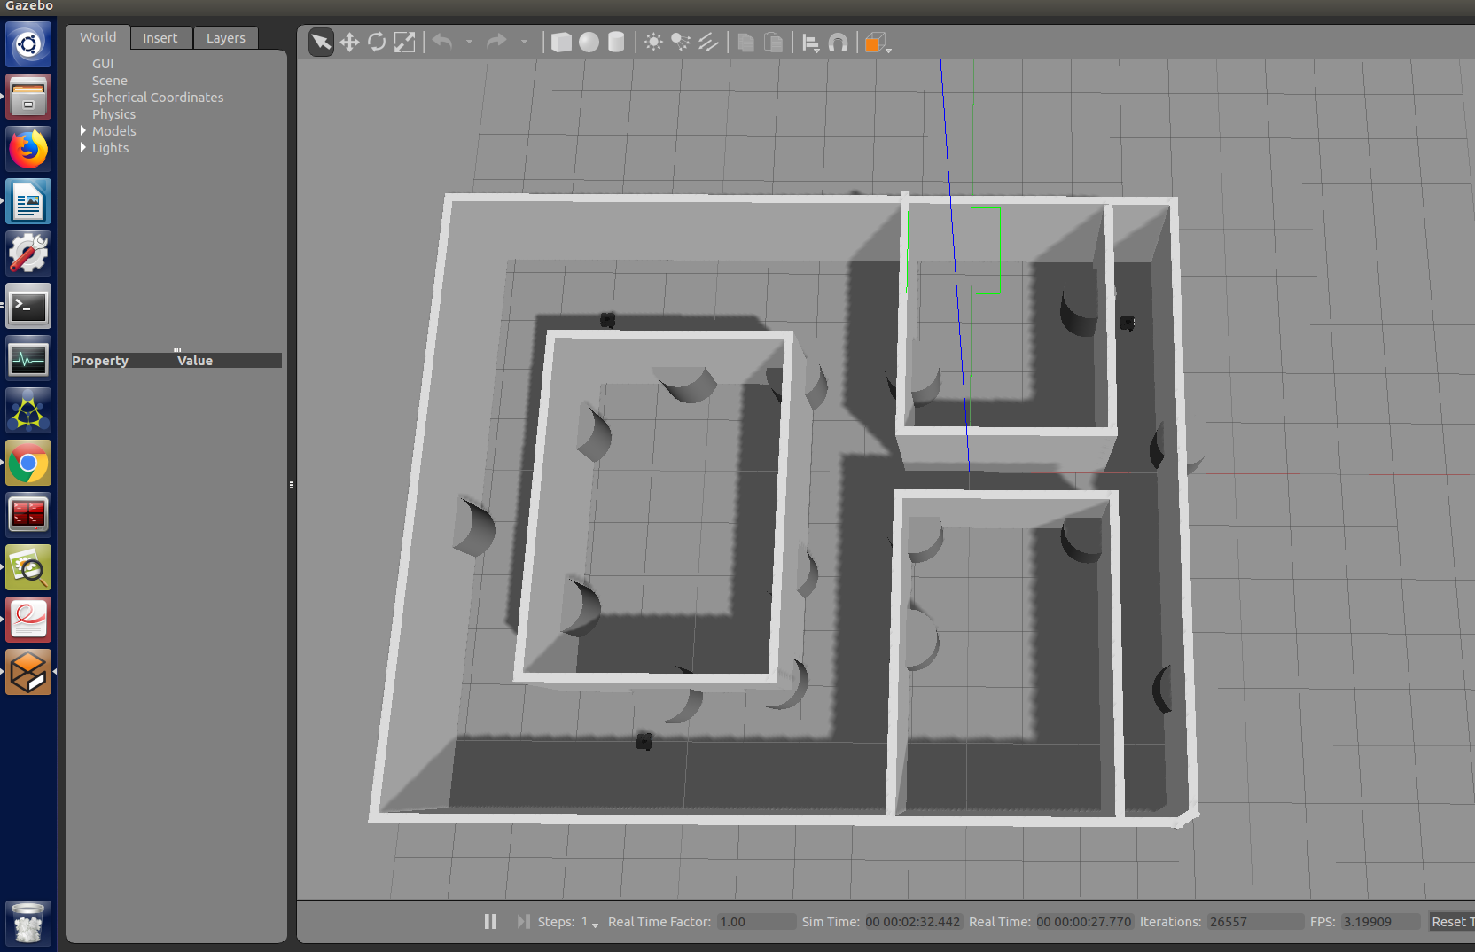
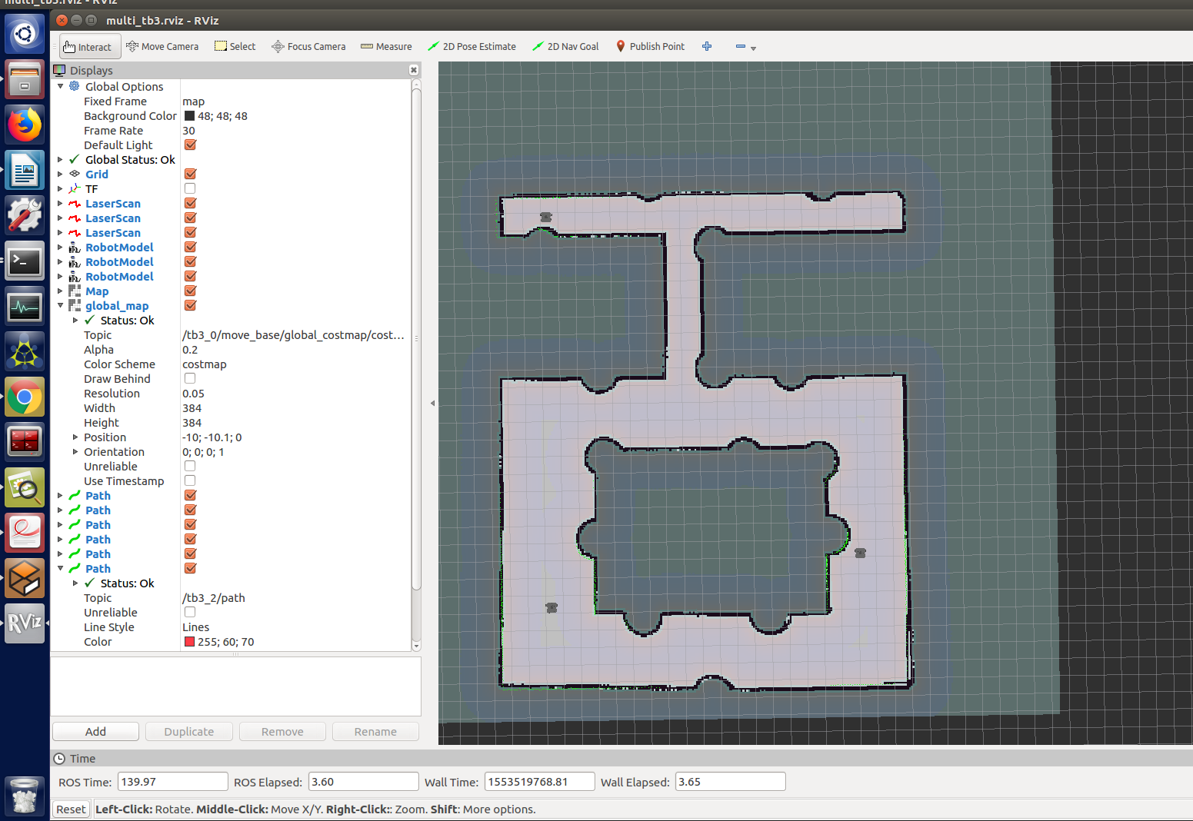
Red Circles show the initial position of the three robots.

Step Three: Path Planning
Since for this setup there is already a build-in path planner loaded by the move_group (dwa_local_planner/DWAPlannerROS) for each robot, there is no need to develop another path planner. The robot can move to destination after received the target published on topic /move_base/target for each robot. This can be down using python script with appropriate library.

However, since there is no collision avoidance and inter-robot communication method being applied, these robots can easily collide and block each other from reach out the destination.

To demonstrate the collision problem the first experiment is designed as following:
Robot0 and robot1 is going to the upper left corner, robot2 is not moving.
Target/robot2
Robot0
Robot1

The result is robot0 and robot1 collide with each other on half way of the path.
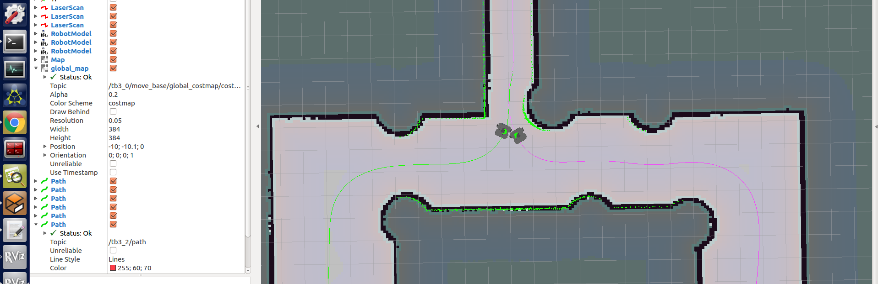

Second experiment: robot1 and robot0 are going to the robot2 initial position, robot2 is going to the robot1 start position.
Robot2
Robot0
Robot1

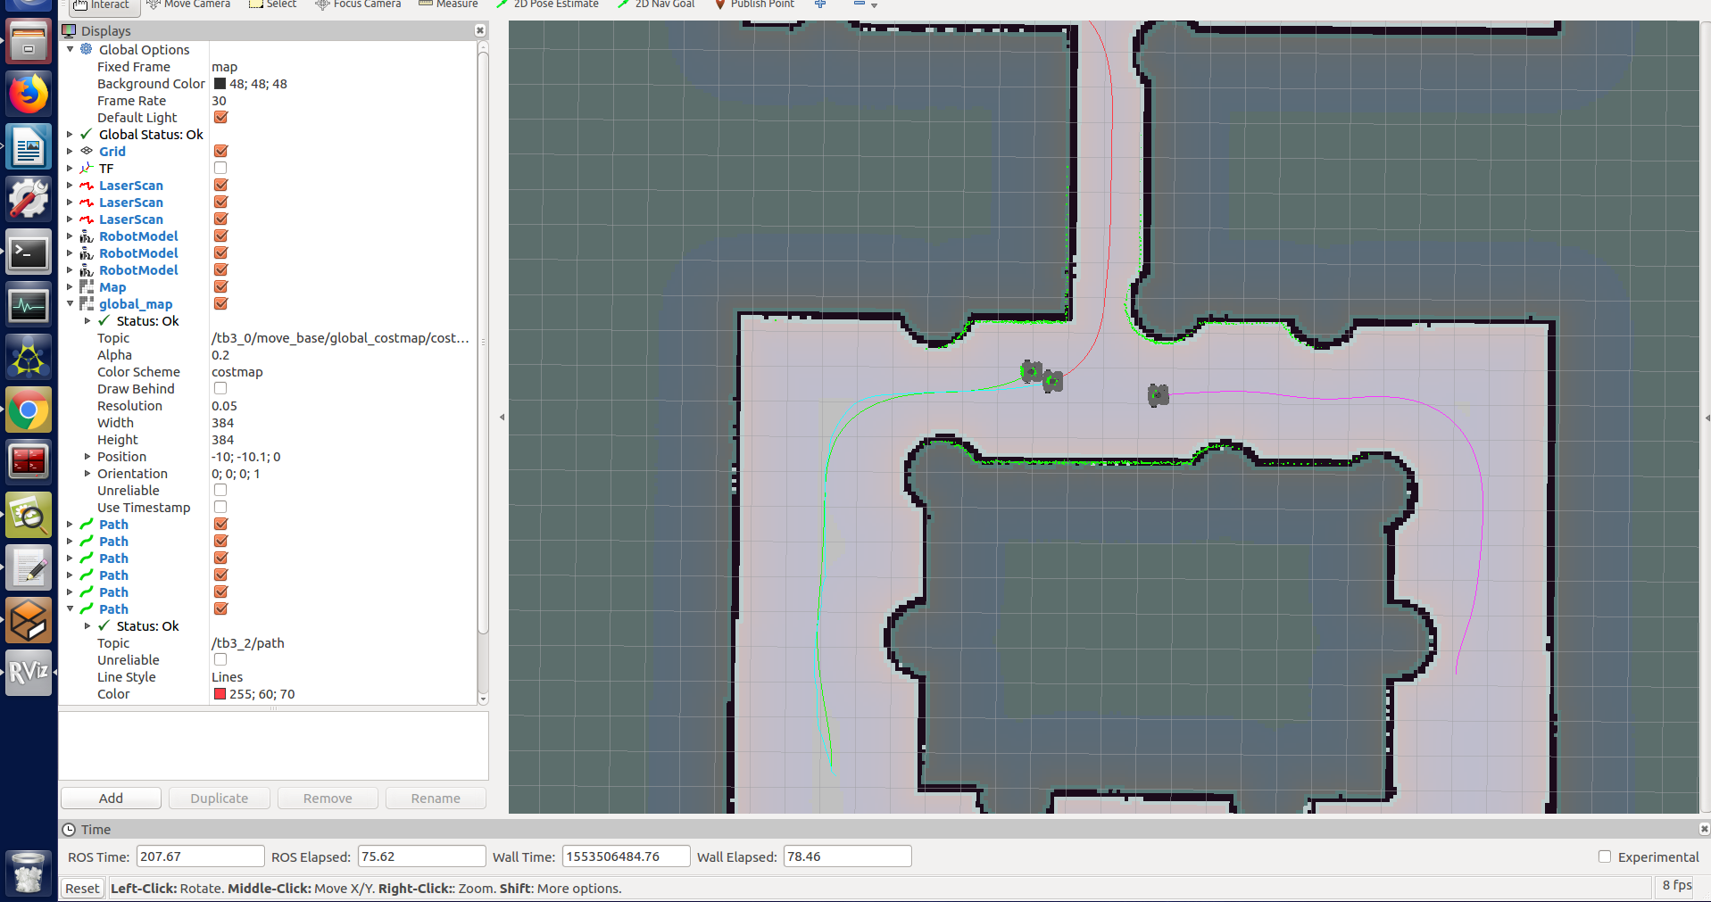
The result is robot0 collide with robot2.

To let three robot reaching their destination in this map without collision on each other, we make following arrangement:

First robot1, robot2 and robot3 are being assigned separate intermediate dentition near the center of the map.
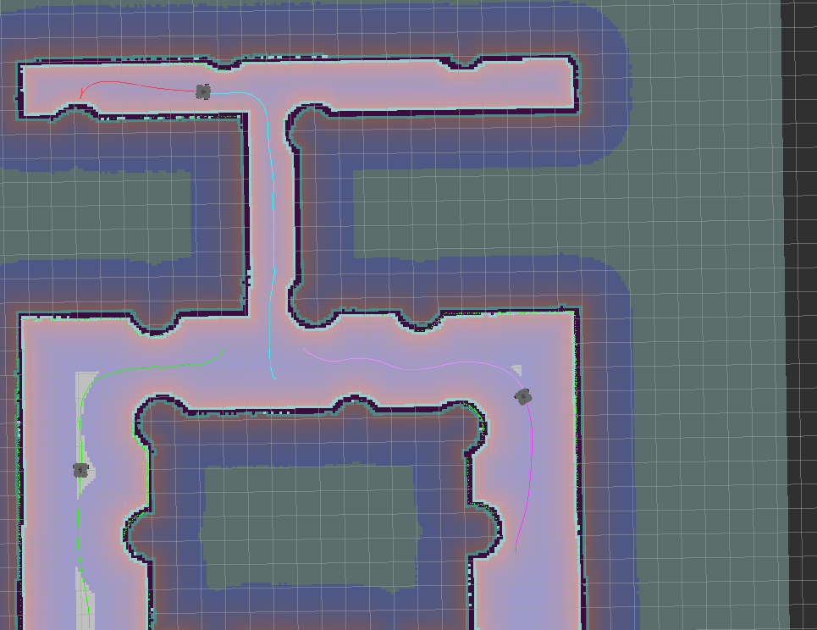
Robot2

Intermediate goals

Robot0
Robot1

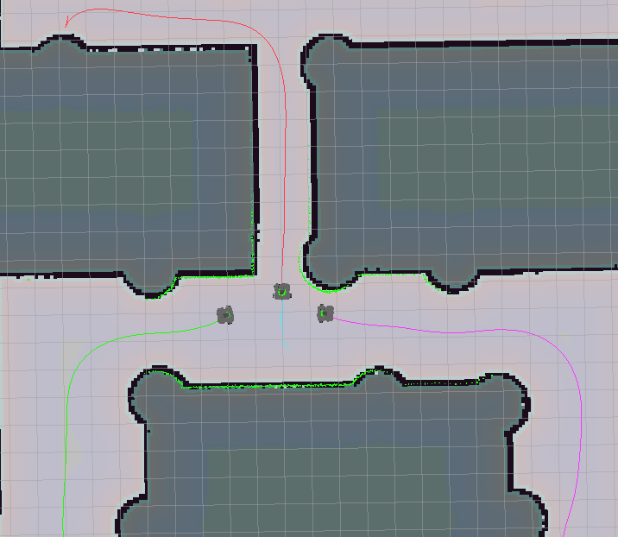
When robot0 and robot1 reach the intermediate goal they will wait until robot2 reach the goal

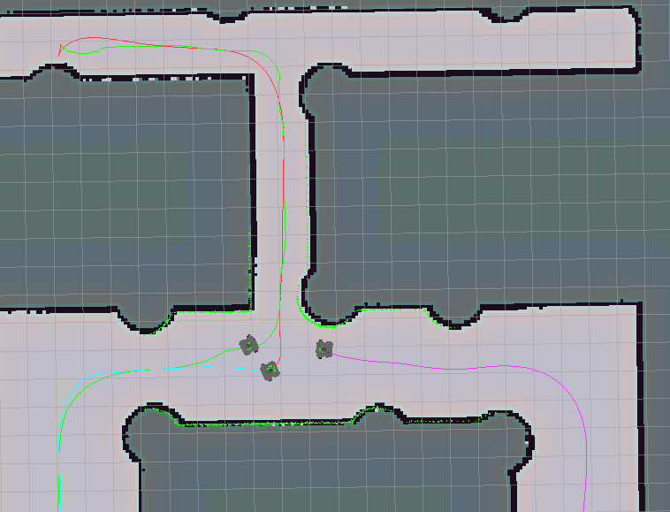
At the moment when robot2 reach the intermediate goal, robot2 and robot0 will be assigned their original goal and start moving.

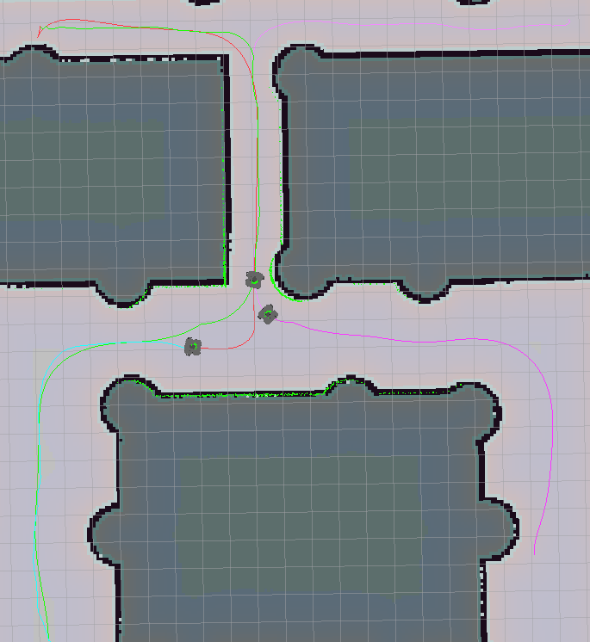
After a few second tobot1 will be assigned its original goal and start moving.
Robot0
Robot1
Robot2

In the end all three robots are able to reach their destination without collision.
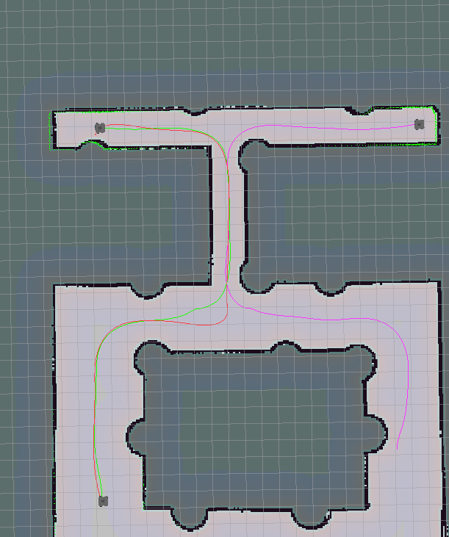
Robot2
Robot1
Robot0

Conclusion
In this project we simulate the multi-robot path planing in a customized map. Although the path planing part is hard coded and way points are hand picked, we demonstrate the idea of how the multi robot path planning is done. In the future we will implement the autonomous multi robot path planning and inter robot commutation and test the algorithm in this environment.

References
Turtlebot3 tutorial.
http://emanual.robotis.com/docs/en/platform/turtlebot3/simulation/#turtlebot3-simulation-using-fake-node
Move_base example
https://github.com/pirobot/ros-by-example/blob/master/rbx_vol_1/rbx1_nav/nodes/move_base_square.py
Amcl/move_base setup for multi-robot simulation
https://answers.ros.org/question/294240/robot-is-not-moving-to-goal/
Multi-robot simulation example
https://github.com/ferherranz/multi_robot

