INSTRUCTION DOC

Name – Aakash Reddy

Email - [kondampallyaakash@gmail.com](mailto:kondampallyaakash@gmail.com)

Output video(gdrive link) - https://drive.google.com/file/d/1DX_-8i0PysCWder5SCQiwC4A67d45rI-/view?usp=sharing

Python version used 3.8.15

Libraries used: numpy, opencv, mediapipe

: ( pip install mediapipe opencv-python numpy )

***Formula used for Stat of Bendness(SOB):***

Used a linear function that maps the range of values from 30 to 140 to the range of 0 to 1 can be represented by the following formula:

**SOB = (x - 30) / (140 - 30)**

where x is the average rep angle.

Assuming 30 is the minimum achievable rep angle, and maximum allowed angle is 140.

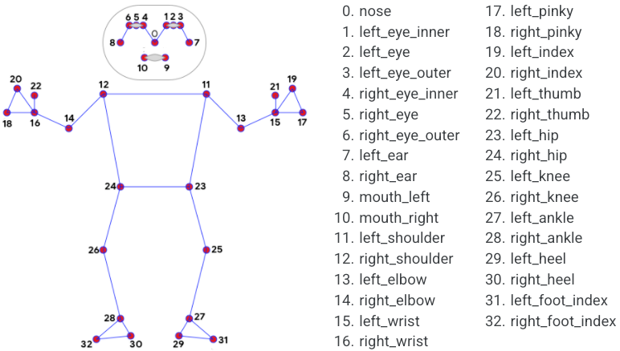

Used the angle between left_hip, left_knee and left_ankle to determine the rep angle, which are derived using the joint mapping provided by mediapipe model.

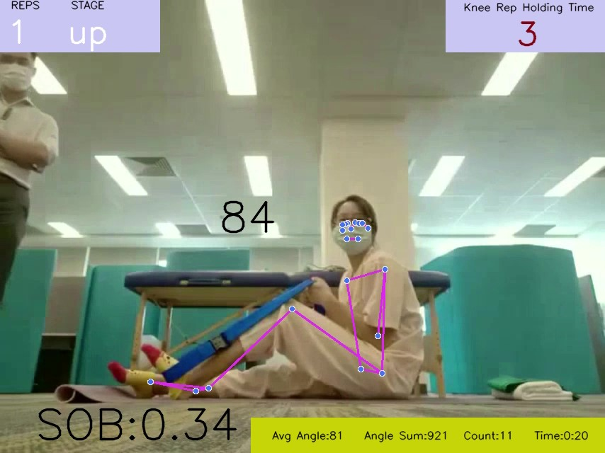

**The top left** indicates no of reps successfully completed, stage indicates is knee up or down to determine is the rep currently going on is she in the rest state.

The **top right** indicates the current time of the rep(3 sec), A rep is deemed successful if the knee holding timer goes above 8 seconds and comes to rest.

The **bottom left SOB** indicates the stat of bendness of the rep using the above-mentioned formula.

The **bottom right** indicates the Average angle for half the second time period ( to take care of the fluctuations), Sum of angles in half a second and no of frames counted in that half of second as count. Time determines the total time elapsed in the video.

I also showed the real time hip-knee-ankle angle over the knee of the person, so that it is easy to visualize the angle.

I predicted the landmarks of joints and connections using a model complexity of 2 using mediapipe, and detection and tracking confidence as 0.5.