**Objective** :-

The assignment is meant for you to apply learnings of the module on Hive on a real-life dataset. One of the major objectives of this assignment is gaining familiarity with how an analysis works in Hive and how you can gain insights from large datasets.

**Problem Statement:-**

New York City is a thriving metropolis and just like most other cities of similar size, one of the biggest problems its residents face is parking. The classic combination of a huge number of cars and a cramped geography is the exact recipe that leads to many parking tickets.

**Download Dataset** - <https://data.cityofnewyork.us/browse?q=parking+tickets>

create table parking_violations_issued

(

Summons_Number bigint,

Plate_ID string,

Registration_State string,

Plate_Type string,

Issue_Date string,

Violation_Code int,

Vehicle_Body_Type string,

Vehicle_Make string,

Issuing_Agency string,

Street_Code1 int,

Street_Code2 int,

Street_Code3 int,

Vehicle_Expiration string,

Violation_Location int,

Violation_Precinct int,

Issuer_Precinct int,

Issuer_Code int,

Issuer_Command string,

Issuer_Squad string,

Violation_Time string,

Time_First_Observed string,

Violation_County string,

Violation_In_Front_Of_Or_Opposite string,

House_Number string,

Street_Name string,

Intersecting_Street string,

Date_First_Observed int,

Law_Section int,

Sub_Division string,

Violation_Legal_Code string,

Days_Parking_In_Effect string,

From_Hours_In_Effect string,

To_Hours_In_Effect string,

Vehicle_Color string,

Unregistered_Vehicle int,

Vehicle_Year string,

Meter_Number string,

Feet_From_Curb int,

Violation_Post_Code string,

Violation_Description string,

No_Standing_or_Stopping_Violation string,

Hydrant_Violation string,

Double_Parking_Violation string)

row format delimited

fields terminated by ','

tblproperties ("skip.header.line.count" = "1");

hive>load data local inpath'file///home/cloudera/Parking_Violations_Issued_-_Fiscal_Year_2017.csv' into table parking_violations_issued;

* **Creating Partitions on Violation Country and Buckets on Summons_Number:**

create table parking_violations_2017

(

Summons_Number bigint,

Plate_ID string,

Registration_State string,

Plate_Type string,

Issue_Date int,

Violation_Code int,

Vehicle_Body_Type string,

Vehicle_Make string,

Issuing_Agency string,

Street_Code1 int,

Street_Code2 int,

Street_Code3 int,

Vehicle_Expiration string,

Violation_Location int,

Violation_Precinct int,

Issuer_Precinct int,

Issuer_Code int,

Issuer_Command string,

Issuer_Squad string,

Violation_Time string,

Time_First_Observed string,

Violation_In_Front_of_or_Opposite string,

House_Number string,

Street_Name string,

Intersecting_Street string,

Date_First_Observed int,

Law_Section int,

Sub_Division string,

Violation_Legal_Code string,

Days_Parking_In_Effect string,

From_Hours_In_Effect string,

To_Hours_In_Effect string,

Vehicle_Color string,

Unregistered_Vehicle int,

Vehicle_Year string,

Meter_Number string,

Feet_From_Curb int,

Violation_Post_Code string,

Violation_Description string,

No_Standing_or_Stopping_Violation string,

Hydrant_Violation string,

Double_Parking_Violation string)

partitioned by (Violation_County string)

CLUSTERED BY (Summons_Number) sorted by (Summons_Number) INTO 8 BUCKETS

row format delimited

fields terminated by ','

tblproperties ("skip.header.line.count" = "1");

* **Set few properties to enable bucketing and Dynamic partition**

hive>set hive.exec.dynamic.partition=true;

hive>set hive.exec.dynamic.partition.mode=nonstrict;

hive>set hive.enforce.bucketing = true;

* **loding data into parking_violations_2017**

insert overwrite table parking_violations_2017

partition(Violation_County) Select

Summons_Number,

Plate_ID,

Registration_State,

Plate_Type,

unix_timestamp(Issue_Date,'MM/DD/YYYY'),

Violation_Code,

Vehicle_Body_Type,

Vehicle_Make,

Issuing_Agency,

Street_Code1,

Street_Code2,

Street_Code3,

Vehicle_Expiration,

Violation_Location,

Violation_Precinct,

Issuer_Precinct,

Issuer_Code,

Issuer_Command,

Issuer_Squad,

Violation_Time,

Time_First_Observed,

Violation_In_Front_Of_Or_Opposite,

House_Number,

Street_Name,

Intersecting_Street,

Date_First_Observed,

Law_Section,

Sub_Division,

Violation_Legal_Code,

Days_Parking_In_Effect,

From_Hours_In_Effect,

To_Hours_In_Effect,

Vehicle_Color,

Unregistered_Vehicle,

Vehicle_Year,

Meter_Number,

Feet_From_Curb,

Violation_Post_Code,

Violation_Description,

No_Standing_or_Stopping_Violation,

Hydrant_Violation,

Double_Parking_Violation,

Violation_County

from parking_violations_issued

where unix_timestamp(Issue_Date,'MM/DD/YYYY') between unix_timestamp('01/01/2017','MM/DD/YYYY') and unix_timestamp('12/31/2017','MM/DD/YYYY');

**Part-I: Examine the data**

1. **Find the total number of tickets for the year**.

select count(distinct summons_number) as No_of_Tickets from parking_violations_2017

asn: 204038

* **Find out how many unique states the cars which got parking tickets came from.**

Hive> select count(distinct Registration_State) as Registration_states from parking_violations_2017;

Total Number of Unique States are : 63

* **Some parking tickets don’t have addresses on them, which is cause for concern. Find out how many such tickets there are(i.e. tickets where either "Street Code 1" or "Street Code 2" or "Street Code 3" is empty )**

select count(distinct summons_number) as Tickets_without_address from parking_violations_2017 where Street_code1 = 0 or Street_code2 = 0 or Street_code3 = 0;

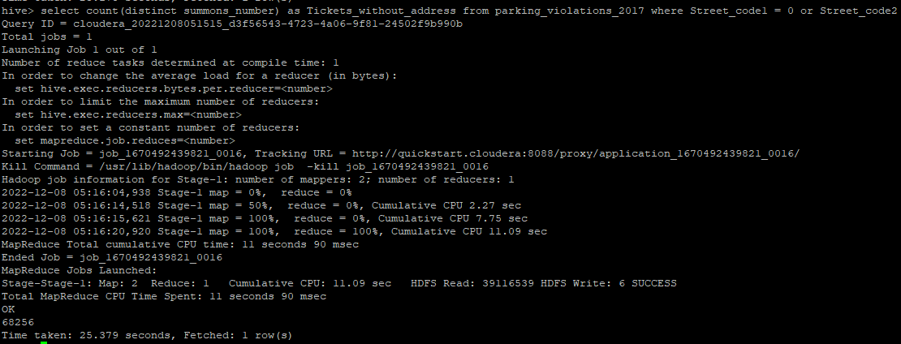

Ans : 68256

Part-II: Aggregation tasks

1. **How often does each violation code occur? (frequency of violation codes - find the top 5)**

Hive> select count(Violation_Code) as violation_codes_frequency,Violation_Code from parking_violations_2017 group by Violation_Code order by violation_codes_frequency desc limit 5;

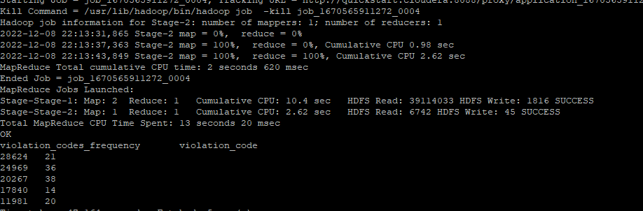

**2.) How often does each vehicle body type get a parking ticket? How about the vehicle make? (find the top 5 for both)**

Hive> select Vehicle_Body_Type,count(summons_number)as Vehicle_body_frequency from parking_violations_2017 group by Vehicle_Body_Type order by Vehicle_body_frequency desc limit 5;

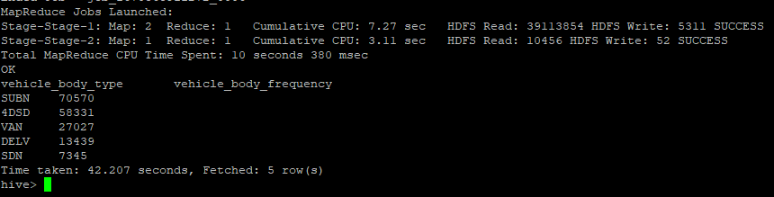

Hive> select Vehicle_make,count(summons_number)as vehicle_make_frequency from parking_violations_2017 group by Vehicle_make order by vehicle_make_frequency desc limit 5;

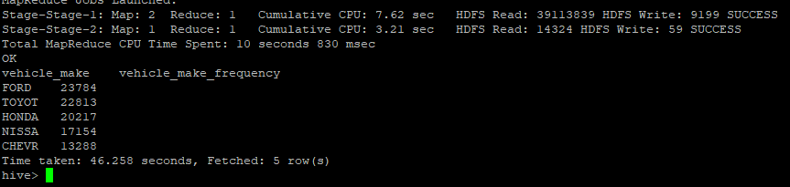

**3.) A precinct is a police station that has a certain zone of the city under its command. Find the (5 highest) frequencies of:**

**a.) Violating Precincts (this is the precinct of the zone where the violation occurred)**

hive> select Violation_Precinct ,count(Violation_Precinct) as violation_precinct_frequency from parking_violations_2017 group by Violation_Precinct order by violation_precinct_frequency desc limit 5; Text

**b.) Issuer Precincts (this is the precinct that issued the ticket)**

hive> select issuer_Precinct ,count(issuer_Precinct) as issuer_precinct_frequency from parking_violations_2017 group by issuer_Precinct order by issuer_precinct_frequency desc limit 5;

**4.) Find the violation code frequency across 3 precincts which have issued the most number of tickets - do these precinct zones have an exceptionally high frequency of certain violation codes?**

Hive> select Issuer_Precinct,Violation_Code, count(*) as Violation_code_frequency from parking_violations_2017 group by Issuer_Precinct, Violation_Code order by Violation_code_frequency desc limit 10;

**18,19,14 are the three issuer precincts which have the maximum number of violations. Lets dive into the Issuer Precincts one by one.**

* **Issuer Precinct 18**

Hive> select Issuer_Precinct,Violation_Code, count(*) as Violation_code_frequency from parking_violations_2017 where issuer_precinct = 18 group by Issuer_Precinct, Violation_Code order by Violation_code_frequency desc limit 10;

* **Issuer Precinct 19**

Hive> select Issuer_Precinct,Violation_Code, count(*) as Violation_code_frequency from parking_violations_2017 where issuer_precinct = 19 group by Issuer_Precinct, Violation_Code order by Violation_code_frequency desc limit 10;

* **Issuer Precinct 14**

Hive> select Issuer_Precinct,Violation_Code, count(*) as Violation_code_frequency from parking_violations_2017 where issuer_precinct = 14 group by Issuer_Precinct, Violation_Code order by Violation_code_frequency desc limit 10;

**5.) Find out the properties of parking violations across different times of the day: The Violation Time field is specified in a strange format. Find a way to make this into a time attribute that you can use to divide into groups.**

Hive> select from_unixtime(unix_timestamp(concat(violation_time,'M'), 'HHmmaaa'),"HH:mmaaa") as date_data from parking_violations_2017 limit 10;

**6.) Divide 24 hours into 6 equal discrete bins of time. The intervals you choose are at your discretion. For each of these groups, find the 3 most commonly occurring violations**

hive> create view vw_parking_violations_partitoned_2017

partitioned on (Violation_Code)

as

SELECT

Summons_Number,

Violation_Time,

Issuer_Precinct,

case

when substring(Violation_Time,1,2) in ('00','01','02','03','12') and upper(substring(Violation_Time,-1))='A' then 1

when substring(Violation_Time,1,2) in ('04','05','06','07') and upper(substring(Violation_Time,-1))='A' then 2

when substring(Violation_Time,1,2) in ('08','09','10','11') and upper(substring(Violation_Time,-1))='A' then 3

when substring(Violation_Time,1,2) in ('12','00','01','02','03') and upper(substring(Violation_Time,-1))='P' then 4

when substring(Violation_Time,1,2) in ('04','05','06','07') and upper(substring(Violation_Time,-1))='P' then 5

when substring(Violation_Time,1,2) in ('08','09','10','11') and upper(substring(Violation_Time,-1))='P'then 6

else null

end as Violation_Time_bin,

Violation_Code

from parking_violations_2017

where

Violation_Time is not null

or (length(Violation_Time)=5 and upper(substring(Violation_Time,-1))in ('A','P')

and substring(Violation_Time,1,2) in ('00','01','02','03','04','05','06','07', '08','09','10','11','12'));

select Violation_Code,Violation_Time_bin, count(*) frequency_violation from vw_parking_violations_partitoned_2017 group by Violation_Code,Violation_Time_bin limit 5;

* **bin1**

select Violation_Code,count(*) frequency_violation from vw_parking_violations_partitoned_2017 where Violation_Time_bin =1 group by Violation_Code order by frequency_violation desc limit 3;

* **bin2**

select Violation_Code,count(*) frequency_violation from vw_parking_violations_partitoned_2017 where Violation_Time_bin =2 group by Violation_Code order by frequency_violation desc limit 3;

* **bin3**

select Violation_Code,count(*) frequency_violation from vw_parking_violations_partitoned_2017 where Violation_Time_bin =3 group by Violation_Code order by frequency_violation desc limit 3;

* **bin4**

select Violation_Code,count(*) frequency_violation from vw_parking_violations_partitoned_2017 where Violation_Time_bin =4 group by Violation_Code order by frequency_violation desc limit 3;

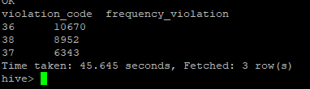

* **bin5**

select Violation_Code,count(*) frequency_violation from vw_parking_violations_partitoned_2017 where Violation_Time_bin =5 group by Violation_Code order by frequency_violation desc limit 3;

* **bin6**

select Violation_Code,count(*) frequency_violation from vw_parking_violations_partitoned_2017 where Violation_Time_bin =6 group by Violation_Code order by frequency_violation desc limit 3;

**7.) Now, try another direction. For the 3 most commonly occurring violation codes, find the most common times of day (in terms of the bins from the previous part)**

Hive> select Violation_Time_bin, count(*) frequency_times from vw_parking_violations_partitoned_2017 where Violation_Code in (21, 38,36)

group by Violation_Time_bin order by frequency_times desc limit 3;

**8.) Let’s try and find some seasonality in this data**

**a.) First, divide the year into some number of seasons, and find frequencies of tickets for each season. (Hint: A quick Google search reveals the following seasons in NYC: Spring(March, April, March); Summer(June, July, August); Fall(September, October, November); Winter(December, January, February))**

**Created View to divide the year into Seasons:**

Hive> create view vw_tickets_issued_2017

partitioned on (Violation_Code)

as

select Issuer_Precinct,

case

when MONTH(from_unixtime(Issue_Date)) between 03 and 05 then 'spring'

when MONTH(from_unixtime(Issue_Date)) between 06 and 08 then 'summer'

when MONTH(from_unixtime(Issue_Date)) between 09 and 11 then 'autumn'

when MONTH(from_unixtime(Issue_Date)) in (1,2,12) then 'winter'

else 'unknown'

end as season,

Violation_Code

from parking_violations_2017;

Hive> select season, count(*) as frequency from vw_tickets_issued_2017 group by season order by frequency desc;