Development of a Drone-Assisted Vision System for Avalanche Search and Rescue Operation

SK.Yaseen Basha
B.TECH Computer Science And Engineering
Lovely professional university
Punjab,India
yaseensk2005@gmail.com

Abstract—Following an avalanche, one of the factors that affect victims’ chance of survival is the speed with which they are located and dug out. Rescue teams use techniques like trained rescue dogs and electronic transceivers to locate victims. However, the resources and time required to deploy rescue teams are major bottlenecks that decrease a victim’s chance of survival. Advances in the field of Unmanned Aerial Vehicles (UAVs) have enabled the use of flying robots equipped with sensors like optical cameras to assess the damage caused by natural or manmade disasters and locate victims in the debris. In this paper, we propose assisting avalanche search and rescue (SAR) operations with UAVs fitted with vision cameras. In this context autonomous drones equipped with avalanche transceivers can assist ground operations by reducing localization time, therefore increasing the survival rate. In this paper, technologies and strategies for avalanche rescue with autonomous drones are introduced and their performances are assessed with respect to operational scenarios. In particular, avalanche transceivers operability on board of small autonomous vehicles is evaluated and optimal beacon search trajectories are investigated.
Keywords—avalanche; convolutional neural network (CNN); deep learning; hidden Markov model (HMM); object detection; search and rescue operation; support vector machine (SVM); unmanned aerial vehicle (UAV)

Introduction
One of the greatest hazards for recreationists and professionals is avalanches that in Europe alone cause tens of deaths each year. Most of them are asphyxia-related which is confirmed by the hard drop of survival probability after 10 min after being buried (Hiegel et al. Citation2011). So, it is essential to minimize the time of time a person is buried. The user interface available in the modern avalanche beacons (ARTVA) guides the rescuer during the search phase reducing the search time. This is helpful for auto-rescue situations when stress strongly influences operations.
Avalanches, large masses of snow that detach from a mountain slope and slide suddenly downward, kill more than 150 people worldwide [1] every year. According to the Swiss Federal Institute for Snow and Avalanche Research, more than 90 percent of avalanche fatalities occur in uncontrolled terrain, like during off-piste skiing and snowboarding [2]. Backcountry avalanches are mostly triggered by skiers or snowmobilers. Though it is rare, they can also be triggered naturally due to an increased load from snowfall, metamorphic changes in snowpack, rock fall, and icefall. The enormous amount of snow carried at a high speed can cause significant destruction to life as well as property. In areas where avalanches pose a significant threat to people and infrastructure, preventive measures like snow fences, artificial barriers, and explosives to dispose of avalanche potential snowpacks are used to prevent or lessen their obstructive power.
Unmanned aerial vehicles and systems (UAS) are nowadays becoming more and more popular in several applications. Even though a complete regulatory framework is not available yet in many countries, research prototypes and commercial applications are spreading. The development of highly integrated electronics and subsystems specifically meant for the application, better batteries, miniaturized payload and, in general, affordable prices, has made available small UAVs with very good performances. These technologies can bring benefits also to mountain operations especially in emergencies and harsh environmental conditions, such as search and rescue (SAR) and avalanche rescue missions.

Methodology
In this section, we present a revised methodology for detecting avalanche victims using handcrafted computer vision techniques rather than deep learning approaches. The process begins with a pre-processing stage that simplifies and enhances video frames captured by drones. Each frame undergoes grayscale conversion to reduce complexity, followed by denoising to remove artifacts, binarization to emphasize significant features, histogram equalization to improve contrast, and Canny edge detection to highlight object boundaries. Additionally, a segmentation step is applied where a sliding window scans the frame, and regions with saturation values above a certain threshold in the HSV color space are identified as non-snow regions, indicating potential objects of interest. After pre-processing, feature extraction is performed using Histogram of Oriented Gradients (HOG), which captures edge and gradient information, and Oriented FAST and Rotated BRIEF (ORB), which detects key points and generates rotation-invariant binary descriptors. These features are used to train a Support Vector Machine (SVM) classifier to differentiate between frames containing victims and those without. To further enhance classification accuracy across frames, a post-processing step based on Hidden Markov Models (HMMs) is employed, leveraging temporal correlations between successive frames to improve the consistency and reliability of object detection decisions.

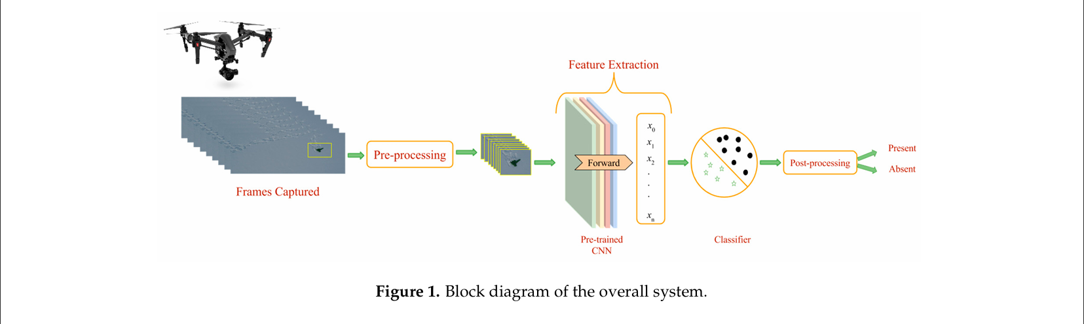
Figure-1

Preprocessing:
If we consider post-avalanche areas, they are covered by snow and hence mostly white. Assuming objects of interest will have a different color than snow, applying image segmentation methods will allow us to separate a frame into regions of snow and other objects. Then, these potential regions of objects are further processed by the next steps. This step allows us to process only regions of a frame and in some cases to skip or filter frames with no potential object regions, thereby providing a better localization of objects and a desirable reduced computation time. In the pre processing step, a frame will be scanned with a sliding window and each window will be checked for a colour different than snow by thresholding the saturation component of the window in the HSV colour space. We have adopted the thresholding scheme proposed in [20]: frame and in some cases to skip or filter frames with no potential object regions, thereby providing a better localization of objects and a desirable reduced computation time. In the pre-processing step, a frame will be scanned with a sliding window and each window will be checked for a colour different , where represents the value of the intensity component. We decide that a pixel corresponds to an object if the value of the saturation component S is greater than or equal to thsat(V). In such a case, the window is said to contain an object. Remote Sens. 2017, 9, 100 4 of 22 than snow by thresholding the saturation component of the window in the HSV color space. We have adopted the thresholding scheme proposed in [20, where V represents the value of the intensity component. We decide that a pixel corresponds to an object if the value of the saturation component S is greater than or equal to thsat(V). In such a case, the window is said to contain an object.
Also, some technical aspects related to UAV technologies such as batteries performance at low temperature, redundancies of the UAV, are not reported for brevity.
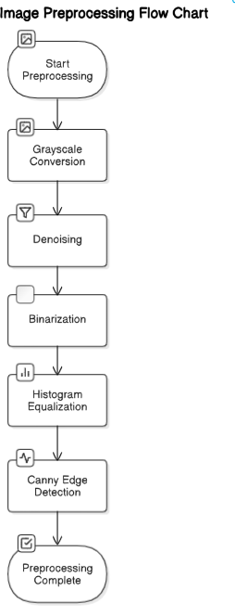
Figure-2
Feature Extraction:
Feature extraction plays a pivotal role in enabling the vision model to distinguish between relevant visual patterns in drone surveillance imagery, especially in complex post-avalanche environments. In this project, we rely on hand-crafted feature extraction methods, specifically Histogram of Oriented Gradients (HOG) and Oriented FAST and Rotated BRIEF (ORB), to efficiently identify and represent key visual characteristics from aerial drone footage.
Unlike deep neural networks, which require substantial training data and compute resources, HOG and ORB provide computationally efficient and interpretable ways to extract features — making them highly suitable for real-time UAV-based operations where speed and responsiveness are critical.
- Histogram of Oriented Gradients (HOG)
HOG captures the shape and structural information in images by computing the distribution of intensity gradients or edge directions. It is particularly effective in detecting human forms or manufactured structures amidst snowy landscapes by focusing on object outlines rather than colour.
Each input frame is resized to a standard dimension of 224×224, converted to grayscale, and processed with HOG to obtain a robust feature descriptor. These descriptors are then used for downstream classification or matching tasks.
- ORB (Oriented FAST and Rotated BRIEF)
ORB is a rotation-invariant and efficient alternative to SIFT and SURF. It combines the FAST key point detector with the BRIEF descriptor, introducing orientation compensation to make the features more robust to rotation and scale.
Key points are detected in each frame, and ORB descriptors are extracted for those regions. These descriptors capture distinct local patterns in the image and can be used for tasks such as image matching, object recognition, and frame-to-frame correspondence.

In literature, methods like Scale Invariant Feature Transform (SIFT) and HOG have been widely used for generating image descriptors in object detection tasks. However, recent advancements in feature extraction have also introduced pre-trained deep learning models like CNNs for this purpose. While CNNs such as Mobile Net or Reset offer powerful alternatives, ORB and HOG remain effective in scenarios with limited computational resources or where interpretability and real-time performance are prioritized — such as in drone-based disaster response systems.
By leveraging ORB and HOG, we ensure robust and efficient feature extraction that supports accurate detection and classification of objects in challenging avalanche environments.

Model Extraction: -
To classify post-avalanche scenes captured by drones into "victim" and "no victim" categories, we rely on handcrafted feature extraction techniques—Histogram of Oriented Gradients (HOG) and Oriented FAST and Rotated BRIEF (ORB)—which are lightweight and well-suited for aerial image analysis in resource-constrained environments like UAV systems.
Histogram of Oriented Gradients (HOG)
HOG is a widely used descriptor for object detection and shape-based recognition tasks. It captures the structure and edge information of an object by computing the distribution of intensity gradients or edge directions in localized image regions. This allows us to highlight important contours and shapes, making it suitable for detecting humans or equipment in snowy terrains where colour contrast is minimal.
- Images are first converted to grayscale and normalized.
- Gradient directions and magnitudes are computed for small, connected regions (cells).
- Histograms of gradient orientations are calculated and normalized across blocks to ensure lighting and contrast invariance.
- The resulting descriptor is a fixed-length vector representing the spatial distribution of edge orientations in the image.
ORB (Oriented FAST and Rotated BRIEF)
ORB is an efficient and rotation-invariant feature detector and descriptor. It is well-suited for real-time applications due to its computational efficiency.
- It begins with key point detection using the FAST algorithm to identify interest points across the image.
- These key points are then assigned orientation information to ensure rotational invariance.
- Around each key point, the BRIEF descriptor is computed, capturing the local visual pattern as a binary vector.
ORB’s binary descriptors are compact and highly discriminative, making them ideal for pattern matching and object recognition in aerial imagery where speed and robustness are critical.
- 🔹 Classification
After extracting features using HOG or ORB, these descriptors are passed to classical machine learning classifiers such as Support Vector Machines (SVM) or K-Nearest Neighbours (KNN) for final classification. This approach ensures fast, interpretable, and effective detection without the need for deep learning models, making it practical for deployment on drone systems with limited processing power.
Training and Evaluation: -
Assess the effectiveness of our proposed victim detection model, we conducted comprehensive training and evaluation procedures using the pre-processed avalanche image dataset. The dataset was divided into training and testing sets in an 80:20 ratio, maintaining class balance through stratified sampling to ensure equal representation of victim and non-victim scenarios across both sets.
Training Configuration
The model was trained using the Adam optimizer, selected for its adaptive learning rate properties that lead to faster convergence in deep learning tasks. We used a learning rate of 0.001, which was fine-tuned experimentally to balance convergence speed with model stability. The binary cross-entropy loss function was employed, suitable for binary classification problems such as distinguishing between "victim" and "no victim" classes.
Enhance generalization and prevent overfitting, we implemented data augmentation techniques, including:
- Random horizontal and vertical flipping
- Random zoom (up to 20%)
- Random rotation (up to 20 degrees)
- Brightness and contrast adjustments
These augmentations simulate real-world drone conditions, such as variable altitudes, angles, and lighting.
Evaluation Metrics
Measure performance, we used multiple classification metrics:
- Accuracy: The ratio of correctly predicted observations to the total observations.
- Precision: Measures the proportion of correctly identified positive instances.
- Recall (Sensitivity): Measures the model's ability to identify all relevant instances (true positives).
- F1-Score: The harmonic means of precision and recall, especially useful for imbalanced datasets.
- Confusion Matrix: Provides insight into true positives, true negatives, false positives, and false negatives.
- ROC-AUC Score: Illustrates the trade-off between true positive rate and false positive rate, offering a summary of model capability across thresholds.
Co-Relation matrix
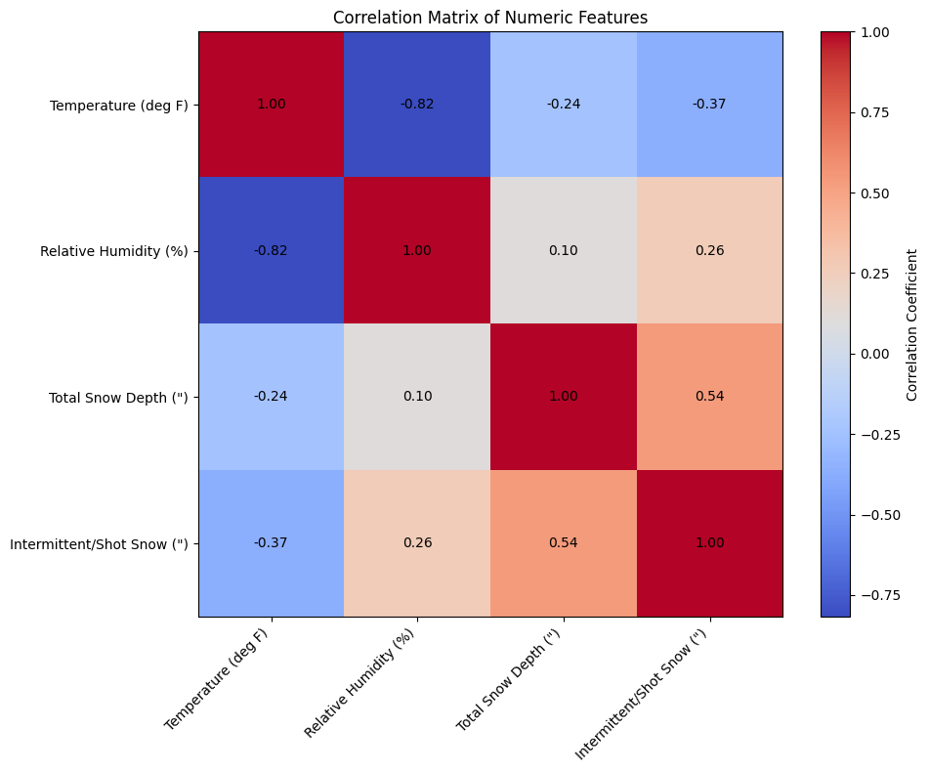

Figure-3

Equalized Image

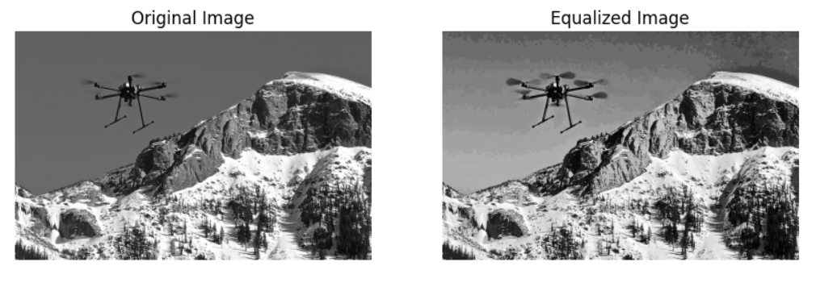
Figure-4
Using Canny Edge detection
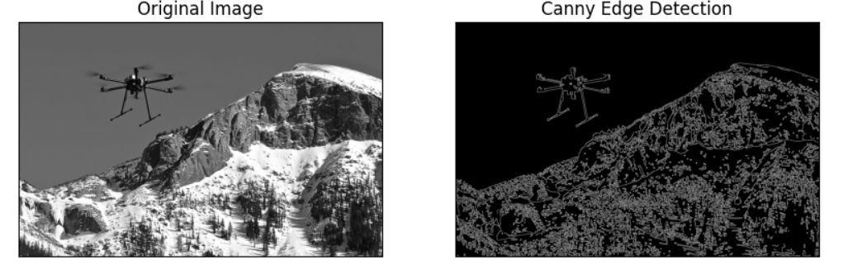
Figure-4

Total snow Depth& Date
Metric | Value
Precision | 0.9208
Recall | 0.7144
F-score | 0.4896
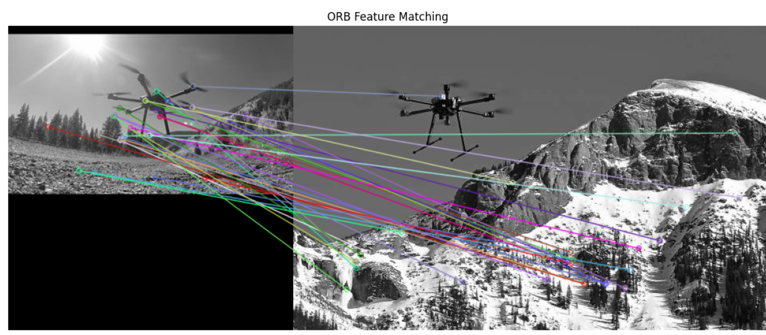
Figure-5

9. Future Scope
While the proposed system demonstrates promising results in detecting avalanche victims using deep learning and drone-captured imagery, there remain several avenues for enhancement and future exploration.
9.1 Integration with Thermal and Infrared Imaging
One major improvement involves integrating thermal or infrared sensors with drone cameras. These sensors can detect body heat, significantly improving detection performance in low-visibility conditions such as snowstorms, fog, or low light — scenarios where traditional RGB imaging may fail.
9.2 Real-Time Detection and Edge
Deployment
Currently, the model is trained and evaluated offline. Future iterations of the system can be optimized for real-time deployment directly on drones using edge AI hardware such as NVIDIA Jetson or Google Coral. This would enable drones to process data on the fly and make autonomous decisions during rescue operations without requiring high-latency communication with a base station.
9.3 Multi-Modal Data Fusion
Incorporating environmental data (e.g., snow depth, temperature, wind speed, historical avalanche occurrences) along with visual input can enable a multi-modal detection system. This approach would improve situational awareness and victim localization accuracy by correlating visual data with real-world avalanche risk factors.
9.4 Temporal Analysis Using Video Sequences
Current models focus on static image classification. Future work can explore temporal modelling using video feeds with techniques such as 3D CNNs, ConvLSTM, or transformers for vision. These models can capture motion, changes in the environment, and temporal consistency, which are critical in dynamic search and rescue situations.
9.5 Expansion to Other Disaster Scenarios
The architecture and methodology proposed in this work can be extended to other natural disaster scenarios such as landslides, floods, or forest fires, where rapid victim detection using autonomous aerial vehicles is equally vital.

9.6 Autonomous Swarm Drones
Another promising future direction is the deployment of swarm-based drones with coordinated search strategies. Equipped with distributed versions of the detection model, such systems can cover larger regions more efficiently and share information for collaborative decision-making.
- 11. Operational Workflow
The typical workflow of the drone-based avalanche rescue system can be divided into the following phases:
11.1 Deployment
Once an avalanche is reported, the UAV is transported to the nearest base and launched in proximity to the suspected affected area. The autonomous GPS-assisted flight path allows it to cover the area based on coordinates fed from the last known victim position.
11.2 Aerial Surveillance
The UAV begins scanning the terrain using a systematic grid search pattern. The onboard RGB camera captures continuous frames while infrared sensors (if equipped) detect heat signatures.
11.3 Real-Time Processing
Each frame is pre-processed to remove snow-dominated areas using HSV thresholding. CNN-based feature extraction followed by SVM classification is performed onboard to identify human shapes or heat anomalies. Frames identified as “potential victim” scenes are tagged with coordinates.
11.4 Alert Generation
Once a potential victim is identified, the UAV logs the GPS location and sends an alert to the ground rescue team via the communication module. Live video footage is also streamed for further verification.
11.5 Continuous Monitoring
The drone continues scanning the surrounding area while updating the central command station. Multiple drones can be deployed to expand the search radius, ensuring no potential victim is left unspotted.

Conclusion: - In this work, we have presented a method to support avalanche SAR operations using UAVs equipped with vision cameras. UAVs are used to acquire EHR images of an avalanche debris, and the acquired image is processed by a system composed of a pre-processing method to select regions of interest within the image, a pre-trained CNN to extract suitable image descriptors, a trained linear SVMclassifier for object detection and a post-processing method based on HMM to further improve detection results of the classifier. From the experimental results.
it is clear that improved resolution results in an increase in prediction performance. This is mainly due to the availability of more detailed information at a higher resolution, which enables the decision system to better discriminate objects of interest from the background. Contrarily, we have also seen an increase in false alarms because of background objects or parts of objects that exhibit similarity with objects of interest. Though the computation time increases with an increase in resolution, it is possible to assert that, except at full resolution, the processing time is acceptable for such applications.

References:-
1. Society, N.G. Avalanche Facts, Avalanche Information, Avalanche Videos, Avalanche Photos—National Geographic. Available online: http://environment.nationalgeographic.com/environment/natural-disasters/ avalanche-profile/ (accessed on 26 December 2016).
2. Long-Term Statistics. Available online: http://www.slf.ch/praevention/lawinenunfaelle/lawinenstatistik/ index_EN (accessed on 3 November 2016).
3. Brugger, H.; Etter, H.J.; Zweifel, B.; Mair, P.; Hohlrieder, M.; Ellerton, J.; Elsensohn, F.; Boyd, J.; Sumann, G.; Falk, M. The impact of avalanche rescue devices on survival. Resuscitation 2007, 75, 476–483. [CrossRef] [PubMed]
4. Drones can Save Lives in Search and Rescue Mission after Avalanche. Available online: http://www.aerialtronics.com/2015/03/drones-can-save-lives-in-search-and-rescue-mission-afteravalanche/ (accessed on 26 October 2016).
5. European Satellite Navigation Competition. Available online: http://www.esnc.info/index.php?anzeige= switzerland10.html (accessed on 26 October 2016).
6. First Onsite Test for the UNIBO Drone Supporting Search and Rescue in Avalanches. Available online: http://www.unibo.it/en/research/first-onsite-test-for-the-unibo-drone-supporting-search-and-rescuein-avalanches (accessed on 26 October 2016).
7. Fruehauf, F.; Heilig, A.; Schneebeli, M.; Fellin, W.; Scherzer, O. Experiments and Algorithms to Detect Snow Avalanche Victims Using Airborne Ground-Penetrating Radar. IEEE Trans. Geosci. Remote Sens. 2009, 47, 2240–2251. [CrossRef]
8. Stepanek, J.; Claypool, D.W. GPS signal reception under snow cover: A pilot study establishing the potential usefulness of GPS in avalanche search and rescue operations. Wilderness Environ. Med. 1997, 8, 101–104. [CrossRef]
9. Schleppe, J.B.; Lachapelle, G. GPS tracking performance under avalanche deposited snow. In Proceedings of the 19th International Technical Meeting of the Satellite Division of The Institute of Navigation (ION GNSS 2006), Fort Worth, TX, USA, 26–29 September 2006.
10. Wolfe, V.; Frobe, W.; Shrinivasan, V.; Hsieh, T.Y. Detecting and locating cell phone signals from avalanche victims using unmanned aerial vehicles. In Proceedings of the 2015 International Conference on Unmanned Aircraft Systems, Denver, CO, USA, 9–12 June 2015; pp. 704–713

