DESIGN AND EVALUATION OF AN ARABIC-AWARE PROMPT COMPRESSION SELECTOR FOR LARGE LANGUAGE MODELS

By

Badr Abouabdou

A DISSERTATION

Submitted to

The University of Liverpool

in partial fulfilment of the requirements
for the degree of

MASTER OF SCIENCE

02/11/2026

DECLARATION
I hereby certify that this dissertation constitutes my own product, that where the language of others is set forth, quotation marks so indicate, and that appropriate credit is given where I have used the language, ideas, expressions, or writings of another.
I declare that the dissertation describes original work that has not previously been presented for the award of any other degree of any institution.

Signed,
Student, Supervisors and Classes:
Student name: | Badr Abouabdou
Student ID number: | 30026
DL name: | Andrea Corradini
DA name: | Laud Charles Ochei

DESIGN AND EVALUATION OF AN ARABIC-AWARE PROMPT COMPRESSION SELECTOR FOR LARGE LANGUAGE MODELS

A DISSERTATION

Submitted to

The University of Liverpool

in partial fulfilment of the requirements
for the degree of

MASTER OF SCIENCE

02/11/2026
ABSTRACT

DESIGN AND EVALUATION OF AN ARABIC-AWARE PROMPT COMPRESSION SELECTOR FOR LARGE LANGUAGE MODELS

LLM APIs charge per token, and their tokenisers split Arabic words into far more tokens than English ones, so Arabic users pay more for the same content. Prompt compression can cut this cost, but existing methods were built and tested on English. This dissertation asks how well they work on Arabic, which prompt features drive their performance, and whether a recommender can choose the best strategy for each prompt.
Following design science, the project built AraPromptBench (1,000 Arabic prompts from six public corpora plus synthetic creative prompts) and a 400-prompt fresh exam set. It compared LLMLingua, LLMLingua-2 and random deletion at three rates over more than 17,000 API calls. Fidelity was measured on the LLM's answers with AraBERT BERTScore, against a threshold derived from the model's own repeat-call noise.
LLMLingua-2 was the best compressor, beating random deletion by 0.04–0.05 F1 at every rate. Prompt-level similarity ranked the methods backwards. Task type and length explained outcomes; morphology did not. The artefact, the Arabic-Aware Prompt Compression Selector (APCS), reached 31% accuracy as a rule-based selector. A decision-tree redesign reached 38.5% on the pre-registered exam, significantly above the best fixed strategy (Holm p = 0.028). Unexpectedly, compression raised the total bill by 5–24%, because it deleted answer-length instructions and answers grew. Protecting those instructions turned the penalty into a 5–8% saving. Arabic prompt compression must therefore be judged on outputs and total cost, not tokens saved.
ACKNOWLEDGEMENTS

I am grateful to my Dissertation Advisor (DA), Dr. Laud Charles Ochei, for the guidance, constructive feedback and encouragement given throughout this project, and for questions that sharpened its methodology, including the suggestion to test the effect of synthetic data. I also thank the Dissertation Lead (DL), Dr. Andrea Corradini, for overseeing the dissertation process and for the support provided throughout the module.
This project uses publicly available datasets released by their authors: CIDAR, the Aya dataset, XL-Sum, the Essex Arabic Summaries Corpus, TyDi QA and ARCD. Their licences are recorded per prompt in AraPromptBench.
Generative AI tools were used in this project in two ways. First, to generate the synthetic datasets: the 500-prompt pilot set (gpt-5.4-mini), the v2 creative prompts and the Experiment 09 probe pool (Claude Fable 5), and the exam creative briefs (Claude Opus 5.5). These are identified as synthetic throughout, and their effect was measured (Experiment 09). Second, as a coding assistant for the experiment pipeline and the APCS package. The author directed this work throughout: the author defined the research questions, made all design and methodological decisions, oversaw every stage of the pipeline, and reviewed and revised every piece of code before it was used. All analyses and conclusions are the author's own, and every reported number was independently verified against the raw data.

TABLE OF CONTENTS

Page

LIST OF TABLES viii

LIST OF FIGURES ix

Chapter 1. Introduction 1

1.1 Chapter Introduction 1

1.2 Problem Statement 1

1.3 Project Aims and Objectives 2

1.4 Approach 3

1.5 Outcome 4

1.6 Chapter Summary 5

Chapter 2. Background and Review of Literature 6

2.1 Chapter Introduction 6

2.2 Research Background 6

2.3 Literature Review 7

2.3.1 Prompt compression methods 7

2.3.2 Adaptive and cost-aware LLM use 9

2.3.3 Multilingual tokenisation and morphology 10

2.3.4 Arabic NLP and LLM evaluation 11

2.3.5 Evaluating compressed prompts 12

2.3.6 The research gap 13

2.4 Theory 14

2.5 Terminology 15

2.6 Chapter Summary 16

Chapter 3. Analysis and Design 18

3.1 Chapter Introduction 18

3.2 Project Specification 18

3.3 Research Methods 19

3.4 Design Considerations 21

3.4.1 Benchmark design 21

3.4.2 Compression candidates 22

3.4.3 LLM under test and calling protocol 23

3.4.4 Fidelity measurement 24

3.4.5 Labels and metrics 24

3.4.6 APCS architecture 25

3.4.7 Evaluation plan and hypotheses 26

3.5 Chapter Summary 26

Chapter 4. Implementation (Realisation) 28

4.1 Chapter Introduction 28

4.2 Details of the Implementation 28

4.2.1 Environment and tooling 28

4.2.2 Pilot phase and the design changes it triggered 29

4.2.3 Building AraPromptBench v2 30

4.2.4 The benchmark pipeline 31

4.2.5 Calibrating APCS 1.0.0 32

4.2.6 The Experiment 11 redesign 33

4.2.7 Changes from the Specification and Design Report 34

4.3 The IT Artefact 35

4.4 Chapter Summary 37

Chapter 5. Results and Evaluation 38

5.1 Chapter Introduction 38

5.2 Evaluation of IT Artefact 38

5.2.1 Measurement validity: the noise ceiling 38

5.2.2 RQ1: effectiveness of compression methods on Arabic 39

5.2.3 Category fragility and task accuracy 42

5.2.4 RQ2: which prompt features matter 42

5.2.5 The cost finding: fewer input tokens, a bigger bill 44

5.2.6 RQ3 (stage 1): APCS 1.0.0 on the held-out test split 46

5.2.7 RQ3 (stage 2): the redesigned selectors on the fresh exam 47

5.2.8 The length-protected compressor 49

5.2.9 Synthetic data sensitivity 50

5.2.10 Robustness and verification 51

5.2.11 Answering the research questions 52

5.3 Chapter Summary 53

Chapter 6. Conclusions 54

6.1 Chapter Introduction 54

6.2 Lessons Learned 54

6.3 Strengths and Weakness of the Project 57

6.4 Academic Application and Limitations 59

6.5 Business Application and Limitations 60

6.6 Recommendations / Prospects for Future Research / Work 61

6.7 Chapter Summary 62

REFERENCES CITED 63

APPENDICES 69

LIST OF TABLES

Page

Table 1. Prompt compression alternatives evaluated against the project's requirements 9
Table 2. Project components and the research questions they serve 19
Table 3. AraPromptBench v2 and exam set composition 21
Table 4. Implementation environment 28
Table 5. Pilot experiments and the design decisions they produced 30
Table 6. Changes from the SDR and their justification 35
Table 7. Structure of the APCS package 35
Table 8. Output-level fidelity of LLMLingua-2 vs random deletion (dev, n = 800, paired) 40
Table 9. OLS model of LLMLingua-2 @ 0.5 output fidelity (dev, R² = 0.148) 43
Table 10. Input-token saving vs total measured cost change (dev, output priced at 6× input) 44
Table 11. Selector and baseline performance on the held-out test split (n = 200) 46
Table 12. Pre-registered hypotheses on the fresh exam (n = 400; exact two-sided McNemar for H1 and H2, conservative for directional hypotheses) 48
Table 13. All policies on the fresh exam (n = 400) 48
Table 14. Plain vs length-protected LLMLingua-2 on exam prompts with a length instruction (n = 180) 50
Table 15. Answers to the research questions 52
Table 16. SDR project plan and outcomes 56
Table 17. APCS feature definitions 94
Table 18. Worked example of plain vs protected compression (exam-qa-043) 96
Table 19. Experiment log summary 97

LIST OF FIGURES

Page

Figure 1. Architecture of the APCS artefact and the evaluation pipeline that calibrates it 25
Figure 2. Repeat-call noise ceiling on the dev set: distribution of output F1 between two answers to the identical prompt, with the SDR threshold (0.85) and the adopted τ (0.65) 39
Figure 3. Compression trade-off by method on the dev set: mean TCR against mean output F1 at target rates 0.7, 0.5 and 0.3 40
Figure 4. The ranking flip: LLMLingua-2 minus random deletion at prompt level (negative) and output level (positive) 41
Figure 5. Spearman correlation between prompt features and output fidelity at target rate 0.5 (dev) 43
Figure 6. Input tokens saved vs total API bill saved per policy (dev; negative bill saving = costs more) 45
Figure 7. Confusion matrix of APCS 1.0.0 recommendations against best-balance labels (test) 47
Figure 8. Best-balance accuracy of each policy on the fresh exam, with 95% bootstrap confidence intervals 48
Figure 9. Total API cost relative to the uncompressed prompt, plain vs protected LLMLingua-2 (exam prompts with a length instruction) 50
Figure 10. Fidelity difference between synthetic and real prompts by category and rate, with 95% bootstrap intervals 51

Introduction

Chapter Introduction
Large language models (LLMs) are now accessed mostly through commercial application programming interfaces (APIs) that charge per token, separately for the tokens sent in the prompt and the tokens generated in the answer. For organisations building Arabic-language applications, this pricing model carries a hidden surcharge. Tokenisers trained mainly on English text split Arabic words into many more sub-word pieces than English words, so the same content costs more to process (Ahia et al., 2023; Petrov et al., 2023). Prompt compression, which shortens a prompt before it is sent while trying to keep its meaning, is one of the most practical ways to reduce that cost (Li et al., 2025). Almost all compression methods, however, were designed and evaluated on English.
This dissertation investigates whether existing prompt compression methods work for Arabic and whether a lightweight recommender can choose, for each Arabic prompt, the compression strategy that best balances token savings against fidelity. It presents three linked contributions: AraPromptBench, an Arabic benchmark for prompt compression; an empirical analysis of compression behaviour on Arabic; and the Arabic-Aware Prompt Compression Selector (APCS), a Python artefact that recommends a compression strategy. This chapter states the problem, the research questions, the aims and objectives, the approach taken and the intended outcomes.

Problem Statement
Practitioners who deploy LLMs for Arabic users face two unresolved problems, first identified in the project proposal and Specification and Design Report (SDR) (Appendices A and B).
The first is a measurement problem. Leading compression methods such as LLMLingua (Jiang et al., 2023) and LLMLingua-2 (Pan et al., 2024) report large reductions in prompt length with little loss of task performance, but their evidence comes from English benchmarks and English-trained scoring models. Arabic differs from English in ways that plausibly matter for compression: it is morphologically rich, attaches clitics such as conjunctions, prepositions and pronouns to words, and is written in a script that byte-level tokenisers fragment heavily (Habash, 2010). Whether methods that decide which tokens are "unimportant" in English make sensible decisions in Arabic is an open empirical question.
The second is a selection problem. Even if compression helps on average, no single method or compression rate is likely to be best for every prompt. Short questions may tolerate no compression at all, while long articles to be summarised may tolerate heavy compression. Work on cost-efficient LLM use shows that adaptive, per-query strategies outperform fixed ones (Chen, Zaharia and Zou, 2024; Ding et al., 2024), but this principle has not been applied to choosing a compression strategy, and the prompt characteristics that should drive such a choice for Arabic are unknown.
The project addresses both problems with the three research questions fixed in the proposal:
- RQ1. How effective are existing prompt compression techniques on Arabic prompts?
- RQ2. How do prompt features influence compression performance?
- RQ3. Can a recommendation system accurately select the optimal compression strategy?
The proposed solution is an IT artefact, the APCS, that extracts features from an Arabic prompt and recommends a compression method and target rate. Its rules are derived from the benchmark built to answer RQ1 and RQ2.

Project Aims and Objectives
The aim of the project is to investigate the effectiveness of prompt compression techniques on Arabic prompts, and to design, implement and evaluate an Arabic-Aware Prompt Compression Selector that recommends the most suitable compression strategy for a given Arabic prompt while balancing token reduction against semantic fidelity.
The aim is pursued through five objectives, carried over from the proposal:
1. Review the literature on prompt compression, efficient LLM use, multilingual tokenisation, morphology and Arabic natural language processing (NLP) to identify the research gap (Chapter 2).
2. Design a benchmarking framework and recommendation architecture, including the structure of AraPromptBench, the prompt features, the evaluation criteria and the APCS decision logic (Chapter 3).
3. Implement the system: construct AraPromptBench, integrate the compression methods into a reproducible pipeline and build the APCS as a Python package (Chapter 4).
4. Evaluate the compression methods and the APCS using token compression ratio, semantic fidelity, recommendation accuracy and measured cost, against baseline strategies on held-out data (Chapter 5).
5. Recommend how Arabic prompt compression should be used in practice, and where it should not (Chapter 6).
In scope are Modern Standard Arabic (MSA) prompts in four task categories (instruction following, summarisation, question answering and creative writing); extractive, token-deletion compression methods that work with any black-box LLM API; and one commercial LLM under test, used with fixed, deterministic settings. Out of scope are dialectal Arabic beyond a small probe; "soft" compression methods that require access to model internals (Mu, Li and Goodman, 2023; Ge et al., 2024); long-context retrieval-augmented generation; and training new compression models.

Approach
The project follows the design science research paradigm (Hevner et al., 2004): it builds a purposeful artefact, evaluates its utility rigorously, and reports what was learned both about the artefact and about the problem. The work proceeded through eleven documented experiments in four phases.
1. Pilot (Experiments 01–07). A 500-prompt pilot set was used to select the fidelity scorer, test which compression methods run correctly on Arabic, measure LLM output variability and build a first APCS. The pilot was dev-only from the start, so nothing in it informs the held-out evaluations.
2. Benchmark construction (Experiment 08). AraPromptBench v2 contains 1,000 prompts: 850 drawn from six public Arabic corpora and 150 synthetic creative prompts. It is split 800/200 into development and held-out test sets.
3. Final benchmark (Experiments 09–10). Every prompt was compressed by each method at three target rates, sent to the LLM under test (13,438 API calls) and scored at output level against the answer to the uncompressed prompt. APCS 1.0.0 was calibrated on the 800 development prompts and evaluated once on the 200 test prompts.
4. Redesign on a fresh exam (Experiment 11). Results from Experiment 10 motivated an improved selector, a cost-aware selector and a length-protecting compressor. Because the test split had already been used, these were evaluated on a newly built 400-prompt exam set, with hypotheses pre-registered before any exam answer was collected.
Fidelity is measured by BERTScore F1 (Zhang et al., 2020) between the LLM's answer to the compressed prompt and its answer to the original prompt. The pass threshold is derived from the LLM's own repeat-call noise. Methods are compared with paired non-parametric tests, and selectors with exact McNemar tests and bootstrap confidence intervals. Chapters 3 and 4 describe the method and its implementation in detail.

Outcome
The intended outcomes, as set out in the proposal, were:
- AraPromptBench, a reproducible Arabic benchmark for prompt compression with documented provenance, licences and splits;
- empirical evidence on how LLMLingua, LLMLingua-2 and a random-deletion baseline behave on Arabic prompts across task types, and which prompt features explain the differences;
- the APCS artefact, an open, explainable Python package with a command-line interface and library API, evaluated against no-compression, fixed-method and random-selection baselines;
- practical guidance for developers deploying Arabic LLM applications.
All four were delivered. The evaluation also produced an outcome that was not anticipated: on a model whose output tokens cost six times its input tokens, compressing prompts made the total bill higher, because the compressor deleted instructions that controlled answer length. This finding reshaped the final design and is treated as a contribution in its own right (Chapters 5 and 6).

Chapter Summary
This chapter introduced the cost problem that motivates Arabic prompt compression, framed it as a measurement problem and a selection problem, and stated three research questions, an aim and five objectives. It summarised the design-science approach and the eleven experiments through which the work was carried out, and listed the intended outcomes. Chapter 2 reviews the literature on which the project builds and identifies the research gap it fills.

Background and Review of Literature

Chapter Introduction
This chapter establishes what is already known about the problem and where the gap lies. Section 2.2 explains why token-based pricing makes Arabic prompts disproportionately expensive. Section 2.3 reviews five bodies of work: prompt compression methods; adaptive, cost-aware LLM use; multilingual tokenisation and morphology; Arabic NLP and LLM evaluation; and the methodology for evaluating compressed prompts. It critically compares the alternatives and closes with the research gap. Section 2.4 sets out the theory on which the APCS is built: compression strategy selection as an algorithm selection problem under a fidelity constraint, with an explicit cost model. Section 2.5 defines the terms used throughout.

Research Background
Commercial LLM APIs bill each request by the number of tokens processed, with separate prices for input (prompt) tokens and output (completion) tokens. Prices differ by up to two orders of magnitude between providers and models (Chen, Zaharia and Zou, 2024). Output tokens are typically several times more expensive than input tokens; for the model used in this project, the ratio is 6:1 (US$0.20 per million input tokens and US$1.20 per million output tokens). Token count therefore determines cost, latency, energy use and how much of the model's context window a request uses (Wan et al., 2024). Inference energy grows with the number of tokens processed and generated (Samsi et al., 2023), so shorter exchanges are also greener.
Tokenisers do not treat languages equally. Ahia et al. (2023) measured OpenAI's API on 22 typologically diverse languages and found that some languages need up to five times more tokens than English for the same content, so speakers of those languages pay more while often receiving worse results. Petrov et al. (2023) found differences of up to fifteen times between language pairs, and showed that even byte-level tokenisers leave large gaps. Arabic is among the disadvantaged languages. In this project the tokeniser of the target API (cl100k_base) produced a mean of 4.1 tokens per Arabic word across the 1,000 AraPromptBench prompts (10th–90th percentile 3.7–4.6). In other words, a typical Arabic word is split into four pieces, each billed separately. Arabic users therefore pay what can fairly be called a tokeniser tax.
Two responses to the tax exist. Model builders can extend the vocabulary with Arabic tokens: ALLaM merged a dedicated Arabic tokeniser into an English model's vocabulary (Bari et al., 2025), and AraLLaMA expanded the vocabulary progressively during training (Zhu et al., 2025). Both remedies are available only to whoever trains the model. Developers who consume a commercial API cannot change its tokeniser; they can only change what they send. For them, prompt compression is the practical lever, and that is the setting this project addresses.
Arabic LLM capability has improved quickly. Arabic-centric models such as AceGPT (Huang et al., 2024a) and ALLaM, and benchmarks such as ORCA (Elmadany, Nagoudi and Abdul-Mageed, 2023), Dolphin (Nagoudi et al., 2023) and ArabicMMLU (Koto et al., 2024), have made Arabic understanding and generation measurable. Efficiency for Arabic, however, has received far less attention than capability. That imbalance is the background to the research questions.

Literature Review

Prompt compression methods
Li et al. (2025) survey the field and divide prompt compression into two families. Soft-prompt methods compress a prompt into learned continuous vectors. Gisting trains a model to summarise an instruction into a few "gist" tokens, reaching up to 26-fold compression (Mu, Li and Goodman, 2023). AutoCompressors recursively summarise long documents into summary vectors (Chevalier et al., 2023). The In-context Autoencoder encodes a context into compact memory slots using a lightly fine-tuned copy of the LLM (Ge et al., 2024). These methods compress very effectively but need access to the model's weights or embedding layer. A developer calling a closed commercial API cannot send vectors instead of text, so soft-prompt methods are unusable in the setting of this project.
Hard-prompt methods instead output a shorter natural-language prompt that any API accepts. Selective Context removes phrases and sentences with low self-information, estimated by a small causal language model. It halves context length with only a 0.023 drop in BERTScore on English tasks (Li et al., 2023). LLMLingua (Jiang et al., 2023) refines the same idea with a coarse-to-fine procedure: a budget controller allocates compression across prompt sections, then tokens are removed iteratively according to a small model's perplexity. It reaches up to 20-fold compression on English reasoning and conversation benchmarks. LongLLMLingua adds question-aware scoring and document reordering for long retrieval contexts (Jiang et al., 2024). RECOMP compresses retrieved documents into extractive or abstractive summaries before they are added to the prompt (Xu, Shi and Choi, 2024). Nano-Capsulator rewrites prompts into shorter natural-language capsules with a fine-tuned LLM (Chuang et al., 2024). Other recent work learns which tokens to delete with reinforcement learning (Jung and Kim, 2024), prunes in-context examples for reasoning tasks (Huang et al., 2024b), or scores whole sentences with a context-aware encoder (Liskavets et al., 2025).
LLMLingua-2 (Pan et al., 2024) departs from perplexity scoring. Its authors argue that the entropy of a causal model is unidirectional and not aligned with the compression objective. They distil keep-or-drop labels from GPT-4 and train a bidirectional token classifier (XLM-RoBERTa-large) to predict them. The result is three to six times faster than LLMLingua and more faithful to the original prompt. Two properties make LLMLingua-2 especially relevant here: its encoder is multilingual, and its compression rate can be controlled precisely.
Evaluations of these methods are becoming more critical. Jha et al. (2024) find that simple extractive compression often beats token pruning, despite claims to the contrary. Łajewska et al. (2025) show that several state-of-the-art methods fail to preserve key details such as entities, which hurts complex tasks. Nagle et al. (2024) derive the distortion–rate function for black-box prompt compression and show a large gap between current methods and the optimum. The gap is narrowed by compression that is query-aware and variable-rate, meaning it knows the downstream task and adapts the rate to each input. This is the theoretical case for choosing the compression rate per prompt rather than fixing it globally. Table 1 summarises the alternatives against the requirements of this project.
Method family | Representative work | Black-box API compatible | Multilingual scorer available | Rate control | Suitability here
Soft prompts / memory slots | Mu, Li and Goodman (2023); Chevalier et al. (2023); Ge et al. (2024) | No | Model-dependent | Fixed by training | Excluded: needs model internals
Perplexity-based token deletion | Li et al. (2023); Jiang et al. (2023) | Yes | Yes, if the scorer is swapped | Approximate | Included (LLMLingua)
Question-aware long-context | Jiang et al. (2024); Xu, Shi and Choi (2024) | Yes | Partly | Approximate | Excluded: targets long retrieval contexts
Classifier-based token deletion | Pan et al. (2024) | Yes | Yes (XLM-RoBERTa) | Precise | Included (LLMLingua-2)
Generative rewriting | Chuang et al. (2024) | Yes | Needs a fine-tuned LLM | Weak | Excluded: needs training, adds an LLM call
Learned or sentence-level selection | Jung and Kim (2024); Liskavets et al. (2025) | Yes | Needs retraining for Arabic | Coarse (sentence) or learned | Excluded: no Arabic models; coarse units suit long contexts
Random token deletion | — (baseline) | Yes | Not applicable | Precise | Included as control
Table 1. Prompt compression alternatives evaluated against the project's requirements
Every one of these methods was developed and evaluated on English. LLMLingua's reference scorers are GPT-2 and LLaMA-7B. LLMLingua-2's distillation data (MeetingBank) is English. None of the papers reports results on Arabic or any other morphologically rich language. Whether English-learned notions of token importance transfer to Arabic is therefore untested. RQ1 addresses this.

Adaptive and cost-aware LLM use
A second body of work shows that choosing per query beats committing to one global strategy. FrugalGPT combines prompt adaptation, model approximation and an LLM cascade. It matches GPT-4's accuracy at up to 98% lower cost by sending each query only as far up the cascade as needed (Chen, Zaharia and Zou, 2024). Hybrid LLM trains a router that predicts query difficulty and sends easy queries to a small model, cutting large-model calls by up to 40% without loss of quality (Ding et al., 2024). RouteLLM learns routers from human preference data and more than halves cost (Ong et al., 2025). FORC uses a meta-model to predict each candidate model's performance on an input and chooses the cheapest adequate one, reducing cost by 63% (Šakota, Peyrard and West, 2024).
These systems share the APCS's structure: inexpensive features of the input drive a choice among options with different cost–quality trade-offs. They differ in what they choose, which is models rather than compression strategies, and all were evaluated on English. They also optimise expected cost directly, using measured prices. As Chapter 5 shows, that turns out to matter: a selector that optimises token reduction is not optimising the bill.
The same structure has a long history in computer science as the algorithm selection problem (Rice, 1976). Given a problem space, a set of algorithms and a performance measure, a selection mapping uses features of each problem instance to choose the algorithm expected to perform best. Framing compression choice this way identifies the components the APCS needs (instance features, a candidate set, a performance measure and a learned mapping) and the right baseline: the single best solver, the one fixed algorithm that performs best on average.

Multilingual tokenisation and morphology
Why might Arabic behave differently under compression? The tokenisation literature offers mechanisms. Limisiewicz, Balhar and Mareček (2023) show that multilingual tokenisers allocate vocabulary unevenly across languages, and that the allocation predicts downstream performance gaps. Ali et al. (2024) find that tokeniser choice measurably changes both downstream accuracy and training cost. English-centric tokenisers used for multilingual models cause severe downstream degradation and up to 68% additional training cost. On morphology, Park et al. (2021) find that languages with richer inflectional morphology are harder to model, though the effect weakens when segmentation respects morpheme boundaries. Arnett and Bergen (2025) test three explanations for the gap. They find no evidence that tokenisers' alignment with morpheme boundaries explains it, some evidence for tokenisation quality, and the clearest effect from training-data size. The gap largely disappears when datasets are equated in size after adjusting for each script's encoding efficiency (its "byte premium"), so morphological type itself confers no intrinsic disadvantage. MorphBPE builds morpheme boundaries into byte-pair encoding and improves training efficiency for morphologically rich languages, including Arabic (Asgari et al., 2026).
Two hypotheses follow for compression. First, if a prompt's tokens are mostly fragments of words, deleting tokens may break words. Deleting one byte-level fragment of a multi-byte Arabic character can even corrupt the text. Second, prompts with dense morphology, where many function words are fused into each orthographic word, may carry more information per word and so tolerate deletion less. The SDR turned the second hypothesis into a morphology-based selection rule. RQ2 tests both. The evidence above suggests morphology itself may matter less than tokenisation and the amount of text, and that is the outcome Chapter 5 reports.

Arabic NLP and LLM evaluation
Habash (2010) describes the properties of Arabic that complicate processing: root-and-pattern morphology, clitic attachment, optional diacritics, and the coexistence of Modern Standard Arabic with regional dialects. Language-specific processing pays off. The Farasa segmenter splits words into clitics and stems quickly and accurately (Abdelali et al., 2016). AraBERT, pre-trained on Arabic with segmentation-aware preprocessing, outperforms multilingual BERT on Arabic understanding tasks (Antoun, Baly and Hajj, 2020). Both are used in this project: Farasa to measure morphological density, and AraBERT as the fidelity scorer.
Arabic LLM evaluation has matured rapidly. GPTAraEval evaluated ChatGPT on 44 Arabic tasks and found it clearly behind smaller fine-tuned models on many of them (Khondaker et al., 2023). ArabicMMLU measures knowledge with school-exam questions from Arabic-speaking countries (Koto et al., 2024). ORCA and Dolphin provide understanding and generation benchmarks respectively (Elmadany, Nagoudi and Abdul-Mageed, 2023; Nagoudi et al., 2023). Public instruction corpora now exist: CIDAR provides 10,000 culturally reviewed instruction–response pairs (Alyafeai et al., 2024), and the Aya dataset provides human-written instructions in many languages and dialects (Singh et al., 2024). Together with older task corpora (XL-Sum for summarisation (Hasan et al., 2021), the Essex Arabic Summaries Corpus (El-Haj, Kruschwitz and Fox, 2010), TyDi QA (Clark et al., 2020) and ARCD (Mozannar et al., 2019) for question answering), these made it possible to build AraPromptBench from credible, licensed sources rather than from invented prompts.
None of these benchmarks studies efficiency. They measure whether a model can do a task in Arabic, not what it costs or how far a prompt can be shortened. To the author's knowledge, no Arabic prompt compression benchmark existed when this project began.

Evaluating compressed prompts
Three methodological issues from the literature shape how compression should be evaluated.
Fidelity measurement. BERTScore compares texts by matching contextual token embeddings, which captures paraphrase better than n-gram overlap (Zhang et al., 2020). Its behaviour depends on the encoder, so an Arabic-specific encoder may separate good from bad Arabic outputs better than multilingual BERT (Devlin et al., 2019). Experiment 01 tests this (Chapter 4). An alternative is to ask a strong LLM to judge answer quality. Such judges agree well with human preferences (Zheng et al., 2023; Chiang and Lee, 2023), but they add an extra paid call per comparison and bring biases of their own, including a preference for longer answers. For a benchmark of tens of thousands of comparisons, a deterministic embedding-based metric is more reproducible and affordable. It also matters which texts are compared. Comparing the compressed prompt with the original rewards keeping words, not keeping meaning. Comparing the LLM's answers to the two prompts measures what users actually experience. Selective Context and LLMLingua both report task performance on outputs for this reason (Li et al., 2023; Jiang et al., 2023).
Non-determinism. Supposedly deterministic LLM settings are not deterministic. Ouyang et al. (2025) found that ChatGPT gives different code for the same prompt even at temperature zero. Song et al. (2025) show that evaluations based on a single sample per prompt hide considerable variability. A fidelity threshold must therefore be judged against the model's own noise: if two calls with the identical prompt often score below a threshold, that threshold cannot separate compression damage from chance. The SDR's fixed threshold of 0.85 was not tested this way. This project tests it (Chapter 5).
Output length. LLMs trained with reinforcement learning from human feedback tend to produce longer answers, because preference models reward length (Singhal et al., 2024). Automatic evaluators share the bias and must be corrected for length (Dubois et al., 2024). Explicit length instructions are one of the main ways to control answer length (Jie et al., 2024), and adding a token budget to the prompt cuts reasoning tokens substantially (Han et al., 2025). The implication for compression has not been drawn in the compression literature: when output costs more than input, the words that control how much the model writes may be the most valuable words in the prompt.
Two further concerns apply to evaluation data. Contamination: benchmark items seen during development, or during model training, inflate measured performance (Sainz et al., 2023; Deng et al., 2024). Public test sets can be traced in a model's outputs (Golchin and Surdeanu, 2024). Selectors tuned after looking at test results can be contaminated in the same way, so a design changed in response to test results must be re-evaluated on unseen data. Synthetic data: LLM-generated examples can fill gaps cheaply but may differ systematically from real data (Long et al., 2024; Liu et al., 2024), so their effect must be measured rather than assumed.

The research gap
The literature establishes that prompt compression can reduce token use substantially (Jiang et al., 2023; Pan et al., 2024); that adaptive per-input selection beats fixed strategies for cost-efficient LLM use (Chen, Zaharia and Zou, 2024; Šakota, Peyrard and West, 2024); and that tokenisation imposes a measurable cost penalty on Arabic (Ahia et al., 2023; Petrov et al., 2023). These findings have not been connected. Specifically, to the best of the author's knowledge, based on searches of the ACL Anthology and Google Scholar (October 2026):
1. no published study evaluates prompt compression methods on Arabic, so it is unknown whether English-trained compressors transfer (RQ1);
2. no study relates prompt features such as length, task type, tokeniser fragmentation or morphological density to compression outcomes in Arabic (RQ2);
3. no feature-based recommender exists for selecting a compression strategy per prompt, in Arabic or any other language (RQ3);
4. compression is evaluated by token reduction or input cost. Its effect on output length, and so on the total bill under output-weighted pricing, has not been measured.
The fourth gap emerged during the project rather than from the initial review. It is included because the literature on length bias (Singhal et al., 2024) and length control (Jie et al., 2024) predicts it, and because the results confirm it.

Theory
Compression as constrained optimisation. Let p be a prompt and M the LLM under test. A compression strategy s = (method, target rate) maps p to a shorter prompt s(p). Its token compression ratio is TCR(s, p) = 1 − |s(p)| / |p|. Its fidelity is F(s, p) = BERTScore F1 between M(s(p)) and M(p), the answers to the compressed and original prompts. The proposal defines the best strategy as the one that "maximises token reduction while maintaining semantic fidelity above a defined threshold". Formally, for a candidate set S that always contains no compression (TCR = 0, F = 1):
s∗(p) = arg max over s ∈ S of TCR(s, p), subject to F(s, p) ≥ τ
This best-balance label exists for every prompt, because no compression always satisfies the constraint. It turns per-prompt evaluation into a classification target.
Selection as algorithm selection. Following Rice (1976), the APCS is a mapping from a feature vector f(p) to a strategy in S, and is judged by how often it chooses s∗(p) on unseen prompts. The natural baselines are the single best fixed strategy, random selection and never compressing. Interpretable mappings, such as ordered threshold rules and shallow decision trees, are preferred over black-box classifiers. A developer can inspect them, they can be audited against the evidence that produced them, and they suit small calibration sets. This follows the SDR's emphasis on explainability.
The cost model. For a call with n_{in} prompt tokens and n_{out} completion tokens, the cost is C = π_{in}·n_{in} + π_{out}·n_{out}, with π_{out} = 6π_{in} for the model studied. Compression reduces n_{in} by the TCR, but the saving only materialises if n_{out} does not grow. The total saving from compressing is π_{in}·Δn_{in} − π_{out}·Δn_{out}, so a 10% increase in answer length cancels a 60% reduction in prompt length when answers and prompts are of similar size. Token reduction is therefore a reliable proxy for cost only if compression leaves answer length unchanged. This theory makes the fourth research gap testable. It is also why the project measures cost from the token counts the API actually bills, never from TCR.
Measurement noise and the threshold. Because M is not deterministic, F has a noise floor: the distribution of BERTScore F1 between two answers to the identical prompt. A sensible τ should be failed by pure noise only rarely. This project sets τ at the 0.4th percentile of the repeat-call distribution (99.6% specificity), rounded to a convenient value. A compressed prompt that falls below τ has then almost certainly been damaged by compression rather than by chance.

Terminology
- Prompt compression: reducing a prompt's token count before sending it to an LLM while trying to preserve the information it needs.
- Target rate (keep rate): the fraction of tokens a compressor is asked to keep (0.7, 0.5 or 0.3 in this project). Achieved keep is the fraction actually kept.
- Token Compression Ratio (TCR): 1 − compressed tokens / original tokens, counted with the cl100k_base tokeniser.
- Fragmentation ratio: tokens per orthographic word; the size of the tokeniser tax for a given prompt.
- Morphological density: mean number of Farasa segments (clitics and stems) per Arabic word.
- Prompt-level fidelity: BERTScore F1 between the compressed and original prompts. Diagnostic only.
- Output-level fidelity: BERTScore F1 between the LLM's answers to the compressed and original prompts. The primary fidelity measure.
- Noise ceiling: the distribution of output-level F1 between two answers to the identical prompt.
- τ (tau): the fidelity threshold derived from the noise ceiling (0.65 for AraBERT).
- Best-balance label: for a prompt, the strategy with the largest TCR whose output F1 ≥ τ, or no compression if none qualifies.
- Cheapest-faithful label: for a prompt, the strategy with the lowest measured API cost whose output F1 ≥ τ.
- Length instruction: an explicit constraint on answer length, such as "briefly", "in three sentences" or "no more than fifty words".
- LLMLingua-2-protected: the variant developed in this project that keeps sentences containing length instructions verbatim and compresses the rest.
- APCS 1.0.0, APCS-v2, APCS-cost: the calibrated rule-based selector, the redesigned decision-tree selector, and the cost-aware selector (Chapter 4).
- Dev, test and exam sets: the 800-prompt development split, the 200-prompt held-out split and the 400-prompt fresh exam set.

Chapter Summary
The literature shows that hard-prompt compression is the only family usable with a closed API; that LLMLingua and LLMLingua-2 represent its two main scoring philosophies; that adaptive per-input selection outperforms fixed strategies elsewhere in cost-efficient LLM use; and that tokenisation makes Arabic disproportionately expensive. It has not tested compression on Arabic, related prompt features to compression outcomes, built a compression selector, or measured compression's effect on output length and total cost. The theory section formalised the best-balance target, framed the APCS as an algorithm selector and showed with a cost model why token reduction need not reduce the bill. Chapter 3 turns this into a specification and research design.

Analysis and Design

Chapter Introduction
This chapter explains how the literature and theory of Chapter 2 were turned into a research design and an artefact design. Section 3.2 restates the project specification and maps each component to a research question. Section 3.3 describes the research methodology: design science, a controlled paired experiment, and the safeguards against contamination and post-hoc tuning. Section 3.4 sets out the design decisions for the benchmark, the compression candidates, the LLM protocol, fidelity measurement, labels and metrics, the APCS architecture and the evaluation plan, each with its justification. Where the final design differs from the SDR, this chapter gives the evidence-based reason; Section 4.2.7 consolidates all deviations.

Project Specification
The project must deliver (i) a benchmark that can measure compression on Arabic, (ii) an analysis pipeline that relates prompt features to compression outcomes, and (iii) an artefact that recommends a compression strategy for any Arabic prompt. Table 2 links each component to the research question it serves, as the SDR required.
Component | Serves | Specification
AraPromptBench v2 (1,000 prompts) and exam set (400) | RQ1, RQ3 | MSA prompts from credible public corpora; four task categories; documented licences; deconfounded length bands; dev / test / exam separation with zero overlap
Compression layer | RQ1 | LLMLingua, LLMLingua-2 and random deletion at target keep rates 0.7 / 0.5 / 0.3, plus no compression; deterministic and seeded
LLM and evaluation module | RQ1–RQ3 | One fixed LLM with deterministic settings; output-level BERTScore with a noise-derived threshold; measured token usage and cost per call
Feature extractor | RQ2, RQ3 | Character length, token count, fragmentation ratio, structural complexity, morphological density, task category (plus a length-instruction flag added in Experiment 11)
APCS decision engine | RQ3 | Interpretable mapping from features to a strategy; calibrated on dev only; frozen before held-out evaluation
Interfaces | Artefact use | Python library API and command-line interface; JSON output; versioned rule files
Table 2. Project components and the research questions they serve
The non-functional requirements carried over from the SDR are reproducibility (seeds, configuration and model snapshot recorded with every result), explainability (the selector must state why it chose a strategy), low inference overhead (feature extraction without a GPU or an LLM call), and evaluation integrity (held-out data used once, after the design is frozen).

Research Methods
Methodology. The project follows design science research (Hevner et al., 2004). This methodology suits a project that must both build an artefact and generate knowledge about the problem it addresses. Hevner et al.'s guidelines map directly onto the work. Design as an artefact: the APCS and AraPromptBench. Problem relevance: the Arabic tokeniser tax (Section 2.2). Design evaluation: held-out and fresh-exam experiments against baselines. Research rigour: paired tests, pre-registration and an independent audit. Design as a search process: the iteration from the pilot rule through APCS 1.0.0 to APCS-v2. Research contributions: both the artefact and the empirical findings on Arabic compression. Communication: this dissertation, the experiment log and a public-ready repository.
Research approach. The empirical work is quantitative and experimental. The unit of analysis is a prompt. Every prompt is processed by every strategy, which gives a fully paired (within-prompt) design: differences between strategies are not confounded by differences between prompts, and paired tests can be used. Sampling into the benchmark is stratified by source, category and length band with a fixed seed (42), so the dataset is reproducible and its composition controlled.
Statistical methods. The choice of tests follows the SDR and standard practice for paired NLP comparisons:
- Method comparisons (RQ1): Wilcoxon signed-rank test on per-prompt output F1 differences (Wilcoxon, 1945). This test is non-parametric because F1 differences are bounded and skewed. Paired bootstrap 95% confidence intervals (10,000 resamples) are given for mean differences.
- Feature effects (RQ2): Spearman correlations within strata; Kruskal–Wallis tests for category effects within length bands; ordinary least squares regression with standardised features and category indicators. The unique variance of each predictor is the drop in R² when it is removed from the full model.
- Selector accuracy (RQ3): exact McNemar test on paired correct/incorrect outcomes (McNemar, 1947), with bootstrap 95% confidence intervals for accuracy and accuracy differences.
- Multiplicity: Holm's sequentially rejective procedure across the pre-registered hypotheses of Experiment 11 (Holm, 1979).
- Cost: one-sided Wilcoxon test on per-prompt cost differences, plus the change in total measured cost.
Safeguards against contamination and over-fitting. Evaluation data seen during design inflates measured performance (Sainz et al., 2023; Deng et al., 2024). Four safeguards were applied. (1) The 500-prompt pilot was designated dev-only before any analysis, and AraPromptBench v2 was built with zero overlap with it, so the v2 test split is untouched by pilot-era decisions. (2) The v2 test split was read by a single script, run once, after APCS 1.0.0 was frozen. (3) When Experiment 10's results motivated a redesign, the redesigned selectors were not evaluated on the already-used test split. A new 400-prompt exam set was built instead, with zero exact or 12-word passage overlap with every earlier set. (4) Selectors, hypotheses, comparators and the analysis script for the exam were frozen and committed in a pre-registration document before any exam answer was collected (Appendix D).
Ethics. The project involves no human participants, personal data or user prompts. All corpora are public and used under their licences (Table 3), and the creative, probe and pilot prompts are synthetic. The proposal records that ethics approval was not required, and nothing in the final design changed that (Appendix C). Two indirect issues are handled explicitly: licences are tracked per prompt, and findings are reported as applying to Modern Standard Arabic and not generalised to all Arabic varieties.

Design Considerations

Benchmark design
AraPromptBench v2 follows the composition planned in the SDR (Table 3). Prompts are built from task corpora using fixed templates: five summarisation phrasings and three QA phrasings, rotated to avoid template artefacts. Each prompt is screened by an Arabic-character gate (at least 80% Arabic letters) and deduplicated after Unicode and diacritic normalisation, both within v2 and against the pilot. Length bands are defined in cl100k tokens: short 30–90, medium 91–250, long 251–650.
Source | Category | Licence | n (v2) | n (exam)
CIDAR (Alyafeai et al., 2024) | Instruction | CC BY-NC 4.0 | 250 | 84
Aya, Arabic subset incl. dialectal probe (Singh et al., 2024) | Instruction | Apache 2.0 | 100 | 56
XL-Sum Arabic (Hasan et al., 2021) | Summarisation | CC BY-NC-SA 4.0 | 150 | 60
EASC (El-Haj, Kruschwitz and Fox, 2010) | Summarisation | Research use | 100 | 40
TyDi QA GoldP Arabic (Clark et al., 2020) | QA | Apache 2.0 | 159 | 64
ARCD (Mozannar et al., 2019) | QA | CC BY-SA 4.0 | 91 | 36
Synthetic creative briefs (Claude Fable 5; exam: Claude Opus 5.5) | Creative | CC BY 4.0 | 150 | 60
Total |  |  | 1,000 | 400
Table 3. AraPromptBench v2 and exam set composition
A design weakness found in the pilot drove one deliberate change. In the pilot, almost all short prompts were QA or creative and almost all long ones were summarisation, so length and task type were confounded and their effects could not be separated. The v2 design therefore fills every category × length cell, deliberately including 57 short summarisation prompts and 99 long QA prompts. This deconfounding is what allows RQ2 to separate the two effects.
The 150 creative prompts are synthetic because public Arabic creative-writing prompts with suitable licences were not available at the required scale. To avoid circularity between generator and evaluator, they were generated with Claude Fable 5 (Anthropic), a model from a different provider and family than the LLM under test (OpenAI's gpt-5.6-luna). Every brief caps the requested answer at 120 words or fewer, which fixed the pilot's frequent truncation of creative answers. Because synthetic prompts might behave differently, their effect is measured, not assumed (Experiment 09; Section 5.2.9). The resulting v2 prompts average 220 cl100k tokens (median 185, range 30–664), with a mean fragmentation ratio of 4.1 tokens per word.
The exam set (400 prompts: 140 instruction, 100 summarisation, 100 QA, 60 creative) was built with the same sources, templates and band mix, but a different seed (4242). Its 60 creative briefs were newly generated with Claude Opus 5.5 (Anthropic) in the same format, with the same 120-word cap. Every v2 record, every v2 QA passage and any text sharing a 12-word span with a pilot, v2 or probe prompt was excluded. Shared instruction templates were exempted because they are identical by design. An independent audit (Section 5.2.10) confirmed zero overlap.
Synthetic data provenance. Synthetic prompts were generated with the most capable model available to the author at the time of each generation step: the 500-prompt pilot set with gpt-5.4-mini (OpenAI); the 150 v2 creative prompts and the 456-prompt Experiment 09 probe pool with Claude Fable 5 (Anthropic); and the 60 exam creative briefs with Claude Opus 5.5 (Anthropic). All synthetic prompts that contribute to held-out results were therefore produced by a different provider from the LLM under test, which avoids generator–evaluator circularity. The pilot set, whose generator came from the same provider as the pilot's LLM, was used only for development and informs no held-out result.

Compression candidates
Three compressors and a no-compression option were selected from the alternatives in Table 1:
- LLMLingua-2 (Pan et al., 2024) with its released XLM-RoBERTa-large classifier, representing classifier-based scoring;
- LLMLingua (Jiang et al., 2023), representing perplexity-based scoring. Its default GPT-2 scorer was replaced with Qwen2.5-0.5B, because the vertical slice showed that GPT-2 corrupts Arabic (Section 4.2.2);
- random deletion at the same keep rate, seeded per prompt: the control that any intelligent method must beat;
- no compression, which is always available and always passes the fidelity constraint.
Each compressor runs at target keep rates of 0.7, 0.5 and 0.3, the rates fixed in the SDR. Experiment 11 adds LLMLingua-2-protected at the same rates (Section 4.2.6). LongLLMLingua, named in the proposal, was replaced by LLMLingua-2 at the SDR stage. LongLLMLingua's question-aware machinery targets long multi-document retrieval contexts that AraPromptBench does not contain, while LLMLingua-2 gives the scientifically more useful contrast of classifier against perplexity scoring.

LLM under test and calling protocol
One commercial LLM is used throughout the final benchmark, with the most deterministic settings it accepts: temperature 0 and reasoning effort "none", so no hidden reasoning tokens are billed. The completion limit is 1,024 tokens. The SDR's limit of 512 truncated 9.6% of pilot answers (401 of 4,173), which biased the fidelity scores. The SDR specified gpt-4o-mini, and the pilot used it. For the final benchmark the project moved to gpt-5.6-luna, a newer small model from the same provider, billed the same way (separate prices per input and output token). The reason was relevance: the final results should describe the current generation of low-cost models that practitioners are deploying now, so that the measured noise ceiling, answer-length behaviour, costs and selector calibration remain accurate for present-day use. All reported results come from one model snapshot in one uninterrupted run. Every call records the API's own prompt-token and completion-token counts and the model snapshot. The order of calls is shuffled with a fixed seed so that any drift over time cannot line up with a method or category.

Fidelity measurement
Three design decisions govern fidelity.
Output level, not prompt level. Fidelity is measured between the LLM's answers to the compressed and original prompts, not between the prompts. The pilot showed why: at prompt level, random deletion scores higher than LLMLingua-2, because BERTScore rewards keeping words verbatim. At output level the ranking reverses (Section 5.2.2). Prompt-level F1 is retained only as a diagnostic.
Scorer. The SDR named multilingual BERT as the primary scorer and AraBERT-v02 as the check. Experiment 01 compared them on 4,000 controlled perturbation pairs. Both rank pairs almost identically (Spearman 0.98), but AraBERT has 50% more dynamic range (0.51 vs 0.34 between identical and unrelated texts). Under multilingual BERT, randomly deleting 30% of a prompt still passes the SDR's 0.85 threshold 86% of the time; under AraBERT, 9.8% of the time. AraBERT therefore became primary (layer 9, no rescaling), consistent with Antoun, Baly and Hajj (2020), and multilingual BERT the sensitivity check.
Threshold from the noise ceiling. Each prompt's original version was sent twice, and the two answers scored against each other. τ is the 0.4th percentile of this repeat-call distribution on the dev prompts, rounded to 0.65 for AraBERT (0.75 for multilingual BERT). Section 5.2.1 shows why the SDR's fixed 0.85 could not be kept.

Labels and metrics
The primary label is best balance (Section 2.4): the candidate with the largest TCR whose output F1 ≥ τ, chosen from no compression and LLMLingua-2 at 0.7, 0.5 and 0.3. The SDR's original metric, the share of prompts on which the selector picks any Pareto-optimal candidate, was implemented and found to be degenerate. Because no compression always has the highest fidelity, it is always Pareto-optimal, so the trivial policy "never compress" scored 88.5% on the test split, higher than any real selector (Section 5.2.6). Best-balance accuracy keeps the proposal's own definition of "best balance" and removes this degeneracy, so it was adopted as the primary RQ3 metric. Pareto-hit rate is reported as a footnote.
A second label, cheapest faithful, is the candidate with the lowest measured call cost whose F1 ≥ τ, chosen from ten candidates. It was introduced in Experiment 11 to evaluate the cost-aware selector. Secondary metrics are mean TCR, mean output F1, the rate of answers below τ, the change in total measured cost relative to never compressing, and, for QA prompts, QA correctness: whether the answer contains the gold answer string.

APCS architecture
Figure 1 shows the architecture as built. The APCS is a thin, dependency-light layer: a feature extractor that needs only a tokeniser (plus an optional Java segmenter for morphology), a decision engine that reads its rules from a versioned JSON file, and an optional compression step that applies the recommendation through LLMLingua. The evaluation pipeline is outside the artefact. It produces the evidence from which the rules are calibrated.
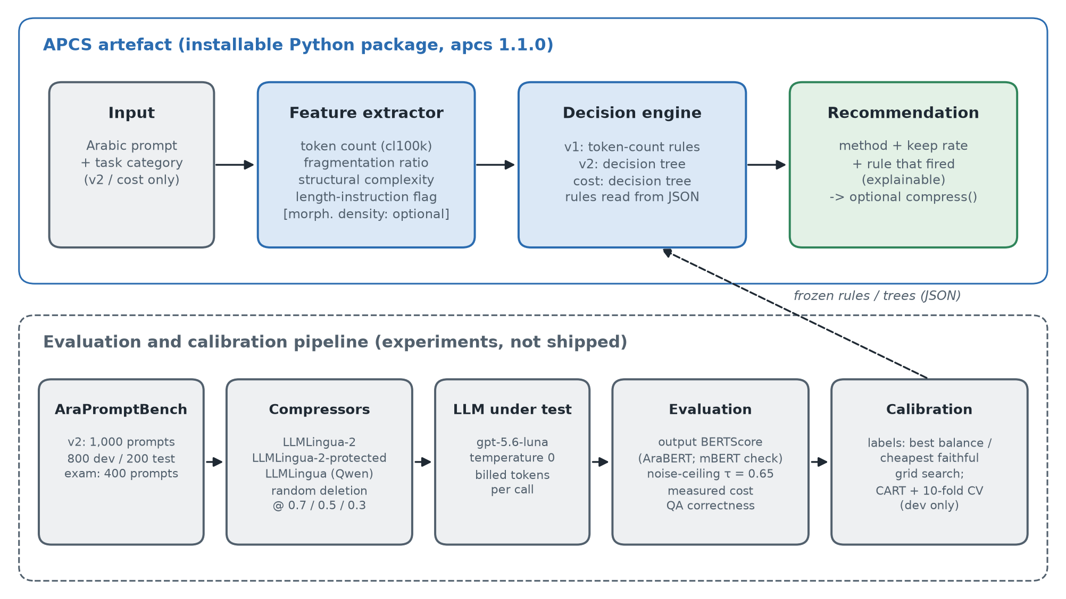
Figure 1. Architecture of the APCS artefact and the evaluation pipeline that calibrates it
The decision engine was designed in two generations. APCS 1.0.0 keeps the SDR's form, an ordered list of guarded threshold rules. Calibration searches a grid of token-count thresholds T1 < T2 and rates for the "medium" and "long" branches, and picks the rule that maximises best-balance accuracy on dev. The SDR's draft rules also used structural complexity, morphological density and a creative-category clause. They were retained only if the dev evidence supported them; Experiment 05 and Experiment 10 found that it did not (Section 5.2.4). APCS-v2 keeps interpretability but replaces hand-written guards with a shallow decision tree, learned with the CART algorithm in scikit-learn (Pedregosa et al., 2011) over the full feature set plus task category. Depth and minimum leaf size are chosen by 10-fold stratified cross-validation on dev only. A tree of depth four is still a short list of readable if/then rules (Appendix D), so the SDR's explainability requirement is met. APCS-cost uses the same tree learner trained on cheapest-faithful labels, with the protected compressor and LLMLingua among its candidates.

Evaluation plan and hypotheses
Evaluation proceeds in three stages, each on data the previous stage never saw.
1. Development (800 prompts): RQ1 and RQ2 analyses, τ derivation and selector calibration.
2. Held-out test (200 prompts): a single evaluation of APCS 1.0.0 against the SDR's baselines: no compression, always LLMLingua-2 (each rate), always LLMLingua (each rate, on labels that admit LLMLingua) and random selection.
3. Fresh exam (400 prompts): a pre-registered evaluation of three hypotheses, Holm-corrected:
- H1. APCS-v2 achieves higher best-balance accuracy than always using LLMLingua-2 @ 0.5, the best fixed strategy on dev (exact McNemar).
- H2. APCS-v2 achieves higher accuracy than APCS 1.0.0 (exact McNemar).
- H3. APCS-cost lowers the measured bill relative to never compressing (one-sided Wilcoxon on per-prompt cost differences, and a negative total cost change).
The replication accuracy of APCS 1.0.0 on the exam, the protected compressor's effect and QA correctness were declared as secondary analyses.

Chapter Summary
This chapter specified the components of the system and linked them to the research questions; described a design-science methodology built on a paired, stratified experiment with explicit safeguards against contamination; and justified each design decision. These covered the deconfounded benchmark, the compression candidates, the LLM protocol, output-level fidelity with an Arabic scorer and a noise-derived threshold, the best-balance and cheapest-faithful labels, the APCS architecture in two generations, and a three-stage evaluation ending in pre-registered hypotheses. Chapter 4 describes how this design was implemented and how it evolved along the way.

Implementation (Realisation)

Chapter Introduction
This chapter describes what was built and how the design of Chapter 3 was realised in practice, including where implementation evidence forced the design to change. Section 4.2 covers the environment, the pilot experiments and the design decisions they triggered, the construction of AraPromptBench v2, the benchmark pipeline, the calibration of APCS 1.0.0, the Experiment 11 redesign, and a consolidated account of every change from the SDR with its justification. Section 4.3 presents the IT artefact itself: the APCS package, its interfaces, its tests and how it is reproduced.

Details of the Implementation

Environment and tooling
All work was done in Python 3.11.9 on a Windows 11 workstation with an NVIDIA RTX 5070 GPU (12 GB), which ran the compressors and BERTScore locally. Only LLM calls went to the API. Table 4 lists the main libraries. Every experiment lives in its own folder containing the scripts, a README stating the question and method, a results/ folder with raw outputs and configuration, and a FINDINGS file with results, decision and caveats. Git and a GitHub repository recorded each milestone, with one commit per milestone. A chronological experiment log indexes all eleven experiments and one supplementary measurement (Appendix E).
Purpose | Library (version)
Compression | llmlingua 0.2.2 (LLMLingua, LLMLingua-2)
Models and scoring | torch 2.11 (CUDA 12.8), transformers 5.13, bert-score 0.3.13
Tokenisation | tiktoken 0.13 (cl100k_base)
Morphology | farasapy 0.1.1 (Farasa, Java 21)
LLM API | openai 2.44 (asynchronous client)
Analysis | pandas 3.0, scipy 1.17, statsmodels 0.15, scikit-learn 1.9
Testing | pytest
Table 4. Implementation environment
Two platform problems had to be solved. First, the GPU's Blackwell architecture required PyTorch builds for CUDA 12.8. Second, Farasa's interactive mode silently corrupted Arabic text passing through the Windows process pipe. It was run in standalone mode instead, which needs a Java runtime but returns correct segmentations.

Pilot phase and the design changes it triggered
Seven pilot experiments on the 500-prompt pilot set tested each design assumption before money was spent on the final benchmark. The pilot set consists of 500 Modern Standard Arabic prompts, 125 per category, generated with gpt-5.4-mini (OpenAI). Because it was used only for development, its synthetic origin does not affect any held-out result. Table 5 summarises what each found and what it changed.
Exp. | Question | Finding | Design consequence
01 | Which BERTScore encoder? | AraBERT and mBERT rank pairs alike (ρ = 0.98), but AraBERT has 50% more dynamic range; under mBERT, random 30% deletion passes 0.85 in 86% of cases | AraBERT primary, mBERT sensitivity check (roles swapped from the SDR)
02 | Do the compressors run on Arabic? | LLMLingua with its default GPT-2 scorer crashed on all long prompts and corrupted characters in 38 of 45 outputs; with Qwen2.5-0.5B it ran cleanly but left short prompts uncompressed; LLMLingua-2 hit all target rates | GPT-2 scorer dropped; Qwen2.5-0.5B adopted; LLMLingua's length gate recorded as a property of the method
03 | Local benchmark at scale | 5,000 compressions, 0 errors; at prompt level random deletion beats LLMLingua-2 (p < 1e−22) | Prompt-level F1 judged a mechanical artefact; fidelity moved to output level
04 | Output-level evaluation | 4,173 API calls (US$0.66); ranking flips: LLMLingua-2 beats random deletion at every rate (p ≤ 4e−9); 9.6% of answers truncated at 512 tokens | Two-level design vindicated; completion limit raised to 1,024
05 | Feature analysis | Length dominates (ρ ≈ +0.4 with LLMLingua-2 fidelity); morphological density weak (absolute ρ ≤ 0.19); length and category confounded | Morphology rule not adopted; v2 dataset deconfounded by length band
06 | First APCS | Rule "tokens < 120 → none, else LLMLingua-2 @ 0.5": 41.2% best-balance accuracy in-sample; Pareto-hit metric degenerate | Best-balance accuracy adopted as the primary metric; package scaffolded
07 | Protocol checks | Only 13% of repeat calls identical; 31% of identical-prompt pairs score below 0.85 | SDR threshold retired; noise-ceiling τ adopted
Table 5. Pilot experiments and the design decisions they produced
Experiment 02 deserves comment because it is direct evidence for RQ1. LLMLingua's published default configuration does not transfer to Arabic. GPT-2's byte-level tokeniser inflates Arabic two- to three-fold, which pushes summarisation prompts past GPT-2's 1,024-token context. When the compressor deletes one byte of a multi-byte Arabic character, the result is an invalid character (for example, زيادة becomes �يادة). Replacing the scorer with the multilingual Qwen2.5-0.5B fixed the corruption, but a length gate remains: short prompts come back almost untouched whatever rate is requested, and disabling the method's sentence- and context-level filters does not change this. The vertical slice also rejected BLOOM-560m as a scorer because it was incompatible with the installed packages.
One defect was found later in the pilot code. The morphological-density feature counted Farasa's punctuation and numeral tokens as words. It was corrected so that only tokens containing an Arabic letter are counted, unit-tested, and the Experiment 05 analysis re-run. Rankings were nearly unchanged (ρ = 0.94 between old and new values), but the association with fidelity became slightly stronger and statistically significant (absolute ρ ≤ 0.19), still far weaker than length. An erratum (05e) records the correction and the softened conclusion.

Building AraPromptBench v2
build_sourced.py draws the 850 corpus prompts with seed 42. It rotates templates, enforces per-category length-band quotas, applies the 80% Arabic-character gate and deduplicates against the pilot after normalisation. For QA, long passages are truncated around the answer span so the question stays answerable. Three of the six corpora (XL-Sum, TyDi QA and ARCD) could no longer be loaded through the datasets library's script loaders and were read from the Hugging Face Hub's parquet conversions instead. Two compositional deviations from the SDR resulted. The ARCD pool was exhausted at 91 prompts after deduplication and answer-preserving truncation, so QA was topped up from TyDi QA. And Aya's "mixed" rows were all instruction-like, which made the categories 350/250/250/150 rather than 250 each. assemble_v2.py merges the parts, assigns identifiers, draws the stratified 80/20 split and writes a quality report and a 5% stratified inspection sample, which the author reviewed before any benchmark call.
The exam set was built by build_exam.py with the same machinery and a different seed. Its first version contained five prompts that partially overlapped earlier passages. A 12-word shingle filter was added and the set rebuilt; audit_exam.py then confirmed zero overlap. A 20-prompt sample was reviewed by the author before the exam run.

The benchmark pipeline
The final benchmark runs in three stages, each a separate script that reads the previous stage's output, so any stage can be re-run without repeating the others.
1. Local compression (`run_local.py`). Each prompt is compressed by LLMLingua (Qwen scorer), LLMLingua-2 and random deletion at each target rate. Achieved token counts, TCR and prompt-level F1 under both scorers are recorded. Exp 10 produced 14,560 rows covering the 1,000 v2 prompts and a 456-prompt synthetic probe pool (generated with Claude Fable 5) used by Experiment 09.
2. API calls (`run_api.py`). Calls are deduplicated by a hash of (prompt identifier, exact text), so identical compressed texts are sent once. They are shuffled with a fixed seed and sent asynchronously with retries. Each response is appended to a JSON-lines file with the model snapshot, finish reason and the API's token counts, which makes the run resumable. A smoke-test mode checks parameters and projects cost before the full run. The script stops cleanly if the account's quota is exhausted. The final run made 13,438 calls with no failures, one model snapshot throughout and a measured cost of US$2.49. 79 answers (0.6%) reached the 1,024-token limit. One answer, to a random-deletion variant, came back empty and is scored 0.
3. Scoring and analysis (`score_and_analyze.py`, `rq2_final.py`, `cost_analysis.py`, `apcs_final.py`). Output-level BERTScore is computed under both scorers. The repeat-call ceiling and τ are derived, and the RQ1, RQ2 and cost analyses are run on dev. The one-shot test evaluation runs last. run_chain.py executes the whole chain in order and logs it.
Two implementation details protect validity. AraBERT's input window is 512 word-pieces. 2.6% of dev answer pairs exceed it, so every RQ1 comparison is repeated without them; the differences change by at most 0.002. The cost of each call is computed from the token counts the API returned for that call, priced at US$0.20 and US$1.20 per million input and output tokens: cost = prompt tokens × 0.20/10⁶ + completion tokens × 1.20/10⁶. The cost of a policy is the sum over prompts of the cost of the call for the strategy it chose. Cost is never estimated from TCR.

Calibrating APCS 1.0.0
apcs_final.py computes best-balance labels on the 800 dev prompts, searches a grid of 7 × 6 token-count thresholds and 3 × 3 rates, and writes the winning rule to the package. The rule is:
- token count < 80 → no compression;
- 80 ≤ token count < 250 → LLMLingua-2 @ 0.5;
- token count ≥ 250 → LLMLingua-2 @ 0.3.
Its dev accuracy is 38.0%. The script was written to ship a single global rule, as the SDR specified. Per-category rules were computed for reference only: they raised dev accuracy by 5.6 points in-sample, a gain that, with 120–280 dev prompts per category, could easily be over-fitting. The signal they hinted at was followed up properly, on fresh data, in Experiment 11. The script then read the 200 test prompts once, evaluated APCS 1.0.0 and all baselines, and wrote the result. A later bug fix to the LLMLingua comparison in score_and_analyze.py re-scored the same stored answers deterministically. The APCS test evaluation was not re-run.

The Experiment 11 redesign
Experiment 10 left two clear leads (Chapter 5): task category carried more signal than length, and LLMLingua-2 made answers longer by deleting length instructions. Experiment 11 acted on both. All design work used dev data only.
Length-protected compression (`protect.py`). A regular expression identifies Arabic length instructions such as بإيجاز ("briefly"), في ثلاث جمل ("in three sentences") and لا يتجاوز ("not exceeding"). It is the same marker set used to test the mechanism in Experiment 10. The prompt is split into sentence-like segments at sentence punctuation, colons and line breaks. Segments containing a marker are kept verbatim, the rest are compressed with LLMLingua-2 at the target rate, and the pieces are reassembled in order. Prompts without a marker are compressed exactly as plain LLMLingua-2 would compress them. On dev, the variant removed most of the cost penalty and raised fidelity, at the price of a lower achieved TCR. A second idea, protecting question marks in QA prompts, was tested and rejected: dropping the question mark did not reduce QA correctness, so the extra complexity was not justified.
QA correctness (`qa_metrics.py`). For QA prompts, an answer is counted correct if it contains any gold answer as a whole-word sequence, after Arabic normalisation: diacritics, tatweel and punctuation removed, and alef, ya and taa-marbuta variants unified. This gives a task-accuracy check that does not depend on BERTScore.
APCS-v2 and APCS-cost (`design_selectors.py`). Both are CART decision trees trained on the 800 dev prompts. The features are the five numeric APCS features, the length-instruction flag and one-hot task category. Depth (1–5) and minimum leaf size (10, 20, 40) were chosen by 10-fold stratified cross-validation. APCS-v2 uses best-balance labels and the same four candidates as APCS 1.0.0, so the comparison isolates the selector. The chosen tree (depth 4, minimum leaf 20) reached 43.5% cross-validated accuracy (SD 5.2), against 36.0% for the APCS 1.0.0 rule under the same folds. APCS-cost uses cheapest-faithful labels over ten candidates, including the protected variant and LLMLingua. Its tree (depth 3, minimum leaf 40) cut the cross-validated bill by 1.9%. Both trees were saved as JSON with their readable rules (Appendix D), committed and pre-registered together with evaluate_exam.py. The evaluation script had first been run on dev data purely as a code check. run_exam.py then compressed, answered and scored the exam: 3,828 calls, no failures, US$0.61. evaluate_exam.py ran once.
The learned APCS-v2 tree is easy to read. It first separates creative prompts from the rest. Creative prompts are left uncompressed below 86 tokens and otherwise compressed lightly. For other categories it uses token count, with QA treated separately: long QA prompts are compressed less, because their answers depend on details that heavy compression removes. A fragmentation-ratio split leaves short, heavily fragmented prompts uncompressed. APCS-cost is simpler still. It leaves every prompt of up to 127 tokens uncompressed. Above that, prompts without a length instruction stay uncompressed unless they are QA, which get LLMLingua-2 @ 0.5. Prompts with a length instruction get the protected variant @ 0.3, except creative prompts, which get light plain compression (@ 0.7). The selector has in effect learned that compression pays only when the prompt is long and its answer length is either anchored by a protected instruction or naturally short, as in QA.

Changes from the Specification and Design Report
The rubric expects any change from the SDR to be identified and justified. Table 6 lists every material change. Each was driven by evidence gathered during the project and decided before the data it would be evaluated on was examined.
SDR specification | As implemented | Evidence and justification
LLM: gpt-4o-mini, max_tokens 512 | gpt-5.6-luna, temperature 0, reasoning "none", 1,024 completion tokens (pilot used gpt-4o-mini) | A newer model from the same provider gives results that are more relevant and accurate for current deployments; 512 truncated 9.6% of pilot answers (Exp 04). Same provider and billing structure; one snapshot throughout
BERTScore: mBERT primary, AraBERT check | AraBERT primary, mBERT check | Exp 01: AraBERT 50% more dynamic range; mBERT passes random 30% deletion at 0.85 in 86% of cases
Fidelity threshold F1 ≥ 0.85 | τ = 0.65 from the model's repeat-call noise ceiling (0.75 for mBERT) | Exps 07 and 10: about 31% of identical-prompt answer pairs fall below 0.85, so it cannot separate compression damage from noise
LLMLingua with its reference scorer | LLMLingua with Qwen2.5-0.5B | Exp 02: GPT-2 crashes and corrupts Arabic; BLOOM incompatible
Primary metric: Pareto-hit rate | Best-balance accuracy (proposal's own definition); Pareto-hit as footnote | Exp 06 and Table 11: "never compress" always Pareto-optimal, scores 88.5%
Rule engine incl. morphology, structure and creative clauses | APCS 1.0.0: token-count rule; APCS-v2: tree over all features + category | Exps 05 and 10: morphology not predictive when other features are controlled; rules kept only where dev evidence supported them
Creative prompts author-written | Synthetic briefs generated with Claude Fable 5 (different provider from the LLM under test) | Scale and licensing; effect measured in Exp 09
Categories 250 × 4 | 350 / 250 / 250 / 150 | ARCD pool exhausted; Aya rows instruction-like (Exp 08)
Single held-out evaluation | Held-out test (Exp 10) plus fresh pre-registered exam (Exp 11) | Redesign motivated by test results could not be evaluated on the same test without contamination
Recommendation of (method, rate) only | Adds APCS-cost and the length-protected compressor | Exp 10: compression raised the total bill; the SDR's cost-saving objective required a cost-aware design
Table 6. Changes from the SDR and their justification
None of these changes alters the aim or the research questions. Three of them (the scorer swap, the threshold and the primary metric) were corrections of the SDR's evaluation design that the pilot showed to be necessary. The others kept the study current (the newer LLM), responded to data availability, or followed findings (the cost effect) that the original design could not have anticipated.

The IT Artefact
The APCS is distributed as an installable Python package (apcs, version 1.1.0, MIT licence) in the project repository. Its core dependency is only tiktoken. LLMLingua (for applying a recommendation) and farasapy (for morphological density) are optional extras, so recommendations are fast and need no GPU. Table 7 shows the structure.
Module | Responsibility
features.py | Normalises the prompt (Unicode NFC) and computes the feature vector: character length, cl100k token count, word count, fragmentation ratio, structural complexity, optional morphological density, and the length-instruction flag
selector.py | Decision engine. APCSSelector("v1") applies the APCS 1.0.0 rules from rules_default.json; "v2" and "cost" walk the frozen decision trees in selectors/*.json. Returns a Recommendation (method, rate, the guards that fired, the features and the rules version)
protect.py | The length-protected LLMLingua-2 compressor
cli.py | Command-line interface: apcs "<prompt>" or apcs --file, with --selector, --category and --json
rules_default.json, selectors/ | Versioned, frozen calibration data, including the dev set it was trained on, τ and the readable rules
Table 7. Structure of the APCS package
The decision engine treats rules as data: recalibrating for a different LLM or price ratio means producing a new JSON file, not changing code. Each recommendation states the rule that produced it, which meets the explainability requirement. For example, for a 191-token summarisation prompt from the dev set:
$ apcs --selector v2 --category summarisation --file prompt.txt
recommendation : llmlingua2 @ rate 0.5
rule fired : cat_creative <= 0.5 and token_count > 104.5 and cat_qa <= 0.5 and token_count <= 243
features : tokens=191 words=41 frag=4.6585 struct=5
rules version : apcs_v2

$ apcs --selector cost --category summarisation --file prompt.txt
recommendation : llmlingua2_protected @ rate 0.3
rule fired : token_count > 127.5 and has_length_instruction > 0.5 and cat_creative <= 0.5
The two selectors disagree in an informative way. The prompt begins "write a summary in one paragraph", a length instruction. APCS-v2, which maximises token reduction, picks plain LLMLingua-2. APCS-cost picks the protected variant, which keeps the instruction and therefore the answer's length. In library form, the same call is:
from apcs import APCSSelector
rec = APCSSelector("cost").recommend(prompt, category="summarisation")
compressed = APCSSelector("cost").compress(prompt, category="summarisation")
Testing. The package has 18 unit tests. They check feature extraction (empty input rejected, Farasa's punctuation excluded from morphological density), the APCS 1.0.0 rule branches, custom rule files, serialisation, the tree selectors' category handling and their treatment of a missing optional feature. One integration test feeds all 400 exam prompts through the package's own feature extraction and confirms that the shipped APCS-v2 and APCS-cost trees choose exactly the strategy recorded in the pre-registered exam evaluation. The artefact a user installs is therefore the one that was evaluated.
Documentation. The package README serves as the user manual, covering installation, the command-line and library interfaces, the three selectors and recalibration. An example notebook (apcs/examples/apcs_example.ipynb) walks through single and batch recommendations, applying a recommendation and custom calibration. Together they deliver the manual and example notebook promised in the proposal.
Overhead. A supplementary measurement (Experiment 12; 100 dev prompts, rate 0.5) timed each step on the project workstation. The APCS recommendation itself takes about 0.05 ms per prompt, so the selector adds no meaningful latency. Applying a recommendation does take time: LLMLingua-2 needs about 30 ms per prompt on the consumer GPU and about 0.4 s on CPU, because it runs a 560-million-parameter encoder; the protected variant costs the same. For prompts of a few hundred tokens, this is of the same order as, or larger than, the prompt-processing time that compression removes. Compression should therefore be justified by cost or context-window limits rather than by speed. End-to-end API latency was not measured.
Reproducibility and verification. Every result file is accompanied by its configuration (model snapshot, parameters, prices, seeds). Before writing began, an independent audit script that imports no experiment code recomputed every headline number in this dissertation from the raw data. It covered the dataset sizes and overlaps, the 13,438 and 3,828 stored responses and their costs, the RQ1–RQ3 statistics and the exam hypotheses, and all 117 checks passed (Section 5.2.10).

Chapter Summary
The design was implemented as a staged, resumable pipeline around three compressors, one LLM and two BERTScore encoders. Seven pilot experiments tested the design's assumptions and changed it where they failed: the scorer, the threshold, the LLMLingua scorer model, the completion limit and the primary metric. AraPromptBench v2 and the exam set were built from six licensed corpora with documented deviations. APCS 1.0.0 was calibrated on dev and evaluated once on test. Its results motivated a length-protected compressor and two decision-tree selectors, which were pre-registered and evaluated on the fresh exam. All changes from the SDR were listed with their evidence. The artefact is a small, explainable, tested package whose shipped selectors reproduce the evaluated ones exactly. Chapter 5 presents the results.

Results and Evaluation

Chapter Introduction
This chapter evaluates the compression methods and the APCS against the project's aims. As a reminder, the aim was to establish how well existing compression methods work on Arabic (RQ1), which prompt features drive their performance (RQ2), and whether a feature-based selector can choose the best strategy per prompt (RQ3). The evaluation strategy was set out in Section 3.4.7. Results are presented in the order that the logic requires. Section 5.2.1 first establishes that the fidelity measurement is valid. Sections 5.2.2–5.2.5 answer RQ1 and RQ2 on the 800 development prompts and report the effect on cost. Sections 5.2.6–5.2.8 evaluate the APCS on held-out data: once on the v2 test split and once on the pre-registered fresh exam. Sections 5.2.9–5.2.10 test robustness, and Section 5.2.11 answers each research question. Unless stated otherwise, fidelity is output-level BERTScore F1 under AraBERT, τ = 0.65, and costs are measured from billed token counts.

Evaluation of IT Artefact

Measurement validity: the noise ceiling
Before compression can be judged, the measuring instrument must be shown to separate compression damage from chance. Sending each uncompressed dev prompt twice to the LLM, at temperature 0 with no reasoning, produced identical text only 29.6% of the time. The median F1 between the two answers was 0.930, and 31.8% of identical-prompt pairs scored below 0.85 (Figure 2). The pilot model gave almost the same figure (31.2%), so the effect is not specific to one model. This replicates the non-determinism reported by Ouyang et al. (2025) and Song et al. (2025), and has a direct consequence. The SDR's threshold of 0.85 would have classified almost a third of unaltered prompts as damaged, and any compressor would have "failed" on many prompts through no fault of its own.
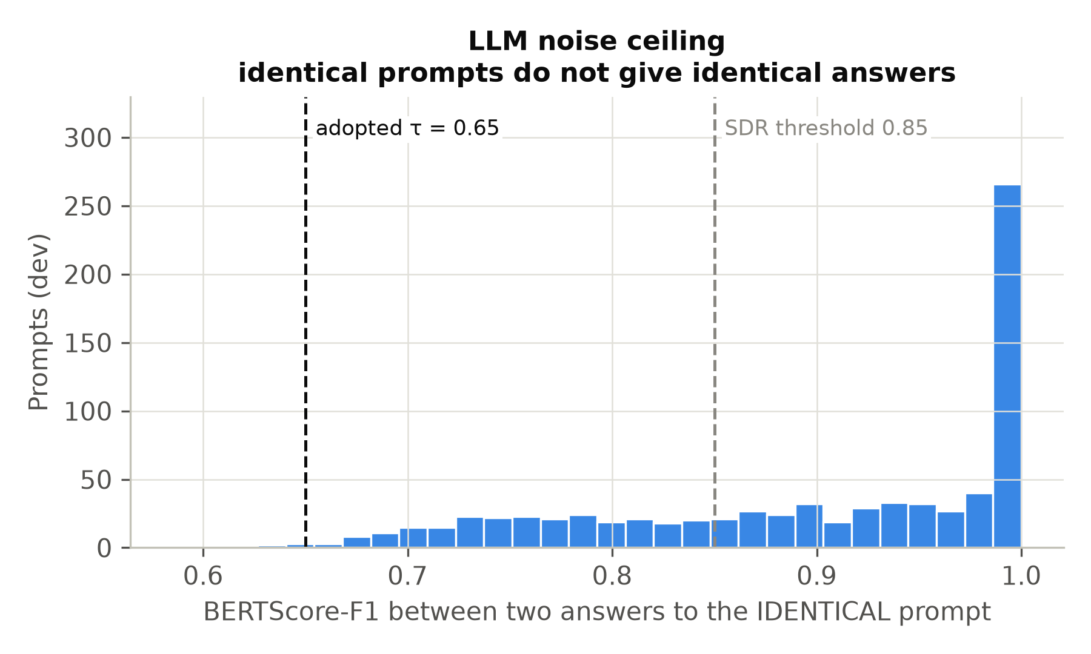
Figure 2. Repeat-call noise ceiling on the dev set: distribution of output F1 between two answers to the identical prompt, with the SDR threshold (0.85) and the adopted τ (0.65)
τ was therefore set at the 0.4th percentile of this distribution (0.640, rounded to 0.65). Only about 0.4% of noise pairs fall below it, so a compressed prompt that scores below τ has almost certainly been damaged. The ceiling also varies by category. QA answers are the most deterministic (median repeat F1 1.0) and creative answers the least. Raw F1 therefore flatters categories with deterministic answers and penalises creative writing; Section 5.2.3 corrects for this.

RQ1: effectiveness of compression methods on Arabic
Figure 3 shows the trade-off between tokens removed and output fidelity for each method on the 800 dev prompts. LLMLingua-2 dominates random deletion at every rate: at the same achieved TCR it gives higher fidelity, and Table 8 shows the paired differences are highly significant.
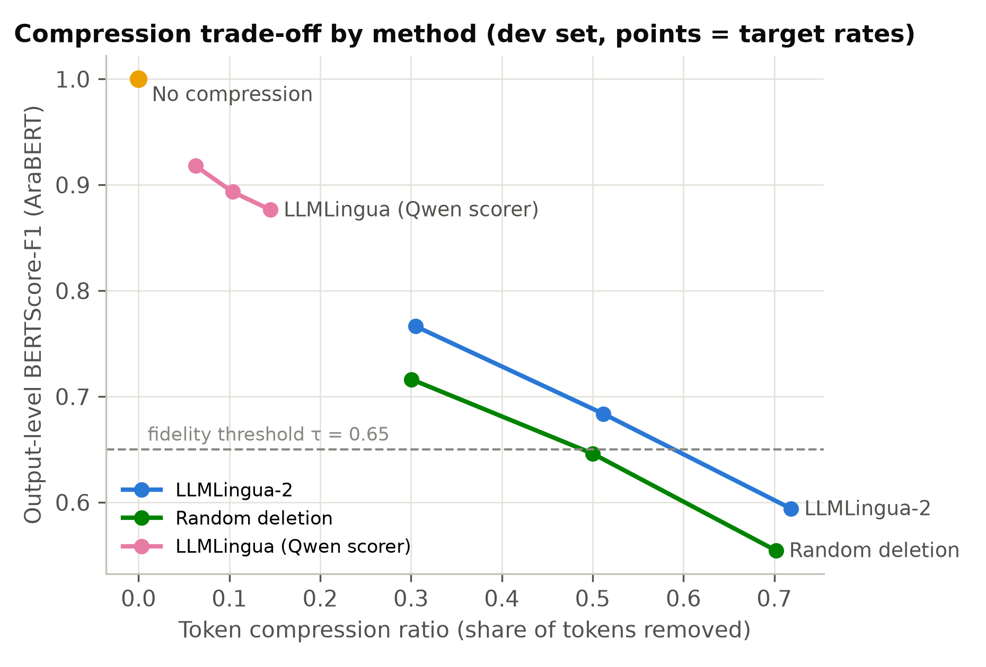
Figure 3. Compression trade-off by method on the dev set: mean TCR against mean output F1 at target rates 0.7, 0.5 and 0.3
Target rate | LLMLingua-2 | Random deletion | Difference [95% CI] | Wilcoxon p
0.7 | 0.766 | 0.716 | +0.050 [0.041, 0.059] | 2 × 10⁻²⁹
0.5 | 0.684 | 0.646 | +0.038 [0.029, 0.046] | 6 × 10⁻²⁰
0.3 | 0.594 | 0.554 | +0.040 [0.032, 0.047] | 6 × 10⁻²⁵
Table 8. Output-level fidelity of LLMLingua-2 vs random deletion (dev, n = 800, paired)
The advantage is real but modest, about 0.04–0.05 F1. LLMLingua-2's classifier, trained on English distillation data, carries a useful notion of token importance into Arabic, but it is far from lossless. At rate 0.5, mean fidelity (0.684) is only just above τ, and at 0.3 it falls below τ on average. Arabic prompts tolerate light compression; heavy compression damages most answers.
The ranking flip. At prompt level the order reverses. Random deletion scores higher than LLMLingua-2 at every rate (−0.014, −0.026 and −0.028; all p < 10⁻¹⁴; Figure 4). BERTScore rewards verbatim retention of surface words, and random deletion keeps whole words scattered evenly through the prompt, while LLMLingua-2 deletes function words and morphological fragments that it rightly judges uninformative. An evaluation that compared prompts, as many compression studies effectively do when they report prompt similarity, would have ranked the methods backwards. This finding, first observed in the pilot (Experiments 03 and 04) and replicated on v2, is a methodological contribution: for Arabic, compression must be evaluated on the LLM's outputs, not on the compressed prompts.
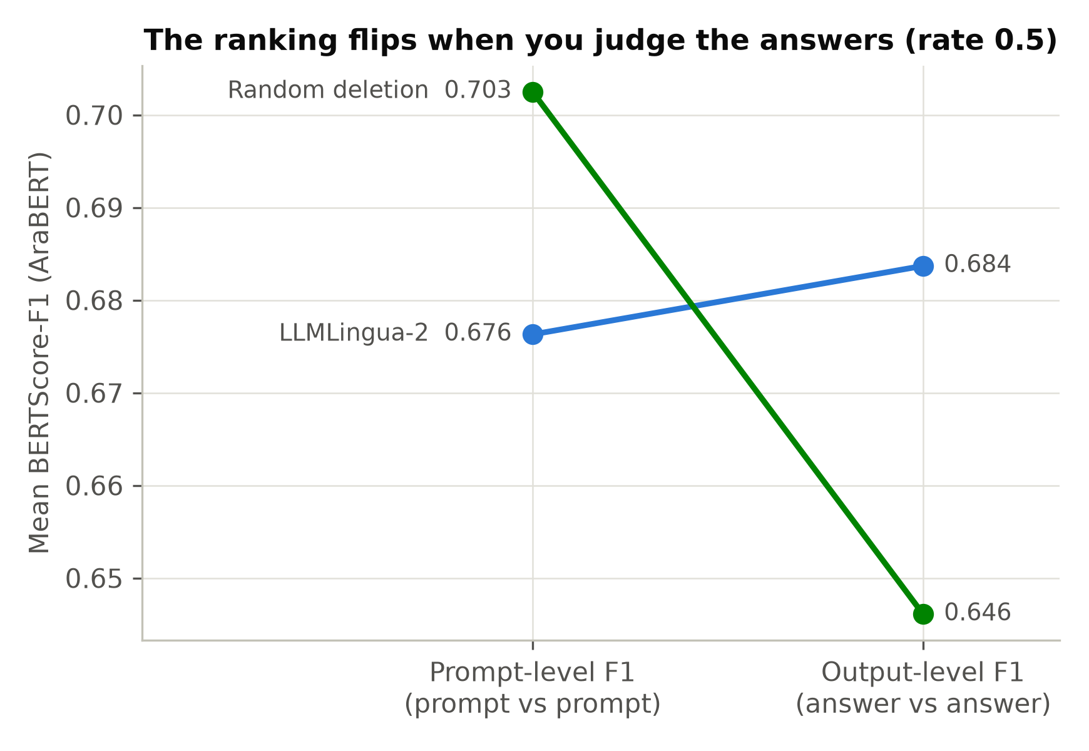
Figure 4. The ranking flip: LLMLingua-2 minus random deletion at prompt level (negative) and output level (positive)
LLMLingua versus LLMLingua-2. LLMLingua with the Qwen scorer behaves differently. It refuses to compress most prompts: 50–83% are returned untouched, depending on category. Its achieved keep is strongly tied to prompt length (Spearman ρ between tokens and keep from −0.71 to −0.79). This is the intrinsic length gate first seen in Experiment 02. At the same target rate the two methods are therefore not comparable, because LLMLingua simply compresses less. When each prompt that LLMLingua did compress is paired with the LLMLingua-2 variant closest in achieved keep, LLMLingua-2 is better by +0.030 [0.014, 0.045] at keep ≈ 0.52 and +0.041 [0.025, 0.056] at keep ≈ 0.66. The two do not differ at the lightest setting, where LLMLingua kept more text. Classifier-based scoring therefore transfers to Arabic better than perplexity-based scoring, consistent with Pan et al.'s (2024) argument that unidirectional entropy is poorly aligned with compression.
In summary for RQ1: published English defaults do not transfer (GPT-2 scoring corrupts Arabic); with a multilingual scorer, perplexity-based compression barely compresses short Arabic prompts; and classifier-based LLMLingua-2 is the most effective method, beating random deletion by a modest, consistent margin.

Category fragility and task accuracy
Dividing each category's mean LLMLingua-2 @ 0.5 fidelity by its own median noise ceiling gives the share of attainable fidelity that survives compression: creative 83.7%, summarisation 76.7%, instruction 75.4% and QA 70.6%. On raw F1, creative answers looked the most damaged. Once their natural variability is accounted for, the order reverses: QA answers, which depend on specific facts that compression can delete, lose the most. Creative answers vary anyway, so compression costs them relatively little.
QA correctness on the exam confirms this with a measure independent of BERTScore. Uncompressed prompts produced answers containing the gold answer in 57% of QA cases. Compression lowered this to 46–53% with LLMLingua, 32–46% with LLMLingua-2 (decreasing with rate), 31–47% with the protected variant and 21–31% with random deletion. The methods rank in the same order as on BERTScore, which supports the validity of the similarity measure, and the size of the drop shows that heavy compression is unsafe for factual QA.

RQ2: which prompt features matter
Figure 5 shows the rank correlation of each feature with output fidelity at rate 0.5. For LLMLingua-2, longer prompts survive compression better (ρ = +0.28): they contain more redundancy for the compressor to remove. Structural complexity correlates positively (+0.19), fragmentation weakly negatively (−0.12), and morphological density not at all (+0.01). For LLMLingua the length correlation is strongly negative (−0.67), because its gate leaves short prompts untouched and therefore perfectly faithful.
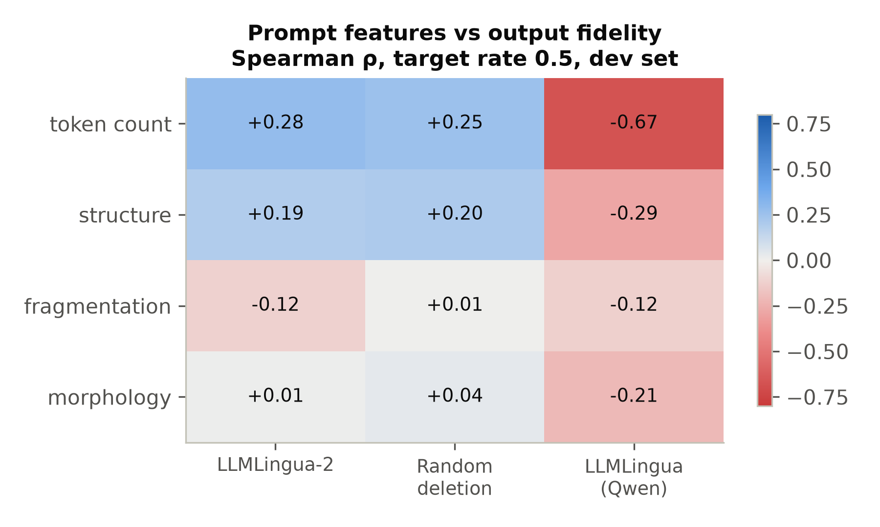
Figure 5. Spearman correlation between prompt features and output fidelity at target rate 0.5 (dev)
Because v2 was deconfounded by design (Section 3.4.1), length and task type can be separated:
- Length helps within every category. Spearman correlations with output F1 are creative +0.33, summarisation +0.27 and instruction +0.23 (all p < 0.001), and QA +0.13 (p = 0.07).
- Category matters within every length band. Kruskal–Wallis p = 0.011 (short), 10⁻¹³ (medium) and 3 × 10⁻⁸ (long). Summarisation prompts are the most tolerant, creative the least.
- Joint model. An OLS regression of output F1 on all features and category explains R² = 0.148. Removing category reduces R² by 6.5 points and removing length by 3.4 points. Among standardised features, log length (β = +0.027, p = 3 × 10⁻⁸) and fragmentation (β = −0.012, p = 0.007) are significant; structure (β = −0.003) and morphological density (β = +0.002, p = 0.65) are not.
Predictor | Standardised β | p | Unique R²
Task category (3 indicators) | — | — | 0.065
log token count | +0.027 | 3 × 10⁻⁸ | 0.034
Fragmentation ratio | −0.012 | 0.007 | —
Structural complexity | −0.003 | n.s. | —
Morphological density | +0.002 | 0.65 | —
Table 9. OLS model of LLMLingua-2 @ 0.5 output fidelity (dev, R² = 0.148)
Two conclusions follow. First, task type and length both matter, and task type slightly more. This revises the pilot's conclusion that length dominated. In the pilot, short prompts were almost all QA or creative, so part of the apparent length effect was a task-type effect. Second, morphological density, the feature on which the SDR built its Arabic-specific rule, does not predict compression outcomes once length and category are controlled. This agrees with Arnett and Bergen (2025), who find that morphological type itself confers no intrinsic disadvantage. What does matter is the tokeniser: fragmentation has a small but significant negative effect, as Limisiewicz, Balhar and Mareček (2023) and Ahia et al. (2023) would predict. The low overall R² is itself informative: most of the variation in fidelity is prompt-specific and not captured by these surface features, which caps the accuracy any feature-based selector can reach.

The cost finding: fewer input tokens, a bigger bill
The proposal's fourth metric was cost saving. Table 10 compares the input tokens saved with the change in the total measured bill on the dev set.
Policy | Input tokens saved | Total cost change | Median answer length vs uncompressed
LLMLingua-2 @ 0.7 | 29.7% | +4.6% | ×1.06
LLMLingua-2 @ 0.5 | 49.1% | +10.9% | ×1.19
LLMLingua-2 @ 0.3 | 67.7% | +24.3% | ×1.52
LLMLingua @ 0.7 / 0.5 / 0.3 | 8.4–23.9% | −2.2 to −3.0% | ×1.00
Random deletion @ 0.3 | 66.1% | −27.0% | ×1.00 (fidelity 0.55)
Table 10. Input-token saving vs total measured cost change (dev, output priced at 6× input)
LLMLingua-2 removed up to two-thirds of the input tokens and still raised the bill by 5–24% (Figure 6). The cause is output length. Answers to LLMLingua-2-compressed prompts were longer, by a median factor of up to 1.5, and every output token costs six times an input token. Following the cost model of Section 2.4, a modest growth in a typically longer answer outweighs a large cut in the prompt.
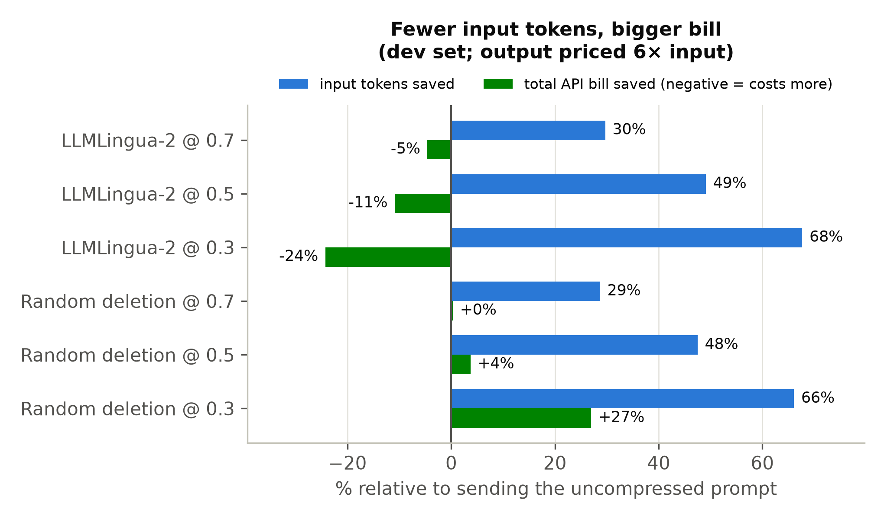
Figure 6. Input tokens saved vs total API bill saved per policy (dev; negative bill saving = costs more)
The mechanism was tested, not assumed. 347 dev prompts contain an explicit length instruction ("answer briefly", "in three sentences", "no more than fifty words"). LLMLingua-2 deleted that instruction in 58%, 39% and 21% of cases at rates 0.3, 0.5 and 0.7. When it was deleted, answers were 1.3–2.4 times longer; when it was kept, about 1.1 times (Mann–Whitney p ≤ 2 × 10⁻⁵ at every rate). The classifier scores words such as "briefly" or "three" as low-information, and in a sense they are: they carry little content. But they are exactly the tokens that control how much the model writes, which is consistent with the length-control literature (Jie et al., 2024; Han et al., 2025). Random deletion removes length instructions just as often, but its garbled prompts produce shorter, lower-quality answers, so it "saves" money only by destroying fidelity. Appendix D gives a worked example: on one exam QA prompt, plain compression deleted "answer briefly", the answer grew from 23 to 85 tokens and the call cost nearly three times as much, while the protected variant kept the answer short.
To the author's knowledge, this is a new finding, and it has practical weight. For any model whose output tokens cost several times its input tokens, which is common in current commercial pricing, compression ratio is not a proxy for cost saving, and a compressor can increase the bill it was meant to reduce. The finding motivated the cost-aware selector and the protected compressor evaluated below.

RQ3 (stage 1): APCS 1.0.0 on the held-out test split
APCS 1.0.0 (Section 4.2.5) was evaluated once on the 200 untouched test prompts. The test labels were close to uniform (LLMLingua-2 @ 0.3: 29%, @ 0.5: 28.5%, none: 22%, @ 0.7: 20.5%), which makes this a hard four-way choice in which the best fixed strategy can reach at most 29% (chance level is 25%).
Policy | Accuracy [95% CI] | Mean TCR | Mean out-F1 | Below τ | Cost vs none | Pareto-hit
APCS 1.0.0 | 31.0% [24.5, 37.5] | 0.43 | 0.750 | 39.0% | +34.2% | 79.5%
always LLMLingua-2 @ 0.3 | 29.0% | 0.72 | 0.595 | 71.0% | +37.8% | 86.5%
always LLMLingua-2 @ 0.5 | 28.5% | 0.51 | 0.676 | 45.0% | +19.0% | 66.5%
random selection | 27.0% | 0.39 | 0.751 | 35.5% | +14.3% | 75.5%
never compress | 22.0% | 0.00 | 1.000 | 0.0% | 0.0% | 88.5%
always LLMLingua-2 @ 0.7 | 20.5% | 0.30 | 0.752 | 22.5% | +9.6% | 64.0%
always LLMLingua (best rate)‡ | 6.0% | 0.11 | 0.883 | 9.5% | −1.2% | 78.0%
Table 11. Selector and baseline performance on the held-out test split (n = 200)
‡ Compared on extended labels that admit LLMLingua candidates; under the primary labels it can never be correct.
APCS 1.0.0 had the highest accuracy and was significantly better than never compressing (+9.0 points, 95% CI [1, 17], McNemar p = 0.038), always LLMLingua-2 @ 0.7 (+10.5, p = 0.048) and always LLMLingua at every rate (p < 10⁻⁸). It was not significantly better than always LLMLingua-2 @ 0.5 (+2.5, p = 0.61), always @ 0.3 (+2.0, p = 0.75) or random selection (+4.0, p = 0.45). The multilingual BERT re-run, with its own τ and recalibrated rule, gave the same picture (34% accuracy). APCS 1.0.0 delivered a sensible balance: the TCR class of random selection, far fewer fidelity violations than always compressing at 0.3, and per-category accuracy between 29% and 34%. But measured by the primary metric, a one-feature rule was only marginally better than the best fixed strategy. The drop from 38.0% on dev to 31.0% on test is the expected optimism of in-sample calibration.
The Pareto-hit column shows why the SDR's metric was replaced. "Never compress" scores 88.5%, the highest of any policy, because its fidelity of 1.0 can never be dominated. A metric that rewards doing nothing cannot evaluate a compression selector.
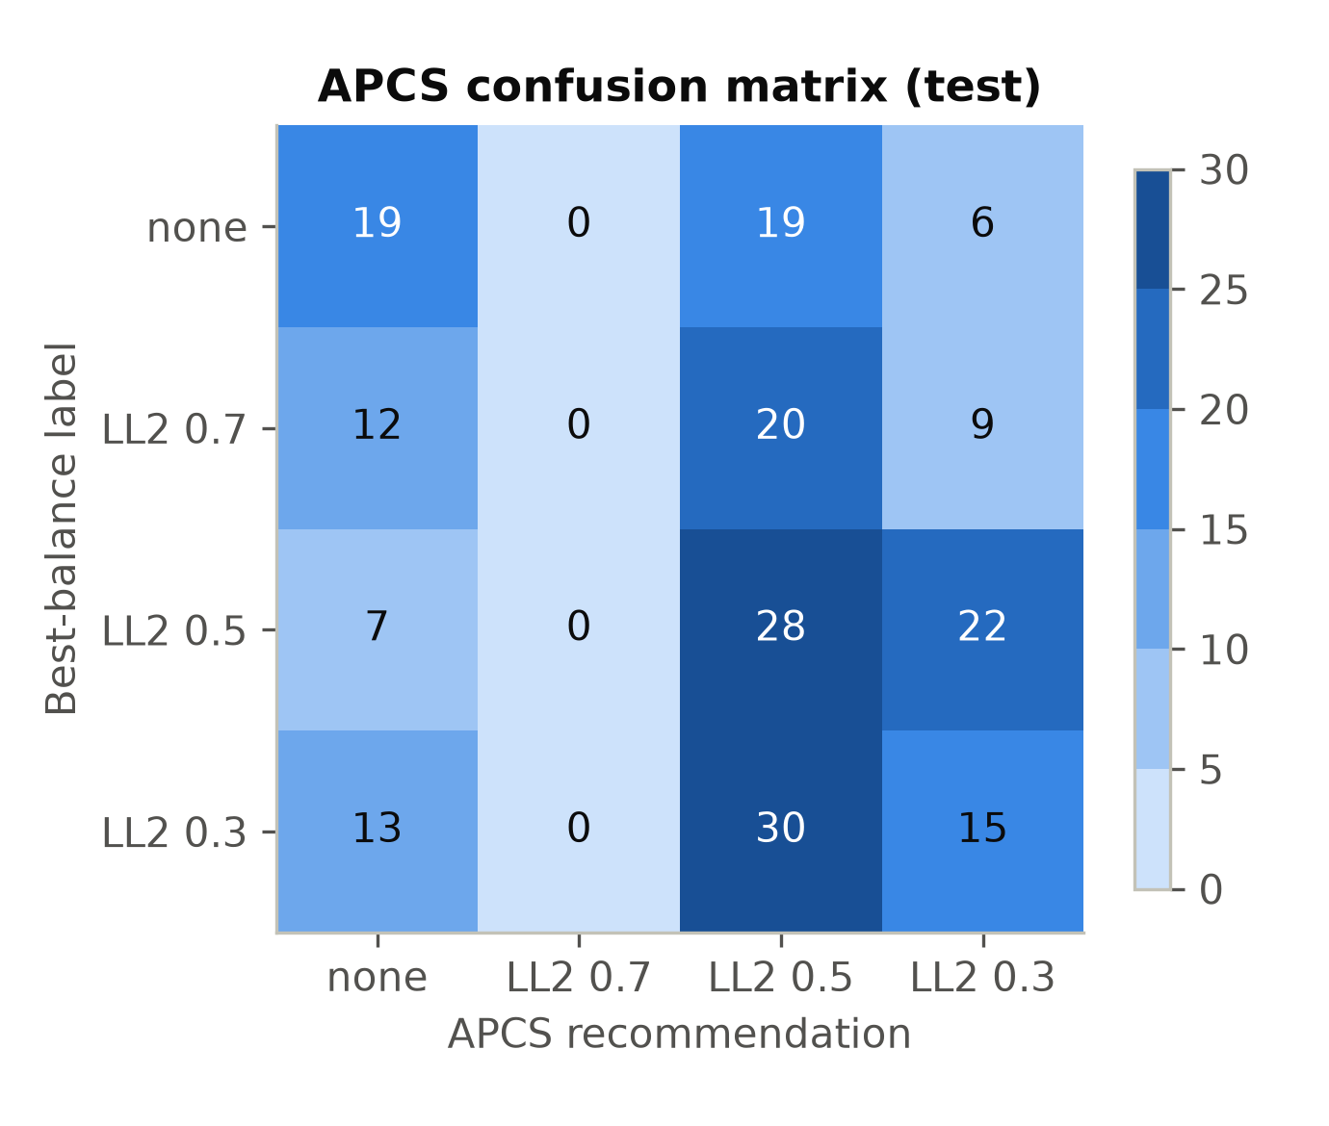
Figure 7. Confusion matrix of APCS 1.0.0 recommendations against best-balance labels (test)
The confusion matrix (Figure 7) shows where the rule fails. It never recommends LLMLingua-2 @ 0.7, although that was the best choice for 20.5% of test prompts. It also recommends @ 0.5 for many prompts whose best choice was no compression or @ 0.3. Token count alone cannot tell these apart. RQ2 had already indicated what was missing, namely task category, and the cost analysis indicated that the target itself (token reduction) was misaligned with the bill. Both were followed up in Experiment 11, on fresh data.

RQ3 (stage 2): the redesigned selectors on the fresh exam
All three selectors were evaluated once on the 400 never-seen exam prompts under the pre-registered protocol. Table 12 gives the results and Figure 8 the accuracies.
Hypothesis | Result | Holm p | Verdict
H1: APCS-v2 > always LLMLingua-2 @ 0.5 | 38.5% vs 32.8%, +5.8 points [0.8, 10.5] | 0.028 | Supported
H2: APCS-v2 > APCS 1.0.0 | 38.5% vs 31.2%, +7.2 points [2.5, 12.0] | 0.008 | Supported
H3: APCS-cost bill < never compress | total −1.0%; per-prompt one-sided Wilcoxon | 0.001 | Supported (small effect)
Table 12. Pre-registered hypotheses on the fresh exam (n = 400; exact two-sided McNemar for H1 and H2, conservative for directional hypotheses)
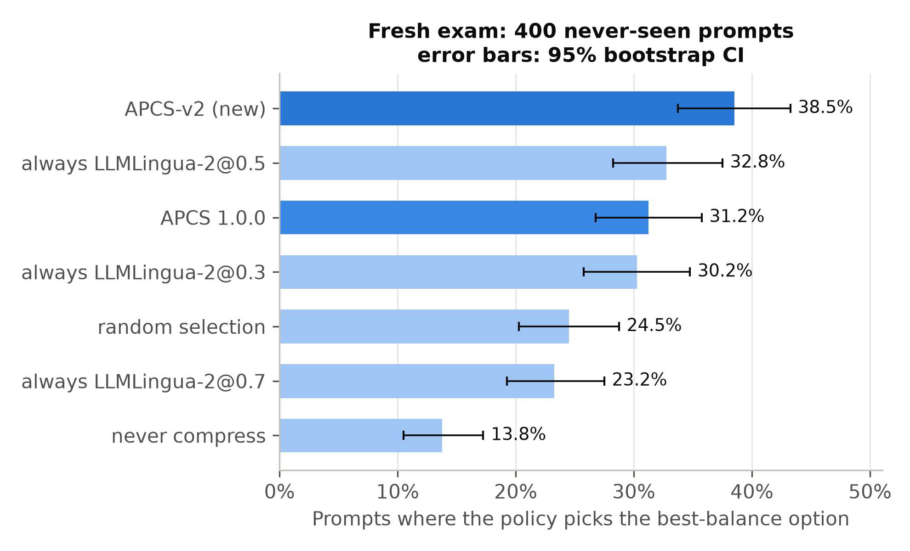
Figure 8. Best-balance accuracy of each policy on the fresh exam, with 95% bootstrap confidence intervals
Policy | Accuracy [95% CI] | Mean TCR | Mean out-F1 | Below τ | Cost vs none | QA correct
APCS-v2 | 38.5% [33.8, 43.3] | 0.48 | 0.709 | 34.2% | +15.9% | 41%
always LLMLingua-2 @ 0.5 | 32.8% [28.3, 37.5] | 0.51 | 0.683 | 39.8% | +12.1% | 40%
APCS 1.0.0 | 31.2% [26.8, 35.8] | 0.43 | 0.757 | 34.5% | +19.7% | 40%
always LLMLingua-2 @ 0.3 | 30.2% | 0.72 | 0.602 | 69.8% | +27.1% | 32%
random selection | 24.5% | 0.38 | 0.765 | 30.5% | +7.5% | 42%
always LLMLingua-2 @ 0.7 | 23.2% | 0.31 | 0.765 | 16.0% | +8.4% | 46%
APCS-cost | 19.5%† | 0.22 | 0.880 | 9.2% | −1.0% | 42%
always LLMLingua @ 0.3 | — | 0.17 | 0.862 | 17.5% | −4.0% | 46%
never compress | 13.8% | 0.00 | 1.000 | 0.0% | 0.0% | 57%
Table 13. All policies on the fresh exam (n = 400)
† APCS-cost optimises a different target. On its own cheapest-faithful labels it scores 35.7%, the highest of any policy.
H1 and H2. APCS-v2 was the most accurate policy and significantly better than every alternative. For reference, chance level for this four-way choice is 25%, and random selection scored 24.5%. Beyond the pre-registered comparisons, it beat always @ 0.3 by +8.3 points (p = 0.027), always @ 0.7 by +15.2 (p < 10⁻⁴), random selection by +14.0 (p < 10⁻⁴) and never compressing by +24.7 (p < 10⁻¹²); these secondary tests are uncorrected. It also had fewer fidelity violations than the best fixed strategy (34.2% vs 39.8%). The by-category breakdown shows where the gain comes from. For APCS-v2, APCS 1.0.0 and always @ 0.5 respectively, accuracy was creative 45 / 23 / 20%, summarisation 53 / 46 / 39%, instruction 30 / 24 / 29% and QA 32 / 31 / 40%. Treating creative and summarisation prompts differently produces the gain. On QA, a fixed 0.5 rate still does better than either selector, a limitation discussed in Chapter 6.
Replication. APCS 1.0.0 scored 31.2% on the exam against 31.0% on the test split. Its held-out performance replicated almost exactly on independent data, which supports the reliability of both evaluations.
H3 and the accuracy–cost tension. APCS-cost met its pre-registered criterion: the per-prompt cost difference was significantly negative and the total fell by 1.0%. It did so while keeping fidelity high (mean 0.880; only 9.2% of answers below τ, the lowest of any compressing policy). The effect, however, is small. The bootstrap interval for the mean per-prompt saving spans zero, so the saving is consistent in direction but modest in total, and is reported as such. APCS-v2, which optimises the proposal's best-balance target, raised the bill by 15.9%. A simple fixed LLMLingua @ 0.3 saved more (−4.0%), but with nearly twice APCS-cost's rate of low-fidelity answers. Accuracy against the best-balance label and cost pull in different directions, and no single selector maximises both.

The length-protected compressor
The protected compressor was evaluated on the 180 exam prompts that contain a length instruction (Table 14; Figure 9).
Target rate | Cost: plain → protected | Output F1: plain → protected | TCR: plain → protected
0.7 | +7.2% → +0.8% | 0.762 → 0.803 | 0.30 → 0.22
0.5 | +17.6% → −5.3% | 0.677 → 0.747 | 0.51 → 0.36
0.3 | +47.6% → −7.9% | 0.597 → 0.687 | 0.71 → 0.51
Table 14. Plain vs length-protected LLMLingua-2 on exam prompts with a length instruction (n = 180)
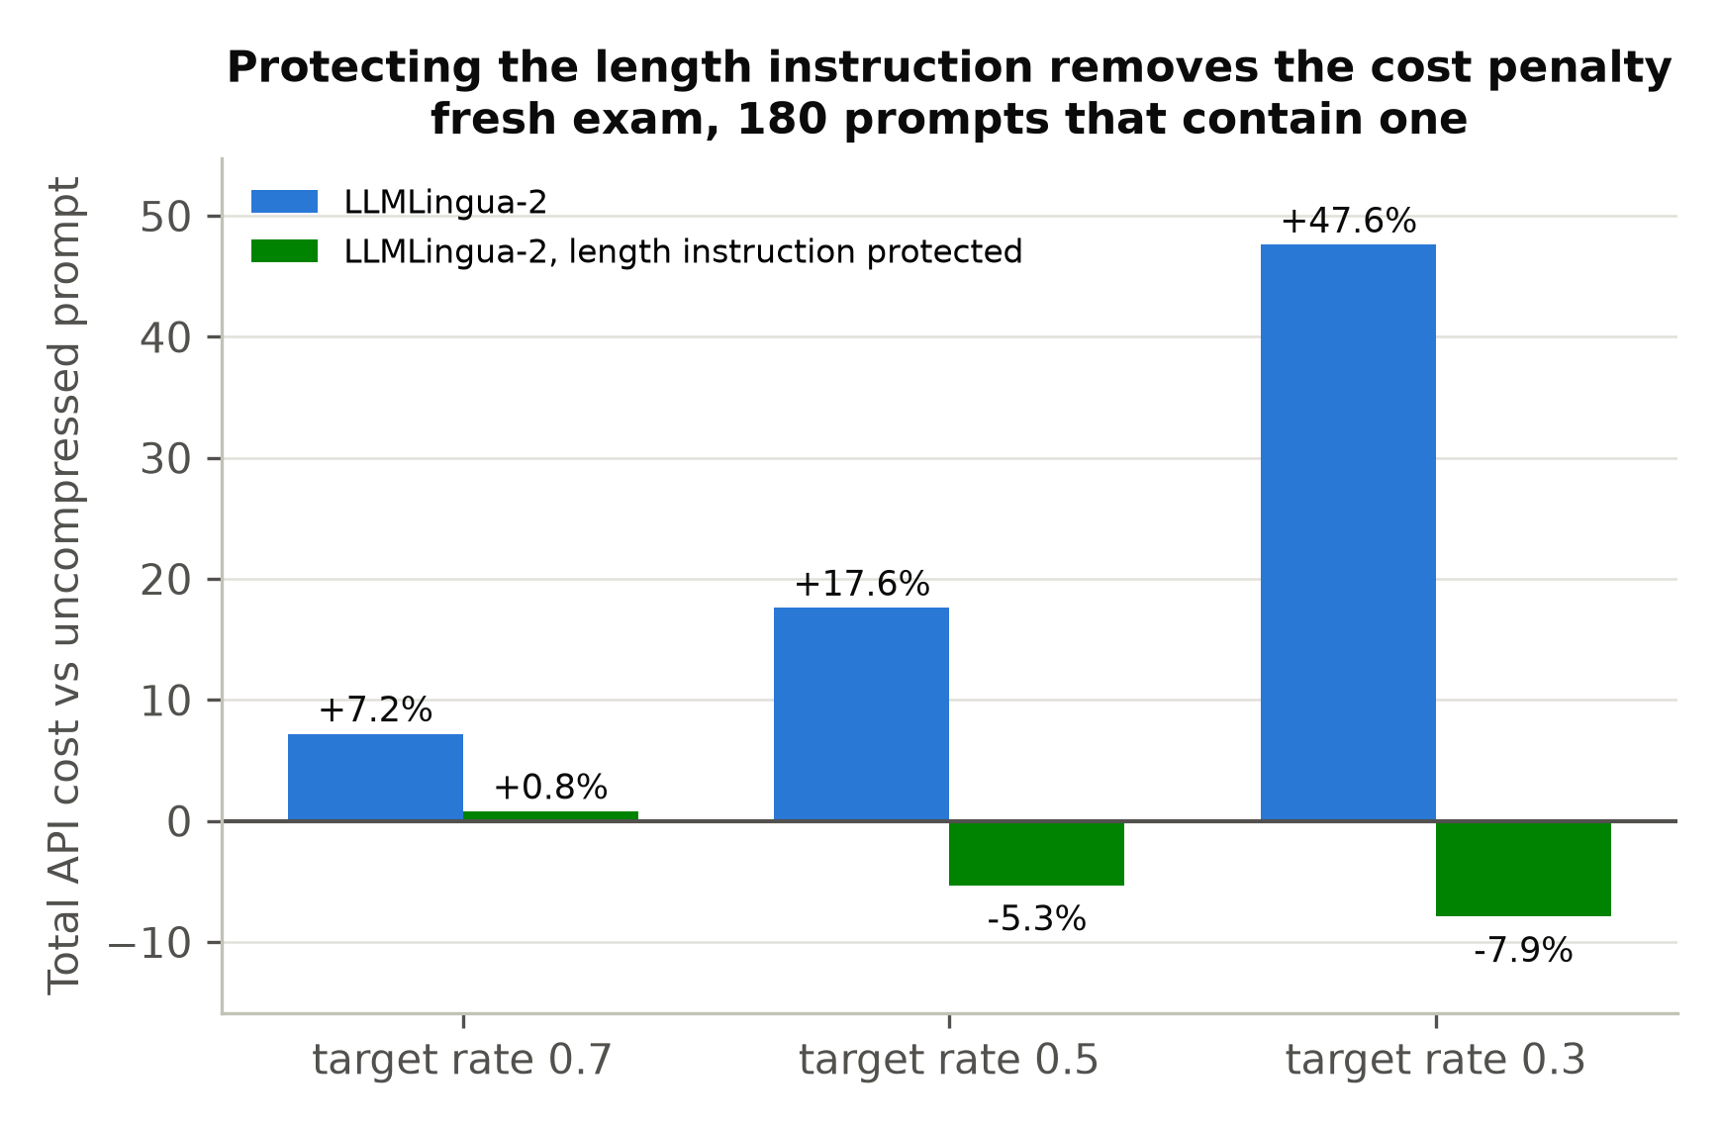
Figure 9. Total API cost relative to the uncompressed prompt, plain vs protected LLMLingua-2 (exam prompts with a length instruction)
Keeping the length instruction verbatim turned a cost increase of up to 48% into a saving of 5–8% at the two heavier rates. It also raised fidelity by 0.04–0.09, at the price of compressing less. The same pattern had been found on dev before the exam was run, so this is a replicated result. It shows that under output-weighted pricing the largest lever is the compressor, not the selector: protecting the few tokens that control answer length is what turns compression into a saving.

Synthetic data sensitivity
Experiment 09 tested whether the 15% synthetic share of v2 could have biased the results, in response to a question from the dissertation advisor. (a) Calibration: APCS was recalibrated on 200 bootstrap mixes at 15%, 30% and 50% synthetic share, with category and length quotas held fixed. The learned rule barely changed: the no-compression threshold moved by one grid step (40 → 60 tokens), the chosen rates never changed, and accuracy moved by 0.6 points (0.380 → 0.374). (b) Fidelity: a separate pool of 456 synthetic instruction, summarisation and QA prompts, generated with Claude Fable 5, was compared with real prompts of the same category, weighted to the same length mix. In eight of nine category × rate cells the 95% interval excluded zero. Synthetic instruction and summarisation prompts lost 0.02–0.05 more fidelity under compression, and the QA differences changed sign with rate (Figure 10).
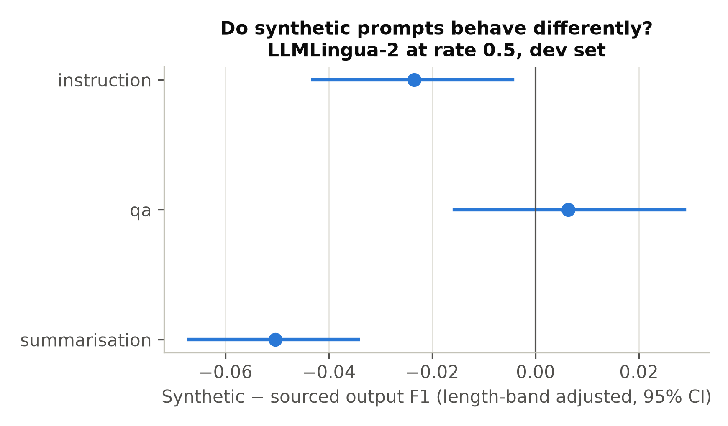
Figure 10. Fidelity difference between synthetic and real prompts by category and rate, with 95% bootstrap intervals
Synthetic prompts are therefore safe for calibrating a selector but are *not a drop-in substitute for real prompts when measuring fidelity*: their bias is of the same order as the method differences in Table 8. For this reason the headline method comparisons rest on the 850 real corpus prompts plus the 150 synthetic creative prompts, which are confined to one category, and creative-category results carry this caveat (Long et al., 2024; Liu et al., 2024).

Robustness and verification
The main results were checked in four ways.
- Scorer. Every RQ1 comparison holds under multilingual BERT (LLMLingua-2 beats random deletion by +0.017 to +0.033, all p < 10⁻¹⁴), and the mBERT APCS evaluation reaches the same conclusions.
- Scorer window. Removing the 2.6% of pairs that exceed AraBERT's 510-word-piece window changes the RQ1 differences by at most 0.002.
- Replication across data. The ranking flip, the method ordering, the cost penalty and APCS 1.0.0's accuracy all replicated from pilot to v2 and from test to exam. The size of the cost penalty varies between prompt sets: LLMLingua-2 @ 0.5 adds 10.9% on dev, 19.0% on test and 12.1% on the exam. Its direction never changes.
- Independent audit. A script that imports none of the experiment code recomputed every number cited in this chapter from the raw files. It re-joined all 13,438 and 3,828 stored responses to the results tables, recomputed costs from token counts, re-applied the frozen selectors and re-ran the statistical tests. All 117 checks passed. The audit found three documentation errors in the experiment log, which were corrected, and none in the data or results.

Answering the research questions
RQ | Answer | Key evidence
RQ1: effectiveness on Arabic | Partly effective. English defaults fail (GPT-2 scoring corrupts Arabic). Classifier-based LLMLingua-2 transfers best, beating random deletion by 0.04–0.05 F1 at every rate, and beats compression-matched LLMLingua. Light compression is tolerable; heavy compression damages most answers and lowers QA correctness from 57% to as little as 32%. Prompt-level evaluation ranks methods backwards. | Table 8; Figures 3 and 4
RQ2: feature effects | Task type and length matter; morphology does not. Category explains 6.5% and length 3.4% of unique variance; fragmentation has a small negative effect; morphological density is not significant. QA is the most fragile category once noise is accounted for. Prompt-level features explain only 15% of the variation. | Table 9; Figure 5
RQ3: can a selector choose accurately? | Yes, with a modest effect. A tree over task category and length (APCS-v2) beats the best fixed strategy on unseen prompts (+5.8 points, Holm p = 0.028) and the rule-based APCS 1.0.0 (+7.2, p = 0.008). Absolute accuracy (38.5%) remains limited by the noisy, near-uniform labels. A cost-aware variant lowers the bill only slightly (−1.0%) while keeping fidelity high. | Tables 11–13; Figure 8
Additional finding | Compression can raise the bill. Under 6:1 output pricing, LLMLingua-2 deletes length instructions, answers grow 1.3–2.4×, and total cost rises 5–24%. Protecting length instructions reverses this (−5 to −8%) and raises fidelity. | Tables 10 and 14; Figures 6 and 9
Table 15. Answers to the research questions

Chapter Summary
The evaluation first established that a fixed 0.85 threshold could not be used, because a third of identical-prompt answer pairs fail it, and set a noise-derived τ instead. On that basis, LLMLingua-2 is the most effective compressor for Arabic. Output-level evaluation is essential, because prompt-level scores rank methods backwards. Task type and length, not morphology, drive compression outcomes. The original rule-based APCS replicated at about 31% but did not reliably beat the best fixed strategy. The redesigned APCS-v2 did, on pre-registered fresh data. Under output-weighted pricing, compression raised the bill because it deleted length instructions. Protecting those instructions turned the cost penalty into a saving, while a cost-aware selector achieved a small but significant saving at high fidelity. Chapter 6 reflects on these outcomes, their limitations and their implications.

Conclusions

Chapter Introduction
This final chapter looks back on the project as a whole. Section 6.2 sets out the lessons learned about the topic, about research method and about the project plan. Section 6.3 appraises the project's strengths and weaknesses. Sections 6.4 and 6.5 discuss its academic and business contributions and the limits of each, and extend the findings beyond Arabic. Section 6.6 recommends future research, and Section 6.7 closes the dissertation.
The project set out to discover whether existing prompt compression methods work on Arabic, which prompt features govern their behaviour, and whether a feature-based selector can choose the best strategy per prompt. In brief: classifier-based compression transfers to Arabic with a modest but consistent advantage over chance; task type and length, not morphology, drive the outcome; and a selector that knows a prompt's task category beats every fixed strategy on unseen prompts, though by a modest margin. Along the way the project found that, under current API pricing, compressing a prompt can make it more expensive, and showed how to prevent that.

Lessons Learned
About the topic. The most important lesson is that cheaper input is not a cheaper call. The project began, like the literature it built on, by treating token reduction as the goal. The measured bills showed that the compressor's deletions changed the answer as well as the prompt. When output is priced well above input, words that carry almost no content, such as "briefly" or "in three sentences", are among the most valuable in the prompt. This lesson generalises beyond Arabic and beyond compression. Any intervention on a prompt, whether compression, translation, templating or truncation, should be evaluated on what it does to the whole exchange, not only to the input.
A second lesson is that the evaluation instrument must be validated before it is used. Two choices that looked reasonable in the SDR would have produced wrong conclusions. A fixed threshold of 0.85 would have classified a third of unaltered prompts as damaged. Prompt-level similarity would have ranked random deletion above LLMLingua-2. Both errors were caught only because the pilot measured the instrument itself, through repeat calls and perturbation tests, before measuring the methods. For practitioners, the message is to measure an LLM's own variability before trusting any fidelity threshold, and to compare outputs, not inputs.
A third lesson concerns intuitions about Arabic. The project's starting hypothesis, carried into the SDR's decision rules, was that Arabic's rich morphology would be the key to compression behaviour. The data did not support it. What mattered was what the prompt was for (its task) and how much text it contained. Once those were known, the tokeniser tax still mattered a little (fragmentation), but morphology did not. Linguistic intuition is a good source of hypotheses, but it must be tested.
About research method. Several practices proved their value and would be repeated. Running a cheap pilot on data designated dev-only before building the final dataset allowed the design to be corrected without contaminating the held-out evaluation. Recording every experiment with its question, method, results, decision and caveats made the project auditable. It allowed a morphology-measure defect to be found, corrected and reported as an erratum rather than silently absorbed, and it made writing this dissertation largely a matter of assembly. Pre-registering the exam hypotheses removed any temptation to adjust the selectors after seeing the results, and gave the positive H1 and H2 results credibility that an exploratory analysis could not have. The independent audit before writing was cheap insurance: it found three documentation errors, and none in the results.
About the project plan. Table 16 summarises the SDR's plan and what each phase delivered.
Phase (SDR plan) | Planned | Outcome | Note
Dataset construction | 18 May – 14 Jun | Pilot set (500) and AraPromptBench v2 (1,000) built and frozen | v2 deconfounded by length band, informed by the pilot
Framework implementation | 15 Jun – 12 Jul | Pipeline built incrementally through Exps 01–07 | Resumable and deduplicating
Experimental benchmarking | 13 Jul – 9 Aug | Full benchmark: 13,438 calls, one model snapshot | Run on gpt-5.6-luna for current results
APCS design and implementation | 10 Aug – 6 Sep | Pilot package, APCS 1.0.0, then redesign (APCS-v2, APCS-cost) | Redesign added beyond the plan
Artefact evaluation | 7 – 27 Sep | Held-out test evaluation and fresh pre-registered exam | Exam added beyond the plan
Dissertation writing | 21 Sep – 18 Oct | Draft written and revised | —
Table 16. SDR project plan and outcomes
The project followed the phase order of the SDR plan, and each phase produced its planned deliverable: the benchmark, the pipeline, the experimental results, the APCS and its held-out evaluation. The evaluation phase was extended beyond the plan with a second, pre-registered evaluation on a fresh exam set, added because the redesigned selectors could not be evaluated fairly on the already-used test split. Two features of the plan proved their worth: running a pilot before the final benchmark, which allowed the evaluation design to be corrected cheaply, and the resumable, deduplicating pipeline, which ran the full 13,438-call benchmark in about an hour for US$2.49. With hindsight, the plan could also have scheduled human evaluation of answer quality, which would have strengthened the fidelity measurements.
Personal growth as a researcher. This project changed how I approach evidence. I began by trusting the instruments I had specified: the SDR's threshold of 0.85 looked reasonable until a simple repeat-call test showed that a third of answers to identical prompts failed it. Since then, my first question about any evaluation has been how much the measurement varies on its own, before asking whether a method works.
I also learned to let data overrule my intuition. The idea at the heart of my SDR was that Arabic's rich morphology would decide how well prompts compress, and the results showed that it did not. Reporting that clearly, rather than searching for an analysis that would rescue it, was uncomfortable at first, but I now see negative results as findings in their own right. The cost result taught a related lesson. I expected compression to save money, and when the bill went up, the satisfying part was not the surprise but tracing it to a mechanism (deleted length instructions) and then fixing it. It made me look at systems as a whole rather than optimising the one number in front of me.
The fresh exam taught me discipline. Writing down my hypotheses and freezing the selectors before seeing a single result removed any temptation to adjust them afterwards, and it is the reason I trust the positive results. Finding a defect in my own morphology measure and filing an erratum taught me that admitting a mistake openly strengthens a piece of work rather than weakening it.
Technically, I gained practical skills in Arabic NLP tools, paired statistical testing and building reproducible pipelines on a budget. Just as importantly, I learned to verify my own work systematically, which is why the project ends with an independent audit of every number. If I started again, I would add human evaluation of answer quality from the outset and measure total cost from the very first pilot, so that effects such as the cost penalty are visible from the start.

Strengths and Weakness of the Project
Strengths.
- Rigour of evaluation. The paired design, noise-derived threshold, two independent held-out evaluations, pre-registration, Holm correction and an independent audit give the conclusions a strong evidential basis. Negative and partial results (APCS 1.0.0 not beating the best fixed strategy; morphology not predictive) are reported as clearly as the positive ones.
- Credible, documented data. 850 of the 1,000 benchmark prompts come from six published, licensed corpora, with per-prompt provenance, deliberate deconfounding of length and task type, and a measured rather than assumed treatment of the synthetic share.
- Replication. The ranking flip, method ordering, cost penalty and APCS 1.0.0 accuracy each replicated across independent prompt sets, the last within 0.2 points.
- A finding of practical value. The cost penalty, its mechanism and its remedy (the protected compressor) are concrete, testable and immediately useful.
- An honest, usable artefact. The APCS is small, explainable, tested, and provably identical to the evaluated selectors.
Weaknesses.
- One LLM. All final results come from one commercial model. The method ordering is likely to generalise, because it replicated from the pilot model to the final one, but the cost results depend on that model's verbosity and its 6:1 price ratio.
- Automatic fidelity measure. BERTScore is a proxy. QA correctness provides an independent check for one category, but no human judgement of answer quality was collected, and creative quality in particular is poorly captured by similarity to a single reference answer.
- Noisy labels. Best-balance labels depend on single answers that vary from call to call. With labels this noisy and near-uniform, the attainable accuracy of any selector is limited. Part of the gap between 38.5% and 100% is irreducible noise, not selector error.
- Modest effect sizes. APCS-v2's advantage over the best fixed strategy (+5.8 points) is significant but modest, and APCS-cost's saving (1%) is small. A selector is not a large lever on its own.
- QA. On QA prompts a fixed 0.5 rate beat both selectors on the exam, so the selectors' features do not yet capture what makes a QA prompt compressible.
- Coverage. Dialectal Arabic is represented only by a 2% probe, prompts are at most about 650 tokens long, and the creative category is synthetic.
- Possible training-data exposure. The source corpora are public, so the LLM may have seen some passages during training (Golchin and Surdeanu, 2024). This could affect absolute QA correctness, but it should not bias the paired comparisons between compression methods, which all use the same prompts.
- Latency not measured end to end. The compressor's own time was measured (Section 4.3), but API response latency was not, so no claim is made that compression makes requests faster.

Academic Application and Limitations
The project contributes to research on efficient LLM use in four ways. First, it provides what is, to the author's knowledge, the first systematic evaluation of prompt compression on Arabic, establishing that classifier-based compression transfers and perplexity-based compression with English defaults does not. This fills the first gap identified in Section 2.3.6. Second, it shows that output-level evaluation is necessary: prompt-level similarity ranks methods backwards. This methodological point applies to compression research in any language, and particularly to morphologically rich ones, where surface-word retention and meaning retention diverge. Third, it provides evidence on what drives compressibility: task type and length matter, while morphological density, once controlled, does not. This is consistent with recent findings that morphological type itself confers no intrinsic disadvantage in language modelling (Arnett and Bergen, 2025). Fourth, it identifies the output-length side-effect of compression, which connects the compression literature to the literature on length bias and length control (Singhal et al., 2024; Jie et al., 2024), and shows how the cost model must change when output is priced above input.
AraPromptBench and its exam set are reusable assets. The documented protocol (noise ceiling, output-level scoring, paired tests, pre-registered fresh evaluation) is a template that can be transferred to other languages.
The academic limitations follow from the scope set in Section 1.3. The conclusions apply to MSA, to prompts of a few hundred tokens, to extractive hard-prompt compression and to one LLM. They do not cover long-context retrieval, soft-prompt methods or dialects. The RQ2 regression explains 15% of variance, so the features studied describe only part of what makes a prompt compressible. The finding that morphology does not matter is conditional on the morphology measure used, average Farasa segments per word, and a richer measure might detect an effect this one missed.

Business Application and Limitations
For organisations deploying Arabic LLM applications, the findings translate into concrete guidance:
1. Do not judge compression by tokens saved. Measure the total bill, input and output, on your own traffic. On output-heavy pricing, naive compression can cost more.
2. Protect answer-length instructions. If prompts contain constraints such as "in three sentences" or "no more than fifty words", keep them verbatim. The protected compressor turned a 48% cost increase into an 8% saving on such prompts.
3. Compress selectively. Leave short prompts (below roughly 80–130 tokens) alone. Compress long summarisation and instruction prompts. Be cautious with factual QA, where compression measurably reduces correctness.
4. Choose the selector by objective. Use APCS-v2 when the aim is the maximum safe token reduction, for example to fit a context window. Compression adds about 30 ms per prompt on a GPU (Section 4.3), so it is not a way to reduce latency for prompts of this length. Use APCS-cost when the aim is the lowest bill at high fidelity.
5. Use a classifier-based compressor. LLMLingua-2 was the best method tested. Do not use perplexity-based compression with English scorer models on Arabic.
The commercial value of these measures depends on scale. At the prices studied, the whole 1,000-prompt benchmark cost only a few dollars, so savings matter for high-volume services, not for occasional use. The business limitations mirror the academic ones: the results were measured on one provider's model and price ratio, and the APCS's thresholds should be recalibrated, using the published pipeline, for a different model, a different price ratio or a different prompt mix. Prices and models change quickly; the method for deciding whether compression pays is more durable than any specific number in this dissertation.
Beyond Arabic. The core findings are not specific to Arabic and are likely to apply in other settings. Any language that pays a tokeniser tax (Ahia et al., 2023; Petrov et al., 2023) faces the same incentive to compress and the same evaluation pitfalls. The output-length effect depends on pricing, not on language, so it applies to English deployments too. Routing systems that choose between models (Ding et al., 2024; Ong et al., 2025) should account for answer length in the same way. The general lesson is that, in systems where several cost components interact, optimising one component (input tokens) in isolation can worsen the total.

Recommendations / Prospects for Future Research / Work
1. Cross-model replication. Repeat the benchmark on several LLMs with different price ratios and verbosity, including open Arabic models such as ALLaM (Bari et al., 2025), to separate effects of the compressor from effects of the model. The pipeline makes this a matter of changing a configuration file.
2. Length-aware compressors. The protected variant is a rule-based patch. A better solution is to train compression classifiers that know which tokens control output length, for example by including answer-length change in the distillation objective of an LLMLingua-2-style model (Pan et al., 2024). An Arabic-specific distillation corpus could also improve the classifier's token-importance judgements.
3. Better labels and human evaluation. Use several answers per prompt to reduce label noise, which would raise the ceiling on selector accuracy. Add human judgement of answer quality, at least for creative and summarisation tasks where BERTScore is weakest, or a length-debiased LLM judge validated against a human sample (Zheng et al., 2023; Dubois et al., 2024).
4. Richer selector features. Features describing what a QA prompt asks, such as answer type, question position or passage–question overlap, may fix the selectors' weakness on QA. Learned text embeddings could be tested against the interpretable features, trading some explainability for accuracy.
5. Joint optimisation. Treat compression strategy, model choice and answer-length control as one decision, in the spirit of FrugalGPT's cascades (Chen, Zaharia and Zou, 2024), optimising expected total cost under a fidelity constraint.
6. Dialects and longer contexts. Extend AraPromptBench to major dialects and to long-context and retrieval prompts, where compression ratios, and the case for query-aware methods (Jiang et al., 2024; Nagle et al., 2024), are greatest.
7. Release. Publish AraPromptBench, subject to each source corpus's licence, together with the APCS package and its example notebook, so that others can extend the benchmark and recalibrate the selector.

Chapter Summary
The project answered its three research questions. Existing compression methods are partly effective on Arabic, with classifier-based LLMLingua-2 the best. Task type and length govern compression outcomes, and morphology does not. A feature-based selector can beat every fixed strategy on unseen prompts, by a modest margin. The project delivered AraPromptBench, a reproducible evaluation protocol, and the APCS artefact in three validated variants. Its most practically important finding is that compression can increase the cost of an LLM call by changing the answer, and that protecting answer-length instructions prevents this. The lessons learned (validate the instrument, compare outputs rather than inputs, measure the whole bill, pre-register before testing) apply well beyond Arabic prompt compression. They are offered as the project's contribution to the wider effort to make large language models affordable and fair for speakers of every language.

REFERENCES CITED
Abdelali, A. et al. (2016) 'Farasa: a fast and furious segmenter for Arabic', in Proceedings of the 2016 Conference of the North American Chapter of the Association for Computational Linguistics: Demonstrations. San Diego, CA: Association for Computational Linguistics, pp. 11–16. Available at: https://doi.org/10.18653/v1/N16-3003.
Ahia, O. et al. (2023) 'Do all languages cost the same? Tokenization in the era of commercial language models', in Proceedings of the 2023 Conference on Empirical Methods in Natural Language Processing. Singapore: Association for Computational Linguistics, pp. 9904–9923. Available at: https://doi.org/10.18653/v1/2023.emnlp-main.614.
Ali, M. et al. (2024) 'Tokenizer choice for LLM training: negligible or crucial?', in Findings of the Association for Computational Linguistics: NAACL 2024. Mexico City: Association for Computational Linguistics, pp. 3907–3924. Available at: https://doi.org/10.18653/v1/2024.findings-naacl.247.
Alyafeai, Z. et al. (2024) 'CIDAR: culturally relevant instruction dataset for Arabic', in Findings of the Association for Computational Linguistics: ACL 2024. Bangkok: Association for Computational Linguistics, pp. 12878–12901. Available at: https://doi.org/10.18653/v1/2024.findings-acl.764.
Antoun, W., Baly, F. and Hajj, H. (2020) 'AraBERT: transformer-based model for Arabic language understanding', in Proceedings of the 4th Workshop on Open-Source Arabic Corpora and Processing Tools, with a Shared Task on Offensive Language Detection. Marseille: European Language Resources Association, pp. 9–15. Available at: https://aclanthology.org/2020.osact-1.2/ (Accessed: 5 October 2026).
Arnett, C. and Bergen, B. (2025) 'Why do language models perform worse for morphologically complex languages?', in Proceedings of the 31st International Conference on Computational Linguistics. Abu Dhabi: Association for Computational Linguistics, pp. 6607–6623. Available at: https://aclanthology.org/2025.coling-main.441/ (Accessed: 5 October 2026).
Asgari, E. et al. (2026) 'MorphBPE: morphology-aware tokenization for efficient LLM training', in Findings of the Association for Computational Linguistics: ACL 2026. Association for Computational Linguistics, pp. 41610–41621. Available at: https://doi.org/10.18653/v1/2026.findings-acl.2068.
Bari, M.S. et al. (2025) 'ALLaM: large language models for Arabic and English', in Proceedings of the Thirteenth International Conference on Learning Representations (ICLR 2025). Singapore. Available at: https://proceedings.iclr.cc/paper_files/paper/2025/file/54c15a3033686e7999aecd2740c5a7c4-Paper-Conference.pdf (Accessed: 5 October 2026).
Chen, L., Zaharia, M. and Zou, J. (2024) 'FrugalGPT: how to use large language models while reducing cost and improving performance', Transactions on Machine Learning Research. Available at: https://openreview.net/forum?id=cSimKw5p6R (Accessed: 5 October 2026).
Chevalier, A. et al. (2023) 'Adapting language models to compress contexts', in Proceedings of the 2023 Conference on Empirical Methods in Natural Language Processing. Singapore: Association for Computational Linguistics, pp. 3829–3846. Available at: https://doi.org/10.18653/v1/2023.emnlp-main.232.
Chiang, C.-H. and Lee, H.-y. (2023) 'Can large language models be an alternative to human evaluations?', in Proceedings of the 61st Annual Meeting of the Association for Computational Linguistics (Volume 1: Long Papers). Toronto: Association for Computational Linguistics, pp. 15607–15631. Available at: https://doi.org/10.18653/v1/2023.acl-long.870.
Chuang, Y.-N. et al. (2024) 'Learning to compress prompt in natural language formats', in Proceedings of the 2024 Conference of the North American Chapter of the Association for Computational Linguistics: Human Language Technologies (Volume 1: Long Papers). Mexico City: Association for Computational Linguistics, pp. 7756–7767. Available at: https://doi.org/10.18653/v1/2024.naacl-long.429.
Clark, J.H. et al. (2020) 'TyDi QA: a benchmark for information-seeking question answering in typologically diverse languages', Transactions of the Association for Computational Linguistics, 8, pp. 454–470. Available at: https://doi.org/10.1162/tacl_a_00317.
Deng, C. et al. (2024) 'Investigating data contamination in modern benchmarks for large language models', in Proceedings of the 2024 Conference of the North American Chapter of the Association for Computational Linguistics: Human Language Technologies (Volume 1: Long Papers). Mexico City: Association for Computational Linguistics, pp. 8706–8719. Available at: https://aclanthology.org/2024.naacl-long.482/ (Accessed: 5 October 2026).
Devlin, J. et al. (2019) 'BERT: pre-training of deep bidirectional transformers for language understanding', in Proceedings of the 2019 Conference of the North American Chapter of the Association for Computational Linguistics: Human Language Technologies. Minneapolis, MN: Association for Computational Linguistics, pp. 4171–4186. Available at: https://doi.org/10.18653/v1/N19-1423.
Ding, D. et al. (2024) 'Hybrid LLM: cost-efficient and quality-aware query routing', in Proceedings of the Twelfth International Conference on Learning Representations (ICLR 2024). Vienna. Available at: https://proceedings.iclr.cc/paper_files/paper/2024/hash/b47d93c99fa22ac0b377578af0a1f63a-Abstract-Conference.html (Accessed: 5 October 2026).
Dubois, Y. et al. (2024) 'Length-controlled AlpacaEval: a simple way to debias automatic evaluators', in Proceedings of the First Conference on Language Modeling (COLM 2024). Philadelphia, PA. Available at: https://arxiv.org/abs/2404.04475 (Accessed: 5 October 2026).
El-Haj, M., Kruschwitz, U. and Fox, C. (2010) 'Using Mechanical Turk to create a corpus of Arabic summaries', in Proceedings of the Workshop on Language Resources and Human Language Technologies for Semitic Languages, LREC 2010. Valletta: European Language Resources Association, pp. 36–39.
Elmadany, A., Nagoudi, E.M.B. and Abdul-Mageed, M. (2023) 'ORCA: a challenging benchmark for Arabic language understanding', in Findings of the Association for Computational Linguistics: ACL 2023. Toronto: Association for Computational Linguistics, pp. 9559–9586. Available at: https://doi.org/10.18653/v1/2023.findings-acl.609.
Ge, T. et al. (2024) 'In-context autoencoder for context compression in a large language model', in Proceedings of the Twelfth International Conference on Learning Representations (ICLR 2024). Vienna. Available at: https://proceedings.iclr.cc/paper_files/paper/2024/hash/0b276510ec2d3f6613a8b60c41ff0438-Abstract-Conference.html (Accessed: 5 October 2026).
Golchin, S. and Surdeanu, M. (2024) 'Time travel in LLMs: tracing data contamination in large language models', in Proceedings of the Twelfth International Conference on Learning Representations (ICLR 2024). Vienna. Available at: https://proceedings.iclr.cc/paper_files/paper/2024/file/bc39a59c49b731c51398ad6b12f301d3-Paper-Conference.pdf (Accessed: 5 October 2026).
Habash, N.Y. (2010) Introduction to Arabic natural language processing. San Rafael, CA: Morgan & Claypool.
Han, T. et al. (2025) 'Token-budget-aware LLM reasoning', in Findings of the Association for Computational Linguistics: ACL 2025. Vienna: Association for Computational Linguistics, pp. 24842–24855. Available at: https://aclanthology.org/2025.findings-acl.1274/ (Accessed: 5 October 2026).
Hasan, T. et al. (2021) 'XL-Sum: large-scale multilingual abstractive summarization for 44 languages', in Findings of the Association for Computational Linguistics: ACL-IJCNLP 2021. Online: Association for Computational Linguistics, pp. 4693–4703. Available at: https://doi.org/10.18653/v1/2021.findings-acl.413.
Hevner, A.R. et al. (2004) 'Design science in information systems research', MIS Quarterly, 28(1), pp. 75–105.
Holm, S. (1979) 'A simple sequentially rejective multiple test procedure', Scandinavian Journal of Statistics, 6(2), pp. 65–70.
Huang, H. et al. (2024a) 'AceGPT, localizing large language models in Arabic', in Proceedings of the 2024 Conference of the North American Chapter of the Association for Computational Linguistics: Human Language Technologies (Volume 1: Long Papers). Mexico City: Association for Computational Linguistics, pp. 8139–8163. Available at: https://doi.org/10.18653/v1/2024.naacl-long.450.
Huang, X. et al. (2024b) 'Fewer is more: boosting math reasoning with reinforced context pruning', in Proceedings of the 2024 Conference on Empirical Methods in Natural Language Processing. Miami, FL: Association for Computational Linguistics, pp. 13674–13695. Available at: https://doi.org/10.18653/v1/2024.emnlp-main.758.
Jha, S. et al. (2024) 'Characterizing prompt compression methods for long context inference', in Workshop on Efficient Systems for Foundation Models (ES-FoMo II), 41st International Conference on Machine Learning. Vienna. Available at: https://arxiv.org/abs/2407.08892 (Accessed: 5 October 2026).
Jiang, H. et al. (2023) 'LLMLingua: compressing prompts for accelerated inference of large language models', in Proceedings of the 2023 Conference on Empirical Methods in Natural Language Processing. Singapore: Association for Computational Linguistics, pp. 13358–13376. Available at: https://doi.org/10.18653/v1/2023.emnlp-main.825.
Jiang, H. et al. (2024) 'LongLLMLingua: accelerating and enhancing LLMs in long context scenarios via prompt compression', in Proceedings of the 62nd Annual Meeting of the Association for Computational Linguistics (Volume 1: Long Papers). Bangkok: Association for Computational Linguistics, pp. 1658–1677. Available at: https://doi.org/10.18653/v1/2024.acl-long.91.
Jie, R. et al. (2024) 'Prompt-based length controlled generation with multiple control types', in Findings of the Association for Computational Linguistics: ACL 2024. Bangkok: Association for Computational Linguistics, pp. 1067–1085. Available at: https://doi.org/10.18653/v1/2024.findings-acl.63.
Jung, H. and Kim, K.-J. (2024) 'Discrete prompt compression with reinforcement learning', IEEE Access, 12, pp. 72578–72587. Available at: https://doi.org/10.1109/ACCESS.2024.3403426.
Khondaker, M.T.I. et al. (2023) 'GPTAraEval: a comprehensive evaluation of ChatGPT on Arabic NLP', in Proceedings of the 2023 Conference on Empirical Methods in Natural Language Processing. Singapore: Association for Computational Linguistics, pp. 220–247. Available at: https://doi.org/10.18653/v1/2023.emnlp-main.16.
Koto, F. et al. (2024) 'ArabicMMLU: assessing massive multitask language understanding in Arabic', in Findings of the Association for Computational Linguistics: ACL 2024. Bangkok: Association for Computational Linguistics, pp. 5622–5640. Available at: https://doi.org/10.18653/v1/2024.findings-acl.334.
Łajewska, W. et al. (2025) 'Understanding and improving information preservation in prompt compression for LLMs', in Findings of the Association for Computational Linguistics: EMNLP 2025. Suzhou: Association for Computational Linguistics, pp. 17520–17541. Available at: https://aclanthology.org/2025.findings-emnlp.949/ (Accessed: 5 October 2026).
Li, Y. et al. (2023) 'Compressing context to enhance inference efficiency of large language models', in Proceedings of the 2023 Conference on Empirical Methods in Natural Language Processing. Singapore: Association for Computational Linguistics, pp. 6342–6353. Available at: https://doi.org/10.18653/v1/2023.emnlp-main.391.
Li, Z. et al. (2025) 'Prompt compression for large language models: a survey', in Proceedings of the 2025 Conference of the Nations of the Americas Chapter of the Association for Computational Linguistics: Human Language Technologies (Volume 1: Long Papers). Albuquerque, NM: Association for Computational Linguistics, pp. 7182–7195. Available at: https://doi.org/10.18653/v1/2025.naacl-long.368.
Limisiewicz, T., Balhar, J. and Mareček, D. (2023) 'Tokenization impacts multilingual language modeling: assessing vocabulary allocation and overlap across languages', in Findings of the Association for Computational Linguistics: ACL 2023. Toronto: Association for Computational Linguistics, pp. 5661–5681. Available at: https://doi.org/10.18653/v1/2023.findings-acl.350.
Liskavets, B. et al. (2025) 'Prompt compression with context-aware sentence encoding for fast and improved LLM inference', Proceedings of the AAAI Conference on Artificial Intelligence, 39(23), pp. 24595–24604. Available at: https://doi.org/10.1609/aaai.v39i23.34639.
Liu, R. et al. (2024) 'Best practices and lessons learned on synthetic data', in Proceedings of the First Conference on Language Modeling (COLM 2024). Philadelphia, PA. Available at: https://arxiv.org/abs/2404.07503 (Accessed: 5 October 2026).
Long, L. et al. (2024) 'On LLMs-driven synthetic data generation, curation, and evaluation: a survey', in Findings of the Association for Computational Linguistics: ACL 2024. Bangkok: Association for Computational Linguistics, pp. 11065–11082. Available at: https://doi.org/10.18653/v1/2024.findings-acl.658.
McNemar, Q. (1947) 'Note on the sampling error of the difference between correlated proportions or percentages', Psychometrika, 12(2), pp. 153–157. Available at: https://doi.org/10.1007/BF02295996.
Mozannar, H. et al. (2019) 'Neural Arabic question answering', in Proceedings of the Fourth Arabic Natural Language Processing Workshop. Florence: Association for Computational Linguistics, pp. 108–118. Available at: https://doi.org/10.18653/v1/W19-4612.
Mu, J., Li, X. and Goodman, N. (2023) 'Learning to compress prompts with gist tokens', in Advances in Neural Information Processing Systems 36. New Orleans, LA: Curran Associates, pp. 19327–19352.
Nagle, A. et al. (2024) 'Fundamental limits of prompt compression: a rate-distortion framework for black-box language models', in Advances in Neural Information Processing Systems 37. Vancouver: Curran Associates, pp. 94934–94970.
Nagoudi, E.M.B. et al. (2023) 'Dolphin: a challenging and diverse benchmark for Arabic NLG', in Findings of the Association for Computational Linguistics: EMNLP 2023. Singapore: Association for Computational Linguistics, pp. 1404–1422. Available at: https://doi.org/10.18653/v1/2023.findings-emnlp.98.
Ong, I. et al. (2025) 'RouteLLM: learning to route LLMs from preference data', in Proceedings of the Thirteenth International Conference on Learning Representations (ICLR 2025). Singapore. Available at: https://iclr.cc/virtual/2025/poster/30737 (Accessed: 5 October 2026).
Ouyang, S. et al. (2025) 'An empirical study of the non-determinism of ChatGPT in code generation', ACM Transactions on Software Engineering and Methodology, 34, pp. 1–28. Available at: https://doi.org/10.1145/3697010.
Pan, Z. et al. (2024) 'LLMLingua-2: data distillation for efficient and faithful task-agnostic prompt compression', in Findings of the Association for Computational Linguistics: ACL 2024. Bangkok: Association for Computational Linguistics, pp. 963–981. Available at: https://doi.org/10.18653/v1/2024.findings-acl.57.
Park, H.H. et al. (2021) 'Morphology matters: a multilingual language modeling analysis', Transactions of the Association for Computational Linguistics, 9, pp. 261–276. Available at: https://doi.org/10.1162/tacl_a_00365.
Pedregosa, F. et al. (2011) 'Scikit-learn: machine learning in Python', Journal of Machine Learning Research, 12, pp. 2825–2830.
Petrov, A. et al. (2023) 'Language model tokenizers introduce unfairness between languages', in Advances in Neural Information Processing Systems 36. New Orleans, LA: Curran Associates, pp. 36963–36990.
Rice, J.R. (1976) 'The algorithm selection problem', Advances in Computers, 15, pp. 65–118.
Sainz, O. et al. (2023) 'NLP evaluation in trouble: on the need to measure LLM data contamination for each benchmark', in Findings of the Association for Computational Linguistics: EMNLP 2023. Singapore: Association for Computational Linguistics, pp. 10776–10787. Available at: https://doi.org/10.18653/v1/2023.findings-emnlp.722.
Šakota, M., Peyrard, M. and West, R. (2024) 'Fly-swat or cannon? Cost-effective language model choice via meta-modeling', in Proceedings of the 17th ACM International Conference on Web Search and Data Mining (WSDM '24). Merida: ACM, pp. 606–615. Available at: https://doi.org/10.1145/3616855.3635825.
Samsi, S. et al. (2023) 'From words to watts: benchmarking the energy costs of large language model inference', in 2023 IEEE High Performance Extreme Computing Conference (HPEC). Boston, MA: IEEE, pp. 1–9. Available at: https://doi.org/10.1109/HPEC58863.2023.10363447.
Singh, S. et al. (2024) 'Aya dataset: an open-access collection for multilingual instruction tuning', in Proceedings of the 62nd Annual Meeting of the Association for Computational Linguistics (Volume 1: Long Papers). Bangkok: Association for Computational Linguistics, pp. 11521–11567. Available at: https://doi.org/10.18653/v1/2024.acl-long.620.
Singhal, P. et al. (2024) 'A long way to go: investigating length correlations in RLHF', in Proceedings of the First Conference on Language Modeling (COLM 2024). Philadelphia, PA. Available at: https://arxiv.org/abs/2310.03716 (Accessed: 5 October 2026).
Song, Y. et al. (2025) 'The good, the bad, and the greedy: evaluation of LLMs should not ignore non-determinism', in Proceedings of the 2025 Conference of the Nations of the Americas Chapter of the Association for Computational Linguistics: Human Language Technologies (Volume 1: Long Papers). Albuquerque, NM: Association for Computational Linguistics, pp. 4195–4206. Available at: https://aclanthology.org/2025.naacl-long.211/ (Accessed: 5 October 2026).
Wan, Z. et al. (2024) 'Efficient large language models: a survey', Transactions on Machine Learning Research. Available at: https://openreview.net/forum?id=bsCCJHbO8A (Accessed: 5 October 2026).
Wilcoxon, F. (1945) 'Individual comparisons by ranking methods', Biometrics Bulletin, 1(6), pp. 80–83. Available at: https://doi.org/10.2307/3001968.
Xu, F., Shi, W. and Choi, E. (2024) 'RECOMP: improving retrieval-augmented LMs with context compression and selective augmentation', in Proceedings of the Twelfth International Conference on Learning Representations (ICLR 2024). Vienna. Available at: https://proceedings.iclr.cc/paper_files/paper/2024/file/bda88ed2892f5e61c9a9bf215c566913-Paper-Conference.pdf (Accessed: 5 October 2026).
Zhang, T. et al. (2020) 'BERTScore: evaluating text generation with BERT', in Proceedings of the Eighth International Conference on Learning Representations (ICLR 2020). Addis Ababa (virtual). Available at: https://openreview.net/forum?id=SkeHuCVFDr (Accessed: 5 October 2026).
Zheng, L. et al. (2023) 'Judging LLM-as-a-judge with MT-Bench and Chatbot Arena', in Advances in Neural Information Processing Systems 36 (Datasets and Benchmarks Track). New Orleans, LA: Curran Associates, pp. 46595–46623.
Zhu, J. et al. (2025) 'Second language (Arabic) acquisition of LLMs via progressive vocabulary expansion', in Proceedings of the 63rd Annual Meeting of the Association for Computational Linguistics (Volume 1: Long Papers). Vienna: Association for Computational Linguistics, pp. 2025–2042. Available at: https://aclanthology.org/2025.acl-long.100/ (Accessed: 5 October 2026).

APPENDICES

Approved Dissertation Proposal
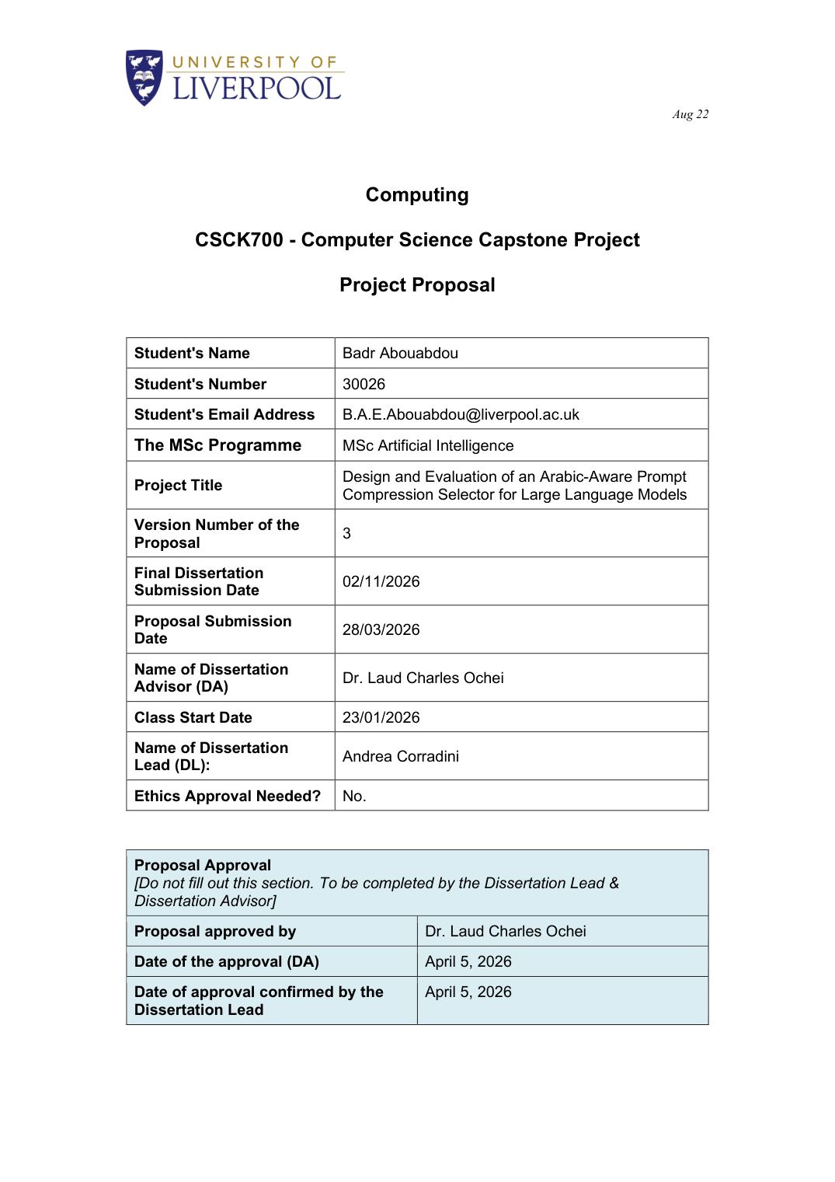
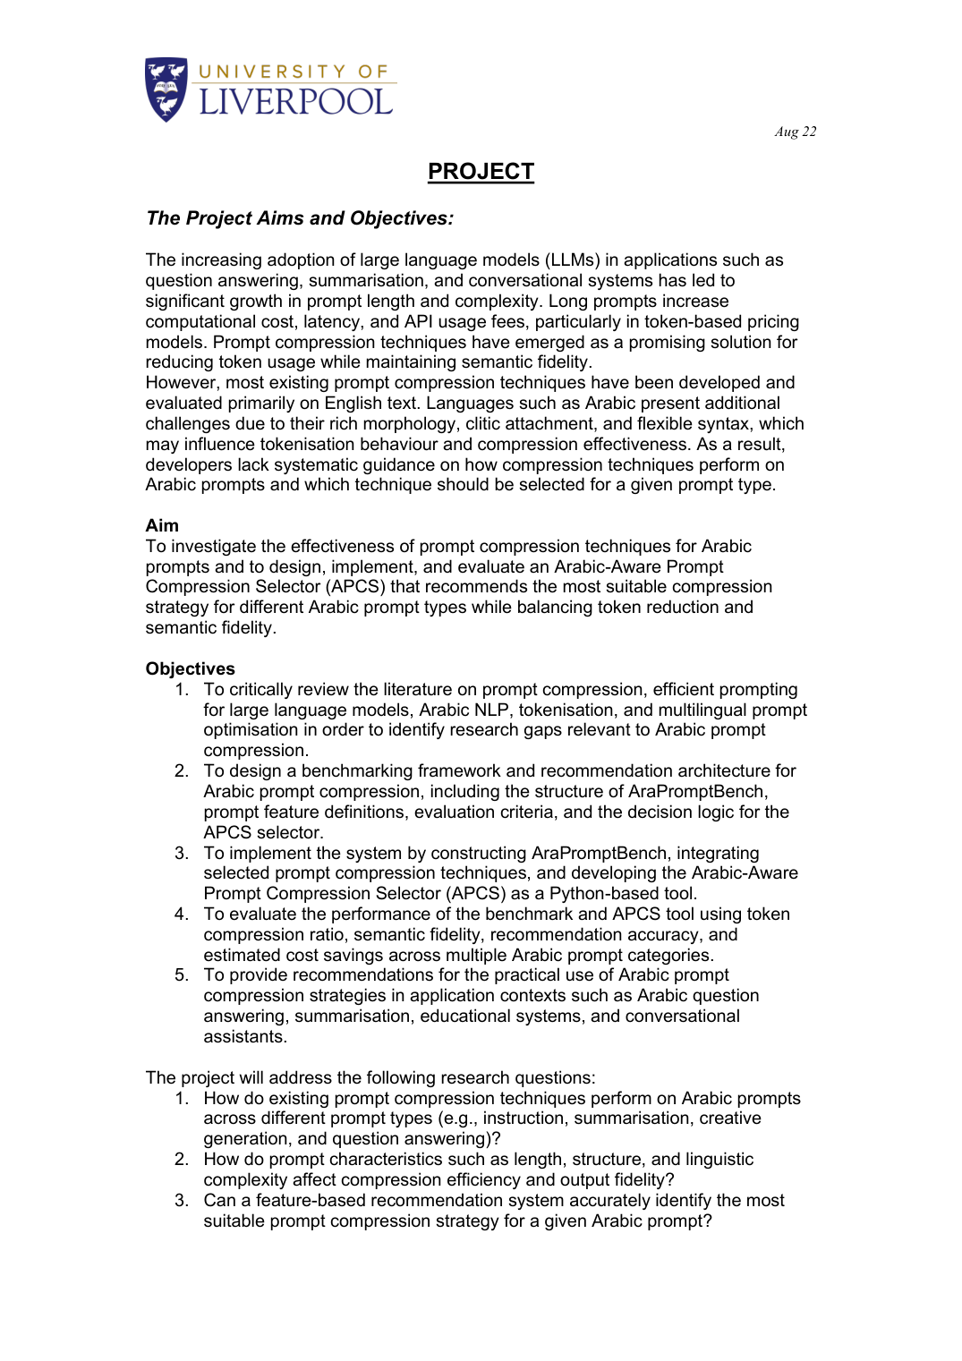
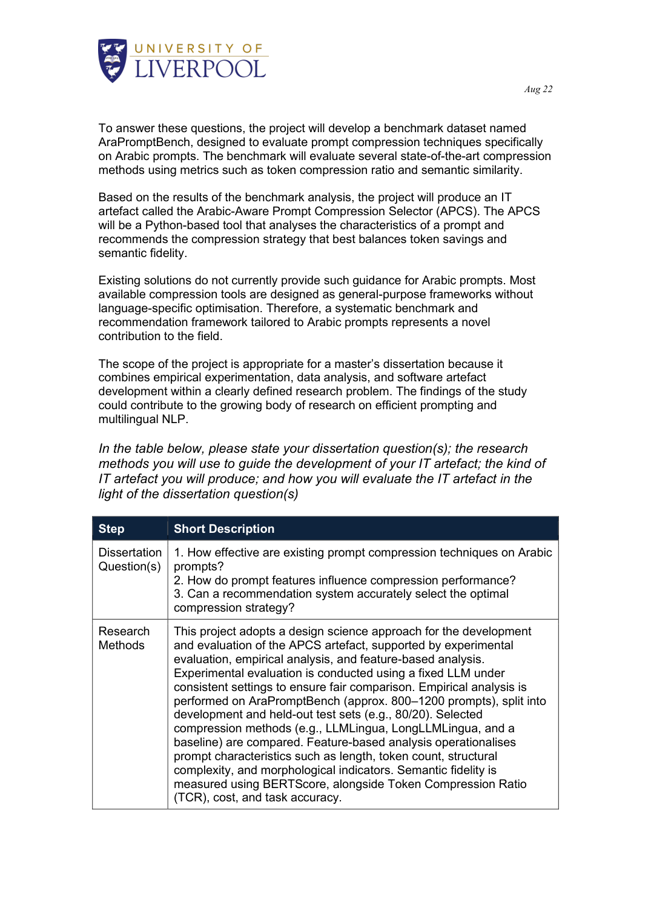
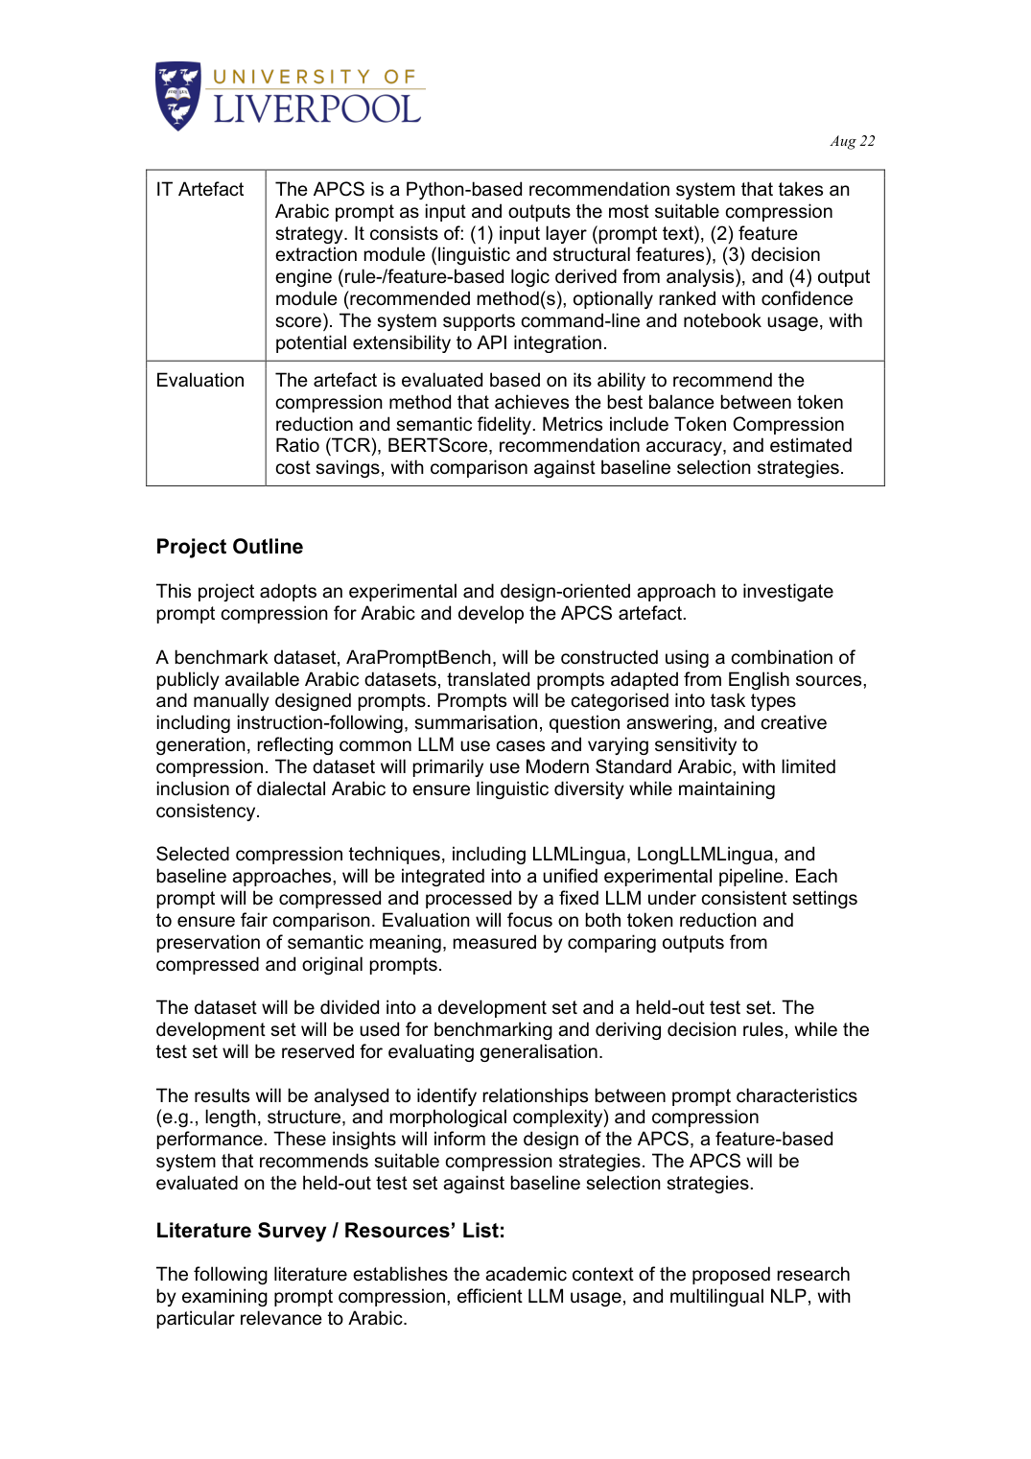
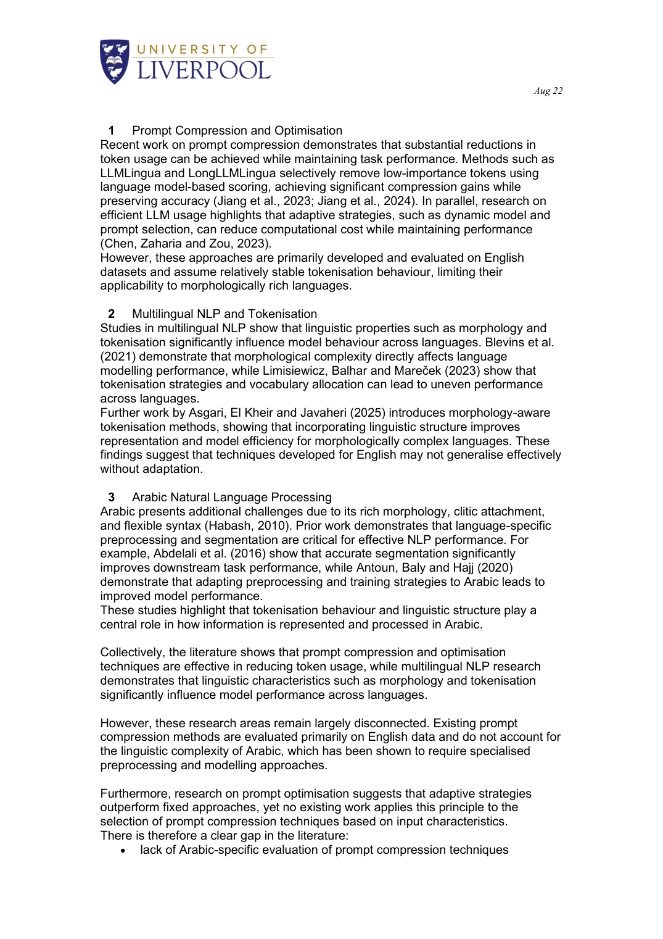
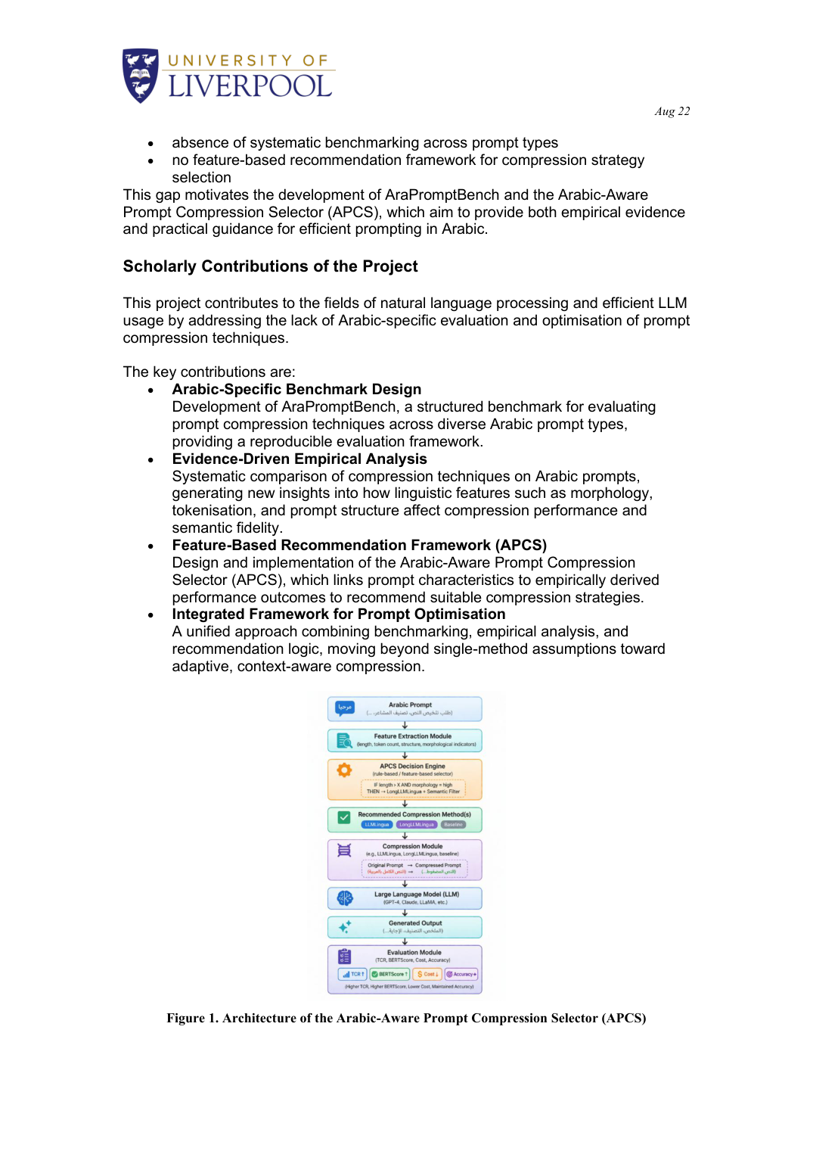
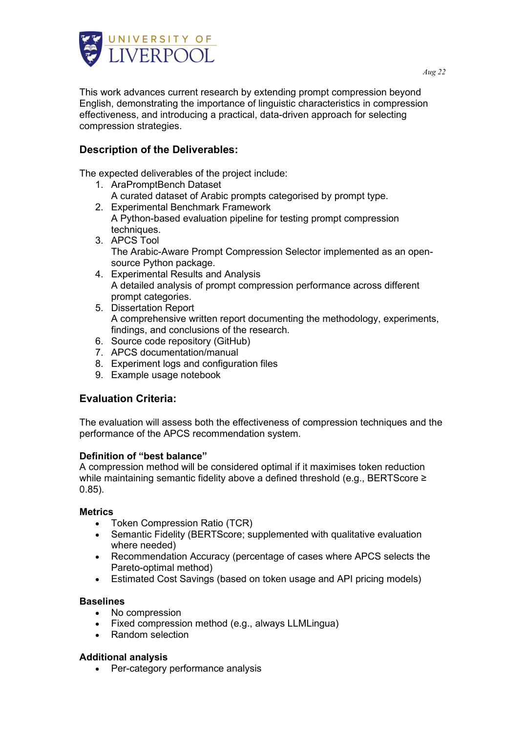
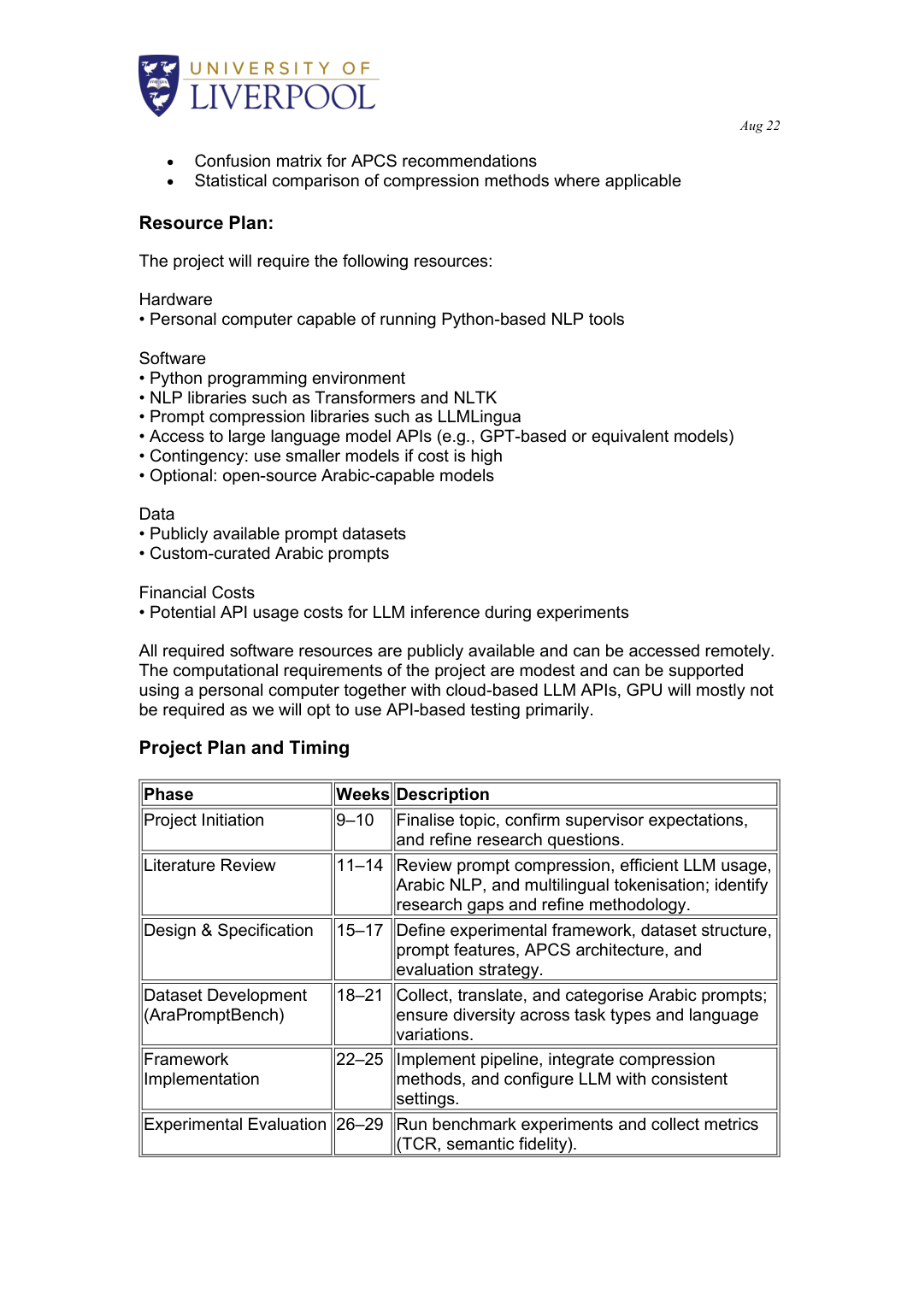
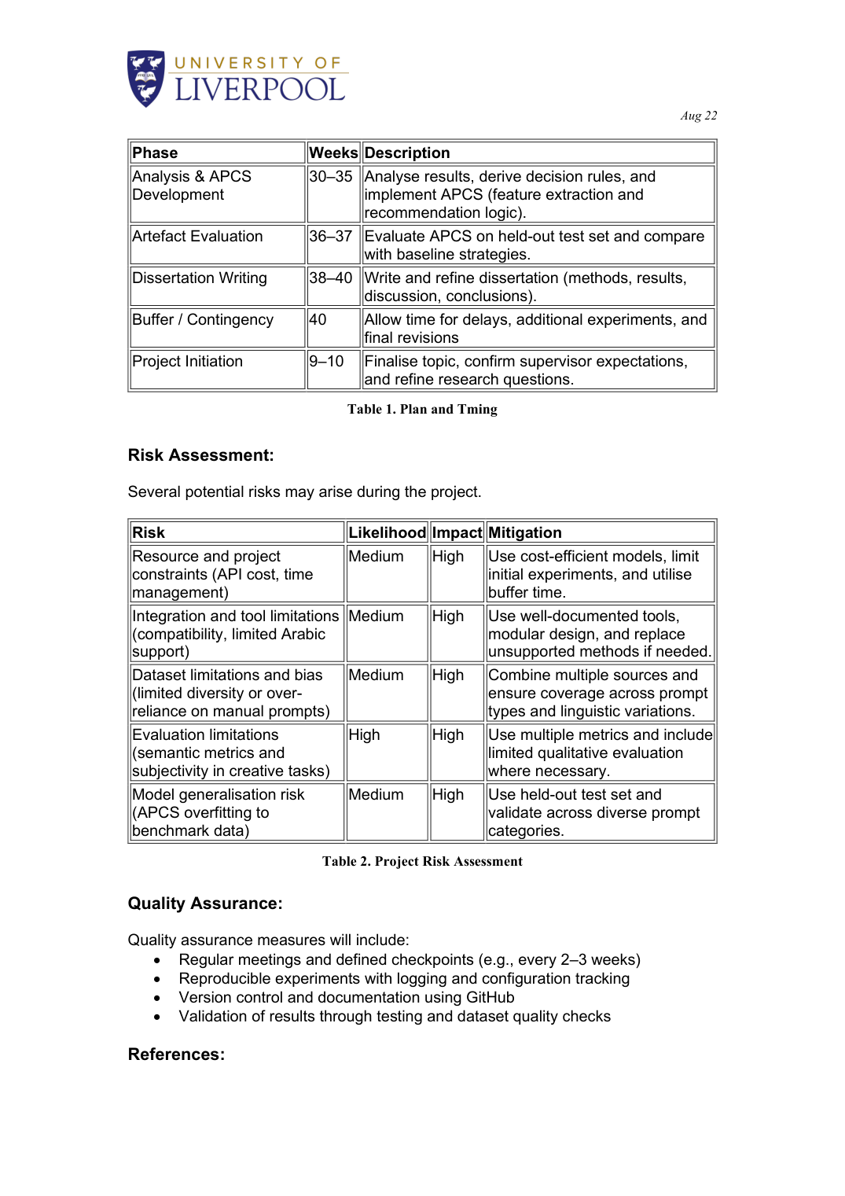
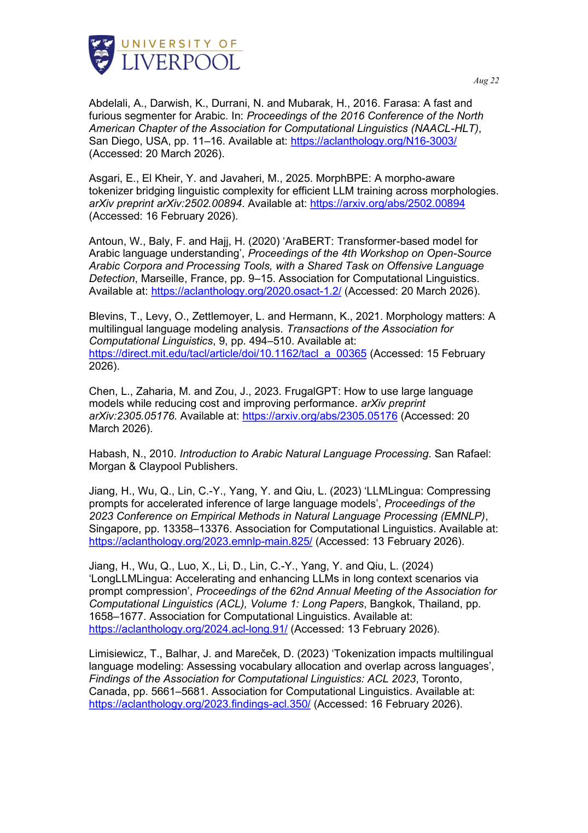

Specification & Design Report
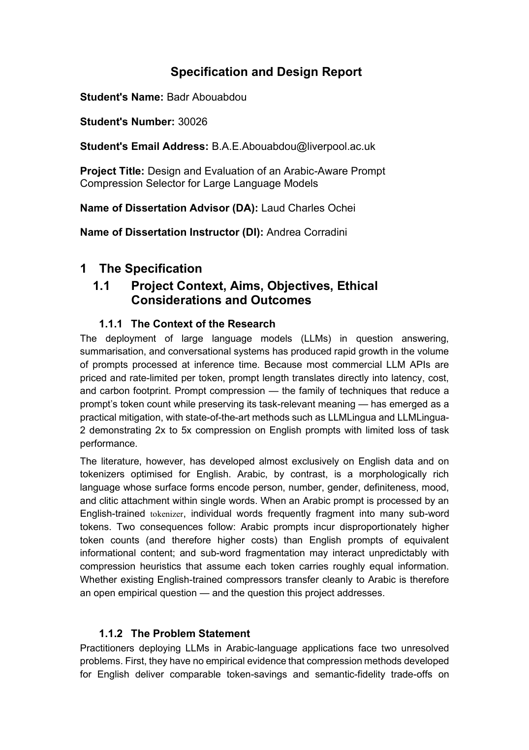
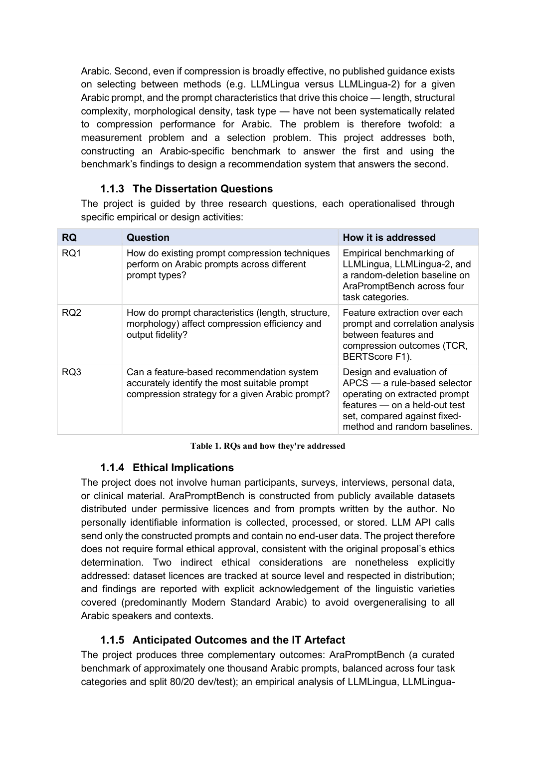
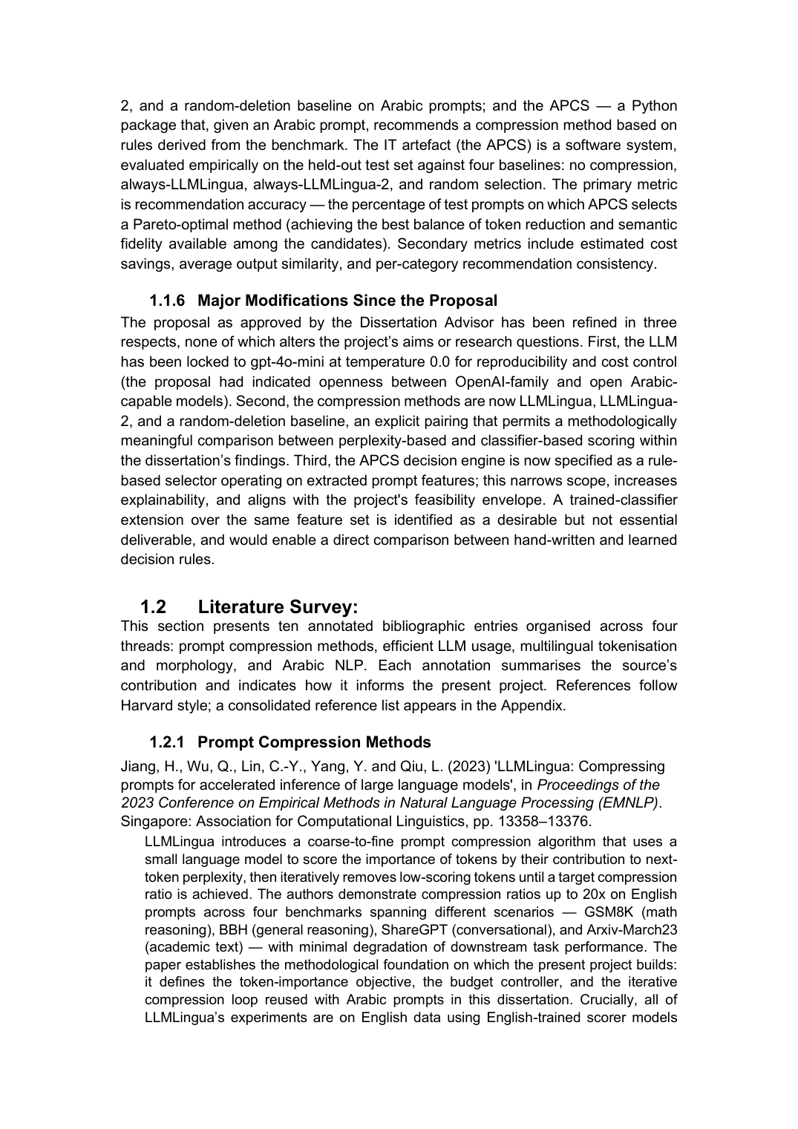
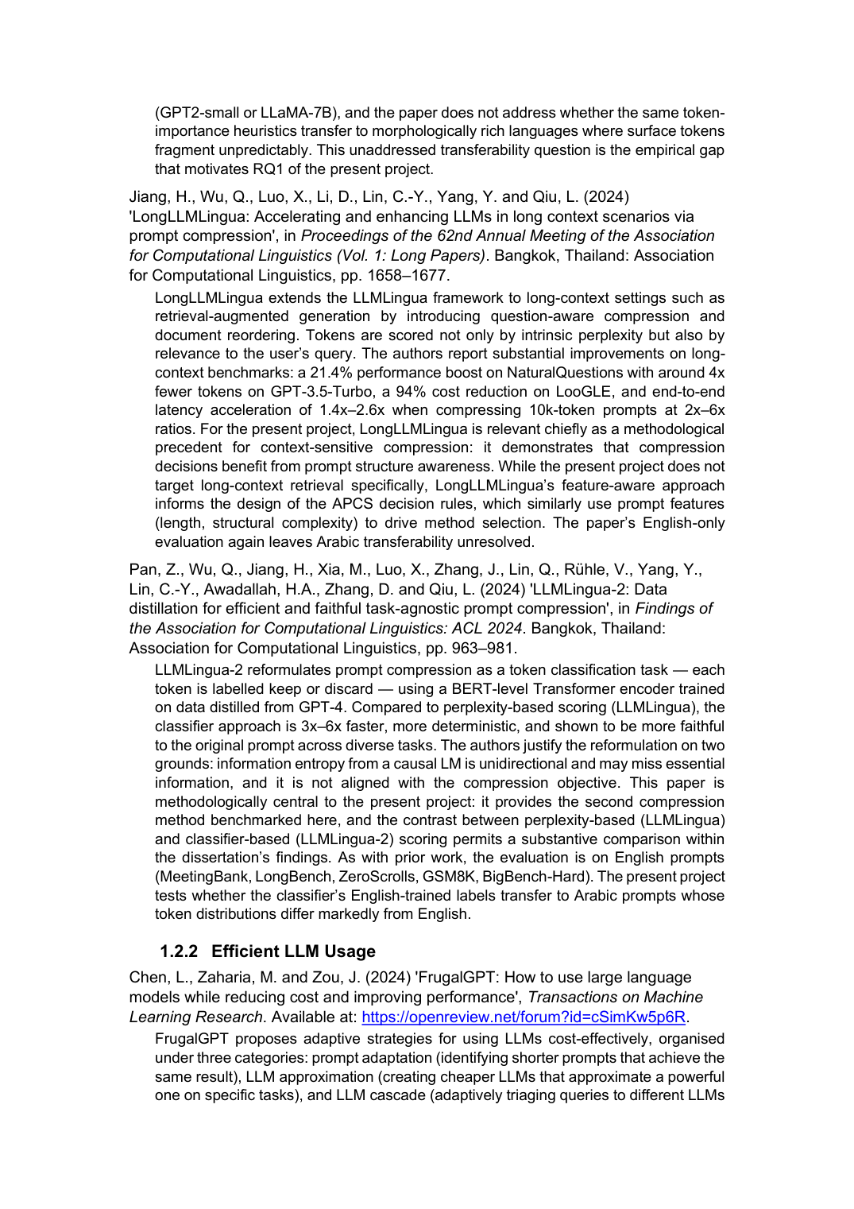
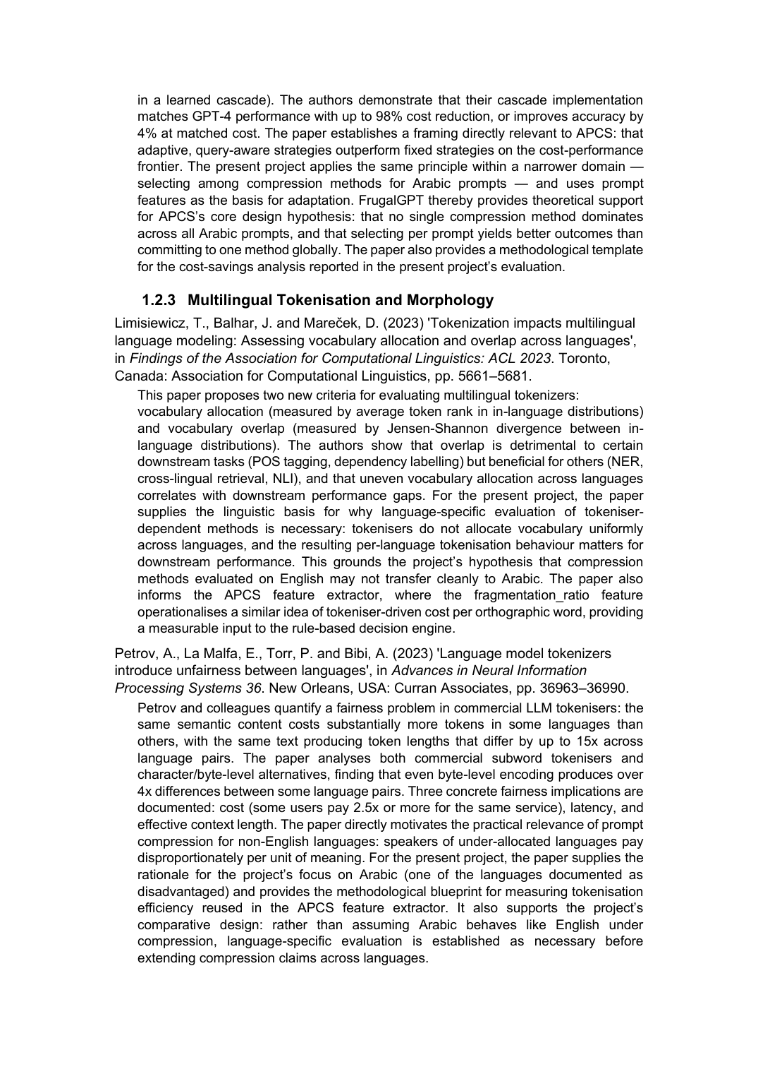
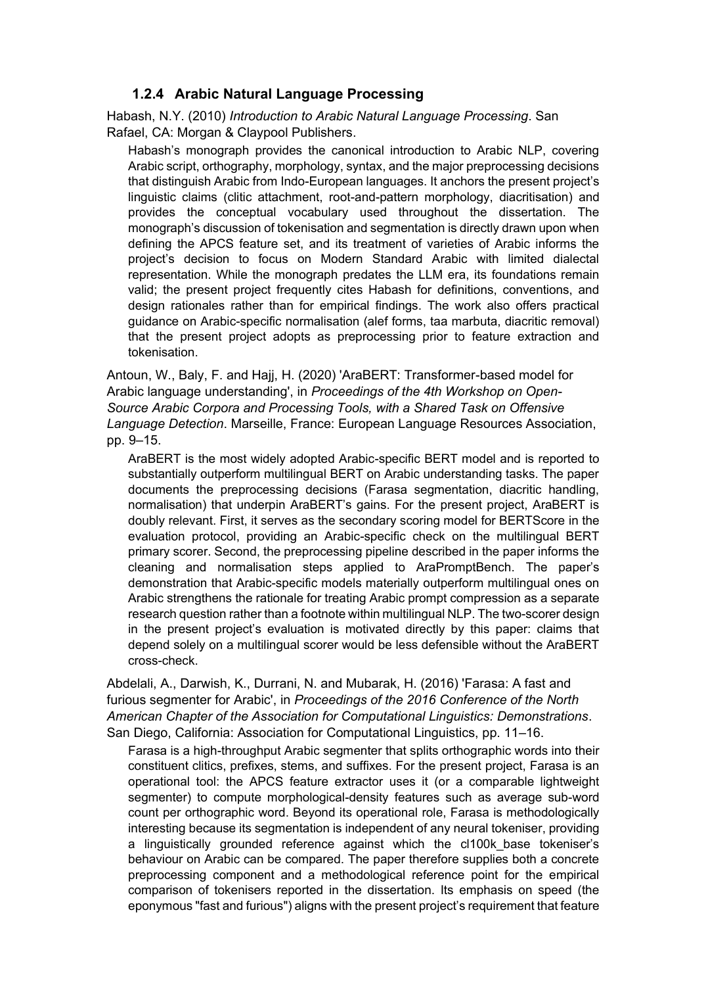
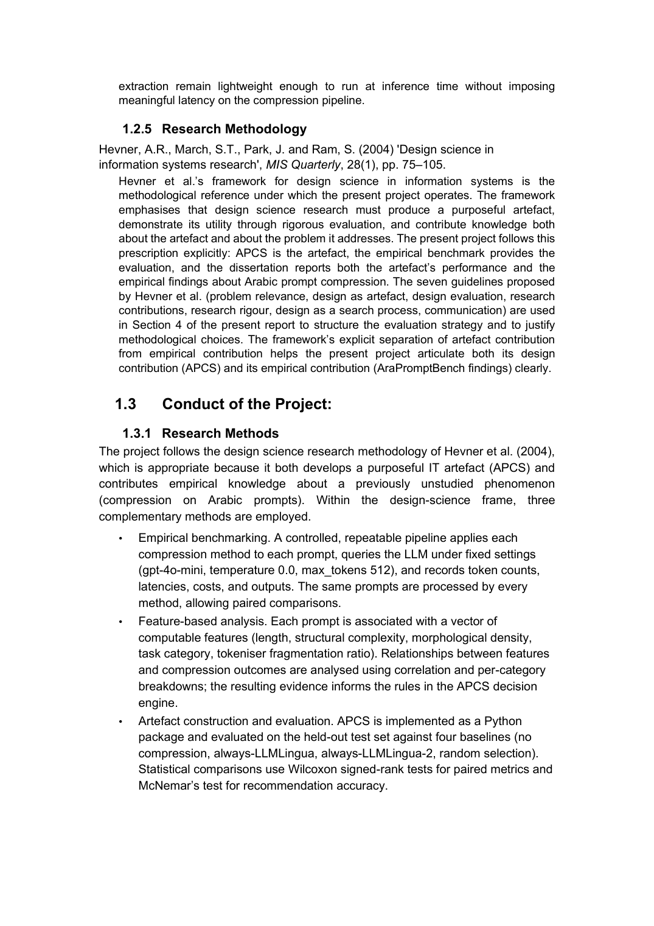
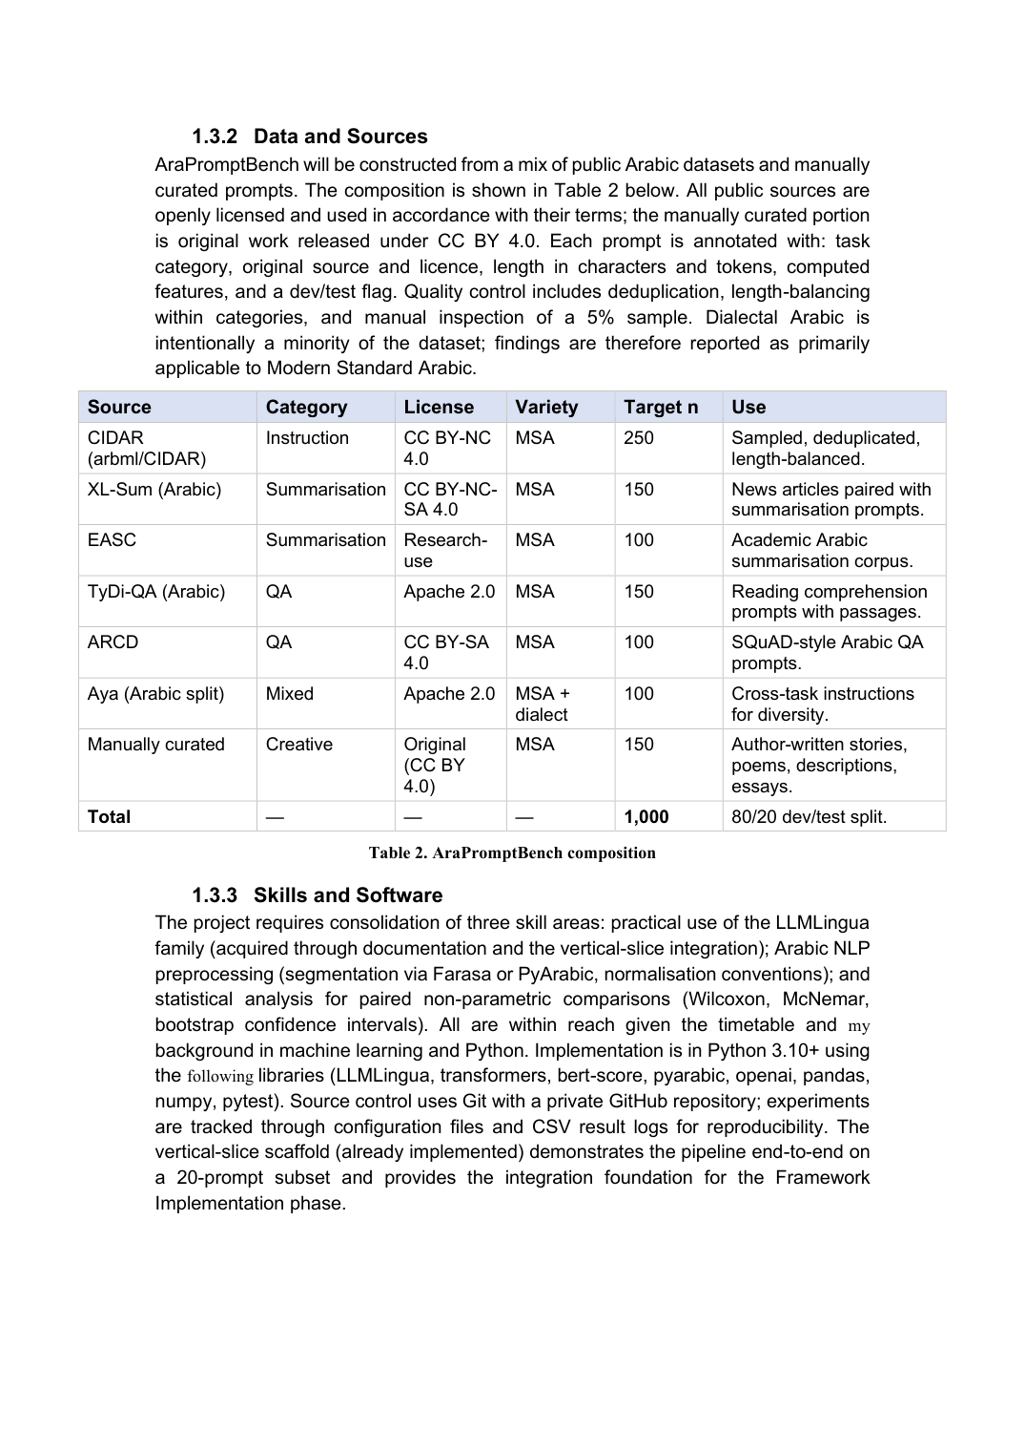
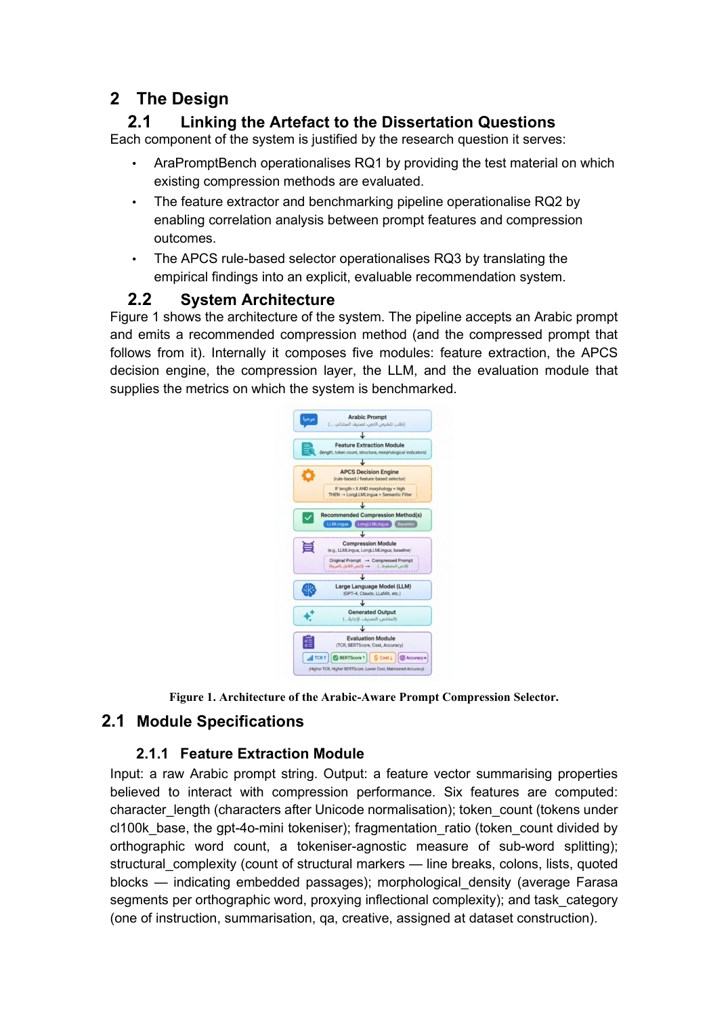
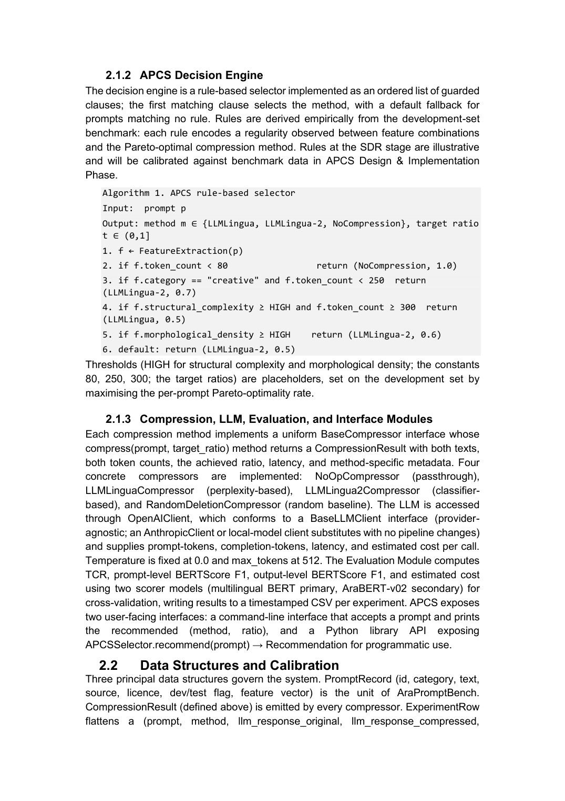
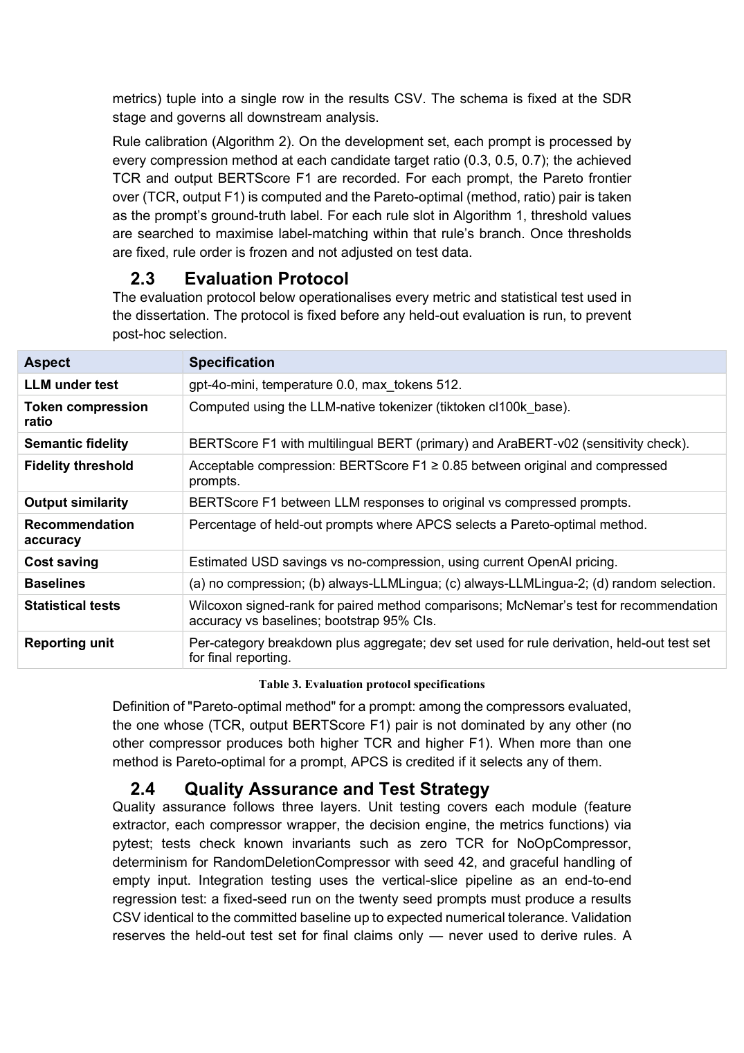
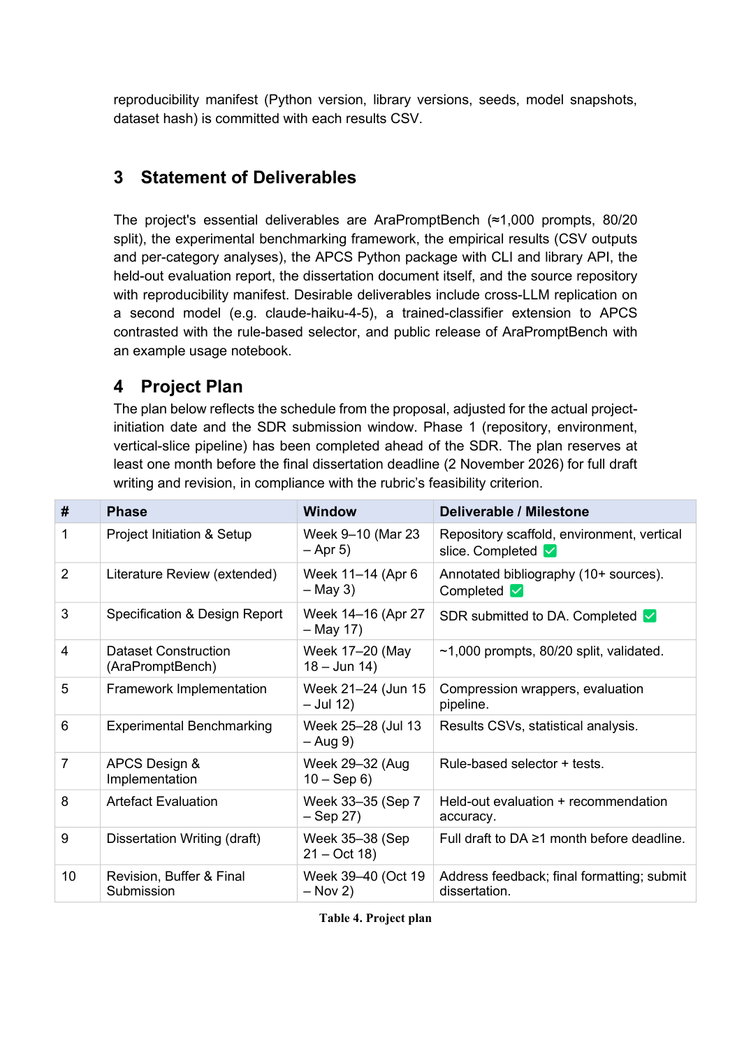
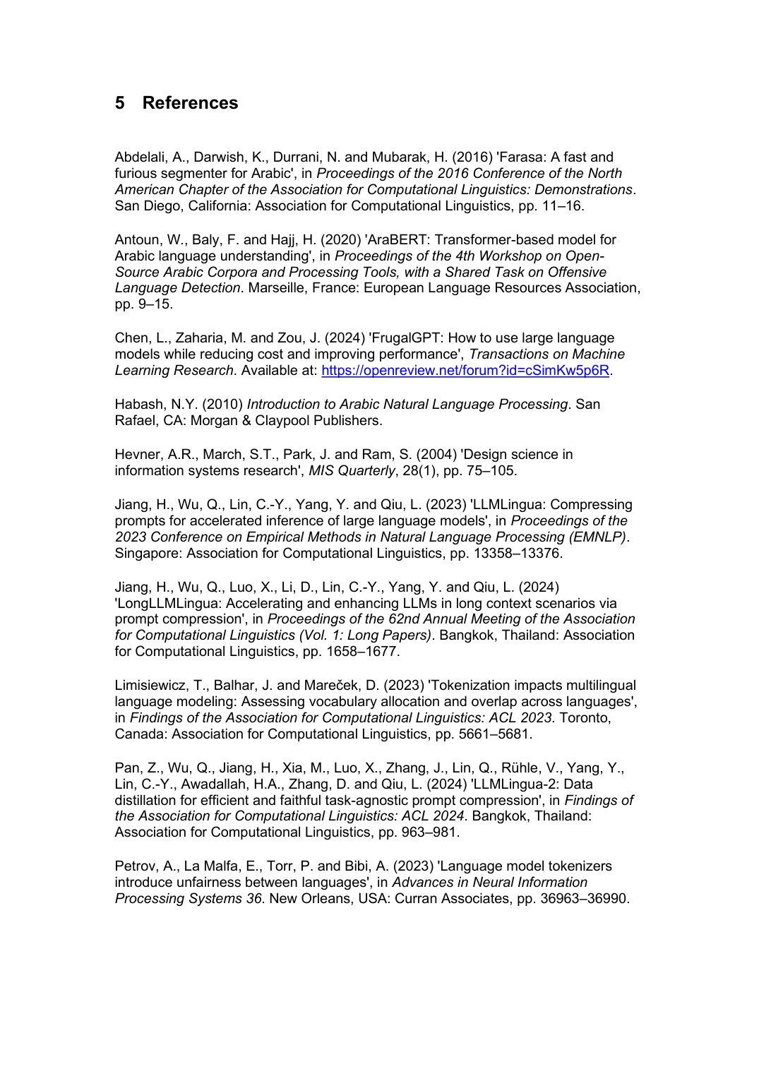

Ethical Approval Form
No ethical approval application was required. The approved proposal (Appendix A) records "Ethics Approval Needed? No", and the SDR (Appendix B, "Ethical Implications") confirms the determination. The project involved no human participants, surveys, interviews, personal data or user-generated prompts. All prompts were taken from publicly released research corpora under their stated licences, or were generated synthetically, and LLM API calls contained only these prompts. Nothing in the final design changed this determination.

Detailed Design

Feature definitions
Feature | Definition | Used by
character_length | Characters after Unicode NFC normalisation | Analysis
token_count | Tokens under tiktoken cl100k_base | APCS 1.0.0, APCS-v2, APCS-cost
word_count | Whitespace-separated words | Analysis
fragmentation_ratio | token_count / word_count | APCS-v2
structural_complexity | Count of line breaks, colons, quoted blocks, brackets, bullets and enumerations | APCS-v2
morphological_density | Farasa segments per Arabic word (tokens containing an Arabic letter only) | Analysis (not predictive)
has_length_instruction | Prompt contains an Arabic length marker (Section D.5) | APCS-cost
task_category | instruction / summarisation / qa / creative (one-hot) | APCS-v2, APCS-cost
Table 17. APCS feature definitions

APCS 1.0.0 rules (rules_default.json)
version: 1.0.0-final; calibrated on AraPromptBench v2 dev (800 prompts)
LLM under test: gpt-5.6-luna; fidelity threshold tau = 0.65 (AraBERT)
if token_count < 80 -> no compression
if token_count >= 250 -> LLMLingua-2 @ 0.3
otherwise -> LLMLingua-2 @ 0.5

APCS-v2 decision tree (depth 4, minimum leaf 20; dev 10-fold CV accuracy 43.5%)
cat_creative <= 0.5 (not creative)
| token_count <= 104.5
| | fragmentation_ratio <= 4.85
| | | structural_complexity <= 6.5 -> LLMLingua-2 @ 0.5
| | | structural_complexity > 6.5 -> LLMLingua-2 @ 0.7
| | fragmentation_ratio > 4.85 -> no compression
| token_count > 104.5
| | not QA: token_count <= 243 -> LLMLingua-2 @ 0.5
| | token_count > 243 -> LLMLingua-2 @ 0.3
| | QA: token_count <= 433 -> LLMLingua-2 @ 0.5
| | token_count > 433 -> LLMLingua-2 @ 0.7
cat_creative > 0.5 (creative)
| token_count <= 85.5 -> no compression
| token_count > 85.5
| | fragmentation_ratio <= 4.12 -> LLMLingua-2 @ 0.7
| | 4.12 < fragmentation_ratio <= 4.43 -> LLMLingua-2 @ 0.5
| | fragmentation_ratio > 4.43 -> LLMLingua-2 @ 0.7

APCS-cost decision tree (depth 3, minimum leaf 40; dev 10-fold CV cost change −1.9%)
token_count <= 127.5 -> no compression
token_count > 127.5
| no length instruction: not QA -> no compression
| QA -> LLMLingua-2 @ 0.5
| length instruction: not creative -> LLMLingua-2-protected @ 0.3
| creative -> LLMLingua-2 @ 0.7
(The learned tree contains two further splits, on token count and on morphological density, whose branches all lead to no compression; they are collapsed here.)

Length-instruction markers
The protected compressor and the has_length_instruction feature use one regular expression over the following Arabic markers: بإيجاز ("briefly"), موجز ("concise"), جملتين ("two sentences"), ثلاث جمل ("three sentences"), جملة واحدة ("one sentence"), فقرة واحدة ("one paragraph"), لا يتجاوز ("not exceeding") and كلمة ("word", as in "fifty words").

Pre-registration (Experiment 11, committed before the exam run)
Data: 400 never-seen exam prompts with zero exact, 12-word or record overlap with the pilot, v2 or probe sets. Protocol identical to Experiment 10, with τ = 0.65 fixed from Experiment 10. Frozen selectors: APCS 1.0.0 (replication), APCS-v2 (primary) and APCS-cost (extension). Hypotheses, with Holm correction across H1–H3 at α = 0.05:
- H1 (primary): APCS-v2 best-balance accuracy > always LLMLingua-2 @ 0.5, the best fixed strategy on dev. Exact McNemar; supported if the Holm-adjusted p < 0.05 and APCS-v2 is ahead.
- H2: APCS-v2 accuracy > APCS 1.0.0. Exact McNemar; same criterion.
- H3 (extension): APCS-cost lowers the measured total bill relative to never compressing. One-sided Wilcoxon signed-rank test on per-prompt cost differences; supported if the Holm-adjusted p < 0.05 and the total cost change < 0.
Reported regardless of outcome: APCS 1.0.0 replication accuracy; every policy's best-balance and cheapest-faithful accuracy, mean TCR, mean output F1, share below τ, total cost change and QA correctness; APCS-v2 against every other policy (secondary, uncorrected); and accuracy by category. No selector, threshold, label definition or test could be altered after the exam answers were collected. The full document is experiments/11_fresh_exam/PREREGISTRATION.md (commit 318d593).

Worked example: how compression lengthens the answer
Exam prompt exam-qa-043 (76 cl100k tokens) asks, based on a passage, "Where is the headquarters of Forbes magazine?" and begins "answer briefly" (أجب بإيجاز):
بناءً على الفقرة التالية، أجب بإيجاز: تصنيف: شركات مقرها في جيرسي سيتي. السؤال: اين يقع مقر مجلة فوربس؟
Plain LLMLingua-2 @ 0.5 deleted "briefly" and garbled the question:
الفقرة أجب:شركات جيرسي سيتي مقر مجلة فوربس؟
The protected variant kept the instruction sentence verbatim and compressed the rest:
بناءً على الفقرة التالية، أجب بإيجاز: جيرسي سيتي مقر مجلة فوربس؟
Variant | Billed input tokens | Answer tokens | Call cost (US$ × 10⁻⁶) | Output F1
Uncompressed | 44 | 23 | 36.4 | 1.000
LLMLingua-2 @ 0.5 | 24 | 85 | 106.8 | 0.638
LLMLingua-2-protected @ 0.5 | 30 | 17 | 26.4 | 0.768
Table 18. Worked example of plain vs protected compression (exam-qa-043)
Plain compression saved 20 input tokens but the model, no longer told to be brief and given a garbled question, wrote a hedged 85-token answer, so the call cost nearly three times as much. The protected variant saved 14 input tokens, kept the answer short and was the cheapest of the three.

Code used to develop the IT artefact

Repository and reproduction
All source code, data and results are in the project repository (GitHub: skybadr/CSCK700-Computer-Science-Capstone-Project; access is provided to the examiners, as the module guidance requires). Its structure is:
README.md, requirements.txt start here: overview, quick start and pinned dependencies
AraPromptBench_dataset.json pilot set (500 prompts, dev-only)
AraPromptBench_v2.json final benchmark (1,000 prompts, 800 dev / 200 test)
AraPromptBench_exam.json fresh exam set (400 prompts)
apcs/ the IT artefact (Python package, tests, README)
experiments/
01_scorer_selection/ ... 12_compression_overhead/ one folder per experiment:
README.md (question, method), *.py (scripts),
results/ (raw outputs, configuration, FINDINGS.md)
EXPERIMENT_LOG.md chronological index of all experiments
AUDIT/ independent verification of every reported number
Reproducing the final results: create a Python 3.11 virtual environment and run pip install ‑r requirements.txt (the top-level README gives step-by-step instructions), set the OPENAI_API_KEY environment variable, then run experiments/10_final_benchmark/run_local.py, run_api.py and run_chain.py, followed by the Experiment 11 scripts in the order given in its README. Stored responses make every analysis re-runnable offline. experiments/AUDIT/verify_results.py re-checks every headline number from the raw data.

Experiment log
# | Experiment | Outcome
01 | Scorer selection | AraBERT primary, mBERT sensitivity check
02 | Compression vertical slice | GPT-2 scorer unusable on Arabic; Qwen2.5-0.5B adopted
03 | Local benchmark | Prompt-level F1 ranks random above LLMLingua-2
04 | Output-level evaluation | Ranking flips at output level
05 | Feature analysis (erratum 05e) | Length dominant in pilot; morphology weak
06 | APCS calibration (pilot) | 41.2% in-sample; Pareto-hit degenerate
07 | Protocol checks | Noise ceiling; 0.85 threshold retired
08 | AraPromptBench v2 | 1,000 prompts frozen, 800/200 split
09 | Synthetic-data sensitivity | Safe for calibration, not for fidelity measurement
10 | Final benchmark | RQ1/RQ2 answered; cost penalty; APCS 1.0.0 31.0% on test
11 | Fresh exam | APCS-v2 38.5%; H1–H3 supported
12 | Compression overhead (supplementary) | Selector ≈0.05 ms; LLMLingua-2 ≈30 ms (GPU), ≈0.4 s (CPU)
Table 19. Experiment log summary

Source code of the APCS package
Listing: apcs/apcs/features.py
"""Feature extraction for Arabic prompts (APCS Feature Extraction Module).

Mirrors the definitions used throughout the AraPromptBench experiments
(Experiment 05): the same code path produced the calibration data, so
inference-time features are consistent with the rules by construction.
"""

from __future__ import annotations

import re
import unicodedata
from dataclasses import dataclass, asdict

import tiktoken

_ENC = tiktoken.get_encoding("cl100k_base")

_STRUCT_PATTERNS = [
r"\n", # line breaks
r"[:：]", # colons (list/definition markers)
r"«[^»]*»", # quoted blocks
r"[\(\)\[\]]", # parentheses/brackets
r"^\s*[-•*]\s", # bullets
r"^\s*\d+[\.\)]\s", # enumerations
]

# explicit answer-length instructions ("briefly", "in three sentences",
# "no more than N words"); compressors that delete them make answers longer
# (Experiment 10, F5)
LENGTH_MARKERS = re.compile(
r"بإيجاز|موجز|جملتين|ثلاث جمل|جملة واحدة|فقرة واحدة|لا يتجاوز|كلمة")

@dataclass(frozen=True)
class PromptFeatures:
character_length: int
token_count: int
word_count: int
fragmentation_ratio: float
structural_complexity: int
morphological_density: float | None # requires optional Farasa/Java
has_length_instruction: bool = False

def as_dict(self) -> dict:
return asdict(self)

def has_length_instruction(text: str) -> bool:
return bool(LENGTH_MARKERS.search(text))

def structural_complexity(text: str) -> int:
return sum(len(re.findall(p, text, flags=re.MULTILINE))
for p in _STRUCT_PATTERNS)

def extract_features(text: str, *, morphology: bool = False) -> PromptFeatures:
"""Compute the APCS feature vector for one prompt.

morphology=True computes Farasa morphological density (requires the
'morphology' extra and a Java runtime; adds noticeable latency). The
shipped decision rules do not use it (Experiment 05: weak predictor),
so it defaults to off.
"""
if not isinstance(text, str) or not text.strip():
raise ValueError("prompt must be a non-empty string")
text = unicodedata.normalize("NFC", text)
words = text.split()
n_tok = len(_ENC.encode(text))
density = _morphological_density(text) if morphology else None
return PromptFeatures(
character_length=len(text),
token_count=n_tok,
word_count=len(words),
fragmentation_ratio=round(n_tok / len(words), 4),
structural_complexity=structural_complexity(text),
morphological_density=density,
has_length_instruction=has_length_instruction(text),
)

_ARABIC_LETTER = re.compile(r"[ء-غف-يٱ-ۓ]")

def density_from_segmented(segmented: str) -> float | None:
"""Farasa segments per Arabic word, from one segmented line.

Farasa emits punctuation and numerals as separate tokens; only tokens
containing an Arabic letter count as words, otherwise punctuation
inflates or deflates the measure depending on the denominator."""
words = [t for t in segmented.split() if _ARABIC_LETTER.search(t)]
if not words:
return None
return round(sum(w.count("+") + 1 for w in words) / len(words), 4)

def _morphological_density(text: str) -> float | None:
# standalone mode: farasapy's interactive mode corrupts Arabic through
# the Windows process pipe (AraPromptBench Experiment 05 finding)
from farasa.segmenter import FarasaSegmenter
seg = FarasaSegmenter(interactive=False).segment(" ".join(text.split()))
return density_from_segmented(seg)
Listing: apcs/apcs/selector.py
"""APCS decision engine.

Three selectors, all calibrated on the AraPromptBench v2 dev split (800
prompts) and frozen as data files:

- "v1" (APCS 1.0.0, rules_default.json): ordered token-count rules
(Experiment 10). Needs only the prompt.
- "v2" (APCS-v2, selectors/apcs_v2.json): depth-4 decision tree over the
feature vector and the task category, maximising best-balance
accuracy (Experiment 11, H1/H2 supported on the fresh exam).
- "cost" (APCS-cost, selectors/apcs_cost.json): depth-3 tree choosing the
cheapest strategy that keeps output fidelity above tau, including
the length-protected LLMLingua-2 variant (Experiment 11, H3).

The tree selectors need the prompt's task category, one of
instruction / summarisation / qa / creative.
"""

from __future__ import annotations

import json
from dataclasses import dataclass
from importlib import resources
from pathlib import Path

from .features import PromptFeatures, extract_features

CATEGORIES = ("instruction", "summarisation", "qa", "creative")
_TREE_FILES = {"v2": "apcs_v2.json", "cost": "apcs_cost.json"}
_METHOD_NAMES = {"noop": "none", "llmlingua2": "llmlingua2",
"llmlingua2_protected": "llmlingua2_protected",
"llmlingua_qwen": "llmlingua"}

@dataclass(frozen=True)
class Recommendation:
method: str # "none" | "llmlingua2" | "llmlingua2_protected" | "llmlingua"
rate: float # target keep-rate (1.0 for "none")
rule: str # human-readable guard(s) that fired
features: PromptFeatures
rules_version: str

def as_dict(self) -> dict:
d = {"method": self.method, "rate": self.rate, "rule": self.rule,
"rules_version": self.rules_version}
d["features"] = self.features.as_dict()
return d

def _load(rules_path, package_file):
if rules_path is not None:
return json.loads(Path(rules_path).read_text(encoding="utf-8"))
src = resources.files("apcs")
for part in package_file.split("/"):
src = src.joinpath(part)
return json.loads(src.read_text(encoding="utf-8"))

def tree_inputs(f: PromptFeatures, category: str) -> dict:
"""Feature dictionary in the form the frozen trees were trained on."""
if category not in CATEGORIES:
raise ValueError(f"category must be one of {CATEGORIES}")
x = {"token_count": f.token_count,
"structural_complexity": f.structural_complexity,
"fragmentation_ratio": f.fragmentation_ratio,
"morphological_density": f.morphological_density,
"has_length_instruction": int(f.has_length_instruction)}
x.update({f"cat_{c}": int(c == category) for c in CATEGORIES})
return x

def walk_tree(node: dict, x: dict) -> tuple[str, list[str]]:
"""Return (leaf label, path of guards). A missing feature value (only
morphological density, which is optional) follows the <= branch; in the
shipped trees both of its branches lead to the same strategy."""
path = []
while "leaf" not in node:
name, thr = node["feature"], node["threshold"]
v = x[name]
if v is None or v <= thr:
path.append(f"{name} <= {thr:g}")
node = node["le"]
else:
path.append(f"{name} > {thr:g}")
node = node["gt"]
return node["leaf"], path

class APCSSelector:
"""Arabic prompt-compression selector.

>>> APCSSelector().recommend("...").method # APCS 1.0.0
>>> APCSSelector("v2").recommend("...", category="qa").method # APCS-v2
"""

def __init__(self, selector: str = "v1", rules_path: str | Path | None = None):
if selector not in ("v1", "v2", "cost"):
raise ValueError("selector must be 'v1', 'v2' or 'cost'")
self.selector = selector
if selector == "v1":
cfg = _load(rules_path, "rules_default.json")
self.version = cfg["version"]
self.tau = cfg["fidelity_threshold_tau"]
t = cfg["thresholds"]
self.t1, self.t2 = t["T1"], t["T2"]
self.r_mid, self.r_long = t["r_mid"], t["r_long"]
else:
cfg = _load(rules_path, "selectors/" + _TREE_FILES[selector])
self.version = cfg["name"]
self.tau = cfg["tau"]
self.tree = cfg["tree"]

def recommend(self, prompt: str, category: str | None = None) -> Recommendation:
f = extract_features(prompt)
if self.selector == "v1":
method, rate, rule = self._rules_v1(f)
else:
if category is None:
raise ValueError(f"selector '{self.selector}' needs the task "
f"category, one of {CATEGORIES}")
leaf, path = walk_tree(self.tree, tree_inputs(f, category))
name, r = leaf.split("@")
method, rate, rule = _METHOD_NAMES[name], float(r), " and ".join(path)
return Recommendation(method=method, rate=rate, rule=rule,
features=f, rules_version=self.version)

def _rules_v1(self, f):
if f.token_count < self.t1:
return "none", 1.0, f"token_count {f.token_count} < {self.t1}"
if f.token_count >= self.t2:
return ("llmlingua2", self.r_long,
f"token_count {f.token_count} >= {self.t2}")
return ("llmlingua2", self.r_mid,
f"{self.t1} <= token_count {f.token_count} < {self.t2}")

def compress(self, prompt: str, category: str | None = None) -> str:
"""Recommend and apply (requires the 'compression' extra)."""
rec = self.recommend(prompt, category)
if rec.method == "none":
return prompt
from llmlingua import PromptCompressor # lazy heavy import
if rec.method == "llmlingua":
pc = PromptCompressor(model_name="Qwen/Qwen2.5-0.5B")
return pc.compress_prompt(prompt, rate=rec.rate)["compressed_prompt"]
pc = PromptCompressor(
model_name="microsoft/llmlingua-2-xlm-roberta-large-meetingbank",
use_llmlingua2=True)
if rec.method == "llmlingua2_protected":
from .protect import compress_protected
return compress_protected(pc, prompt, rec.rate)
return pc.compress_prompt(prompt, rate=rec.rate)["compressed_prompt"]
Listing: apcs/apcs/protect.py
"""LLMLingua-2 with length instructions protected (Experiment 11).

Splits the prompt into sentence-like segments, keeps every segment that
contains a length instruction verbatim, compresses the remaining text with
LLMLingua-2 at the target rate and reassembles it in the original order.
Prompts without a length instruction are compressed exactly as plain
LLMLingua-2 would compress them.
"""

from __future__ import annotations

import re

from .features import LENGTH_MARKERS

# split after sentence punctuation, colons and newlines, keeping delimiters
_SPLIT = re.compile(r"(?<=[.؟!:\n])")

def compress_protected(pc, text: str, rate: float) -> str:
"""pc: an llmlingua PromptCompressor configured for LLMLingua-2."""
if not LENGTH_MARKERS.search(text):
return pc.compress_prompt(text, rate=rate)["compressed_prompt"]
out, buffer = [], []

def flush():
if buffer:
chunk = "".join(buffer)
out.append(pc.compress_prompt(chunk, rate=rate)["compressed_prompt"]
if chunk.strip() else chunk)
buffer.clear()

for seg in (s for s in _SPLIT.split(text) if s.strip()):
if LENGTH_MARKERS.search(seg):
flush()
out.append(seg.strip())
else:
buffer.append(seg)
flush()
return " ".join(s for s in out if s)

