**#Analysis of Variance test:-**

**#One-way ANOVA test**

library(dplyr)

boxplot(mtcars$disp~factor(mtcars$gear),xlab="gear",ylab="disp")

mtcars_aov<- aov(mtcars$disp~factor(mtcars$gear))

summary(mtcars_aov)

**#Two-way ANOVA test**

library(dplyr)

boxplot(mtcars$disp~mtcars$gear,subset = (mtcars$am == 0),

xlab = "gear",ylab="disp",main="Atomatic")

boxplot(mtcars$disp~mtcars$gear,subset=(mtcars$am==1),

xlab = "gear",ylab="disp",main="Manual")

mtcars_aov2<-aov(mtcars$disp~factor(mtcars$gear)*factor(mtcars$am))

summary(mtcars_aov2)

**OUTPUT: -**

#One-way ANOVA test

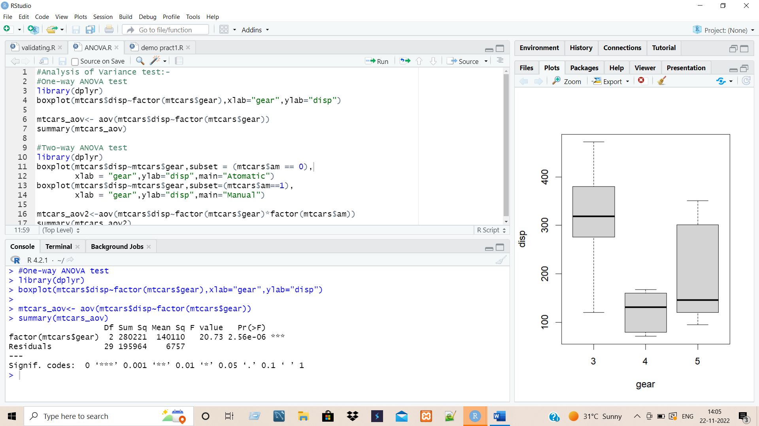

> library(dplyr)

> boxplot(mtcars$disp~factor(mtcars$gear),xlab="gear",ylab="disp")

>

> mtcars_aov<- aov(mtcars$disp~factor(mtcars$gear))

> summary(mtcars_aov)

Df Sum Sq Mean Sq F value Pr(>F)

factor(mtcars$gear) 2 280221 140110 20.73 2.56e-06 ***

Residuals 29 195964 6757

---

Signif. codes: 0 ‘***’ 0.001 ‘**’ 0.01 ‘*’ 0.05 ‘.’ 0.1 ‘ ’ 1

#Two-way ANOVA test

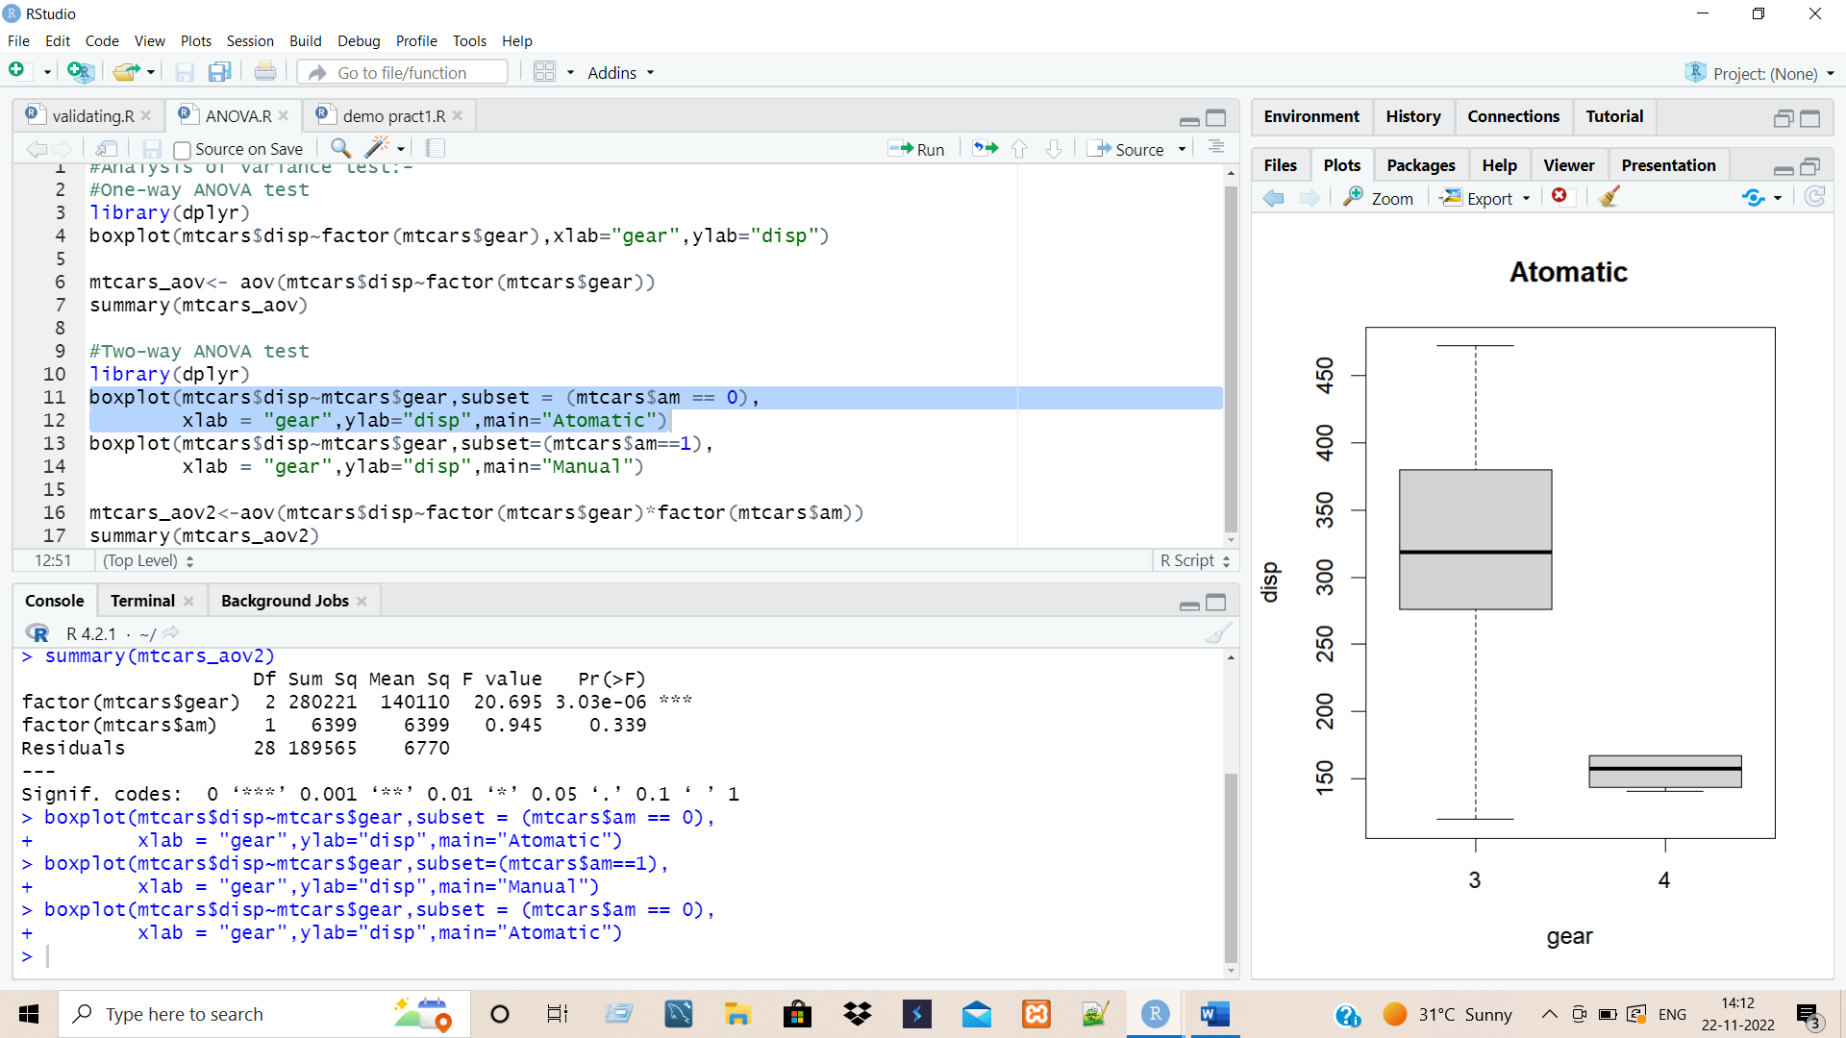 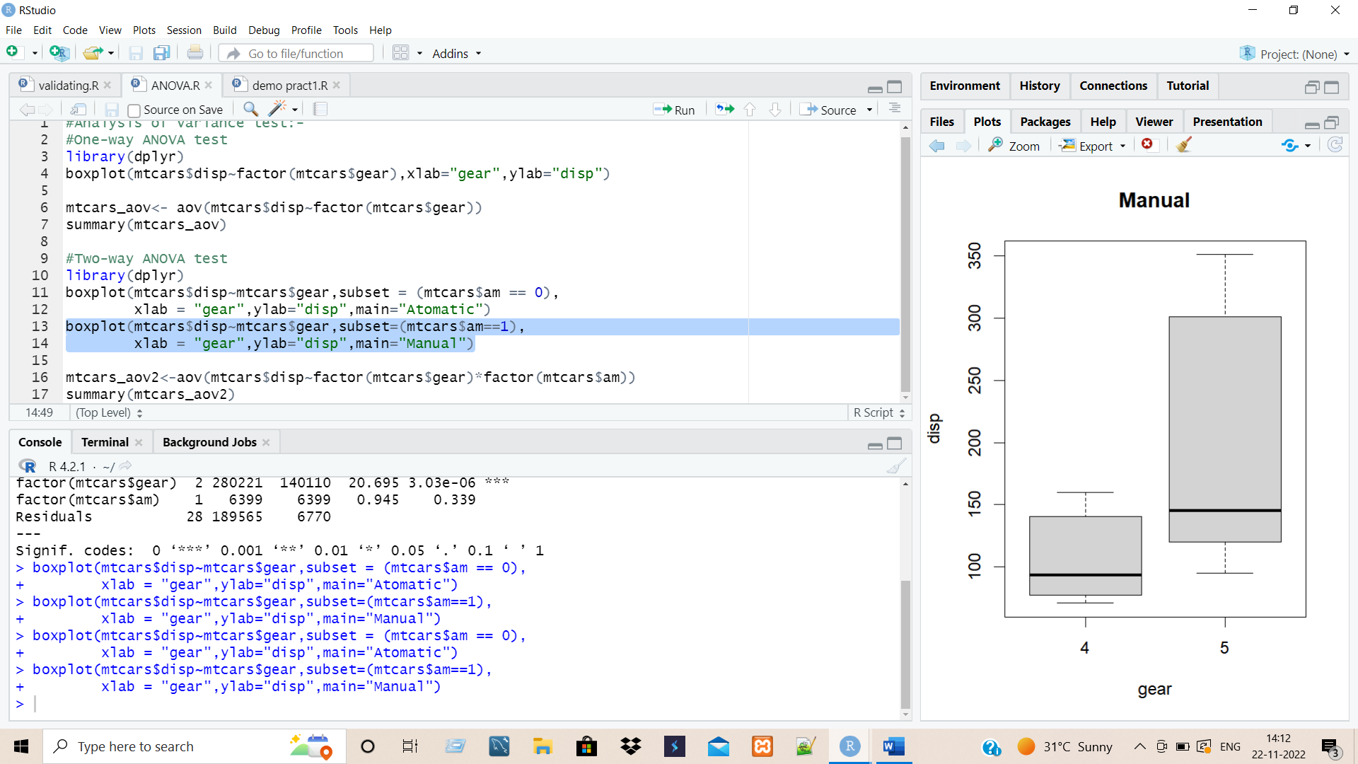

> library(dplyr)

> boxplot(mtcars$disp~mtcars$gear,subset = (mtcars$am == 0),

+ xlab = "gear",ylab="disp",main="Atomatic")

> boxplot(mtcars$disp~mtcars$gear,subset=(mtcars$am==1),

+ xlab = "gear",ylab="disp",main="Manual")

>

> mtcars_aov2<-aov(mtcars$disp~factor(mtcars$gear)*factor(mtcars$am))

> summary(mtcars_aov2)

Df Sum Sq Mean Sq F value Pr(>F)

factor(mtcars$gear) 2 280221 140110 20.695 3.03e-06 ***

factor(mtcars$am) 1 6399 6399 0.945 0.339

Residuals 28 189565 6770

---

Signif. codes: 0 ‘***’ 0.001 ‘**’ 0.01 ‘*’ 0.05 ‘.’ 0.1 ‘ ’ 1