Haproxy+Keepalived+Nginx+Lamp+Nfs实现高可用集群

## 1 实验拓扑图

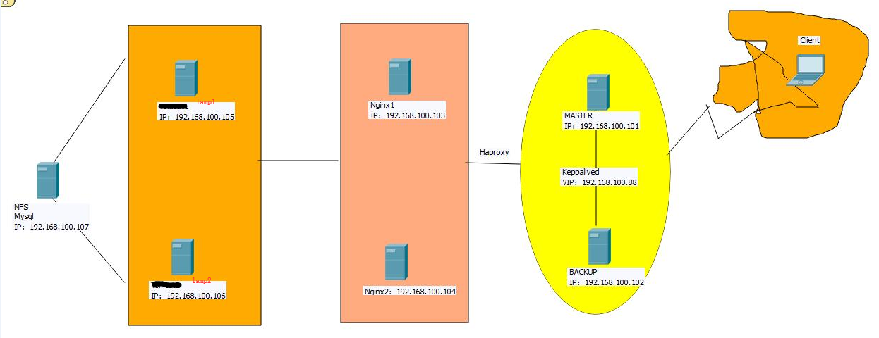

## 2.实验环境

|  |  |  |  |
| --- | --- | --- | --- |
| 系统 | IP地址 | 主机名 | 软件 |
| Centos7 .4 1708 | 192.168.100.101 | Ld1.linuxfan.cn | Haproxy ，keepalived |
| Centos7 .4 1708 | 192.168.100.102 | Ld2.linuxfan.cn | Haproxy ，keepalived |
| Centos7 .4 1708 | 192.168.100.103 | Ng1.linuxfan.cn | Nginx |
| Centos7 .4 1708 | 192.168.100.104 | Ng2.linuxfan.cn | Nginx |
| Centos7 .4 1708 | 192.168.100.105 | Lamp1.linuxfan.cn | Httpd,mariadb-server,mysql,php,php-server |
| Centos7 .4 1708 | 192.168.100.106 | Lamp2.linuxfan.cn | Httpd,mariadb-server,mysql,php,php-server |
| Centos7 .4 1708 | 192.168.100.107 | St.linuxfan.cn | Mariadb-server,rpcbind,nfs,mysql,discuz |
|  | 192.168.100.88 | Vip地址www.linuxfan.cn |  |

## 3.实验步骤

* 部署两台nginx节点（两台节点配置相同，在此列举一台的配置）；
* 部署两台lamp节点（两台节点配置相同，在此列举一台的配置）；
* 安装配置后端存储节点的nfs服务并设置共享的数据；
* 安装配置后端存储节点的数据库服务，并配置项目中的数据库；
* 两台nginx节点挂载后端存储（两台节点配置相同，在此列举一台的配置）；
* 两台lamp节点挂载后端存储（两台节点配置相同，在此列举一台的配置）；
* 安装两台调度器节点的haproxy服务（两台节点配置相同，在此列举一台的配置）；
* 配置两台调度器节点的haproxy服务（两台节点配置相同，在此列举一台的配置）；
* 安装两台调度器节点的keepalived服务（两台节点配置相同，在此列举一台的配置）；
* 配置master主调度器并启动服务；
* 配置backup从调度器并启动服务；
* 客户端访问集群的静态网站；
* 客户端访问集群vip地址并安装bbs论坛项目；
* 模拟nginx1节点down，测试集群可用性；
* 模拟lamp1节点down，测试集群可用性；
* 模拟ld1主调度器节点down，测试集群可用性；

# 3.实验流程

* 部署两台nginx节点（两台节点配置相同，在此列举一台的配置）；

**[root@ng1 ~]# useradd -M -s /sbin/nologin nginx #创建nginx程序用户**

**[root@ng1 ~]# yum -y install pcre-devel zlib-devel #安装依赖**

**[root@ng1 ~]# tar zxvf nginx-1.12.2.tar.gz -C /usr/src/**

**[root@ng1 ~]# cd /usr/src/nginx-1.12.2/**

**[root@ng1 nginx-1.12.2]# ./configure --prefix=/usr/local/nginx --user=nginx --group=nginx --with-http_stub_status_module &&make &&make install**

**[root@ng1 ~]# ln -s /usr/local/nginx/sbin/nginx /usr/local/sbin/**

**[root@ng1 ~]# vi /usr/lib/systemd/system/nginx.service**

**[Unit]**

**Description=nginxapi**

**After=network.target**

**[Service]**

**Type=forking**

**PIDFile=/usr/local/nginx/logs/nginx.pid**

**ExecStart=/usr/local/nginx/sbin/nginx**

**ExecReload=kill -s HUP $(cat /usr/local/nginx/logs/nginx.pid)**

**ExecStop=kill -s QUIT $(cat /usr/local/nginx/logs/nginx.pid)**

**PrivateTmp=Flase**

**[Install]**

**WantedBy=multi-user.target**

**：wq**

**[root@ng1 ~]# systemctl start nginx.service**

**[root@ng1 ~]# systemctl enable nginx.service**

**[root@ng1 ~]# echo "this is nginx103"> /usr/local/nginx/html/index.html**

**[root@ng1 ~]# netstat -plunt |grep nginx**

**tcp 0 0 0.0.0.0:80 0.0.0.0:* LISTEN 4365/nginx: master**



* 部署两台lamp节点（两台节点配置相同，在此列举一台的配置）；

**[root@lamp1 ~]# yum -y install httpd mariadb-server mysql php-mysql php**

**[root@lamp1 ~]# sed -i '/short_open/s/Off/On/g' /etc/php.ini**

**[root@lamp1 ~]# systemctl start mariadb**

**[root@lamp1 ~]# systemctl start httpd**

**[root@lamp1 ~]# systemctl enable httpd**

**[root@lamp1 ~]# systemctl enable mariadb**

**[root@lamp1 ~]# cat <<END >>/var/www/html/index.php**

**<?php**

**phpinfo();**

**?>**

**END**

**[root@lamp1 ~]# mysqladmin -u root password 123123**

**[root@lamp1 ~]# mysql -uroot -p123123**

**Welcome to the MariaDB monitor. Commands end with ; or \g.**

**Your MariaDB connection id is 3**

**Server version: 5.5.56-MariaDB MariaDB Server**

**Copyright (c) 2000, 2017, Oracle, MariaDB Corporation Ab and others.**

**Type 'help;' or '\h' for help. Type '\c' to clear the current input statement.**

**MariaDB [(none)]> exit**



* 安装配置后端存储节点的nfs服务并设置共享的数据；

[root@st ~]# yum -y install rpcbind nfs-utils

[root@st ~]# mkdir /opt/nginx

[root@st ~]# mkdir /opt/lamp

[root@st ~]# cat /etc/exports

/opt/nginx 192.168.100.0/24(rw,sync,no_root_squash)

/opt/lamp 192.168.100.0/24(rw,sync,no_root_squash)

[root@st ~]# chmod 777 /opt/nginx/

[root@st ~]# chmod 777 /opt/lamp/

[root@st ~]# echo "this is linuxfan nginx " >/opt/nginx/index.html

[root@st ~]# unzip discuz_7.2_full_sc_utf8.zip

[root@st ~]# cp -fr upload/ /opt/lamp/bbs

[root@st ~]# ls /opt/nginx/

index.html

[root@st ~]# ls /opt/lamp/

Bbs

[root@st ~]# cd /opt/lamp/bbs/

[root@st bbs]# chmod 777 forumdata/ attachments/ uc_client/data/cache/ templates/ config.inc.php –R

[root@st bbs]# systemctl start rpcbind

[root@st bbs]# systemctl start nfs

Job for nfs-server.service failed because the control process exited with error code. See "systemctl status nfs-server.service" and "journalctl -xe" for details.

[root@st bbs]# kill -HUP `cat /run/gssproxy.pid`

[root@st bbs]# systemctl start nfs

[root@st ~]# showmount -e 192.168.100.107

Export list for 192.168.100.107:

/opt/lamp 192.168.100.0/24

/opt/nginx 192.168.100.0/24

* 安装配置后端存储节点的数据库服务，并配置项目中的数据库；

[root@st ~]# yum -y install mariadb-server mysql

[root@st ~]# systemctl start mariadb

[root@st ~]# systemctl enable mariadb

[root@st ~]# mysqladmin -uroot password 123123

MariaDB [(none)]> create database bbsdb;

MariaDB [(none)]> grant all on bbsdb.*to'linuxfan'@'192.168.100.%'identified by '123123';

MariaDB [(none)]> flush privileges;

MariaDB [(none)]> exit

* 两台nginx节点挂载后端存储（两台节点配置相同，在此列举一台的配置）；

[root@ng1 ~]# yum -y install rpcbind nfs-utils

[root@ng1 ~]# echo "192.168.100.107:/opt/nginx /usr/local/nginx/html/ nfs defaults,_netdev 0 0" >>/etc/fstab

[root@ng1 ~]# mount -a

[root@ng1 ~]# ls /usr/local/nginx/html/

index.html

* 两台lamp节点挂载后端存储（两台节点配置相同，在此列举一台的配置）；

[root@lamp1 ~]# yum -y install rpcbind nfs-utils

[root@lamp1 ~]# echo "192.168.100.107:/opt/lamp/ /var/www/html/ nfs defaults,_netdev 0 0" >>/etc/fstab

[root@lamp1 ~]# mount -a

[root@lamp1 ~]# ls /var/www/html/

bbs

* 安装两台调度器节点的haproxy服务（两台节点配置相同，在此列举一台的配置）；

[root@ld1 ~]# yum -y install pcre-devel bzip2-devel

[root@ld1 ~]# tar zxvf haproxy-1.4.24.tar.gz -C /usr/src/

[root@ld1 ~]# cd /usr/src/haproxy-1.4.24/

[root@ld1 haproxy-1.4.24]# make TARGET=linux310

[root@ld1 haproxy-1.4.24]# make install

[root@ld1 ~]# mkdir /etc/haproxy

[root@ld1 ~]# cp /usr/src/haproxy-1.4.24/examples/haproxy.init /etc/init.d/haproxy

[root@ld1 ~]# chmod +x /etc/init.d/haproxy

* 配置两台调度器节点的haproxy服务（两台节点配置相同，在此列举一台的配置）；

[root@ld1 ~]# vi /etc/haproxy/haproxy.cfg

global

log 127.0.0.1 local0 info

log 127.0.0.1 local1 notice

maxconn 4096

uid 99

gid 99

daemon

defaults

log global

mode http

option httplog

option dontlognull

option httpclose

retries 3

maxconn 2000

contimeout 5000

clitimeout 50000

srvtimeout 50000

frontend http

bind *:80

acl linuxfan1 hdr_end(host) -i www.linuxfan.cn

acl linuxfan2 hdr_end(host) -i 192.168.100.88

acl linuxfan4 hdr_reg -i .*\.(php|css|jsp|js|do|png|jpg|jpeg)$

acl linuxfan5 path_beg -i /wordpress

acl linuxfan6 path_beg -i /bbs

use_backend dongtai if linuxfan5 or linuxfan6

use_backend dongtai if linuxfan1 linuxfan5 linuxfan4

use_backend dongtai if linuxfan2 linuxfan5 linuxfan4

use_backend dongtai if linuxfan1 linuxfan4

use_backend dongtai if linuxfan2 linuxfan4

default_backend jingtai

backend jingtai

mode http

balance roundrobin

server jingtai01 192.168.100.103:80 check inter 2000 fall 3

server jingtai02 192.168.100.104:80 check inter 2000 fall 3

backend dongtai

mode http

balance roundrobin

server dongtai01 192.168.100.105:80 check inter 2000 fall 3

server dongtai02 192.168.100.106:80 check inter 2000 fall 3

:wq

[root@ld1 ~]# /etc/init.d/haproxy start

Reloading systemd: [ 确定 ]

Starting haproxy (via systemctl): [ 确定 ]

[root@ld1 ~]# netstat -plunt

Active Internet connections (only servers)

Proto Recv-Q Send-Q Local Address Foreign Address State PID/Program name

tcp 0 0 0.0.0.0:80 0.0.0.0:* LISTEN 2170/haproxy

* 安装两台调度器节点的keepalived服务（两台节点配置相同，在此列举一台的配置）；

[root@ld1 ~]# yum -y install kernel-devel openssl-devel popt-devel

[root@ld1 ~]# tar zxvf keepalived-1.2.13.tar.gz

[root@ld1 ~]# cd keepalived-1.2.13/

[root@ld1 keepalived-1.2.13]# ./configure --prefix=/usr/local/keepalived

[root@ld1 keepalived-1.2.13]# make &&make install

[root@ld1 keepalived-1.2.13]# cd

[root@ld1 ~]# mkdir /etc/keepalived

[root@ld1 ~]# cp /usr/local/keepalived/etc/keepalived/keepalived.conf /etc/keepalived/

[root@ld1 ~]# cp /usr/local/keepalived/etc/sysconfig/keepalived /etc/sysconfig/

[root@ld1 ~]# cp /usr/local/keepalived/etc/rc.d/init.d/keepalived /etc/init.d/

[root@ld1 ~]# cp /usr/local/keepalived/sbin/keepalived /usr/sbin/

[root@ld1 ~]# chmod 755 /etc/init.d/keepalived

* 配置master主调度器并启动服务；

[root@ld1 ~]# vi /etc/keepalived/keepalived.conf

global_defs { router_id HA_TEST_R1

}

vrrp_instance VI_1 {

state MASTER

interface eth0

virtual_router_id 1

priority 100

advert_int 1

authentication {

auth_type PASS

auth_pass 123456

}

virtual_ipaddress {

192.168.100.88

}

}

virtual_server 192.168.100.88 80 {

persistence_timeout 60

protocol TCP

real_server 192.168.100.101 80 {

weight:3 notify_down /etc/keepalived/check.sh

TCP_CHECK {

connect_timeout 10

nb_get_retry 3

delay_before_retry 3

connect_port 80

}

}

}

:wq

[root@ld1 ~]# cat /etc/keepalived/check.sh

#!/bin/bash

/etc/init.d/keepalived stop

[root@ld1 ~]# chmod +x /etc/keepalived/check.sh

[root@ld1 ~]# /etc/init.d/keepalived start

[root@ld1 ~]# ip a|grep 88

inet 192.168.100.88/32 scope global eth0

* 配置backup从调度器并启动服务；

[root@ld2 ~]# vi /etc/keepalived/keepalived.conf

global_defs { router_id HA_TEST_R2

}

vrrp_instance VI_1 {

state BACKUP

interface eth0

virtual_router_id 1

priority 99

advert_int 1

authentication {

auth_type PASS

auth_pass 123456

}

virtual_ipaddress {

192.168.100.88

}

}

virtual_server 192.168.100.88 80 {

persistence_timeout 60

protocol TCP

real_server 192.168.100.102 80 {

weight :3 notify_down /etc/keepalived/check.sh

TCP_CHECK {

connect_timeout 10

nb_get_retry 3

delay_before_retry 3

connect_port 80

}

}

}

:wq

[root@ld2 ~]# cat /etc/keepalived/check.sh

#!/bin/bash

/etc/init.d/keepalived stop

[root@ld2 ~]# chmod +x /etc/keepalived/check.sh

[root@ld2 ~]# /etc/init.d/keepalived start

[root@ld2 ~]# ip a |grep 88

* 客户端访问集群的静态网站；





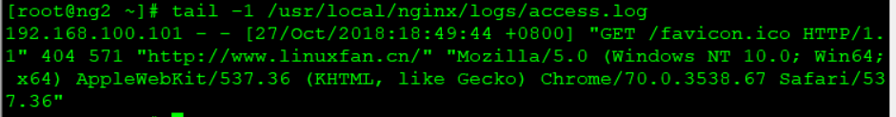

* 客户端访问集群vip地址并安装bbs论坛项目；



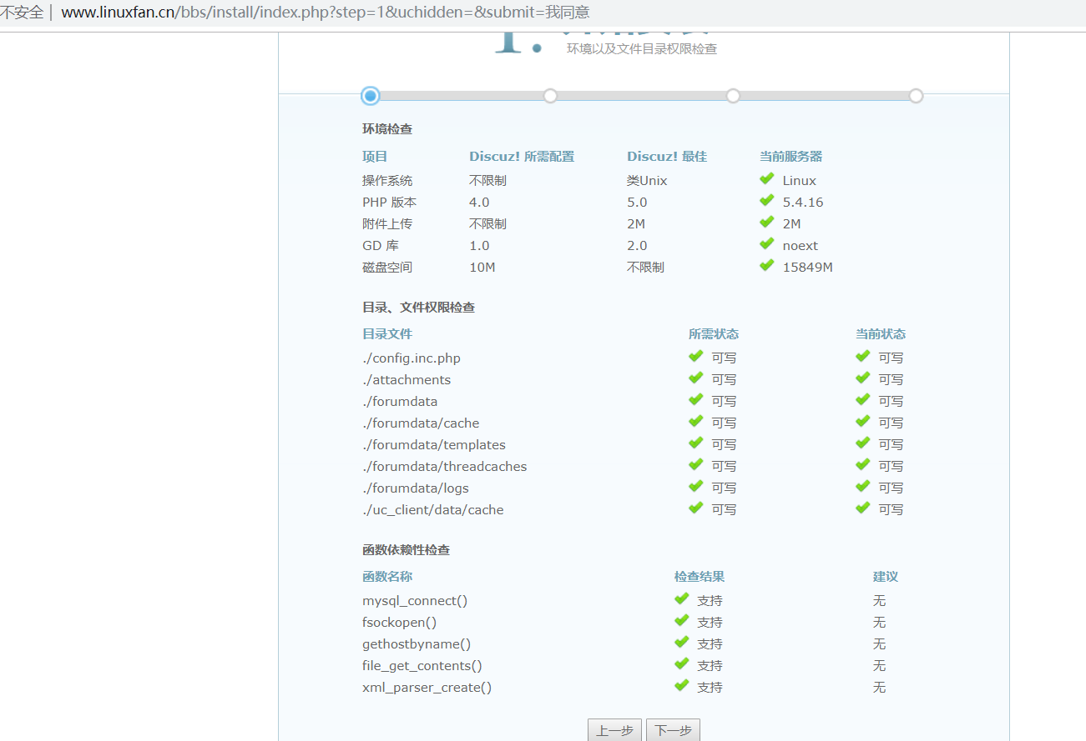









* 模拟nginx1节点down，测试集群可用性；





* 模拟lamp1节点down，测试集群可用性；





* 模拟ld1主调度器节点down，测试集群可用性；

