第五章2：企业级监控实例

**案例环境：根据第五章1搭建zabbix server端；**

**一、Zabbix监控Nginx访问数据；**

**二、Zabbix监控Mysql主从复制；**

**三、**

**一、Zabbix监控Nginx访问数据；**

**案例步骤：**

* 部署Nginx服务器；
* 配置Nginx页面监控；
* 编写Nginx的监控脚本；
* 在nginx服务器上安装zabbix_agent端并配置；
* zabbix服务端测试获取数据；
* zabbix服务器端添加监控主机nginx，配置监控项；
* 测试验证监控数据收集情况；
* **部署Nginx服务器；**

[root@nginx ~]# yum -y install pcre-devel zlib-devel

[root@nginx ~]# useradd -M -s /sbin/nologin nginx

[root@nginx ~]# tar zxvf nginx-1.12.2.tar.gz -C /usr/src/

[root@nginx ~]# cd /usr/src/nginx-1.12.2/

[root@nginx nginx-1.12.2]# ./configure --prefix=/usr/local/nginx --user=nginx --group=nginx --with-http_stub_status_module

[root@nginx nginx-1.12.2]# make &&make install

[root@nginx nginx-1.12.2]# ls /usr/local/nginx/

client_body_temp conf fastcgi_temp html logs proxy_temp sbin scgi_temp uwsgi_temp

[root@nginx nginx-1.12.2]# cd

* **配置Nginx页面监控；**

[root@nginx ~]# ln -s /usr/local/nginx/sbin/nginx /usr/local/sbin/

[root@nginx ~]# vi /usr/local/nginx/conf/nginx.conf

47 location /status {

48 stub_status on;

49 access_log off;

50 }

:wq

[root@nginx ~]# nginx

[root@nginx ~]# netstat -utpln |grep nginx

tcp 0 0 0.0.0.0:80 0.0.0.0:* LISTEN 3713/nginx

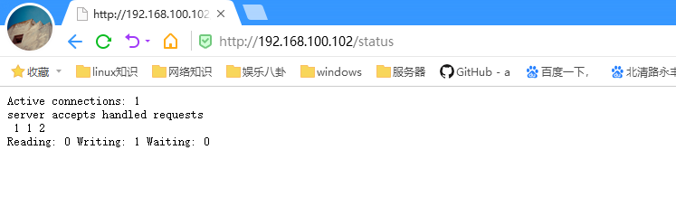

* **编写Nginx的监控脚本；**

**[root@nginx ~]# vi /tmp/ngx_status.sh**

#! /bin/bash

#date: 2018-05-04

# Description：zabbix监控nginx性能以及进程状态

# Note：此脚本需要配置在被监控端，否则ping检测将会得到不符合预期的结果

HOST="192.168.100.102" ##记得修改主机名

PORT="80"

# 检测nginx进程是否存在

function ping {

/sbin/pidof nginx | wc -l

}

# 检测nginx性能

function active {

/usr/bin/curl "http://$HOST:$PORT/status/" 2>/dev/null| grep 'Active' | awk '{print $NF}'

}

function reading {

/usr/bin/curl "http://$HOST:$PORT/status/" 2>/dev/null| grep 'Reading' | awk '{print $2}'

}

function writing {

/usr/bin/curl "http://$HOST:$PORT/status/" 2>/dev/null| grep 'Writing' | awk '{print $4}'

}

function waiting {

/usr/bin/curl "http://$HOST:$PORT/status/" 2>/dev/null| grep 'Waiting' | awk '{print $6}'

}

function accepts {

/usr/bin/curl "http://$HOST:$PORT/status/" 2>/dev/null| awk NR==3 | awk '{print $1}'

}

function handled {

/usr/bin/curl "http://$HOST:$PORT/status/" 2>/dev/null| awk NR==3 | awk '{print $2}'

}

function requests {

/usr/bin/curl "http://$HOST:$PORT/status/" 2>/dev/null| awk NR==3 | awk '{print $3}'

}

# 执行function

$1

[root@nginx ~]# chmod +x /tmp/ngx_status.sh

* **在nginx服务器上安装zabbix_agent端并配置；**

[root@server ~]# cat <<END >>/etc/hosts

192.168.100.102 nginx

END

[root@nginx ~]# wget -O /etc/yum.repos.d/CentOS-Base.repo http://mirrors.aliyun.com/repo/Centos-6.repo

[root@nginx ~]# yum -y install libxml2-devel libcurl-devel pcre-devel ntpdate

[root@nginx ~]# ntpdate ntp1.aliyun.com

[root@nginx ~]# tar zxvf zabbix-3.4.2.tar.gz

[root@nginx ~]# cd zabbix-3.4.2

[root@nginx zabbix-3.4.2]# ./configure --prefix=/usr/local/zabbix --enable-agent --enable-ipv6 --with-net-snmp --with-libcurl --with-libxml2

[root@nginx zabbix-3.4.2]# make &&make install

[root@nginx zabbix-3.4.2]# cp misc/init.d/tru64/zab**bix_agentd /etc/init.d/**

**[root@nginx zabbix-3.4.2]# vi /etc/init.d/zabbix_agentd**

**24 DAEMON=/usr/local/zabbix/sbin/zabbix_agentd**

**:wq**

**[root@nginx zabbix-3.4.2]# chmod +x /etc/init.d/zabbix_agentd**

**[root@nginx zabbix-3.4.2]# cd**

[root@nginx ~]# **groupadd zabbix**

[root@nginx ~]# **useradd -r -g zabbix zabbix**

[root@nginx ~]# **chown -R zabbix:zabbix /usr/local/zabbix/**

[root@nginx ~]# **vi /usr/local/zabbix/etc/zabbix_agentd.conf**

**LogFile=/tmp/zabbix_agentd.log**

**Server=192.168.100.101**

**ServerActive=192.168.100.101**

**Hostname=nginx**

**UnsafeUserParameters=1**

**UserParameter=nginx.status[*],/tmp/ngx_status.sh $1**

**:wq**

[root@nginx ~]# **/etc/init.d/zabbix_agentd start**

**Zabbix agent started.**

[root@nginx ~]# netstat -utpln |grep zabbix

tcp 0 0 0.0.0.0:10050 0.0.0.0:* LISTEN 14707/zabbix_agentd

* **zabbix服务端测试获取数据；**

[root@server ~]# zabbix_get -s 192.168.100.102 -k nginx.status[active]

1

[root@server ~]# zabbix_get -s 192.168.100.102 -k nginx.status[writing]

1

* **zabbix服务器端添加监控主机nginx，配置监控项；**

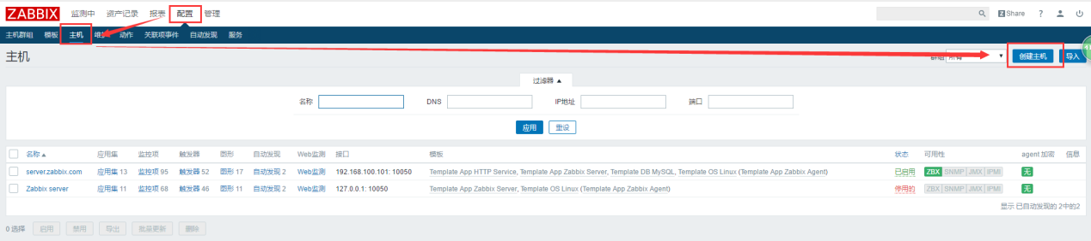

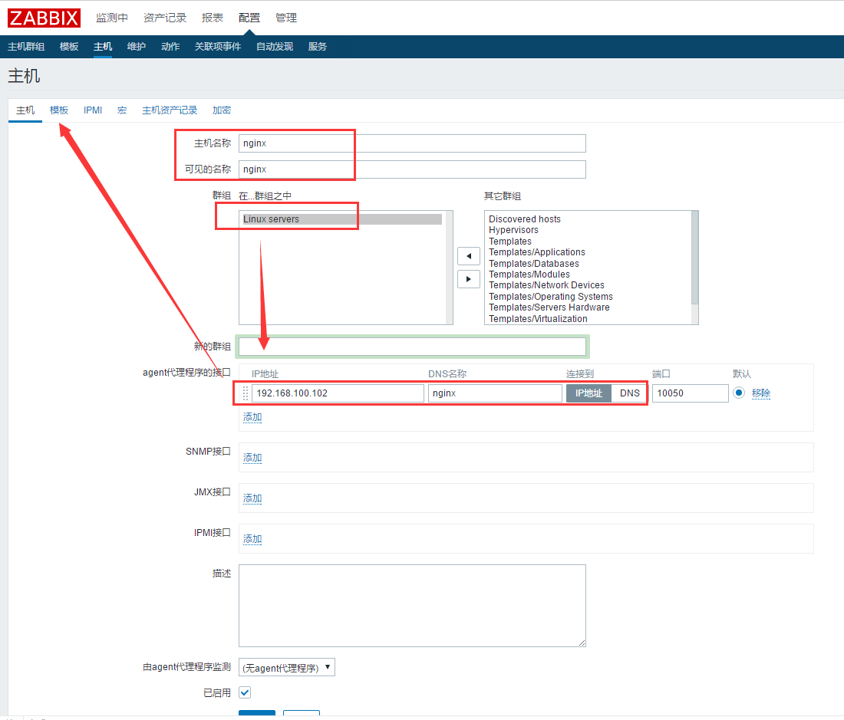

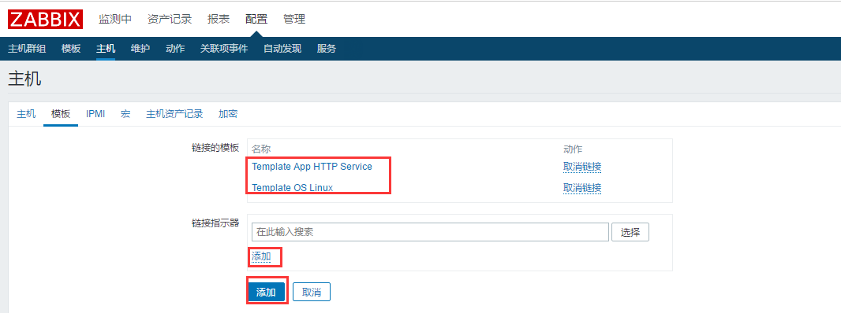

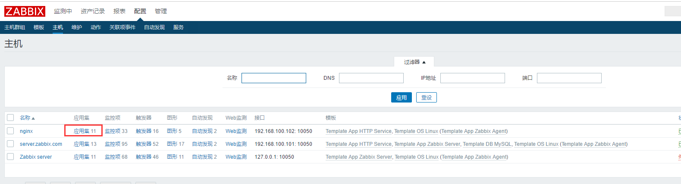

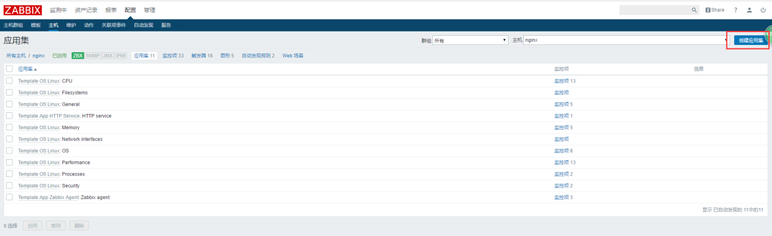



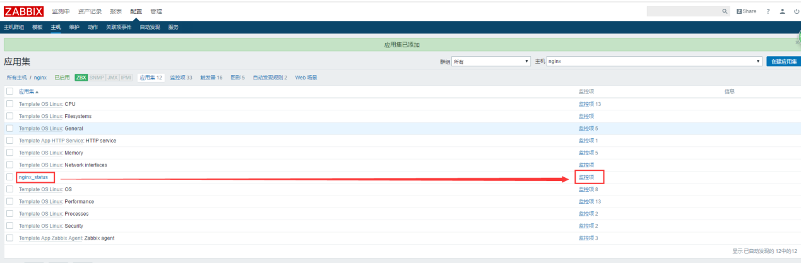

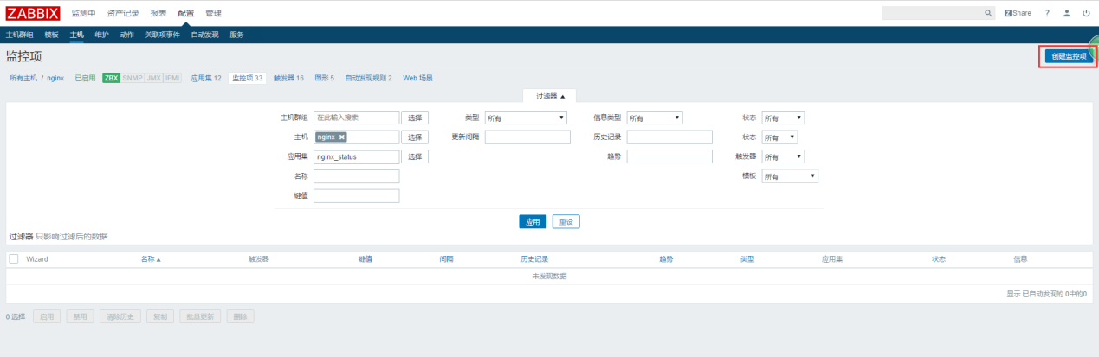

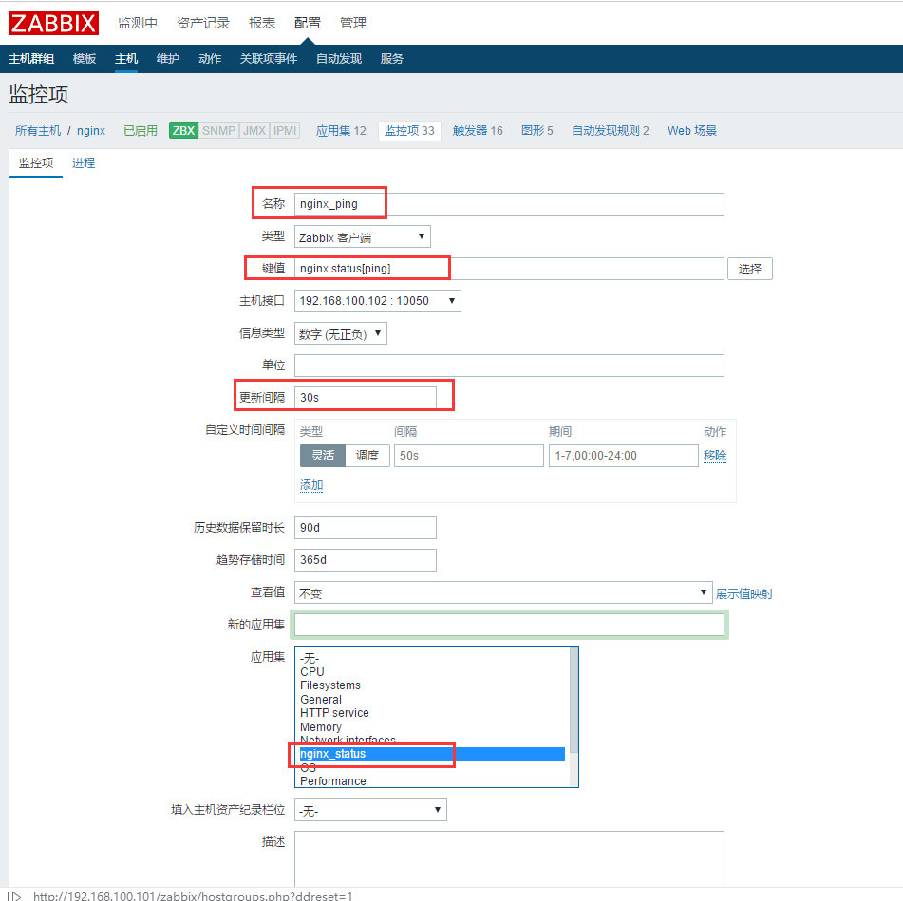

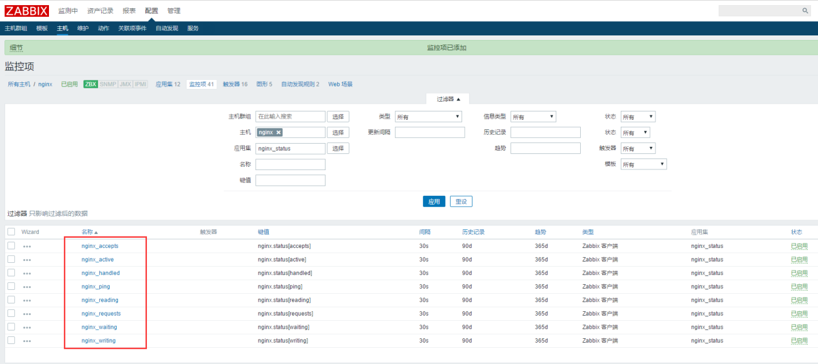

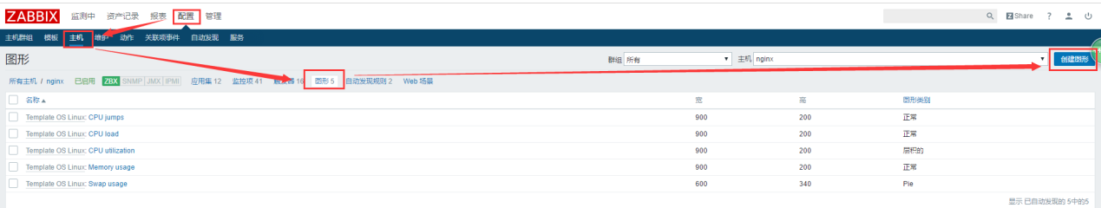

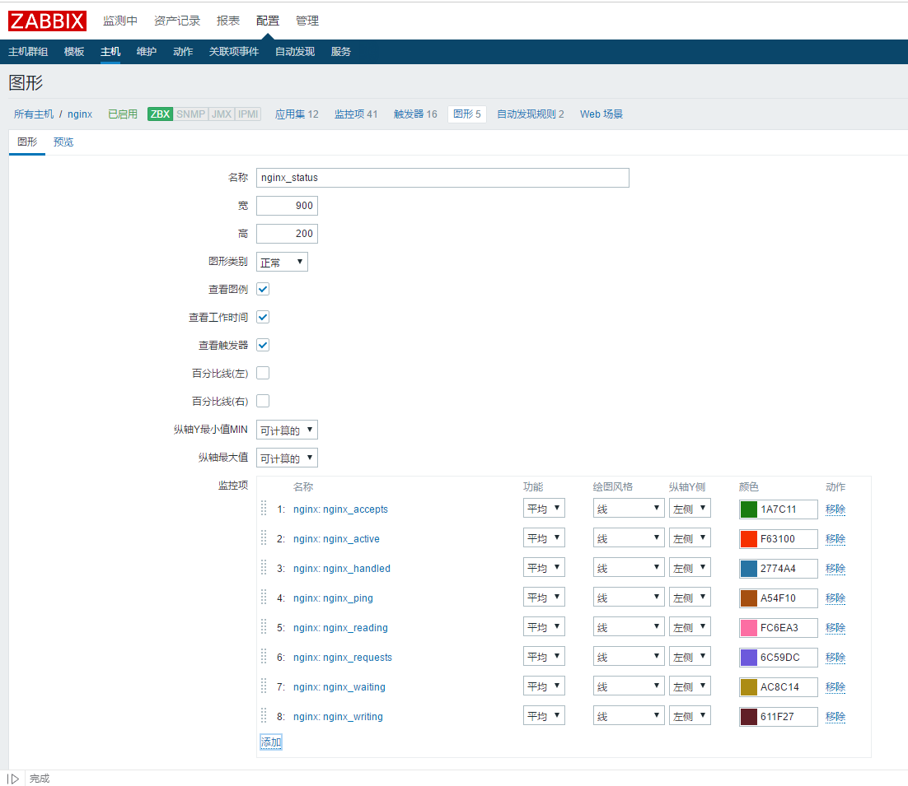

* **测试验证监控数据收集情况；**

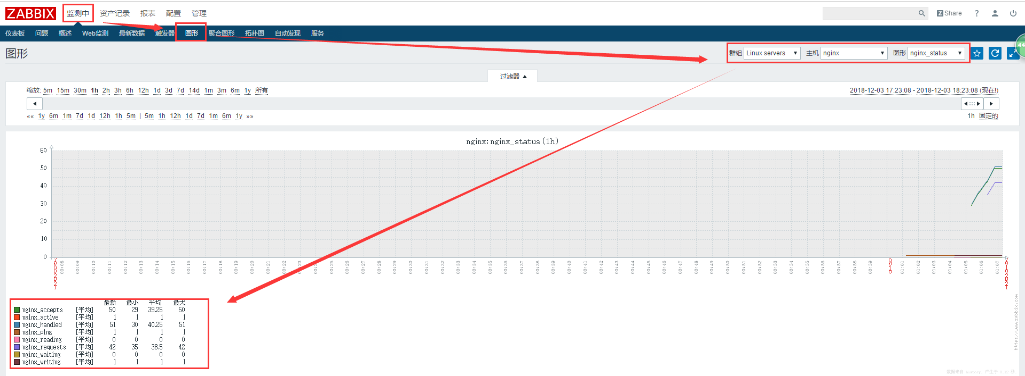

**二、Zabbix监控Mysql主从复制；**

**案例步骤：**

* 搭建Mysql主从复制环境；
* 在slave节点上安装部署zabbix_agent程序；
* 在zabbix 服务端配置监控mysql的slave节点的复制状态；
* 测试查看mysql_replication复制数据；
* **搭建Mysql主从复制环境；**

[root@slave ~]# mysql -uroot -p123123

mysql> show slave status\G;

*************************** 1. row ***************************

Slave_IO_State: Waiting for master to send event

Master_Host: 192.168.100.102

Master_User: linuxfan

Master_Port: 3306

Connect_Retry: 60

Master_Log_File: master-bin.000001

Read_Master_Log_Pos: 453

Relay_Log_File: relay1-log-bin.000003

Relay_Log_Pos: 668

Relay_Master_Log_File: master-bin.000001

Slave_IO_Running: Yes

Slave_SQL_Running: Yes

Replicate_Do_DB:

Replicate_Ignore_DB:

Replicate_Do_Table:

Replicate_Ignore_Table:

Replicate_Wild_Do_Table:

Replicate_Wild_Ignore_Table:

Last_Errno: 0

Last_Error:

Skip_Counter: 0

Exec_Master_Log_Pos: 453

Relay_Log_Space: 1051

Until_Condition: None

Until_Log_File:

Until_Log_Pos: 0

Master_SSL_Allowed: No

Master_SSL_CA_File:

Master_SSL_CA_Path:

Master_SSL_Cert:

Master_SSL_Cipher:

Master_SSL_Key:

Seconds_Behind_Master: 0

Master_SSL_Verify_Server_Cert: No

Last_IO_Errno: 0

Last_IO_Error:

Last_SQL_Errno: 0

Last_SQL_Error:

Replicate_Ignore_Server_Ids:

Master_Server_Id: 1

Master_UUID: f1f6990a-f172-11e8-b42e-000c2965c231

Master_Info_File: mysql.slave_master_info

SQL_Delay: 0

SQL_Remaining_Delay: NULL

Slave_SQL_Running_State: Slave has read all relay log; waiting for more updates

Master_Retry_Count: 86400

Master_Bind:

Last_IO_Error_Timestamp:

Last_SQL_Error_Timestamp:

Master_SSL_Crl:

Master_SSL_Crlpath:

Retrieved_Gtid_Set:

Executed_Gtid_Set:

Auto_Position: 0

Replicate_Rewrite_DB:

Channel_Name:

Master_TLS_Version:

1 row in set (0.00 sec)

mysql> grant replication client on *.* to 'zabbix'@'localhost';

Query OK, 0 rows affected, 2 warnings (0.00 sec)

mysql> flush privileges;

Query OK, 0 rows affected (0.00 sec)

* **在slave节点上安装部署zabbix_agent程序；**

[root@slave ~]# wget -O /etc/yum.repos.d/CentOS-Base.repo http://mirrors.aliyun.com/repo/Centos-6.repo

[root@slave ~]# yum -y install libxml2-devel libcurl-devel pcre-devel ntpdate

[root@slave ~]# ntpdate ntp1.aliyun.com

[root@slave ~]# tar zxvf zabbix-3.4.2.tar.gz

[root@slave ~]# cd zabbix-3.4.2

[root@slave zabbix-3.4.2]# ./configure --prefix=/usr/local/zabbix --enable-agent --enable-ipv6 --with-net-snmp --with-libcurl --with-libxml2

[root@slave zabbix-3.4.2]# make &&make install

[root@slave zabbix-3.4.2]# cp misc/init.d/tru64/zab**bix_agentd /etc/init.d/**

**[root@slave zabbix-3.4.2]# vi /etc/init.d/zabbix_agentd**

**24 DAEMON=/usr/local/zabbix/sbin/zabbix_agentd**

**:wq**

**[root@slave zabbix-3.4.2]# chmod +x /etc/init.d/zabbix_agentd**

**[root@slave zabbix-3.4.2]# cd**

[root@slave ~]# **groupadd zabbix**

[root@slave ~]# **useradd -r -g zabbix zabbix**

[root@slave ~]# **chown -R zabbix:zabbix /usr/local/zabbix/**

[root@slave ~]# **vi /usr/local/zabbix/etc/zabbix_agentd.conf**

**LogFile=/tmp/zabbix_agentd.log**

**Server=192.168.100.101**

**ServerActive=192.168.100.101**

**Hostname=slave**

**UnsafeUserParameters=1**

**UserParameter=mysql.replication,/tmp/zabbix_mysql_slave.sh**

**:wq**

[root@slave ~]# **/etc/init.d/zabbix_agentd start**

**Zabbix agent started.**

[root@slave ~]# netstat -utpln |grep zabbix

tcp 0 0 0.0.0.0:10050 0.0.0.0:* LISTEN 14707/zabbix_agentd

[root@slave ~]# vi /tmp/zabbix_mysql_slave.sh

#!/bin/bash

/usr/local/mysql/bin/mysql -uzabbix -e 'show slave status\G' |grep -E "Slave_IO_Running|Slave_SQL_Running"|awk '{print $2}'|grep -c Yes

:wq

[root@slave ~]# chmod +x /tmp/zabbix_mysql_slave.sh

* **在zabbix 服务端配置监控mysql的slave节点的复制状态；**

[root@server ~]# cat <<END >>/etc/hosts

192.168.100.103 slave

END

[root@server ~]# zabbix_get -s 192.168.100.103 -k "mysql.replication"

2

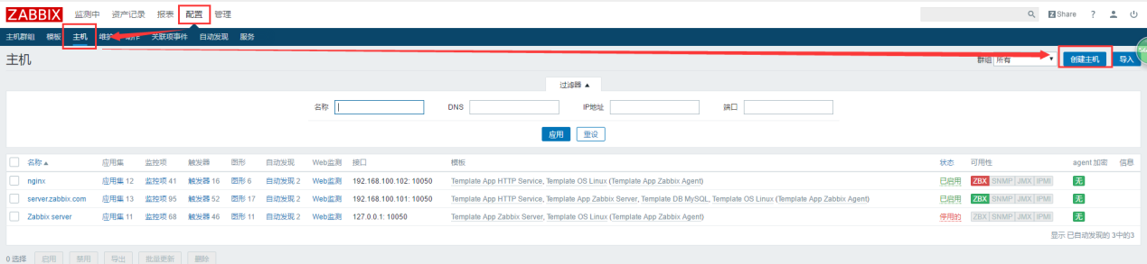

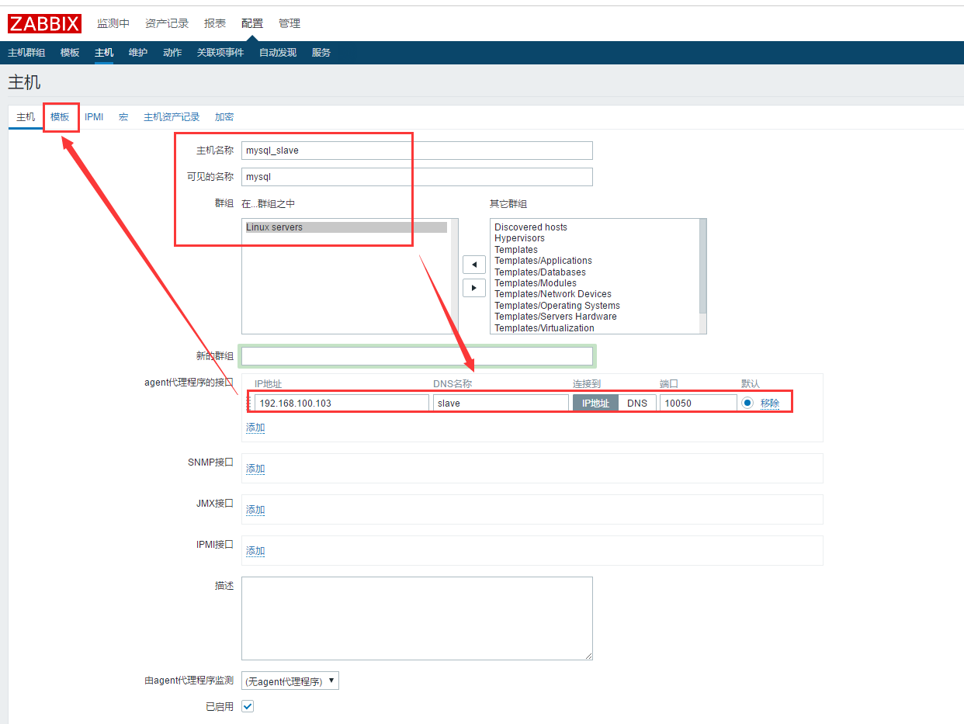

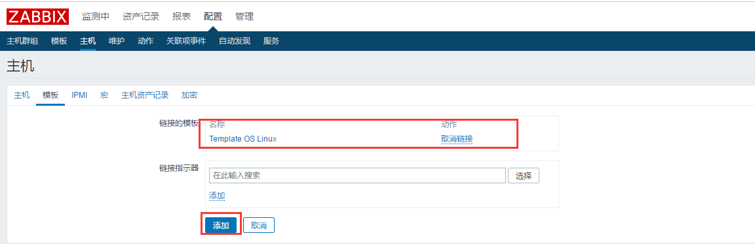

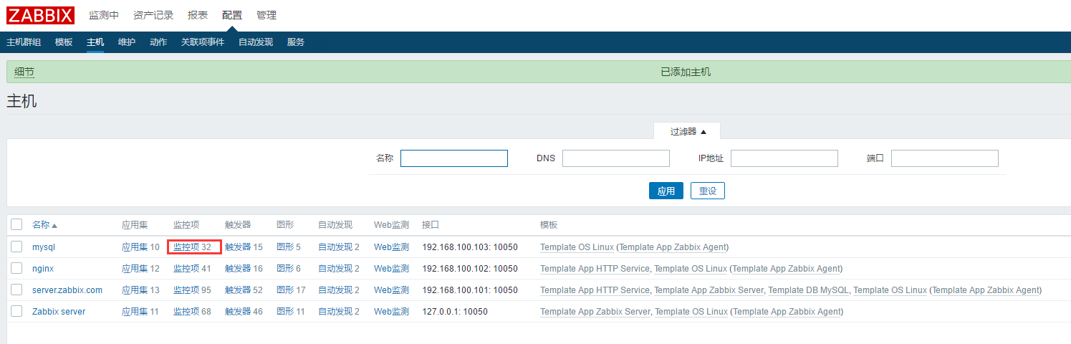

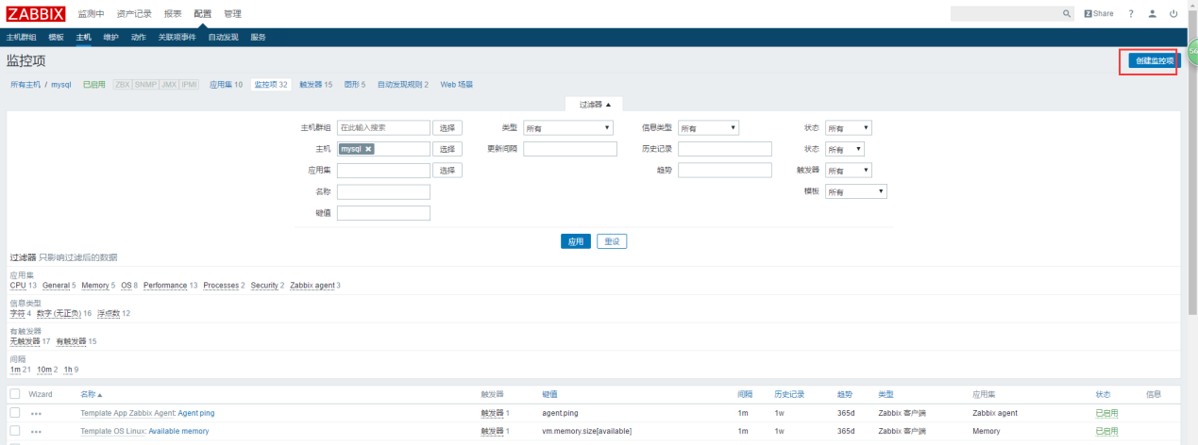

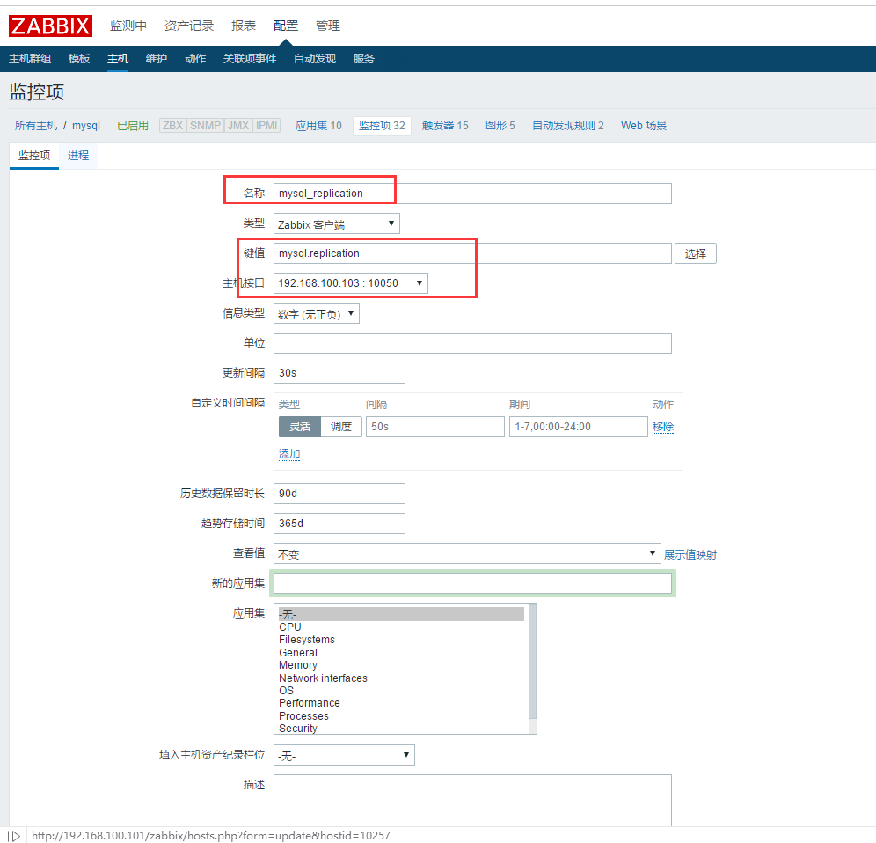

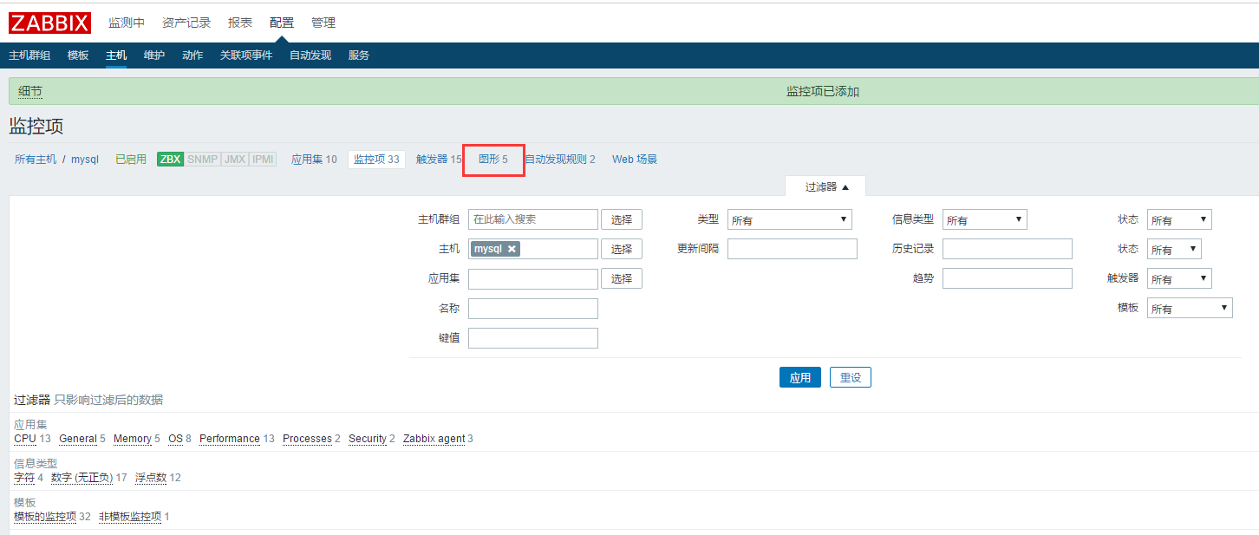

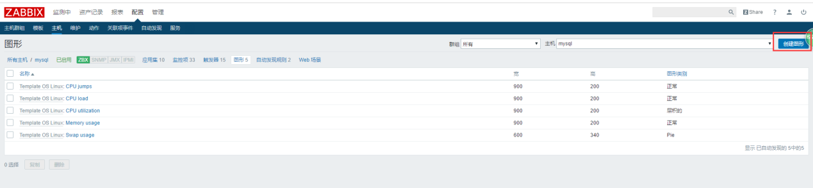

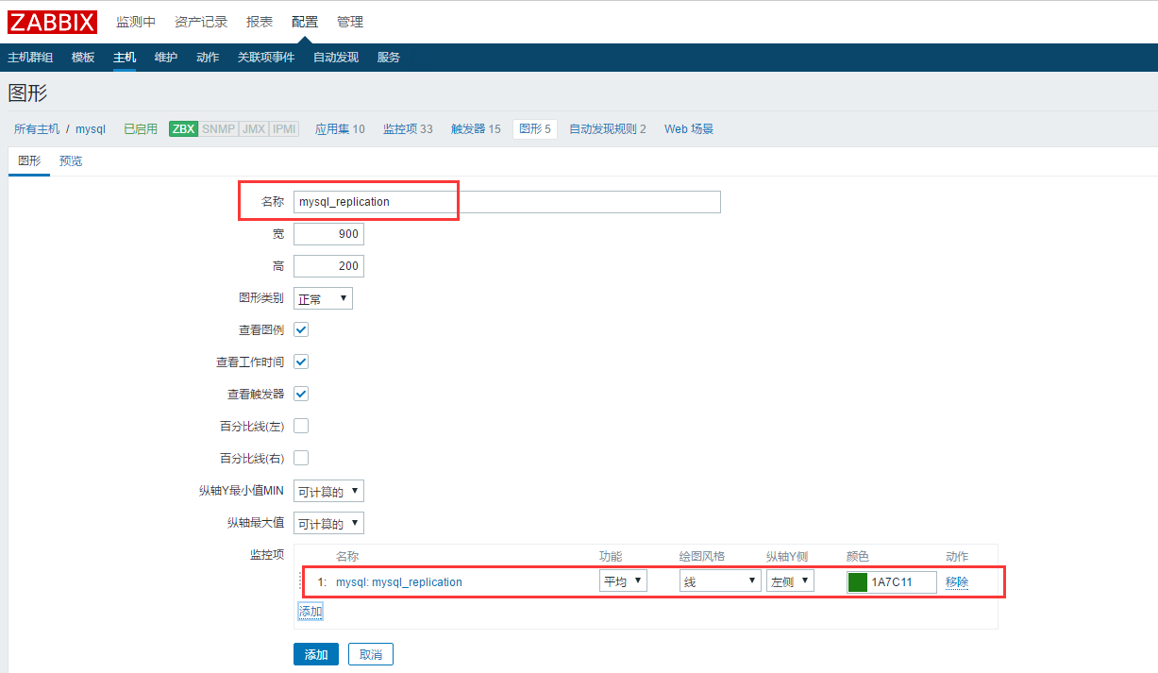

* **测试查看mysql_replication复制数据；**

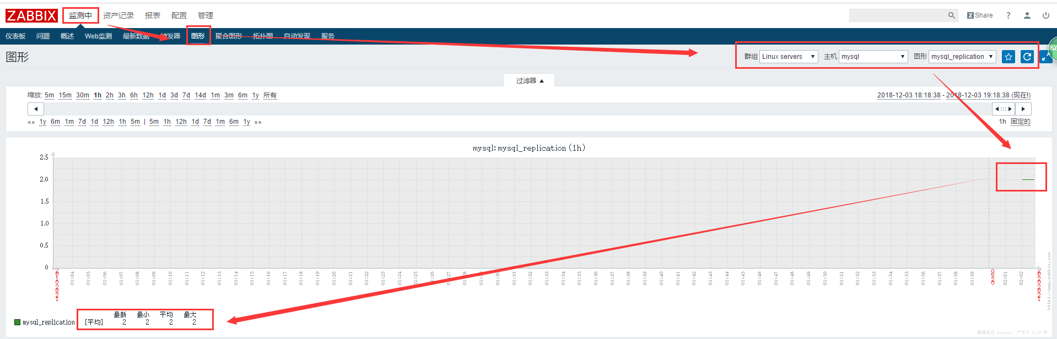

**三、**