Backend dev (for companies)

* **Personal data**
  + List of employees
  + Employee card
* **JOBperson + JOBshare**
  + Categories list
    - Split by
      * JOBperson
      * JOBshare
  + Add new category
    - Checkbox
      * JOBperson
      * JOBshare
    - Name
  + Edit existing categories
  + Delete categories
    - You can delete a category only if it has no associated message (JOBchat)
  + Default contents - JOBperson
    - Paycheck, Contracts, Shifts / Working hours, Full holidays, Leave, Convocations of health surveillance visits, Welfare
  + Default contents - JOBshare
    - CCNL, Disciplinary Code / Ethical Code, CIA, Trade Union Agreements, Regulations, Smartworking, Trade Union Communications, Health-Safety Protocol, Privacy Notice

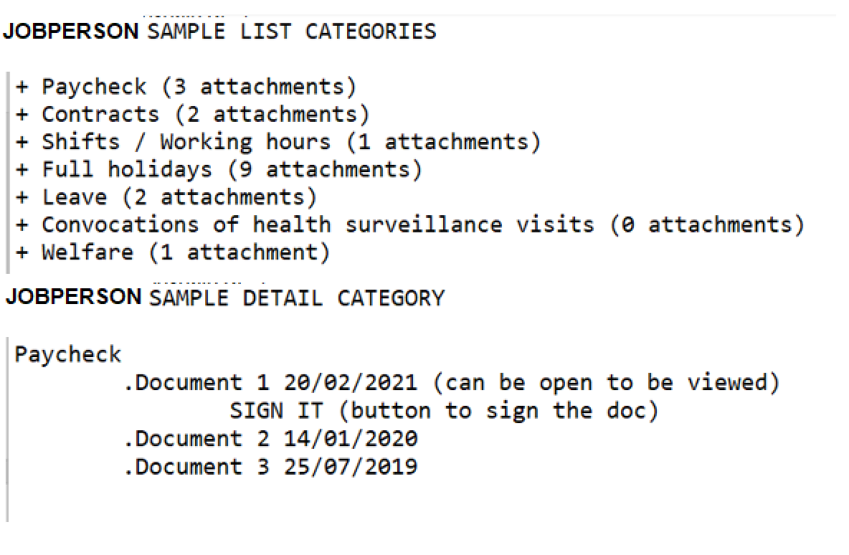

PS: It isn’t important UI design.