
School of Pure and Applied Sciences
ARCH-FL: A Differential Privacy Framework for Federated Learning in Chest X-Ray Classification
Submitted by
WAMBUA MWIKYA: PA106/17483/22
Mburu Kevin Kamau : PA106/G/17500/22
John ng’ang’a: CT100/G/15922/22
Victor kamau mwangi: CT102/G/13883/21
SUPERVISOR
DR. GILBERT LANGAT
A project documentation Submitted to KIRINYAGA UNIVERSITY Department of Pure and Applied Sciences, School of Pure and Applied Sciences in Partial Fulfilment of the requirement of the award of a BACHELORS degree in SOFTWARE ENGINEERING, BBIT, and COMPUTER SCIENCE.

DECLARATION

We declare that this work has not been submitted in this or any other University for the awarding of the course marks. To the best of our knowledge and belief, this work contains no material previously published or written by another person except where due reference is made.
Student Name: Wambua Mwikya
Signature: .................................................. Date: ..........................................................
Student Name: Mburu Kevin Kamau
Signature: ................................................. Date: ..........................................................
Student Name: John Ng’ang’a
Signature: ................................................. Date: ..........................................................
Student Name: Victor Kamau Mwangi
Signature: ................................................. Date: ..........................................................

DECLARATION
I, Gilbert Langat, confirm that I have reviewed the work presented in this proposal and that it meets the required academic standards. I have provided guidance and supervision throughout the project, and I am satisfied with the originality and integrity of the work submitted.

Supervisor: Gilbert Langat
Signature: ……………………………… Date: ………………………………………

Dedication
We dedicate this project to the divine guidance of God, and to our families and friends whose consistent encouragement has been a constant source of strength. Special thanks are extended to our classmates for their diligent efforts, steadfast dedication, and unwavering support. We express gratitude to the instructor who generously dedicated time to guide us. This dedication is a token of appreciation to all those who have contributed to the success of this project, making it a collaborative effort and a reflection of shared dedication and support.

Acknowledgement

I extend my gratitude to the developers and maintainers of PyTorch, CheXpert, and MIMIC-CXR whose tools and datasets made this research feasible. Special thanks to the federated learning research community for establishing foundational methodologies that enable collaborative learning without data sharing.

Abstract
Federated Learning (FL) enables collaborative model training across decentralized data sources without sharing raw data, offering a promising solution for privacy-sensitive domains like healthcare. However, standard FL remains vulnerable to privacy inference attacks and suffers performance degradation under non-Independent and Identically Distributed (non-IID) data distributions common in medical settings. While Differential Privacy (DP) can mitigate privacy risks, its impact on model utility in medical FL lacks comprehensive analysis under realistic conditions. This research develops ARCH-FL, a framework integrating DP with FL for chest X-ray analysis. Using PyTorch, the CheXpert and MIMIC-CXR datasets from Hugging Face, we systematically evaluate the privacy-utility trade-off across various non-IID scenarios. The study provides empirical guidelines for implementing privacy-preserving FL in healthcare, demonstrating that carefully calibrated DP parameters can maintain clinical utility while ensuring formal (ε,δ)-privacy guarantees. Our open-source implementation offers a validated baseline for deploying ethical AI in medical imaging.

Table of Contents
DECLARATION ii
DECLARATION iii
Dedication iv
Acknowledgement v
Abstract vi
Abbreviations ix
Chapter 1: Introduction 1
1.1 Introduction to the Chapter 1
1.2 Background 1
1.3 Current/Existing System 1
1.4 Problem Statement 2
1.5 Proposed System 2
1.6 Purpose of the Study 3
1.7 General Objective 3
1.8 Specific Objectives 3
1.9 Justification 3
1.10 Scope 4
1.11 Limitations 4
1.12 Significance of the Study 4
1.13 Operational Definition of Terms 5
Chapter 2: Literature Review 6
2.1 Introduction to the Chapter 6
2.2 Related Literature Review 6
2.2.1 Foundational FL-DP Integration in Healthcare 6
2.2.2 Advanced Privacy Mechanisms: Beyond Uniform DP 6
2.2.3 Hybrid Cryptographic and DP Defences 7
2.2.4 Architectural Innovations for Heterogeneous Data and Models 7
2.2.5 Systematic Analysis of the Privacy-Performance Trade-off 7
2.3 Identified Gaps/Lacunas 8
2.4 Conceptual Framework 9
2.5 Chapter Conclusion 10
Chapter 3: Research Methodology 11
3.1 Introduction to the Chapter 11
3.2 Development Methodology 11
3.3 Justification of Methodology 13
3.4 Data Collection 14
3.4.1 Datasets 14
3.4.2 Data Partitioning 14
3.5 Data Analysis Framework 15
3.5.1 Quantitative Metrics 17
3.5.2 Statistical Methods 17
3.6 Technical Stack Architecture 17
3.7 Experimental Design Matrix 19
3.8 Ethical Considerations 20
3.9 Validation Strategy 20
3.10 Limitations of the Methodology 20
3.11 Chapter Conclusion 20
CHAPTER 4: SYSTEM DESIGN 21
4.1 Introduction 21
4.2 Requirements 21
4.4 Context level diagram 21
4.5 Input design 21
4.6 Process design 21
4.7 Database design 21
4.8 Output design 21
4.9 Chapter conclusion 21
References 22
Appendices 23

Abbreviations
Abbreviation | Full Form
FL | Federated Learning
DP | Differential Privacy
ARCH-FL | Architecture for Federated Learning
IID | Independent and Identically Distributed
non-IID | Non-Independent and Identically Distributed
DP-SGD | Differentially Private Stochastic Gradient Descent
ε (epsilon) | Privacy Budget
δ (delta) | Privacy Failure Probability
CXR | Chest X-Ray
CNN | Convolutional Neural Network
FedAvg | Federated Averaging
ML | Machine Learning
AI | Artificial Intelligence
EHR | Electronic Health Records
HIPAA | Health Insurance Portability and Accountability Act
GDPR | General Data Protection Regulation

Table of Figures
Conceptual Framework 9
Development Methodology 12
Methodology alignment to objectives 13
Data partitioning process 15
Data Analysis Framework 16
Technical stack overview 18
Experimental Design 19
Ethical Consideration Framework 22
Validation Approach 23

Index of Tables
List of Abbreviations ix
Tools Stack 17

Chapter 1: Introduction
This chapter establishes the foundational context for the research project, ARCH-FL. It begins by outlining the background of federated learning and its significance in the medical domain, followed by a critique of the current systems and a clear articulation of the existing problems. The chapter then presents the proposed system as a solution, detailing its purpose, objectives, and justifications. Finally, it defines the scope, acknowledges limitations, and clarifies the operational terms used throughout the study.

1.1 Introduction to the Chapter
The proliferation of Artificial Intelligence (AI) in healthcare, particularly in medical image analysis, has demonstrated remarkable potential for improving diagnostic accuracy and efficiency (Esteva et al., 2019). However, the development of robust AI models requires access to large, diverse datasets, which are often siloed across different hospitals due to patient privacy concerns, proprietary interests, and stringent data protection regulations (Kaissis et al., 2020). This data fragmentation creates a significant bottleneck for medical AI research. Federated Learning (FL) was introduced by McMahan et al. (2017) as a decentralized machine learning approach that circumvents the need for data centralization. In a typical FL system, a global model is trained by aggregating model updates learned from local data on client devices or institutions, while the raw data never leaves its original location. Despite its promise, vanilla FL is not inherently private; model updates can leak information about the underlying training data, making them vulnerable to membership inference and reconstruction attacks (Nasr, Shokri, & Houmansadr, 2019).

1.2 Background
The current state-of-the-art for multi-institutional medical AI research often involves cumbersome data sharing agreements and the creation of centralized data repositories. Where FL is implemented, it frequently relies on the basic Federated Averaging (FedAvg) algorithm without formal privacy guarantees. Existing open-source FL frameworks (e.g., TensorFlow Federated, PySyft) provide the architectural backbone but with limited, non-standardized integrations with rigorous privacy-preserving technologies like Differential Privacy (DP) for medical imaging tasks. Furthermore, most research and implementations assume IID data distribution across clients, an assumption that is routinely violated in real-world healthcare scenarios where patient demographics and disease prevalence vary significantly between hospitals (Sheller et al., 2020). This gap between research assumptions and practical realities hinders the effective deployment of FL in clinical settings.

1.3 Current/Existing System
The core problem is the absence of a systematically evaluated, open-source framework that integrates Differential Privacy with Federated Learning specifically tailored for the challenges of medical image analysis, particularly under non-IID data distributions. This leads to a critical dilemma: how can hospitals collaboratively train accurate AI models without sharing data and without sacrificing patient privacy or model utility?

1.4 Problem Statement
The specific issues addressed are:
- The vulnerability of standard FL to privacy attacks in a medical context.
- The performance degradation of FL models under realistic non-IID medical data.
- The lack of clear guidelines on the trade-off between privacy budget (ε) and model utility (e.g., accuracy) in federated medical imaging.
This research implements ARCH-FL: a novel, open-source framework for Federated Learning with Differential Privacy designed specifically for medical image analysis. The system implements a secure coordinator server that aggregates locally trained model updates from multiple simulated hospital clients. Each client employs DP-SGD during local training to ensure that the model updates provide formal (ε, δ)-differential privacy guarantees. The framework is designed to systematically test and evaluate model performance under various levels of privacy protection and different types of non-IID data splits, providing a comprehensive analysis of the privacy-utility trade-off.

1.5 Proposed System

1.6 Purpose of the Study
The purpose of this study is to design, implement, and empirically evaluate a differentially private federated learning framework that enables effective and secure collaborative training of medical image analysis models across distributed data sources.

1.7 General Objective
To develop and validate the ARCH-FL framework for privacy-preserving federated learning in medical image analysis.

1.8 Specific Objectives
- To design a system architecture that integrates differential privacy mechanisms within a federated learning pipeline for managing distributed chest X-ray datasets from multiple clinical sources.
- To implement the ARCH-FL framework using PyTorch, featuring configurable privacy parameters (ε, δ), non-IID data partitioning strategies, and support for multi-label classification on the CheXpert and MIMIC-CXR datasets.
- To conduct a series of experiments using the CheXpert and MIMIC-CXR datasets to establish baseline performance for multi-label thoracic disease classification without privacy and under IID conditions.
- To analyse the impact of varying differential privacy budgets and non-IID data distributions on model utility, measured by area under the receiver operating characteristic curve (AUROC) per pathology, convergence speed, and performance fairness across clients.
- To disseminate the research findings, the open-source codebase, and practical implementation guidelines for privacy-preserving federated learning in chest X-ray analysis to the healthcare AI community.

This research is justified by the critical need to advance medical AI in an ethical and legally compliant manner. It addresses the direct concerns of healthcare institutions regarding data privacy and security. By providing a validated framework and concrete evidence on the privacy-utility trade-off, this study lowers the barrier for hospitals to engage in collaborative research. This may potentially accelerate the development of more robust and generalizable diagnostic AI models without compromising patient trust or violating data protection laws.

1.9 Justification
The scope of this study is confined to multi-label classification tasks using 2D chest radiographs, primarily benchmarked on the CheXpert dataset and validated on a subset of the MIMIC-CXR dataset. The federated learning environment will be simulated on a single machine, with clients represented as separate data partitions. The research will focus on the FedAvg aggregation algorithm and the DP-SGD mechanism for privacy, specifically evaluating performance for thoracic disease detection across 14 clinical observations. The study will not address segmentation, detection tasks, or real-time deployment across physical hospital networks.

1.10 Scope
The primary limitation of this work is the use of simulated clients and publicly available datasets, which may not fully capture the complexities of a real-world multi-hospital network, including communication overheads, systems heterogeneity, and adversarial client Behaviour. Furthermore, the study is limited to classification tasks and may not generalize to more complex medical imaging problems like segmentation or detection without further modification.

1.11 Limitations
This study is significant because it provides a practical, open-source tool and a comprehensive empirical analysis that bridges a critical gap in privacy-preserving medical AI. The findings will offer much-needed insights and benchmarks for researchers and practitioners aiming to deploy FL in clinical settings, thereby contributing to the responsible advancement of AI in healthcare.

1.12 Significance of the Study

1.13 Operational Definition of Terms
- Federated Learning (FL): A distributed machine learning technique where a model is trained across multiple decentralized devices or servers holding local data samples, without exchanging them.
- Differential Privacy (DP): A rigorous mathematical framework for ensuring that the output of a computation does not reveal information about any individual data point in the input dataset.
- Privacy Budget (ε): A parameter that quantifies the privacy loss; a smaller ε implies stronger privacy guarantees.
- Non-IID Data: Data that is not Independent and Identically Distributed across clients. In this context, it refers to uneven distributions of disease labels or image types across different hospital datasets.
- Model Utility: The performance of the machine learning model, typically measured by metrics such as accuracy, precision, recall, and F1-score on a held-out test set.
- DP-SGD: Differentially Private Stochastic Gradient Descent, an optimization algorithm that adds calibrated noise to gradients during training to achieve differential privacy.

Chapter 2: Literature Review

2.1 Introduction to the Chapter
This chapter critically examines the existing body of scholarly work relevant to the development of the ARCH-FL framework. It synthesizes key findings from recent research on federated learning (FL) and differential privacy (DP) in medical imaging, identifying dominant trends, established methodologies, and significant challenges. The review systematically analyses the privacy-utility trade-off, a central concern in privacy-preserving machine learning. Furthermore, it pinpoints specific gaps in the current literature that the ARCH-FL project seeks to address. The chapter concludes by presenting a conceptual framework that integrates these insights to guide the subsequent design and implementation of the proposed system.

2.2 Related Literature Review
The integration of Federated Learning with Differential Privacy has emerged as a leading paradigm for privacy-preserving collaborative model training in healthcare. The following analysis covers the core themes in this domain.

2.2.1 Foundational FL-DP Integration in Healthcare
The foundational work by McMahan et al. (2017) introduced Federated Averaging (FedAvg) as a core algorithm for decentralized learning. Building on this, subsequent research has demonstrated the viability of combining FL with DP for biomedical image classification. For instance, studies have implemented feedforward neural networks (FNNs), Gaussian processes (GPs), and deep neural networks (DNNs) within an FL framework enhanced with DP, showing that it is possible to maintain model performance while improving privacy preservation. These studies established that FL alone is insufficient for privacy, as gradient updates can leak sensitive information, thereby necessitating the formal guarantees provided by DP.

2.2.2 Advanced Privacy Mechanisms: Beyond Uniform DP
A significant evolution in this field is the move away from uniform DP application. Traditional DP-SGD applies the same noise level to all data, which can lead to excessive utility loss for less-sensitive data and insufficient protection for high-risk samples. To address this, novel notions like Sensitivity-Aware Differential Privacy (SDP) have been proposed. SDP dynamically calibrates privacy protection by first using local simulations of Gradient Inversion Attacks (GIAs) to objectively quantify the sensitivity of individual data samples. Data with higher privacy leakage risks receive stronger noise protection, which has been shown to improve average model performance by 13.5% under equivalent privacy risk compared to state-of-the-art methods. Another relaxation, Metric Privacy, has been introduced to mitigate the negative impact of standard DP on model convergence in FL, showing promising results in medical imaging tasks.

2.2.3 Hybrid Cryptographic and DP Defences
To counter a broader range of threats, including poisoning and collusion attacks, researchers have begun designing hybrid defence mechanisms. The DPSHE scheme exemplifies this approach by integrating local differential privacy with threshold homomorphic encryption. This framework employs a “List Screening Center” to filter out malicious clients and uses homomorphic encryption to enable the server to perform directed aggregation on encrypted model parameters. This hybrid architecture protects model privacy from the server and other clients while maintaining model accuracy and convergence speed, offering a robust solution for secure multi-institutional collaboration.

2.2.4 Architectural Innovations for Heterogeneous Data and Models
A prominent challenge in real-world FL is data and system heterogeneity (non-IID data). The FednnU-Net framework addresses this in the context of medical image segmentation by introducing two novel methods: Federated Fingerprint Extraction and Asymmetric Federated Averaging. These techniques allow for the federated training of the highly adaptive nnU-Net architecture, which normally customizes itself to a single dataset. This work highlights the need for FL aggregation strategies that can handle clients with differing model architectures or data characteristics, a key consideration for deploying FL across diverse hospitals.

2.2.5 Systematic Analysis of the Privacy-Performance Trade-off
The inherent trade-off between privacy and model utility is a critical area of investigation. A systematic literature review on balancing privacy and performance in FL underscores that integrating privacy-preserving mechanisms like DP often increases communication and computational overhead. This body of work emphasizes that achieving an optimal balance is not a one-size-fits-all solution but requires careful consideration of application-specific requirements, including target accuracy, convergence time, and the specific privacy threats faced.

2.3 Identified Gaps/Lacunas
Despite the significant advancements outlined above, several critical gaps remain in the current research landscape:
- Lack of Fine-Grained, Attack-Aware DP for Medical Imaging: While SDP and Metric Privacy represent important steps forward, their application and evaluation on large-scale, real-world medical imaging datasets like CheXpert and MIMIC-CXR are still limited. Many existing DP implementations in medical FL continue to rely on uniform noise addition, which fails to optimally balance utility and privacy.
- Insufficient Exploration of Multi-Label Classification under DP: Most studies in private FL for medical imaging focus on single-label classification or segmentation tasks. The specific challenges of multi-label classification—such as dealing with label co-occurrence and class imbalance across federated clients—in the context of non-IID data and differential privacy are underexplored.
- Limited Comprehensive Analysis of Non-IID and DP Interaction: Although the negative impact of non-IID data on FL convergence is well-known, and the utility cost of DP is well-documented, there is a lack of systematic research that jointly analyses their interaction. A comprehensive study quantifying how different non-IID severities affect the privacy-utility trade-off at various DP budgets is needed to provide practical guidelines for clinical deployments.
- Framework Complexity and Clinical Accessibility: Advanced frameworks like DPSHE and FednnU-Net offer powerful solutions but can be complex to implement. There is a gap for a streamlined, open-source framework that prioritizes accessibility and reproducibility for researchers and practitioners, enabling easier adoption and validation of DP-FL methods in medical imaging.

2.4 Conceptual Framework
The conceptual framework for the ARCH-FL project, illustrated below, synthesizes the insights from the literature to address the identified gaps. It outlines a structured process from data preparation through to a rigorously evaluated private FL model, with a core focus on the dynamic interplay between non-IID data partitioning and adaptive privacy mechanisms.
Figure 1: Conceptual Framework
The framework is built on several foundational pillars derived from the literature. The use of Sensitivity-Aware DP addresses the gap of uniform noise addition by dynamically adjusting the privacy level based on data sensitivity. The explicit incorporation of non-IID data partitioning allows for a systematic investigation of its interaction with DP, a key research gap. Focusing on multi-label classification directly tackles an underexplored area in medical FL. Finally, the closed-loop evaluation and analysis phase is designed to generate the comprehensive insights and practical guidelines that are currently lacking.

2.5 Chapter Conclusion
This literature review established that while Federated Learning combined with Differential Privacy is a powerful and necessary approach for collaborative medical image analysis, the field is evolving beyond simple, uniform privacy applications. Recent research has made significant strides with adaptive privacy notions, hybrid cryptographic defences, and architectures capable of handling heterogeneity. However, clear gaps persist, particularly concerning the application of fine-grained DP to complex multi-label tasks on real-world datasets and a nuanced understanding of the non-IID-DP interaction. The conceptual framework for ARCH-FL presented herein is designed to directly confront these challenges. By proposing a system that integrates sensitivity-aware privacy mechanisms with a rigorous evaluation of multi-label classification under non-IID conditions, this research aims to contribute a validated, practical solution that advances the state-of-the-art in privacy-preserving medical AI.

Chapter 3: Research Methodology

3.1 Introduction to the Chapter
This chapter outlines the research methodology adopted for the design, implementation, and evaluation of the ARCH-FL framework. It details the development approach, tools, and techniques used to achieve the stated objectives. The chapter is structured to provide a clear and reproducible roadmap for the study, ensuring methodological rigour and alignment with the research questions identified in Chapters 1 and 2 (Kothari, 2019).

3.2 Development Methodology
The study follows an Agile-Experimental Development Methodology, integrating iterative software development with systematic experimentation. The process is visualized in the figure below:
The methodology is divided into sequential yet overlapping phases:
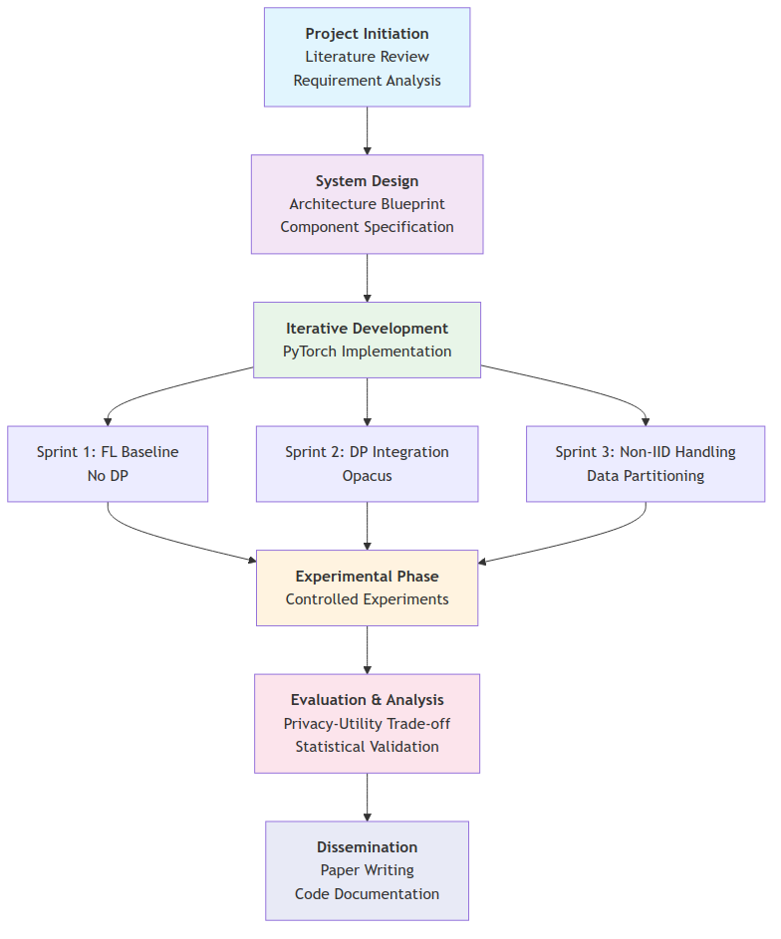Figure 1: Development Methodology
- Design Phase: Architectural planning and component specification.
- Development Phase: Iterative implementation using PyTorch and Opacus.
- Experimental Phase: Controlled experiments on privacy levels, non-IID settings, and model architectures.
- Evaluation Phase: Quantitative and qualitative analysis of results.
- Dissemination Phase: Academic writing, code release, and dashboard deployment.

3.3 Justification of Methodology
The Agile-Experimental approach was chosen for its flexibility, adaptability, and alignment with software engineering best practices (Sommerville, 2016). It allows for incremental development, continuous testing, and integration of feedback—essential for a research project involving complex machine learning and privacy components. The experimental design follows empirical software engineering principles, ensuring reproducibility and validity of findings (Wohlin et al., 2012).
The diagram below illustrates how the methodology aligns with research objectives:
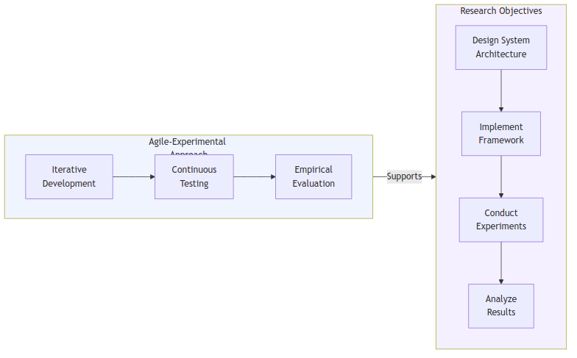Figure 1: Methodology alignment to objectives

3.4 Data Collection
The study utilizes publicly available medical imaging datasets to ensure reproducibility and compliance with ethical research standards. No primary data collection from human subjects was conducted.

3.4.1 Datasets
- CheXpert Dataset: 224,316 chest radiographs with multi-label annotations for 14 thoracic conditions (Irvin et al., 2019).
- MIMIC-CXR Dataset: 377,110 chest X-ray studies from Beth Israel Deaconess Medical Center (Johnson et al., 2019).

3.4.2 Data Partitioning
The data partitioning process is visualized below:
- IID (baseline): Uniform distribution of labels.
- Non-IID (Dirichlet distribution): Label skew across clients.
- Quantity-based skew: Varying dataset sizes per client.
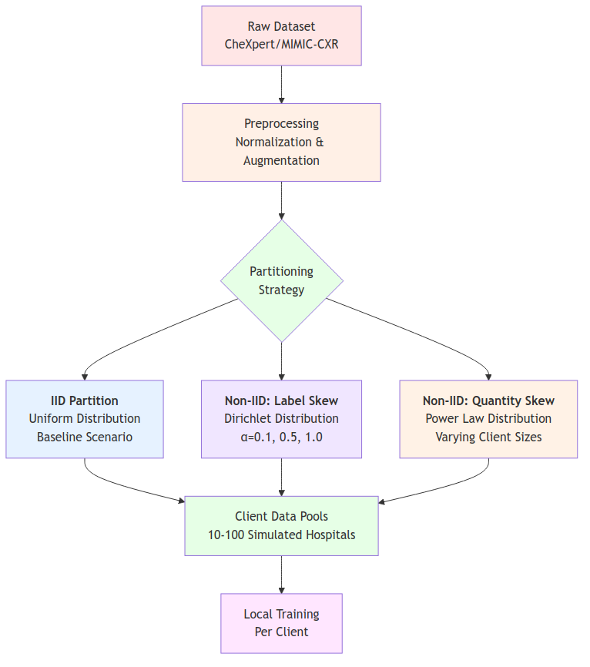Figure 1: Data partitioning process

3.5 Data Analysis Framework

Both quantitative and qualitative analysis methods are employed:
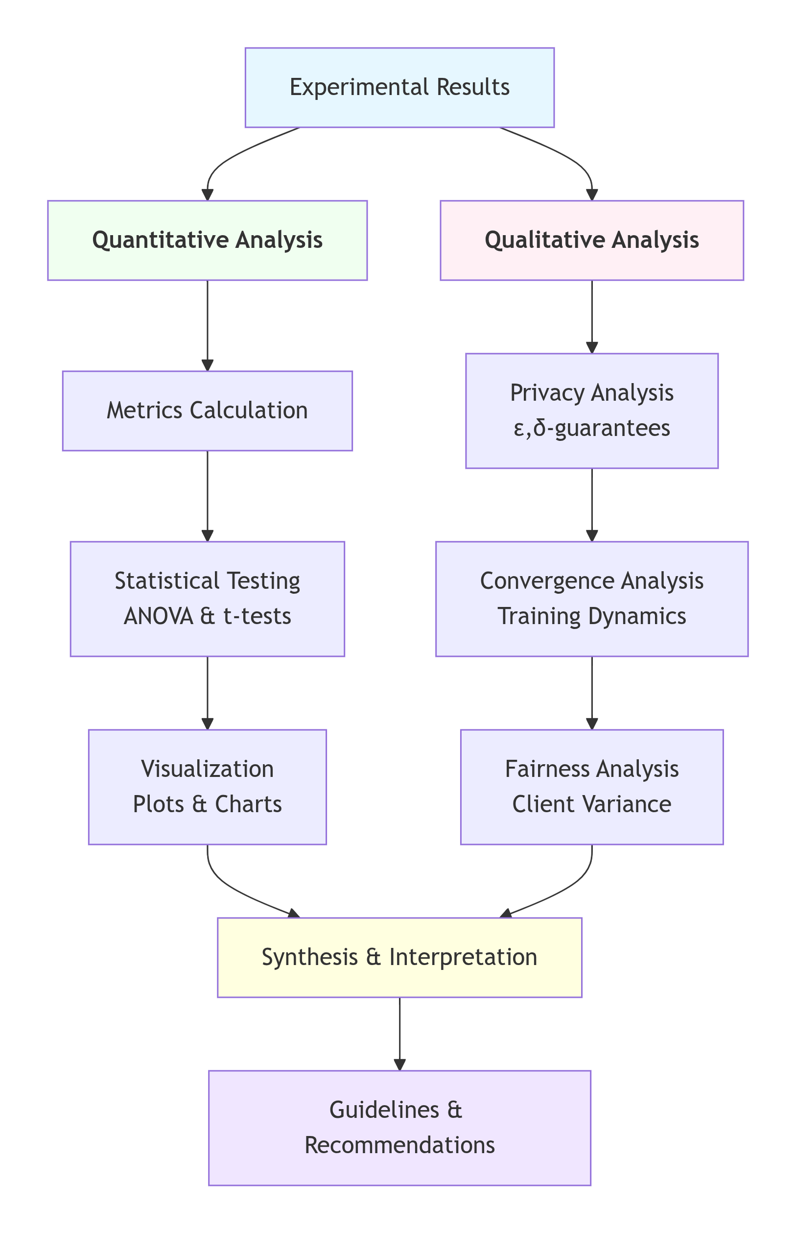Figure 1: Data Analysis Framework

3.5.1 Quantitative Metrics
- Model Utility: AUROC, Accuracy, F1-Score.
- Privacy Guarantees: (ε, δ)-Differential Privacy.
- Convergence Behavior: Training loss curves, communication rounds.
- Fairness: Performance variance across clients.

3.5.2 Statistical Methods
- Hypothesis Testing: t-tests and ANOVA to compare performance across privacy levels and non-IID settings.
- Visualization: Confusion matrices, ROC curves, and privacy-utility plots using Matplotlib and Plotly.

3.6 Technical Stack Architecture
Detailed Tool Stack:
Category | Tools/Libraries | Purpose
Deep Learning | PyTorch, PyTorch Lightning | Model development and training
Privacy | Opacus, TensorFlow Privacy | Differential privacy implementation
Data Processing | Pandas, Dask | Data manipulation and partitioning
Visualization | Streamlit, Plotly, Matplotlib | Results presentation
Experiment Tracking | MLflow, Weights & Biases | Experiment management
Development | Git, Docker, Conda | Version control and environment
Table 1: Tools Stack

The integrated technical architecture is shown below:
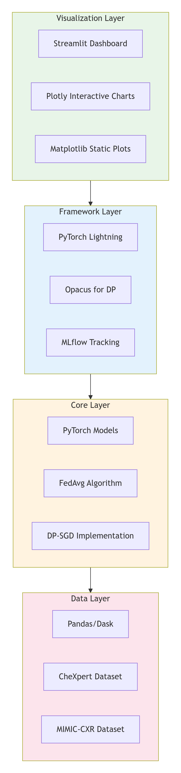Figure 1: Technical stack overview

3.7 Experimental Design Matrix
The experimental design follows a comprehensive matrix approach:
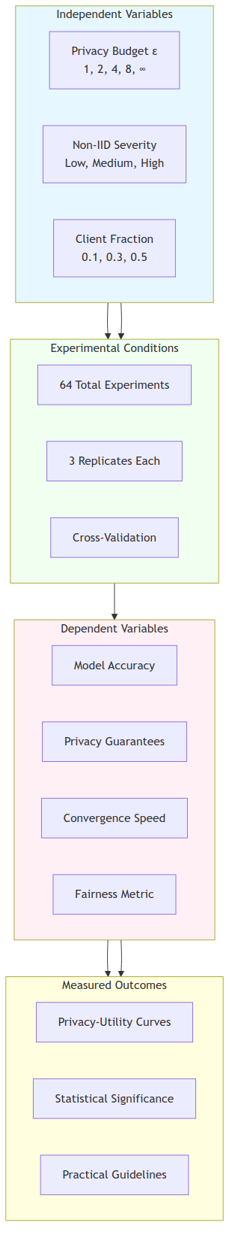Figure 1: Experimental Design

3.8 Ethical Considerations
The study adheres to ethical AI research principles:
- Use of de-identified public datasets.
- Implementation of formal privacy guarantees via DP.
- Transparent reporting of limitations and potential biases.
- Open-source release of code for reproducibility and community scrutiny.

3.9 Validation Strategy
The framework is validated through:
- Baseline Comparisons: Against centralized training and non-private FL.
- Ablation Studies: To isolate the effects of DP and non-IID.
- Cross-Dataset Validation: Training on CheXpert, testing on MIMIC-CXR.
- Peer Review: Submission to conferences/journals for external validation.

3.10 Limitations of the Methodology
- Simulated FL environment may not capture real-world network delays.
- Use of public datasets may not represent all hospital settings.
- Computational constraints may limit hyperparameter exploration.

3.11 Chapter Conclusion
This chapter has detailed the Agile-Experimental Methodology adopted for the ARCH-FL project, justifying its selection and outlining the data, tools, analysis techniques, and ethical considerations involved. The structured approach ensures that the research is systematic, reproducible, and aligned with both software engineering and machine learning best practices. The next chapter will present the system design and architectural implementation of ARCH-FL.

CHAPTER 4: SYSTEM DESIGN

4.1 Introduction
This chapter presents the comprehensive system design of the ARCH-FL Dashboard, a web-based interface for the ARCH-FL (Adaptive Resource-Constrained Healthcare Federated Learning) framework. The dashboard provides a user-friendly platform for configuring, monitoring, and analyzing federated learning experiments in medical imaging scenarios.

The system design follows modern software engineering principles, emphasizing modularity, scalability, and user experience. The architecture leverages contemporary web technologies to create an intuitive interface that integrates seamlessly with the underlying ARCH-FL framework.

4.2 Requirements

4.2.1 Functional Requirements
FR1: Experiment Management
- The system shall allow users to create, view, edit, and delete federated learning experiments
- Users shall be able to configure experiment parameters including dataset, architecture, and training settings
- The system shall provide a multi-step wizard for experiment creation
FR2: Real-time Monitoring
- The system shall display real-time progress of running experiments
- Users shall be able to view training metrics (accuracy, loss) across federated learning rounds
- The system shall support WebSocket-based updates for live monitoring
FR3: Architecture Visualization
- The system shall provide visual representations of model architectures
- Users shall be able to browse and select from available architecture configurations
- The system shall display compatibility information between architectures and datasets
FR4: Results Analysis
- The system shall present experiment results in both tabular and graphical formats
- Users shall be able to compare results across multiple experiments
- The system shall support export of results in common formats (CSV, JSON)
FR5: User Configuration
- The system shall allow users to customize dashboard settings
- Users shall be able to set preferences for theme, notifications, and display options
- The system shall persist user preferences across sessions

4.2.2 Non-Functional Requirements
NFR1: Performance
- The dashboard shall respond to user interactions within 200ms for 95% of requests
- API endpoints shall have an average response time of less than 500ms
- The system shall support concurrent monitoring of up to 50 experiments
NFR2: Usability
- The system shall follow WCAG 2.1 AA accessibility guidelines
- The user interface shall be responsive and adapt to different screen sizes
- The system shall provide clear error messages and recovery options
NFR3: Security
- All API communications shall use HTTPS
- User data shall be protected according to GDPR guidelines
- The system shall implement proper authentication and authorization
NFR4: Compatibility
- The system shall support modern web browsers (Chrome, Firefox, Safari, Edge)
- The backend shall be compatible with Python 3.8+
- The frontend shall support Node.js 16+

4.3 System Architecture
The ARCH-FL Dashboard follows a client-server architecture with clear separation of concerns between the frontend presentation layer and the backend service layer.
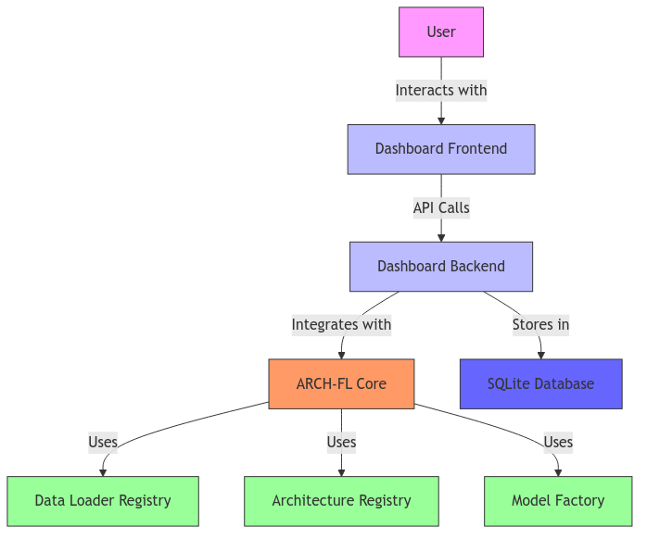Figure 1: High-Level Architecture

4.3.1 High-Level Architecture

4.3.2 Low level architecture

4.3.2 Component Diagram

4.4 Context level diagram
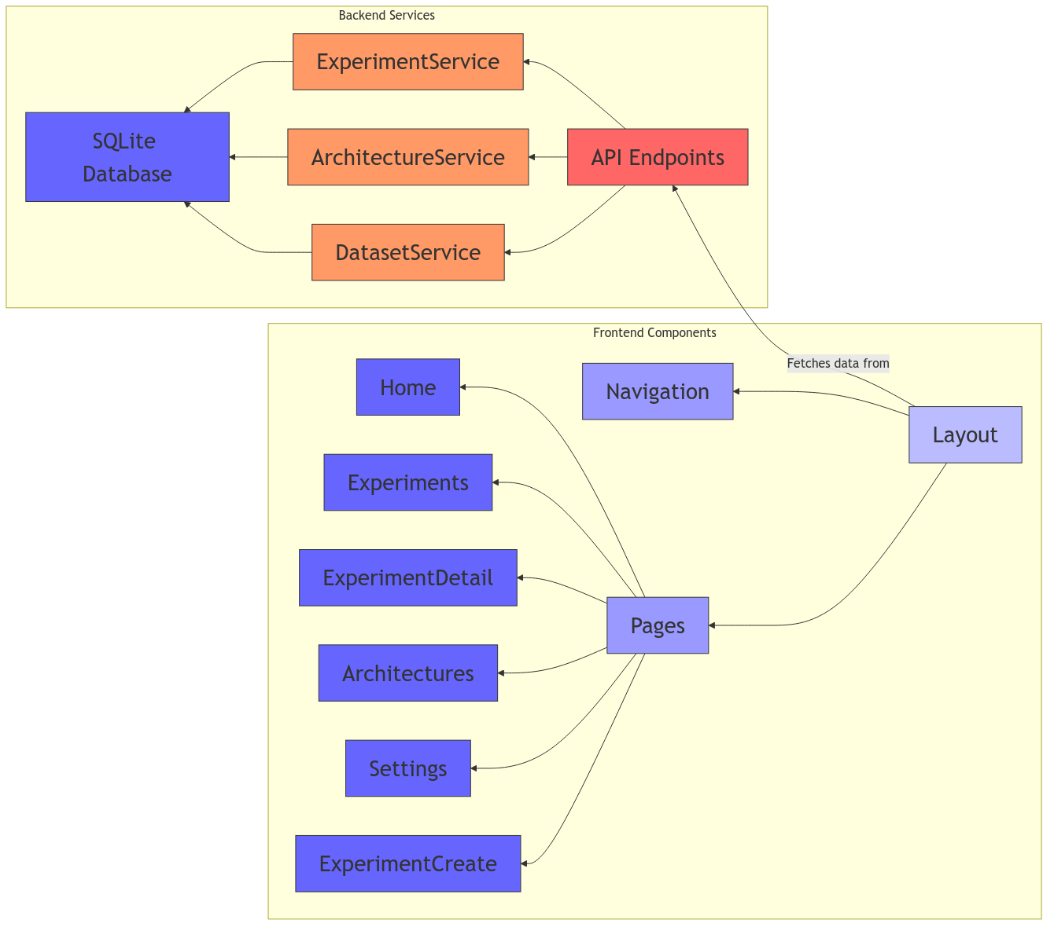Figure 1: Component Diagram
The context level diagram illustrates how the ARCH-FL Dashboard interacts with external entities and systems:
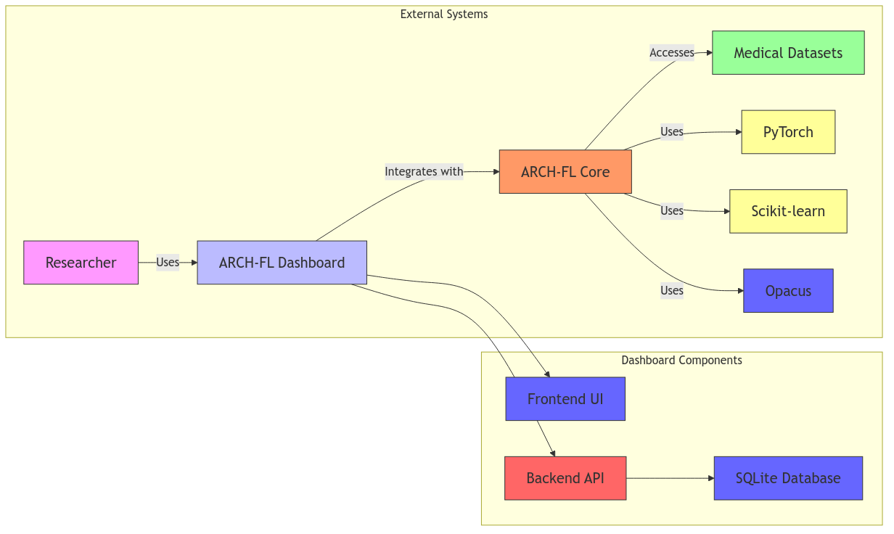Figure 2: Context Level Diagram

4.5 Input design

4.5.1 User Input Forms
The dashboard provides several input forms for experiment configuration:
Experiment Creation Form:
- Fields: Experiment name, description, dataset selection, architecture selection
- Validation: Required fields marked with asterisks, real-time validation
- Input Types: Text input, dropdown selects, radio buttons
Experiment Configuration Form:
- Fields: Number of clients (2-20), data distribution (IID/Non-IID), training epochs (1-100), batch size (8-256), learning rate (0.0001-0.1)
- Validation: Range validation, numeric input constraints
- Input Types: Number inputs, radio buttons, sliders
User Settings Form:
- Fields: Theme selection (light/dark), notification preferences, auto-refresh settings, default values
- Validation: None required, all optional
- Input Types: Radio buttons, checkboxes, number inputs

4.5.2 Input Validation
The system implements comprehensive input validation:
- Client-Side Validation:
  - Required field validation
  - Data type validation
  - Range validation for numeric inputs
  - Real-time feedback with error messages
- Server-Side Validation:
  - Pydantic model validation for API requests
  - Database constraint validation
  - Security validation (input sanitization)
- Error Handling:
  - Clear error messages with specific guidance
  - Visual indicators for invalid fields
  - Graceful degradation for failed operations

4.5.3 Example Input Screens
Experiment Creation - Step 1 (Basic Info):
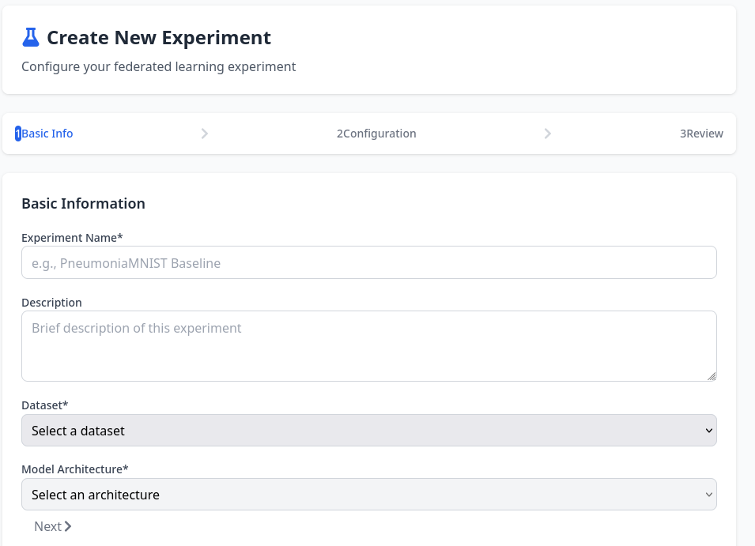
Experiment Creation — Step 2 (Configuration):
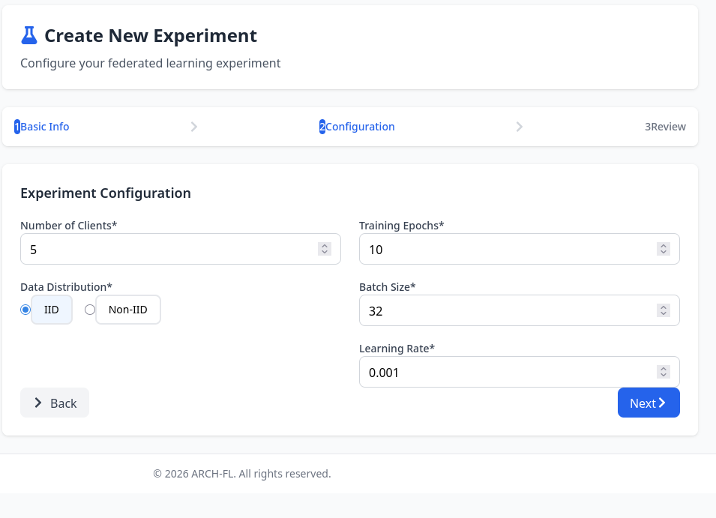

4.6 Process design

4.6.1 Experiment Creation Process
Figure 1: Experiemnt Creation Workflow

4.6.2 Data Flow Process
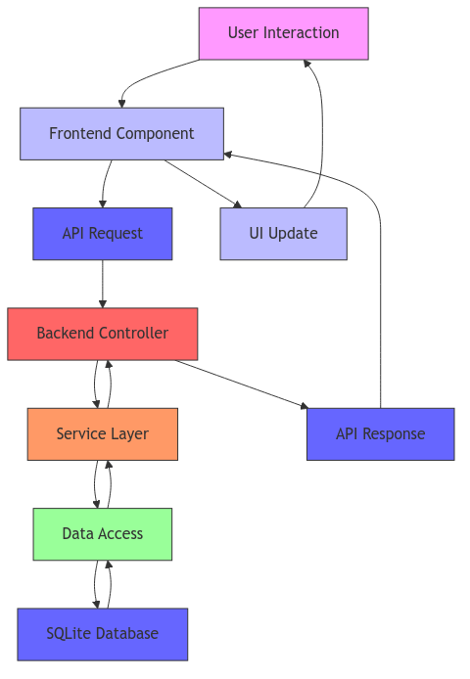

4.6.3 Error Handling Process
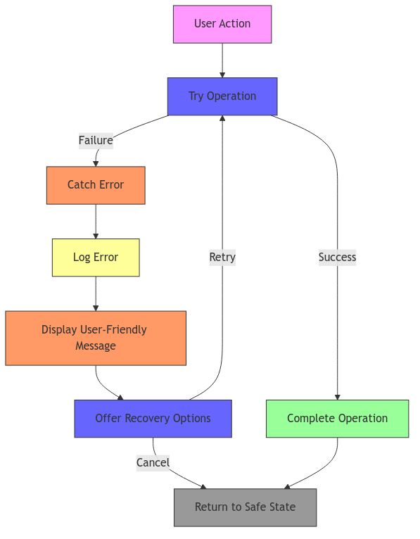Figure 1: Error Handling Process

4.7 Database design

4.7.1 Entity-Relationship Diagram
The dashboard uses a SQLite database with the following schema:
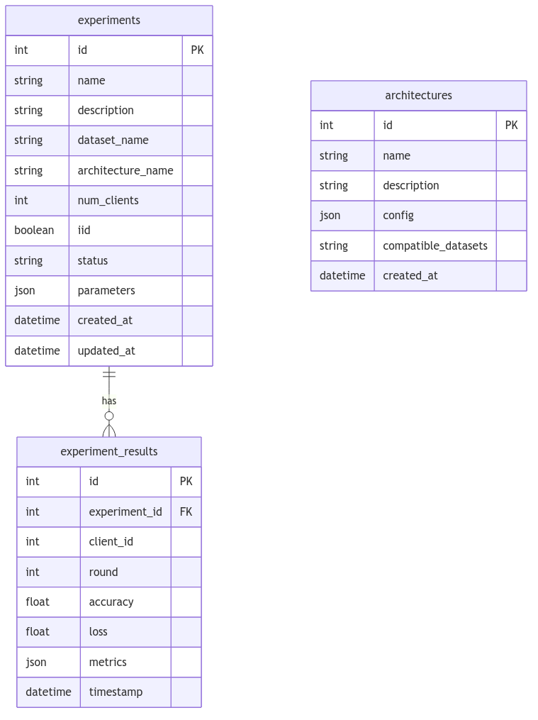Figure 1: Entity-Relationship Diagram

4.7.2 Database Schema SQL

4.8 Output design

4.9 Chapter conclusion

References
Irvin, J., Rajpurkar, P., Ko, M., Yu, Y., Ciurea-Ilcus, S., Chute, C., ... & Ng, A. Y. (2019). CheXpert: A large chest radiograph dataset with uncertainty labels and expert comparison. Proceedings of the AAAI Conference on Artificial Intelligence, 33, 590–597.
Johnson, A. E., Pollard, T. J., Berkowitz, S. J., Greenbaum, N. R., Lungren, M. P., Deng, C. Y., ... & Horng, S. (2019). MIMIC-CXR, a de-identified publicly available database of chest radiographs with free-text reports. Scientific Data, 6(1), 317.
Kothari, C. R. (2019). Research Methodology: Methods and Techniques (4th ed.). New Age International.
Sommerville, I. (2016). Software Engineering (10th ed.). Pearson.
Wohlin, C., Runeson, P., Höst, M., Ohlsson, M. C., Regnell, B., & Wesslén, A. (2012). Experimentation in Software Engineering. Springer.

Appendices
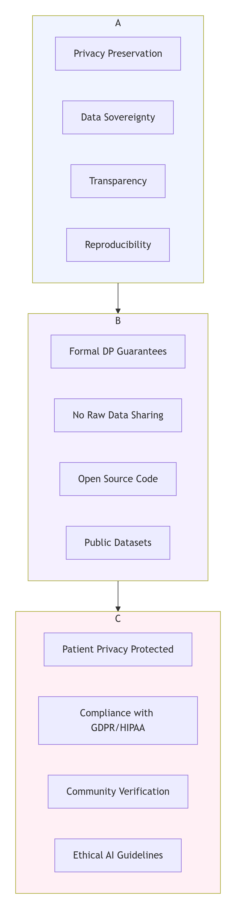Figure 1: Ethical Consideration Framework
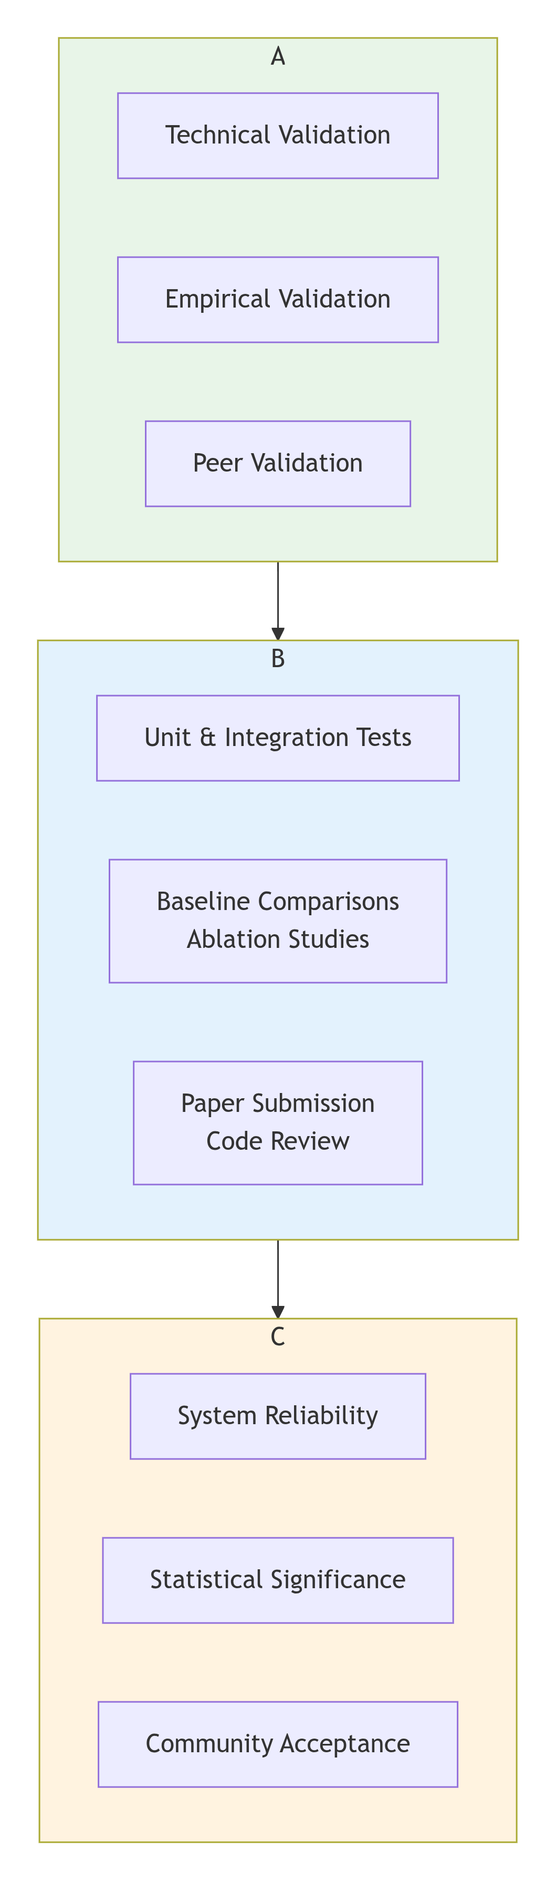Figure 2: Validation Approach

