# **Dynamic PKI-Enabled File Encryption System**

## **Overview**

This project implements a 1. **PKI -> Public Key infrastructure** 2. **PKI-enabled file encryption and decryption system** with automated directory monitoring and **file sharing** capabilities. The system is designed to facilitate secure file sharing, authentication, and encryption in a networked environment, using certificates issued by a Root CA and signed by an Intermediate CA.

## **Features**

1. **PKI Framework**:
   * Root CA initializes the chain of trust and generates Intermediate CA credentials.
   * Intermediate CA acts as the signing authority for host certificates.
2. **Host Certificates**:
   * Hosts generate unique certificate signing requests (CSRs) and obtain signed certificates from the Intermediate CA.
   * Signed certificates are installed with the Intermediate CA and Root CA certificates to complete the chain of trust.
3. **File Encryption and Decryption**:
   * Encrypts files dynamically using public keys from a shared public key store.
   * Decrypts encrypted files when accessed and re-encrypts them after closure.
4. **File Sharing**:
   * Hosts can share files over the network using a lightweight file-sharing server.
   * Includes support for file uploads and downloads within the same network.

## **Setup Instructions**

### **1. Root CA Setup**

#### **Files and Structure**

* All files outside the users@hosts directory belong to the Root CA.

#### **Steps**

1. Transfer the Root CA files to the server machine (Windows/Linux).
2. Install the required libraries:

* python -m pip install -r requirements.txt
* or simply:
* pip install -r requirements.txt

1. Initialize the Root CA:

* python AutoRootCA_PKI.py

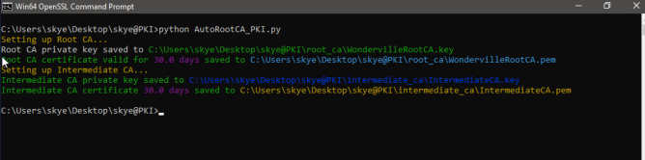Illustration 1:

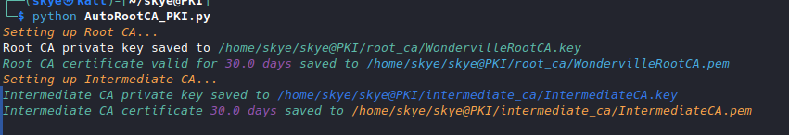Illustration 2:

* This script generates the Root CA keys and sets up the Intermediate CA.

1. Start the Intermediate CA server:

* python WIN-N55Q3T15CyEL4_server.py

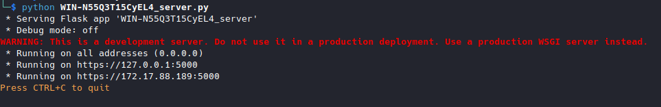Illustration 3:

* or :
* gunicorn -c gunicorn.conf.py WIN-N55Q3T15CyEL4_server:app

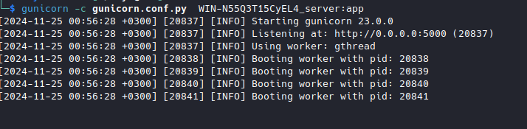Illustration 4:

* + This starts a PKI server where hosts/users can connect to obtain, sign, or update their certificates.

### **2. Host/User Setup**

#### **Files and Structure**

* Host assets are located in the users@hosts directory.
* These files should be transferred to the user’s computer for local operations.

#### **Steps**

1. Transfer the host files to the user’s computer.
2. Install the required libraries:

* python -m pip install -r requirements.txt
* or simply:
* pip install -r requirements.txt

1. You need to install openssl and add it to system path
   1. On windows Run: python opensslSetup.py located in the [user@host](mailto:user@host) folder
   2. Or manualy download and install the executable (You can find it in the user@host/src folder
2. Generate Certificates:
   * python AutoCertsGen.py

## **Require Administrator(Root) privileges see:**

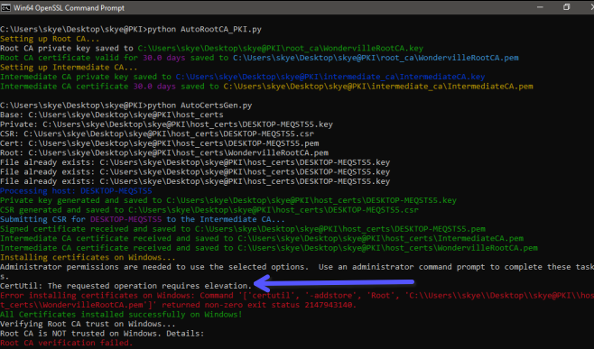Illustration 5:

* + This script generates the host’s unique certificate and requests signing from the Intermediate CA.
  + The Intermediate CA:
    - Signs the certificate.
    - Provides its own certificate and that of the Root CA.
  + These certificates are installed locally, completing the chain of trust.

1. Verify Certificates:

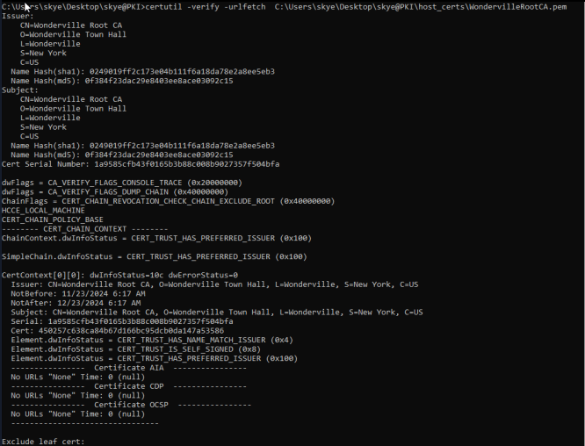Illustration 6:

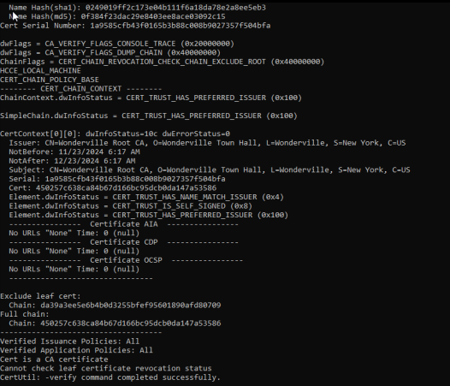Illustration 7:

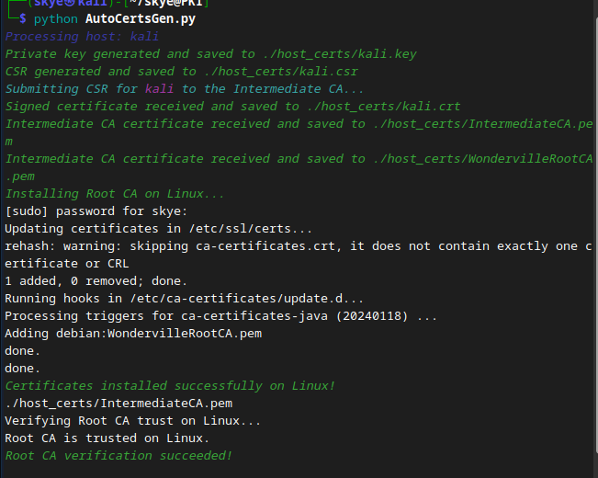Illustration 8:

* + Once installed, the host verifies the authenticity of the Intermediate CA certificate.

### **3. File Sharing**

#### **Steps**

1. Start the File Sharing Server:

gunicorn -c gunicorn.conf.py FileShareProServer:app

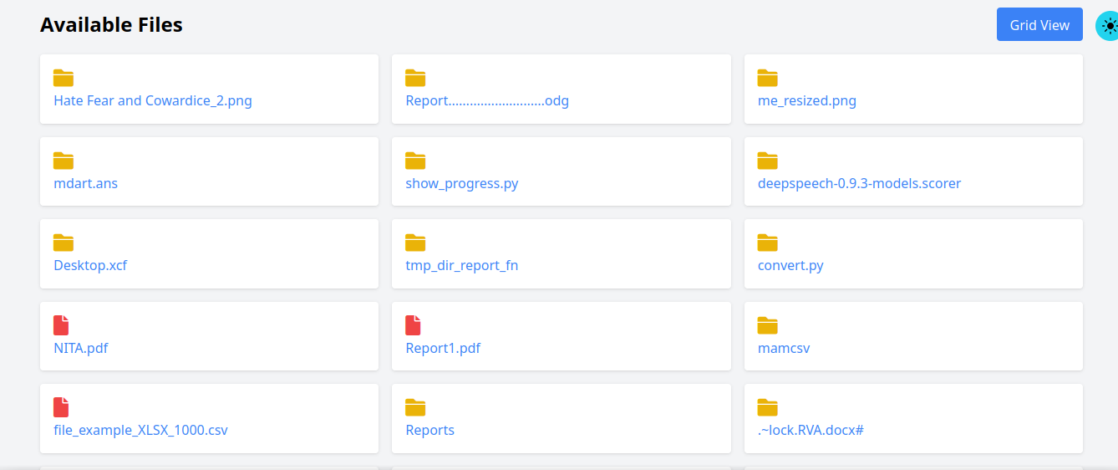Illustration 9:

* python FileShareProServer.py **NOT RECOMMENDED but still works fine**

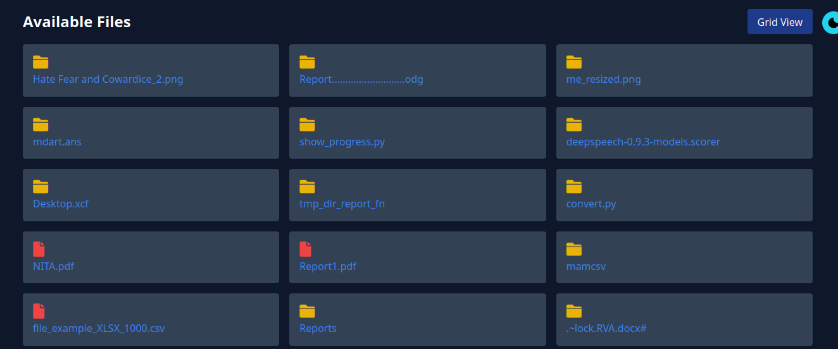Illustration 10:

* + This file is located in the App directory.

1. Configure the Server:
   * Open the .ini file and:
     + Set up folder-sharing options.
     + Define the download location.
2. Access the File Sharing Server:
   * Members of the same network can:
     + Access the server using its IP address.
     + Download files directly.
     + Upload files to the host.

## **Advanced Usage**

### **File Encryption and Decryption(Experimental)**

**-----------------------------------------------------------------------------------------------------------------------------**

**==========================CAREFUL BELOW===========================**

**-----------------------------------------------------------------------------------------------------------------------------**

1. **Encrypt Files**:
   * Automatically encrypts files in the monitored directory.
   * Uses the recipient’s public key, fetched dynamically from the public key store.
2. **Decrypt Files**:
   * Decrypts files when accessed, saving a temporary plaintext version.
   * Opens the decrypted file using the system’s default application.
   * Re-encrypts the file after closure.
3. **File Monitoring**:
   * Uses the watchdog library to monitor file creation and modification events.

### **Public Key Store**

* The public key store (PUBLIC_KEY_STORE) contains public keys for all machines in the network.
* Public keys are named after their respective machine identities (e.g., machine_name.pem).

## **Directory Monitoring Setup**

### **Configuration**

Edit the following variables in the script as needed: - **WATCHED_DIR**: - Path to the monitored directory (e.g., /mnt/shared_folder or \\server_ip\shared_folder). - **PUBLIC_KEY_STORE**: - Path to the directory containing public keys. - **PRIVATE_KEY_PATH**: - Path to the host’s private key file. - **ENCRYPTED_EXTENSION**: - File extension for encrypted files (default: .enc).

### **Run the Script**

1. Mount the shared folder:
   * **Unix/Linux**:
   * sudo mount -t cifs -o username=<username>,password=<password> //<server>/<shared_folder> /mnt/shared_folder
   * **Windows**:
   * net use X: \\<server>\<shared_folder> /user:<username> <password>
2. Start monitoring:

* python PKI_crypto.py monitor

## **Logging**

### **Log File**

* All activities are logged in file_activity.log:
  + Encryption and decryption events.
  + Errors and warnings.

### **Sample Log Output**

2024-11-23 14:10:00 - INFO - Watching directory: /mnt/shared_folder  
2024-11-23 14:12:01 - INFO - File encrypted: /mnt/shared_folder/document.txt.enc  
2024-11-23 14:14:45 - INFO - Decrypted file saved temporarily at /tmp/document.txt  
2024-11-23 14:15:12 - INFO - Temporary file /tmp/document.txt deleted securely.  
2024-11-23 14:15:13 - INFO - File encrypted: /mnt/shared_folder/document.txt.enc

## **Troubleshooting**

### **File Not Encrypted**

* Ensure the file doesn’t already have the .enc extension.
* Verify the public key exists in the PUBLIC_KEY_STORE.

### **Certificate Issues**

* Verify the chain of trust by checking the Root CA and Intermediate CA certificates.
* Ensure the Intermediate CA server is running and accessible.

### **Shared Folder Not Accessible**

* Check network connectivity and permissions.
* Ensure the shared folder is mounted properly.

## **Future Improvements**

1. **Key Management**:
   * Automate updates to the public key store via an API or centralized server.
2. **Access Control**:
   * Implement authentication for shared folder access.
   * Restrict decryption based on roles.
3. **File Integrity**:
   * Add digital signatures to verify file authenticity before decryption.
4. **GUI**:
   * Develop a graphical interface for easier management of encryption and file sharing.

## **Contributors**

* **[Wambua]** – Project Lead [Follow Me on github](https://github.com/skye-cyber)
* Interrested in encryption -> <https://github.com/skye-cyber/EncryptsionSuite>