**1. Inspect the digital brain phantom**

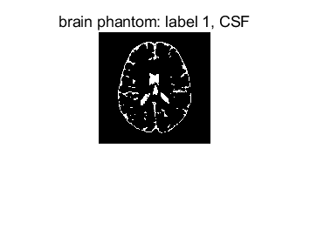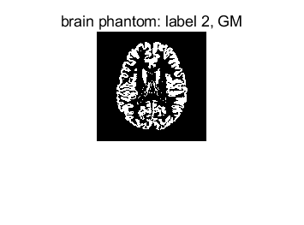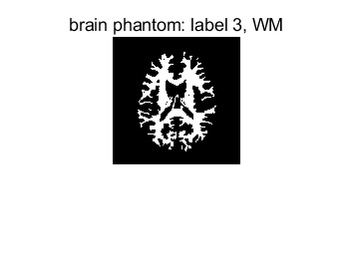

T1 CSF = 2569ms

T2 CSF = 329ms

SD CSF = 1

T1 GM = 833ms

T2 GM = 83ms

SD GM = 0.86

T1 WM = 500ms

T2 WM = 70ms

SD WM = 0.77

**2.Simulate MR image contrast from pulse sequences**

**2.1.Spin Echo Proton density weighted (PDw):**

The table below is the definition of various contrast weighting.

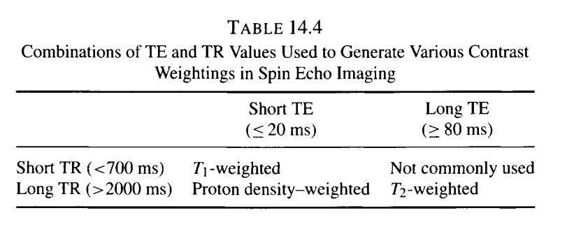

The results are as follow:

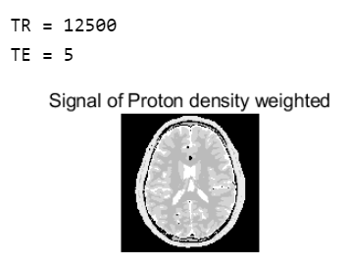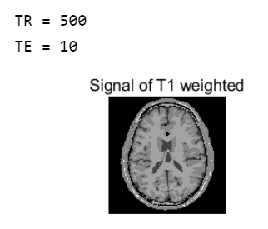

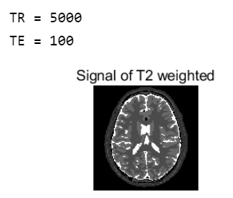

**2.2 FLAIR sequence:**

TI =log(2)*T1_csf. This is T2-weighted-FLAIR. The definition of parameters and the image are as follow.

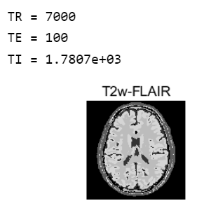

**2.3 MPRAGE**

The detailed initialization refer to the code below.

Use the signal function of MPRAGE to calculate:



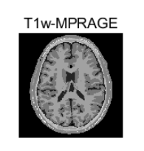

**3.1 Add noise to the simulated data**

1). calculate the variance of noise according to the definition of SNR

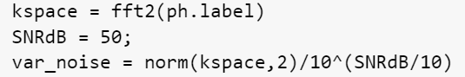

2). create nois_ kspace and add to kspace



3). inverse fft



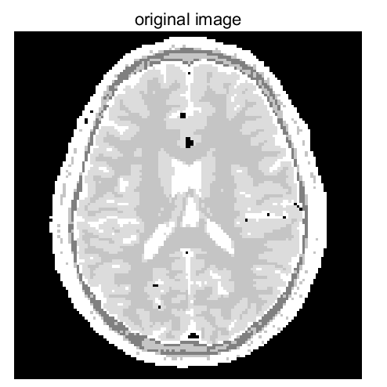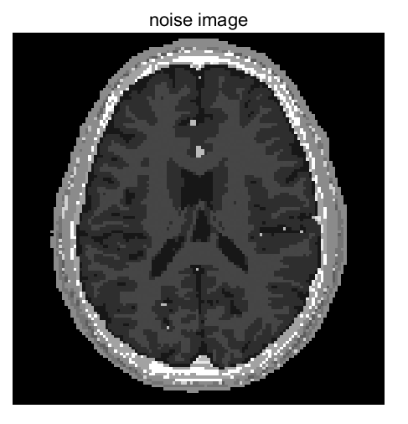

**3.2 T2 mapping for CSF, GM and WM**

**3.2.1 TE is 11. The more TE, the more precise the fitting function is.**

The fitting result is as followed. T2 is the x value, mapping to 63% of the maximal y value.

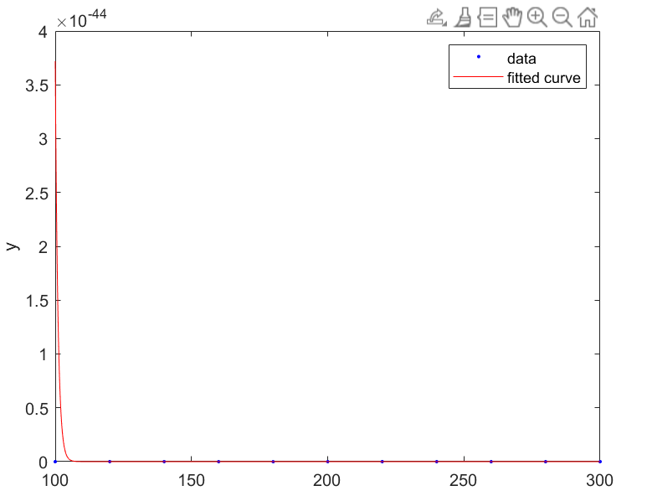

**Appendix: code**

