**Computational MR imaging**

**Lecture 1: Fundamentals of Magnetic Resonance Imaging**

**Nan Lan**

**1. Load and show phantom**

**1.1 regions**

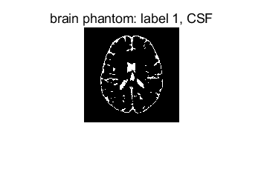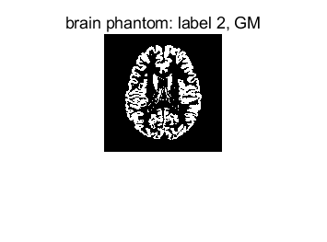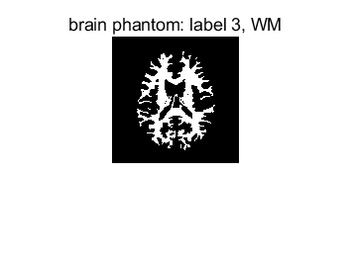

**1.2 T1, T2 and SD values**

T1 CSF = 2569ms

T2 CSF = 329ms

SD CSF = 1

T1 GM = 833ms

T2 GM = 83ms

SD GM = 0.86

T1 WM = 500ms

T2 WM = 70ms

SD WM = 0.77

**2.Simulate MR image contrast from pulse sequences**

**2.1.Spin Echo Proton density weighted (PDw):**

The table below is the definition of various contrast weighting.

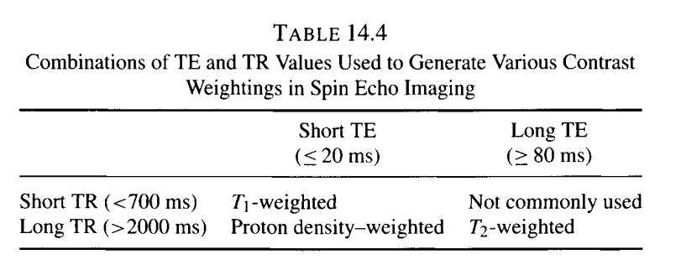

The whole task is implemented based on Spin Echo Sequence, the signal equation is:

***s = M0 * (1-2e-(TR-TE/2)/T1) + e-(TR/T1)) * e-TE/T2***

The results are as follow:

For PD weighting, we need long TR and short TE

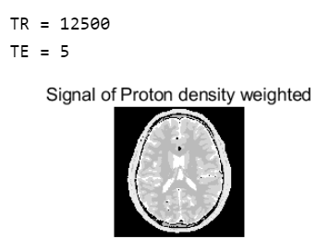

For T1 weighting, we need short TR and short TE,

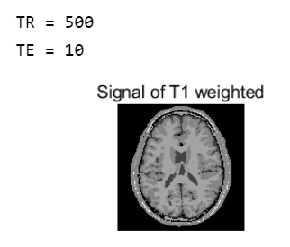

For T2 weighting, we need long TR and long TE,

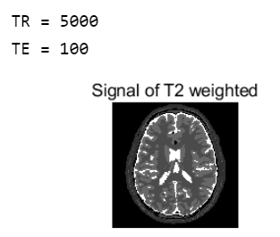

**Conclusion**:

The echo time (**TE**) represents the time from the center of the RF-pulse to the center of the echo.

The repetition time (**TR**) is the length of time between corresponding consecutive points on a repeating series of pulses and echoes.

**A**. by PD weighting, the repetition time is long enough so the magnitude of all the tissues could aligned对齐 again with the main field B0, and also because the echo time is short enough, so that the transversal magnitude almost didn’t reduce. Signal now only depends on the proton density of different tissue, thus CSF with SD of 1.0 is brightest and White matter with 0.75 is the darkest.

**B**. by T1 weighting, echo time is short enough to avoid reduction but the repetition time is also short, so the signal is major depends on the T1 time of different tissue, thus white matter with T1 of 500ms is brightest, and CSF with 2569ms is darkest.

**C**. by T2 weighting, repetition time is long enough for recovery of the longitudinal magnitude, but the echo time is also too long so that the transversal magnitude would reduce differently due to different T2. the signal is major depends on the T2. Thus CSF with 329ms is the brightest and white matter with 70ms is darkest.

**2.2 FLAIR sequence:**

Also based on Spin Echo, but add a extra 180 inversion pulse to totally chancel out the signal of fluid. Inversion time TI =log(2)*T1_csf. This is T2-weighted-FLAIR. The definition of parameters and the image are as follow.

Conclusion: The signal of CSF is totally suppressed, so it shows totally dark in the image

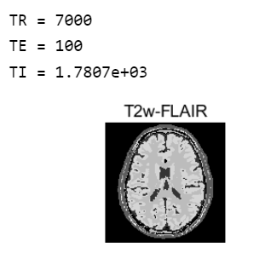

**2.3 MPRAGE**

The detailed initialization refer to the code below.

Use the signal function of MPRAGE to calculate:



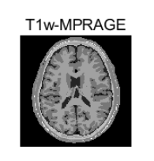

**3.1 Add noise to the simulated data**

1). calculate the variance of noise according to the definition of SNR

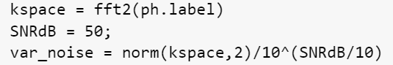

2). create nois_ kspace and add to kspace



3). inverse fft



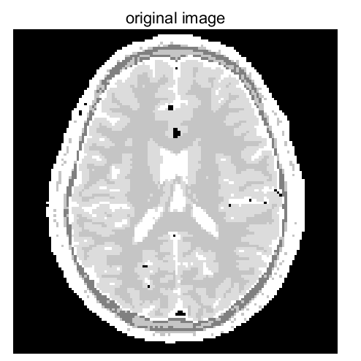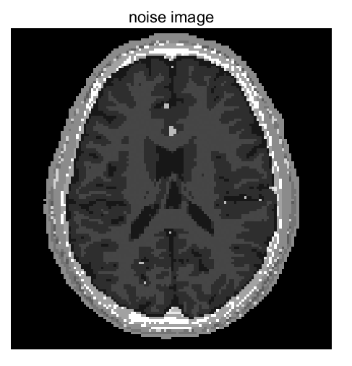

**3.2 T2 mapping for CSF, GM and WM**

**3.2.1 TE is 11. The more TE, the more precise the fitting function is.**

The fitting result is as followed. T2 is the x value, mapping to 63% of the maximal y value.

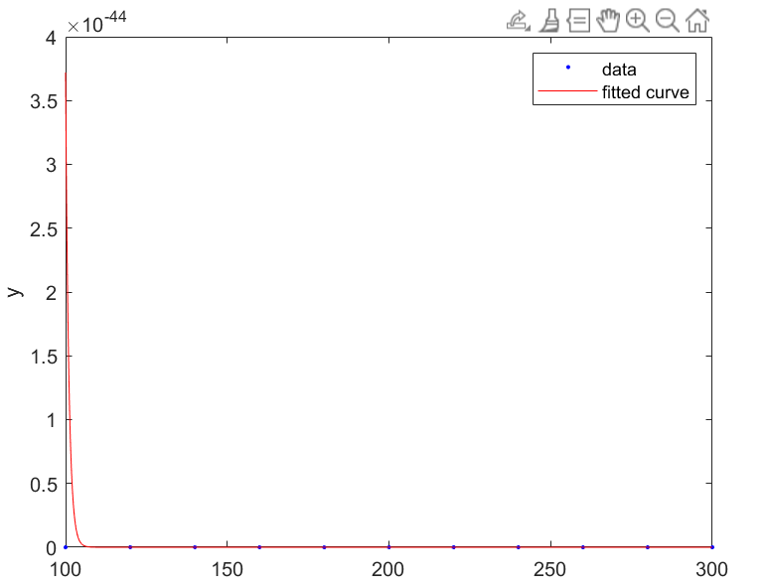

**3.2 spin echo sequence with multiple TEs for T2-mapping**

1). Why it is a good choice? Because it could be much more faster than SE-SE.

2). How many TEs? 9-15 , so we can fit a good curve for T2

3). Different or same sequence parameters for all three tissues?

Different:

+: set the TE accordingly, so we can analysis even the different region of one tissue to find the unusual

-: need to do the scan multiple time for different tissue

Same:

+: with one time scan we can approximately get the T2 mapping of every tissue , but not the fine details

-: can only determinate the T2 difference between different tissue but not the fine difference within the tissue, which is the most important information we want to gain during T2-mapping.

4). Use the signal either from region or pixel?

Region: faster, but only T2 for different tissue, no fine details

Pixels: slower, but can lead us to find location of potential lesions in the tissue (normally has unusual T2)

**Appendix: code**

