**Computational MR imaging**

**Laboratory 3: Partial Fourier imaging**

**Nan Lan**

1. **Hermitian symmetry reconstructed image**

What’s **Partial Fourier imaging** :

Partial Fourier imaging are reconstruction methods in which data from as little as one-half of k-space is used to generate an entire MR image

What’s **Hermitian symmetry**:

Provided no phase errors occur during data collection, k-space possesses a peculiar mirrored property known as Hermitian symmetry.

Conjugate symmetry applies to pairs of points (like P and Q) that are located diagonally from each other across the origin of k-space. If the data at P is the complex number [a+bi], the data at Q is immediately known to be P's complex conjugate, [a−bi].

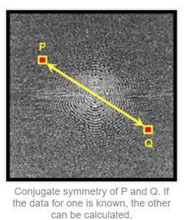

Use the Hermitian symmetry to estimate the zero_padding part of original kspace.

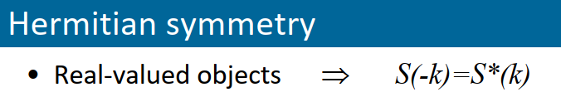

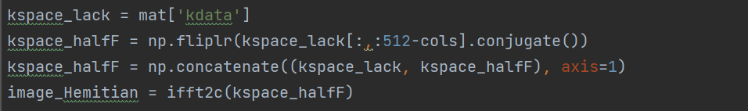

The result below shows the PatialFourier=9/16 image and the Hermitian symmetry reconstructed image. The right image is less blurry than the left one. But Hermitian symmetry reconstructed image has obvious ringing artifact at the edge and in the center. The reason is that the condition of Hermitian symmetry is value in the image ought to be pure real, which means there should have no phase errors.

In fact, all image data sets contain some phase errors, and therefore the conjugate symmetry approximations are not perfect. The sources of these phase errors include the usual "posibilities": Bo inhomogeneity, susceptibility effects, eddy currents, object motion and so on.

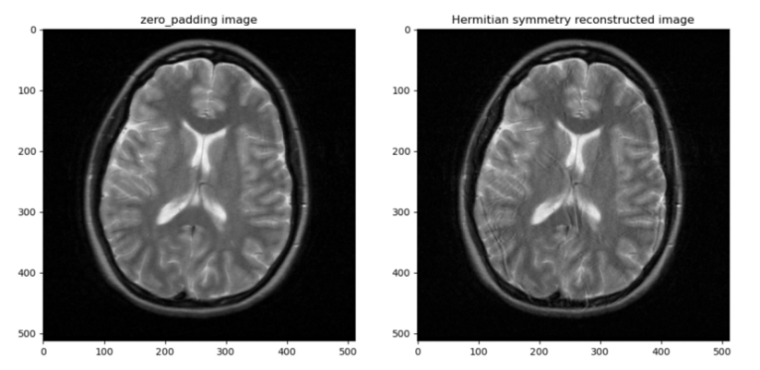

1. **Process of Phase estimation from center kspace**

Why phase estimation: object has phase error inpractice.

How to: measure more k-space samples, estimate the phase and reconstruct the magnitude image

1. Crop the center kspace and zero pad



1. Create the hamming window and zero pad



1. Use the filtered center space to estimate the phase



The result below shows the zero padding kspace with logirithm and the 2D hamming window.

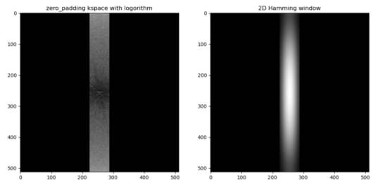

The result below is the phase estimation from the center kspace after filtering by 2D hamming window.

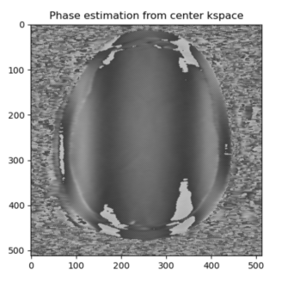

1. **Process of Margosian method**

The principle of margosian method is as followed: The left part is phase elimination.

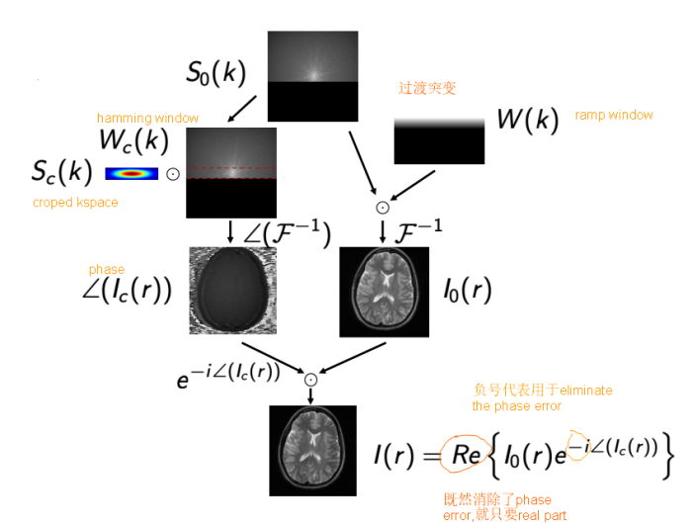

1. Create ramp filter with the size of (512,64)

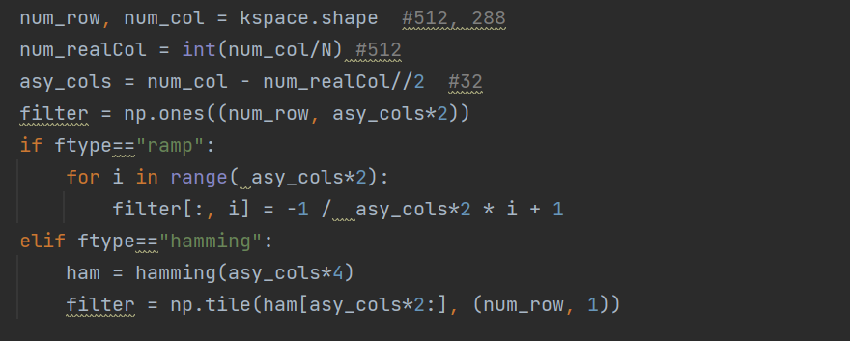

1. Use ramp filter to smooth the transition between kspace and zero padding parts, so as to reduce Gibbs ring artifact. Obtain I0(r) now (I0(r): zero-filled FT reconstruction of the filtered k-space data).

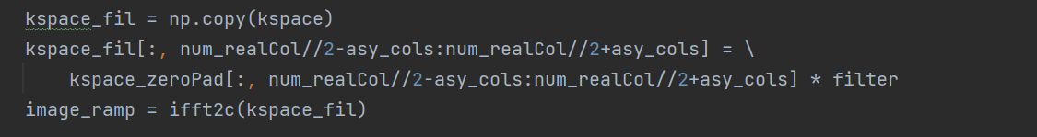

3) Estimate phase(∠Ic(r)) and use hamming window(wc(k)) of corresponding size to smooth the transaction.



4) Eliminate the phase error exp(**-**∠Ic(r)) and reconstruct image with magnitude part based on Margosian method. Obtain the phase corrected image



1. **Process of POCS method**

The principle of POCS is as followed:

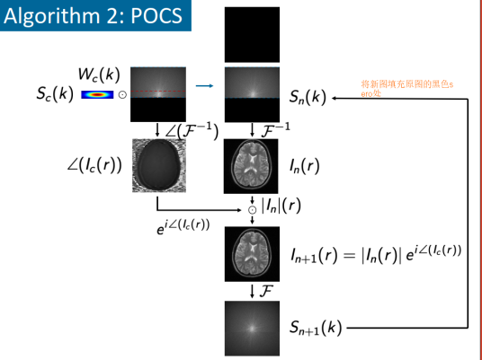

1. Initialize and use ifft to obtain the zero_padding image In(r)

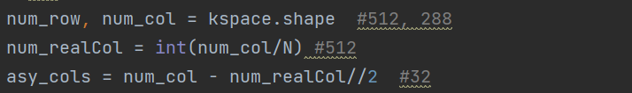

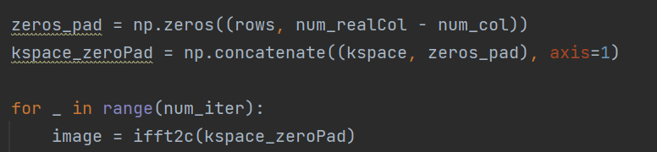

1. Reconstruct image with phase part and magnitude of zero_padding image In+1(r)



1. Use fft to obtain the new kspace



1. Fill the zero padding part in orignal kspace with the corresponding part of new kspace, and go to step1



The code below is the whole process:

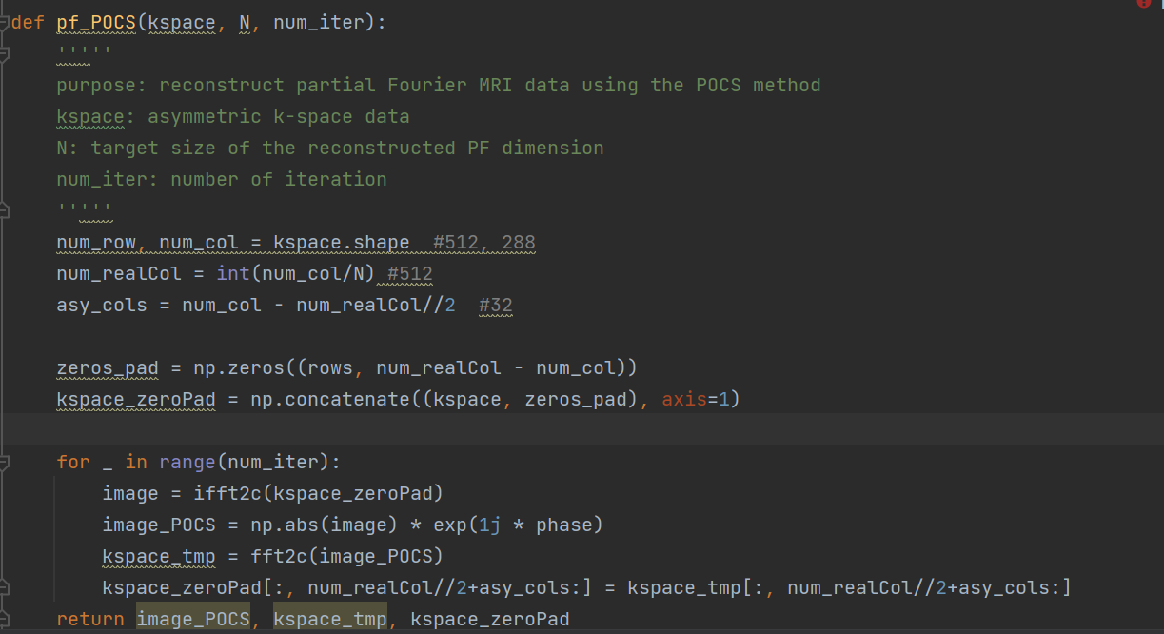

The pictures below are the reconstructed image from POCS , the given kspace and the reconstructed kspace where the right part of given kspace is filled by the estimated kspace.

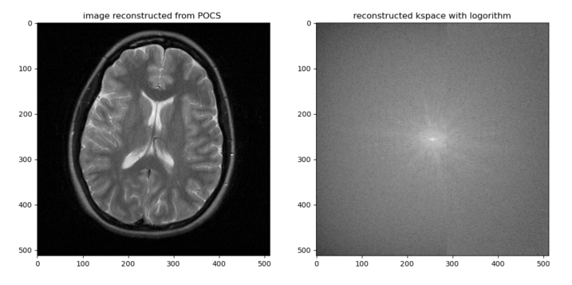

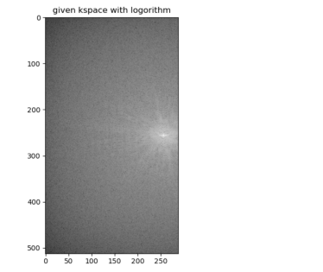

1. **Result of Margosian method**

The result below shows the result of margosian method.

Compared withe zero-padding image, the reconstructed image from Margosian has higher spatial resolution but also stronger gibbs ring.

There are no big differences between Margosian(ramp) and Margosian(hamming)

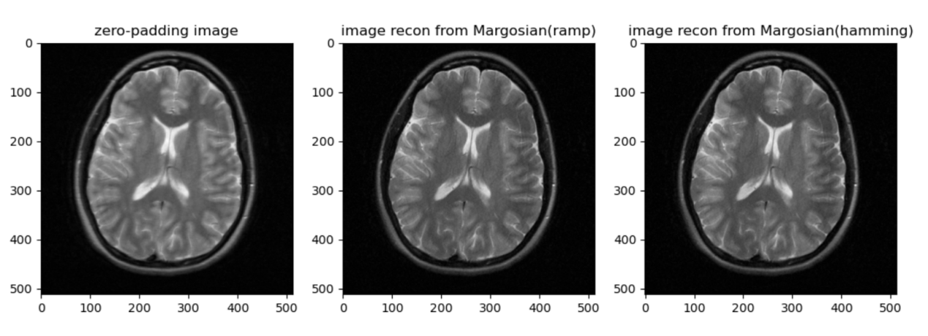

1. **Different iteration of POCS Method**

The result below shows Different iteration of POCS Method. The large the the iteration number is, the less blurry the reconstructed image is. When the iteration number reach 6, the the algorithm has converged, because the upcoming reconstructed image doesn’t change much.

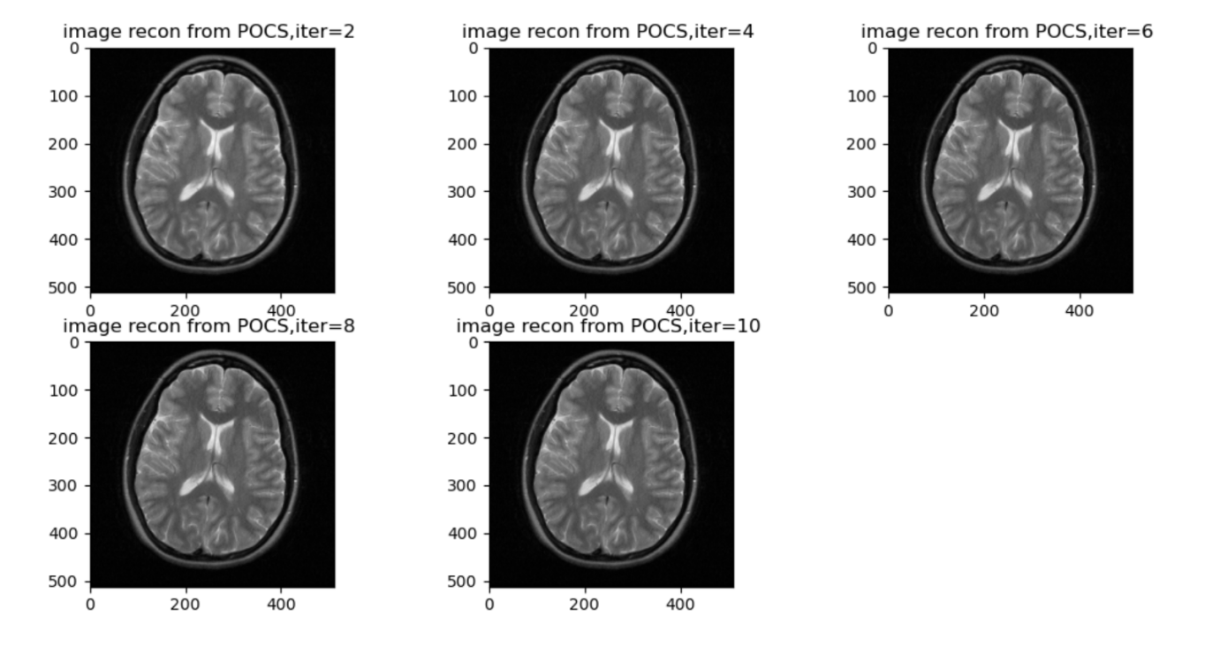

1. **Hermitian, Margosian, POCS methods comparison**

The result below shows the reconstruted image from Original, Hermitian, Margosian(ramp), Margosian(hamming), POCS methods.

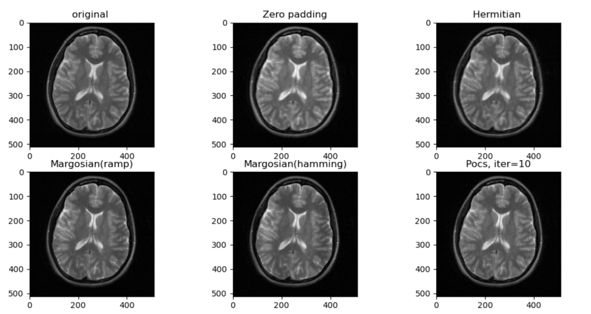

Now we compare these different methods in terms of SNR, spatial resolution, residual artifacts and ringing

**SNR**: The POCS and Margosian methods have lower SNR. Take the definition of SNR for partial Fourier MRI (refer to the image below). R = 16/9 in our example is larger than 1, so 1/sqrt(R) would be less than 1. SNR loss of partial Fourier close to square root of 2

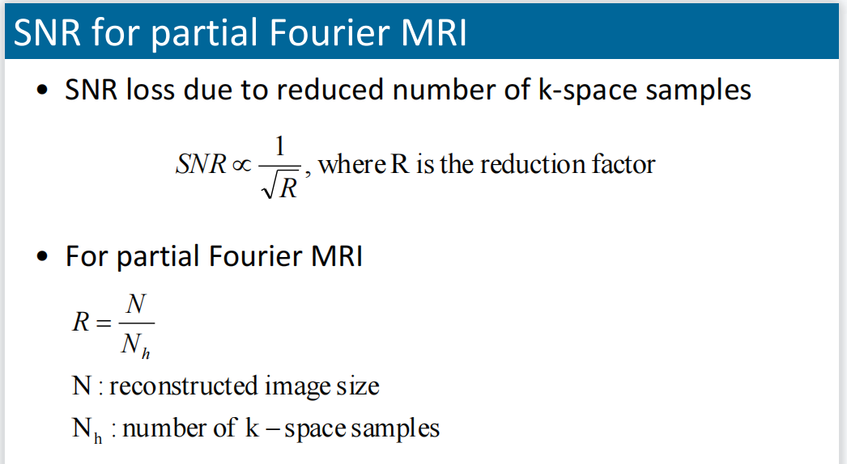

Source: computer MRI slice

**Spacial resolution**: The POCS and Margosian methods can get the better reconstructed image than Hermitian method. POCS method has higher spacial resolution than Margosian method, because it estimate the not only the phase but the zero part of kspace.

**Residual Artifact:** The result below shows the residual artifact which is calculated by: the magnitude of reconstruted image minus the magnitude of original image.

POCS method can help to reduce the residual artifact.

Residual artifact from margosian looks like a image, because the image from margosian algorithm has only real part but the original image has both real and imaginary parts. Actually the residual artifact from margosian is not supposed to be like this.

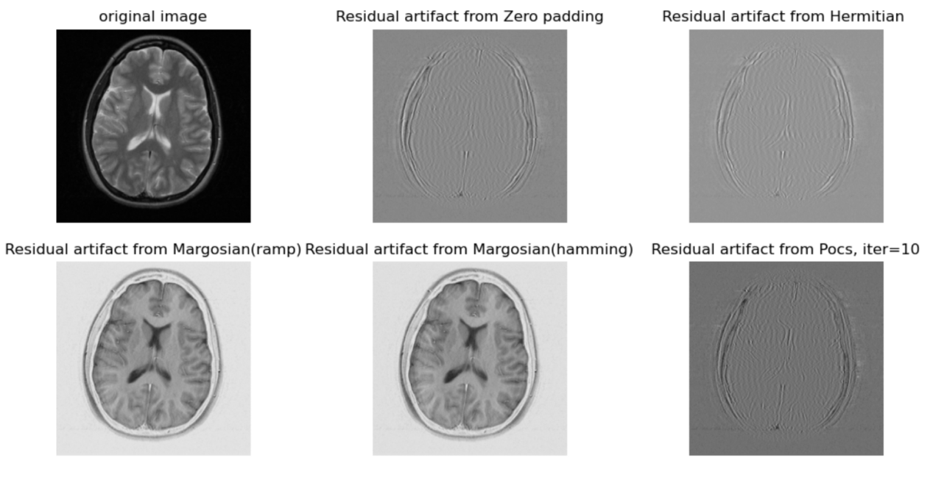

**Ringing**: Hermisian will lead to stronger gibbs ringing than the POCS method and Margosian. The reason is that the condition of Hermitian symmetry is value in the image ought to be pure real, which means there should have no phase errors. For detailed explaination, please refer to question2.