**Computational MR imaging**

**Laboratory 5: Image space parallel imaging**

**Nan Lan**

1. **Multicoil combination**
2. **Multicoil combination algotrithms**

The results below shows MRI coil images from 8 coils.

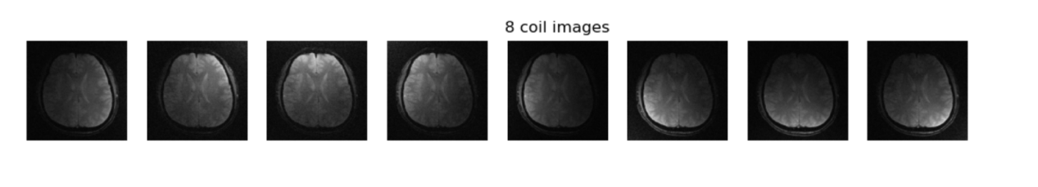

The results below shows outputs of different Multicoil combination algotrithms.

Due to the phase cancellation in ‘’Complex sum’’, the result is quite noisy.

The images reconstructed from ‘’Sum of square’’ and ‘’matched filter’’ are clear and similar.

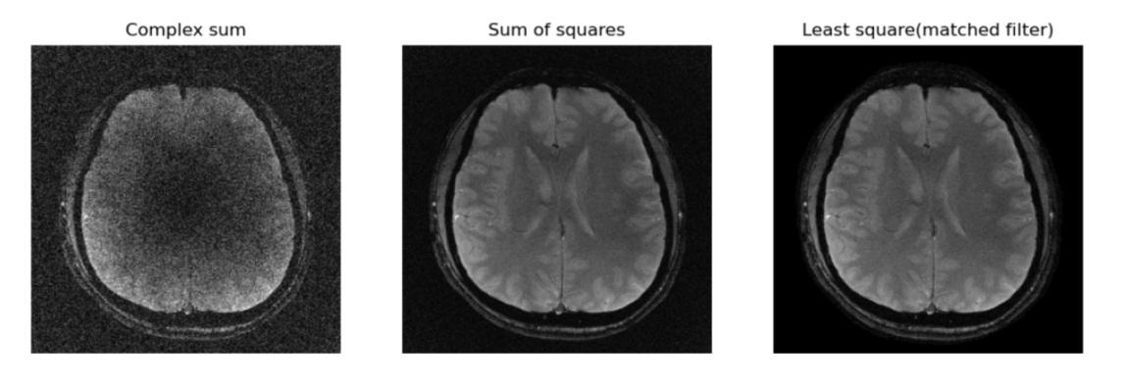

**The process of complex sum is as follow:**

Sum up all the pixel along the coil direction.

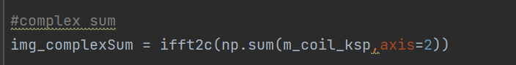

**The process of sum of square is as follow:**

Use L2-norm along coil direction to combine the coil images.

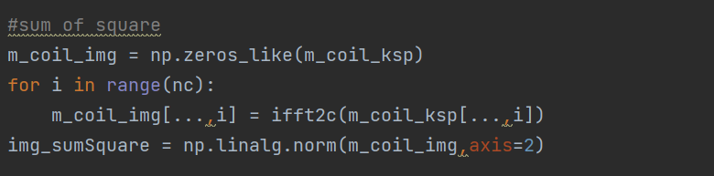

**The process of match filter is as follow:**

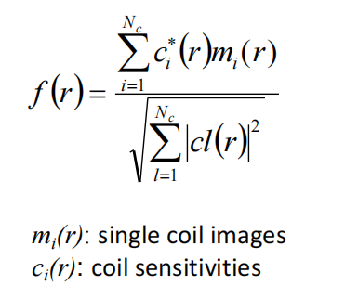

Use the equation above to combine the coil image, also along the coil direction.

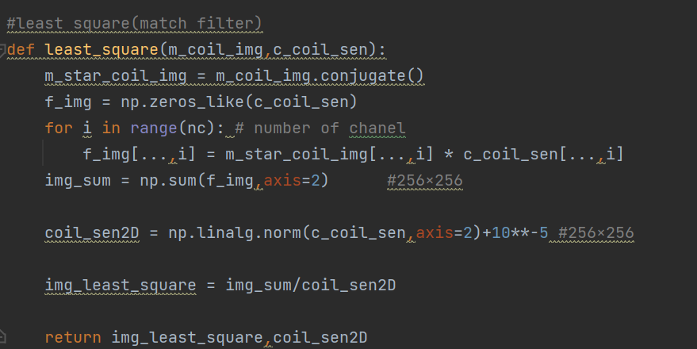

1. **Coil noise covariance matrix**

The results below shows the effect of coil noise covariance matrix.

The correction of coil noise covariance matrix doesn’t have much effect on the recontructed image.

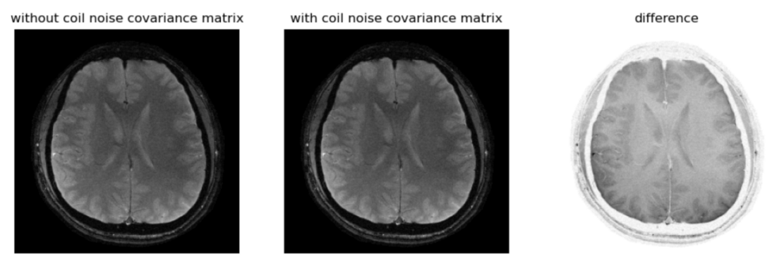

**The process of the Coil noise covariance matrix is as follow:**

1. Calculate the half inverse of the coil noise covariance matrix Ψ-½

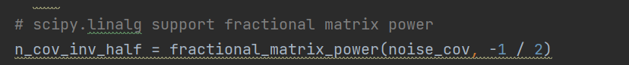

1. Pre-whitening: correct coil img and coil sensitivity with half inverse of noise covariance matrix, based on the equation below.

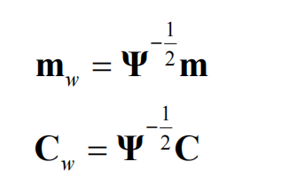

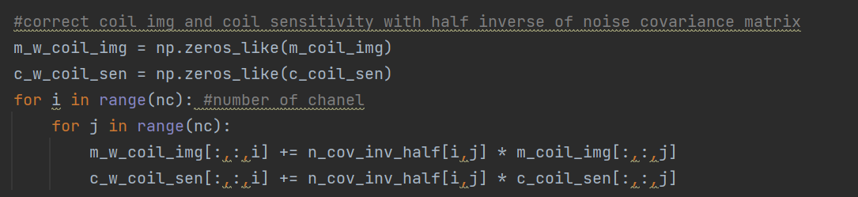

1. The same step as matched filter algorithm.

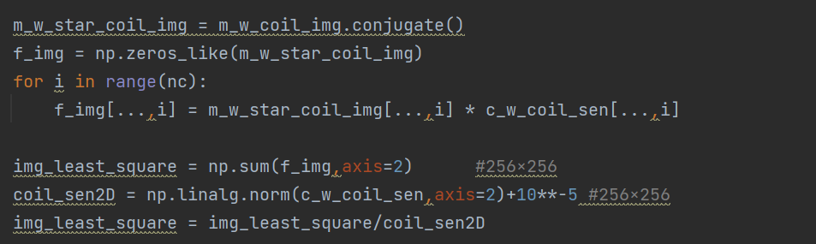

1. **Cartesian SENSE reconstruction and g-factor**
2. **SENSE algorithm**

The results below shows MRI coil alias images from 8 coils, with g-factor of 2.

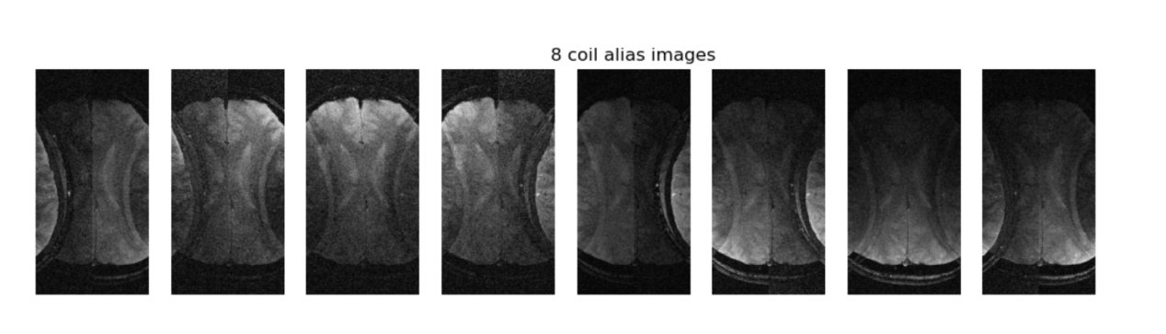

The results below shows outputs of SENSE algorithm, with different accelaration factor(R=2,3,4).

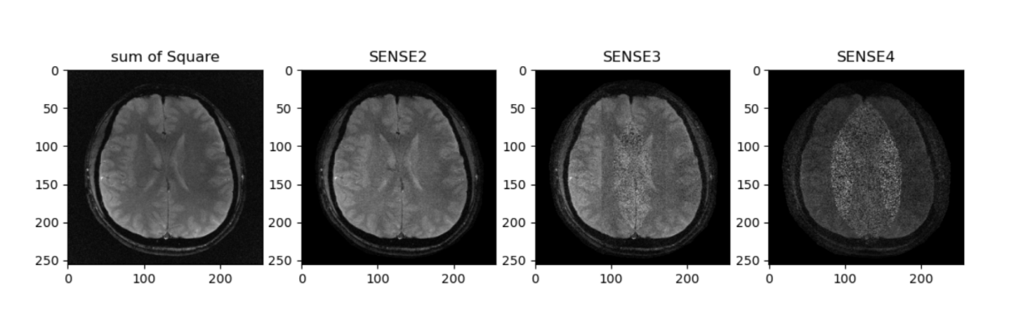

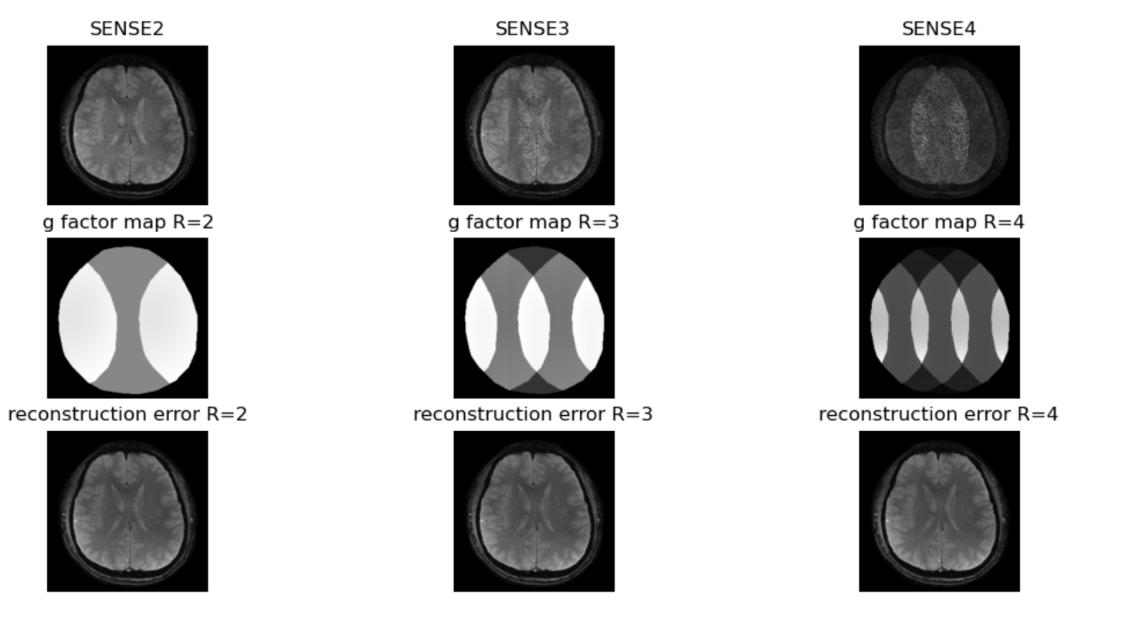

The larger the accelaration factor R, the more noise the MRI image. Besides, the noise in SENSE recontructed image is not uniformly distributed throughout the image. Instead, the noise is mainly located in the middle region, where the pixel overlap there.

Parallel imaging (PI) seem "noisy" . This is a direct result of the fact that the main purpose of PI technology is to reduce imaging time. In SENSE algorithm so, fewer data points are collected and averaged, so the signal-to-noise ratio (SNR) is reduced accordingly. Therefore, the SNR of the PI sequence is always lower than the equivalent non-PI sequence.

The SNR equation is as follow.

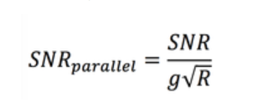

1. **G-factor and SNR loss and RMSE**

**Average g-factor:** mean g-factor exclude the pixels outside the brain

**SNR loss**: SNR_loss = (1-1/(g_mean*np.sqrt(r)))*100

**RMSE**:

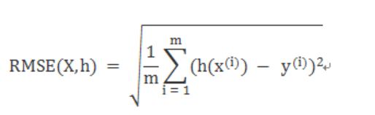

The result of average g-factor, SNR loss and RMSE are as following:

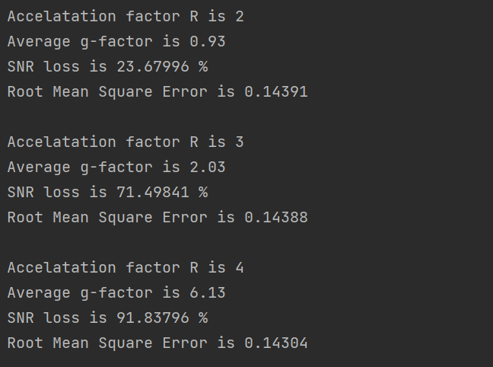

**The principle of the SENSE is as follow:**

1. correct coil img and coil sensitivity with the half inverse of the coil noise covariance matrix Ψ-½

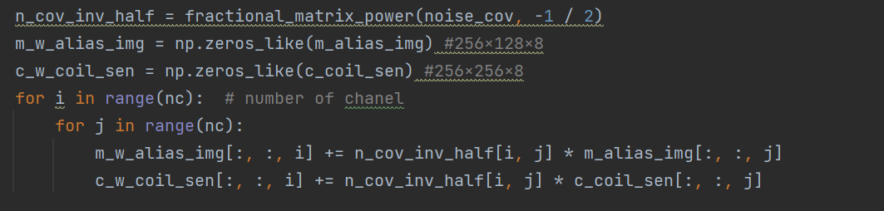

1. create C for each pixel in alias image

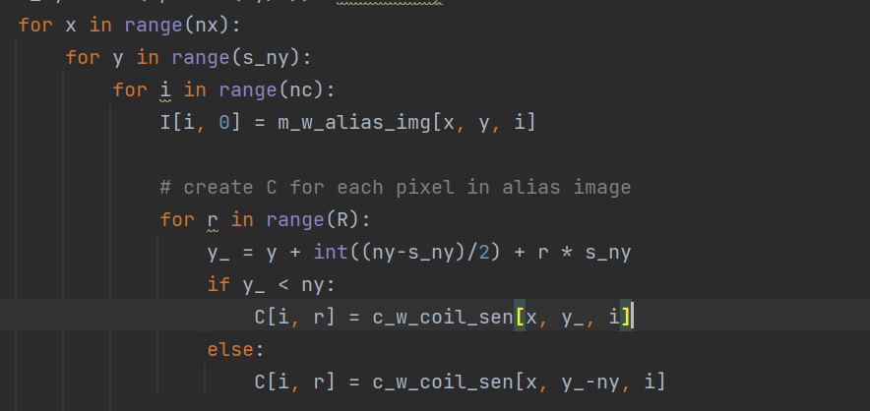

1. Calculate the pixel value ‘u’ in reconstructed MRI image and the g-factor, based on the equation below.

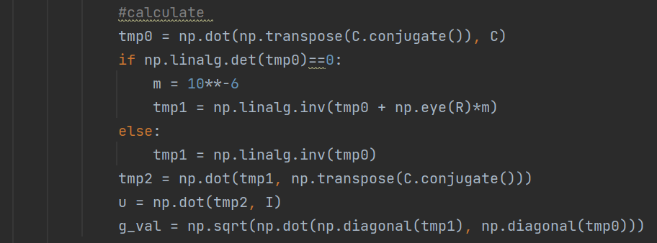

1. reconstruct image and g-factor

