**Computational MR imaging**

**Laboratory 5: Image space parallel imaging**

**Nan Lan**

1. **Multi-coil combination**

What’s **Parallel Imaging(PI)**

PI uses the data redundancy(Multiple coils with different spatial sensitivities). It allows the reduction in the number of phase-encoding steps, hence reducing the imaging time.

1. **Multi-coil combination algorithms**

The result below shows MRI coil images from 8 coils.

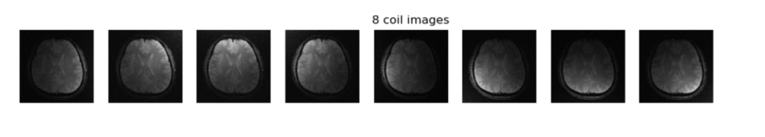

The results below shows outputs of different multi-coil combination algorithms.

Due to the phase cancellation in ‘’Complex sum’’, the result is quite noisy.

The images reconstructed from ‘’Sum of square’’ and ‘’matched filter’’ are clear and similar.

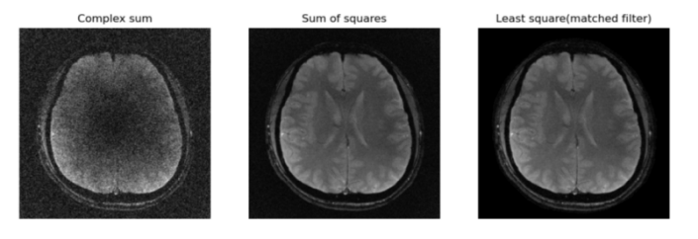

**The process of complex sum is as follow:**

Sum up all the pixel along the coil direction.

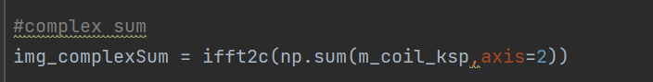

**The process of sum of square is as follow:**

Use L2-norm along coil direction to combine the coil images, based on the equation below.

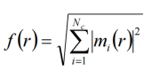

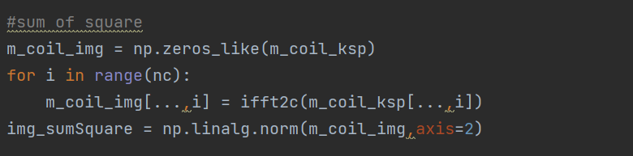

**The process of match filter is as follow:**

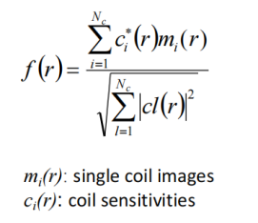

Use the equation above to combine the coil image, also along the coil direction.

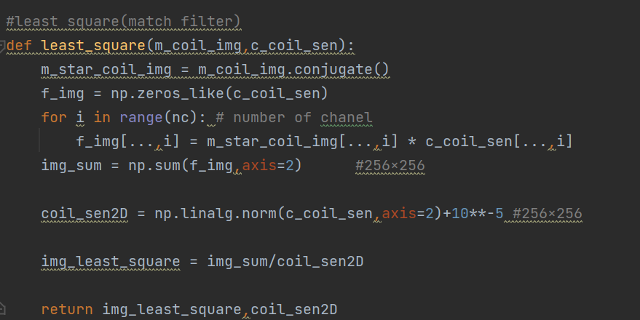

1. **Coil noise covariance matrix**

The results below shows the effect of coil noise covariance matrix.

The correction of coil noise covariance matrix doesn’t have much effect on the reconstructed image.

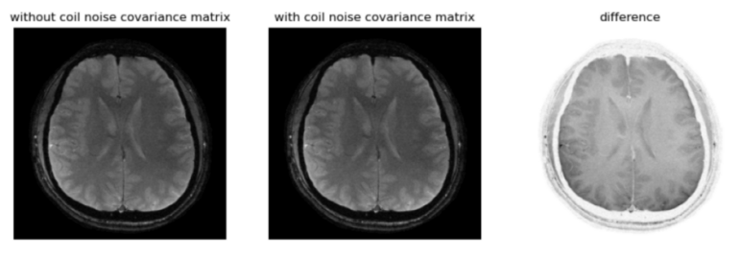

**The process of the Coil noise covariance matrix is as follow:**

1. Calculate the half inverse of the coil noise covariance matrix Ψ-½

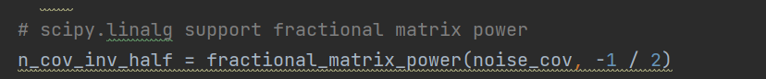

1. Pre-whitening: correct coil img and coil sensitivity with half inverse of noise covariance matrix, based on the equation below.

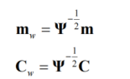

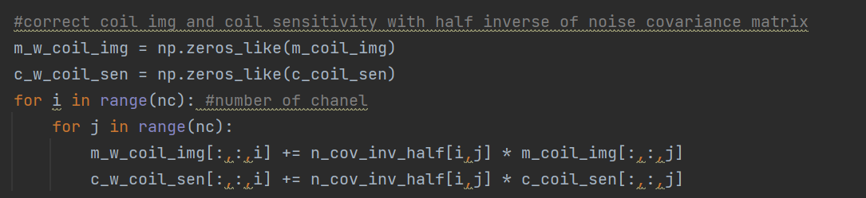

1. The same step as matched filter algorithm.

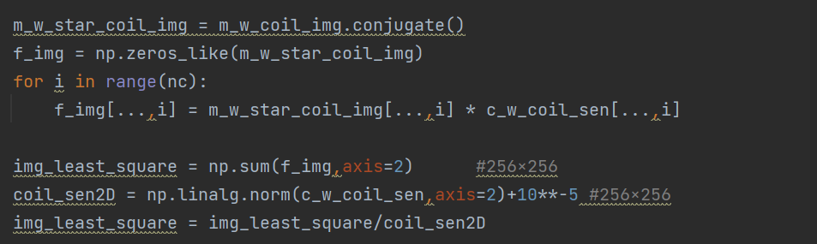

1. **Cartesian SENSE reconstruction and g-factor**
2. **SENSE algorithm**

**The principle of the SENSE is as follow:**

**Sense** technique are performed in image space after Fourier transform of kdata from individual coils. (This contrasts with GRAPPA/ARC methods which operate primarily on k-space data before Fourier transform).

The images below shows MRI coil alias images from 8 coils (R=2). For a PI acceleration factor of 2, every second lines of k-space are skipped, resulting in a ½-FOV images obtained from each coil with aliasing (wrap-around).

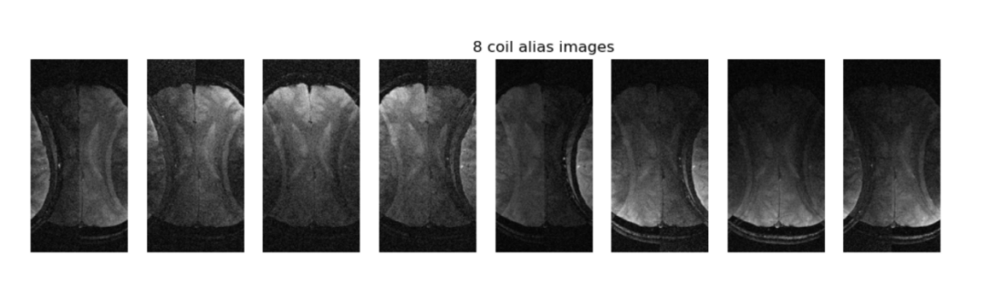

Each pixel (I) in the ½-FOV images has a signal that is the sum of contributions from two points (u1 and u2) in the patient, combining with the coil sensitivity in u1 and u2 position of reconstructed image.

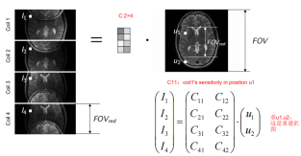

1. correct coil img and coil sensitivity with the half inverse of the coil noise covariance matrix Ψ-½

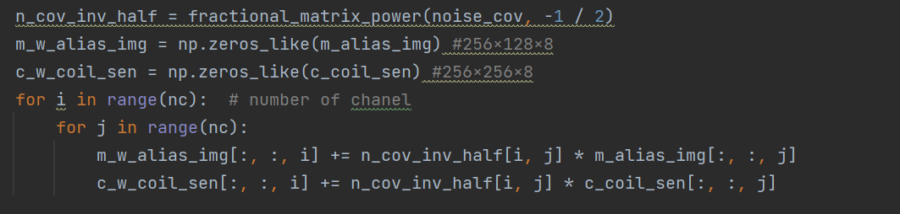

1. Confirm C(coil sensitivity). The shape of C is (R, num_coil)

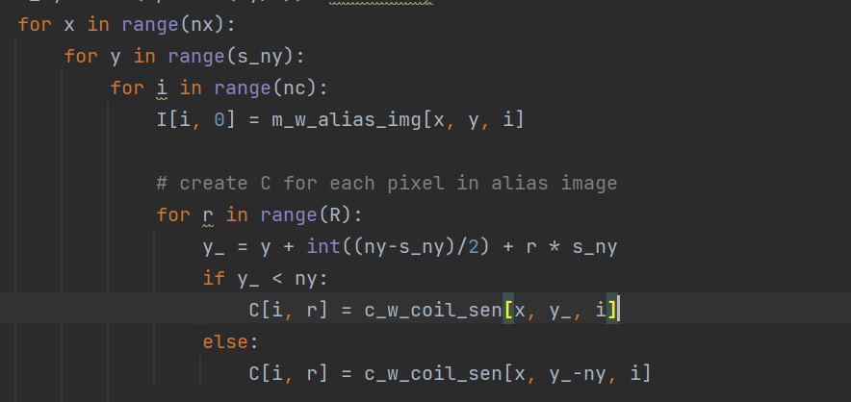

1. Calculate the pixel value ‘u’ in reconstructed MRI image and the g-factor, using a matrix inversion technique below. I is the alias coil images

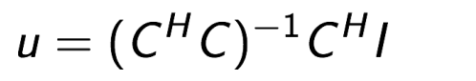

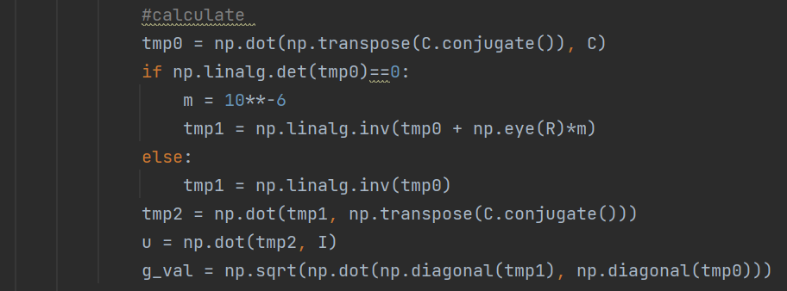

1. reconstruct image and g-factor

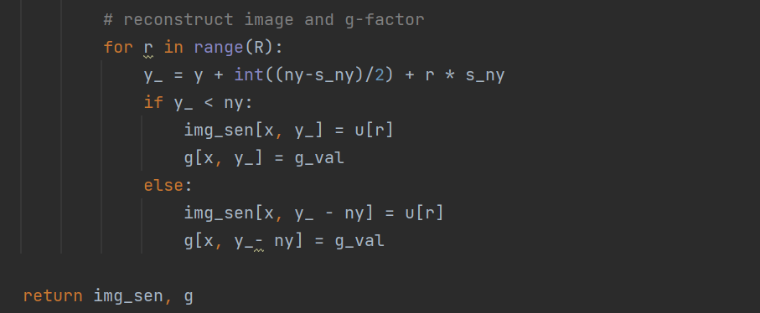

**Result:**

The results below shows outputs of SENSE algorithm, with different acceleration factor(R=2,3,4).

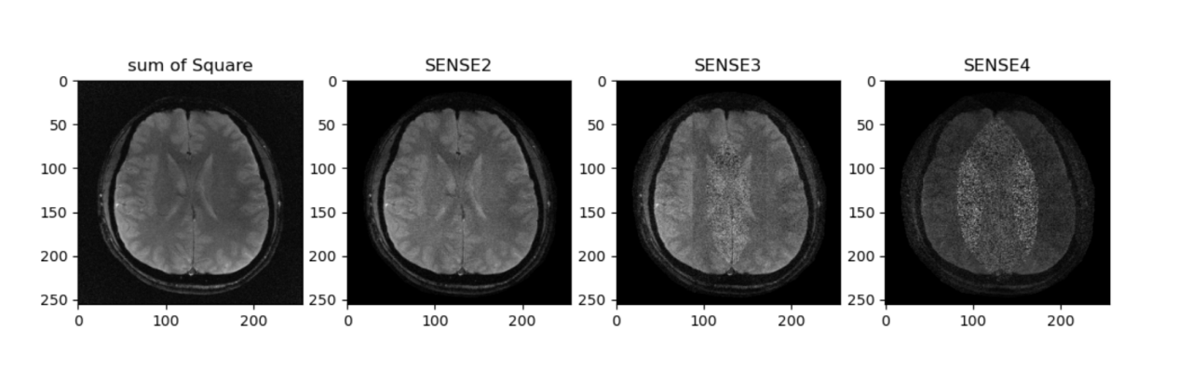

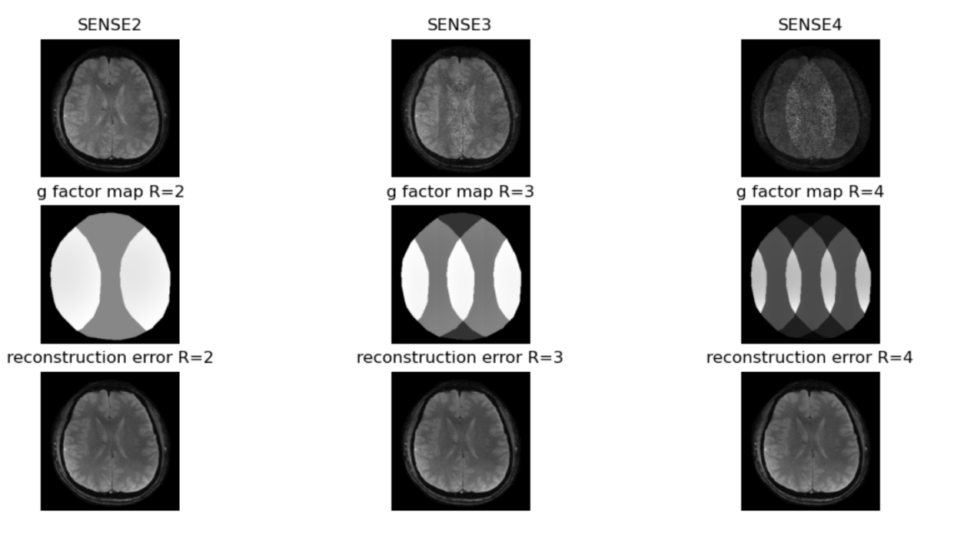

**Acceleration factor R**: The larger the acceleration factor R, the more noise the MRI image. Besides, the noise in SENSE reconstructed image is not uniformly distributed throughout the image. Instead, the noise is mainly located in the middle region, where the signal overlap there.

**SNR**: Parallel imaging (PI) seem "noisy" . This is a direct result of the fact that the main purpose of PI technology is to reduce imaging time. In SENSE algorithm, fewer data points are collected and averaged, so the signal-to-noise ratio (SNR) is reduced accordingly. Therefore, the SNR of the PI sequence is always lower than the equivalent non-PI sequence. It’s called SNR penalty.

The SNR equation is as follow.

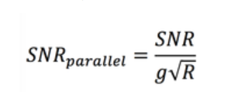

1. **G-factor and SNR loss and RMSE**

**G-factor:** geometry factor，represent noise amplification

**Average g-factor:** mean g-factor exclude the pixels outside the brain

**SNR loss**: SNR_loss = (1-1/(g_mean*np.sqrt(R)))*100

**RMSE**:

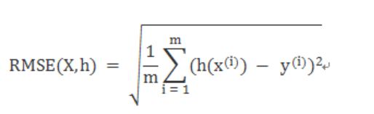

The result of average g-factor, SNR loss and RMSE are as following:

