**Computational MR imaging**

**Laboratory 6: k-space parallel imaging**

**Nan Lan**

1. **Simple GRAPPA reconstruction**

**GRAPP**: Phase undersampling reduces imaging time but results in overlapping/aliased. In GRAPPA, the correction is made in k-space before Fourier transformation.

**ACS**: In many k-space lines will be missing in parallel imaging. However, in GRAPPA lines through the center of k-space are fully sampled and constitute the autocalibration signal (ACS) region. ACS is used to calculate the weighting of k-space lines. Missing lines is estimated by weights and know value from the neighboring points.

The results below shows simple grappa reconstruction, where acceleration factor Ry=2(in column direction), kernel size is 2x3.

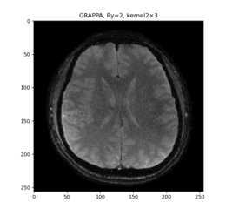

1. **Modified GRAPPA reconstruction**

The results below shows simple grappa reconstruction, where acceleration factor Ry=2,3,4 (in column direction), kernel size is 4x3.

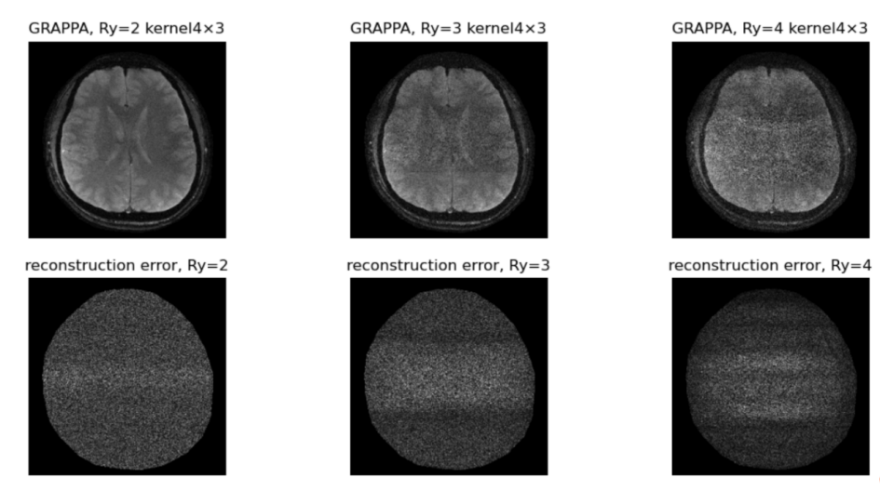

**RMSE:**

RMSE is calculated through:



The result of RMSE is:

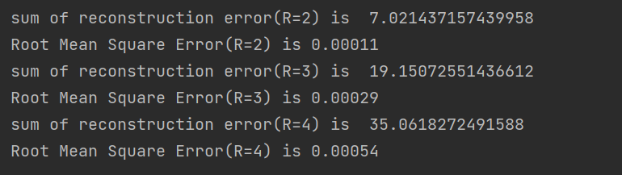

From the GRAPPA reconstructed image and the RMSE, we can see that the noise and error increase with higher acceleration factor(R). The noise of GRAPPA mainly locate in the center of the brain region.

**Comparison between SENSE and GRAPPA:**

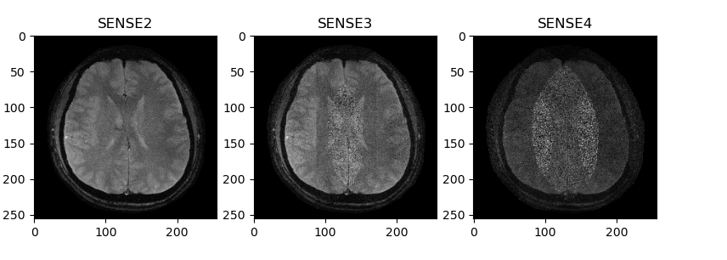

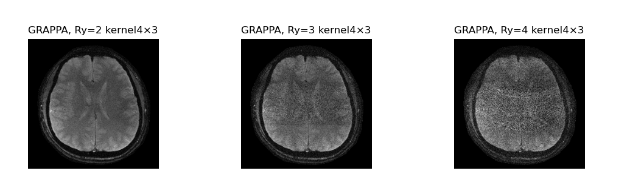

SENSE method reconstructs images from the individual coils and correction is performed in the image domain. GRAPPA method operate in the frequency domain; data is corrected in k-space before reconstruction.

**Image quality:** The image quality of both algorithm are similar, when R=2,R=3.

GRAPPA has a slight better reconstruction result than SENSE, when R =4. GRAPPA is more robust (against motion artifact due to the ACS where signal is fully sample).

**Gerneralization**: SENSE fits all trajectory; GRAPPA is suitable for Cartesian-trajectory because GRAPPA in non-Cartesian needs specific kernel size. GRAPPA is simple for 1D acceleration(same weight everywhere), hard for 2D acceleration(weights are different in diff geometry)

**Total image time**: GRAPPA longer due to ACS

**The process of grappa is as follow:**

1. Create the undersampled kspace and the Autocalibration signal

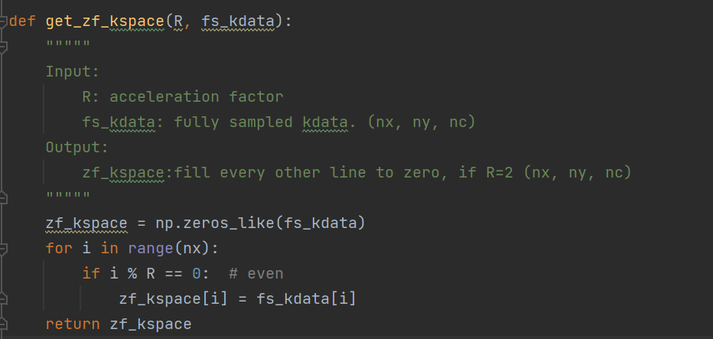

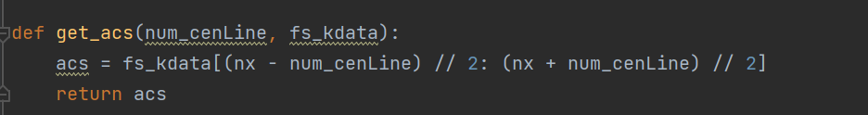

1. get source and target in ACS region

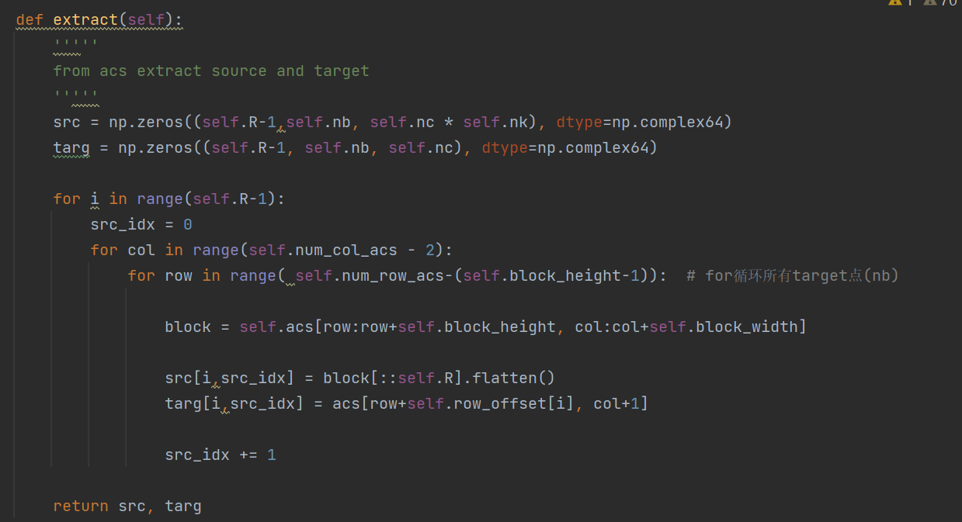

1. calculate weight, based on the equation:

target(nb× nc)=source(nb × nknc)*weights(nknc × nc)

where nb is the number of target points in ACS in a coil image; nc is the number of coil; nk is the number of kernel.

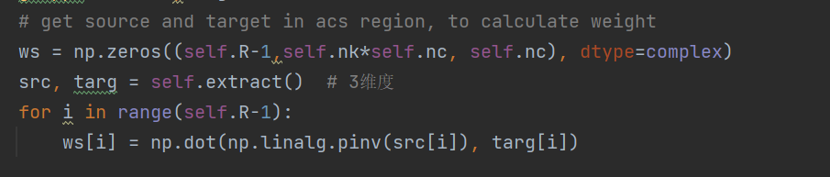

1. enlarge kspace with zero-pad, so that the data in the boundary can also be calculated

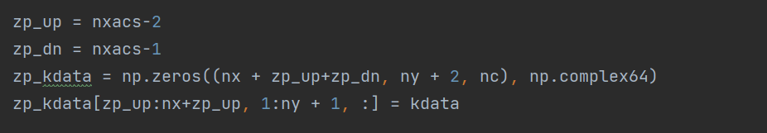

1. Interpolate the missing lines in the kspace

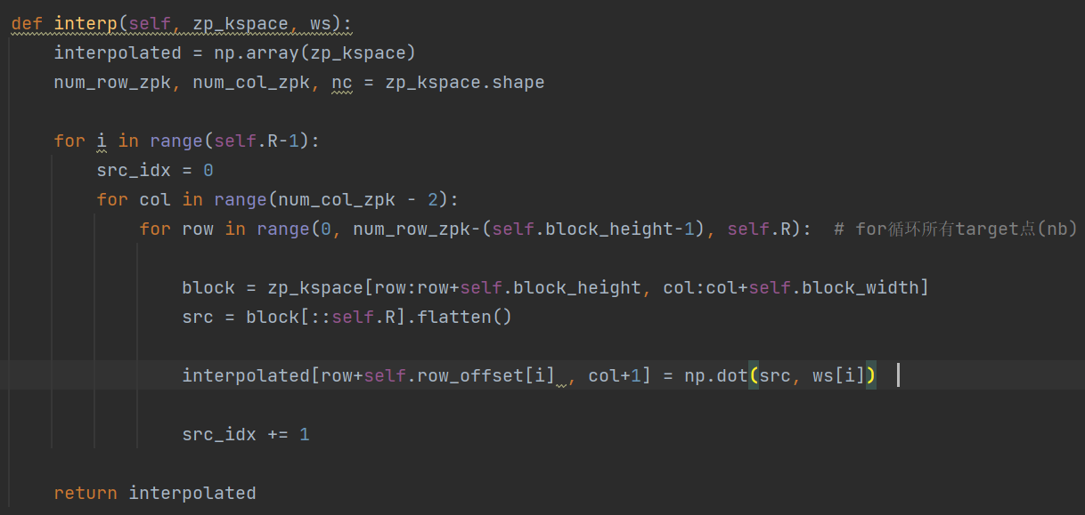

1. Get the kspace from the enlarged-reconstructed kspace, using the weights.

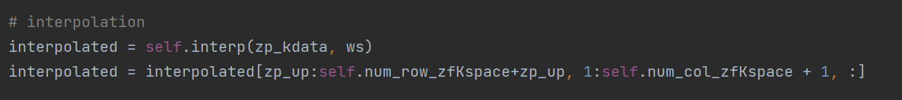

1. Generate the individual coil images and use least square algorithm to combine the coil images, so as to reconstruct MRI image.

