**Computational MR imaging**

**Laboratory 6: k-space parallel imaging**

**Nan Lan**

1. **Simple GRAPPA reconstruction**

The results below shows simple grappa reconstruction, where acceleration factor Ry=2(in column direction), kernel size is 2x3. 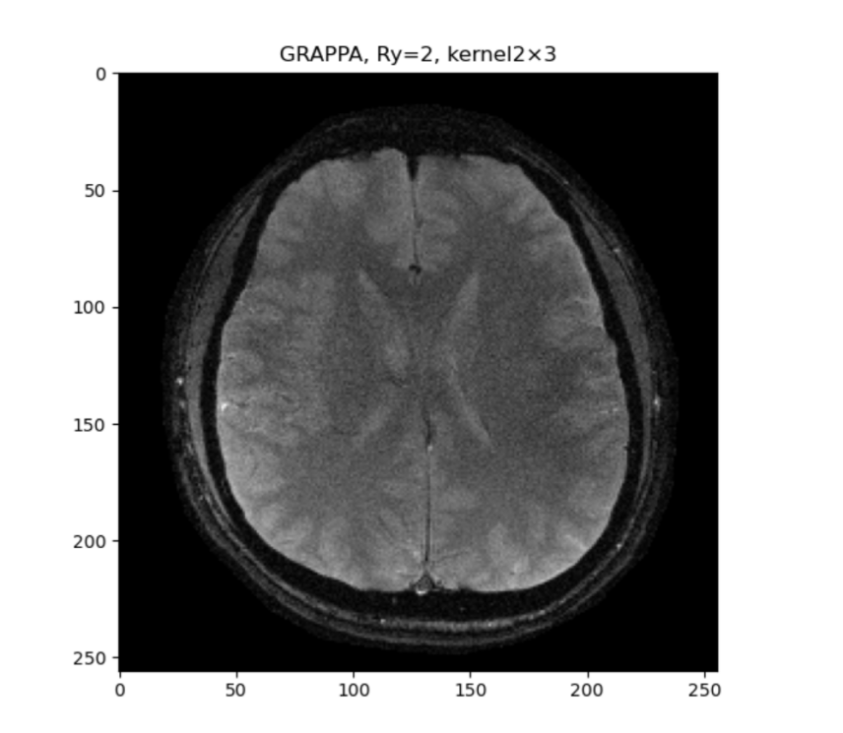

1. **Modified GRAPPA reconstruction**

The results below shows simple grappa reconstruction, where acceleration factor Ry=2,3,4 (in column direction), kernel size is 4x3.

Reconstruction error is calculated through:



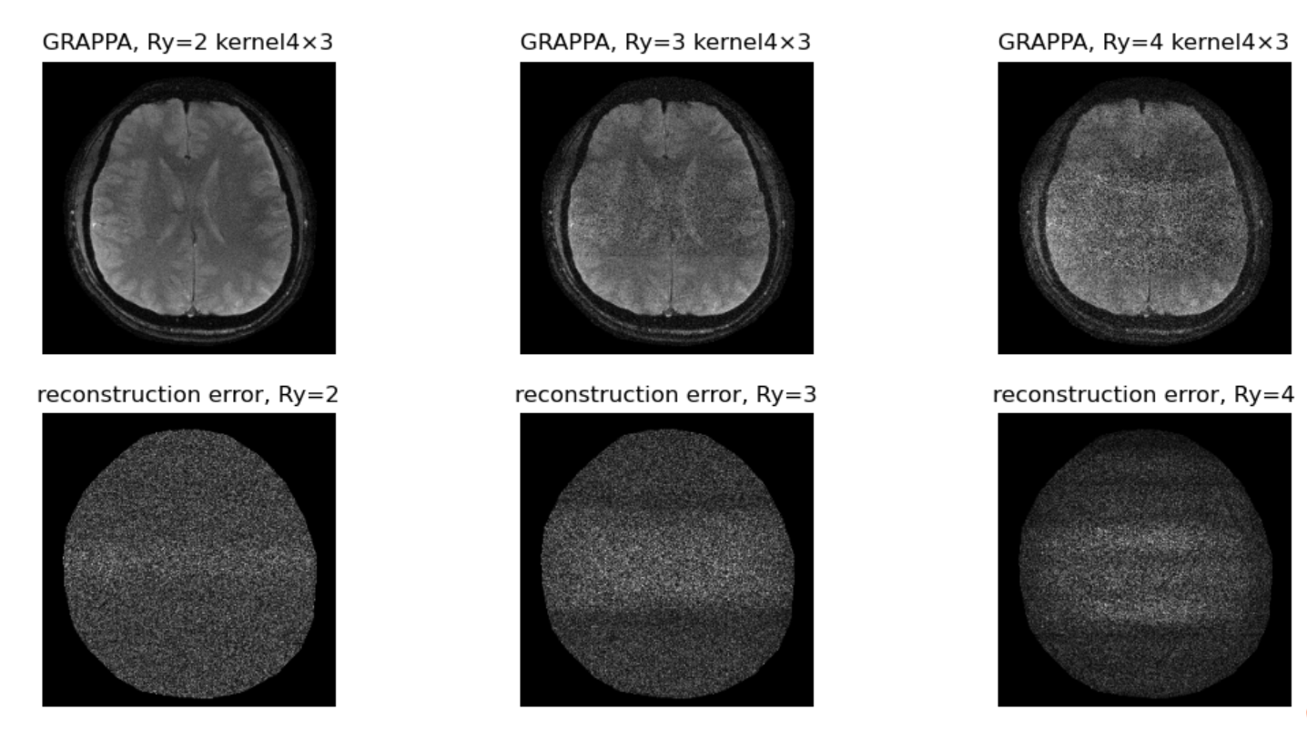

**RMSE:**

RMSE is calculated through:



The result of RMSE is:

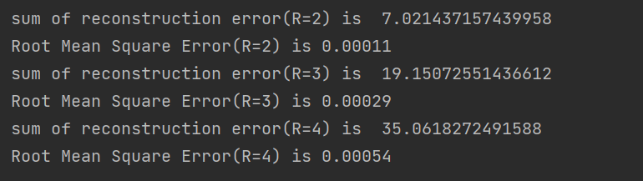

From the GRAPPA reconstructed image and the RMSE, we can see that the noise and error increase with higher accelaration factor(R). The noise of GRAPPA mainly locate in the center of the brain region.

**Comparison between SENSE and GRAPPA:**

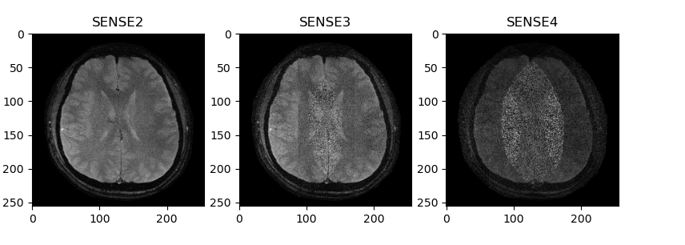

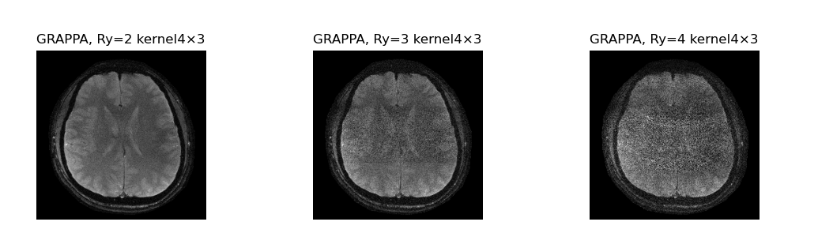

SENSE method reconstructs images from the individual coils and correction is performed in the spatial/image domain. GRAPPA method operate in the frequency domain; data is corrected in k-space before reconstruction.

The image quality of both algorithm are similar, when R=2,R=3. GRAPPA has a slight better reconstruction result than SENSE, when R =4.

**The process of grappa is as follow:**

1. Create the undersampled kspace and the Autocalibration signal

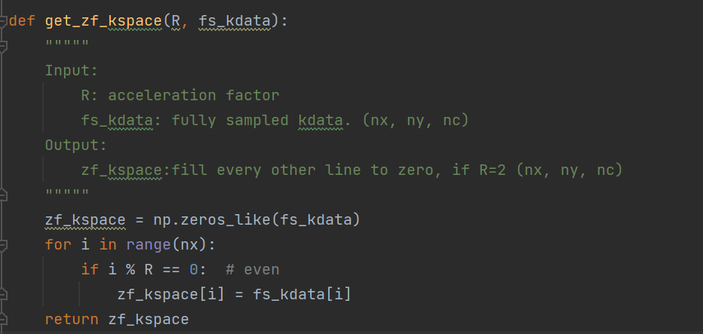

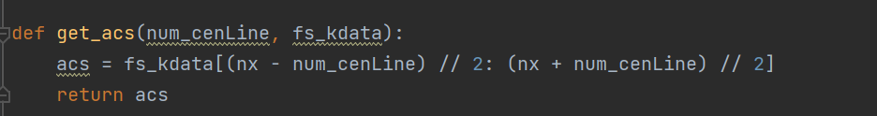

1. get source and target in ACS region

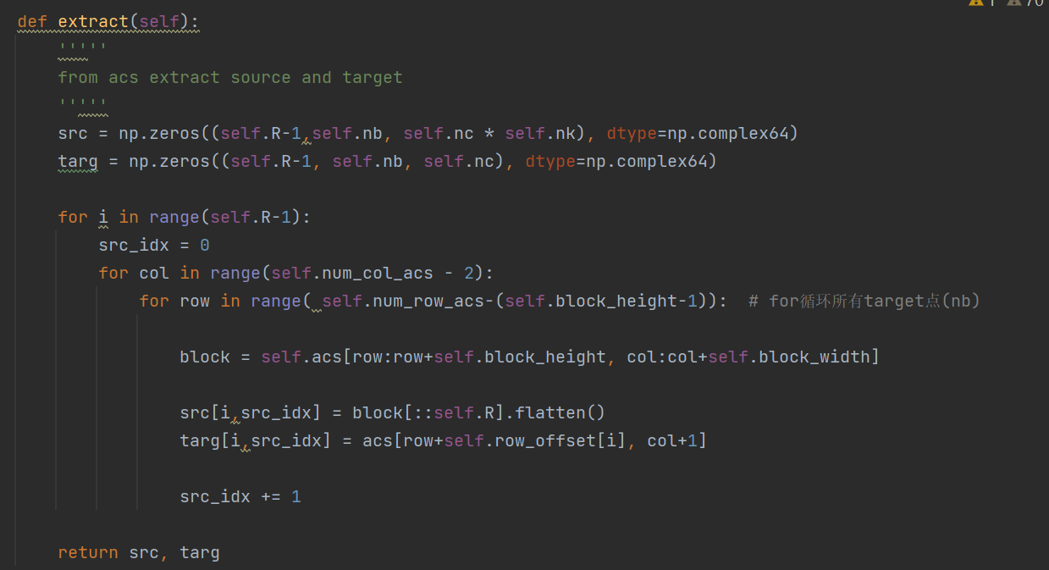

1. calculate weight, based on the equation: target=source*weights

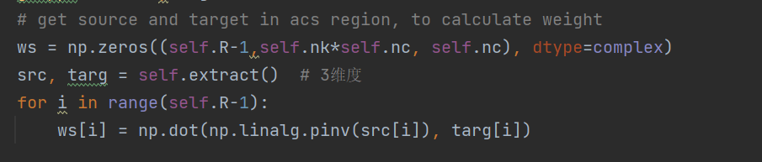

1. enlarge kspace with zero-pad, so that the data in the boundary can also be calculated

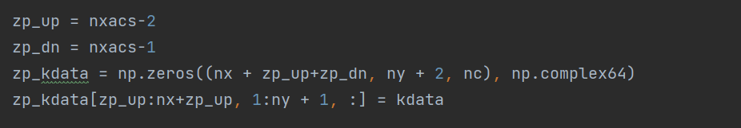

1. Interpolate the lacking datapoint in the kspace

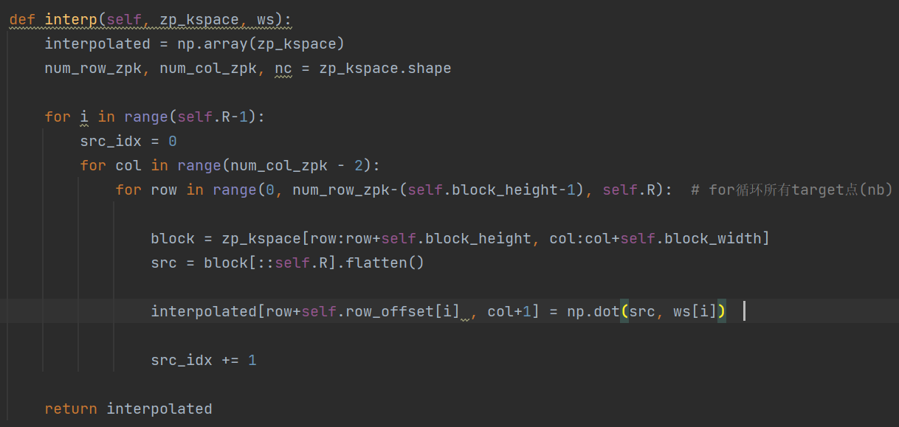

1. Get the kspace from the enlarged-reconstructed kspace.

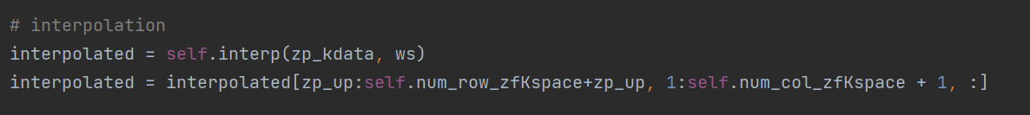

1. Use least square algorithm to combine the coil kspaces and return the reconstructed MRI image.

