**Computational MR imaging**

**Laboratory 7: Parallel Imaging III: Non-Cartesian Imaging and Iterative Reconstruction**

**Nan Lan**

1. **Derivation of gradient descent (analytical):**

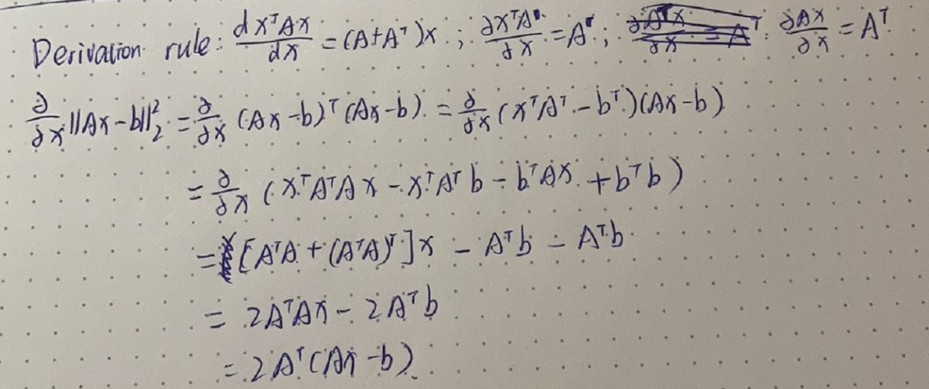

1. **Iterative image reconstruction with gradient descent**
   1. **Plot the kdata and at the sampling trajectory**

Each column corresponds to the readout dimension for each radial line.

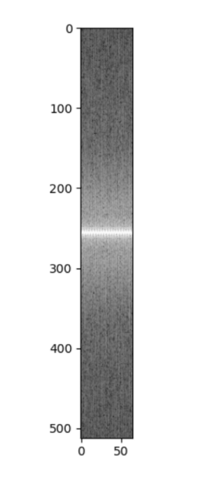

**2.2 NUFFT**

The process of NUFFT is as follow:

1. Initialization of cartesian image and coil image;

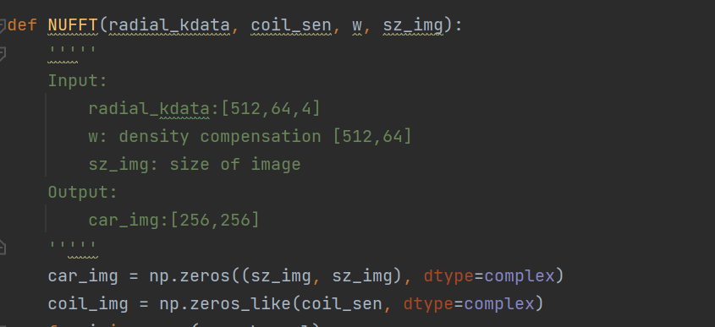

1. Density compensation of kdata;



1. Mapping ratial kdata to cartesian grid;



1. Inverse fourier transform of kspace_catesian_grid and get coil image;



1. Combine coil image and get cartesian image



**2.3 Gradient Descent Reconstruction**

The process of gradient descent reconstrution is as follow:

1. Construct kdata trajectory, which is suitatble for KbNufft toolbox.

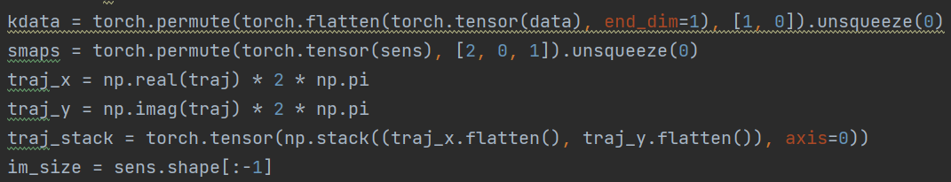

1. Instantiate the mappings from cartesian image to radial trajectory and from radial trajectory to cartesian image.



1. Run gradient descent method

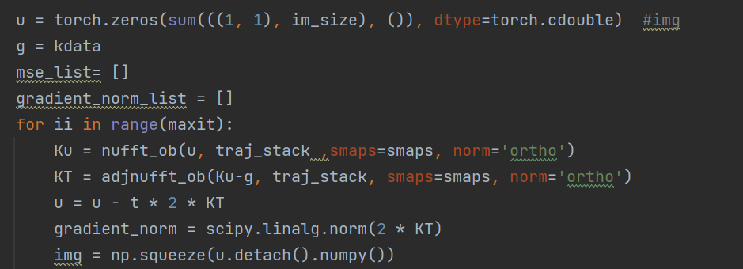

1. Calculate mean square error and l2 norm of the gradient over the iterations

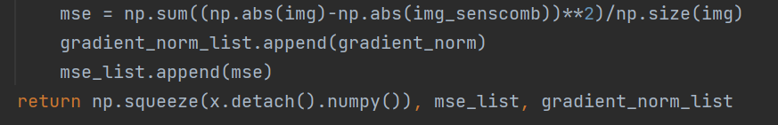

**2.4 Gradient descent reconstructed image, ground truth, difference,NUFFT**

As the result below shown, the gradient descent reconstructed image has lower resolution but also weaker artifact than NUFFT.

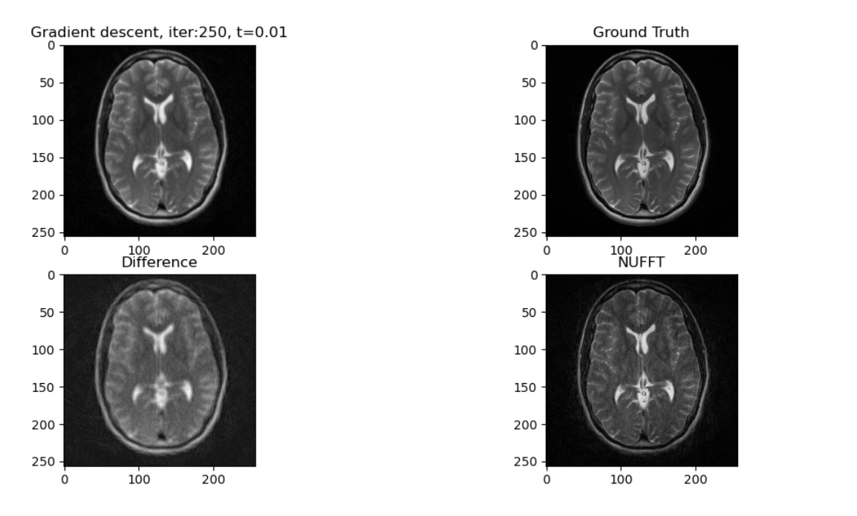

**2.5 MSE & L2 norm of the gradient over the iterations.**

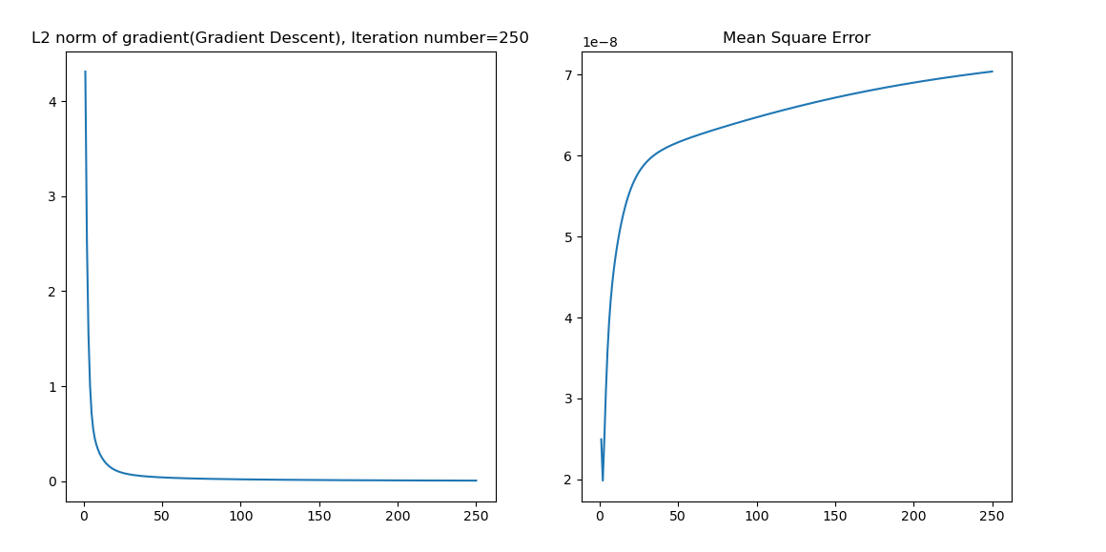

L2 norm of the gradient deceases and converges at iteration 20.

Mean square error is quite small, although it increases.

1. **Iterative image reconstruction with conjugate gradient**
   1. **NUFFT**

The same as 2.2

**3.2 Conjugate gradient SENSE reconstruction**

L2 norm of Conjugate gradient SENSE reconstruction method(CG) and Gradient descent (GD)is as followed:

L2 norm of CG converges at iteration 15 and L2 norm of GD converges at iteration 20. CG method converges a bit earlier.

L2 norm of CG is round 10 times smaller than GD, no matter in which iteration(before converge).

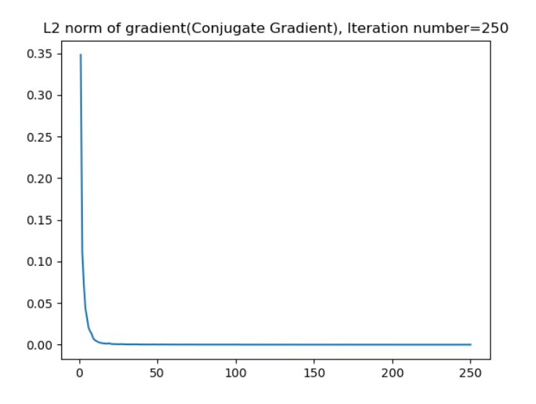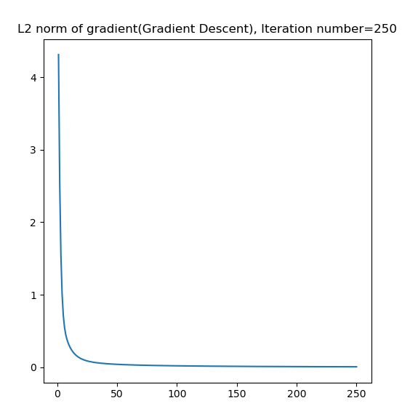

**3.3 Conjugate gradient reconstructed image, ground truth, difference,NUFFT**

As the result below shown, the conjugate gradient reconstructed image has higher resolution but also stronger artifact than gradient descent method(image above).

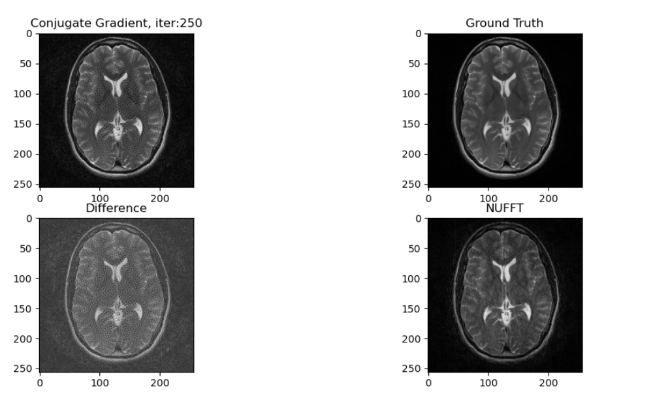

**3.4 CG reconstruction with noise**

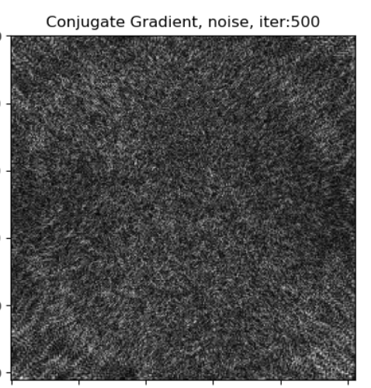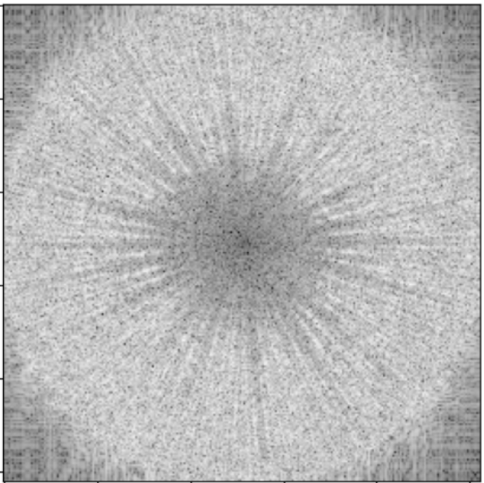

The image left is the noise in time domain ; The image right is the noise in kspace.

As the result show, the noise mainly located at the surrounding of radial trajetory instead of in the center.

