**Computational MR imaging**

**Laboratory 8: Compressed Sensing**

**Nan Lan**

1. **Sparsity/compressibility of brain images using the wavelet transform:**
2. **Wave transfrom**

The result below is the wavelet transform, using fully sampled kspace(without compressing).

From the norm1 loss, we can know that there is no great difference between the original image and reconstructed image.

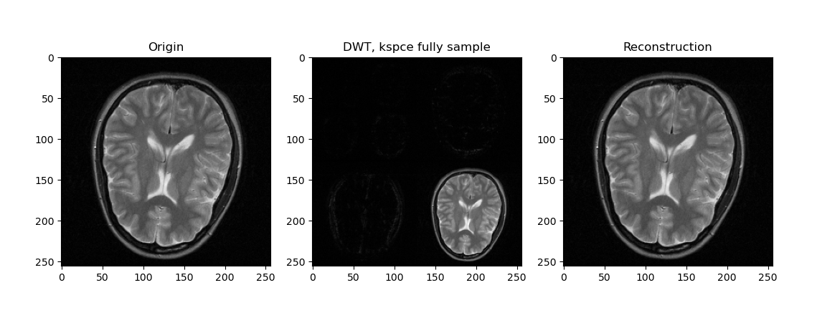





1. **Compress the brain image by factors 5, 10 and 20**

**The process of compress sensing algorithm is as followed:**

1. Get the undersampled kspace, according to different compress factor.



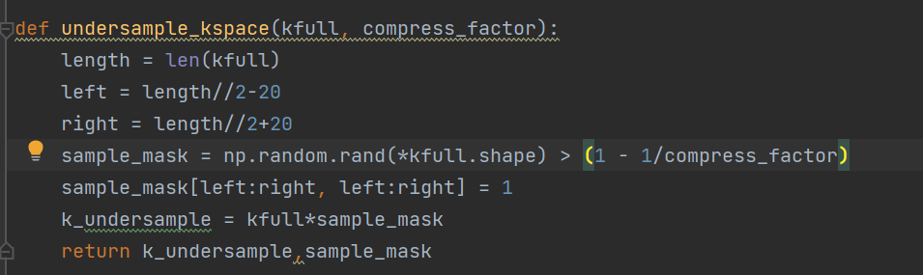

The middle of kspace is fully sampled, the surround of kspace is randomly undersampled

The sample mask is as follow:

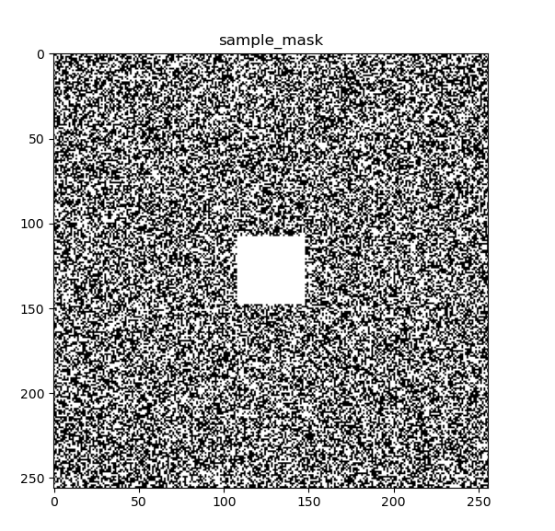

1. Convert the image to wavelet domain



1. Denoise the img_wavelet

Wavelet coefficients represent both space and spatial frequency information. Each band of wavelet coefficients represents a scale (frequency band) of the image. The location of the wavelet coefficient within the band represents its location in space. Threshold the wavelet coefficients retaining only the largest part of the coefficients, according to the compress factor.



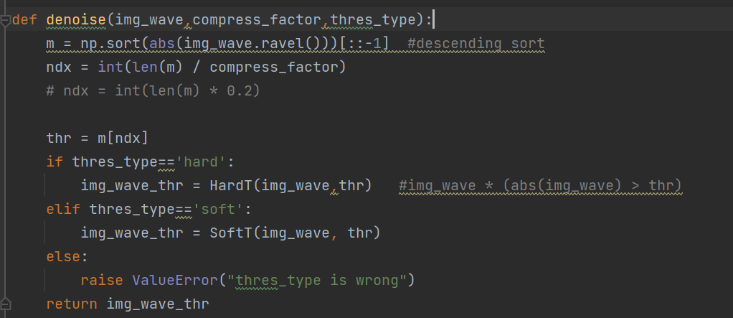

1. Convert the data from wavelet domain back to image domain



**Here is the result.**

The result below is the original image(scale: 0-1).

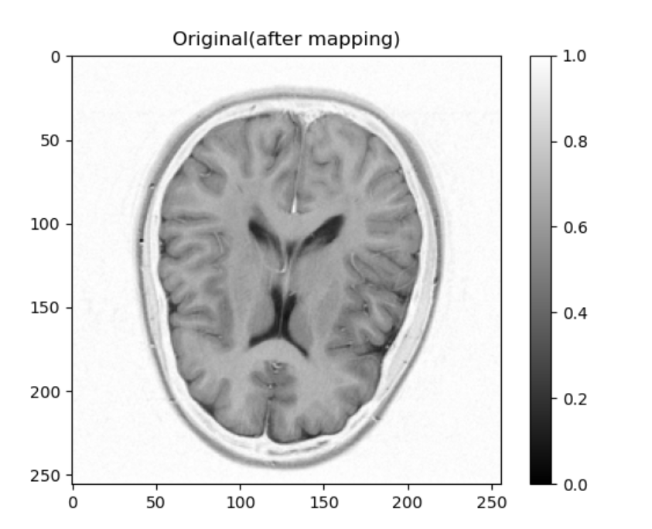

The result below are the Daubechies wavelet transform, reconstructed images(scale: 0-1) and error(scale: 0-0.1).

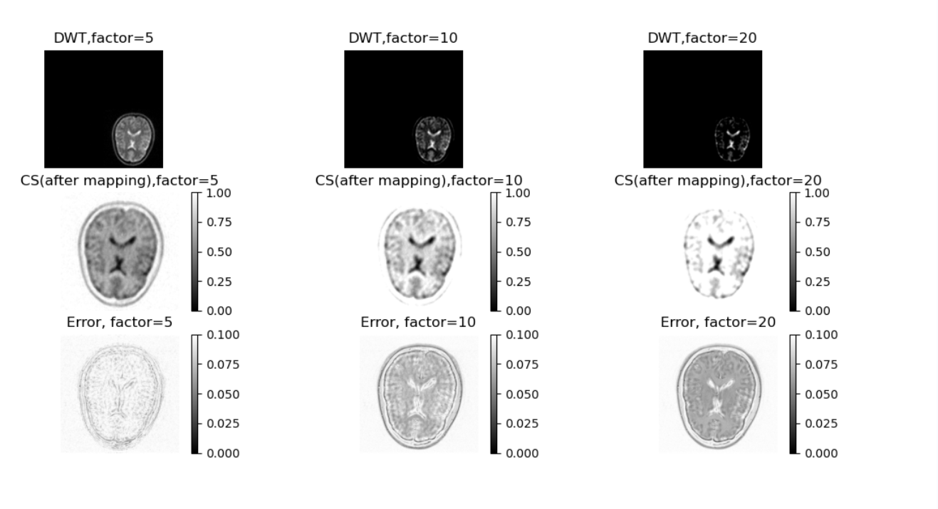

The following is the evaluation result of different compressing factors. The higher the compress factor, the larger the RMSE.

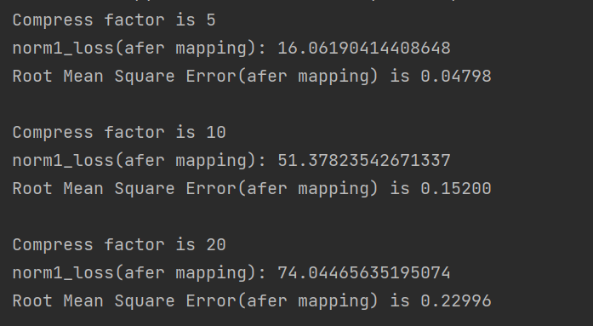

1. **Compressed sensing reconstruction using iterative soft thresholding:**
2. **iterative soft-thresholding**

**The process of iterative soft-thresholding algorithm is as followed:**

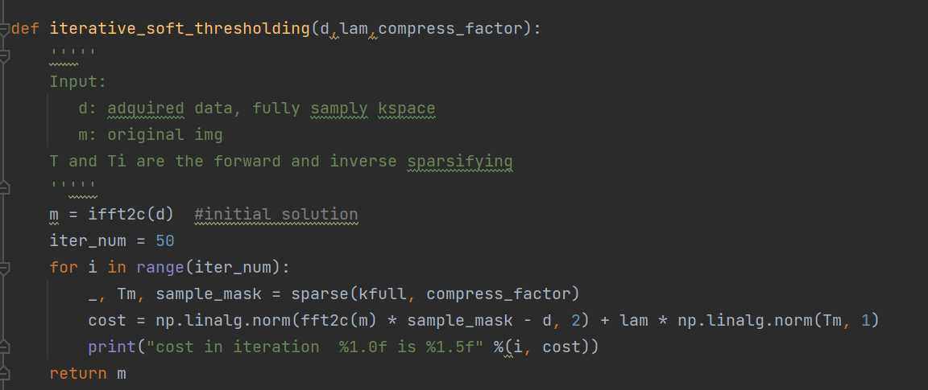

Here is the cost

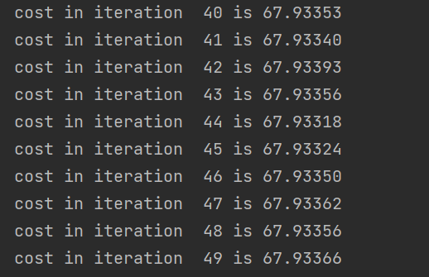

1. **kacc**

The following is the kacc

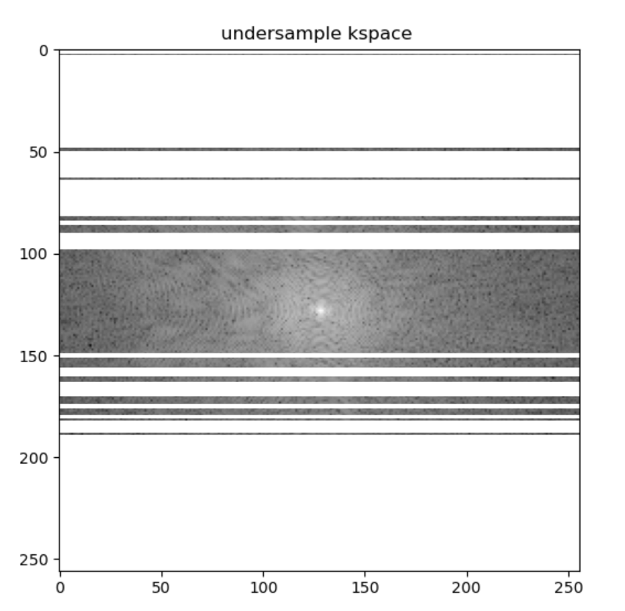

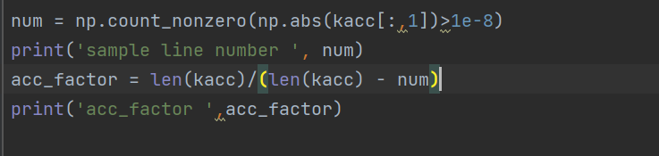

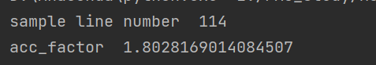

The acceleration factor is 1.8