

IT342-[Section]
System Integration and Architecture

System Design Document (SDD)

Project Title: FoodCloud
Prepared By: Durano, Ashlee Skye A.
Version: 0.3
Date: 3/2/2026
Status: Draft

REVISION HISTORY TABLE
Version | Date | Author | Changes Made | Status
0.1 | 2/23/26 | Ashlee Skye Durano | Initial draft | Draft
0.2 | 2/28/26 | Ashlee Skye Durano | Refined the initial draft | Review
0.3 | 3/0/26 | Ashlee Skye Durano | refine | Review
0.4 | 3/7/26 | Ashlee Skye Durano | final | final
0.5 | [Date] | [Your Name] |  | Revised
0.6 | [Date] | [Your Name] |  | Final
1 | [Date] | [Your Name] |  | Approved

TABLE OF CONTENTS
Contents
EXECUTIVE SUMMARY 4
1.0 INTRODUCTION 5
2.0 FUNCTIONAL REQUIREMENTS SPECIFICATION 5
3.0 NON-FUNCTIONAL REQUIREMENTS 8
4.0 SYSTEM ARCHITECTURE 9
5.0 API CONTRACT & COMMUNICATION 10
Authentication Endpoints 11
User Registration 11
User Login 11
6.0 DATABASE DESIGN 13
7.0 UI/UX DESIGN 14
8.0 PLAN 17

EXECUTIVE SUMMARY
1.1 Project Overview
FoodCloud is a specialized e-commerce MVP platform designed exclusively for C I T University students and staff. The platform enables users to browse, order, and receive delivery of snacks, drinks, and food items from on-campus vendors. The system comprises a Spring Boot backend API, React web application, and Android mobile app, all integrated to provide a seamless food ordering experience within the university campus.
1.2 Objectives
- Develop a campus-exclusive food delivery MVP with authentication, product catalog, shopping cart, and checkout
- Implement a three-tier architecture using Spring Boot (backend), React (web), and Android (mobile)
- Create RESTful APIs for communication between all system components
- Design a responsive user interface optimized for students ordering food on-the-go
- Deploy all system components to production-ready environments with campus-specific configurations
1.3 Scope
Included Features:
- User registration and authentication (email/password with student/staff verification via google api login)
- Product listing with search and vendor filtering functionality
- Shopping cart management (add, remove, update quantities)
- Checkout process with campus delivery location collection (building name, room number)
- Order placement with confirmation and simple status tracking
- Vendor panel for product management (for canteen/food stall operators)
- Responsive web interface optimized for all devices
- Native Android mobile application
- PostgreSQL database with relational schema
- Cash on delivery as payment method

Excluded Features:
- Sand - boxed payment simulating real time payment and transactions.
- Product reviews and ratings system
- Automated inventory management
- Email notification system
- Gmail media login integration
- Push notifications

1.0 INTRODUCTION
1.1 Purpose
This document serves as the comprehensive design specification for the FoodCloud system. It provides detailed requirements, architectural decisions, API contracts, database design, and implementation roadmap to guide development and ensure all components integrate seamlessly for the C I T University campus community.

2.0 FUNCTIONAL REQUIREMENTS SPECIFICATION
2.1 Project Overview
Project Name: FoodCloud
Domain: E-commerce/Food
Primary Users:
- Students (primary customers)
- Faculty/Staff (customers)
- Vendors (canteen/food stall operators)
- System Administrators
Problem Statement: C I T University students and staff need a quick, reliable way to purchase snacks, drinks, meals and choose from a wide variety of foods without leaving campus or waiting in long cafeteria lines during break times. Current options are limited to physical food outlets with fixed operating hours, limited food and drinks options and no delivery option.
Solution: A clean and simple campus-exclusive food delivery platform enabling users to order from multiple on-campus vendors and receive delivery to any location within the university grounds.

2.2 Core User Journeys
Journey 1: First-time Student Purchase
- Student visits web application or downloads mobile app
- Clicks "Sign Up" and creates account Gmail.
- Browses food items from various campus vendors
- Clicks product to view details and estimated preparation time
- Adds items to cart
- Views cart and proceeds to checkout
- Enters delivery location (building name, room/lecture hall number)
- Places order with "Cash on Delivery" option
- Receives order confirmation with estimated delivery time
- Tracks order status (Preparing → Ready → Out for Delivery → Delivered)

Journey 2: Returning Customer Purchase
- User logs in with existing credentials
- Searches for specific food item or browses by vendor/category
- Adds multiple items to cart from same or different vendors
- Updates cart quantities
- Completes checkout using saved delivery location
- Receives order confirmation with updated tracking
Journey 3: Vendor Product Management
- Vendor logs in with vendor credentials
- Navigates to vendor dashboard
- Adds new food items with details (name, price, description, image, available quantity)
- Edits existing product information (price updates, availability toggling)
- Views incoming orders and updates order status
- Marks orders as ready for pickup/delivery
Journey 4: Administrator Oversight
- Admin logs in with admin credentials
- Views all orders across all vendors
- Manages vendor accounts (add/remove vendors)
- Monitors platform activity and resolves disputes
- Views basic sales analytics

2.3 Feature List (MoSCoW)
MUST HAVE
- User authentication with google email domain validation
- Product catalog (list by vendor, detail view, search by name)
- Shopping cart (add, remove, update, view)
- Checkout process with campus location collection
- Order placement with confirmation
- Order status tracking (basic: Received, Preparing, Ready, Delivered)
- Vendor panel for product management (CRUD operations)
- Cash on Delivery as payment method

SHOULD HAVE
- Product categories and filtering (by vendor, by food type)
- Order history for users
- Basic input validation feedback
- Responsive design for all screen sizes
- Multiple items from different vendors in one cart

COULD HAVE
- Estimated delivery/preparation time
- Basic sales dashboard for vendors
- Favorite/reorder previous orders
- Order notes/special instructions
WON'T HAVE
- Real payment processing
- Social login
- Advanced analytics
- Multi-language support
- Push notifications

2.4 Detailed Feature Specifications
Feature: User Authentication
- Screens: Registration, Login, Forgot Password
- Fields: Email, Password, Confirm Password, Full Name, Student/Faculty ID (optional)
- Validation: Email format with gmail, password strength (min 8 characters), uniqueness
- API Endpoints: POST /auth/register, POST /auth/login, POST /auth/logout, POST /auth/refresh
- Security: JWT tokens, password hashing with bcrypt, gmail email domain verification
Feature: Vendor Management
- Screens: Vendor Registration (admin only), Vendor List, Vendor Details
- Fields: Vendor name, description, location on campus, operating hours, contact info
- API Endpoints: GET /vendors, GET /vendors/{id}, POST /vendors (admin), PUT /vendors/{id} (vendor/admin)
- Access Control: Vendors can only manage their own information
Feature: Product Catalog
- Screens: Product Listing (by vendor), Product Detail
- Display: Grid layout, food images, names, prices, vendor name, availability status
- Search: By product name, by vendor name
- Filtering: By vendor, by category (snacks, drinks, meals, etc.)
- API Endpoints: GET /products, GET /products/{id}, GET /products/search, GET /vendors/{vendorId}/products
- Vendor Functions: POST /products, PUT /products/{id}, DELETE /products/{id}, PATCH /products/{id}/availability
Feature: Shopping Cart
- Screens: Cart View
- Functions: Add product, remove product, update quantity, clear cart
- Grouping: Items grouped by vendor for organized checkout
- Persistence: Database storage per user
- API Endpoints: GET /cart, POST /cart/items, PUT /cart/items/{id}, DELETE /cart/items/{id}, DELETE /cart
Feature: Checkout Process
- Screens: Checkout Form, Order Review, Order Confirmation
- Data Collected: Delivery location (building name, room/area), special instructions, contact number
- Process: Validate input, create order, clear cart, assign to appropriate vendors
- Split Orders: If items from multiple vendors, create separate orders per vendor linked to a single parent order
- API Endpoints: POST /orders, GET /orders/{id}, GET /orders/user
Feature: Order Tracking
- Screens: Order Status, Active Orders, Order History
- Statuses: PENDING, CONFIRMED, PREPARING, READY, OUT_FOR_DELIVERY, DELIVERED, CANCELLED
- API Endpoints: GET /orders/active, PUT /orders/{id}/status (vendor), PATCH /orders/{id}/cancel (user/vendor)
Feature: Vendor Panel
- Screens: Dashboard, Product Management, Order Management
- Functions: Add/edit/delete products, view incoming orders, update order status
- Access Control: Vendor role required, restricted to own products and orders
- API Endpoints: Vendor-specific endpoints with role validation
Feature: Admin Panel
- Screens: User Management, Vendor Management, System Overview
- Functions: Approve vendors, view all orders, manage users
- Access Control: Admin role required
2.5 Acceptance Criteria
AC-1: Successful Student Registration
- Given I am a new student user
- When I enter valid @gmail email and strong password
- And confirm password matches
- And provide my full name
- And click "Create Account"
- Then my account should be created
- And I should be automatically logged in
- And redirected to the food catalog homepage
AC-2: Food Order Purchase Flow
- Given I am logged in as a student
- When I browse food items from various vendors
- And add multiple items to my cart
- And proceed to checkout
- And enter valid campus delivery location (e.g., "Engineering Building, Room 204")
- And place the order
- Then I should see order confirmation with estimated time
- And my cart should be empty
- And the order should appear in the vendor's order list
AC-3: Vendor Product Management
- Given I am logged in as a vendor
- When I add a new food item with valid details (name, price, description, image)
- And save the product
- Then the product should appear in customer product listing
- And be available for purchase by students
- And I should be able to edit or mark it as unavailable later
AC-4: Multi-Vendor Order Handling
- Given I am logged in as a student
- When I add items from Vendor A and Vendor B to my cart
- And proceed to checkout
- And place the order
- Then separate orders should be created for each vendor
- And I should see a consolidated order view showing all items
- And each vendor should only see their respective items in their order queue

3.0 NON-FUNCTIONAL REQUIREMENTS

3.1 Performance Requirements
- API response time: ≤ 2 seconds for 95% of requests
- Web page load time: ≤ 3 seconds on campus WiFi/broadband
- Mobile app cold start: ≤ 3 seconds
- Support 200 concurrent users (peak lunch hour traffic)
- Database queries complete within 500ms
- Order processing time: ≤ 5 seconds from submission to confirmation

3.2 Security Requirements
- HTTPS for all communications
- JWT token authentication with short-lived access tokens (15 min) and refresh tokens (7 days)
- Password hashing with bcrypt
- Gmail validation (@gmail)
- SQL injection prevention via JPA/Hibernate
- XSS protection on all frontend inputs
- Rate limiting: 100 requests/minute per IP, 20 login attempts per hour
- Vendor/admin endpoints require role-based verification
- Data isolation: vendors can only access their own data

3.3 Compatibility Requirements
- Web Browsers: Chrome, Firefox, Safari, Edge (latest 2 versions)
- Android: API Level 24+ (Android 7.0+)
- Screen Sizes: Mobile (360px+), Tablet (768px+), Desktop (1024px+)
- Operating Systems: Windows 10+, macOS 10.15+, Linux Ubuntu 20.04+, Android 7.0+
- Network: Works on campus WiFi and mobile data (4G/5G)

3.4 Usability Requirements
- Complete first order within 5 minutes for new users
- WCAG 2.1 Level AA compliance for web
- Consistent navigation across all pages
- Clear error messages with recovery options
- Touch targets minimum 44x44px on mobile
- Keyboard navigation support for web
- Order confirmation visible within 3 seconds of placement
- Clear visual distinction between different vendors' items

4.0 SYSTEM ARCHITECTURE
4.1 Component Diagram
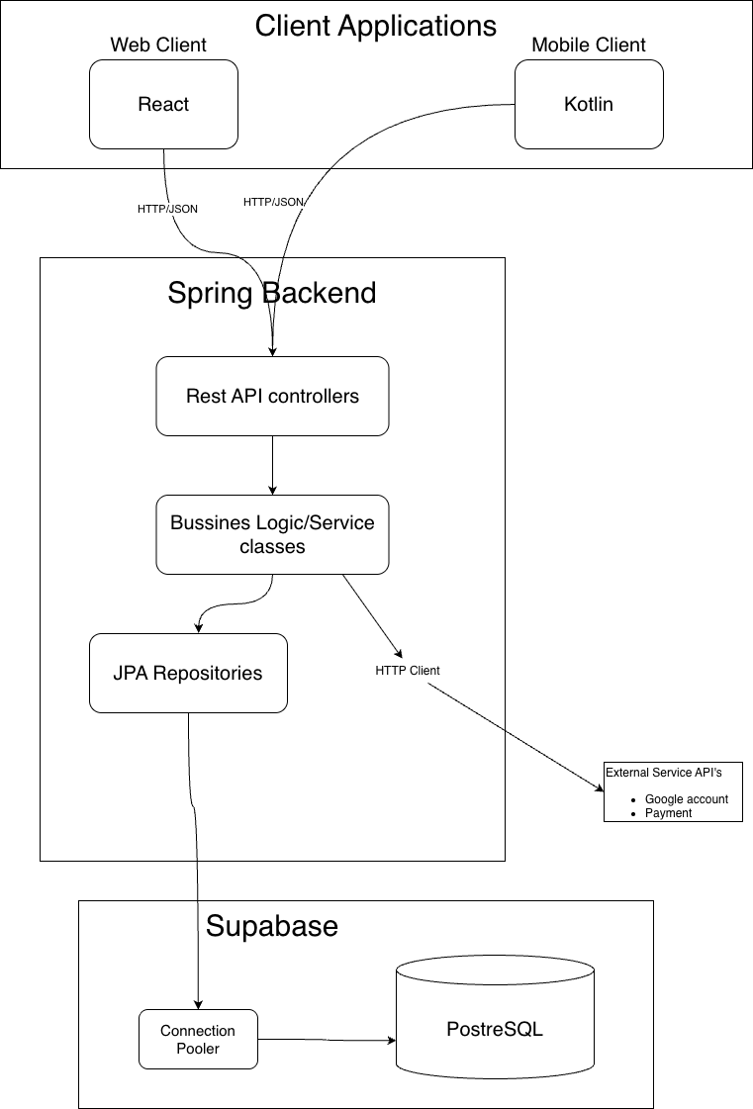
Technology Stack:

Layer | Technology | Version | Purpose
Backend | Java | 17 | Core language
 | Spring Boot | 3.x
 | Spring Security | 6.x
 | Spring data JPA | 3.x
 | JWT | 0.11.x
 | Maven | 3.8+
Database | Postgre SQL/Supabase | 14+ | Primary database
 | Hibernate | 6.x | ORM framework
Web | JavaScript |  | Core language
 | React |  | UI library
 | Axios |  | HTTP client
 | React router |  | routing
Mobile | Koltlin |  | Core language
 | Jetpack compose |  | UI kit
 | retrofit |  | HTTP client
 | gradle |  | Build tool

5.0 API CONTRACT & COMMUNICATION
5.1 API Standards
Base URL | https://[server_hostname]:[port]/api/v1
Format | JSON for all requests/responses
Authentication | Bearer token (JWT) in Authorization header
Response Structure | {  "success": boolean,  "data": object|null,  "error": {  "code": string,  "message": string,  "details": object|null  },  "timestamp": string  }

5.2 Endpoint Specifications

Authentication Endpoints

User Registration
Description | User Registration
API URL | /auth/register
HTTP Request Method | POST
Format | JSON for all requests/responses
Authentication | None
Request Payload | {  “email”: <email>,  “password”: <password>,  “firstname”: <firstname>,  “lastname”: <lastname>,  }
Response Structure | {  "success": boolean,  "data": {  user {  “email”: <email>,  “firstname”: <firstname>,  “lastname”: <lastname>,  },  “accessToken”: <token>,  “refreshToken”: <token>,  },  "error": {  "code": string,  "message": string,  "details": object|null  },  "timestamp": string  }

User Login
Description | User Login
API URL | /auth/login
HTTP Method | POST
Format | JSON for all requests/responses
Authentication | None
Request Payload | {  “email”: <email>,  “password”: <password>,  }
Response Structure | {  "success": boolean,  "data": {  “user”: {  “email”: <email>,  “firstname”: <firstname>,  “lastname”: <lastname>,  “role”: <role>,  },  “accessToken”: <token>,  “refreshToken”: <token>,  },  "error": {  "code": string,  "message": string,  "details": object|null  },  "timestamp": string  }

5.3 Error Handling
HTTP Status Codes
- 200 OK - Successful request
- 201 Created - Resource created
- 400 Bad Request - Invalid input
- 401 Unauthorized - Authentication required/failed
- 403 Forbidden - Insufficient permissions
- 404 Not Found - Resource doesn't exist
- 409 Conflict - Duplicate resource
- 500 Internal Server Error - Server error
Error Code Examples

Example 1 | json  {  "success": false,  "data": null,  "error": {  "code": "AUTH-001",  "message": "Invalid credentials",  "details": "Email or password is incorrect"  },  "timestamp": "2024-01-28T10:30:00Z"  }
Example 2 | {  "success": false,  "data": null,  "error": {  "code": "VALID-001",  "message": "Validation failed",  "details": {  "email": "Email is required",  "password": "Must be at least 8 characters"  }  },  "timestamp": "2024-01-28T10:30:00Z"  }

Common Error Codes
- AUTH-001: Invalid credentials
- AUTH-002: Token expired
- AUTH-003: Insufficient permissions
- VALID-001: Validation failed
- DB-001: Resource not found
- DB-002: Duplicate entry
- BUSINESS-001: Insufficient stock
- SYSTEM-001: Internal server error

6.0 DATABASE DESIGN
6.1 Entity Relationship Diagram
Note: This should be an ERD (Database Schema)

Detailed Relationships:
- One-to-One: Users ↔ Carts (Each user has exactly one cart)
- One-to-Many: Users → Orders (User can have multiple orders)
- One-to-Many: Users → Addresses (user can have multiple address)
- One-to-Many: Carts → CartItems (Cart contains multiple cart_items)
- One-to-Many: Orders → OrderItems (Order contains multiple order_items)
- One-to-One: Payments → Orders
- Many-to-One: CartItems → Products (Items reference products)
- Many-to-One: OrderItems → Products (Items reference products)
- Many-to-One: Products → Categories (product belongs to one category)
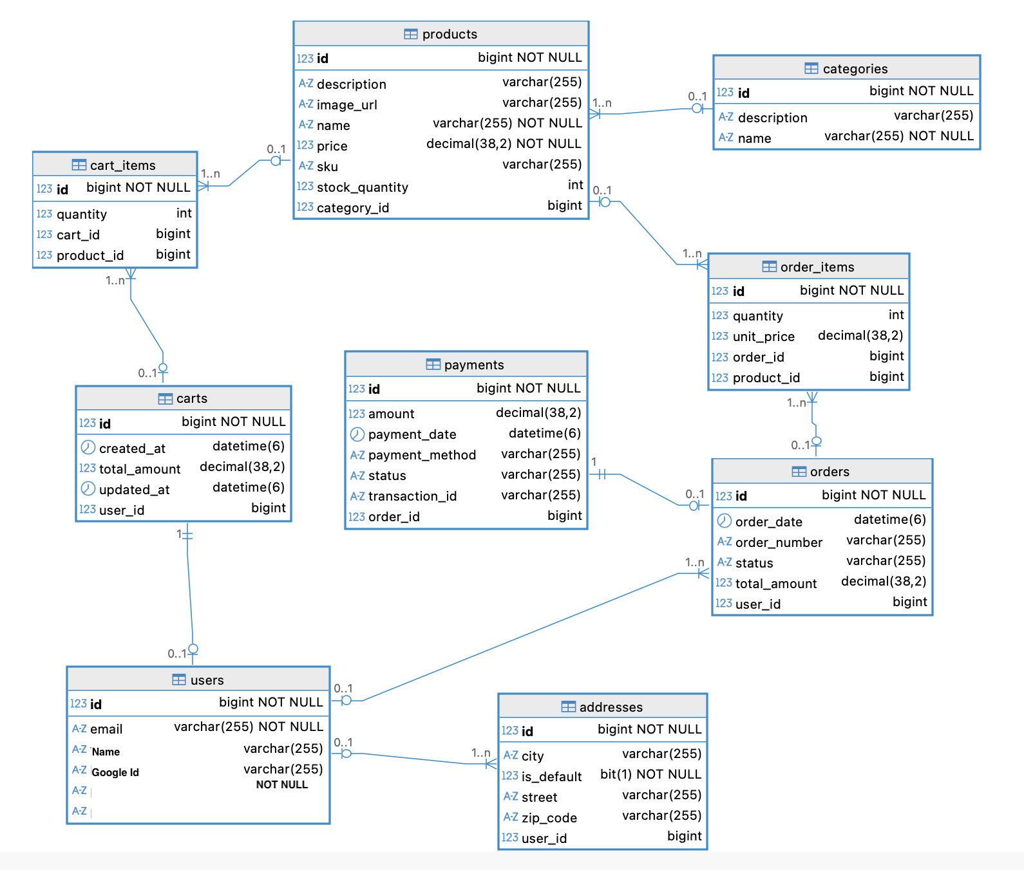

Key Tables:
- users - User accounts and authentication
- products - Product catalog information
- carts - Shopping cart per user
- cart_items - Items in shopping cart
- orders - Customer orders
- order_items - Items in each order
- addresses - user addresses
- categories - product category
- payments - payments for checkout

Table Structure Summary:
- users: id, email, password_hash, full_name, role, created_at
- products: id, name, description, price, stock, image_url, category
- carts: id, user_id, created_at
- cart_items: id, cart_id, product_id, quantity
- orders: id, order_number, user_id, total, status, shipping_address
- order_items: id, order_id, product_id, product_name, quantity, price
- addresses: id, user_id, is_default, street, zip_code
- categories: id,name, description
- payments: id, user_id, order_id, payment_method, status

7.0 UI/UX DESIGN
7.1 Web Application Wireframes
Note: This should be wireframes from Figma
Homepage (Product Listing)
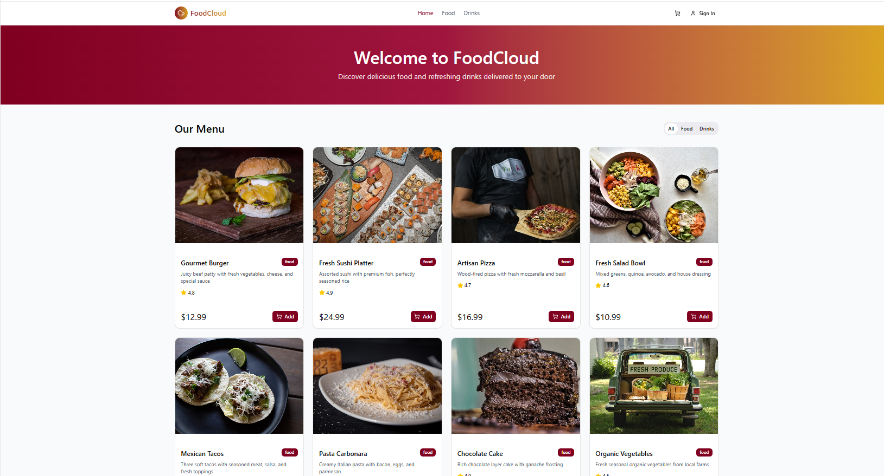

Product Detail Page
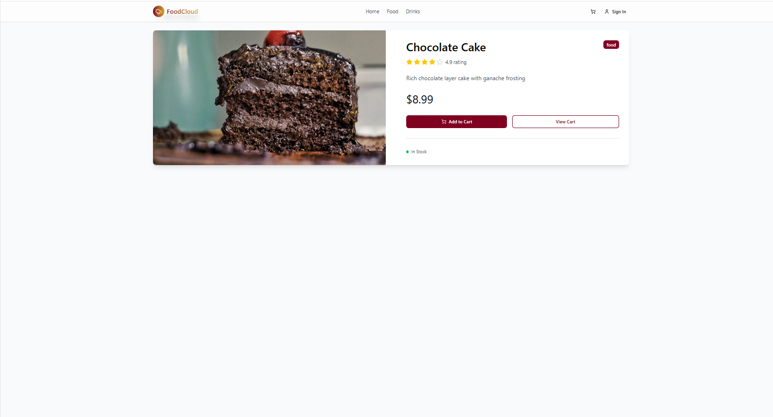

Shopping Cart Page
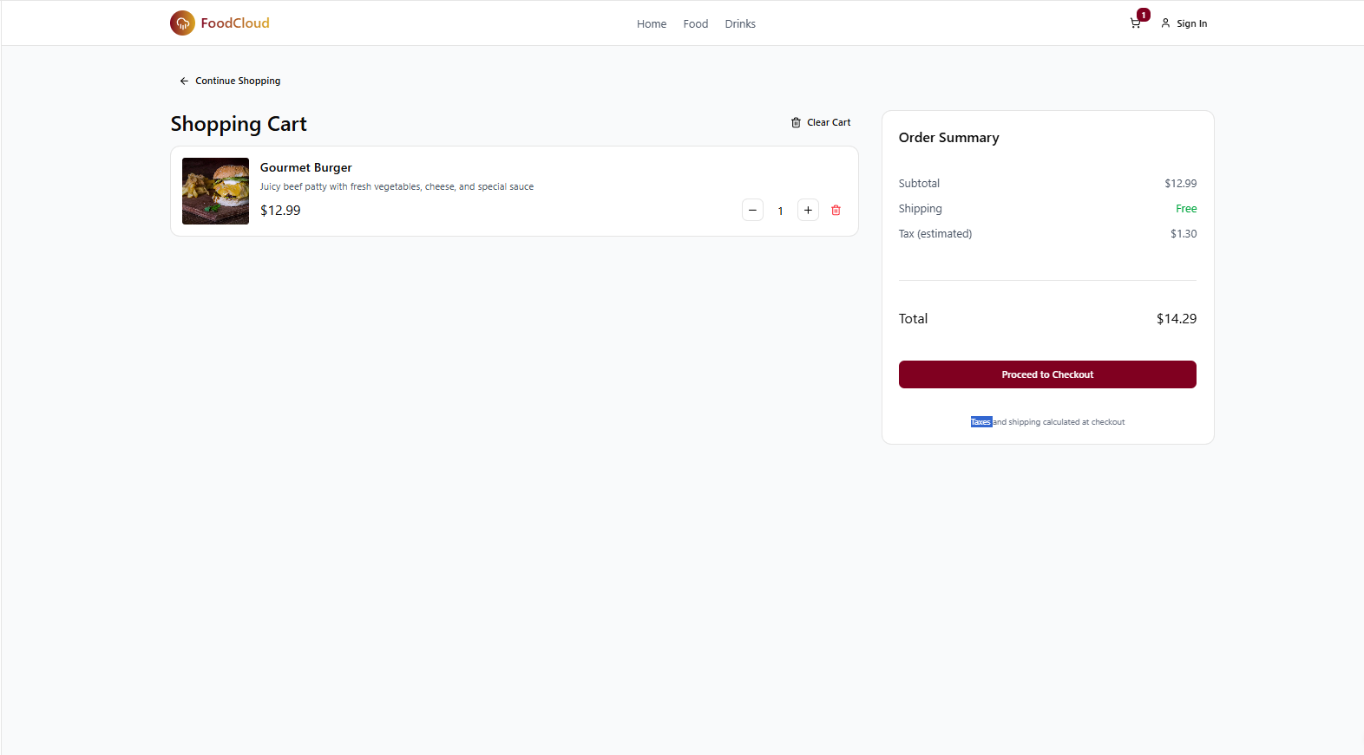

Checkout Page
Shipping Address Form
Order Review (Items, Prices, Totals)
"Place Order" button
Terms and Conditions note

Admin Dashboard
Sidebar Navigation: Dashboard, Products, Orders, Users
Product Management: Add New button, Product list with Edit/Delete
Order Management: Order list with status filters

7.2 Mobile Application Wireframes
Bottom Navigation
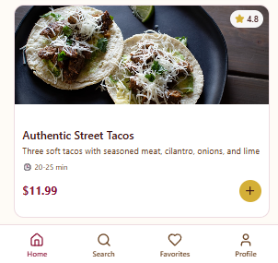
Home Screen
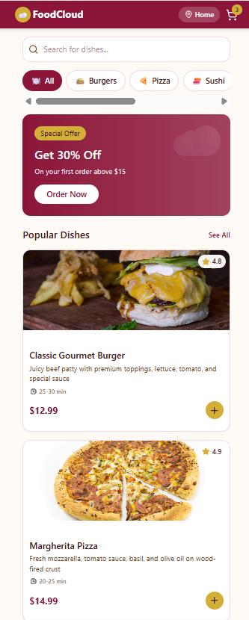

Product Detail Screen
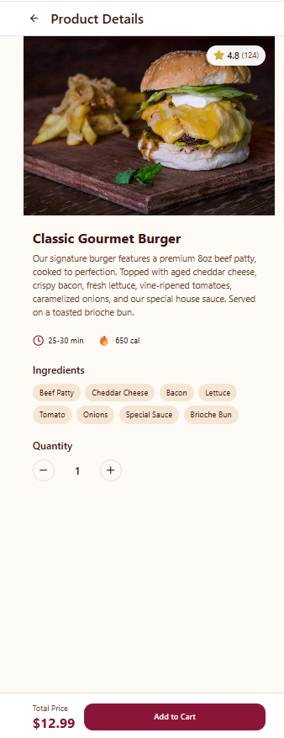

Cart Screen
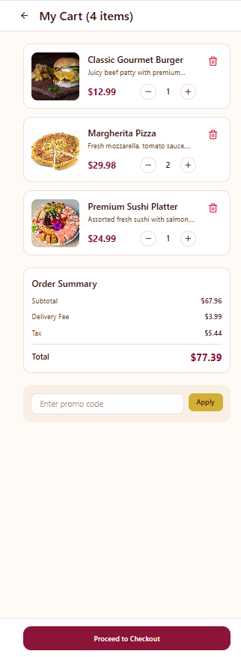

Checkout Flow
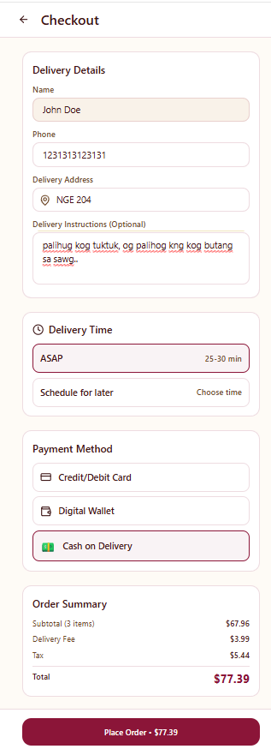
Mobile-Specific Features:
- Touch-optimized buttons (min 44x44px)
- Gesture support (swipe, pull-to-refresh)
- Offline caching for product images
- Bottom navigation for main actions
- Simplified forms for mobile input
Design System:
- Colors: Primary (#2563EB), Secondary (#7C3AED), Success (#10B981), Error (#EF4444)
- Typography: Inter font family, responsive sizing
- Spacing: 8px grid system
- Components: Consistent buttons, inputs, cards, modals
- Responsive: Mobile-first approach, breakpoints at 640px, 768px, 1024px

8.0 PLAN
8.1 Project Timeline
Phase 1: Planning & Design (Week 1-2)
Week 1: Requirements & Architecture
Day 1-2: Project setup and documentation
Day 3-4: Complete FRS and NFR
Day 5-7: System architecture design

Week 2: Detailed Design
Day 1-2: API specification
Day 3-4: Database design
Day 5-6: UI/UX wireframes
Day 7: Implementation plan finalization

Phase 2: Backend Development (Week 3-4)
Week 3: Foundation
Day 1: Spring Boot setup with dependencies
Day 2: Database configuration and entities
Day 3: JWT authentication implementation
Day 4: User management endpoints
Day 5: Product CRUD operations

Week 4: Core Features
Day 1: Cart functionality
Day 2: Order management
Day 3: Search and filtering
Day 4: Error handling and validation
Day 5: API documentation and testing

Phase 3: Web Application (Week 5-6)
Week 5: Frontend Foundation
Day 1: React setup with TypeScript
Day 2: Authentication pages (login, register)
Day 3: Product listing page
Day 4: Product detail page
Day 5: Shopping cart implementation

Week 6: Complete Web Features
Day 1: Checkout flow
Day 2: Order history and confirmation
Day 3: Admin dashboard
Day 4: Responsive design polish
Day 5: API integration and testing

Phase 4: Mobile Application (Week 7-8)
Week 7: Android Foundation
Day 1: Android Studio setup and project structure
Day 2: Authentication screens
Day 3: Product browsing
Day 4: Shopping cart
Day 5: API service layer

Week 8: Complete Mobile App
Day 1: Checkout flow
Day 2: Order management
Day 3: UI polish and animations
Day 4: Testing on emulator/device
Day 5: APK generation and documentation

Phase 5: Integration & Deployment (Week 9-10)
Week 9: Integration Testing
Day 1: End-to-end testing across platforms
Day 2: Bug fixes and optimization
Day 3: Security review
Day 4: Performance testing
Day 5: Documentation updates

Week 10: Deployment
Day 1: Backend deployment (Railway/Heroku)
Day 2: Web app deployment (Vercel/Netlify)
Day 3: Mobile APK distribution
Day 4: Final testing
Day 5: Project submission
Milestones:
- M1 (End Week 2): All design documents complete
- M2 (End Week 4): Backend API fully functional
- M3 (End Week 6): Web application complete
- M4 (End Week 8): Mobile application complete
- M5 (End Week 10): Full system deployed and integrated
Critical Path:
- Authentication system (Week 3)
- Product catalog API (Week 3-4)
- Shopping cart functionality (Week 4)
- Checkout process (Week 6)
- Cross-platform testing (Week 9)
Risk Mitigation:
- Start with simplest working version of each feature
- Test integration points early and often
- Keep backup of working versions
- Focus on core functionality before enhancements

