BD anal

Wills et al

Oct, 2018

General Anlysis of BD data collected. mutliple methods and projects

Data import and prep

## [1] "File downloaded from https://nrcs.box.com/s/tomz9nl719v1e7r4y84d9rv7tn1vnnpz"

## ####Data Prep

#############  
BD <- read_csv('BD_compare.csv' , col_types = "cccccccnnccnnnnncccccccc")  
  
#when there is not project substitute the first word in the submit project name (extract from 1 to the first blank)  
BD$DSP_Project <- ifelse(!is.na(BD$DSP_Project), BD$DSP_Project,   
 substr(BD$submit_proj_name,1, regexpr(" ",BD$submit_proj_name)-1))  
  
BD$BD_diff <- BD$Clod - BD$Core  
  
BD$CROP <- ifelse(BD$Crop != "NA", BD$Crop, substr(BD$lay_field_label3, 1,4))

## SUMMARY PLOTS

#### properties should be selectable via dropdown menu

#scatter plots of BD methods  
  
grid.arrange(   
 BD %>% ggplot(aes(x = Clod, y = Core)) + geom_point(),  
 BD %>% ggplot(aes(x = Clod, y = Compliant_Cavity)) + geom_point(),  
 BD %>% ggplot(aes(x = Clod, y = ars_bd)) + geom_point() + scale_x_continuous(limits = c(0.5,2)) +  
 scale_y_continuous(limits = c(0.5, 2)),  
 BD %>% ggplot(aes(x = Core, y = ars_bd)) + geom_point()+ scale_x_continuous(limits = c(0.5,2)) +  
 scale_y_continuous(limits = c(0.5, 2)),  
ncol = 2)

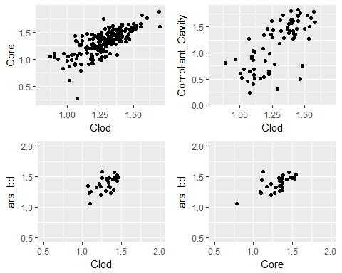

BD %>% ggplot(aes(x = Clod, y = BD_diff)) + geom_point()

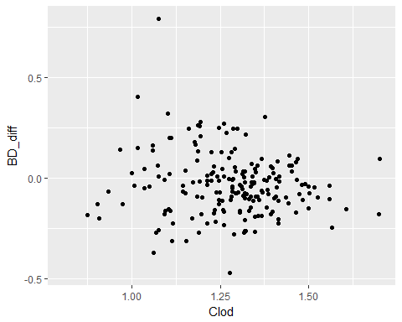

BD %>% ggplot(aes(x = Clod, y = Core)) + geom_point(aes(color = DSP_Project))

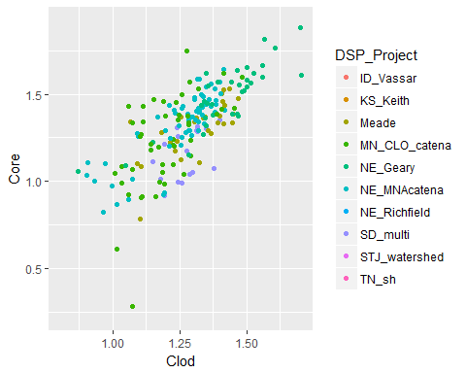

BD %>% ggplot(aes(x = Clod, y = Core, color = DSP_Project)) + geom_point() + geom_smooth(method = "lm")

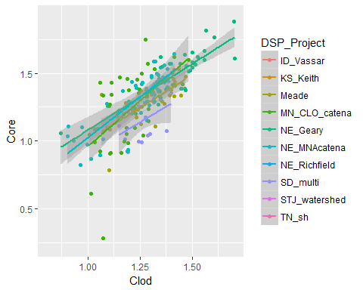

BD %>% ggplot(aes(x = Clod, y = Core, color = texture_description)) + geom_point() + geom_smooth(method = "lm")

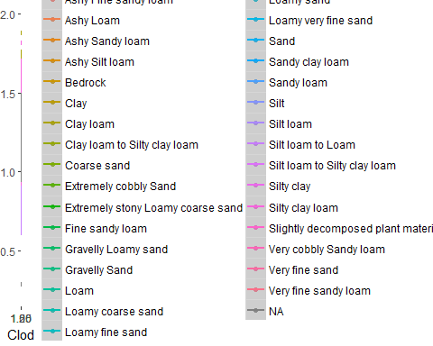

BD %>% ggplot(aes(x = Clod, y = Core, color = MGMT)) + geom_point() + geom_smooth(method = "lm")

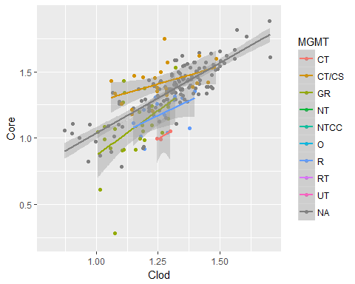

#function to add regression equations  
 ggplotRegression <- function (fit) {  
   
 require(ggplot2)  
   
 ggplot(fit$model, aes_string(x = names(fit$model)[2], y = names(fit$model)[1])) +   
 geom_point() +  
 stat_smooth(method = "lm", col = "red") +  
 labs(title = paste("Adj R2 = ",signif(summary(fit)$adj.r.squared, 5),  
 "Intercept =",signif(fit$coef[[1]],5 ),  
 " Slope =",signif(fit$coef[[2]], 5),  
 " P =",signif(summary(fit)$coef[2,4], 5)))  
}  
  
 fit1 <- lm(Clod ~ Core,BD)  
 ggplotRegression(fit1)

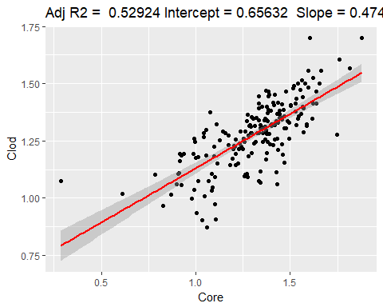

fit2 <- lm(Clod ~ Compliant_Cavity, BD)  
 ggplotRegression(fit2)

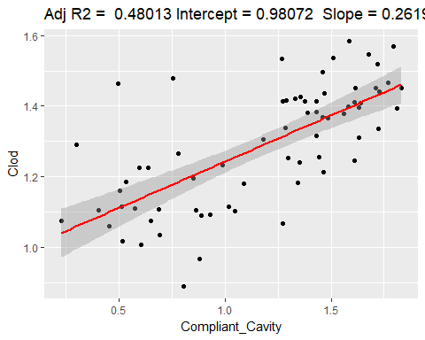

fit_ars <- lm(Clod ~ ars_bd, BD)  
 ggplotRegression(fit_ars)

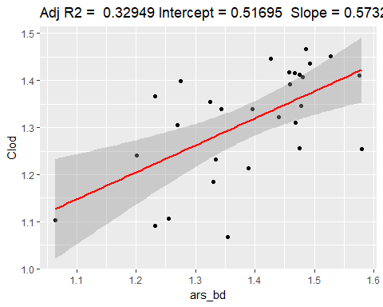

fit_cores <- lm(Core ~ ars_bd, BD)  
 ggplotRegression(fit_cores)

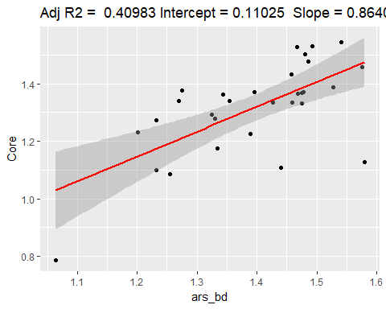

bd <- BD %>%   
 mutate(Clod_compare = Clod) %>%  
 gather(key = "Method", value = "BD", -c(lab_proj_name:texture_description, DSP_Project:Clod_compare))  
  
  
bd %>% ggplot(aes(y = BD, x = Method)) + geom_boxplot()

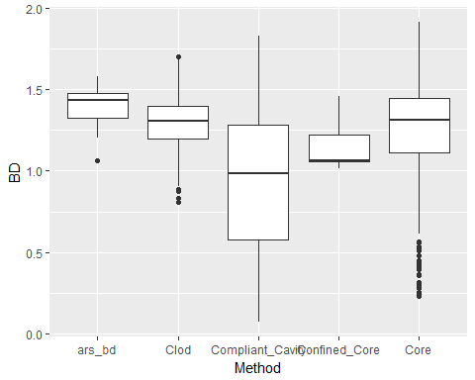

bd %>% ggplot(aes(y = BD, x = Method)) + geom_boxplot(aes(fill = DSP_Project))

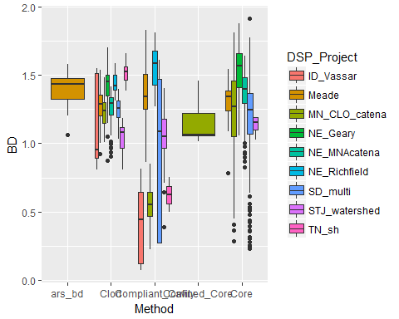

bd %>% filter(DSP_Project == "Meade") %>%  
 ggplot(aes(y = BD, x = Method)) + geom_boxplot(aes(fill = DSP_Project))

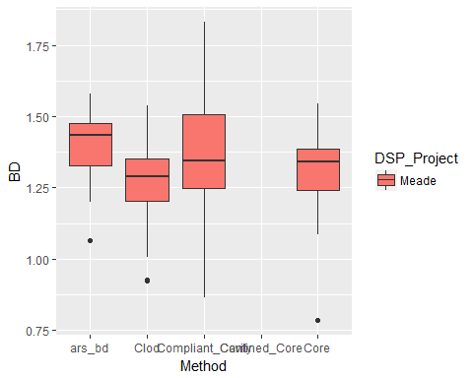

bd %>%  
 ggplot(aes(y = BD, x = Method)) + geom_boxplot(aes(fill = DSP_Project)) + facet_wrap(~DSP_Project) +  
 theme(axis.text.x = element_text(angle = 45, hjust = 1))

