CSE5280
Assignment Floor Plan Analysis

Analysis
2.1
Wall thickness affects how the animation travels to the goal. Wall thickness, regardless of function, increase the influence radius of when the cost function gets added to the cost function which directly changes how far the path finding algorithm moves.
We can see in the first Image. The Radius is set to 0.5 and the second image is set to 3. The large radius has greater influence which caused bigger fluctuations for the point to move. More importantly, the path the function chooses stays further away from the wall.
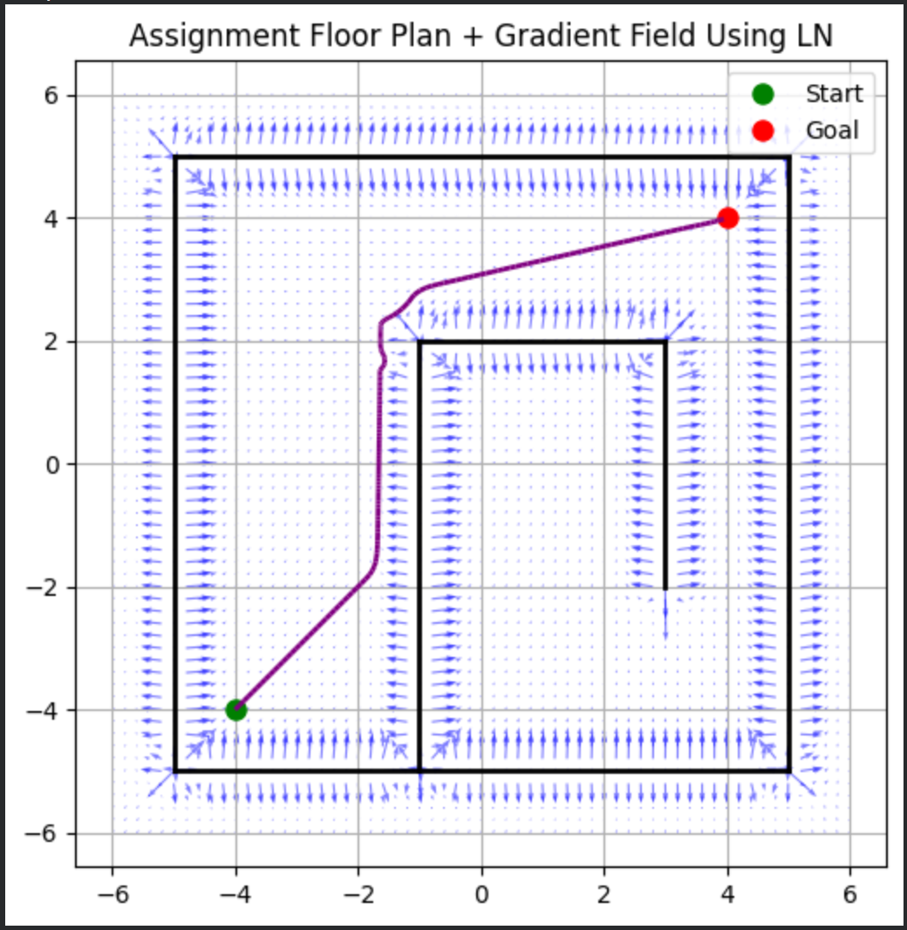

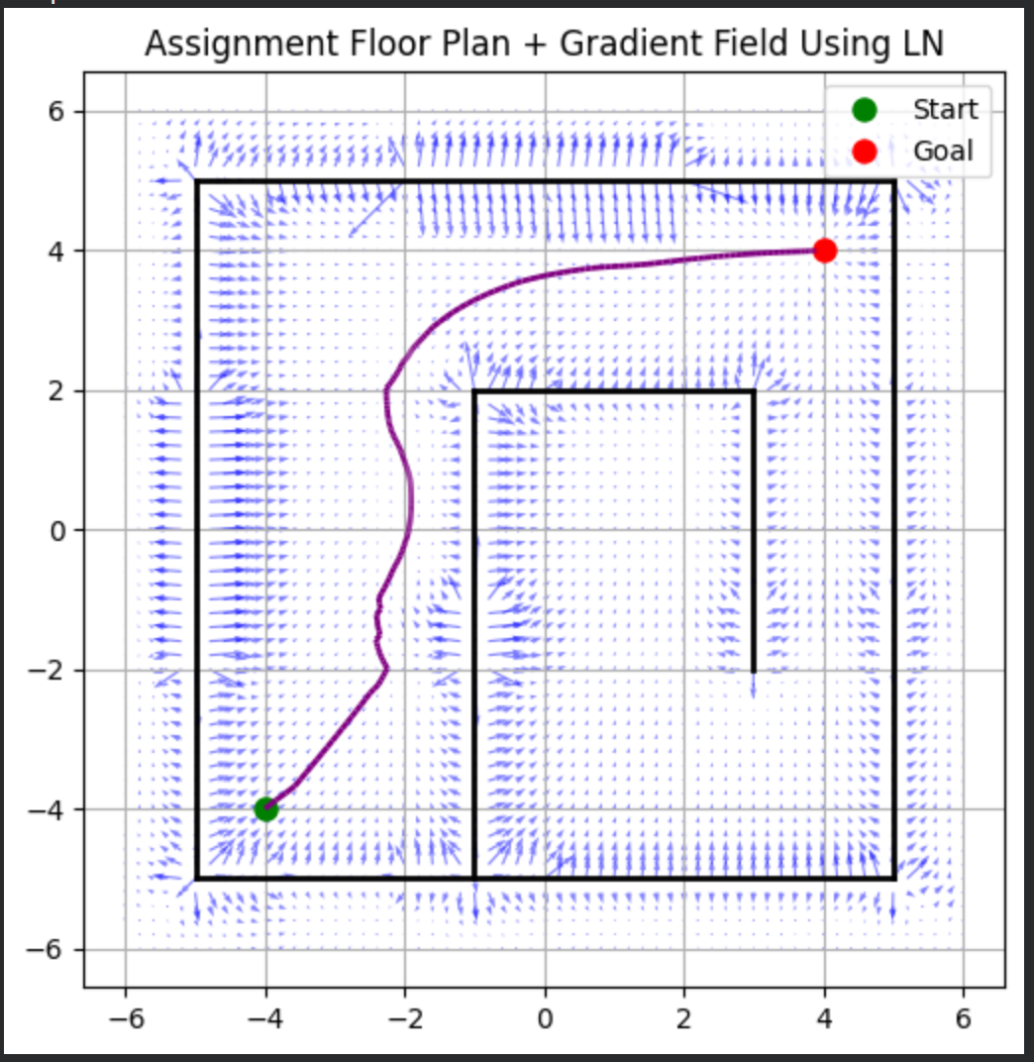
2.2.
Around corners, the cost function weakens and then strengthens as you reach the corner. You can see in the previous images, it shows a small dip in the gradient before hitting the corner and then regaining strength or more strength afterwards.

We can look at the zig-zag map to see what happens in narrow corridors
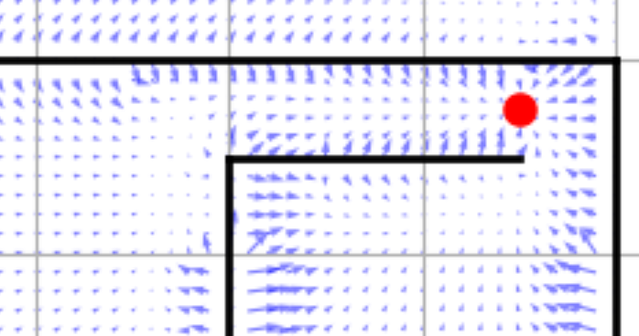
Looking at the image, the walls cost function causes the vector to push towards the center of the corridors and narrowing the space needed to reach the goal. This can cause blockages where the path finding function will get stuck and not find the narrow path.

2.3
The method can get stuck cause the function runs the greediest path towards the goal regardless of if the path reaches a dead end. Looking at the symmetric map, we can see that the path runs right into a dead end, but the gradient function greedily tells the path finding to go towards the goal instead of around the wall first.

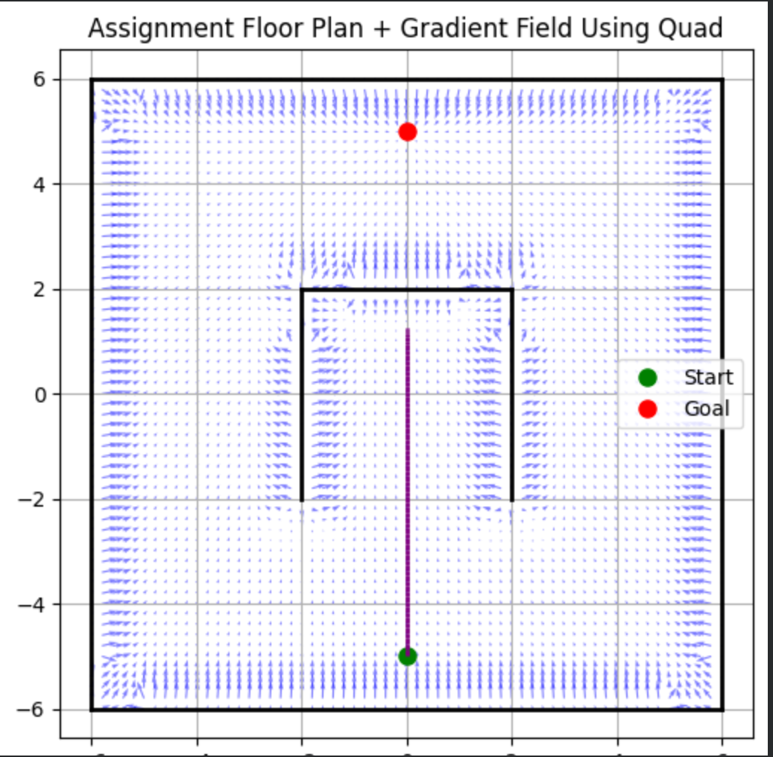
The gradient decent algorithm only follows local influences, but it does not see ahead and checks if the direction leads towards the goal. So, in the function, the vectors can get stuck at a wall creating “pockets” where the path finding can get trapped. We can see a similar subtle effect with corners
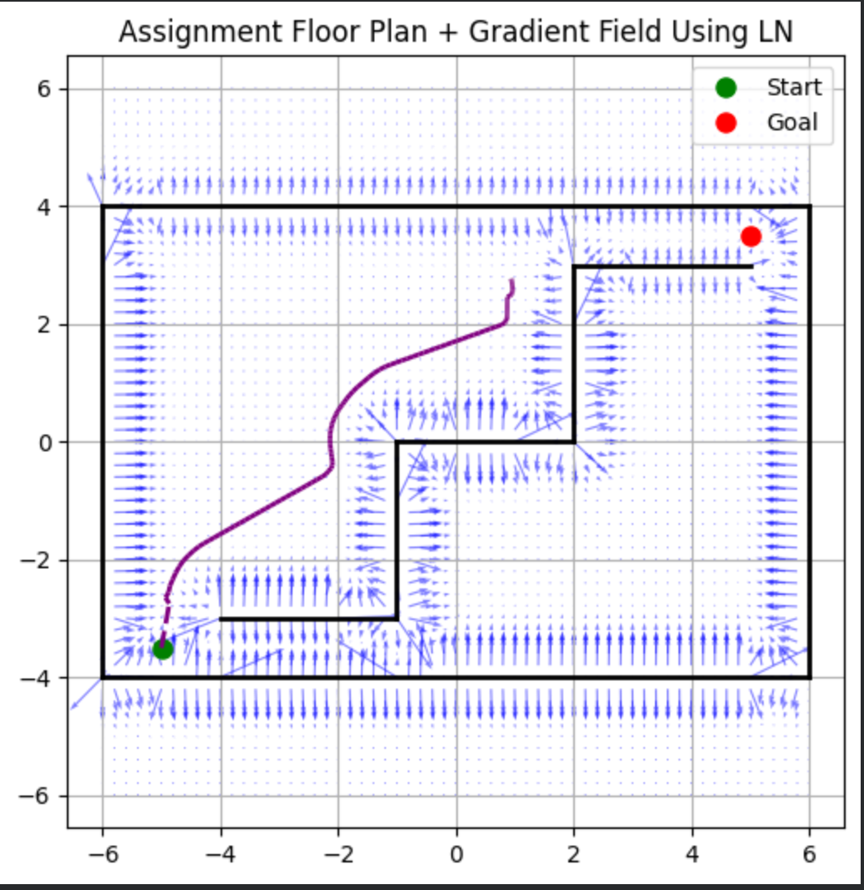
You can see where the pathfinding gets trapped due to the corner having a bit of a drop in strength causing a miniature pocket that the path finding function gets stuck in.

