Privacy-Preserving and Trustworthy Cyber-Infrastructures– Homework 1
Tam Nguyen, Phong Nguyen
- Section 1
ALICE
In our implementation, Alice acts as a sender in a simple stream cipher that uses ChaCha20 as a pseudorandom generator and XOR for encryption. Alice reads the plaintext form “Message.txt” and a 32-bytes share seed from “ShareSeed.txt”, both as unsigned char * arrays so that all operations work on raw binary data. Using shared seed, Alice generates a keystream of the same length as messages with ChaCha20 PRNG, the XORs each plaintext byte with the corresponding keystream byte to produce the ciphertext. Then write both the key and ciphertext to “Key.txt” and “Ciphertext.txt” in hexadecimal format.
ChaCha20 PRNG: Uses seed as key with fixed zero nonce
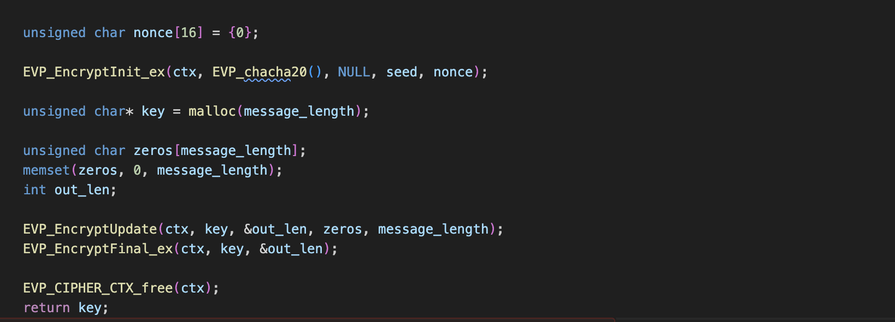
Figure 1: ChaCha20-based PRNG Keystream Generation for Alice
Encrypting zeros extract raw ChaCha20 keystream deterministically.
XORs encryption: C_i = P_i XOR K
SHA-256 verification: After Bob writes “Hash.txt”. Alice reads Bob’s hash as hex string and recomputes SHA-256 hash of her original plaintext message. Then compares her local digest with the one Bob produced. If they match, acknowledgement successfully, otherwise acknowledge failed. SHA-256 digest serves as an integrity check.

BOB
Bob acts as a receiver. Beforehand, Bob and Alice must agree on a shared seed for the PRNG. In our case, because Alice and Bob are on the same machine, we use “SharedSeed.txt”. However, in real-life scenarios, this seed needs to be distributed via a secure protocol. For a communication session, Bob creates a secret key using the PRNG on his side. This key can then be used to decrypt the ciphertext from Alice.
Plaintext P1 is calculated using this formula:
P = C XOR K, where C is the ciphertext, and K is the secret key.

Description XOR is described programmatically in figure 2.
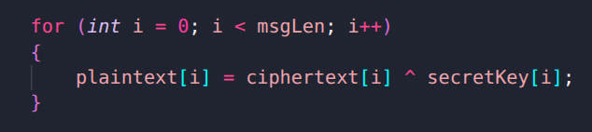
Figure 2: Decryption method to retrieve plaintext from ciphertext. Each byte from ciphertext is XORed with each byte from secret key. The result is a plaintext bytes format.

After message decryption, Alice wants to validate the correctness from Bob’s side; we use hashing for this purpose. Because hashing is a 1-way function, which is easy to compare but hard to reverse, Bob can hash the plaintext and send it back to Alice for validation (Figure 3). We use SHA256 as a hashing method to produce 32-byte hashed text. This text is written with 64 HEX characters in “Hash.txt”.
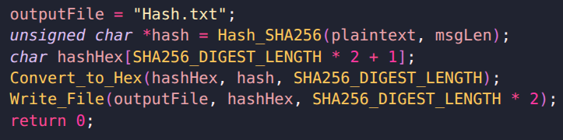
Figure 3: SHA256 Hashing process on Bob side.

- Section 2
A. Potential Vulnerabilities:
In the case of computer crashes where only the code is restarted, it creates a critical vulnerability. A potential attack is designed as below:
Only the code is restarted, but the secret key isn't recycled -> attackers can send fake messages and reveal authentic messages from users.
Let's consider a user's message P1 and ciphertext C1 and secret key K
-> C1 = P1 XOR K.
The attacker composes fake P*, and the server returns C* = P* XOR K. Because both C1 and C* are available to the public, the attacker can do:
C1 XOR C* = (P1 XOR K) XOR (P* XOR K) = P1 XOR P*
Then, P1 can be revealed:
P1 = (C1 XOR C*) XOR P* = P1 XOR P* XOR P* = P1
B. Potential Remedies
To mitigate this risk, the root cause must be addressed, so we must ensure the PRNG input is unique for every session, even if the secret key remains the same: Here are two approaches:
- State/Counter: A PRNG must be supported by a state to ensure unique randomness. The software should implement a counter(cnt) that is saved to the hard dish and incremented before every encryption operation.
r_i = PRNG(seed | cnt_i) where: | is concatenation operation
Since cnt_new > cnt_old so the input to the PRNG is always unique

- Fresh TRNG: TRNGs provide true unpredictability. The software must connect to a secure server (or random beacon) to request a fresh random “Nonce” (N) (or session ID. This Nonce is used to diversify the session key.
SessionSeed = Hash (seed | N_i) where: | is concatenation operation
Keystream = PRNG(SessionSeed)
Since N is unique for every request (high entropy), the SessionSeed will be different from the one used before the crash, completely changing the keystream.

