Module 1 — Understanding Agentic AI

Chapter 1 — From AI Chatbot to AI Employee
Estimated reading time: 15–20 minutes
Difficulty: Beginner

Learning Objectives
By the end of this chapter, you will be able to:
- Explain the difference between Generative AI and an AI Agent.
- Describe why a chatbot is not the same as an autonomous worker.
- Identify the four capabilities that make an AI system "agentic."
- Relate these concepts directly to your Facebook Airbnb Marketing Agent project.

1.1 The Big Picture
Imagine you hire two people to help with your Airbnb business.

Employee A
Answers questions only.
- "How many guests can your Airbnb accommodate?"
- "Do you have WiFi?"
- "Where is the property located?"
After answering, the work stops.

Employee B
Actually helps run the business.
- Reads new Facebook posts.
- Determines whether someone is looking for accommodation.
- Checks your calendar.
- Calculates availability.
- Writes a persuasive reply.
- Posts the reply.
- Records the interaction.
Employee B is far more valuable.
Employee A is a chatbot.
Employee B is an AI agent.
That single distinction is the foundation of everything we will build.

1.2 What Is Generative AI?
Generative AI is a system that can create new content such as:
- Text
- Images
- Audio
- Video
- Code
Examples include:
- ChatGPT
- Claude
- Amazon Nova
- Gemini
When you ask:
"Write a friendly Airbnb reply for a customer looking for a staycation."
the model generates text based on patterns learned from enormous amounts of training data.
Think of it as a brilliant writer.
It knows language extremely well.
It does not automatically know your calendar, your Facebook groups, or your business rules.

1.3 Why a Chatbot Is Not Enough
Suppose a Facebook user posts:
"Looking for accommodation for 6 adults this July 20–22 near Tagaytay."
A normal chatbot can produce a nice sentence such as:
"Our Airbnb may be suitable for your group of six guests."
But it cannot answer the most important business question:
"Are those dates actually available?"
To answer that, the system must interact with the real world.

1.4 The Missing Ingredient: Actions
An AI becomes agentic when it can perform actions.
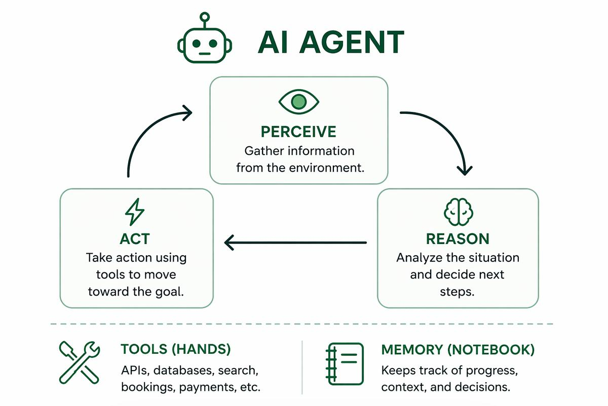
For our project, the agent must be able to:
Understand
Read the post
Think
Extract guests & dates
Use Tools
Check calendar
Act
Reply on Facebook
These four capabilities are the core of nearly every modern AI agent system.

1.5 The Four Agent Superpowers

Superpower #1 — Understand
Input:
"Need a staycation for 7 adults this weekend."
Extracted information:
Intent
Accommodation request
Guests
7
Dates
This weekend
Location
Not specified
This is called intent extraction.

Superpower #2 — Think
The agent reasons:
"I know the guest count and approximate dates. I should check availability before responding."
This is reasoning.

Superpower #3 — Use Tools
Humans use tools such as calculators, phones, and calendars.
AI agents use APIs and functions.
Example tool call:
Tool response:
The model itself did not know this information. The tool provided it.

Superpower #4 — Act
Now the agent performs work:
The customer receives a useful response, and your business moves forward automatically.

1.6 The Brain and the Hands
This is one of the most important mental models in the entire course.
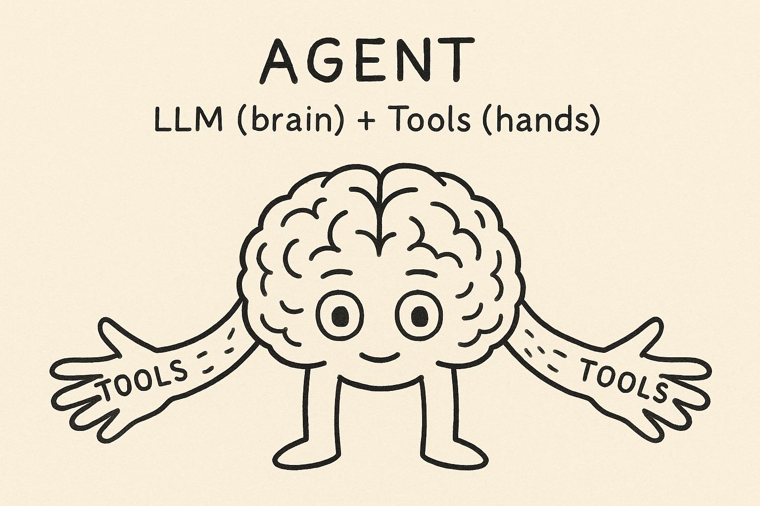

Brain (LLM)
- Understands language
- Reasons about problems
- Plans next steps
- Generates responses

Hands (Tools)
- Check calendars
- Read databases
- Call APIs
- Post comments
- Save records
Rule to remember:
The model thinks. The tools do.
Whenever you are confused about an AI architecture, ask:
"Is this something the model can infer, or something a tool must fetch?"
Availability, prices, bookings, and Facebook posts are tool data, not model knowledge.

1.7 Applying This to Your Project
Let's walk through a real example.
Facebook Post
"Looking for accommodation for 8 people on August 12–14."
The agent's internal workflow:
1
Understand → guests = 8, dates = Aug 12–14
2
Think → "I need availability before answering."
3
Use Tool → check_calendar(Aug 12–14)
4
Observe Result → available = true
5
Act → generate and post a marketing reply
Final reply:
Hi! 😊 Great news—our Airbnb can comfortably accommodate 8 guests, and the dates Aug 12–14 are currently available. The property includes a private pool, fast WiFi, a fully equipped kitchen, and free parking. Here's the listing link: …
That is an end-to-end agentic workflow.

1.8 Why This Matters
Many beginners believe AI projects are mostly about prompts.
In reality, production AI systems are mostly about orchestration:
- When should the model run?
- What tools can it use?
- What permissions does it have?
- What happens if a tool fails?
- How do we log decisions?
- How do we prevent bad actions?
- How do we scale safely?
This is exactly why Amazon Bedrock AgentCore exists.
We'll dive into AgentCore in later chapters, but for now remember:
Bedrock gives us the brain. AgentCore helps us build the worker.

1.9 Knowledge Check
Quick Quiz
- What is the difference between a chatbot and an AI agent?
- Why can't a language model know your Airbnb availability by itself?
- What are the four agent superpowers?
- In our project, which capability checks the calendar?
- What is the difference between the "brain" and the "hands"?
Answers
- A chatbot mainly answers questions; an AI agent performs tasks and takes actions.
- Because availability is real-time external data, not training knowledge.
- Understand, Think, Use Tools, Act.
- Use Tools.
- The brain (LLM) reasons and generates language; the hands (tools) interact with external systems.

1.10 Chapter Summary
You learned
- Generative AI creates content.
- An AI Agent creates content and performs actions.
- Agentic systems combine reasoning + tools + actions.
- The LLM is the brain; external tools are the hands.
- Your Facebook Airbnb system is fundamentally an AI employee, not a chatbot.

Coming Next
In Chapter 2 — The Evolution from Automation to AI Agents, we'll answer a deeper question:
"If we can already automate workflows with code, why do we need AI agents at all?"
You'll learn the difference between:
- Traditional automation
- Rule-based systems
- AI-assisted workflows
- Fully agentic systems
That chapter will give you the architectural mindset used by modern AI engineering teams.
End of Module 1 — Chapter 1

