Land-Ocean Warming: From Emergent Property to Simple Parameterization

Skylar Gering

August 2020

## Abstract

  Climate models are used to predict the future state of the earth system and range in complexity from earth system models (ESMs) to simple climate models (SCMs). SCMs can be parameterized with emergent properties from ESMs in order to increase predictive accuracy and physical realism. One such property is the land-ocean warming ratio, the relationship of the warming of air over land to that of air over ocean. The SCM Hector (version 2.3.0) lacked a parameterization of this property, which introduced inaccuracies into its sub-model calculations. I used Coupled Model Intercomparison Project (CMIP6) data to calculate an emergent warming ratio 1.591 across 17 different ESMs and incorporated this value as a tunable parameter into Hector’s configuration files. The model uses this value to differentiate land and ocean warming from the global mean; downstream changes were also made so that land, ocean, and global temperatures are used as appropriate, for example in calculating the temperature sensitivity of terrestrial respiration. These changes produce more realistic predictions of warming scenarios over land and sea and provide a robust basis for analyses of climate mitigation targets, the effects of permafrost thaw, and other couple natural-human processes in the Earth system.

## Background

### Climate Modeling

      Scientists have created a multitude of climate models to predict the future state of the earth system and its responses to climate forcings. Some of the most complex models are fully coupled earth system models (ESMs), which split the earth and its atmosphere into a large grid system and then use scientific governing equations to calculate the state of the land, ocean, and atmosphere within each grid cell. All of these calculations make ESMs are very computationally expensive and they can take weeks or even months to run (Hartin et al. 2015). ESMs outputs includes data such as estimated future warming and CO2 levels and can reveal new details about the earth system in the form of patterns or constants with physical meanings. An example of one such emergent property that can be deduced from ESMs is the equilibrium climate sensitivity, or the level of warming that can be expected with a doubling of CO2. Additionally, ESMs are the models in the International Panel on Climate Change’s Coupled Model Intercomparison Project, which compares the results of models from modeling groups around the globe. Data from the sixth phase of the coupled Model Intercomparison Project (CMIP6) will be used later in this paper.

      Simple climate models (SCMs) on the other hand only preform vital calculations and have a lower spacial and temporal resolution then ESMs, calculating values globally rather than within many grid cells. Due to their relative simplicity, SCMs can be run almost instantaneously and thus run much more frequently than ESMs. Additionally, emergent properties from ESMs can be incorporated into SCMs as constant to replace the complex calculations present in ESMs (Meinshausen, Raper, and Wigley 2011). When paramaterized with values from ESMs, SCMs can be used to emulate these more complex models, allowing scientists to run a large range of emissions scenarios, and thus gain a greater understanding of potential futures. SCMs can also be used to investigate particular subsets of climate systems by varying inputs over numerous runs in factor separation analysis. Since SCMs offer numerous research benefits for little computational cost, it is vital to make them as accurate as possible without increasing the computational complexity.  
      The Joint Global Change Institute, a joint research facility between Pacific Northwest National Laboratory and University of Maryland, College Park, developed the simple climate carbon-cycle model Hector in the period between 2010-2015. Hector is an open-source, object-oriented model designed to be easy to expand and couple with more complex climate models such as GCAM, as well as acting as a stand alone model that can produce transparent, reproducible data (Hartin et al. 2015). Hector is composed of several distinct sub-models, including temperature, land and ocean, melded together with a coupler that transmits data between distinct components. Hector can be run for a variety or warming scenarios, which specify CO2 output and other forcing factors based on predicted human activity. Warming scenarios range from the low emissions scenario, RCP 2.6, to the high emissions scenario, RCP 8.5, that humanity currently seems to be on.

### Scientific Theory

      Direct observations and climate models show that the air over the land warms faster than the air over the ocean in climate change scenarios. The ratio of warming over land to warming over ocean is called the land-ocean warming ratio. An initial explanation for this ratio was the large thermal inertia of the ocean in comparison to that of the land. However, it was proven that the ocean’s large heat capacity was not the primary cause of the land-ocean warming ratio since it was still present in climate models with a slab ocean (i.e. the ocean was already in a state of thermal equilibrium), although it is a contributing factor (Joshi et al. 2008).  
      Rather, the land-ocean warming constant is driven by earth’s surface energy budget. Much of the solar radiation that falls on the ocean causes evaporation rather than warming of the ocean or the air above it (Sejas et al. 2014). This latent heat flux is in direct contrast to the sensible heat flux that occurs over the land. Due to the lack of moisture in the soil, shortwave radiation heats the land, and the heat is then released into the air above it. Additionally, the increased atmospheric CO2 in global warming scenarios leads to decreased stomatal conductance in plants, which further decreases evaporation over land (Dong, Gregory, and Sutton 2009).  
      Further contributing to this feedback loop, the increased evaporation over the ocean causes a lower lifted condensation level (LCL) and thus an increase in cloud cover, which blocks incoming shortwave radiation (Sejas et al. 2014). Additionally, the difference in LCL over ocean versus land affects the lapse rate of air parcels over the land and ocean, which is theorized to further contribute to the occurrence of the warming ratio (Joshi et al. 2008).  
      Understanding the land-ocean warming constant is important to accurately estimating future warming over both land and ocean. Being able to predict and understand the increased rate of warming that human settlements will undergo on land is important in planning for climate mitigation and resiliency. Integrating the land-ocean warming constant into climate models allows scientists to more accurately predict the future of the planet.

## Methods

      The purpose of this project is to take CMIP6 data and calculate the land-ocean warming constant, an emergent property, and add it as a new parameter in Hector. See Appendix A for information on code availability and function.

### Land-Ocean Warming Ratio Calculations

      The first step of this project was to calculate a reasonable parameterization for the land-ocean warming constant. As mentioned above, the CMIP6 data set was used for this analysis. Specifically, data from one-percent CO2 runs was selected, as these runs represent an idealized climate change scenario with CO2 levels increasing from pre-industrial levels by 1% per year until they double and are then held constant. Since this type of experiment has consistently changing input forces, it provides very clean data. Additionally, the runs are focused on CO2 forcing without other confounding factors such as aerosols. Since CO2 forcing is very well understood, the data is easily interpretable and allows for simpler calculations. Since the land-ocean-warming constant is an emergent property of the system of equations controlling the various models, it is important to have clear data so not to confound the values.

      Additionally, only data from ensemble ‘r1i1p1f1’ was used. Different ensembles represent different starting conditions for each model run. Each ensemble has a specific realization index, initialization index, physics index, and forcing index. A choice of 1 for each of these indexes represents very standard setup and conditions for the run. Further limiting the available data, calculating the land-ocean warming constant requires temperature data as well as a land map made with grid area data and data representing the fractional component of each grid taken up by land. Using all of these criteria, the following 18 models were selected to analyze: ACCESS-CM2, ACCESS-ESM1-5, BCC-ESM1, CanESM5, CESM2, CESM2-WACCM, E3SM-1-0, GFDL-CM4, INM-CM4-8, INM-CM5-0, IPSL-CM6A-LR, MIROC6, MPI-ESM1-2-LR, MRI-ESM2-0, NorCPM1, NorESM2-LM, NorESM2-MM, SAM0-UNICON.

      Each of these models has temperature data, grid area data, and fractional area data as described above in netCDF files. The average annual global, land, and ocean temperatures were calculated using a script leveraging Climate Data Operator (CDO), a collection of command line operators specialized to work on climate data. The script was run on PNNL’s supercomputer PIC. The script output a CSV file containing the temperatures organized by ensemble, model, data type (land, ocean, or global), and time step.

      This output data was then cleaned with an R script on a local machine that removed data that was outside of the plausible temperature range or did not run for the minimum number of years needed, 150 years, and then output a cleaned version of the CSV file. This cleaned data was then used to determine the warming ratio over time.

      The R script developed to calculate the warming ratio averages both the annual land and ocean air warming data sets over 5 distinct 30 year periods for each model. Then, using the value from the first 30 year period as a baseline, the warming for each subsequent time period is calculated for both land and ocean. Finally, the corresponding land and ocean warming for each model and time step are compared to determine the warming ratio. This final data is also output in CSV format to the local machine, which can be used to calculate the median warming ratio for use in the rest of the project.

### Hector C++ Code Modifications

      When working with Hector’s C++ code base, I noticed that not all downstream calculations used the most specific warming for the respective calculations. Thus, the fist step was to ensure that all of Hector’s sub-models used the correct temperature value (i.e. global, land, or ocean air) for their calculations. These downstream changes increase the predictive accuracy of the model and increase the physical realism. In this project, the land sub-model was edited to use the temperature over land rather than global average temperature in its calculations, which affects the calculation of soil respiration. The ocean component of the model was similarly edited to use the temperature of air over the ocean, potentially changing atmospheric-ocean flux. After making these downstream changes, the next step was to add a tunable parameter for land-ocean warming ratio in Hector and expose the parameter in the R interface.

      Within the temperature component, Hector uses DOECLIM calculations to estimate the sea surface temperature, land temperature, and global average temperature (DOECLIM citation here). Before modifications, the land-ocean warming ratio was an emergent property from these calculations. After modifications, users have the option to use the DOECLIM global average temperature and the land-ocean warming ratio parameter to calculate new values for the the ocean air temperature and land temperature. The ocean air temperature can then be used to calculate the sea surface temperature. These three new values then override the DOECLIM calculated parameters, giving a constant warming ratio throughout the run.

      The new values are calculated using a system of two equations: where the warming ratio represented as *wr*, land warming as *lw*, and ocean warming as *ow* and the weighted average and where global average temperature is *gt* and fractional area of the globe covered in land is *frac*.

The fractional land area is a constant parameter within DOECLIM and we use the DOECLIM calculated global temperature, making it possible to calculate both land and ocean air warming. DOECLIM also has a constant parameter for the warming factor between sea surface temperature and ocean air temperature and this constant can be used to calculate sea surface temperature from our calculated ocean air warming value.

      If a Hector user does not desire to input a land-ocean warming ratio for the model, then the exact same calculations as before this implementation are used. However, if a user does with to input a warming ratio, that functionality now exists.

      After making these changes, the new land-ocean warming parameter was exposed within the R interface, meaning that it is now possible to set the land-ocean warming ratio using the Hector R package. This makes it easy to run Hector a multitude of times while varying the value of the warming ratio to investigate the effects on the model.

## Results

      When visualizing the land, ocean, and global temperature for the 17 CMIP6 models used in this analysis, we expect a larger increase in temperature over land than over ocean according to the literature. Our expectations are confirmed as shown in Figure 1. From the graphs below, it is clear that on average the land temperature is raising at a faster rate than the ocean temperature, suggesting a land-ocean warming constant greater than one.

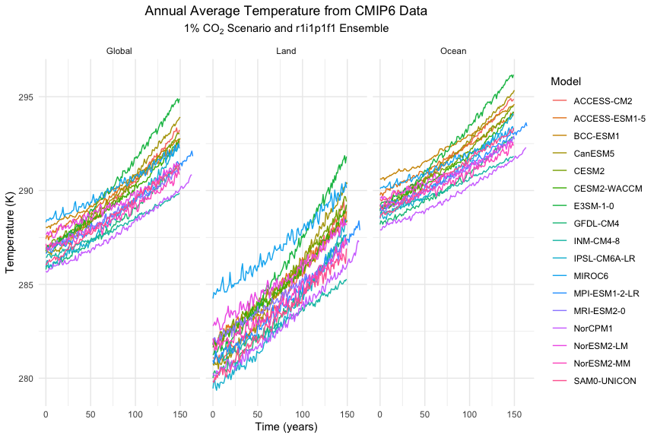

Data from CMIP6 1% CO2 runs in ensemble r1i1f1p1 showing the absolute temperature for land, ocean, and global temperature over 150 year period. Note the greater temperature increase over land than over ocean which suggests a land-ocean warming ratio greater than one.

      Using the temperature data extracted from the CMIP6 data, the land-ocean warming ratio was calculated for each model as described in the methods section. As shown below in Figure 2, the ratio stays relatively constant or decreases slightly over time for all models, again agreeing with previous literature. I hypothesize that for some of the models the ratio decreases slightly over time due to the model state adjusting at it reaches equilibrium and differences between the systems short term and long term reactions.[HELP I AM NOT SURE]. With reassurance that the CMIP6 models’ warming ratios are consistent with expectations I moved forward in my analysis.

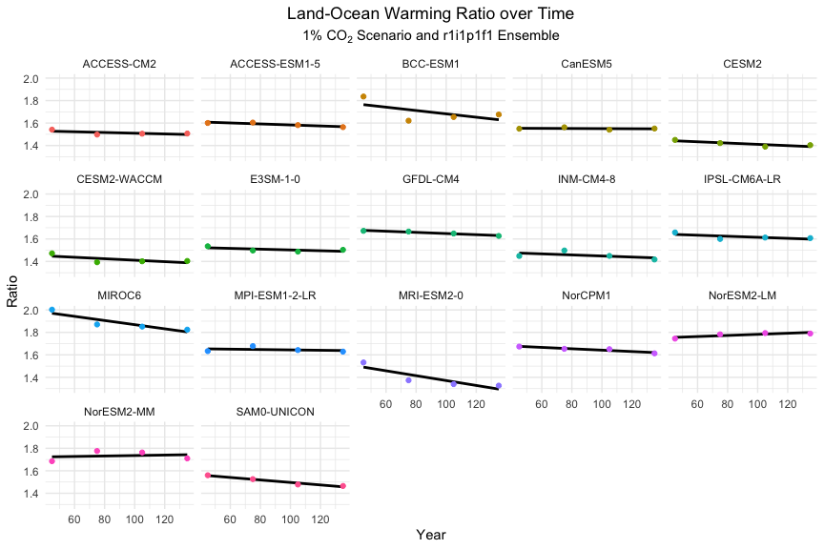

Land-ocean warming ratio over 150 year time period for all CMIP6 models used. Most models show that the ratio is near constant over time which is supported by previous literature.

      Breaking the land-ocean warming data into time periods of 30 years over the 150 years of simulated data shows that the land-ocean warming ratio decreases slightly over time on average (Figure 3). This data shows that the warming ratio varies over time and I wanted to use an estimated value that most closely matches the environment the it will be emulating within Hector. Since Hector is generally run from 2015 to 2100, a time period of 75 years, I used the median of all of the 150 years of data as shown in Figure 4.

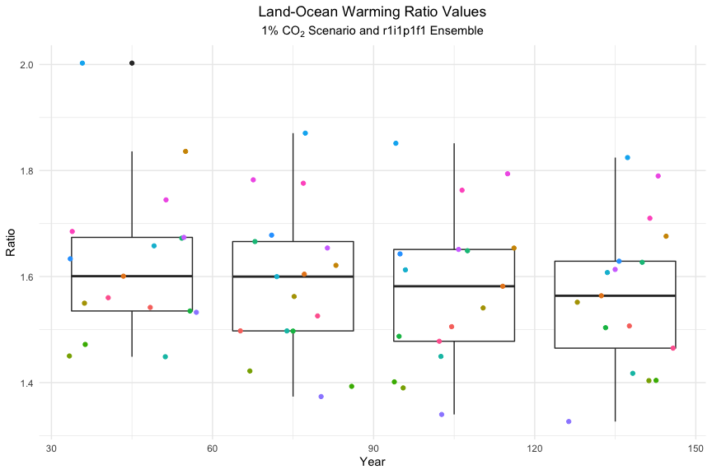

Land-Ocean warming ratio for all models seperated by time period. Note that the ratio decreases slightly over the 150 year timescale.

      Since we are utilizing all of the data points, I determined that the mean of all of our data points is and the median is . Since the median is a more robust metric to the extremes I used the value 1.591 for parameterizing the land-ocean warming ratio within Hector.

      The changes to the code had substantial effects on model outputs such as average global temperature, ambient CO2, forcing caused by C02, and total forcing as shown in Figure 5, which compares the effects on these variables by warming scenario. The orange time shows the absolute changes in results from the original code due to replacing global average temperature with land temperature and ocean air temperatures in the land and ocean components of Hector respectively. The blue line visualizes the result of setting the land-ocean warming ratio to 1.591 in conjunction with the downstream changes. We see increases in all four values displayed below, especially in the high warming RCP 8.5 scenario. [SHOULD I PUT MAX CHANGE VALUES? I HAVE VERY LITTLE NUMBERS IN RESULTS AND IT MAKES ME NERVOUS…]

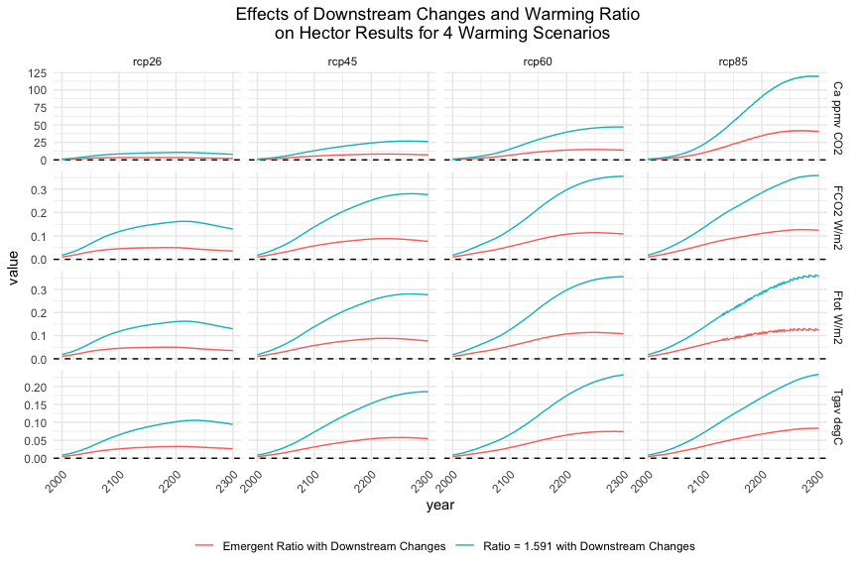

Relative changes due to changes made to model from original code, represented by the dashed line on the y-axis. The orange line reprsents changes due to making downstream changes (i.e. using land temperature for soil respiration calculations) and the blue line represents changes due to downstream changes and setting the warming ratio to 1.591 as determined from CMIP6 data.

After exposing the land-ocean warming ratio within R, I was able to use it to run Hector 500 times, setting the ratio to a random distribution centered on the mean of the CMIP6 warming ratio data. The results show that the value of the land-ocean warming ratio can have large effects on the results of Hector for various parameters. While I am only presenting the data for RCP 4.5 as it had one of the larger spreads, all four warming scenarios had similar results. The large spread of the presented parameters highlights the importance of making the land-ocean warming ratio a tunable parameter within R so robust analysis of the effects of the ratio can be conducted.

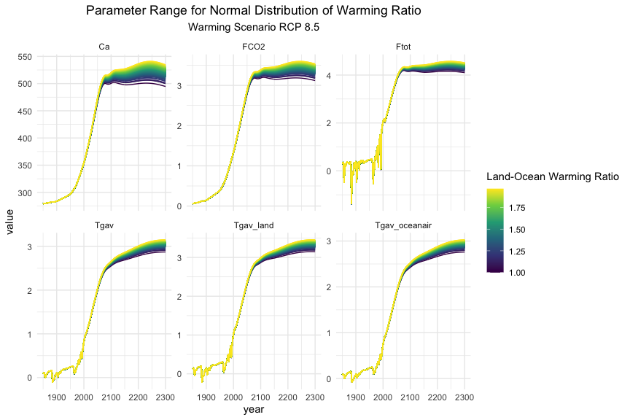

A normal distribution of warming ratio values centered on the mean of the CMIP6 land-ocean warming ratio data for warming scenario RCP 4.5.

## Discussion

      This project was important as it increased the physical realism of Hector predictions and opened an avenue for emulating ESMs using the land-ocean warming ratio. The downstream changes increased the predictive abilities of both global, land and ocean warming, which has the potential to affect climate resiliency planning. Additionally, understanding land warming can be especially important as it can have socioeconomic consequences relating to agriculture, infrastructure and the water and energy sectors. Hector’s ability to emulate ESMs using the land-ocean warming ratio is important due to the computational complexity of ESMs. This change allows the use of Hector to look closer at a multitude of warming scenarios and the earth system response to various parameters and get results that are similar to what would be produced by an ESM. Finally, making this change accessible though R broadens the reach of these benefits as Hector is an open-source climate model available to scientists around the world.

      In the future, the temperature component of Hector needs to be more thoroughly examined. After overwriting the land and ocean air warming with values produced by the warming ratio, I discovered that feeding these values back into the calculation of global temperature created irrational data. I believe there is an unidentified bug in the code, and fixing that would cause the effects of my changes to be larger. While the new values calculated currently feed into the land and ocean components of the model and thus change the carbon cycle, they do not otherwise affect the calculation of the global average temperature. Looking into this should be a top priority moving forward.

## Acknowledgments

      I would like to thank my mentors Dr. Ben Bond-Lamberty, Kayln Dorheim, and Stephanie Pennington for their encouragement and dedication throughout this summer. I truly could not have done it without all three of you. Your guidance was priceless. I would also like to thank Pacific Northwest National Laboratory (PNNL) and the Joint Global Change Research Institute (JGCRI) for hosting me. A special thank you to the PNNL Office of STEM Education team for making this SULI interactive even during these remote-working time.

      This work was supported in part by the U.S. Department of Energy, Office of Science, Office of Workforce Development for Teachers and Scientists (WDTS) under the Science Undergraduate Laboratory Internships Program (SULI).

## Appendix A

      All of the code and data outputs referenced can be found in the GitHub repository land-ocean-warming-ratio at <https://github.com/skygering/land-ocean-warming-ratio> and the Hector code can be found at <https://github.com/JGCRI/hector>.

      Avg_temp_script.R and average_temp_cdo.R can be used calculate the annual average land, ocean, and global average annual temperature from historical CMIP6 data. In order to analyze the data using these scripts, a model must have tas, areacalla, and sftlf data. The scripts will help identify usable models given proper data organization. These two scripts can be run using sbatch avg_temp_job.txt on PNNL’s super computer PIC. The cdo_path variable at the top of avg_temp_script.R will need to be adapted to the local machine, as well as the code to identify the file placement of the temperature and area data as these are specific to the file system and organization of PIC. The path_name should be set to the top level of the project.

      The above files will output a .csv file with the average annual land, ocean, and global temperature for each model organized as well as a folder for each model that will hold a .csv for the model’s data as well as intermediate files if the cleanup variable is set to false.

      The data can then be run through cleaning_temp_data.R (again need to change global variables to fit your local machine and data) to get an updated .csv file with the cleaned data without any bad data. This data can now be used for further investigations.

      The cleaned data can then be run through the script warming_ratio.R, which will output a .csv file containing the warming ratio for each model. Once the above data has been created (all three of the .csv outputs mentioned above are also saved in this repository), the .Rmd file can be run to analyze the data and the create graphs of major trends.

      The .Rmd file will require use of the Hector Package. If my work has been merged to the master branch, this will simply be the normal Hector package. If not, the package will need to be built using the code from the branch land_ocean_warming_ratio in the Hector repository.

## Bibliography

Dong, Buwen, Jonathan M Gregory, and Rowan T Sutton. 2009. “Understanding Land–Sea Warming Contrast in Response to Increasing Greenhouse Gases. Part I: Transient Adjustment.” *Journal of Climate* 22 (11): 3079–97.

Hartin, Corinne A, Pralit L Patel, Adria Schwarber, Robert P Link, and Benjamin Bond-Lamberty. 2015. “A Simple Object-Oriented and Open-Source Model for Scientific and Policy Analyses of the Global Climate System–Hector V1. 0.” *Geoscientific Model Development (Online)* 8 (PNNL-SA-104722).

Joshi, Manoj M, Jonathan M Gregory, Mark J Webb, David MH Sexton, and Tim C Johns. 2008. “Mechanisms for the Land/Sea Warming Contrast Exhibited by Simulations of Climate Change.” *Climate Dynamics* 30 (5): 455–65.

Meinshausen, Malte, Sarah CB Raper, and Tom ML Wigley. 2011. “Emulating Coupled Atmosphere-Ocean and Carbon Cycle Models with a Simpler Model, Magicc6-Part 1: Model Description and Calibration.” *Atmospheric Chemistry and Physics* 11: 1417–56.

Sejas, Sergio A, Oriene S Albert, Ming Cai, and Yi Deng. 2014. “Feedback Attribution of the Land-Sea Warming Contrast in a Global Warming Simulation of the Ncar Ccsm4.” *Environmental Research Letters* 9 (12): 124005.