Hi there

This is a document with label from azure information protection. But it is not protected or encrypted

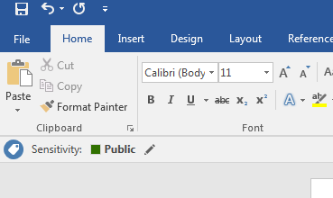

Thanks

.andreas