**QAT:**

Sharepoint: https://aws-qat-eventreceiver.i-shn.net/Pages/Default.aspx?SPHostUrl=https%3A%2F%2Fskyhightest4%2Esharepoint%2Ecom%2Fsites%2FAppCatalog&SPLanguage=en%2DUS&SPClientTag=0&SPProductNumber=16%2E0%2E23207%2E12004&SPAppWebUrl=https%3A%2F%2Fskyhightest4%2Dade80537585dda%2Esharepoint%2Ecom%2Fsites%2FAppCatalog%2FSHN%2DSharepointEventReceivers2&SPAppVer=1.0.0.8

Onedrive: https://aws-qat-eventreceiver.i-shn.net/Pages/Default.aspx?SPHostUrl=https%3A%2F%2Fskyhightest4%2Dmy%2Esharepoint%2Ecom%2Fpersonal%2Fneerada%5Fskyhightest4%5Fonmicrosoft%5Fcom&SPLanguage=en%2DUS&SPClientTag=1&SPProductNumber=16%2E0%2E23207%2E12004&SPAppWebUrl=https%3A%2F%2Fskyhightest4%2D751b0431d303c2%2Esharepoint%2Ecom%2Fpersonal%2Fneerada%5Fskyhightest4%5Fonmicrosoft%5Fcom%2FSHN%2DSharepointEventReceivers2&SPAppVer=1.0.0.8

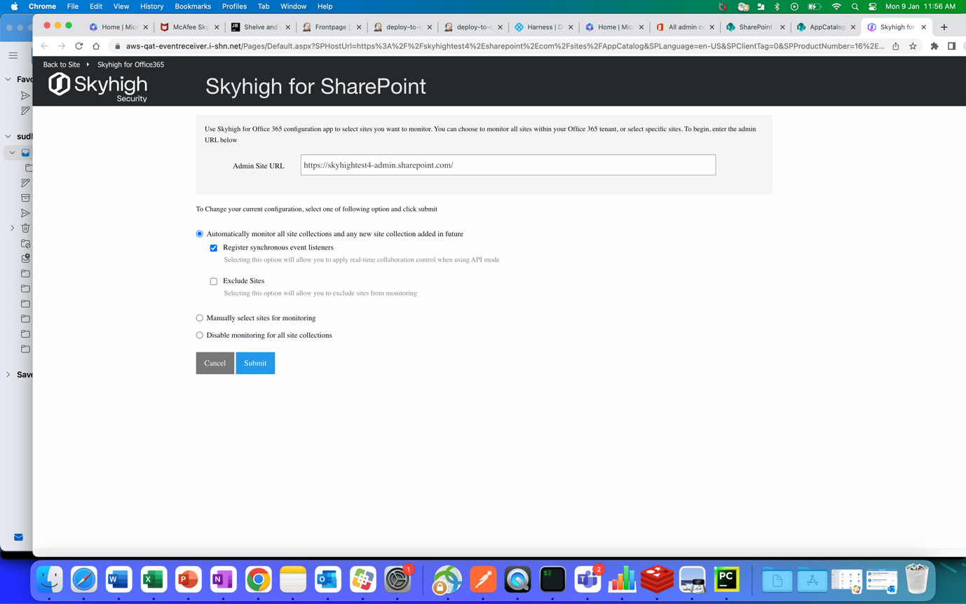

QAAR:

<https://qaar-eventreceiver.i-shn.net/Pages/Default.aspx?SPHostUrl=https%3A%2F%2Fskyhightest4%2Esharepoint%2Ecom%2Fsites%2FAppCatalog&SPLanguage=en%2DUS&SPClientTag=0&SPProductNumber=16%2E0%2E23207%2E12004&SPAppWebUrl=https%3A%2F%2Fskyhightest4%2Dade80537585dd9%2Esharepoint%2Ecom%2Fsites%2FAppCatalog%2FSHN%2DSharepointEventReceivers%2DQaar&SPAppVer=1.0.0.8>

Onedrive:

https://qaar-eventreceiver.i-shn.net/Pages/Default.aspx?SPHostUrl=https%3A%2F%2Fskyhightest4%2Dmy%2Esharepoint%2Ecom%2Fpersonal%2Fneerada%5Fskyhightest4%5Fonmicrosoft%5Fcom&SPLanguage=en%2DUS&SPClientTag=1&SPProductNumber=16%2E0%2E23207%2E12004&SPAppWebUrl=https%3A%2F%2Fskyhightest4%2D751b0431d303c0%2Esharepoint%2Ecom%2Fpersonal%2Fneerada%5Fskyhightest4%5Fonmicrosoft%5Fcom%2FSHN%2DSharepointEventReceivers%2DQaar&SPAppVer=1.0.0.8

