Ceph笔记汇总

PG状态

刚部署后的ceph，起3个OSD环境状态如下：

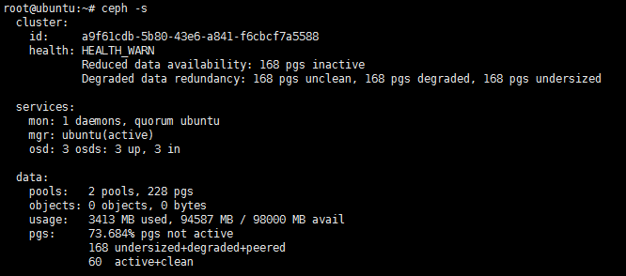

需要修改crushmap的故障域为OSD，默认为host

RBD

列出pool内的img

rbd ls <pool_name>

ISCSI

iscsiadm -m discovery -t sendtargets -p 192.168.199.128 连接报错：

iscsiadm: No portals found

原因：ceph端的tgt用tgtadmin创建的，client端就会提示这个错误，用编辑tgt配置文件创建target方式就无问题！

Mon源码

源码流程

ceph_mon.cc:

main()

new Monitor()

mon->preinit()

msgr->start()

mgr_msgr->start()

mon->init()

monitor.cc

preinit

gdb -pid `pidof ceph-mon`

(gdb) bt

#0 pthread_cond_wait@@GLIBC_2.3.2 () at ../sysdeps/unix/sysv/linux/x86_64/pthread_cond_wait.S:185

#1 0x000055dffc6e09e7 in AsyncMessenger::wait() ()

#2 0x000055dffc2fc70c in main ()

线程：

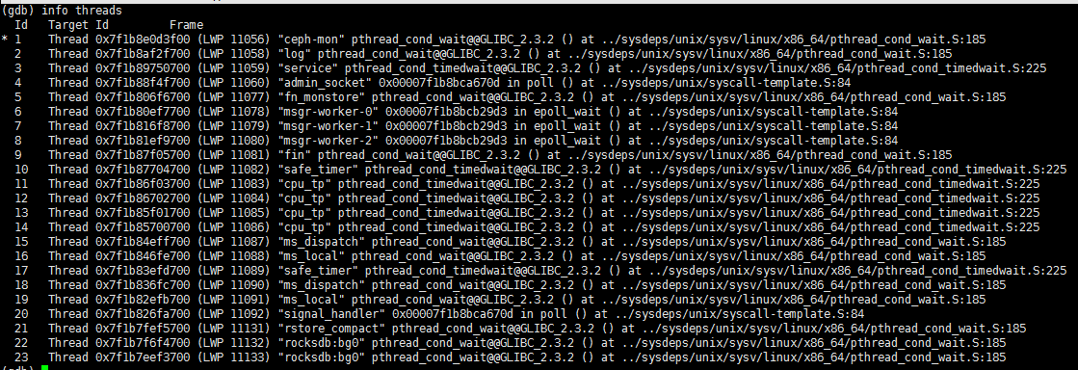

msgr-worker三个线程

src/common/Thread.cc

src/msg/async/stack.cc:35

NetworkStack类：add_thread

AsyncMessanger {

}

|  |
| --- |
| struct StackSingleton {  CephContext *cct;  std::shared_ptr<NetworkStack> stack;  StackSingleton(CephContext *c): cct(c) {}  void ready(std::string &type) {  if (!stack)  stack = NetworkStack::create(cct, type);  }  ~StackSingleton() {  stack->stop();  }  }; |

AsyncMessenger::AsyncMessenger(CephContext *cct, entity_name_t name,

const std::string &type, string mname, uint64_t _nonce)

: SimplePolicyMessenger(cct, name,mname, _nonce),

dispatch_queue(cct, this, mname),

lock("AsyncMessenger::lock"),

nonce(_nonce), need_addr(true), did_bind(false),

global_seq(0), deleted_lock("AsyncMessenger::deleted_lock"),

cluster_protocol(0), stopped(true)

{

std::string transport_type = "posix";

if (type.find("rdma") != std::string::npos)

transport_type = "rdma";

else if (type.find("dpdk") != std::string::npos)

transport_type = "dpdk";

ceph_spin_init(&global_seq_lock);

StackSingleton *single;

cct->lookup_or_create_singleton_object<StackSingleton>(single, "AsyncMessenger::NetworkStack::"+transport_type);

single->ready(transport_type);

stack = single->stack.get();

stack->start();

....

}

|  |
| --- |
| Messenger *Messenger::create(CephContext *cct, const string &type,  entity_name_t name, string lname,  uint64_t nonce, uint64_t cflags)  {  int r = -1;  if (type == "random") {  static std::random_device seed;  static std::default_random_engine random_engine(seed());  static Spinlock random_lock;  std::lock_guard<Spinlock> lock(random_lock);  std::uniform_int_distribution<> dis(0, 1);  r = dis(random_engine);  }  if (r == 0 || type == "simple")  return new SimpleMessenger(cct, name, std::move(lname), nonce);  else if (r == 1 || type.find("async") != std::string::npos)  return new AsyncMessenger(cct, name, type, std::move(lname), nonce);  #ifdef HAVE_XIO  else if ((type == "xio") &&  cct->check_experimental_feature_enabled("ms-type-xio"))  return new XioMessenger(cct, name, std::move(lname), nonce, cflags);  #endif  lderr(cct) << "unrecognized ms_type '" << type << "'" << dendl;  return nullptr;  } |

|  |
| --- |
| src/msg/async/stack.cc  Worker* NetworkStack::get_worker()  {  ldout(cct, 30) << __func__ << dendl;  // start with some reasonably large number  unsigned min_load = std::numeric_limits<int>::max();  Worker* current_best = nullptr;  pool_spin.lock();  // find worker with least references  // tempting case is returning on references == 0, but in reality  // this will happen so rarely that there's no need for special case.  for (unsigned i = 0; i < num_workers; ++i) {  unsigned worker_load = workers[i]->references.load();  if (worker_load < min_load) {  current_best = workers[i];  min_load = worker_load;  }  }  pool_spin.unlock();  assert(current_best);  ++current_best->references;  return current_best;  } |

|  |
| --- |
| void NetworkStack::start()  {  pool_spin.lock();  if (started) {  pool_spin.unlock();  return ;  }  for (unsigned i = 0; i < num_workers; ++i) {  if (workers[i]->is_init())  continue;  std::function<void ()> thread = add_thread(i);  spawn_worker(i, std::move(thread)); //实际执行DPDKStack:spawn_workder  }  started = true;  pool_spin.unlock();  for (unsigned i = 0; i < num_workers; ++i)  workers[i]->wait_for_init();  } |

|  |
| --- |
| void DPDKStack::spawn_worker(unsigned i, std::function<void ()> &&func)  {  // create a extra master thread  //  funcs[i] = std::move(func);  int r = 0;  r = dpdk::eal::init(cct);  if (r < 0) {  lderr(cct) << __func__ << " init dpdk rte failed, r=" << r << dendl;  ceph_abort();  }  // if dpdk::eal::init already called by NVMEDevice, we will select 1..n  // cores  assert(rte_lcore_count() >= i + 1);  dpdk::eal::execute_on_master([&]() {  r = rte_eal_remote_launch(dpdk_thread_adaptor, static_cast<void*>(&funcs[i]), i+1);  if (r < 0) {  lderr(cct) << __func__ << " remote launch failed, r=" << r << dendl;  ceph_abort();  }  });  } |

|  |
| --- |
| std::function<void ()> NetworkStack::add_thread(unsigned i)  {  Worker *w = workers[i];  return [this, w]() {  char tp_name[16];  sprintf(tp_name, "msgr-worker-%d", w->id);  // 实际gdb上去一共3个msgr-worker  6 Thread 0x7f1b80ef7700 (LWP 11078) "msgr-worker-0" 0x00007f1b8bcb29d3 in epoll_wait () at ../sysdeps/unix/syscall-template.S:84  7 Thread 0x7f1b816f8700 (LWP 11079) "msgr-worker-1" 0x00007f1b8bcb29d3 in epoll_wait () at ../sysdeps/unix/syscall-template.S:84  8 Thread 0x7f1b81ef9700 (LWP 11080) "msgr-worker-2" 0x00007f1b8bcb29d3 in epoll_wait () at ../sysdeps/unix/syscall-template.S:84  //  ceph_pthread_setname(pthread_self(), tp_name);  const uint64_t EventMaxWaitUs = 30000000;  w->center.set_owner();  ldout(cct, 10) << __func__ << " starting" << dendl;  w->initialize();  w->init_done();  while (!w->done) {  ldout(cct, 30) << __func__ << " calling event process" << dendl;  ceph::timespan dur;  int r = w->center.process_events(EventMaxWaitUs, &dur);  if (r < 0) {  ldout(cct, 20) << __func__ << " process events failed: "  << cpp_strerror(errno) << dendl;  // TODO do something?  }  w->perf_logger->tinc(l_msgr_running_total_time, dur);  }  w->reset();  w->destroy();  };  } |

|  |
| --- |
| src/common/options.cc:  std::vector<Option> get_global_options() {  // ceph.conf没有配置读取默认配置，3个线程  Option("ms_async_op_threads", Option::TYPE_UINT, Option::LEVEL_ADVANCED)  .set_default(3)  .set_description(""),  } |

ceph-mon线程

ms_dispatch和ms_local线程

|  |
| --- |
| src/mon/monitor.cc  void Monitor::_ms_dispatch(Message *m)  {  } |

|  |
| --- |
| src/common/async/AsyncMessanger.cc  AsyncMessenger::AsyncMessenger(CephContext *cct, entity_name_t name,  const std::string &type, string mname, uint64_t _nonce)  : SimplePolicyMessenger(cct, name,mname, _nonce),  dispatch_queue(cct, this, mname),  lock("AsyncMessenger::lock"),  nonce(_nonce), need_addr(true), did_bind(false),  global_seq(0), deleted_lock("AsyncMessenger::deleted_lock"),  cluster_protocol(0), stopped(true)  {  std::string transport_type = "posix";  if (type.find("rdma") != std::string::npos)  transport_type = "rdma";  else if (type.find("dpdk") != std::string::npos)  transport_type = "dpdk";  ceph_spin_init(&global_seq_lock);  StackSingleton *single;  cct->lookup_or_create_singleton_object<StackSingleton>(single, "AsyncMessenger::NetworkStack::"+transport_type);  single->ready(transport_type);  stack = single->stack.get();  stack->start();  local_worker = stack->get_worker();  local_connection = new AsyncConnection(cct, this, &dispatch_queue, local_worker);  init_local_connection();  reap_handler = new C_handle_reap(this);  unsigned processor_num = 1;  if (stack->support_local_listen_table())  processor_num = stack->get_num_worker();  for (unsigned i = 0; i < processor_num; ++i)  processors.push_back(new Processor(this, stack->get_worker(i), cct));  } |

|  |
| --- |
| src/msg/async/AsyncConnection.cc:  class AsyncConnection : public Connection {  DispatchQueue *dispatch_queue;  }  AsyncConnection::AsyncConnection(CephContext *cct, AsyncMessenger *m, DispatchQueue *q,  Worker *w)  : Connection(cct, m), delay_state(NULL), async_msgr(m), conn_id(q->get_id()),  logger(w->get_perf_counter()), global_seq(0), connect_seq(0), peer_global_seq(0),  state(STATE_NONE), state_after_send(STATE_NONE), port(-1),  dispatch_queue(q), can_write(WriteStatus::NOWRITE),  keepalive(false), recv_buf(NULL),  recv_max_prefetch(MAX(msgr->cct->_conf->ms_tcp_prefetch_max_size, TCP_PREFETCH_MIN_SIZE)),  recv_start(0), recv_end(0),  last_active(ceph::coarse_mono_clock::now()),  inactive_timeout_us(cct->_conf->ms_tcp_read_timeout*1000*1000),  got_bad_auth(false), authorizer(NULL), replacing(false),  is_reset_from_peer(false), once_ready(false), state_buffer(NULL), state_offset(0),  worker(w), center(&w->center)  {  read_handler = new C_handle_read(this);  write_handler = new C_handle_write(this);  wakeup_handler = new C_time_wakeup(this);  tick_handler = new C_tick_wakeup(this);  memset(msgvec, 0, sizeof(msgvec));  // double recv_max_prefetch see "read_until"  recv_buf = new char[2*recv_max_prefetch];  state_buffer = new char[4096];  logger->inc(l_msgr_created_connections);  } |

|  |
| --- |
| src/msg/DispatchQueue.cc  void DispatchQueue::start()  {  assert(!stop);  assert(!dispatch_thread.is_started());  dispatch_thread.create("ms_dispatch");  local_delivery_thread.create("ms_local");  } |

|  |
| --- |
| src/msg/DispatchQueue.cc  class DispatchQueue {  class DispatchThread : public Thread {  DispatchQueue *dq;  public:  explicit DispatchThread(DispatchQueue *dq) : dq(dq) {}  // 重写了父类Thread的entry方法  void *entry() override {  dq->entry();  return 0;  }  } dispatch_thread;  }  void DispatchQueue::entry()  {  lock.Lock();  while (true) {  // gdb中看到的ms_dispatch线程的主循环  while (!mqueue.empty()) {  QueueItem qitem = mqueue.dequeue();  if (!qitem.is_code())  remove_arrival(qitem.get_message());  lock.Unlock();  if (qitem.is_code()) {  if (cct->_conf->ms_inject_internal_delays &&  cct->_conf->ms_inject_delay_probability &&  (rand() % 10000)/10000.0 < cct->_conf->ms_inject_delay_probability) {  utime_t t;  t.set_from_double(cct->_conf->ms_inject_internal_delays);  ldout(cct, 1) << "DispatchQueue::entry inject delay of " << t  << dendl;  t.sleep();  }  // 不同消息类型的入口  switch (qitem.get_code()) {  case D_BAD_REMOTE_RESET:  msgr->ms_deliver_handle_remote_reset(qitem.get_connection());  break;  case D_CONNECT:  msgr->ms_deliver_handle_connect(qitem.get_connection());  break;  case D_ACCEPT:  msgr->ms_deliver_handle_accept(qitem.get_connection());  break;  case D_BAD_RESET:  msgr->ms_deliver_handle_reset(qitem.get_connection());  break;  case D_CONN_REFUSED:  msgr->ms_deliver_handle_refused(qitem.get_connection());  break;  default:  ceph_abort();  }  } else {  Message *m = qitem.get_message();  if (stop) {  ldout(cct,10) << " stop flag set, discarding " << m << " " << *m << dendl;  m->put();  } else {  uint64_t msize = pre_dispatch(m);  msgr->ms_deliver_dispatch(m);  post_dispatch(m, msize);  }  }  lock.Lock();  }  if (stop)  break;  // wait for something to be put on queue  cond.Wait(lock);  }  lock.Unlock();  } |

|  |
| --- |
| src/msg/DispatchQueue.h:  class LocalDeliveryThread : public Thread {  DispatchQueue *dq;  public:  explicit LocalDeliveryThread(DispatchQueue *dq) : dq(dq) {}  void *entry() override {  dq->run_local_delivery();  return 0;  }  } local_delivery_thread; |

|  |
| --- |
| src/msg/DispatchQueue.cc  void DispatchQueue::run_local_delivery()  {  local_delivery_lock.Lock();  while (true) {  // ms_local线程的主循环  if (stop_local_delivery)  break;  if (local_messages.empty()) {  local_delivery_cond.Wait(local_delivery_lock);  continue;  }  pair<Message *, int> mp = local_messages.front();  local_messages.pop_front();  local_delivery_lock.Unlock();  Message *m = mp.first;  int priority = mp.second;  fast_preprocess(m);  if (can_fast_dispatch(m)) {  fast_dispatch(m);  } else {  enqueue(m, priority, 0);  }  local_delivery_lock.Lock();  }  local_delivery_lock.Unlock();  } |

rocksdb:bg0线程

ms_local线程

cpu_tp线程

safe_timer线程

admin_socket线程

signal_handler线程

rstore_compact线程

fin线程

service线程

log线程