1. Client🡪 Dashboard 🡪UI
2. Company users🡪Add User🡪

* The sentence should be “What **best** describes your role with this company?”
* City & State should be dropdown list

1. Basic Reporting Info🡪Basic Info🡪

* Contact Person Legal Middle Name to **Contact Person Legal Middle Name Initial**
* Change the Telephone Number to **Employee Benefit Broker Telephone Number**
* Make these fields mandatory in the Basic Info form, State field should be dropdown.

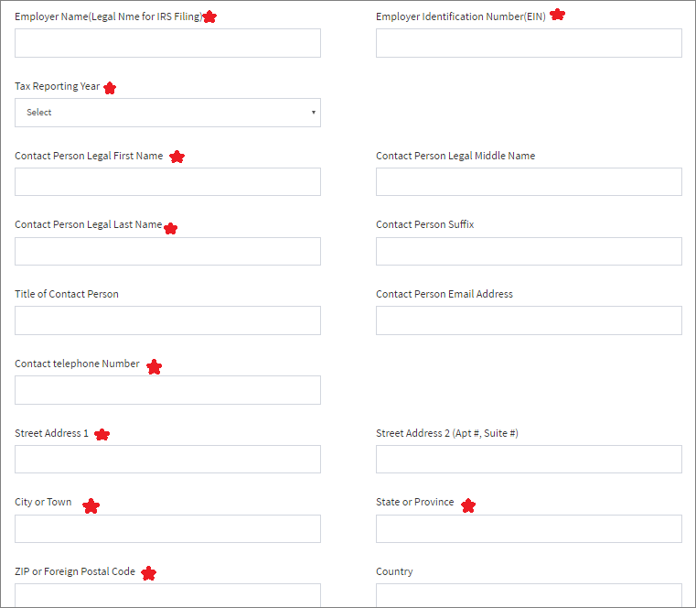

1. Payroll Data🡪UI
2. Medical plan enrollment data🡪UI