**WEBAPP**

Your Project Name Documentation

1. Project Overview

Welcome to the documentation for our Jakarta EE project, "WEBAPP." This project is designed to serve as an educational guide, demonstrating the implementation of various Jakarta EE features. The primary modules include an EJB module for handling batch jobs and a WAR module for web applications.

Project Dashboard

Simple created web dashboard

Accessing the dashboard

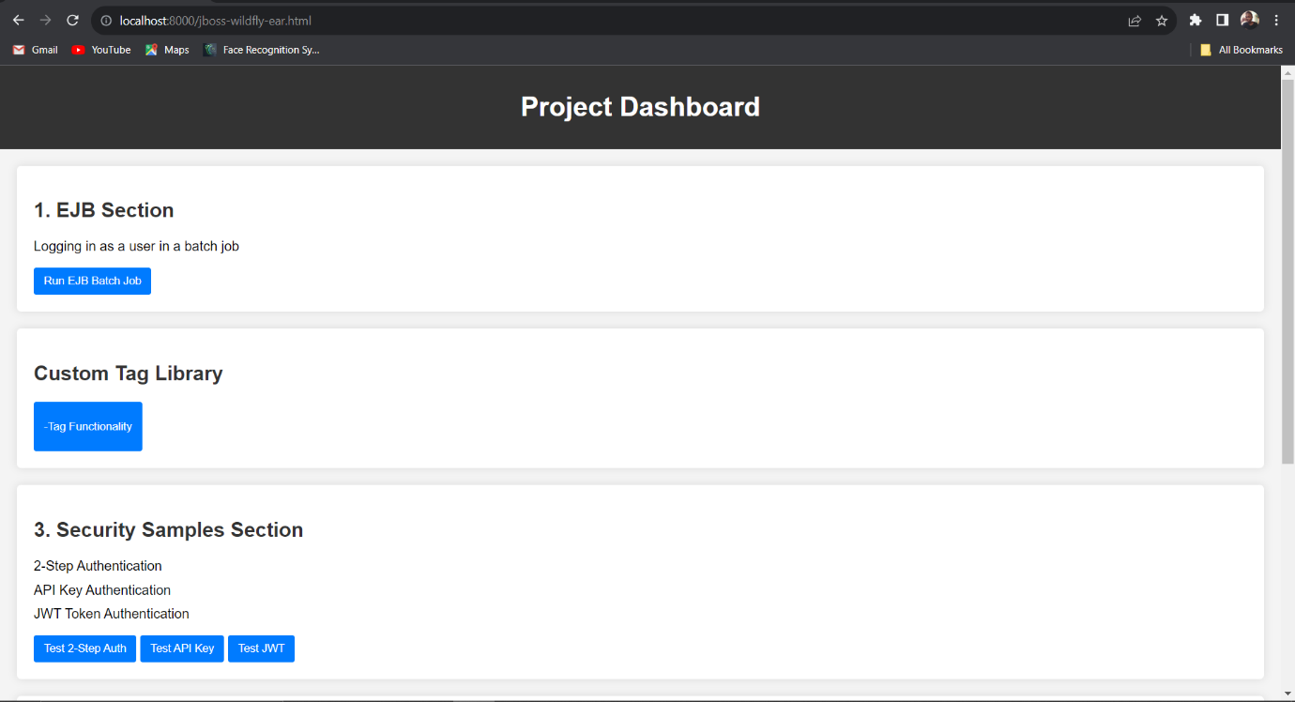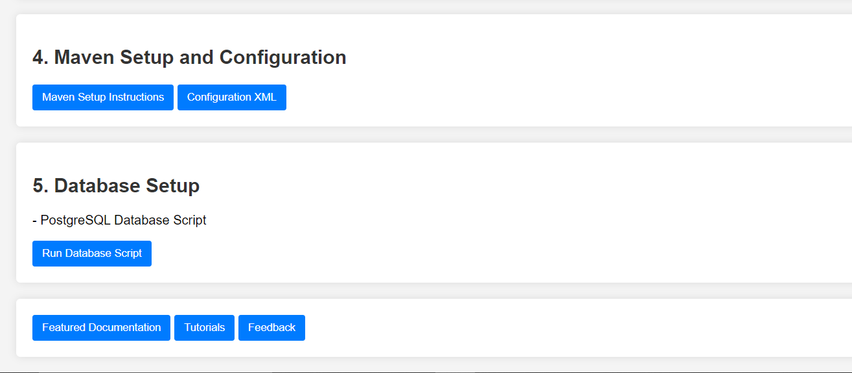

2. Modules

2.1. EJB Module

The EJB (Enterprise JavaBeans) module is responsible for managing batch jobs. Specifically, it contains a singleton EJB (BatchJobEJB) that executes a scheduled batch job to perform a specific task. This module showcases the power of EJBs for background processing.

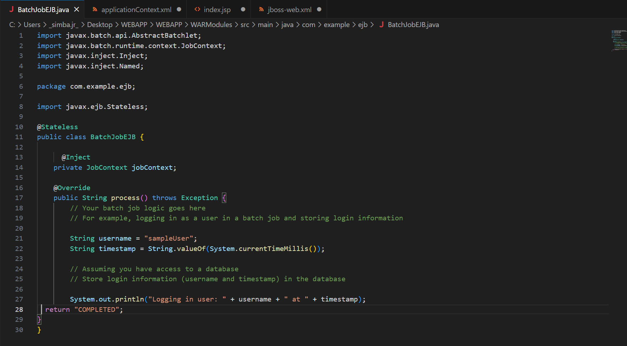

2.2. WAR Module

The WAR (Web Application Archive) module is the web component of our application. It includes features such as 2-step authentication, authentication with API key, authentication with JWT token, plain user/password authentication, and Google login. Additionally, it showcases the integration of a custom tag library (CustomTagHandler) to enhance web page functionality.

TwoStepAuth

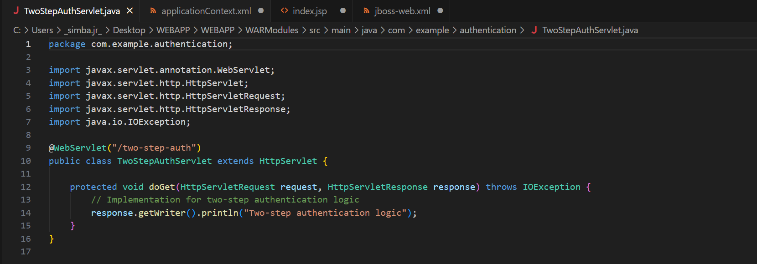

APIKey

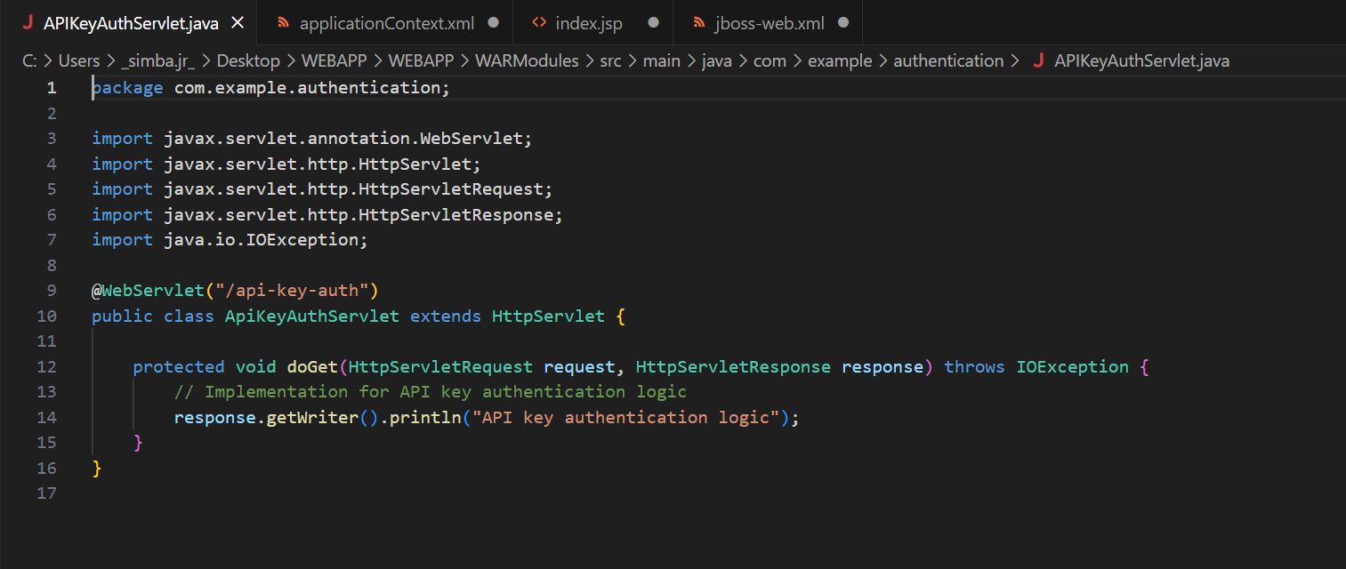

JWT Token

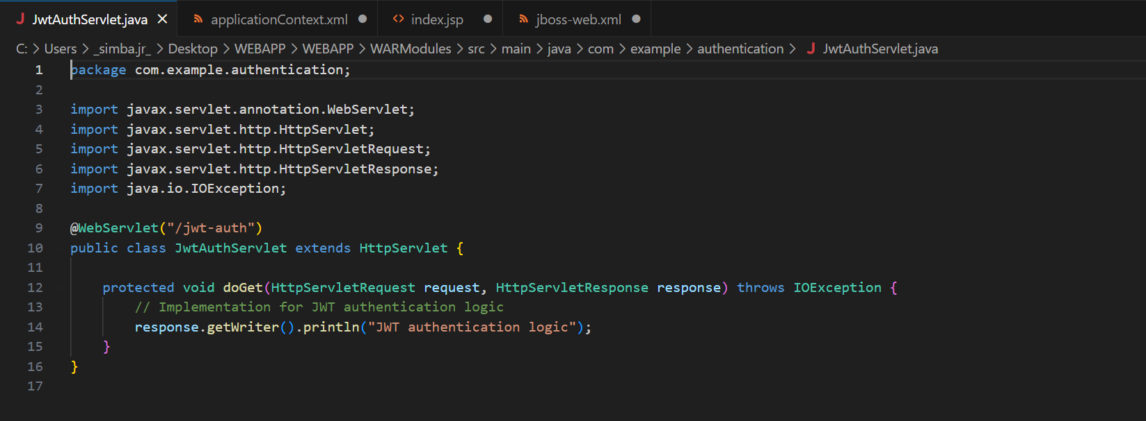

Google Login

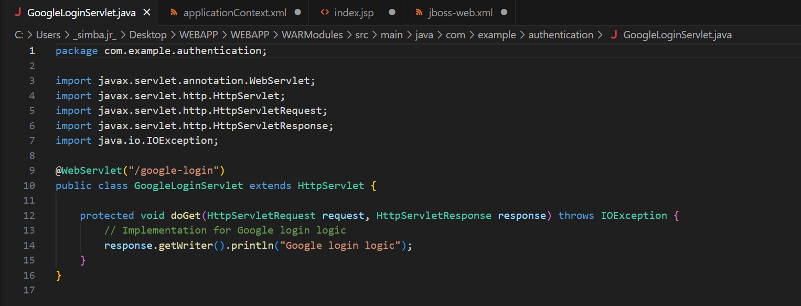

Google Login With Authentication

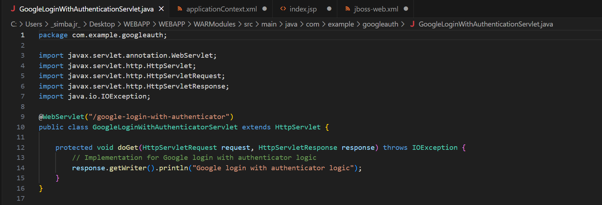

3. Database Schema

The database schema for our project consists of a single table named login_info. This table stores login information, including an auto-incremented id, the username of the user, and the timestamp indicating when the login occurred. The schema is designed to be simple yet effective for our demonstration purposes.

PostgreSQL



Database structure

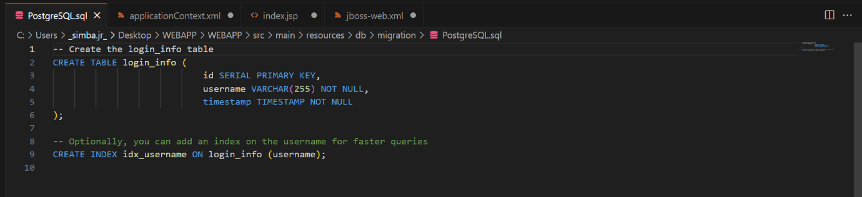

4. Build and Deployment

4.1. Maven Configuration

Our project uses Maven as the build tool. Maven configurations are automatically handled by the default settings. No additional configurations are required for this demonstration.

4.2. Database Setup

To set up the database, execute the provided PostgreSQL script (V1__Create_Login_Info_Table.sql) in your PostgreSQL database. This script creates the necessary table for storing login information.

5. Usage

5.1. Batch Job EJB

The Batch Job EJB (BatchJobEJB) is a singleton EJB scheduled to run at midnight. It performs a task (print a message to the console in our example) and showcases how to use EJBs for background processing.

5.2. Custom Tag Library

Our WAR module includes a custom tag library (CustomTagHandler) that adds a custom tag (<custom:customTag>) to our web pages. This tag is integrated into a Facelets page to display a simple message ("Hello from Custom Tag!"). This demonstrates how to create and use custom tags in Jakarta EE.

Tag Handler

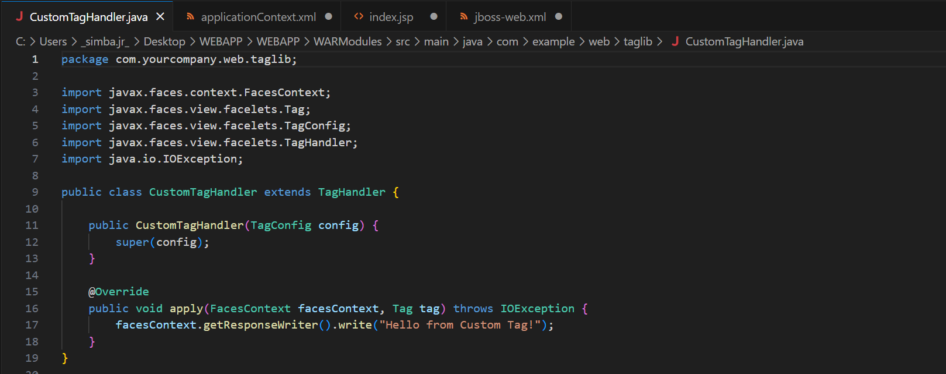

Custom Tag Library

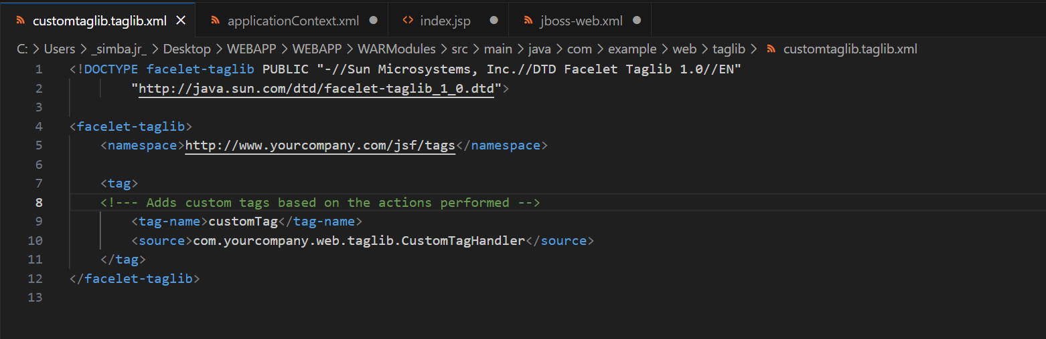

6. Troubleshooting

No specific troubleshooting steps are anticipated for this educational demonstration. If you encounter any issues, please ensure that your environment is set up correctly, and the database script has been executed.