DROPS: Division and Replication of Data in Cloud for Optimal Performance and Security

In this paper author is describing concept to increase performance and to provide security to cloud data without using any security algorithms such as AES or DES.

In existing system all were using security algorithms which causing performance to decrease.

Here in this paper author is dividing files into fragments (blocks) and then storing all blocks into different cloud servers instead of saving in one machine. If a single machine hacks (compromise by attacker) then attacker can get only part of data (one block), from that single block he can’t able to get meaning full information and there will be no way for him to identify locations of other servers which stores remaining blocks.

Here to store blocks author using T-coloring or Centrality concept using which we can find which server is closer to store remaining blocks.

By using above concept security already provided by storing files on different servers and performance will automatically increase as we are not using any heavy computation security algorithms.

To implement above concepts I design three cloud servers with VM ware and when user uploads file then blocks will be generated and send to all three servers for storage

Screen shots

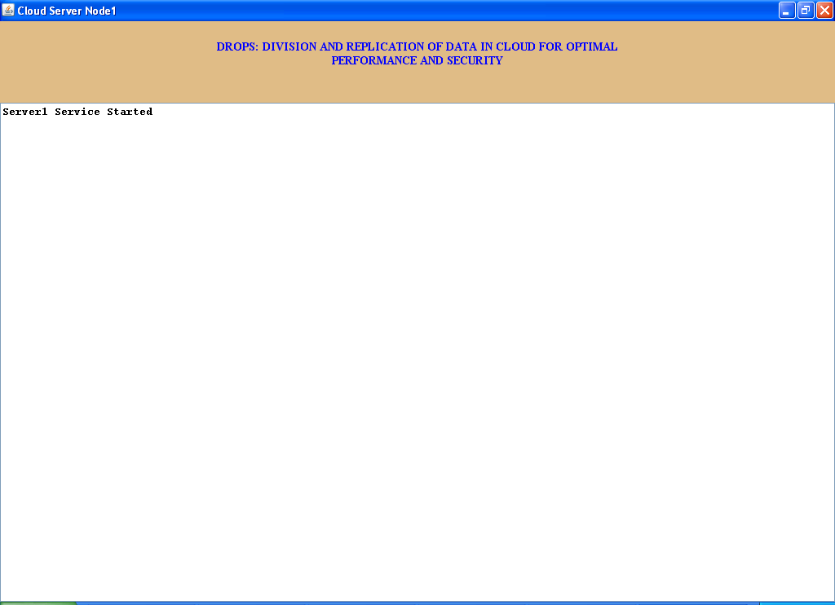

In above screen cloud server1 started

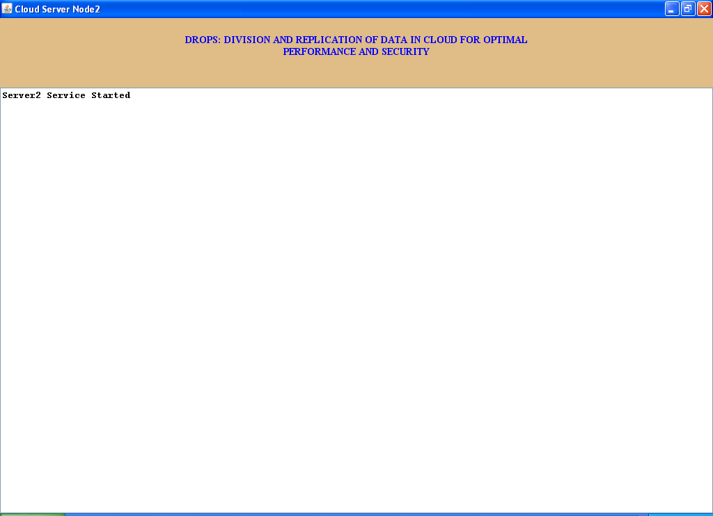

In above screen cloud server2 started

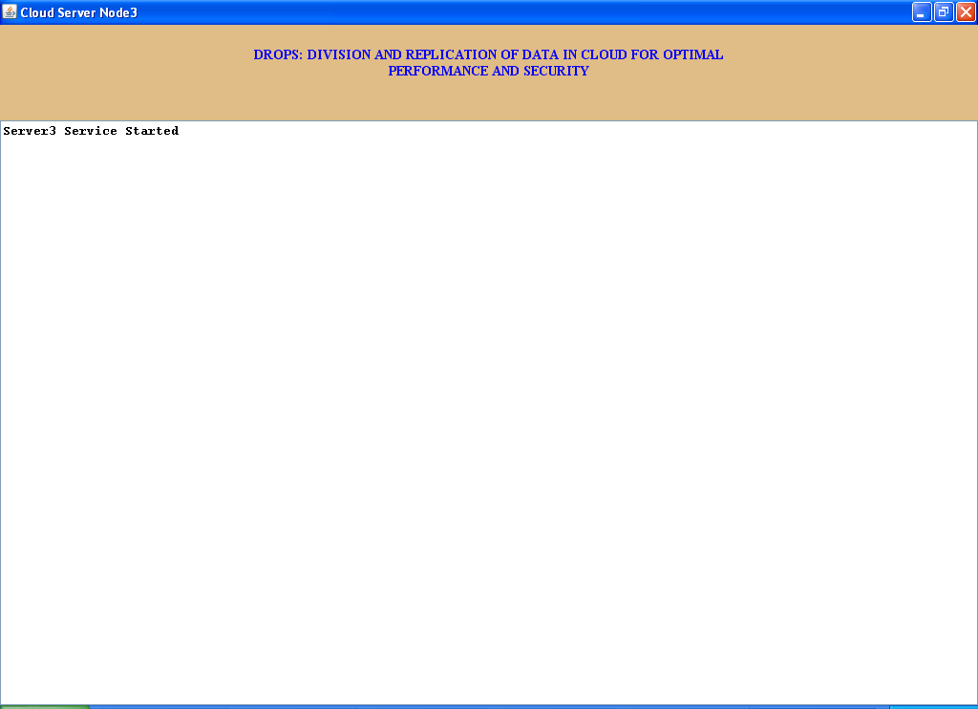

In above screen cloud server3 started. Now run user application

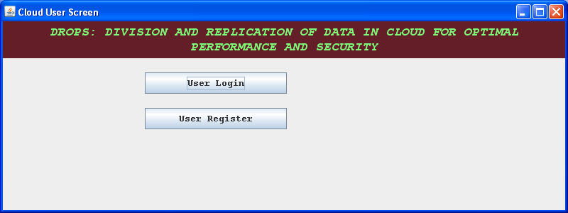

Now click on ‘User Register’ to add new user

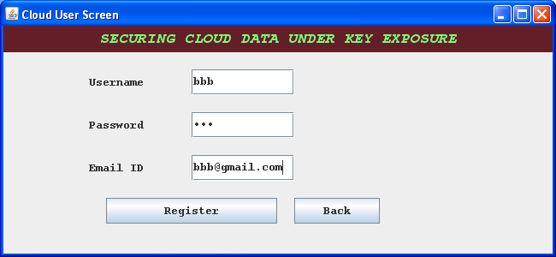

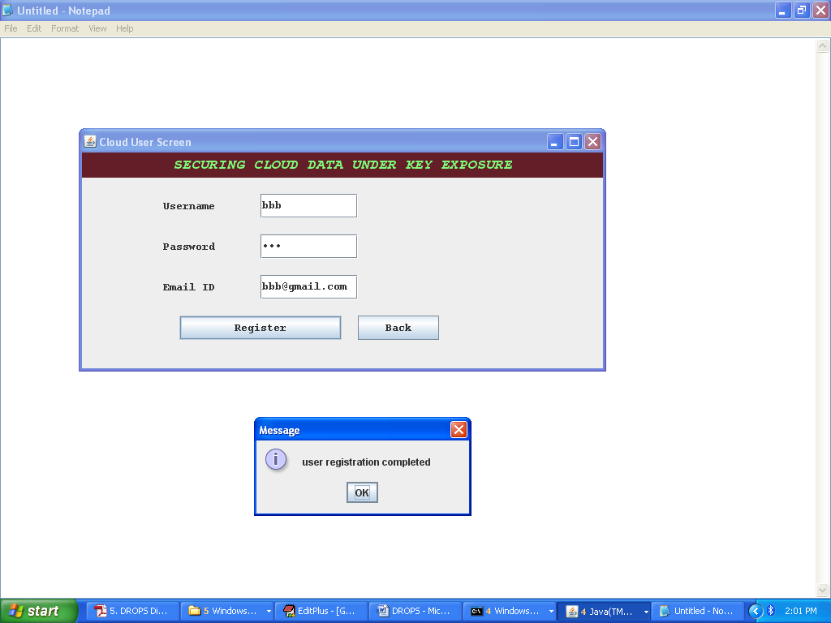

Now login

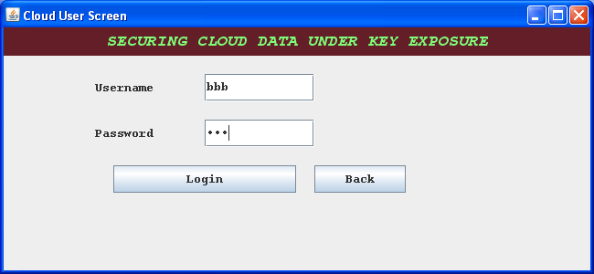

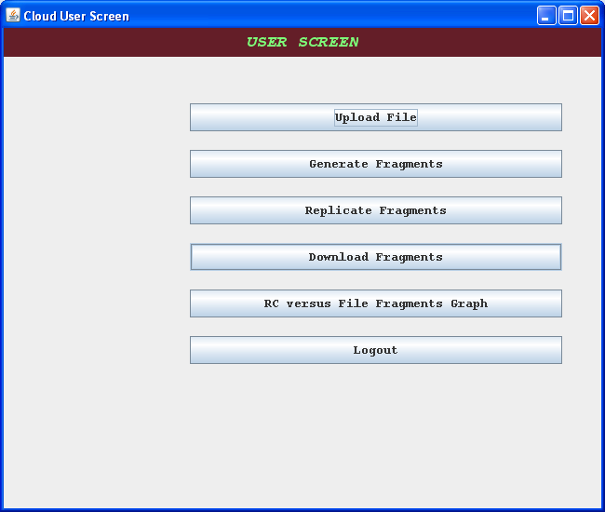

Now click on ‘Upload File’

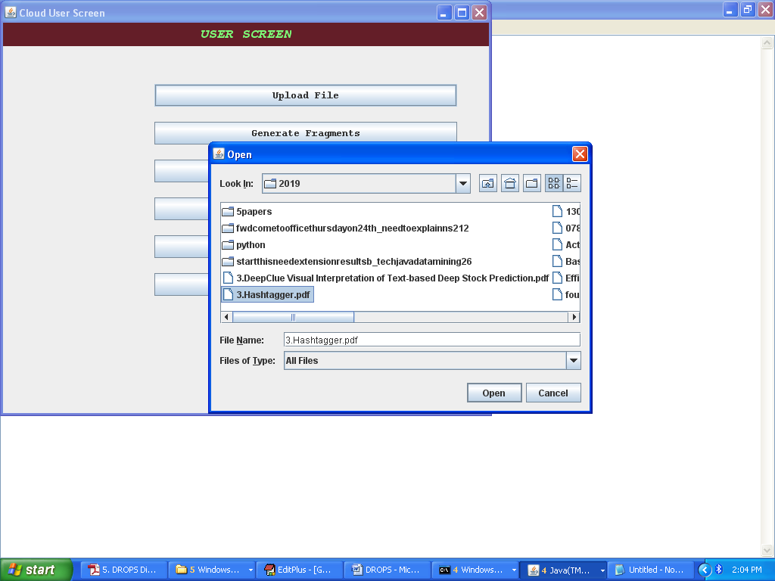

In above screen I am uploading one pdf

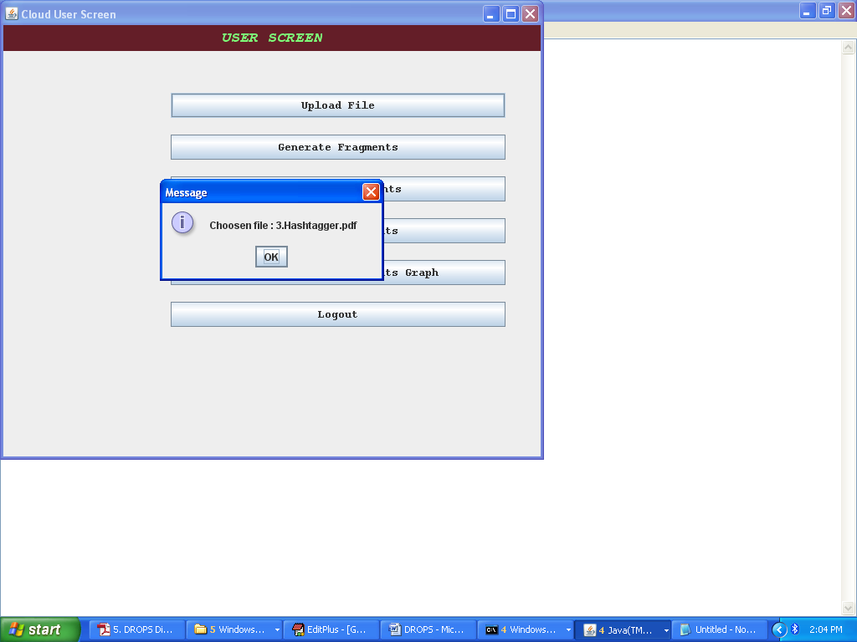

Now click on ‘Generate Fragments’ button to generate blocks

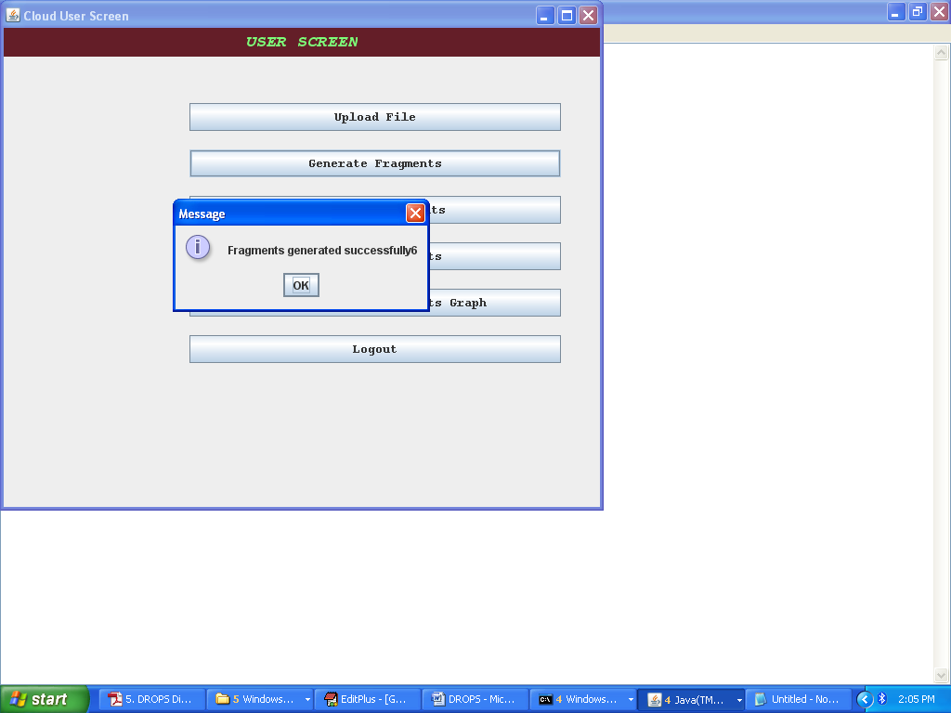

Now click on ‘Replicate’ button to send data

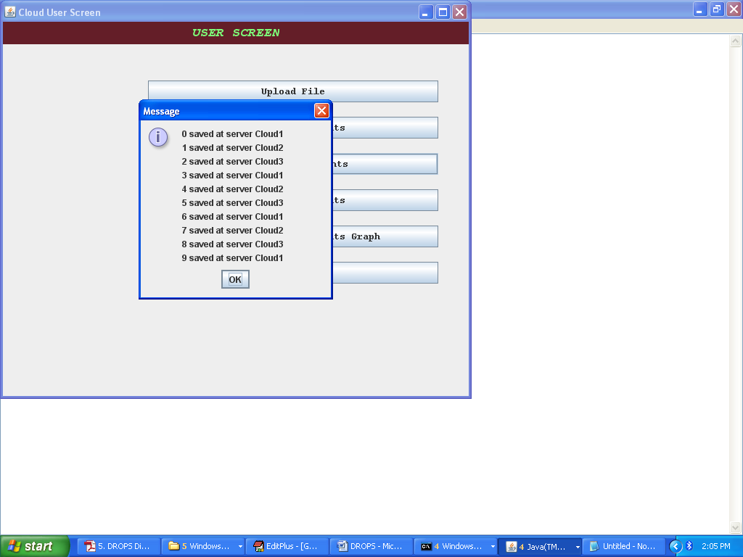

In above screen we can see different blocks sent to different servers. We can see blocks in user directory

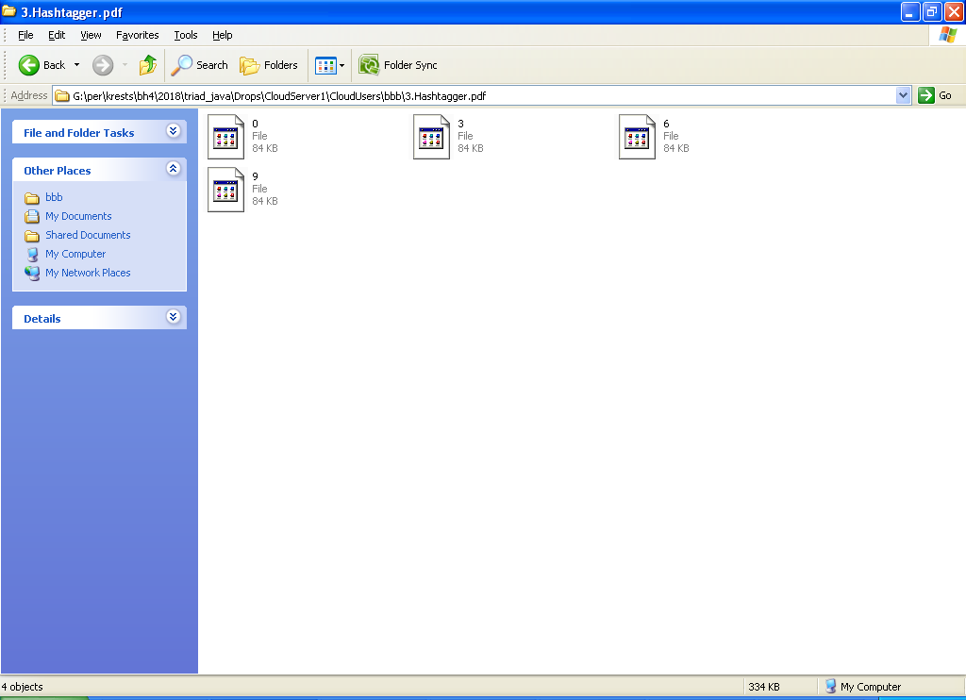

In above screen at server1 0, 3, 6, and 9 blocks are store and remaining sent to other servers

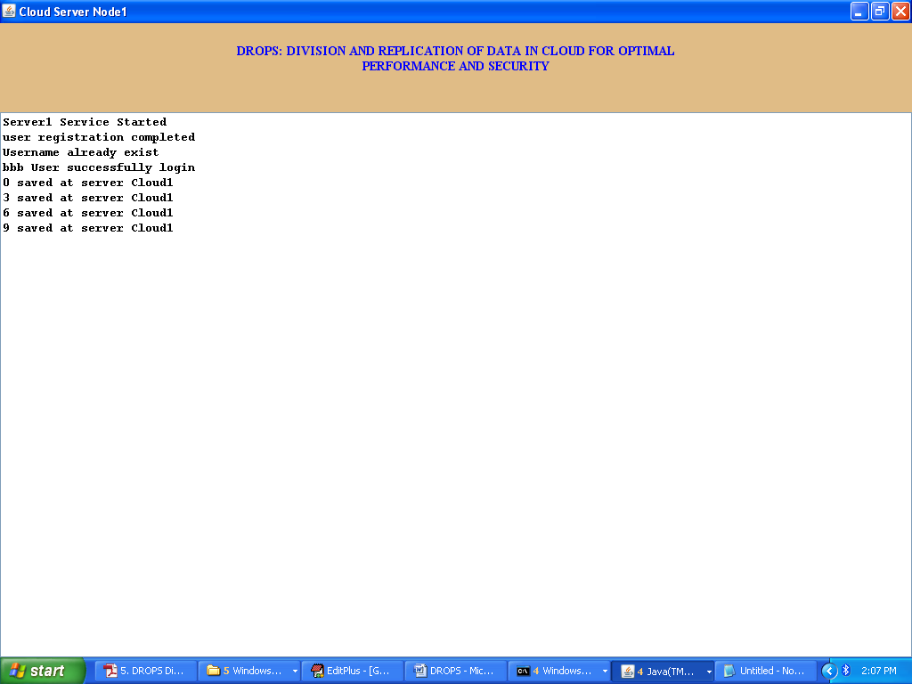

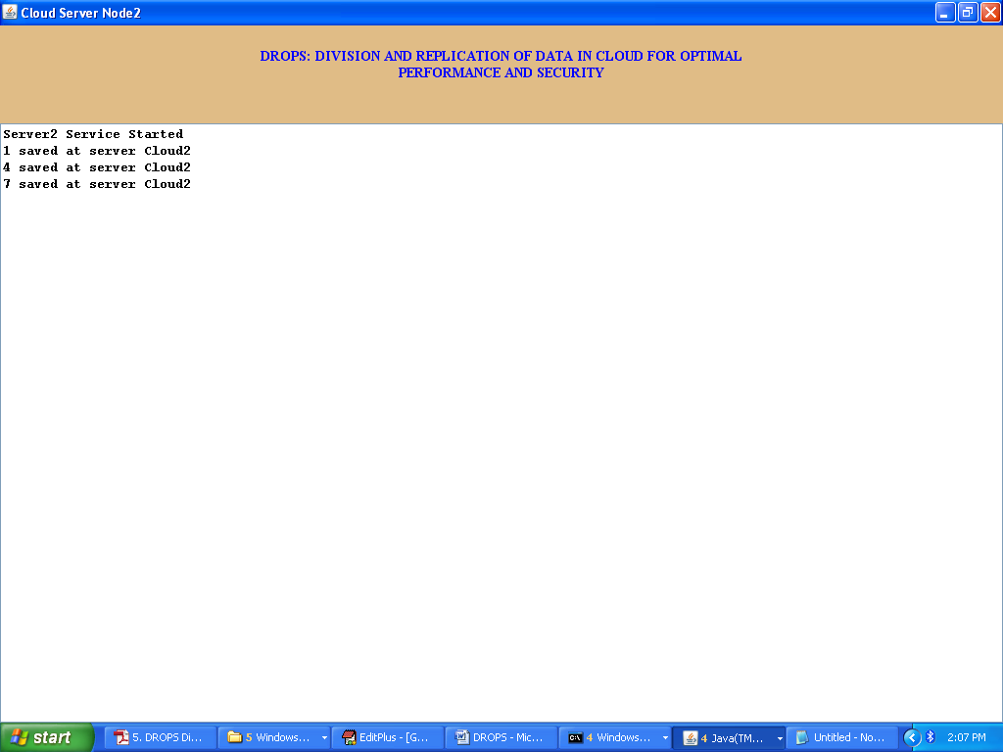

Now click on ‘Download’ button to download file

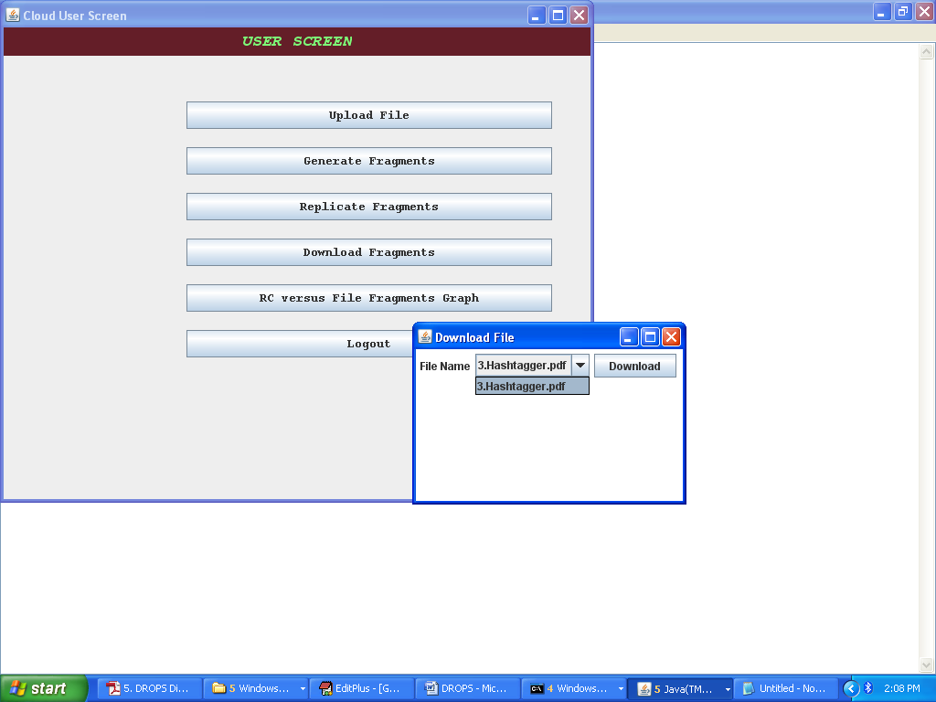

Select the file to download

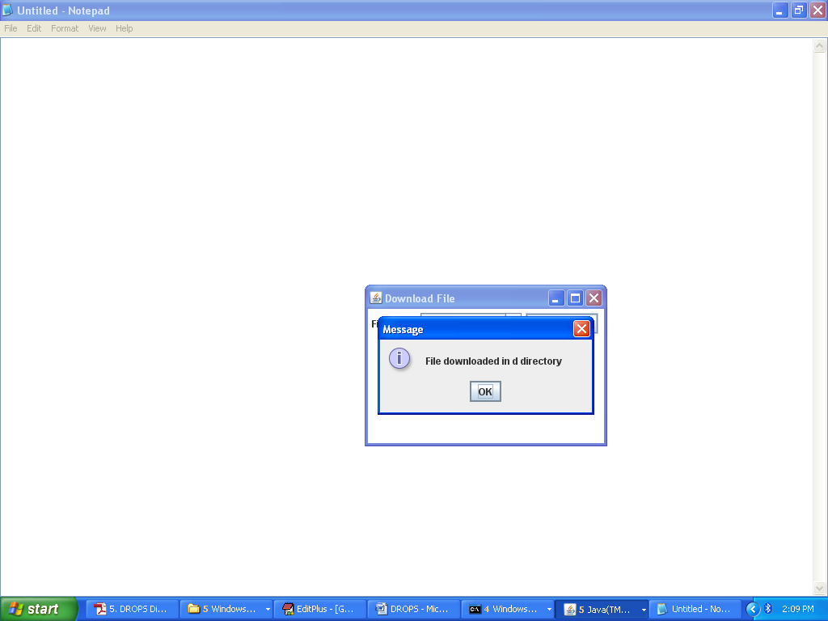

Downloaded file we can see in d directory

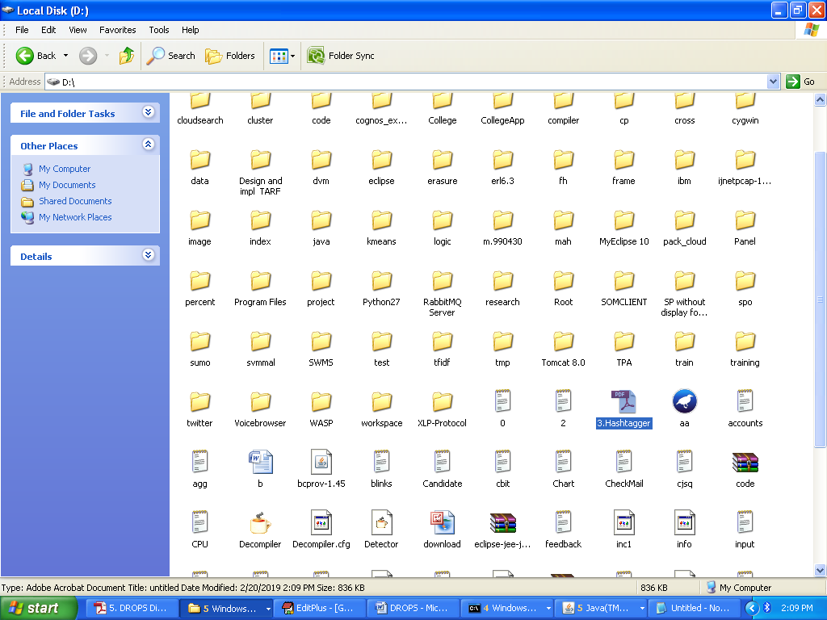

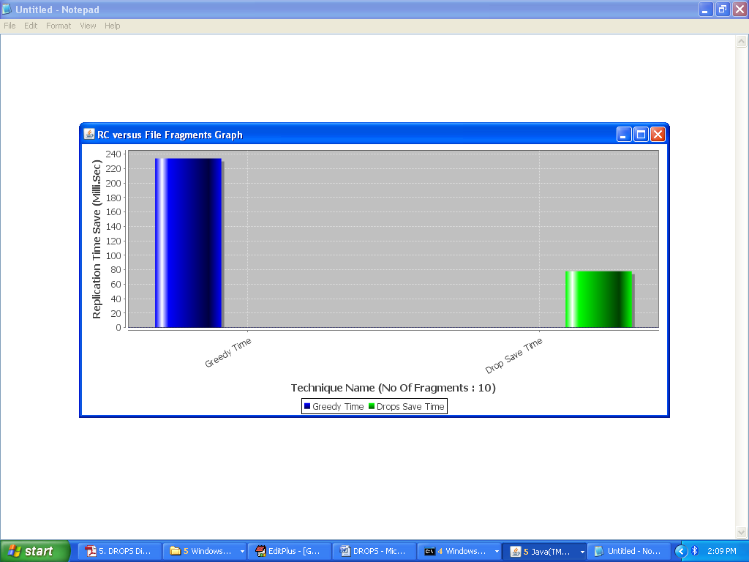

Drop is the propose work