Paper 25 Survey

The paper presented by Dr. Timothy Brown, et al., is proof of concept on how to measure performance of physical mesh networking hardware and protocols. Rather then relying solely on simulation software as many authors have done in the past, this team used a combination of off-the-shelf hardware and in-house developed software to measure dynamic source routing (DSR) mesh networking performance in real-time. While their “test bed,” as it is called throughout the paper, has the potential to facilitate the monitoring of 10’s of nodes, they tended to only test six to eight nodes. The mismatch between potential nodes and the actual number of nodes used is understandable as there are real costs associated with physical hardware and available open space for testing a large number of nodes. Dr. Brown, et al., also admit that their monitoring hardware was significantly under-powered and would have to be upgraded in order to capture the real-time behavior of a larger DSR network.
The test bed used to conduct the research was located at a federal facility near Boulder, Colorado. The facility consisted of an unobstructed, flat 7 km² area. The unique open area of the facility allowed for different types of nodes ranging from hand-held radios to typical drones. Normally a flat area such as this would be “too perfect” to do any sort of real-world performance measurement. Fortunately, the test bed focused on measuring the resiliency of the DSR algorithm itself, rather then on radio interference. In order to capture real-time DSR radio traffic, each node must report wirelessly to a fixed node in the facility. The fixed node takes in all the individual reports and relays them over TCP/IP to a remote monitoring location. It is at the remote monitoring location where the data from all the nodes is compiled and metrics are calculated in real-time. It is also at this location in which one of the many choke points in the system exists. Consider figure 1:

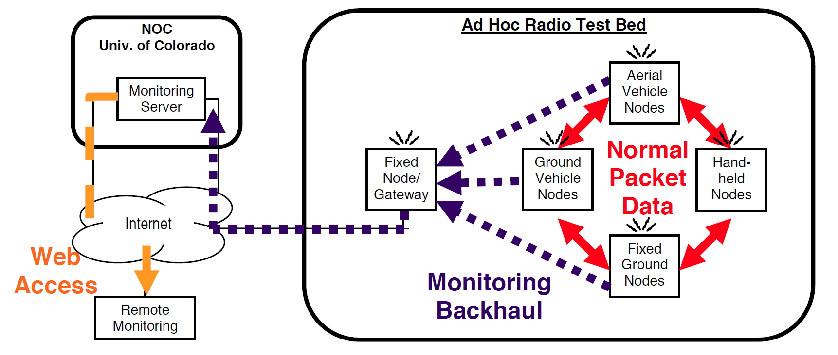

Figure 1 shows the overview of the entire system. Inside the “Ad Hoc Radio Test Bed” box is where the DSR traffic is created and captured. It is unknown what frequencies are used to produce DSR traffic and to produce reports for the fixed node/gateway. The team did report a 10% decrease in performance when DSR monitoring was activated. The performance decrease and subsequent packet loss between nodes is most likely a result of wireless noise and the fixed node/gateway choke point.
One of the four major goals of Dr. Browns research team was to accomplish sufficiently complete, real-time data presentation. They accomplished this goal with little packet loss and reasonably good results considering the hardware and resources at their disposal. In summary, the team used combinations of off-the-shelf computing hardware.
Each node consisted of:
*Soekris Single Board Computer
*Orinoco 802.11b PCMCIA card
*1W Fidelity-Comtech Bidirectional Amplifier
*GPS Receiver
The Gateway consisted of a Click Modular Router.
The Monitoring Server is assumed to be a university rack-mounted data center.
The Remote Monitoring CPU is assumed to be a Pentium-III class computer.

Each individual node consists of a communication framework and an additional system monitoring module. The framework is called the Mesh Network Radio (MNR) framework. The MNR framework consists of a real-time operating system, various hardware drivers, communication interconnects, and a dedicated DSR routing subsystem. Within the MNR framework also lies the Monitoring Module (MM). The purpose of the MM is to sample all incoming and outgoing communications of the host node. Once sampled, the MM uses the internal data structures and various MNR framework services to send real-time metrics directly to a listening gateway. As can be seen from the provided illustration, it’s a rather interesting relationship between the MNR and the MM. Instead of having it’s own dedicated framework, the MM piggybacks on the MNR which maximizes the usage of scarce computing resources.

Figure 2 to be placed here.

The next major part of the test bed is the university hosted monitoring server. The server consists of a single 450Mhz machine running open-source software such as MySQL. It is the job of the server to not only archive all incoming metric packets, but also to sort them out into three distinct categories: per-packet data, per-node data, and application messages. Once sorted, the three different packets can be queried to produce graphical output on any browser or end-user client.
The separation of metric data into three types of packets allows for a deep understanding as to the behavior of the nodes using the DSR protocol. The per-packet data type, for instance, allows for an explicit tracing of a single packet throughout the network. At each hop, the MM reports to the server the location of the packet. This will allow analytical tools to determine the health of the overall network in regards to dropped packets. The next type of packet, the per-node data packet, consists of metrics regarding the physical location of the node and it’s relative distance from other nodes. At various time intervals, the MM simply samples a GPS sensor and reports it to the server. The last packet, the application messages packet, allows for the capturing of incoming text messages and other non-DSR related communications. It should be noted that DSR path maintenance packets and other such DSR protocol specific packets are not captured and reported to the server by the MM.

