Review of Paper: Decentralised Coordination of Unmanned Aerial Vehicles for Target Search using the Max-Sum Algorithm

This paper briefly outlined a method of coordinating the flight path selection for a team of coordinating UAVs. These UAVs share information in order to coordinate their movements in an attempt to maximize the utility of their path decisions. The goal is to maximize the probability of finding a particular target. To do this, the mission planning function onboard each UAV should decide to coordinate and move more UAVs to an area where the target is suspected and less to areas where the expectation of finding the target is low. However, in moving many UAVs to a confined area, there is a risk of those UAVs having significant overlap in their sensors, thus diminishing their value or utility.

In order to quantify the utility of each UAV’s movement, it is assigned a “variable” and a “function” and when flight movement decisions are made, these functions and variables link to those of other UAVs that are flying in the area in an attempt to maximize the combined utility (probability of finding the target of interest).
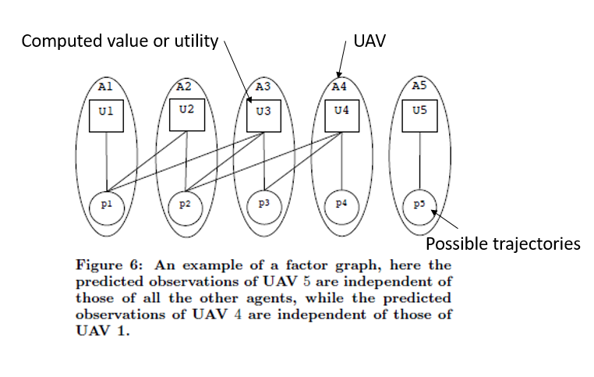

“Variables” refer to the trajectories available to the particular UAV. These trajectories have been reduced to a select few turning angles to reduce the amount of computation required. Speed is constant. “Functions” refer to the utility or value that each UAV has. Note that each UAV’s utility (function) is always linked to its trajectories (variable) since its flight path selection has a direct impact on how useful or valuable the UAV actually is.

At each computation step, this same linking concept is carried out across all UAVs in the operating area such that the utility or value of all the other UAVs is taken into account when a given UAV makes a decision about how to fly.

Once the appropriate linkages between UAVs are established, negotiation begins by trying to find the optimal global utility (sum of all UAV utility) of the entire swarm. Simplifications are made by only allowing a given UAV to link with others having a lower ID and functions only link with variables that have are used in computing the utility.

The result should yield a valuable, if not optimal solution, to the coordination problem.

